
A REPORT ON
STUDENTS INDUSTRIAL WORK EXPERIENCE SCHEME
(SIWES)

UNDERTAKEN AT

ROBUST TECHNOLOGIES INTEGRATED HUB AND ALLIED SERVICE LTD.
Located At: ARA VILLAGE AREA ILORIN KWARA STATE.

BY
GANIYU ALIAH MOTUNRAYO
ND/23/MAC/PT/1041

SUBMITTED TO
THE DEPARTMENT OF MASS COMMUNICATION, INSTITUTE OF INFORMATION AND COMMUNICATION TECHNOLOGY, KWARA STATE POLYTECHNIC, ILORIN.
IN PARTIAL FULFILMENT OF THE REQUIREMENT FOR THE
AWARD OF NATIONAL DIPLOMA (ND) IN MASS COMMUNICATION.

March, 2025
DEDICATION
I dedicate this Students Industrial Work Experience Scheme (SIWES) report to God almighty for his grace and mercy towards the completion of the SIWES programme.

ACKNOWLEDGEMENT
My acknowledgement goes to God almighty, my parents, Kwara State Polytechnic, Ilorin, my supervisors at Robust Technologies Integrated Hub and Allied Service Ltd and to my friends.

REPORT OVERVIEW
This is an industrial attachment report for the Students’ Industrial Work Experience (SIWES) programme carried out at Robust Technologies Integrated Hub and Allied Service Ltd. Located at: Ara Village Area Ilorin Kwara State. 2024 to December, 2024.
The report comprises the background of SIWES, the description of the organization, its aims and objectives, the experiences gained as an industrial training student and the summary, conclusions and recommendations.
It has a total of 5 chapters with sub-chapters. It also has the preliminary pages, such as the title page, report overview and table of contents and recommendations on the improvement of scheme.

TABLE OF CONTENT
Title Page i
Dedication ii
Acknowledgement iii
Report Overview iv
Table of Contents v
TABLE OF CONTENT
Title page
Dedication
Acknowledgement
CHAPTER ONE
  - introduction to siwes
  - brief history of siwes
  - important and objective of siwes
CHAPTER TWO
2.1 brief history of Robust Technologies Integrated Hub and Allied Service Ltd
2.2 administration and operation structure
2.3 organogram/organizational chart
CHAPTER THREE
3.1 technical training experiences
CHAPTER FOUR
4.1 recommendation and conclusion

CHAPTER ONE

INTRODUCTION
The Students’ Industrial Work Experience Scheme (SIWES) is a scheme established by the Industrial Training Fund (ITF) in 1973 to help students of tertiary institution in Nigeria acquire technical skills and practical exposure in an industrial environment based on various course of study.
Prior to the Establishment of SIWES, science and technology education in Nigeria was marred with the problem of lack of adequate practical and industrial skills and working experience that will prepare students of tertiary institution in Nigeria for employment opportunities in industries. It was in this view that the scheme was established and students in tertiary institution of Nigeria studying sciences and technology related courses were mandated to participate in the program to enable them have technical knowledge and working experience before graduating from their prospective institution and makes it a smooth transition from the lecture room to the world of work.
1.1 BACKGROUND TO THE STUDY
SIWES was established by industrial training fund to solve the problem of lack of adequate practical skills in preparation for employment in industries by Nigerian graduates of tertiary institutions.
The Students’ Industrial Work Experience Scheme (SIWES) was designed, established and implemented by the Industrial Training Fund (ITF) in 1974 to ensure acquisition of field practical knowledge and skills by students before graduation, mainly coordinated by the National University Commission (NUC). The NUC recognizing the importance of job specifications in the scheme did set the necessary machinery in motion soon after the resolution was taken in 1998. However, from 1989-1993, the drawing up of the minimum academic standards documents (a major statutory of commission) owe resultant accreditation exercise and the movement of the commission secretariat to Abuja did not leave sufficient time to actualize this goal.
It was not until January 1996 at a 3 days national workshop in Jos that specification was drawn for the entire program that had industrial attachment component in the minimum academic standard documents. Participants were drawn from senior academic from universities across the country, SIWES coordinators and officers in all nine panels, each headed by a senior academic officer were constituted for the entire forty-six program. Prior to drawing job specification, however, a one-day meeting was held at which a five-day meeting was presented and the procedure content and format for presentation of the specification documents were decided.
SIWES commenced in 1974 in the aim of making education more relevant to bridge the gap between the theory and the practice of agriculture, engineering, technology and science related discipline in tertiary institutions in Nigeria.
For students in polytechnics and mono-technics and college of education, the duration of SIWES is for 4 months while university undergraduates go for a 6 months duration. Each institution is expected to have a SIWES coordinator who is in charge of all activities that pertains to students industrial training in the institution.
The production of SIWES job specification is without doubt a milestone in the development of academic activities in the national university system. The benefit derivable by the employer, universities and the students alike are immense and will go a long way to move the country forward technologically.
Operators: The ITF, the coordinating agencies (NUC, NCCE, NBTE), the employers of labor and institution.
Funding: The Federal Government of Nigeria.
Beneficiaries: Undergraduate students of the following; Agriculture, Engineering, Technology, Environmental, Sciences, Education, Medical sciences and Pure and applied sciences.
1.2 OBJECTIVES OF SIWES
- It provides students the opportunity to test their interest in a particular career before permanent commitments are made.
- It provides an avenue for students in tertiary institutions to acquire industrial skills and work experience in their course of study.
- Makes the transition from school to the world of work easier and enhances students contacts for later job placement.
- It helps students to develop skills and techniques directly applicable to their careers.
- It provides students the opportunity to understand informal organizational interrelationships.
- It helps students develop skills in the application of theory to practical work situations.
- It increases a student’s sense of responsibilities
- It prepares students to enter into full time employment in their area of specialization upon graduation.
- It provides students the opportunity to develop attitudes conducive to effective interpersonal relationships.

CHAPTER TWO
2.1 HISTORICAL BACKGROUND OF THE ORGANIZATION
The corporate name of the organization is Robust Technologies Integrated Hub And Allied Service Ltd. The organization has been in existence some years back and it is located Ara Village Area Ilorin Kwara State. The pioneer is a very responsible person and the organization and is permanent staffs are also responsible as well. The organization is known for its diligence and efficiency in tutoring the computer literates in other for them to become professionals.
2.2 ORGANIZATIONAL STRUCTURE
CEO
SECRETARY /RECEPTIONIST
PROGRAMMER/DEVELOPER
ACCOUNTANT
ADMIN DIRECTOR
ICT DIRECTOR
FINANCE DIRECTOR

2.3 MAJOR ACTIVITIES OF THE ORGANIZATION
The ORGANIZATION deals mainly with to Investigative Journalism Platform, News Report, and News Editing etc. The organization proofread the news planned on A-3 paper later compared them after the correlate were effected, they also Participating in the news publishing.
2.4 SECTIONAL/UNIT OF THE ORGANIZATION WITH THEIR SPECIFIC FUNCTIONS.
These are the various units of the organization and their specific functions:
Gathering of News Department: This section is in charge of collecting of news
Edition of News Department: They deal with news edition.
Reading of News Department: This section is in charge of news reading.
Training Centre: This is where student are being lectured.

CHAPTER THREE
TECHNICAL EXPERIENCE
WEEK 1: an interactive season between the student and the management Robust Technologies Integrated Hub And Allied Service Ltd based on the rules and regulation guiding the organization. Various student were group into these two department, news and current affairs department and programme department
WEEK 2: Technical method and introduction to investigative journalism platform. News room is basically where journalist or new caster share.
Investigative journalism is a form of journalism in which reporters deeply investigate a single topic of interest, such as serious crimes, political corruption, or corporate wrongdoing. An investigative journalist may spend months or years researching and preparing a report.
What is the concept of investigative journalism?
Investigative Journalism means the unveiling of matters that are concealed either deliberately by someone in a position of power, or accidentally, behind a chaotic mass of facts and circumstances and the analysis and exposure of all relevant facts to the public.
The core elements of investigative journalism are as follows:
- In-depth Research. An investigative journalism story consists of many weeks, months, or even years of research. ...
- Systematic. ...
- Exposing the story behind the story. ...
- Conducting interviews and fact-checking. ...
- Pursuing hypothesis.
Investigative reporting uncovers topics that are hidden either intentionally or unintentionally and exposing that information to the public. There is a large amount of time that goes into investigative journalism and reporting and that is why some stories can take weeks, month or even years before publishing.

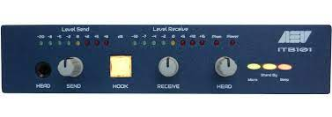
WEEK 3: News Report: group trial and individual attempts on news writing and reporting with general discussion opinionated expressive and exchange of idea one news alignment
News is information that is published in newspapers and broadcast on radio and television about recent events in the country or world or in a particular area of activity. News is information about current events. This may be provided through many different media: word of mouth, printing, postal systems, broadcasting, electronic communication, or through the testimony of observers and witnesses to events. News is sometimes called "hard news" to differentiate it from soft media
Best Ways to Consume News:
- Reading the newspapers
- The mobile applications
- Social media network
- Make best use of the Google Reader
- Tweet, tweet and read
- Instapaper's are the another best ways to store the news
- Youtube – the simplest to view and know
- Reddit is one of the best social news site
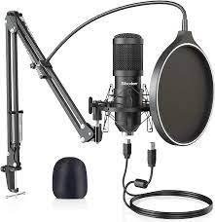
WEEK 4: general discussion with practical demonstration on basic element of news report
Proximity
Location, location, location: If an event is happening nearby, it will impact the audience more than if it were happening somewhere else that doesn't affect them as much, such as in another state or country. For example, if the local high school football team is going to the state championship, or if a music star is coming to town to perform, residents will want to know about it.
Prominence
A well-known person, place, or event has a stronger news angle than something the audience isn’t familiar with. A guest speaker visiting your local elementary school to take over story time doesn't resonate with many people... unless that speaker is Oprah.
Timeliness
Current news has more impact than something that happened yesterday or last week. The public and news media lose interest quickly, and past events become stale when there's always fresh news somewhere. No one cares that a mild tropical storm passed last month, but a hurricane on the horizon… that’s a different story.

Oddity
If something is unusual, shocking, or bizarre, the strangeness and novelty alone could make it newsworthy. A Florida man threw a gator through the Wendy’s drive-thru window? You don’t hear that often.
Consequence
If the impact of an event may directly affect readers, they'll want to know about it. A run-of-the-mill burglary at the Watergate Hotel was white noise on the airwaves until it became clear what the identities of the key players meant for the nation.
WEEK 5: Principle of news alignment of news editing with practical demonstration based on what will discussed
Journalists cannot always guarantee 'truth', but getting the facts right is the cardinal principle of journalism. We should always strive for accuracy, give all the relevant facts we have and ensure that they have been checked. When we cannot corroborate information we should say so.
WEEK 6: Introduction to Studio Equipment: an opportunity to enter the studio was created there in the studio.
Introduction to Studio Equipment: we have the console mixer, the microphone, computer the air conditional and explanation was then technical knowhow on how those equipment are been used and their usefulness.
Speakers Microphone
Mix cab
WEEK 7: Introduction to editing software: we are exposed to tools used for editing which are editing software, computer style book, printer, dictionaries, Smartphone and internet.

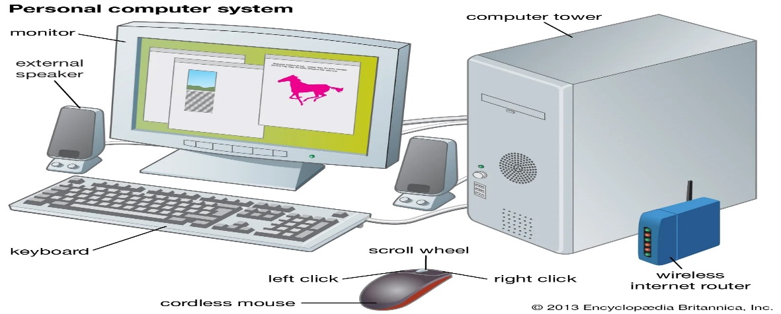

WEEK 8: Communication Editor: continuation on copy editor and was asked what are the responsibilities of copy editor which are
- Spotting and correcting grammatical error punctuation and spelling error
- Ensuring text is clear in meaning
- Streaming and cutting length of story
Text Communication Editor: There could be tools for editing writer communication such as word processors, text editors, or collaborative writing platforms.
Email Editor: Some tools are specifically designed for Editing and composing email, allowing user to format text, insert images and manage attachment.
Communication Protocols: In a technical context, a communication protocols for devices or system.
Collaborative Editing Tools: Platform the facilities collaborative communication and document editing among teams. Examples include: Google docs or Microsoft teams content management system (CMS).
Editions: Editions within CMS platform enable users to edit and manage digital content on website, blogs, or other online platforms.
WEEK 9
Introduction to Technical Works: Technical works" can refer to various types of activities, documents, or projects related to technology, engineering, science, or specialized fields.
Media and Communications.
Information Technology (IT)
Science and Research
The uses of microphone and the type of microphone used in the studio
The three main types of microphones are dynamic microphones, condenser microphones, and ribbon microphones. While they all have the same core construction, each of them has a different method for converting sound into electrical signals, and various uses.

WEEK 10
Introduction to slide on the typography: Typography refers to the art and technique of arranging type to make written language legible, readable, and visually appealing. It involves selecting typefaces, point sizes, line lengths, line-spacing (leading), and letter-spacing (tracking), among other elements. Typography is a crucial aspect of graphic design, web design, publishing, advertising, and other visual communication disciplines.

Head Phone
Introduction to importance of tripod and the parts of the tripod in the camera. A tripod is an essential tool in photography and videography for stabilizing the camera, ensuring sharp, well-composed shots, and enabling more creative control.
Importance of a Tripod in Photography and Videography
Stability and Sharpness: A tripod prevents camera shake, especially during long exposure shots, night photography, or macro photography.
Low Light Photography: In low light conditions, slower shutter speeds are required to capture more light, but this can result in motion blur.
Consistency: For time-lapse photography, panoramas, or any project that requires consistent framing (like video interviews), a tripod helps maintain the same angle and position over time.
Hands-Free Operation: It frees up your hands to adjust settings, pose subjects, or make minor tweaks without worrying about holding the camera.
Creative Flexibility: A tripod allows for precision in framing, leveling the horizon, and achieving interesting angles that might be difficult to hold manually.
Professionalism: Using a tripod can result in more professional, polished work, especially for landscape photographers, videographers, and studio photographers.
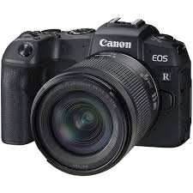
CAMERA
WEEK 12: Introduction to Graphics; Photoshop and Corel Draw, launching and presets. Introduction to Photoshop; creating a preset of the interface, choosing measurements, pixel, inches centimeter etc.
Introduction to Photoshop basic tools and their usage. Pick tool, shape tool, brush tools, zoom tool, blur tool etc. Introduction to other Photoshop basic tools and usage
Menu Bar: Located at the top. It provide access to various commands and features.
Tool Box: On the left side: It provides tools for selection painting navigation, text and more.
Option Bar: Strutted below the menu bar: it displays options for the selected tool.
Panels: These Customizable pands on the right and left side offer access to layers adjustment history and more.
Photo Editing: Adjust exposure color balance and retouch imperfections
Graphic Design: Create posters, banners flyers and others visual elements
Digital Art: Design illustration, Paintivg and composition.
Web Design: Develop web graphics and layouts.
Week 13: PHOTOSHOP: Introduction to layers, properties FX and other Photoshop interface and tools.
PHOTOSHOP: simple letterhead design, (using RUBUST SIWES CENTRE)
PHOTOSHOP: importing and positioning logo into a letterhead design, using the shape to style the background. Individual practical on previous knowledge. General Revision on letterhead design.
KEY TOOLS:
Selection tools: It is used to select any object on the interfaces.
Magic tools: It is used to select pixels with similar colors.
Marguce tools: selection of rectangular elliptical or single row/ column areas.
Pick tools: It is used to pick any object on the interface
Paintings and editing tools
Brush tool: for painting and drawing.
Eraser tool: removes portions of an image.
Clone stamp tool: clone or duplicate part of an image.
TEXT TOOLS:
Type tools: Add text to an image horizontal and vertical types magic
TRANSFORM TOOL:
Move tool: to move object around.
WEEK 14
How to make use of basic question on news story written. If you're working with a basic question related to a news story, you can use it to analyze or better understand the content. Here's how:
1. 5Ws + 1H Approach
This is a common method for examining news stories, based on key questions:
Who is involved in the story? What happened? Where did it happen? When did it take place? Why did it happen? How did it happen?
2. Clarifying Context and Purpose
3. Trigger Further Inquiry
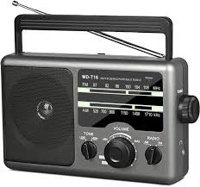
RADIO
WEEK 15: General and individual practical on all previous knowledge. Preparation on photography and photojournalism on Kwara state polytechnic convocation report. Kwara state polytechnic convocation day1. Kwara state polytechnic convocation day2.
WEEK 16: Report on kwara state polytechnic convocation. Reports on photography and photojournalism during kwara state polytechnic. Summary on skill acquired, Discussion on Siwes Report writing.

CHAPTER FOUR
4.1 DISCUSSION
I gained a lot of things during my attachment in the organization. I was introduced to news editing, gathering of report and also studio equipment.
4.2 RELEVANCE OF EXPERIENCE GAINED TO STUDENT FIELD OF STUDY
It enables me to practical zed the theoretical aspect of my course.
It enables me to know the important and usefulness of news editing
It enables me to expose to the activity involved in the system.
4.3 INTERPERSONAL RELATIONSHIP WITH THE ORGANIZATION
Robust Technologies Integrated Hub And Allied Service Ltd is a nice organization where I was able to interact with the director, instructors and students of the organization.
Even when I was about to round up my program, I felt like extending it but I have no option other than to leave.

CHAPTER FIVE
5.1 RECOMMENDATION
Going through some experience gained during the programme I will recommend that there is need for improved on some of the activities both in the media organization where served and the school
- The time duration for the programme should be extended more than three months
- Media organization should create more practical knowledge for the student for them to acquire more knowledge from their versatile staff.
5.2 CONCLUSION
SIWES was established to provide opportunities for students to involve in the industrial training. I gained a wide range of experience from the various assignments undertaken such as news and reporting, news alignment, news commentary and editing process. All the experience gained help to fulfill the objective of siwes

