
A TECHNICAL REPORT
STUDENT INDUSTRIAL WORKING EXPERIENCE SCHEME
(SIWES)

HELD AT:
SOLUTION FM/GRAND PITCH MEDIA
OBAFEMI AWOLOWO WAY, OKE ODO MARKET IBADAN

PREPARED BY:
TIAMIYU RASHEED OLAMIDE
ND/23/MAC/PT/0365

SUBMITTED TO:

DEPARTMENT OF MASS COMMUNICATION
KWARA STATE POLYTECHNIC, ILORIN

IN PARTIAL FULFILLMENT OF THE REQUIREMENTS FOR THE AWARD OF NATIONAL DIPLOMA (ND) IN MASS COMMUNICATION

Sept., – Nov., 2024
DEDICATION
I dedicate this technical report to the Almighty GOD, the giver of knowledge, wisdom and who is rich in mercy.

ACKNOWLEDGEMENT
I take this opportunity to express my profound gratitude and deep regards to the creator of heaven and earth, the one who knows the beginning and the end, the alpha and the omega. my sincere gratitude also goes to my guidance Mr. and Mrs. TIAMIYU for their financial support and word of encouragement during my SIWES Programme and also to those who stood by me during my SIWES programme, thank you all. I also take this opportunity to express a deep sense of gratitude to compliment my supervisor at my place of attachment for taking her time for my practical knowledge and for her cordially support, valuable information and guidance which helped me in completing my SIWES through various stages may Almighty God bless you abundantly.
TABLE OF CONTENT
Title Page
Dedication
Acknowledgement
CHAPTER ONE
Introduction
  - Background
  - History of SIWES
  - Objectives of the Programme
  - Benefits of SIWES to Student
  - Body Involved in the Management of SIWES Peogramme
  - The Industrial Training Fund
  - Core Principles
  - Vision
CHAPTER TWO
2.1 Location and Brief History of Establishment
2.2 Organization Structure/Organogram
2.3 Office Attach to

CHAPTER THRE
3.1 Introduction to Radio Station
CHAPTER FOUR
4.2. Skills Acquired and Experience Gained
CHAPTER FIVE
Summary, Conclusion and Recommendations
5.1 Summary
5.2 Conclusion
5.3 Recommendations

CHAPTER ONE
INTRODUCTION
I.1. BACKGROUND
Students Industrial Work Experience Scheme (SIWES) is a Skills Training Program designed to prepare and expose Students of Universities, Polytechnics, Colleges of Technology, Colleges of Agriculture and Colleges of Education for the Industrial Work situation they are likely to meet after graduation. The Scheme affords Students the opportunity of familiarizing and exposing themselves handling equipment and machinery that are usually not available in their institutions.

1.2 HISTORY OF SIWES
The Students’ Industrial Work Experience Scheme (SIWES) was initiated in 1973 by the Federal Government of Nigeria under the Industrial Training Fund (ITF) to bridge the gap between theory and practice among products of our tertiary Institutions. It was designed to provide practical training that will expose and prepare students of Universities, Polytechnics, and Colleges of Education for work situation they are likely to meet after graduation.
Before the establishment of the scheme, there was a growing concern among the industrialists that graduates of institutions of higher learning lacked adequate practical background studies preparatory for employment in industries. Thus the employers were of the opinion that the theoretical education going on in higher institutions was not responsive to the needs of the employers of labour.
As a result of the increasing number of students’ enrolment in higher institutions of learning, the administration of this function of funding the scheme became enormous, hence ITF withdrew from the scheme in 1978 and was taken over by the Federal Government and handed to National Universities commission (NUC), National Board for Technical Education (NBTE) and National Commission for Colleges of Education (NCCE). In 1984, the Federal Government reverted back to ITF which took over the scheme officially in 1985 with funding provided by the Federal Government.

1.3 OBJECTIVES OF THE PROGRAMME
The specific objectives of SIWES are to:
- Provide placements in industries for students of higher institutions of learning approved by relevant regulatory authorities (NUC, NBTE, NCCE) to acquire work experience and skills relevant to their course of study
- Prepare students for real work situation they will meet after graduation.
- Expose students to work methods and techniques in the handling of equipment and machinery that may not be available in schools.
- Make transition from school to the labour market smooth and enhance students’ conduct for later job placement
- Provide students with the opportunity to apply their knowledge in real life work situation thereby bridging the gap between theory and practice
- Strengthen employer involvement in the entire educational process and prepare students for employment in industry
- Promote the desired technological knowhow required for the advancement of the nation.
1.4 BENEFITS OF SIWES TO STUDENTS
It affords the student an opportunity to learn how to function in multi-disciplinary teams.
- Students can now effectively communicate within the working environment.
- It provides the opportunity for students to understand professional and ethical responsibilities more.
- The scheme provides an opportunity for the industries to evaluate prospective employees and give healthy feedback to the institutions.
- It gives opportunity for the student to make better mastery of the theoretical knowledge acquired in classrooms using practical knowledge acquired in the industry.
- It enhances the student’ attitudes to work like commitment, dedication, punctuality, politeness, effective communication and such like.
1.5 BODY INVOLVED IN THE MANAGEMENT OF SIWES PROGRAMME
The Federal Government of Nigeria,
1. The Industrial Training Fund (ITF),
2. National Universities Commission (NUC),
3. National Board for Technical Education (NBTE),
4. National Commission for Colleges of Education (NCCE),
5. Institutions of Higher Learning;
6. The Employers of Labour
1.6 THE INDUSTRIAL TRAINING FUND
- Formulate policies and guidelines on SIWES for distribution to all SIWES participating bodies, institutions and companies involved in the Scheme;
- Regularly involve in organizing orientation programmes for Students prior to their attachment;
- Receive and process Master and Placement Lists from the Institutions through their Supervisory Agencies (NUC,NBTE & NCCE);
- Supervise and Monitor Students on Industrial Attachment;
- Disburse Supervisory and Students allowances by e-payment.
- Organize Biennial SIWES National Conference and SIWES Review Meetings;
- Provide insurance cover for Students on attachment;
- Provide logistics and materials necessary for effective administration of the Scheme.
- Ensure the visitation (tours) of ITF Officers to the Supervising Agencies, Institutions, Employers and Students on Attachment;
- Provide information on companies for attachment and assist in the industrial placement of students;
- Continuously review and carry out research into the operation of the Scheme;
- Vet, process and verify Students’ logbooks and ITF Form 8
1.7 CORE PRINCIPLES
1. Public Service: Radio FM are established to serve the public interest. Their mission often includes providing informative, educational, and entertaining content that enhances the quality of life for their listeners.
2. Integrity and Credibility: A commitment to journalism integrity and ethical standards is fundamental. This includes accurate reporting, fairness, and transparency in all programming.
3. Diversity and Inclusion: Promoting diversity in programming and providing a platform for various voices and perspectives within the community is essential. This often involves representation of different cultures, languages, and demographics.
4. Innovation and Technology: Embracing new technologies to enhance the listening experience and reach wider audiences is crucial. This may include digital broadcasting, podcasting, and utilizing social media platforms.
5. Local Engagement: Many radio corporations focus on local content to engage with their communities, covering local news, events, and stories that matter to their listeners.
6. Education and Information: Providing educational content that informs listeners about important issues, current events, and cultural topics is often a core principle.
7. Cultural Preservation: Some radio broadcasting corporations aim to preserve and promote local culture and traditions, reflecting the unique identity of the communities they serve.
8. Accessibility: Ensuring that content is accessible to all, including individuals with disabilities, is often emphasized. This may include providing content in multiple formats or languages.
9. Sustainability: Many corporations are increasingly focused on sustainability, both in terms of environmental impact and financial practices, ensuring long-term viability and responsibility.

1.8 Vision
The vision of a radio FM often reflects these principles, aiming to be a trusted source of information and a vital part of the community, while adapting to changing technologies and audience needs.
CHAPTER TWO
DESCRIPTION OF ESTABLISHMENT OF ATTACHMENT
2.1 LOCATION AND BRIEF HISTORY OF ESTABLISHMENT
Solution FM is located in Oke Ode Market Ibadan, Oyo State to transmit commercially viable, relevant and strategic programs/shows that inform, inspire, influence and impact the people of its environment and beyond. Solution FM is a privately owned radio station in Nigeria, keeping people informed and entertained. Categories. Radio Stations.
Broadcast Frequency. 91.1 irrespective of what ever comes, lion fm has staff very committed, ever responding to unsolvable issues, blends to appreciate a goal
The main goal for its establishment was to cater for the needs of the people, serving cultural, indigenous and entertaining content to give listeners a new taste and value for indigenous broadcasting. Our love for reaching out to those in the grassroots is unrivaled.
Solution FM Ibadan boast of the best quality programmes that connect you to your roots, traditions, culture and bring the value and quality of the Yoruba tradition to the fore.
Solution FM Ibadan is a platform that you can use to move your businesses to the larger public and it is very affordable. We love you and so we would never make doing business with us beyond what you can afford.
The best indigenous broadcast station in South-Western Nigeria, Premier 93.5 FM appreciates your love and dedication and immense devotion to us and we promise not to let you down.
• PERIOD OF ATTACHMENT: September, 2024 to November 2024
• DESCRIPTION AND NATURE OF ACTIVITY
Radio Broadcast FM

2.2 ORGANIZATION CHART/ORGANOGRAM
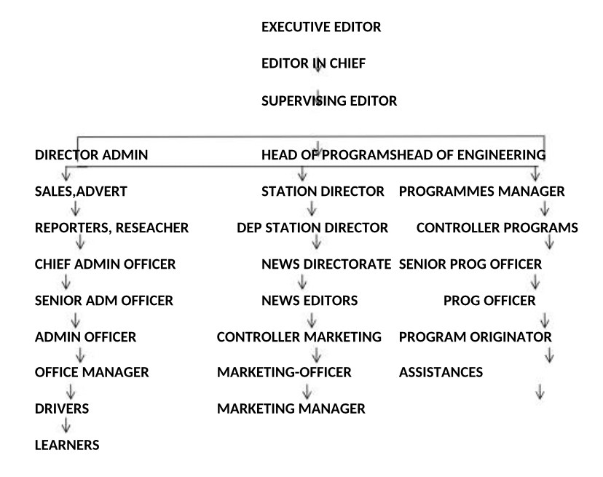

2.3 OFFICE ATTACHED TO
News Department and Program Department
The Various Departments/Group/Sections in the Establishment and their Function:
1. Managing Director (MD): The Managing Director is the decision maker, he says what happen in the establishment and other staff takes order from him.
2. General Manager: The General Manager is the second in command. She is the most senior employee in the company.
3. Supervisor: The supervisor supervises the work been done in the various sections, he tries to find out where wrongs are been done and does correction where necessary, and penalizes when necessary.
4. Accountant: The Accountant is in charge of keeping records of all the expenditure and income earned in a company and responsible for payment of workers.
5. General Administration: General administration operations manage and distribute the revenue received from station sales of advertising time.
6. Sales: The sales department at a television station is responsible for generating the revenue for the station to survive.
7. Programming: The programming department, in conjunction with the production and news departments, acquires and schedules the product that the audience consumes, which in turn allows the sales department to create revenue, which in turn allows the general administration department to facilitate station operations.
8. Production: The production department works closely with the programming, news, engineering, and sales divisions.
9. News: The news department is primarily responsible for creating news programming such as newscasts and news interview shows, although sometimes members of the news team will participate in the production of public-affairs programs.
10. Advertising and Promotions: Advertising and promotions is where a station creates its own promotional spots and advertisements in an attempt to gain more viewership, and therefore more advertising dollars from local, regional, and national companies.
11. Engineering: The linchpin of a television station is the engineering department. It is the duty of this department to transmit the programming product of a station to its audience.

CHAPTER THREE
3.1. INTRODUCTION TO THE RADIO STATE
A radio station is an installation consisting of one or more transmitters or receivers, etc, used for radio communications
3.2 SAFETY RULES IN THE RADIO STATION
Every radio station is expected to adopt a code of disruption free principles and work practice which should be enforced and adhere to strictly by workers and visitors..
• Avoid disrupting radio stations activities you must TURN OFF all cell phones and pagers: their use is prohibited.
• All persons in the quality control unit, including students, staff, and visitors, shall silence when possible
• Eating, drinking, chewing gum, and applying cosmetics are prohibited in the radio boot.
• Do not store food or beverages in the same refrigerators or freezers with, biohazards materials.
• Wearing an iPod, Bluetooth, or any other device that interferes with hearing is not
allowed..
• Always pay attention to your surroundings and be aware of what others are doing. Always be courteous.
In conclusion, maintaining safety in the radio station largely rest on the shoulder of the radio workers. Adequate safety and good factory practice can be avoided irrespective of the location, staff strength and availability of sophisticated safety cabinets in the radio station. What are required are highly standards of work etiquette by the radio station workers to achieve good results in their daily occupational practice.

CHAPTER FOUR
4.1 OFFICE ATTACHED TO
News Department
• DESCRIPTION OF OFFICE ATTACHED TO
As an officer in the radio news department, i manage radio station news departments and staff to ensure the accurate, timely delivery of news. We plan news broadcasts by determining and scheduling all of the content that goes live. radio news directors are in charge of quality control, as they monitor stories for accuracy and ensure that broadcasting rules and regulations are followed.
I also oversee the news content of each edition. I assign stories to reporters, liaise with the sub-editing and photography departments, and decide the priority and importance of news articles. They will also check for legal and ethical issues in a journalist's copy.
Newsroom plays a vital role in the making of a radio news content. In addition, some other activities have been merged with the newsroom which include - Desktop Publishing editing, illustration and transmission etc. which support the editorial and reporting staff in speedy
processing.
JOB UNDERTAKEN
News department plan and schedule program material for stations and networks. We determine what entertainment programs, news broadcasts, and other program material their organizations offer to the public. At a large network, the program director may supervise a large programming staff.
Overseeing the daily operations of the radio newsroom and website content
- Budgeting and hiring news staff
- Reviewing stories to make sure they are fair and accurate before they go on the air
- Ensuring adherence to journalistic and legal standards
- Solving problems when stories selected to be broadcast aren't coming together or when equipment breaks
- Monitoring news developments and sending news feature ideas to personnel for content creation
SKILLS ACQUIRED
I worked at the News department; manage radio station news departments and staff to ensure the accurate, timely delivery of news. We plan news broadcasts by determining and scheduling all of the content that goes live. radio news directors are in charge of quality control
News sourcing
Research and Fact Findings: We were all trained and groomed towards conducting a worthy and reliable research for news broadcast.
As assigned to the programme arm of the department, were I was taught on the identification various component of program
I acquired most relevant and effective practical on radio broadcasting procedures
I learnt how to arrange radio programs for adequate dissemination
An awareness of the general workplace has been developed in me and I have acquired important behavior and interpersonal skill with the opportunity given
POTENTIAL OPPORTUNITIES
• Avenue for me to apply the skill I acquired to more industrial skills and experience in my course of study.
• Preparation for industrial work situation which are likely to meet after graduation
• It prepared me for industrial work situation which are likely to meet after graduation
• It prepared me for my post graduate work situation
• I have the opportunity of retuning back to nOBLE FM for Industrial Training (IT)
• I have the potential of meeting prominent icons who are in line with my course of study.

Program Department
Radio Program Title: "Tech Talk: Innovations in Industry"

Description:
Join us on "Tech Talk," a weekly radio program hosted by a dedicated SIWES student eager to share insights from their industrial training experience. This engaging show explores the latest innovations and technologies shaping various industries today.
Format:
- Duration: 30 minutes
- Frequency: Weekly
- Target Audience: Students, young professionals, and anyone interested in technology and industry trends.

Segments:
1. Industry Insights:
- Discussions on current trends in technology and manufacturing.
- Interviews with industry professionals and experts.
2. Student Spotlight:
- Featuring stories from fellow SIWES students about their experiences and projects.
- Tips for maximizing the SIWES experience.
3. Innovation Showcase:
- Highlighting groundbreaking technologies and startups.
- Reviews of recent tech products relevant to the industry.
4. Q&A Session:
- Answering listener questions about career paths, internships, and technology.
5. Closing Thoughts:
- Summary of key takeaways from the episode and a preview of next week’s topic.
SKILLS ACQUIRED IN RADIO PROGRAM
1. LIVE PROGRAM
- Show Preparation:
- Researching topics and guests relevant to the episode theme.
- Writing scripts and preparing talking points for discussions.
-On-Air Hosting:
- Serving as the host during live broadcasts, introducing segments and guests.
- Engaging with listeners through live calls, social media, or text messages.
- Technical Operations:
- Managing audio equipment, including microphones and mixing boards.
- Monitoring sound levels and ensuring clear audio quality during the broadcast.
Real-Time Interaction:
- Responding to audience questions and comments live on air.
- Facilitating discussions and interviews with guests spontaneously.
RECORDING PROGRAMME
- Content Creation:
- Planning and scripting episodes in advance for later broadcasting.
- Recording segments, interviews, and sound bites for editing.
- Editing and Production:
- Using audio editing software to refine recorded material, ensuring high-quality sound.
- Incorporating music, sound effects, and other audio elements to enhance the program.
- Scheduling and Promotion:
- Organizing the release schedule for recorded episodes.
- Promoting upcoming episodes through social media and other channels.
- Feedback and Improvement:
- Analyzing listener feedback and ratings to improve future episodes.
- Conducting post-production reviews to discuss what worked well and what can be improved
STRUCTURAL PRESENTATION OF STUDIO SIGN
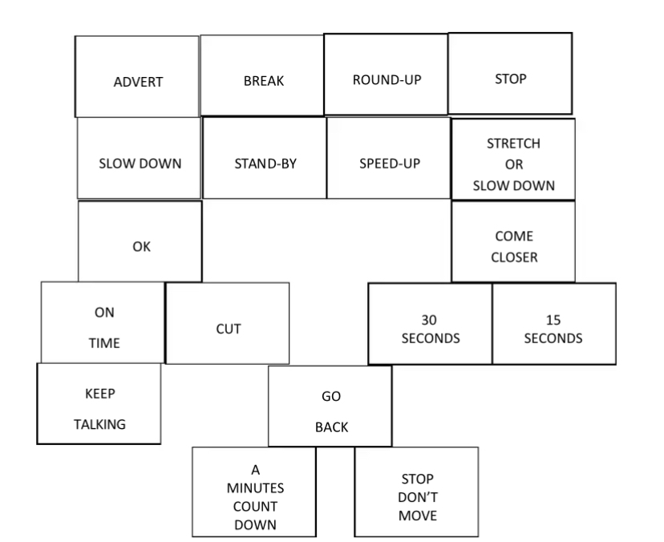

STUDIO EQUIPMENT
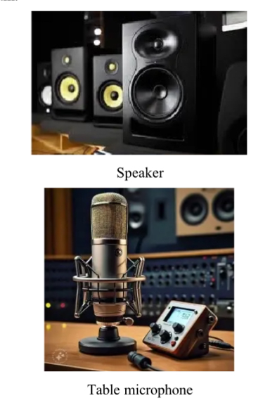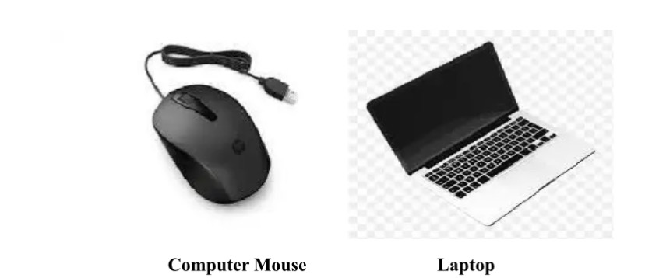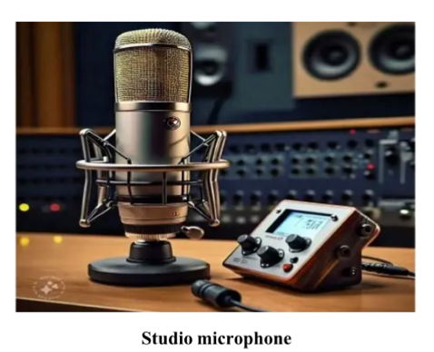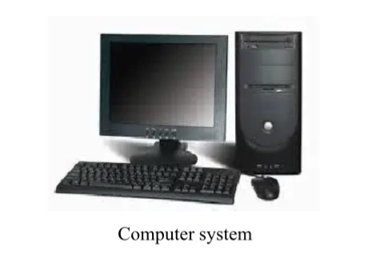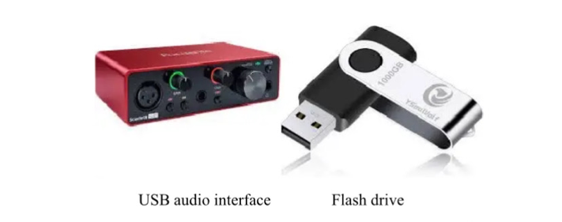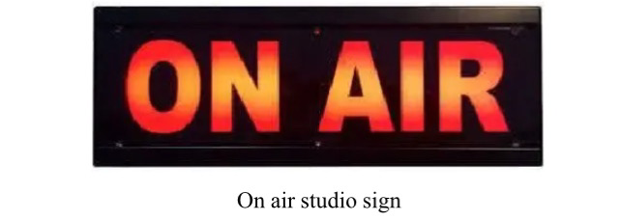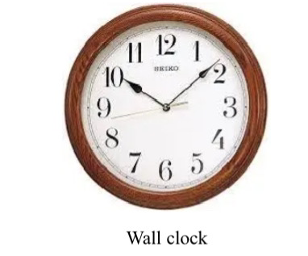

CHAPTER FIVE
5.1 SUMMARY
The Student Industrial Work-Experience Scheme (SIWES) is a planned and supervised training intervention based on stated and specific learning and career objectives, geared towards developing the occupational competencies of the participants. My experience in broadcast station is an exposure of value. I was exposed to the rudiments of News Writing and Reporting. During my training at the News Department, I practically served at the programing unit. I was taught how a news story format for radio broadcast should look like. I learnt that in writing a News story, news is written from the most important to less important and every situation as enshrined in Inverted Pyramid style.
5.2 CONCLUSION
This industrial training has afforded me the basic practical and theoretical knowledge that I may not have gotten from the lecture room. It also gave me the opportunity to have a feel of what it would be like after graduation when I start working.
Good working ethics: As a result of the close working relationship, I had with the ICT manager, I have been able to imbibe good working ethics. These ethics includes been able to handle situation with little or no help, being able to provide solutions to lingering problems, etc.
Career Path: I have been able to use this training to explore various avenues available at my
disposal career-wise. It has given me the opportunity to have a look into the future and access my readiness for employment or entrepreneurship.
Finally the internship has bridged the gap between academic theory and practical and has built a good degree of confidence especially in my abilities to perform. It has also given me a first-hand experience of the entire information and communications technology industry I can confidently say that the experience gotten from this training was a worthwhile experience.
CHALLENGES
Problem of Securing a Place of Attachment:- I had most of problem searching for a place of attachment for my Industrial Training because most of the companies rejected my request giving one reason or the other that they don't want IT student.
5.3 RECOMMENDATIONS/SUGGESTION
Although SIWES undergone did achieve quite a lot of its stated objectives, nevertheless, the following recommendations are suggested to improve the qualitative context of the programme:
1. Participation of private corporate organization to minimize the problem of low funding as recently complained by the director of ITF.
2. Sending students specifically to establishment where the stipulated aims and objectives of SIWES would be achieved.
3. Payment of befitting student allowance to assist in students finances during the period of training. The station should have a method of recognizing its SIWES students through issuance of recommendation letter in addition to letter of completion to enable the students secure job placement in both public and pr.

