

Technical Report
On
STUDENT INDUSTRIAL WORK EXPERIENCE SCHEME (SIWES)

HELD AT
AREA DEVELOPMENT OFFICE SHONGA EDU L.G.A, KWARA STATE

Presented by:
MOHAMMED ABDULWOLI BABA LIMAN
ND/23/PAD/PT/0040

Submitted to:
DEPARTMENT OF PUBLIC ADMINISTRATION, INSTITUTE OF FINANCE AND MANAGEMENT STUDIES
KWARA STATE POLYTECHNIC
P.M.B. 1375, ILORIN

IN PARTIAL FULFILLMENT OF THE REQUIREMENT FOR THE AWARD OF NATIONAL DIPLOMA (ND) IN
PUBLIC ADMINISTRATION, KWARA STATE
POLYTECHNICS, ILORIN

August – December, 2024
PREFACE
This technical report is written to situate the standard of experience gain by student in the industrial as awareness of continuity at the tertiary level of learning. The technical indulgence of training has been expressed formally in these report required by the constitution of the industrial training office of polytechnic.
This report is divided into five different parts which each part explains the meaning of siwes, major organization, work actually carried out and experienced gain. Even challenged faced, conclusion and recommendation are also involved.

DEDICATION
I dedicate this report to the Almighty God, for granting me the privilege to commence this course. Also to my reliable and respectful loving parents, Mr. & Mrs. Mohammed for being there for me. I pray may the Almighty Allah reward you abundantly, Amen.

ACKNOWLEDGEMENT
I acknowledged the existence of monotheism (Allah Subhanahu Watahalla), The Creator of entire universe for all He had done for me,
I am greatly indebted to departmental lecturers and other lecturers of this great institution, more worthily SIWES coordinator and supervisor. I hereby appreciate all their efforts

TABLE OF CONTENT
Title Page
Preface
Dedication
Acknowledgement
Table of content
CHAPTER ONE
1.1 Meaning of SIWES
1.2 Brief history of SIWES
1.3 Aims and Objectives of SIWES
CHAPTER TWO
2.1 History of the Organisation
2.2 The organizational Structure
2.3 Department in the organization
2.4 Interpersonal Relation with the organization
CHAPTER THREE
3.1 Work Actually Carried Out
CHAPTER FOUR
4.1 Experienced Gained
4.2 Challenges Faced
CHAPTER FIVE
5.1 Conclusion
5.2 Recommendation

CHAPTER ONE
1.1 INTRODUCTION
Student industrial work experience scheme (S.I .W. E.) was established for the purpose of exposing and Preparing student of universities, polytechnic and education having school of vocation and computer departments. To gain experience and required skills that will enable them to become self employed,
Therefore every student is expected to undergo this training for the minimum of 12 week for each session at industry or organization readily available.
I decide to undergo my industrial training at Area Development Office Shonga, a subdivision of secretariat of Edu Local Government Area Of Kwara State to enable me gain some needed skills.
1.2 S.I.W.E.S
Student's industry work experience scheme (S.I.W.ES) is a skills training programme designed by (I.T.F) to expose and prepare students of universities, polytechnic. College of Technology, College of Agriculture and College of Education for industrial work experience
1.3. Rice production
The acceleration of rice production in Shonga/Tada farm scheme is part of early initiative by the Federal Government of Nigeria through Federal Ministry Of Water Resources (FMWR) to promote rice production in Nigeria and Shonga rice farming inclusive.

CHAPTER TWO
2.1 Aims and Objectives of SIWES
The aims and objectives of (S.I.W.E.S) are as follows
a. To expose students to work methods and techniques in handling certain work situations.
b. To prepare students for the industrial work situation they are likely to meet after graduation.
c. Enlighten and Strengthen process and prepare students for employment in industry and commerce.
d. To provide students with an opportunity to apply their knowledge in real work situation thereby bridging the gap between practicals and theories.
e. Provision of avenue for students in institutions of higher learning to acquire industrial skills and experience in their course of studies
f. To make the transition from school setting to the world of work easier and enhance students contact for better Job placement

2.2 SKELETON OF ORGANIZATIONAL CHART OF EDU LGA
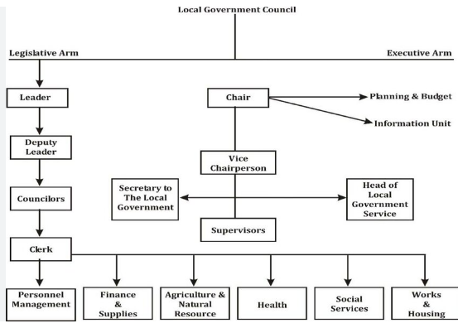

CHAPTER THREE
SHONGA/TADA RICE PRODUCTION
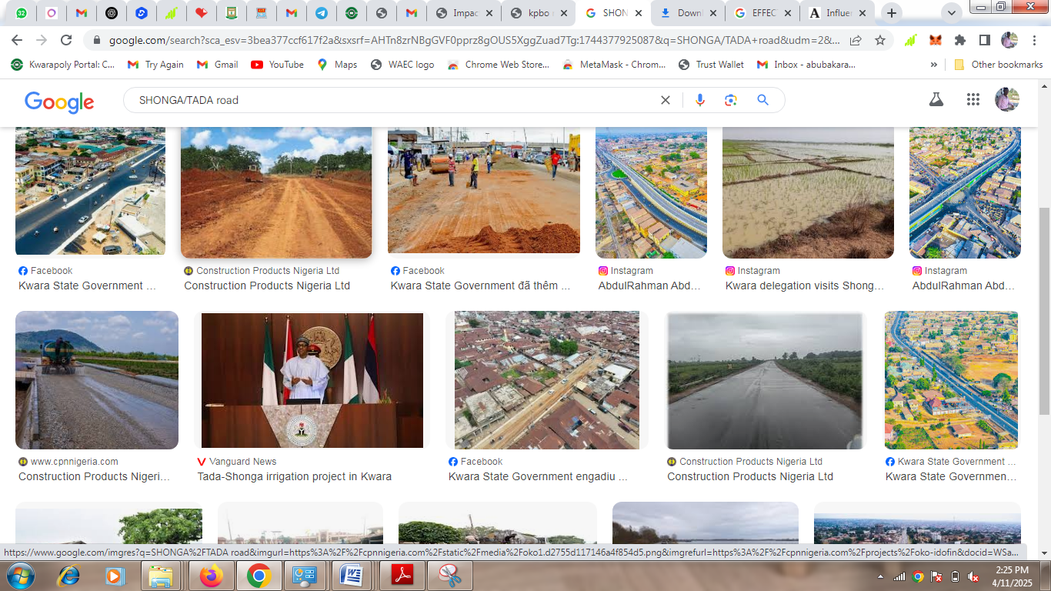 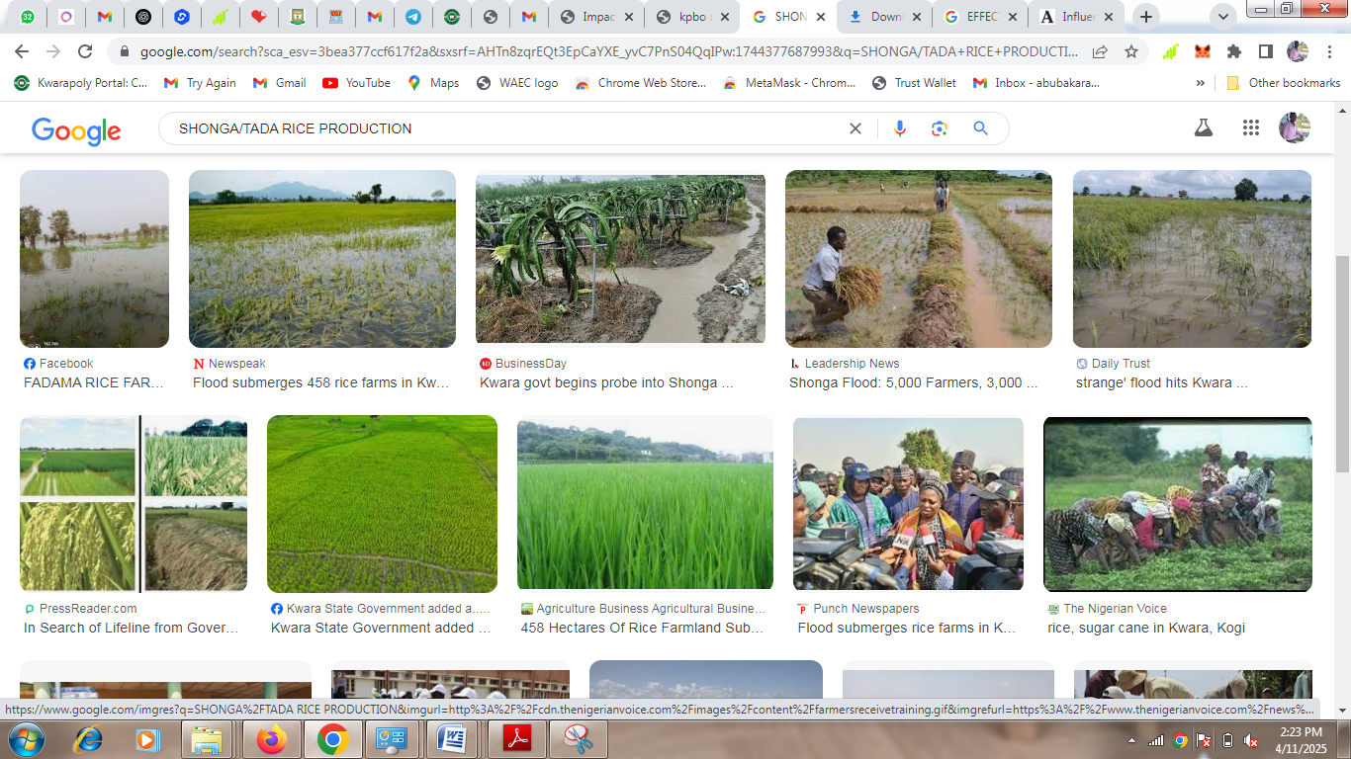 Shonga/Tada road
Rice Farming
Shonga rice production covers an area of 523,000 sq km. from Sea Basin/Niger River in the north extending to the fringes of river Bodzo. The climate is characterized by relatively high temperatures throughout the year and also enough rainfall.
3.2 Role of Agriculture and Irrigation
Although Nigeria's economy relies heavily on the petroleum which generates over half of government revenues while agriculture continues to play an important role in the economy. Agriculture currently contributes closely to meaningful percent to the GDP. It employs about one third of the labour force and provides a lively hood for the bulk of the rural population.
Almost the entire cropped land is rain fall and can support crop production for only 3-6 months of the year. Mixed, small - scale family farming is the predominant form of production
3.3 Shonga upland farming
The most important crops practiced are sorghum and millet, maize, yams, cassava. soya beans. Mellon, potatoes, groundnut, beans pepper fruits, okro, vegetables etc.
3.4 Rice production and Marketing
Shonga rice production, currently estimated two million tonnes of grain per year and does not meet the annual domestic demand of people in Nigeria of about six hundred and seventy five million tones
CHAPTER FOUR
A LOCATION AREA
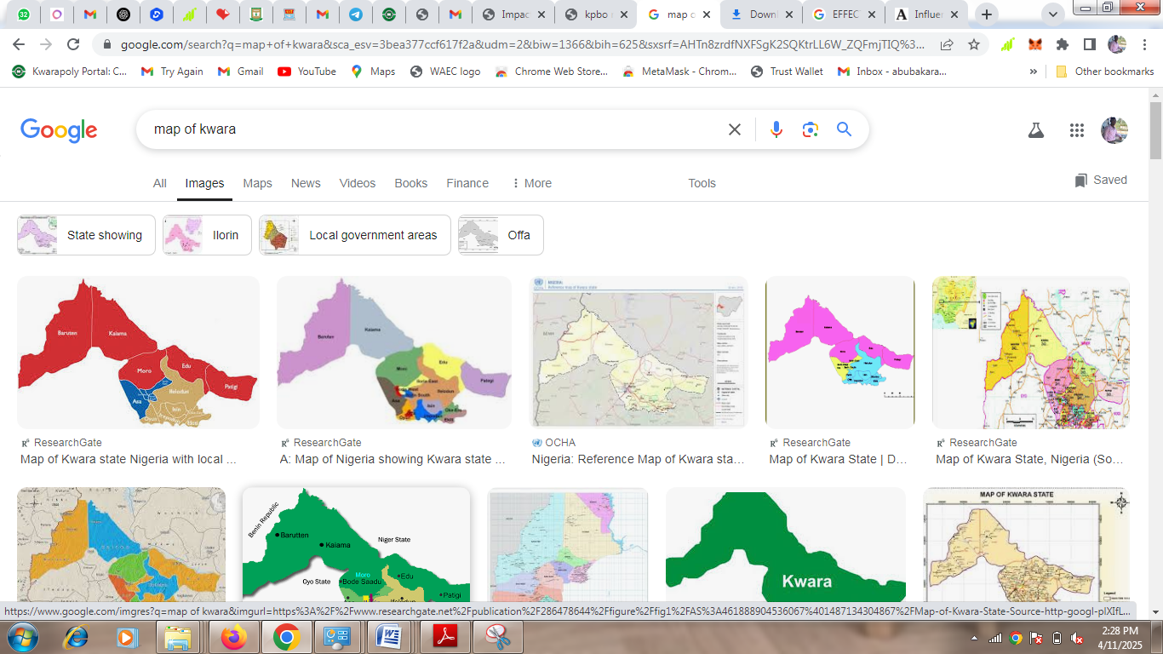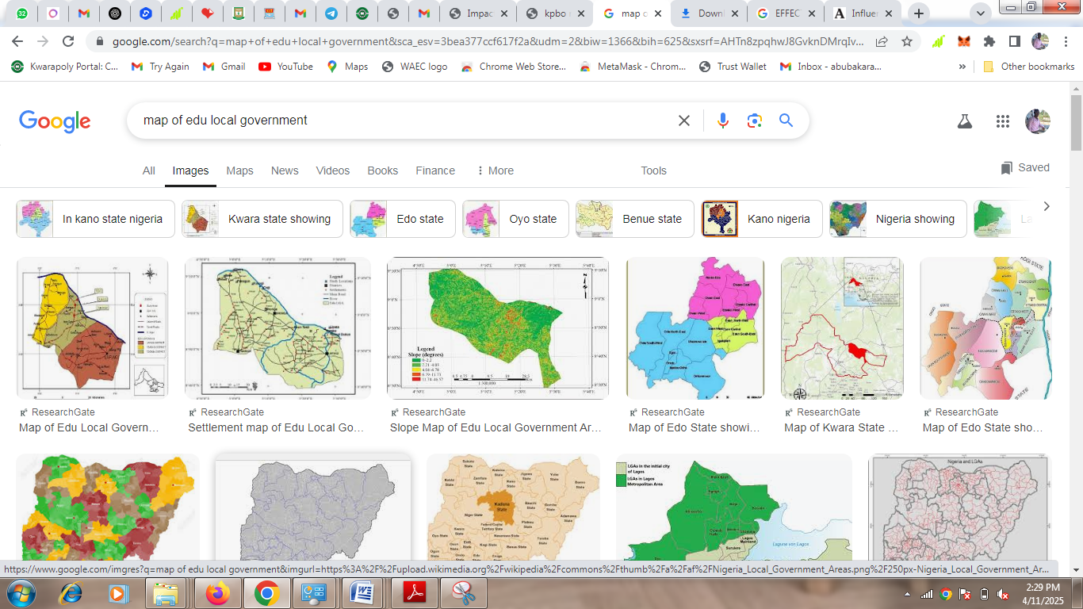
Map of Kwara State Map of Edu
Shonga/Tada rice farming irrigation scheme is located in Edu Local Government Area of Kwara about 125 km North-East of Ilorin, the Kwara State Capital. The SIWES sites can be reached either through Tsaragi/Bacita/Mokwa/Lafiagi respectively. The rice farm land area use for this purpose ranged from 5700 hectares for the irrigation scheme lies to the right bank of river Niger within the flood plain downstream of Jebba, and is suitable for the cultivation of rice. Shong area is linked to Ilorin by a major road. Another 126 km earth road linked shonga with Bacita.
4.2 Other rice farming location Areas are:-
Shonga Kpataringi 14km
Shonga Tada 215km
Shonga Ogudu 227km
Shonga Chijji 306km
Kpilegi Shonga 76km
Kusogi Shonga 98 km
Shonga Kochegi 121km
These roads are usually submerged by floods but with the envisaged construction of the dyke.

CHAPTER FIVE
CONCLUSION AND RECOMMENDATION

5.1 Filing System
Filing system is a method of computing, control, and how to store and retrieve data information in the operating office.
5.2 Filing Indexing
Information indexes may be kept; it is a list of files showing the number of the files with their subjects (tittle)
5.3 Type of filing indexing
1. Personal file indexing officers or persons in employment
2. Subjects file indexing: This an index for all subjects not related to personal or persons.
3. Numerical file indexing: The index order of all files
4. The transit index: the transit index is used for the purpose of file movement (i.e moving record)
5.4 Temporary file
Temporary file is used when the main file is either missing or cannot be released owing to certain actions within 24 hours of receipt of a needed or desired mail for process
5.5 Rules of filing
I every page in a file with something written type on it must be numbered in red ink.
2 Title of a letter to be filed must be recorded
3 All attachment should be on blue ink if they are to remain in the file
4 All papers or inputs should be made up of foolscap
5 A volume multiple page letter is to be enclosed in a file only the front cover should be numbered
Every sheet of paper in the file must be punch-holed
7 All cross reference must be marked.

CHAPTER SIX
6.1 Revenue
Local Government revenue incomes
Revenue is the income generated from normal business operations and it includes discounts and deductions for returned (merchandise) i.e goods that are bought or sold, goods that are for sale in a shop/store.
This is also the top line or crops income figure from which costs are subtracted to determine net income
Revenue is the income of a government from taxation, excise duties. In accounting revenue; revenue is the income that local government has from its normal activities usually from sale of goods and services to customers.
6.2 Government Revenue
. a. Tax revenue
b. Revenue recognition
c. Revenue model
6.3 Examples of revenue Account
a. Sales
b. Service
c. Revenues
d. Fees earned

CHAPTER SEVEN
7.1 Summary
The student industrial work Experience scheme (SIWES) is being organized for student to expose and prepare students to gain much experience of various sectors of organization.
Many students gain experience and technical skills so as to become self employed and make their living easy and overwhelming
7.2 (SIWES)
This program has equipped me with some skills, which will in turn make me self employed. I was made to understand how to manipulate and operate manual typewriter and idea on Software engineering and how I will be able to keep the account book for financial transaction as well.
7.3 Conclusion
From the experience I gained during my (SIWES) program I would like to say that the purpose of establishing (SIWES) has been achieved because; I gained a lot of skills as well as experience at secretariat, Edu Local Government Area Office Shonga Kwara State.
7.4 Recommendation
I want to use this medium to recommend that the Government should continue to support this program so that other students can also participate in the training program
The school should extend the months of SIWES program This will enable the student to learn more.
The SIWES body should be encouraged not to stop the program for it expose the students to practical experience of what were taught in school.

7.5 References
Area officer Edu local Government Area Development Office Shonga
SIWES Report booklet
GOZAN Computers Shonga

