
A TECHNICAL REPORT
ON
STUDENT INDUSTRIAL WORK EXPERIENCE SCHEME
HELD AT
ADMUMSHO AGRO GBAGBA PHASE II, SANGO AREA ILORIN, KWARA STATE.
SUBMITTED BY
SAOBAN OMOTOLANI AYOOLA
ND/23/AGT/FT/0037

SUBMIITTED TO THE DEPARTMENT OF AGRICULTURAL TECHNOLOGY, INSTITUTE OF APPLIED SCIENCE, KWARA STATE POLYTECHNIC, ILORIN.

IN PARTIAL FULFILLMENT OF THE REQUIREMENT FOR THE AWARD OF NATIONAL DIPLOMA (ND) IN AGRICULTURAL TECHNOLOGY, KWARA STATE POLYTECHNIC.

SEPTEMBER TO DECEMBER
CERTIFICATION
This is to certify that, I Saoban Omotolani Ayoola with Matriculation Number ND/23/AGT/FT/0037 in the Department of Agricultural Technology, Kwara State Polytechnic, Ilorin, Kwara State, has duly completed my Student Industrial Work Experience Scheme (SIWES) program at the Admumsho Agro Gbagba phase II, Sango Area Ilorin, Kwara State.

___________________________ ____________________
Student Name Date and Signature

___________________________ ____________________
Supervisor Name Date and Signature

___________________________ ____________________
Head of Department Date and Signature

DEDICATION
All dedication is due to God the creator of the universe, the owner of mankind, for the favour and huge success in completion of this program in Admumsho Agro. I also dedicate this report to my able parent Mr and Mrs Ayoola.

ACKNOWLEDGEMENT
I am indeed most grateful to appreciate almighty God for his unfailing love, goodness and care toward my completion of this student industrial work experience scheme. My appreciation also goes to all the staff and owner of the Admumsho Agro for accommodating me and guiding me through the process of my stayed in the organization. May God in his infinite mercy continue to bless and be with you all.
Lastly to my parent Mr and Mrs Ayoola thanks for the support both financially, morally and spiritually. I can’t thank you enough but God will continue to bless and guide and allow you to reap the fruit of your labor (Amin).

TABLE OF CONTENT
Title Page i
Certification ii
Dedication iii
Acknowledgement iv
Table of content v
CHAPTER ONE
1.0 Introduction to the training program 1
1.1 Purpose of Training 1
1.2 Aims and Objectives of Student Industrial Work Experience Scheme (S.I.W.E.S) 1
CHAPTER TWO
2.0 Company Profile (ADMUMSHO AGRO) 2
2.1 Introduction to Cat Fish Farming 4
2.2 Level of management input 5
2.3 Cat fish feed production 10
CHAPTER THREE
3.0 Pond construction and maintenance practice 13
3.1 Managing pond water chemical parameters. 15
3.2 Treatment of some bacterial diseases of fish 18
3.3 Factors that promote parasite infections 19
CHAPTER FOUR
4.1 Conclusion 20
4.2 Recommendations 20
CHAPTER ONE
1.0 INTRODUCTION TO THE TRAINING PROGRAM
1.1 Purpose of Training
The students industrial work experience scheme (SIWES) was initiated in 1973 by the industrial training fund (ITF).
This was to update practical knowledge of students in the universities, polytechnics and colleges of technology. It was aimed at bridging the gap between the theoretical knowledge acquired in classes and technical knowledge in the industrial by providing students with opportunities to apply their education knowledge in real work situations.
Over the years, SIWES has contributed immensely to building the common pool of technical and allied skills available to the Nigeria economy which are needed for the nation industrial development.
Furthermore, the place and relevance of Siwes is underscored by the fact that the scheme contributes to improving the quality of technical skills generally available in the pool from which employers’ source technical manpower.
It also gives students the opportunity to blend theoretical knowledge acquired in the classroom with practical hands on application of knowledge required to perform work in the industry, also it prepares students for employment and makes the transition from school to the world of work easier after graduation.
1.2 Aims and Objectives of Student Industrial Work Experience Scheme (S.I.W.E.S)
Siwes provides avenue for student to acquire industrial skills and experience in their course of study, this is few objectives of Siwes,
- Provision of avenue for students in the Nigerian universities to gain industrial skills and experience in their course of study.
- To expose students to work methods and techniques in handling equipment and machinery that may not be available in the universities.
- To prepare students for work situation they are likely to meet after graduation.
- To provide students with an opportunity to apply their theoretical knowledge in real work situation, thereby bridging the gap between university work and actual practice.

CHAPTER TWO
2.0 Company Profile (ADMUMSHO AGRO), Gbagba Phase II, Sango Area, Ilorin, Kwara State.
Admumsho Agro was established in the year 2017 by a group of agricultural entrepreneurs passionate about sustainable aquaculture. The organization started as a small scale fish farm in a rural community with just a few earthen ponds and a vision to revolutionize fish farming practice in Ilorin kwara state Nigeria.
Recognizing the challenges local farmer faced in sourcing quality fish feed, Admumsho Agro expanded into feed production in the year 2019, formulating affordable, nutrient rich feeds tailored to local fish species like catfish and tilapia. The organization has since grown into a leading name in integrated aquaculture, providing training, consulting and supply service to fish farmer with Ilorin metropolitan and axis in kwara state.
With a commitment to innovation and community development, Admumsho Agro continues to promotes food security and youth empowerment through sustainable fish farming and feeds production practices.
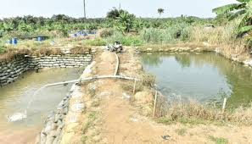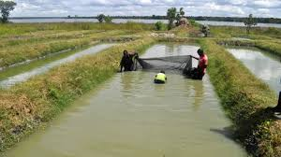
Figure 1: Typical image of an Earthen Pond (Source: Google)

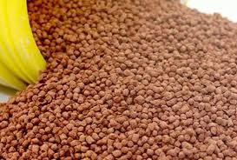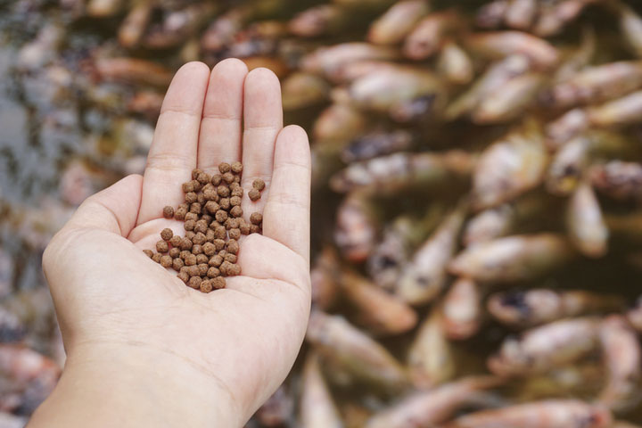
Figure 2: Fish feed
We also render services like
- Consultancy
- Training programmes (IT & SIWES Training for student)
- Expert advice of cost and production of cat fish
- Livestock buying and vaccination
- Feeds for fisheries
2.1 Introduction to Cat Fish Farming
The story of aquaculture in Nigeria is essentially the story of catfish culture and the hope of fish supply in Nigeria hang on its development and culture. Recent trends all over the world, point to a decline in landing from capture fisheries, an indicator that fish stocks have approached or even exceeded the point of maximum sustainable yield. Aquaculture therefore remains the only viable alternative for increasing fish production in order to meet the protein need of the people
Fishery: An industry or occupation that are capable of processing or selling of fish
Fisheries: The science of producing fish and other aquatic resources for the purpose of providing human food, fish product such as fish oil
Aquaculture: Is the practice of cultivating aquatic animals and plants is managed aquatic environment
Polyculture or Composite Fish Culture: Is a type of fish culture in which different types of fishes of different feeding habit are cultured to exploits the different kinds of food that is present in the different parts of the ponds. This type of farming is also called mixed farming.
Liming: Lime is used to improve the pond bottom and kill parasite in the pond. It also prevent water from becoming too acidic. Liming increases the alkalinity of the water there by increasing the availability of carbon dioxide
Fertilization: To make H2O more productivity, fertilizers are added. They contain important nutrient which help in production of natural fish food organism (plan k ton)
Stages of Fish Growth
Larvae Fry Fingerlings Post fingerlings Juvenile Post juvenile Table Size
Importance of Healthy Fish Stock
Assurance of a profit oriented fish farming enterprise. Fish death due to poor health will rob a farmer not only of intended financial profit, but also of the total investment on the farm.
- To ensure good growth of fish
- To prevent disease transmission to man
African Catfish
Types of catfish (common)

Clarais garipinus Heterobrancus

Pattern non pattern bidorsalsi longflees aceto

2.2 Level of management input
1. Extensive Culture System: When food base in a pond is exclusively naturally occurring, without supplementation either feeds or fertilizer.
2. Semi intensive culture system: In this system these is occasional supplementary feeds addition and natural productivity is augmented with manure.
3. Intensive Culture System: This demands the highest level of management input feeds and fertilizers are intensively applied following appropriate recommended rates. Fish grow very fast when intensive managed and grow least in extensive management.
C) Fish Culture Practices: Pond can be classified as being monoculture or polyculture. Type
1. Monoculture: This is the practice of culturing only one species of fish in a pond unit. Under monoculture, a farmer may grow only tilapia in the pond on only clarias in the pond
2. Polyculture: This is the practice of culturing more than one species of fish in the same pond e.g clarias and tilapia fish yield under polyculture can be higher and foods in the pond properly utilized.1
2.3 Scales of production
1. Homestead/Backyard ponds: This is a fish pond that is managed to augment family protein intake. The size of such a pond could vary according to land space available.
2. Commercial fish ponds/farm: This usually have an area of land not less than half hectare under culture. Such a farm will demand more attention from the fish famer.
Commonly Culture fish species in freshwater pond in Nigeria
Common Name scientific Name
Tilapia Oreochromis nioticus
Mud cat-fish Clarias gariepinus
Common Carp Cyprinus carpio
Spotted Cat-fish Heterobranchus bidorcalis
Niger Perch Lates niloticus
African bony tongue Heterotis niloticus
Grey cat fish Ghyscicliltry nitrodigitatus
Trunk- fish Cymnarchus niloticus
Cat fish Bagrus bayad
African carp Labeo coubie
Moon fish Citharinus citherus
Commonly cultured fish species in backish water ponds
Common Name scientific Name
Flat head grey mullet Mugil cephaius
Tilapia Tilapia guinnesis
Atlantic Tarpon Megalops atlanticus
West African Lady fish Elops lacerta
Grey cat-fish Chrysichthys nigrodigitatu
African red snapper Lutjamus agennes
Commonly Culture Fish Species
- Fast grower e.g Hetterobranchus and Clarias
- Accept and utilized supplementary feeds properly e.g Tilapia, Clarias, Heterobranchus
- Must be hardly and resistance to disease e.g clarias
- Must be tolerant to poor water quality e.g Clarias
- The fish must be easy to breed in captivity e.g Clarias and Tilapia
- It must attract low production cost e.g Tilapia & clarias
- Aceptable and marketable to comsumer e.g carp,Heterobranchus, Tilapia and Clarias.
Problems Encounter in Hatching of Fish
- Temperature
- Inadequate of facilities
- Inadequate supply of feeds
Catfish Production
- Materials / Basic Requirement in Catfish Production
  - Mature brood stock
  - Weighing scale
  - Thermometer
  - Acetone
  - Mortal & Pestle
  - Calibrated jug
  - Pair of pincers or hack saw
  - Dissecting kit
  - Syringe and needle
  - Table salt
  - Knife
  - Hand basin
  - Clean water
  - Normal saline
  - Blade
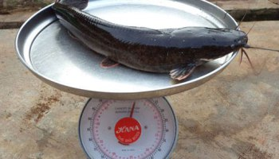
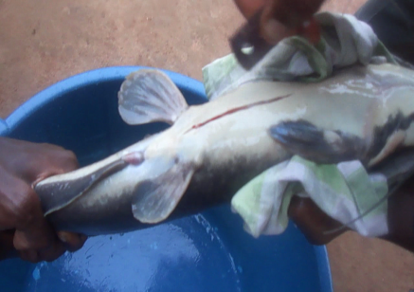
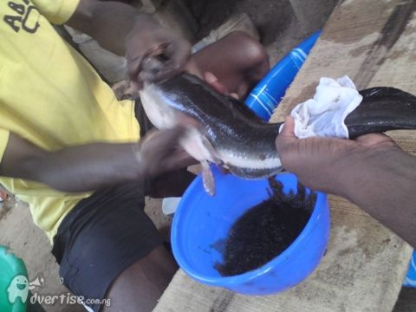
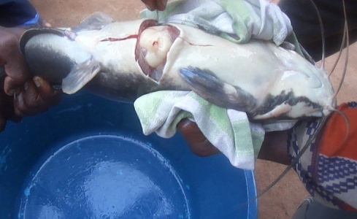
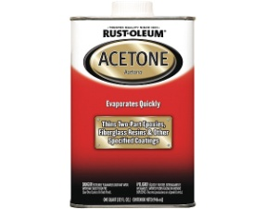
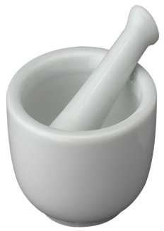

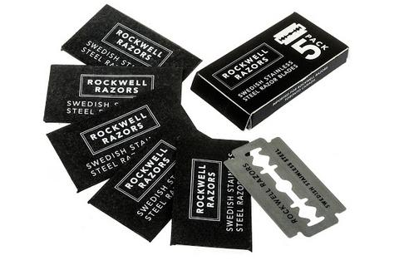
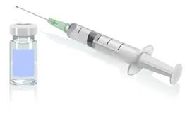
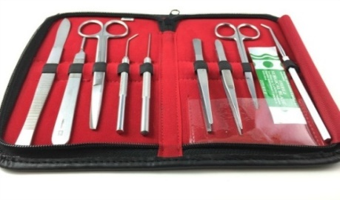
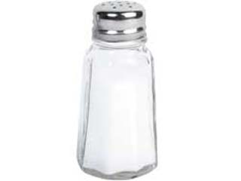
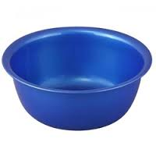
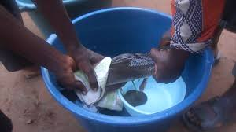
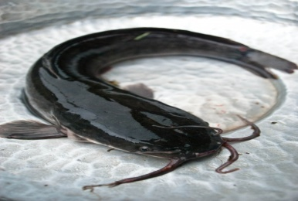
IMAGES OF CAT FISH BROODING
Calibrated jug

Mortal & Pestle

Acetone
Weighing scale

Blade

Dissecting kit

Syringe and needle
Table salt

Hand basin

IMAGES OF EQUIPMENT FOR CATFISH

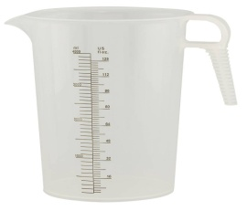

Steps in Catfish Production
Step 1: Sampling of brood stock
Step 2: Size of measurement
Step 3: Measuring of hormonal pituitary
Step 4: Injection
Step 5: Isolation / Separation
Step 6: Preparation of the caccabam incubator
Step 7: waiting for 8 – 12 hours
Step 8: Collection of the eggs
Step 9: Collection of the niilt
Step 10: Fertilisation of the egg
Step 11: Closing fertilization
Step 12: Spawning of the egg
Step 13: Waiting for 12 hours to know the % of fish that will fertilize
Step 14: Waiting for another 12 hours for the eggs to begin to hatch
The first thing I did was to drag out brood stock with the use of dragging net, after then I measured the size of the brood stock, the size of the brood stock will determine the amount of the ml of pitituary gland I used.
After measurement I put the fishes in a pond for them to regain their lost energy when they are been stressed, after some hours I injected the female fish and the male fish was not injected. Separation of the male fish from female fish not to cause damage to them, it takes female fish 24 hours before the eggs was ready for fertilization within time I prepared my caccabam incubator where I layed my eggs when it is ready.
I bisect the male fish and extracted the milt, mix the milt and normal saline then stripped the female fish by pressing the abdomen gently so that the eggs will easily come out, mix thoroughly the milt, the eggs and the normal saline.
Fertilization of eggs takes place; I closed my fertilization by adding water to removed the unfertilized eggs.
Spawning of the eggs take place.
I waited for 12 hours to know the percentage of fish that fertilized, I waited for another 12 hours for the eggs to begin to hatch.
After three days the eggs is now a larvae.
Factors Promoting Ill Health and Diseases In Cultured Fish
Poor Water Quality
Water is the medium for fish rearing. A farmer should therefore be careful on the source of water for the pond. Although water quality management in fish ponds is a wide area, a farmer should ensure that pond water is fertile.
Overstocking
Ignorance on the part of a fish farmer on the stocking densities / stocking rates of cultured fish in a pond environment could result in either under stocking or overstocking fish ponds. Dangers attached to this and numerous, overcrowding, insufficient dissolved oxygen pond water resulting in struggling for survival, cannibalism due to starving and more importantly possible epidemic, resulting in mass fish death.
Erratic (Irregular) Feeding
Like humans, fish need regular and consistent feeding inorder to boost their immune system and make them less susceptible to disease. Under extensive fish culture system, fish are often left to the mercy of natural foods. In pond water with little or no feed supplementation. Excessive feeds in pond encourages water pollution

Nutrients Deficient Feeds
Balanced diet is important to fish in order to ensure the performance of their metabolic activities. Nutrients rich foods are security against susceptibility to ill health and diseases, fish food must be rich in protein content and energy requirements
2.3 Catfish Feed Production
Catfish farming is one of the most profitable aquaculture ventures, especially in countries like Nigeria where catfish (mainly Clarias gariepinus) is widely consumed. Feed plays a crucial role in determining growth rate, health, and profitability in catfish farming. As feed accounts for over 60% of the total production cost, producing quality, cost-effective feed is essential.
Importance of Quality Feed in Catfish Farming
- Growth and Weight Gain: Proper nutrition ensures rapid growth and optimal weight gain within a short culture period.
- Health and Disease Resistance: Balanced feeds enhance immune response and reduce mortality.
- Feed Conversion Ratio (FCR): Good feeds reduce the amount of feed needed to produce a kilogram of fish, thus improving profitability.
Types of Catfish Feed
- Starter Feed (0–4 weeks): Crumbled or powdered feed with high protein (40–45%) for fingerlings.
- Grower Feed (4–12 weeks): Pelleted feed with slightly lower protein (35–40%).
- Finisher Feed (12 weeks and above): Pellets with moderate protein (28–32%) to support growth before harvest.
Essential Ingredients in Catfish Feed
A balanced catfish feed must contain the right proportion of protein, fat, carbohydrate, vitamins, and minerals.
- Protein Sources:
Fish meal (expensive but high quality)
Soybean meal (widely used, plant-based)
Groundnut cake
Blood meal
Maggot or insect meal (alternative sources)
- Energy Sources (Carbohydrates):
Maize
Cassava flour
Wheat offal
Rice bran
- Fats:
Fish oil
Palm oil
Vegetable oils
- Vitamin and Mineral Premix:
Added to support metabolic functions, growth, and bone development.
- Binders:
Starch or gelatinized carbohydrate to bind ingredients and improve water stability of pellets.
Feed Formulation and Nutritional Requirements
The formulation depends on the growth stage. A typical grower feed might have:
Protein: 35–40%
Lipid: 6–10%
Fiber: <5%
Moisture: <12%
Ash: <10%
Feed formulation can be done manually using Pearson Square or using feed formulation software, ensuring nutrient requirements are met based on catfish size and stage.

Feed Production Process
- Ingredient Weighing: Accurate weighing for nutritional balance.
- Grinding: Pulverizing ingredients to ensure uniform particle size.
- Mixing: Uniform blending of dry ingredients and additives.
- Pelleting: Using a pelleting machine to produce pellets of appropriate size (1–6mm).
- Drying: Reducing moisture to prolong shelf life and prevent fungal growth.
- Cooling and Packaging: Pack in moisture-resistant bags and store in a dry, cool place.
Feeding Practices
- Feed 2–3 times daily for young fish, reduce frequency as fish mature.
- Use feeding trays or broadcast feeding.
- Monitor feeding behavior to avoid overfeeding and waste.
- Adjust feeding rate based on biomass and water temperature.
Challenges in Catfish Feed Production
- High Cost of Ingredients: Fish meal and soybean meal prices can be volatile.
- Poor Feed Quality Control: Especially in local or unregulated mills.
- Lack of Technical Know-how: Many small-scale farmers rely on guesswork.
- Storage Issues: Poor storage can lead to mold and loss of nutritional value.
- Overdependence on Imported Inputs: Like vitamin premixes and some protein sources.
Solutions and Innovations
- Use of Alternative Protein Sources: Such as maggot meal, black soldier fly larvae, duckweed.
- Local Feed Formulation Training: Empowering farmers to mix their own feeds.
- Government and NGO Support: For subsidizing feed mills and training programs.
- On-farm Feed Production Units: Reduces costs and improves sustainability.

CHAPTER THREE
3.0 POND CONSTRUCTION AND MAINTENANCE PRACTICE
Pond Impoundment: Impoundment refers to a process of entrapping water (from a good source) into a constructed structure with the aim of retaining/replenishing the required water level for a viable and profitable fish culture.
General Consideration on Impoundment
- Ensure that regular water sources is available to fill pond to require level.
- Impounded water need improvement to be enriched with nutrient for fish to eat.
- Ensure that water source is free from pollutants substances that are poisonous to the fish.
- Impounded water need improvement to be enriched with nutrients for fish to eat.
Stocking: Stocking is the introduction of fish (fingerlings or adult fish) into the new pond environment. Two source of stocking fish are available. Fish can be collected from wild (rivers, streams, lakes e.t.c) or from hatcheries/existing fish ponds. Stock from hatcheries are already adapted to culture condition and are preferable. The closer the source of getting the fish to the pond, the better. Test stocking (pre stocking should be practiced by introducing few fish into the new environment. Test stocking period ranges from two three hours. If the fish survive well, then the pond can be fully stocked.
Recommended stocking rate of fish (ratio of one species to another or male to female) and stocking density (Number of fish per M3 of pond water to avoid over-crowding, should be practiced. This will ease management problems and enhance the success of fish culture.
Importance of Water Quality Management in Fish Ponds
- The quality of water in terms of its suitability for fish growth, and its fertility, to a large extent determines the rate of growth of the fish.
- Pond water that is poor in quality will endanger the health of the fish and a fish farmer will have to spend extra time and money to remedy the situation.
- Where a farmer practices farming integration, for example, rearing livestock like sheep, goat or pig in the same fish pond environment, a polluted pond water can endanger the livestock as well, especially if they drink from such pond.
- When adequate water quality improvement practices are ensured natural production of fish food organisms will be in abundance for the fish to eat.
- Eating fish harvested from polluted pond could endanger the health of a fish farmer and his family.
- Poor quality water in a fish pond is the medium for development and spreading of fish disease.
How to Detect Pond Water of Poor Quality
- When water is clear, it indicates very low or absence of biological production. Such water is not fertile enough and fish will not grow well in it.
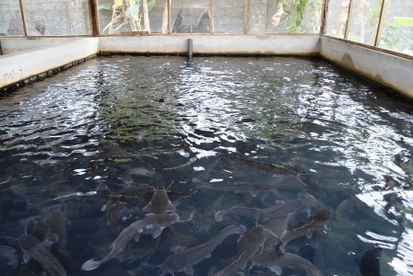
- When water is muddy (that is a lot of clay particle are present) fish can have their gills blocked by the soil particles and this can result in death. Muddy water are not good for fish culture.

- When water is deep green in colour, it indicates over-production of phytoplanktons and Zooplanktons.
- When a fish gives an offensive odour, it indicates pollution of pond water.
- In an already stocked fish pond, if a farmer notice the fish always struggling at the pond water surface to get oxygen then there is low dissolved oxygen (Do) content in the water

3.1 MANAGING POND WATER CHEMICAL PARAMETERS.
In fish pond chemical properties of water include the hydrogen ion concentration (PH), the dissolved oxygen content (Do) the conductivity of water, the carbon dioxide content (Co2) and the amount of mineral elements like nitrogen and phosphorous and compounds like nitrite and nitrate.
Hydrogenion concentration (PH): The various source of water used in fish culture are not chemically pure and contains, in solution, different substances which give it an acidic, neutral or alkaline reaction. The intensity of these characteristics is measured by determining the exacts quantity of the hydrogen ion (H+) PH readings ranges from 1 highly acidic) to 14 (Highly alkaline), PH reading of 7 indicate neutral.
Range for fish culture
PH RANGE | INTERPRETATION | REMARKS
1.0 -4.9 | Extremely acidic | Toxic To Fish
2.0 - 6.6 | Moderately Acidic | Low Productivity
6.7 – 9.9 | suitable H + ion | Desirable for fish(high productivity
9.1 – 11.0 | Moderately Alkaline | Low Productivity
11.1 – 14.0 | Extremely alkaline | Toxic To Fish

Two methods are mostly used to determine the ph of pond water. The more accurate and faster is the use of ph meter (electrometric method. The second method is the use of a ph paper (universal indicator).

Correcting ph in pond water
The ph of pond water may vary according to a number of chemical and biological factors in water with low alkalinity liming will raise the Ph to desires level.
Dissolved oxygen (DO) content in ponds
The distribution of Fish and other animals in water is strictly tied to the concentration of DO. The DO content of pond water depend to a large extend on water temperature, quantity of organic matter present and the population of submerged plants lead to dissolved oxygen depletion and this can be dangerous to fish
Water quality improvement practice
- Liming practices: In natural ponds (earthen) application of lines is important in correcting low ph, improve productivity and important ponds of parasites and diseases
- Fertilization: A fish farmer can increase pond productivity by applying organic manure with chemical fertilizers.
Feeding of pond fish
A) natural fish foods: living organisms are natural fish foods and they are produced in the water where the fish live. Phytoplankton, zooplankton, and larger aquatic organisms like insects, crustacean, moluscs and aquatic plants are all examples of natural foods.
B) supplementary feeds are not available in sufficient quantities to provide adequate nutrition for fish growth. Supplementary feeds should include finely divided artificial food like egg, yoke, blood meal, fish meal, shrimps, flour, beam flour, oil cakes, bone meals, cereal brans etc

Control of diseases and predators
Common fish diseases
Fish diseases are caused mostly by fish parasites
Maintaining hygienic pond environment is the best preventive method of checking diseases outbreak
Diseases can occur in fish pond due to
- Overcrowding i.e high density stocking
- Poor water quality resulting in fish kills
- Erratic feeding practices, starved fish are highly susceptible to diseases attack
- Intrusion of predators into the fond such as snakes, frogs, aquatic birds, dragon files etc.
- Over fertilization of pond water leading to high density algal bloom reduce the amount of dissolved oxygen (DO)
Cropping (harvesting) pond fish
In fish pond culture system, three types of cropping are practiced in routine management
- Test cropping
- Partial Harvest
- Total pond harvest
Test cropping: fish pond should be test cropped routinely to monitor dish growth and health. After examination, test cropped should be returned to the pond
Partial harvesting: when different age groups of the same fish species or different species combination are reared together in pond, the fish are bond to mature to able sizes at different times. Partial harvest should be done with appropriate mesh size
Total harvest: ponds that have been used to rear fish for over 5 years can be totally drained and whole fish harvested total pond harvest from management point of view can be carried

3.2 Treatment of some bacterial diseases of fish
Bacterial are found practically everywhere in water and air, on plants and in the bodies of men and animals. Bacterial infections are among the most common diseases in aquaculture. They can lead to mass mortality, reduced growth rate, and economic loss if not treated early. The most common bacterial diseases include columnaris, aeromoniasis, and bacterial gill disease.
- Columnaris Disease (caused by Flavobacterium columnare)
- Symptoms: Frayed fins, gill necrosis, white/gray patches on skin or gills, ulcers.
Treatment:
- Antibiotics: Use of oxytetracycline or florfenicol via medicated feed.
- Bath Treatment: Potassium permanganate (KMnO₄) or formalin in controlled dosages.
- Environmental Control: Improve water quality and reduce stressors.
- Aeromoniasis (caused by Aeromonas hydrophila)
- Symptoms: Hemorrhages on body, bloated abdomen (dropsy), ulcers, fin rot.
Treatment:
- Medicated Feed: Oxytetracycline, enrofloxacin, or sulfonamides.
- Sanitation: Disinfection of ponds with lime or potassium permanganate.
- Probiotics: Adding beneficial bacteria to water to outcompete pathogens.
- Bacterial Gill Disease (caused by Flavobacterium branchiophilum)
- Symptoms: Labored breathing, swollen gills with mucus or necrosis.
Treatment:
- Chloramine-T: Bath treatment in controlled dosage.
- Improve Oxygen Levels: Use aerators and reduce stocking density.
- Antibiotics: Medicated feed if systemic infection is suspected.\

- General Treatment Approach:
Diagnosis: Always confirm diagnosis before treatment—misuse of antibiotics can cause resistance.
Isolation: Remove infected fish from the healthy stock.
Supportive Therapy: Improve nutrition and reduce handling stress.
Biosecurity: Use disinfected equipment and quarantine new stocks.

3.3 Factors that promote parasite infections
3.3.0 Factors Promoting Bacterial Infection
- Overstocking:
- Wounds on fish flesh
- Presence of dead organic matter in pond
- Low dissolved oxygen content in water
- Climate and seasonal changes
- Presences of wild fish or birds
- Poor pond management
3.3.1 Prevention of Parasitic Infections
- Regular monitoring and diagnostics
- Maintain good water quality and biosecurity
- Use salt baths, formalin or potassium permanganate as preventive treatment
- Apply lime to pond after draining or before restocking
- Conduct quarantine for new stock (10-14 days)
- Educate farm staff on hygiene and handling.

CHAPTER FOUR
4.1 CONCLUSION
The training scheme gave me much acquaintance with the organization and it also give me understanding with exposure to the practical aspect of the work that has been taught in school
I appreciate the effort of those that organize this great program, the organization where I did the program, the government as well as the institution of making the program successful.
4.2 RECOMMENDATIONS
My recommendation to this department is that they should make it compulsory that all students in this department attend this program because it is very important to the practical work of our field of study
Finally, the department should help the students to find appropriate place for both SIWES student and IT student

