
TECHNICAL REPORT
ON
STUDENTS INDUSTRIAL WORKS EXPERIENCE SCHEMES
(SIWES)
HELD AT
ZENITH ACADEMY,
KWARA STATE LIBRARY COMPLEX,
ILORIN, KWARA STATE.
BY:
ABDULKAREEM HABEEBLLAH
ND/22/COM/PT/422
SUBMITTED TO:
DEPARTMENT OF COMPUTER SCIENCE,
INSTITUTE OF INFORMATION AND COMMUNICATION TECHNOLOGY (IICT), KWARA STATE POLYTECHNIC, KWARA STATE.
IN PARTIAL FULFILMENT OF THE REQUIREMENTS FOR THE AWARD OF NATIONAL DIPLOMA (ND) IN COMPUTER SCIENCE, KWARA STATE POLYTECHNIC ILORIN, NIGERIA.

DEDICATION
DEDICATION
I dedicate this project to God Almighty my creator, my strong pillar, my source of inspiration,
wisdom, knowledge and understanding. He has been the source of my strength throughout this
program and on His wings only have I soared.
I also dedicate this to my parents and my loving sister who encouraged me all the way and whose
encouragement have made sure that I give it all it takes to finish that which I have started. May
the blessing of God be with them now and always “AmenDEDICATION
I dedicate this project to God Almighty my creator, my strong pillar, my source of inspiration, wisdom, knowledge and understanding. God has been the source of my strength throughout this program and on His wings only have I soared. I also dedicate this work to my parents who has encouraged me all the way and whose encouragement has made sure that I give it all it takes to finish that which I have started.

ACKNOWLEDGEMENT
This SIWES work has been a great journey for me and has helped me to understand an area of work that is vast and wonderful. It has been completed with months of hard work and dedication and would not have been possible if not for the blessing and guidance I have received from a number of people. For this I am particularly indebted to all staffs of Computer Science Department of Kwara Poly who had earlier thought me all the basics involved with workshop practice. Also, I appreciate the rigorous training and teaching from the staff of Zenith Academy.

TABLE OF CONTENTS
CHAPTER ONE
1.0 INTRODUCTION 1
1.1 DEFINITION OF SIWES 1
1.2 FUNCTIONS OF SIWES UNIT 1
1.3 AIMS AND OBJECTIVES FOR SIWES 2

CHAPTER TWO
2.0 HISTORICAL BACKGROUND OF THE ORGANIZATION ATTACHMENT 3
2.1 ORGANIZATION CHART OF THE ORGANIZATION 3

CHAPTER THREE
3.0 INTRODUCTION TO TECHNICAL TRAINING IN THE ORGANIZATION 4
3.0.1 ZENITH SANDCRETE BLOCKS INDUSTRY 4
3.0.2 ZENITH MINERAL DEPOT 6

CHAPTER FOUR
4.0. WORK CARRIED OUT DURING S.I.W.E.S 8

CHAPTER FIVE
5.0 RECOMMENDATION AND CONCLUSION 11
5.1 CHALLENGES ENCOUNTER 11
5.2 RECOMMENDATIONS 11
5.3 CONCLUSION 12
REFERENCE

CHAPTER ONE
- INTRODUCTION
The student industrial works experience scheme (SIWES) was established by the industrial training fund (I.T.F) in 1973 and control by the national board for technical education (NBTE). The aims and objectives is to develop student skill and to expose students in the school of engineering, technology, environment, science and agriculture and medical science to the working experience in which they will found themselves in future.
It is integral part of degree and National Diploma programme institute of higher learning in Nigeria. This privilege programme would definitely broaden student chance of learning and would empower his/her academic efficiency.
During my four months Industrial Working Experience Scheme (SIWES) at Federal Ministry of Agricultural and Rural Development, the usefulness of maintenance in Tractor was proved and lot of experience was gained.
1.1 DEFINITION OF SIWES
Student industrial Working Experience (SIWES) is a skill acquisition training programme set up by the Federal and State government across the Nation in collaboration with the body known as Industrial Training Fund (I.T.F) for student to have a working experience and a feel of what it takes to be genius in one discipline before challenges ahead.

1.2 FUNCTION OF SIWES UNIT

By the directive of National Universities Commission (NUC) and Industrial Training Fund (ITF), the Unit is mandated to carry out the following functions.
i. Supervision of the students placed in the industries located within our ITFzone.
ii. Processing of students’ logbooks, ITF forms and industrial
attachment reports upon which is based on the Federal Government funding of supervision and
students’ allowances.
iii. Fostering of close links between the university and industries participating in SIWES programme.
iv. Provision of advisory guidance to participating students on careeremployment opportunities.
v. Monitoring of compliance with the requirements of SIWES on the part ofstudents in eligible disciplines as a condition for graduation.

1.3 AIMS AND OBJECTIVES OF SIWES
1. It exposes the prepare students of higher institution for the industrial working situation they can likely to meet in the future.
2. It enables student to apply what they have learn theoretically in class into practice in the real world.
3. It makes student to understand the technical implication of their profession.
4. It helps student to express their initiatives, competence and standard in task they have chosen.
5. It enable student to be technically and morally oriented
6. It helps to make transition from school to the working environment easier and to enhance students contact for later job placement.

CHAPTER TWO
2.0 HISTORICAL BACKGROUND OF THE ORGANIZATION ATTACHMENT
Zenith Academy is a training institute that specializes in impacting knowledge into students. Zenith Academy businesses includes: Zenith School of Advance Studies located in Kwara State and Lagos State, Zenith Mineral Depot located besides Iyi bare filling station, Eleko area, Ilorin and Zenith Block Industry located in Jokolu area, Tipper garage, Oyun, Ilorin, Kwara State. The address of the head office of Zenith Academy is 1st Floor, Kwara State Library Complex, Post Office, Ilorin, Kwara State. It was established in the year 2008 and registered with CAC in the year 2010. It is a non-governmental organization and also renders ICT solutions in Ilorin, Kwara State.
Zenith School of Advance Studies prepares students for both internal and external examinations. They train students in the following examination categories: JUPEB, IJMB, JAMB, WAEC,NECO, NABTEB,CAMBRIDGE etc.
Zenith Mineral Depot sells all kinds of non alcoholic drinks in wholesales, which includes; crate of coke, crate of fanta, packs of plastic water, coke, fanta, malt, fayrouz etc, 5alive, yoghurt etc.
Zenith Block Industry engages in selling brick block and cement. They produce fine and strongest brick block that is affordable. They sell brick block and cement to customers within and outside Ilorin Metropolis.
2.1 Organization Chart of the Organization
MANAGING DIRECTOR
CYBER-CAFÉ
OPERATOR
ATTENDANCE
ENGINEERING
TRAINEE STUDENTS

CHAPTER THREE
3.0 INTRODUCTION TO TECHNICAL TRAINING IN THE ORGANIZATION
ZENITH SANDCRETE BLOCKS INDUSTRY
Sandcrete blocks comprise of natural sand, water and binder. Cement, as a binder, is the most expensive input in to the production of sandcrete blocks.
Zenith bricks and block is in the business of making concrete blocks for modern construction. They produce quality bricks and blocks of uniform quality and at a fair price for mansory, builders and construction agents. Their product are used in the construction of residential, industrial and commercial buildings.
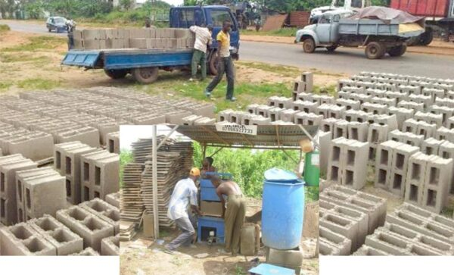
FIGURE ONE: PICTORIAL VIEW OF BRICK BLOCKS PRODUCTION

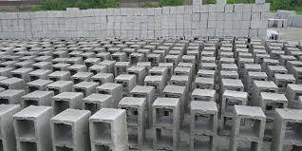
FIGURE TWO: PICTORIAL VIEW OF BRICK BLOCKS
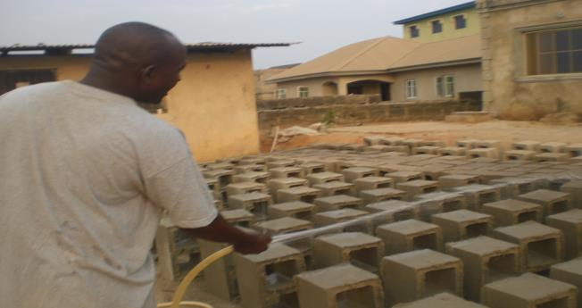
FIGURE THREE: PICTORIAL VIEW OF WETING OFBRICK BLOCKS

ZENITH MINERAL DEPOT
Zenith also operate a mineral drinks depot located besides Iyibare Filling station, along kwarapoly road, eleko area, Ilorin, kwara state. They deals with different kinds of drinks such as coke, fanta, malt,5alive, table water etc.

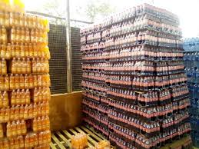
FIGURE FOUR: PICTORIAL VIEW OF PLASTIC DRINKS

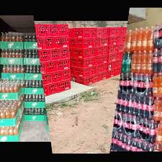
FIGURE FIVE: PICTORIAL VIEW OF CRATE OF MINERALS

ZENITH ICT CENTRE
Zenith School of Advance Studies is equipped with a standard computer centre. The following activities were carried out in the ICT centre.
Application of Computer
Computer has varying applications ranging from the most mundane and simple tasks to the highly sophisticated and seemly complicated. Computers can be applied to basic office jobs like typing memos, letters, graphic design, photo imaging and massive data analysis in different fields such as communication, engineering, crime control, medicine and other technology based field to mention but few.
Computer has made it possible to keep reliable records, to manage large files to conduct near impossible searches, to manage and protect databases and promote secure and efficient payment system.
INTRODUCTION TO MICROSOFT WORD
- CREATING A DOCUMENT
When Microsoft word is started, a basic sheet of electronic paper is displayed on which you can type and text appear in the document and editing occurs.
- HOW TO FORMAT A TEXT
Formatting is when you want to change the characters of your text such a font type, size and the thickness. Color or the position which could be superscript or subscript does as following.
- Step 1Highlight the, it is compulsory to highlight the text you want to modify either by the mouse or keyboard before the operation.
- Step 2 click format
- Step 3 click font
- HOW TO SAVE A DOCUMENT
Saving a document can be done in two ways:
To save a new document
- Click file from menu bar
- Click save as
- Type a file your document
- Click on save
To save subsequent document after the first saving
- Then Click file the menu bar
- Click save or use shortcut key from keyboard “ctrl s”
- PRINTING OF FILE
- Open the file you want to print
- Click file from the menu bar
- Select print from the file menu
- SPELLING AND GRAMMER CHECKING
- At the beginning of the document click review tab
- Select spelling and grammar from the proofing
- Select the correct word from the suggestion list bar
- Click change.
- TO CREATE TABLE
- Position the cursor to where you want the table
- Click insert tab and click table button
- Select insert table from the dialog box.
- Type the number of column in the column box and the number of rows in the rows box
- Select the desired width for each column or select auto
- Click ok.
- EXISTING MICROSOFT WORD
- Select the file command from the main menu
- Select exit and click it take you back to the window menu
- TO INSERT WORD ART
- From the menu, click insert.
- Highlight function and click word art from the sub menu
- Select the desire word art and click it
- Type the text using the desired font and click ok.
- TO INSERT SYMBOL
- Select insert from the main menu
- Select symbol from the sub menu
- Click the desired symbol
- Select close
- STEPS REQUIRE TO ACTIVATE MICROSOFT WORD
- Step 1 Boot the system ( as state above )
- Step 2 Click start button ( or press window on keyboard)
- Step 3 Click on all program
- Step 4 Click on Microsoft office ( from the program submenus)
- Step 5 point Microsoft word
Introduction to Microsoft Excel
Microsoft excel is a spreadsheet program that was created by Microsoft and can be used on computer tablet, phones. It allows people to conveniently share their work with other organized data. In the modern era, many business collect data from multiple source which include store transaction, online sales and social media.
MICROSOFT EXCEL FEATURES
- Title bar
- Formatting bar
- Formula bar
- Standard bar
FUNCTIONS OF MICROSOFT EXCEL
- Protection of document
- Previewing of document before printing
- It’s a spreadsheet for calculation
- It is used for data arranagement and storing of data

CHAPTER FOUR
4.0. EXPERIENCE GAINDURING S.I.W.E.S
During my SIWES program, I have more experience on how to run and supervise business. Though, managing a business successfully demands for skills and knowledge.
Experience gained while learning the above-mentioned web-related programs are:
  - Critical Thinking:
    - During my training I had to develop my critical thinking. Critical thinking is the analysis of facts to form a judgment. The subject is complex, and several definitions exist, generally including the rational, sceptical, unbiased analysis, or evaluation of factual evidence.
  - Colleague Interaction:
    - During my training I interacted with different persons and developed colleague interaction. In a working environment, teamwork is vital in contributing to a strong organization. Teamwork is also essential in reaching the goals of the organization as an entity. Thus, communicating and sharing are much needed in the working environment. Therefore, we should be respecting each other in work, and work together as a team, instead of working alone. This is because working together as a team is easier in reaching our targets, rather than operating individually.
I would like to once again appreciate everyone who has made my industrial training a superb experience.
  - Goal Management:
    - Opposing a Herculean goal seemed to be reachable at first sight, it is better to subdivide the goals into a few achievable tasks so that we will be gaining more confidence by accomplishing those tasks. During my training, I made bits of goals and achieved as much as possible.

  - Time Management:
    - Proper time management will minimize facing overdue deadlines. Effective time management allows us to do our assignments efficiently and meet our schedules. Scheduling avoids time wastage and allows us to plan andgain more as a result. During my training, I developed proper time management skills.
  - Decision Making:
    - During my training I had to develop my decision making. Decision-makingis regarded as the cognitive process resulting in the selection of a belief or a course of action among several alternative possibilities. Decision-making is the process of identifying and choosing alternatives based on the values, preferences and beliefs of the decision-maker. Every decision-making process produces a final choice, which may or may not prompt action.

CHAPTER FIVE
CHALLENGES, RECOMMENDATION AND CONCLUSION
  - CHALLENGES ENCOUNTER
IT Placement:
Finding a location to carry out my industrial training exercise was challenging; I applied to several firms and also get a negative response until I was given up after much waiting and staying at home.
Working Mentality:
Most interns have a poor working mentality and end up dodging or creating excuses where they do their internship.
Internship stipend:
Low internship stipend given to interns in some companies, some don’t even give any stipend.
5.2 RECOMMENDATION
I would recommend that the organization should appeal to the federal government to make provision for necessary equipment for the effectiveness of the programme.
I would recommend that the organization should provide transport facilities for SIWES students so as to ease their mobility.
5.3 CONCLUSION
The SIWES programe is an efficient an effective program which has bring much improvement to my field of study. I have gained a lot of experience from the various works done such as managing a company, using of Excel package and Microsoft, internet and browsing . It is a programe that bridges the gap between theory and practical aspect, so therefore it has made me to have technical knowledge about what I have learnt theoretically in class.

REFERENCE
www.google.com
www.wikipedia.com
My training log book
Machines and laboratory manuals

