
REPORT ON

STUDENT INDUSTRIAL WORK EXPERIENCE SCHEME
(SIWES)

HELD AT

KWARA STATE LIBRARY COMPLEX, ILORIN
(Period of Attachment, August 2024 to November 2024)

BY

ADEDOKUN TOHEEB TEMITOPE
(ND/23/LIS/FT/0113)

SUBMITTED TO

THE DEPARTMENT OF LIBRARY AND INFORMATION SCIENCE,
INSTITUTE OF INFORMATION COMMUNICATION TECHNOLOGY, KWARA STATE POLYTECHNIC, ILORIN

November, 2024
TABLE OF CONTENT
Title page ……………………………………………….. …… 1
Table of Contents …………………………………………….. 2
CHAPTER ONE: Introduction
1.1 Introduction on Conduct of the SIWES ………………… 4
1.2 Brief History of SIWES …………………..……………... 4
1.3 Aims and Objectives 0f SIWES ……………………………… 5
CHAPTER TWO: Description of Kwara State Library Board
2.1 Introduction ……..………………………............................... 6
2.2 Location and Brief History of Kwara State Library Board…… 6
2.3 Organizational Chart of Kwara State Library Board …………… 8
2.5 Department /Section in the Library and their Functions …………… 9
CHAPTER THREE: Actual Work Done at Kwara State Library Board
3.1 Introduction….…………………...................................................... 10
3.2 Experience Gained at Different Sections of the Library…………… 10 -14
CHAPTER FOUR: Equipment used in of Kwara State Library Board
4.1 Introduction …………………………....…………………………. 15
4.2 Equipment used in Kwara State Library Board ….…..….… 15 - 17
CHAPTER FIVE: Summary, Conclusion and Recommendations
5.1 Summary of the SIWES Report……………………………………. 18
5.2 Conclusion ……………………………………………………… 18
- 3 Problem Encountered …………………………………………… 18
5.4 Recommendation ……………………………………………….. 19

CHAPTER ONE
INTRODUCTION

1.1 Introduction on Conduct of the SIWES
The student industrial working experience scheme (SIWES) was the programmed initiated by the industrial training fund (ITF) in 1973 with the aims of impacting practical experience to student in tertiary institutions of Nigerian as well as satisfying requirement for the award of certificate in Nigerian tertiary institutions. The scheme also prepares the student for employment after graduating. This report is prepared on the basis of experiences acquired from six months (September,2024 to February 2025.), the SIWES was conducted at the Kwara State Library Board, Ilorin.

1,2. Brief History of SIWES
The student industrial work experience scheme (SIWES) is a widely accepted in Nigeria and it was initiated by the federal government of Nigeria with the aim of impacting practical knowledge and skills to Nigerian students in tertiary institution. It is a skill acquired program which provides part of the minimum academic requirement in Nigerian tertiary institutions. The idea of industrial work experience could be trace back to 1906 as far away as in the USA where cooperation exists between the tertiary institution and the industries to provide student with a sound practical experience.
At the SIWES/ITF (Industrial training fund) biennial conference held in Jos, Plateau State in 1988, collaborating agencies such as National Universities commission (NUC), National Board of technical education (NBTE), and National certificate of Education (NCE) where given a mandate to draw up job specification for all degree programs approved for student industrial work experience and to help the employer in ensuring that the student acquired at least the minimum required exposure prior to employment. Though the SIWES program is being initiated by federal government, but ITF where saddled with the responsibility of co-coordinating and executing the project base on the ITF policy statement No 49 of 1973 constitution of the federal republic of Nigeria. The industrial training fund was established by decree and act number 47 of both Octobers, 1971 to promote and encourage the acquisition of skills in commerce and industry with a view to generating a pool of indigenous trained manpower sufficient to meet the needs of the economy. The duration for SIWES programmed varies with institutions from the minimum is three months.

1.3 Aims and Objectives 0f SIWES
- Siwes provides an avenue for students in Nigerian tertiary institutions to acquire industrial skills and experience in their courses of study especially the area of vocational, technical and technological education.
- Siwes also exposes students to work methods and techniques in handling equipment and machines that may not be available in their institutions or universities.
- Siwes prepare students for the work situation outside the academic environment for the labor market which they are likely to meet after graduation.
- It also provides the students with an opportunity to apply their theoretical knowledge in real work situation.
- Siwes also create a job opportunity for students after graduation by increasing employer-employee and senior-junior officer cordial relationship which is important item in labor management.
- To make the transition from school to the world of work easier,and enhance student contacts for later job placement.

CHAPTER TWO
DESCRIPTION OF KWARA STATE LIBRARY BOARD

2.1 Introduction
The Kwara State Library has many staffs (including professionals and nonprofessionals) with a Director and a Deputy Director as the head of the Library. The Professionals head each units of the library while the non-professionals (staff) assist the professionals in discharging their duties. Like every other Public Library in the country, the Kwara State Library makes adequately provision of information materials for its users as well as conducive environment. Its strict monitoring of users is till its users a sense of composure diligence in the handling of any material in their possession. Every user of the library must have the library Identity card which he or she must present at the portal before he or she is allowed in and the same way, show the card to the library unit attendant of any unit the user is visiting. This practice helps in monitoring the library users.
Being a public library, the Kwara State Library is majorly funded by the State
Government and little with internal generated revenue through the leasing of offices, multipurpose hall used for Seminars, Conferences and Meetings and Training, registration of users, payment charged for making use of the toilet, photocopy, lamination of documents and project binding for the people at the Bindery Section of the library and support from ETF (Education Trust Fund). The Library gets its books through gift and donation, legal deposit, International books Aid (Aids for British Colonized Countries) and purchasing.
2.2 Location and Brief History of the Kwara State Library
The State library is located in the heart of Ilorin city bearing No 1, Sulu Gambari Road, P.M.B. 1561, Ilorin, Kwara State, Nigeria. After the creation of Kwara State along with other state in 1967, the need for a public library service became necessary. The Northern regional library, Kaduna was decentralized for the new States to establish their own. The area court building was chosen as a suitable place that could accommodate the new library, before it moved to its location in October 1967. Apart from the inherited library materials from the defunct northern region, a total sum of 300 pounds was released to the Interim Administrative Council to purchase more books for the library. On 1st April 1968, the Kwara State Library commenced services to the public after it was realized that the borrowed building was quite unsuitable due to its closeness to the central market (Oja Oba) and had its annex at the old red cross building, under the leadership of late pa J.O Popoola (chief librarian). The problem of accommodation continued for two decades during which the library moved from one building to the other. The lack of a befitting infrastructure was a setback to the library and effort were made to secure a suitable and permanent building for the library.
In November 1987, the then military Governor, Lt. Col. Ahmed Abdullahi laid the foundation of a purposefully-built library where it presently occupies. The completed building was commissioned by General Ibrahim Badamasi Babangida formal military president and commander in chief of the Federal Republic of Nigeria on 21st November, 1990. Between 1990 and 2001, the teeming reading population in the State made use of the library. Within a decade and half, the building got dilapidated, its stock became out-dated and irrelevant to the information needs of users. On assumption of duty as Governor of kwara state, Dr. Abubakar Bukola Saraki visited the library and promised a face-lift. Renovation started on 23rd November, 2005. The transformed library building was commissioned and put back to use 1st July 2006 by His Excellency, President Olusegun Aremu Obasanjo, formal president of Nigeria (Kwara State Library Handbook, 2006, republished). Also, in 2020, the sum of one hundred million was released by the present Governor, Mallam AbdulRasaz AbdulRahman for the renovation of the library.



















ORGANIZATIONAL STRUCTURE OF KWARA STATE LIBRARY

BOARD
CHAIRMAN

&

MEMBER

SECURITY &
MAINTENANCE
UNIT

DIRECTOR

TECHNICAL

DEPARTMENT

READER SERVICE
DEPARTMENT

ACQUISITION
SECTION

CATALOGUING
SECTION

CLASIIFICATION
SECTION

AUTOMATION
SECTION

HUMANITY
SECTION

SCIENCE &
TECHNICAL SECTION

CHILDREN
SECTION

CIRCULATION
SECTION

REFERENCE &
RESERVE SECTION

E
-
LIBRARY
SECTION

SERIAL &
GOVERNMENT
PUBLICATIONS

BINDERY
SECTION

ADMINISTRATIVE

DEPARTMENT

SPECIAL
PEOPLE
SECTION

SECRETARY&
ACCOUNTANT
UNIT

2.4 Department /Section in the Library and their Functions
The Kwara State Library has three (3) major departments which are subdivided into sections.
These major departments are:
- Administrative Department
- The Technical Department
- The Readers Service Department
- THE ADMINISTRATIVE DEPARTMENT
The administrative department: responsible for the more important management functions such as planning, organising, staffing, budget preparation and defense, controlling & supervision, measurement and evaluation of activities, operational procedures and services, and reporting, among others.
- TECHNICAL SERVICES DEPARTMENT
This dept. handles all the activities relating to library acquisitions. Cataloguing and
Classification department: which consists of the Cataloguing and Classification Unit, and Mending Unit and the Bindery Unit. The Division is responsible for the processing of library materials.
- READER SERVICES DEPARTMENT
The User Services Department which is comprised of the Reference Services Section, the Circulation Sections (Humanity and Science/Technology), the Serials & Government Publication Unit and the Children Unit. The Division takes charge of the public services of the Library. Circulation is responsible for the proper registration of users and arrangement of books and other materials on the shelves for users’ consultations.

CHAPTER THREE
ACTUAL WORK DONE AT KWARA STATE LIBRARY BOARD

3.1 Introduction
This chapter covers my experience and activities carried out at the various section at the Kwara State Library. The section and actual work I did are:
- Acquisition Section
The acquisition section receives books gifts and donations from organizations, philanthropists and prominent individuals. The section maintains a registrar called accession registrar, this registrar is used for keeping information of books such as the total number of books, date, the accession number, author’s name, title, publication, year of publication, cost, source and no of copies.
Work done at the Acquisition Section
  - Book selection and acquisitions procedure
  - Receiving new books
  - Accessioning of new books
  - New Book Stamping
  - Keeping Statistics
- Classification section
Classification is headed by Mr. Adelodun. Classification is an important activity of the classification section. By this activity, library materials are given classification number which is popularly referred to as Call Number. This activity allows books and other materials to be grouped according to their subjects. The advantage of this is that books on the same subjects are brought together on the library open book shelves. This gives room for easy location of materials on a given subject. Classification of Library materials are done with the assistance of Dewey Decimal Classification (DDC) Schemes. This section is “OUT OF BOUND” to nonlibrary staff
GENERAL STEPS FOR SUBJECT CLASSIFICATION WITH DDC
STEP 1. Analyse the subject content of the work by going through the title, introduction, preface, table of content, author’s note, flip through the book, look at the flyer etc.
STEP 2. Confirm the formulated possible subject from the subject heading in use.
STEP 3. Go to the index. The index is a pathfinder which direct you to the scheme.
STEP 4. The next step is to go to classification schedule and determine which class number will be allocated from the schedule.
STEP 5. Assign class number after you have made up your mind professionally.
STEP 6. As appropriate from the scheme additional elements from classification number. Such element could be from tables in DDC. c. Cataloguing section
Cataloguing section is headed by Mr. Timothy Adeoti. The Cataloguing section takes care of getting the library materials ready for use for the library users by processing, cataloguing classifying the materials. That is, bibliographic description of the material on 3 by 5 cards. This section just like classification, is “OUT OF BOUND” to non-library staff.
Work done at Cataloguing Section
- Descriptive Cataloging: recording bibliographic details such as title, author, and publication date
- Subject Cataloging: assigning subject headings to help users find relevant materials
d. Serial and government publication section
This section is headed by Mr. Haruna and Mr. Shola. The Serials section contains current and old issues of both newspapers and local journals, magazines, special collections such as Government publications, and other significant collections. To consult any serial collections, the reader must first consult the Serials Librarian who will check the Kardex to know if the information requested are available. Newspapers can also be read in this section of the library. After the materials had been received the readers are expected to sit down in the section and read. The users are expected to submit their library identification cards when consulting serial materials. The serial section manages periodicals, magazines, and newspapers.
Work done at the Serial and government publication Section
  - Serials Management: maintaining serial publications
  - Receiving Serial Publication: recording the arrival of serial issues
  - Binding and Preservation: binding and preserving serials for long-term access e. Reference section
The reference section provides reference services to users. The reference section is headed by a Reference Librarian (Prince. Lukuman Agboola) whose duty is to assist readers in getting information from the Library resources for study, research and teaching. This section renders the following services:
Work done at the Reference section
- Provides answers to specific enquiries
- Instructs readers on the proper use of the library.
- Guides users in locating materials
- Provides inter-Library Services by issuing Letters of Introduction to registered members of the library to use other libraries when required materials are not available in this library.
- Humanities section
This section is headed by Mrs. Gbadeyan. The humanities section is in the reader’s department, it provides books and space for users just like the reference section. The materials in humanities section include all classes of knowledge except Science and Technology (as grouped by Dewey Decimal Classification Scheme). The section is charged with the responsibility of registering library users, keeping the overall statistics of register. The section also takes statistics of user every two hours.
Work done at the Humanities section
  - Reader Statistics
  - Shelving of new books and re-shelving used books
  - Shelf-Reading
  - Moving round to monitor the activities of users
  - Maintain User Statistical Record for future use
- Science & Technology section
The Science and Technology Section is headed by Pastor Ajewole Segun. This section performs the same function as Humanity Section. It is a Reader department that keeps information material under the class of 500 and 600.
Work done at the Humanities section
  - Reader Statistics
  - Shelving of new books and re-shelving used books
  - Shelf-Reading
  - Moving round to monitor the activities of users
  - Maintain User Statistical Record for future use
h Children Section
This section is headwd by Mrs. Raji and assisted by Mrs. Bolaji Aminat. The section houses print books like story books, alphabetical books, pronunciations books, toys and a set of television for the children library users.
Work done at the Children Section
- Receiving Pupils on Excursion to the library
- Story Telling
- Guide the Children on the use of tools in the section
- Taking statistical record of children in the section

CHAPTER FOUR
4:1 Detailed Description of Equipment used and their Functions
I used the following tools at the Kwara State Library:
- Stamps
- Shelf
- Dewey Decimal Classification Scheme and Subject heading of sears list
- Toys at the Children Section
- Catalogue Cards
- Book Guard
STAMPS: Stamp is used in the library to prove the ownership of a library materials and cannot be taken out of the premises without permission.
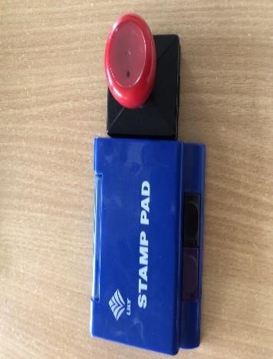

SHELF: This is an area where books are arranged and kept for easy access by users. Shelves are used to organized library material and to ensure books are accessible to the end users.
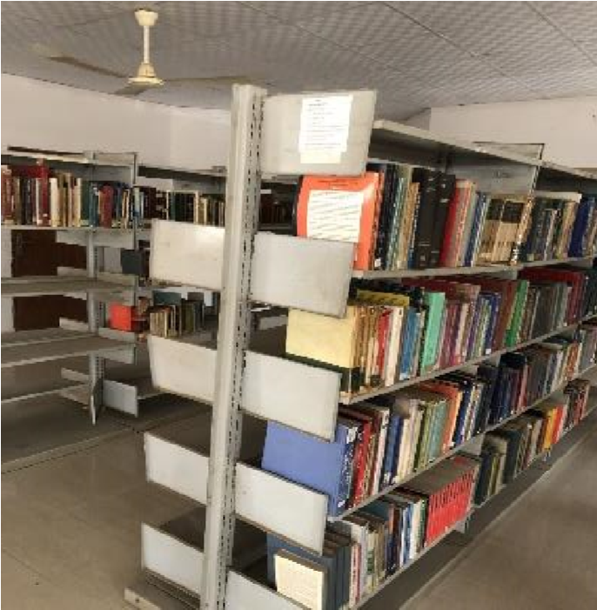
DDC and SEAR’S LIST OF SUBJECT HEADINGS: This is a tool used in cataloguing and classification section in the library. It is a list of possible subject arranged in an alphabetical order, the main use of the subject headings is to determine the subject of a particular book treats
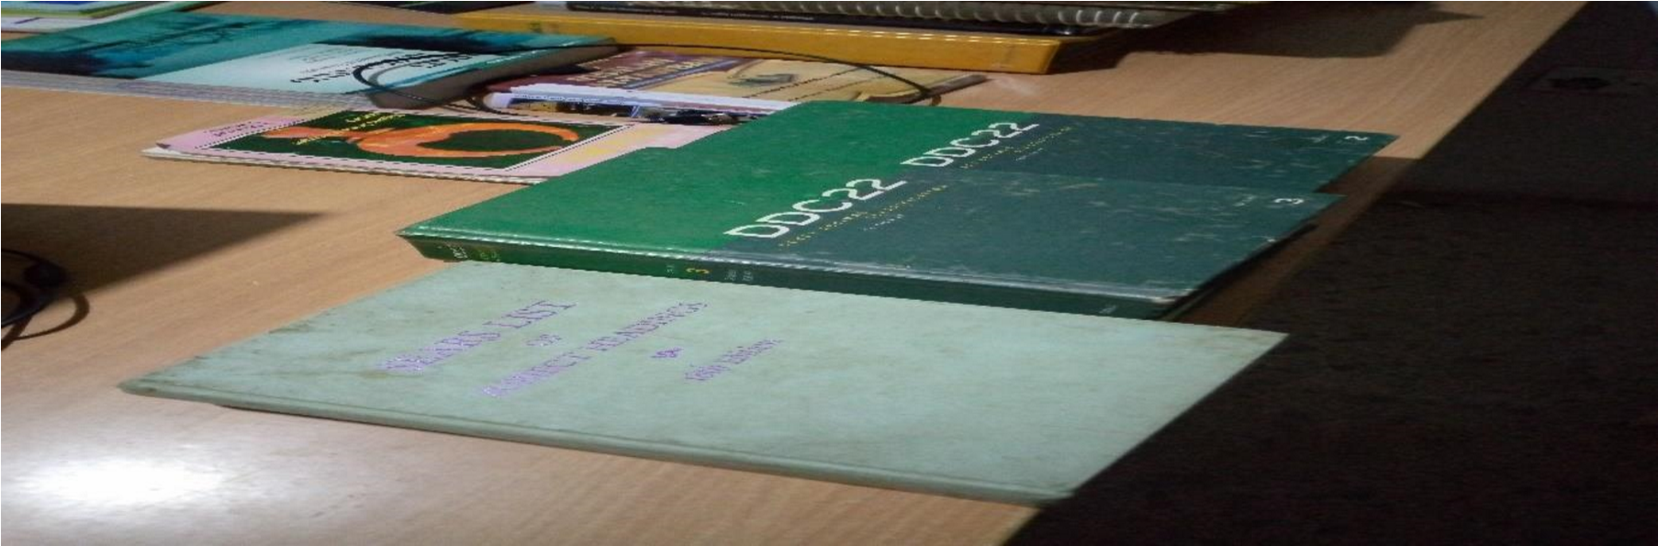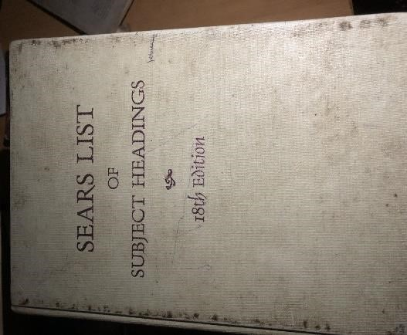
which will then determine the class number.

CATALOGUE CABINET: this is used to arranged catalogue card foe easy access to materials
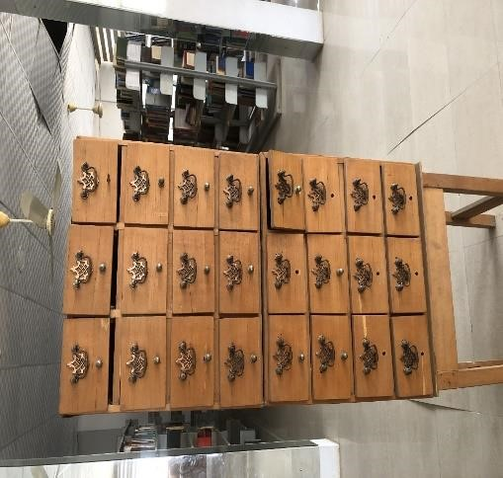

TOYS: this is found in children section to entice the children and it is available for the children to play with.
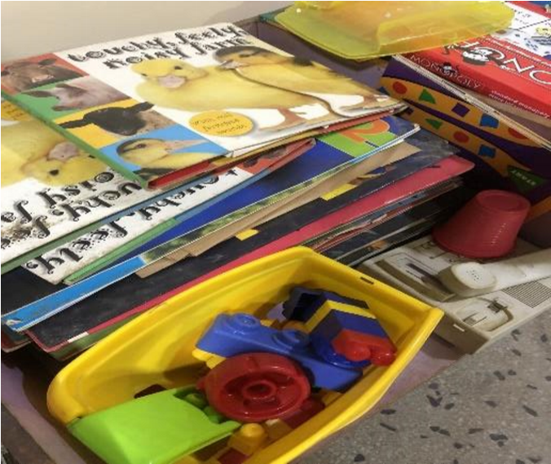

BOOK GUARD: this is a flat iron edge that is used to support books arranged in the shelf.
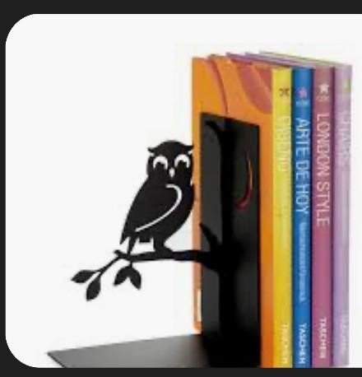

CHAPTER FIVE
SUMMARY, CONCLUSIONS AND RECOMMENDATIONS.
5.1 Summary
During my training, I realized that education in the school is not enough because school alone cannot teach the skills, values, experience and ability needed to fit into the practical aspects of one’s discipline. The report covers my activities at the Kwara State Library, it is in five chapters. Chapters one and two provide information about the establishment of the scheme and the historical background/location of the library. Chapter three covers my experience and the activities in the library, chapter four is all about the tools used in the library.
5.2 Conclusion
The Student Industrial Work Experience Scheme (SIWES) has really helped me to relate and apply the theoretical aspect I was taught in school with the practical aspect. It gave me the opportunity to practice librarianship in its real sense in terms of cataloguing and classification, how to charge and discharge materials, how to acquire new materials and how to become a 21st century librarian. As a matter of fact, SIWES also serves as working experience.
5.3 Problems Encountered During the Programme
Some of the problems I encountered during my training were;
- Sitting down in one place for a long time made the activities bored
- Staff attitude: some staff are not coming to work regularly and this impede our training in those sections
- Transportation fare
5.4 Recommendation
- With regards to the experience that I have acquired during this training, I recommend that this programme should be compulsory for both science and arts students in various higher institutions so as to improve their knowledge in the field of their profession.
- SIWES allowance should be paid during the period of attachment to ease transportation problem
- Staff training should be continuously done by the library
- REFERENCE
- Issa, A. and Akangbe, R. (2012). Reading interests as habit of the Federal
Polytechnic, Offa vi. students, paper presented at the 2012 AGM/Conference.
- ITF (2013). Constraints to students’ effectiveness in practical skills acquisition in
technical colleges in Kogi State, Nigeria. International Journal of Innovative Scientific and Engineering Technologies Research 6(1):1-9.
- Moses, E.A. (2011). Network of Rural Librarians in Nigeria Dissemination of Information: A necessity for National Development. Presented at the 2011, AGM/Conference, Offa.
- Osinem, E.C. and Nwoji, U.C. (2010). Students Industrial Work Experience in Nigeria:
Concepts, principles and practice. Enugu: Cheston Agency Limited.

