

TECHNICAL REPORT ON STUDENT INDUSTRIAL WORK EXPERIENCE SCHEME (SIWES)

HELD AT

RADIO LAGOS (107.5 FM,)/ EKO FM (89.7 FM)

By:

OLUBUADE KOWIYAT ENIOLA
ND/23/MAC/FT/093

SUBMITTED TO:
DEPARTMENT OF MASS COMMUNICATION, INSTITUTE OF INFORMATION AND COMMUNICATION TECHNOLOGY (IICT) KWARA STATE POLYTECHNIC, ILORIN

IN PARTIAL FULFILMENT OF THE REQUIREMENT FOR THE AWARD OF NATIONAL DIPLOMA (ND) IN MASS COMMUNICATION

AUGUST – DECEMBER, 2024
CERTIFICATION
This is to certify that this SIWES was carried out by OLUBUADE, kowiyat eniola with Matric Number: ND/23/MAC/FT/093 in the Department of Mass Communication, Institute of Information and Communication Technology (IICT), Kwara State Polytechnic, Ilorin.

DEDICATION
This SIWES is dedicated to Almighty Allah, the Author and Finisher of my faith.

ACKNOWLEDGEMENTS
First and foremost, I appreciate Almighty Allah for giving me the privilege to partake in the Students Industrial Work Experience Scheme (SIWES).
I acknowledge my amiable and dynamic parents Mr. and Mrs. Olubuade, for their financial, moral and spiritual caring and support during the course of my SIWES programme.
I also appreciate my Industrial based supervisor for their patient, endurance, courage and kind support during the course of my stayed in the Radio Lagos.
I wish to also acknowledge my school based supervisor, for their support, encouragement and kind during their visitation to Radio Lagos.
Finally, I appreciate my colleagues in the same industrial based training, I pray Almighty Allah will grant us success in all our endeavor (Amen).

TABLE OF CONTENTS
TITLE PAGE i
CERTIFICATION ii
DEDICATION iii
ACKNOWLEDGEMENTS iv
TABLE OF CONTENTS v
CHAPTER ONE 1
1.1 Introduction to SIWES 1
1.2 Background to the SIWES 1
1.3 Objectives of SIWES 2
CHAPTER TWO 3
2.1 History of the Organization 3
2.2 Vision And Mission Statement 3
2.2.1 Vision 3
2.2.2 Mission Statement 3
2.2.3 Organisation Structure And Department 4
2.2.4 Departments In Kwara state television authority 4
2.3 Station Running Activities 6
CHAPTER THREE 7
INVOLVEMENT IN THE ORGANIZATION 7
3.1 Experienced Acquired 7
3.2 Work Done 7
3.3 Importance of Paper in News 8
3.4 Instrument Used in the News Room 8
3.5 What is Editing? 10
3.6 Who is a Reporter? 10
3.6.1 Types of Reporter 10
3.7 Sources of News 10
3.8 What is Line-Up? 10
3.9 Rule of Engagement in News Department 10
3.10 What is a Newscasters? 10
3.11 Duties of a Newscaster 10
CHAPTER FOUR 11
EXPERIENCED GAINED IN THE ORGANIZATION 11
4.1 What is Microphone 11
4.2 Types of Microphone 11
4.2.1 What Is A Condenser Microphone? 11
4.2.2 What Is A Dynamic Microphone? 11
4.2.3 What Is A Ribbon Microphone? 12
CHAPTER FIVE 13
CHALLENGES ENCOUNTERED, CONCLUSION AND RECOMMENDATION 13
5.1 Challenges Encountered 13
5.2 Conclusion 13
5.2 Recommendation 13

CHAPTER ONE

1.1 Introduction to SIWES
The Student Industrial Work Experience Scheme (SIWES) exposes students to industry based skills necessary for a smooth transition from the classroom to the world of work. It affords students of tertiary institutions the opportunity of being familiarized and exposed to the needed experience in handling machinery and equipment which are usually not available in the educational institutions and seeing firsthand the practical experience of some theoretical knowledge gained in the course of study.
Participation in SIWES has become a necessary pre-condition for the award of Diploma and Degree certificates in specific disciplines in most institutions of higher learning in the country, in accordance with the education policy of government.

1.2 Background to the SIWES
The Student Industrial Work Experience Scheme (SIWES) is an initiative which was established in 1973 by the Industrial Training Fund (ITF) to help bridge the gap between acquired classroom education and skills necessary for work in the industry.
Before the inception of the scheme in 1973, there was glaring evidence that inadequate practical exposure of students in tertiary institutions posed serious challenges to both the quality and standard of engineering and technological education in our nation. This resulted in half-baked engineering graduates who needed to undergo a form of training (Industrial Training) to be suitable for employment in industries and firms.
In order to forestall this threat that could bring about industrial regression, the Federal Government through the Industrial Training Fund (ITF) which was established by decree 47 of 1971 introduced the Student Industrial Work Experience Scheme (SIWES) in 1973.
SIWES exposes students to machines and equipment, professional work methods and ways of safe guarding the work areas and workers in industries and other organizations. It helps the student to know the link between what is learnt in the university and what is actually practiced on site. It further helps students to appreciate their field of study better, thereby also determining which area of specialization to go into to contribute to technological development of this nation.
The scheme involves the students, the universities and the industry (employers). It is funded by the Federal Government of Nigeria and jointly coordinated by the National Universities Commission (NUC) and the ITF.
SIWES orientation is usually done to intimate students with the rudiments of industrial training before they are being employed. At the end of the industrial training (IT), successful students whose log books were verified and approved by ITF officials are paid SIWES severance allowance.

1.3 Objectives of SIWES
- Provides the student with an opportunity to apply their theoretical knowledge in real work situation thereby bridging the gap between theory and Practical.
- Provides an avenue for students in tertiary institutions to acquire industrial skills and experience in their course of study.
- Expose students to work methods and techniques in handling equipment and machinery that may not be available in universities.
- Familiarizing the student for the working conditions they are likely to meet after graduation; and
- Make the transition from the university to the world of work easier and thus enhance student’s contacts for later job placement.

CHAPTER TWO

2.1 History of the Organization
Radio Lagos 107.5 FM (also known as Tiwa n' Tiwa) began operations in 1977 as an offshoot of the Nigerian Broadcasting Corporation (NBC). It is the first state-owned FM radio station in Lagos State.^{[1]}
The station originally operated on two A.M. Frequencies (990 kHz.303mtrs and 918 kHz.327mtrs). The need for transformation produced Radio Lagos 107.5 FM (Tiwa n'Tiwa) under the control of the Lagos State Radio Service in 2001.^{[2]}
Radio Lagos is the first predominantly specialized language station, with over 98% of its transmission in Yoruba and Egun, and approximately 2% for English bulletins. The station's target audience includes Yoruba speaking listeners in Lagos and the Nigerian diaspora.^{[3]}
Here's a more detailed look at Radio Lagos’s history:
- Establishment:
Radio Lagos 107.5 FM was founded in 1977 with the goal of promoting the state government and its people.
- 24-Hour Broadcast:
On February 1, 2022, KWTV commenced 24-hour live broadcasting, marking a significant milestone after 25 years of operation.
- Transformation:
The station underwent a transformation, including the appointment of a professional as General Manager, and has received support from Governor Babajide Sanwo-olu for its repositioning.
- Local Content:
Radio Lagos 107.5 FM has focused on promoting local content and culture.

2.2 Vision And Mission Statement

2.2.1 Vision
To be the reference point for quality world-class broadcast specially targeted at the youth in Lagos state and an Nigeria at large through institution of the premium corporate culture, corporate accountability, team spirit and all round pursuit of excellence.

2.2.2 Mission Statement
Radio Lagos 107.5 FM is committed to excellence, balance, equity and inclusiveness of all our stakeholders in our determination to add value to our youthful listeners, nurture our culture, norms, values and traditions while accelerating the socio-economic growth of Lagos State in particular and Nigeria at large.

2.2.3 Organization Structure and Department
Radio Lagos 107.5 FM is well structure television station which all running and management is been fully control under the following step structure.
- Board of Trustees
- General Manager
- Station Manager
- Programmes Manager
- Administration Manager
- Marketing/ Finance Manager
- Studio Operators and Engineers

2.2.4 Departments In Kwara Television authority
- Administrative Department
- Programme Department
- Marketing Department
- Engineering Department
- Finance Department
- News and Current affairs
- Audit Department
Administrative Department: This department is in charge of all staffs matters, ranging from the code of conduct for all staffs, moral behavior, rules and regulation and scheme of services for all staffs. The department caters for personal matters training, training of staffs, and employment of new staffs, discipline and promotion. The department handles record keeping, takes care of matters relating to insurance of man and materials, survey of corporations land matters, dealing with contracts, provides clerical and secretariat duties for all department.
News and Programme Department: This department handles the entire programs as well as news section. Various Artists, freelancers as well as in house presenter are manage by this department. The Programme manager is responsible for the initiation of programs, and this idea must serve the purpose of informing, educating, persuading and entertaining.
Marketing Department: This is the department where the financial aspect of the organization is discussed and settled, not only that, the department deals with any jingle or advert rate and payment before going on air once verified by the programme department.
Engineering Department: This department is indebted with the task of supervising the equipment procurement, installation and maintenance of such equipment. He (producer/engineer) must be conversant with the broadcasting technology state.
Finance Department: The finance department is a service department that deals with the inflow and the outflow of the organization finances. It is in charge of budget preparation and budget control. It offers advice on financial matters to the chief director at all times. This department discharge duties ranging from billings, debt collection and payment of all fees for all channel, account reconciliation.
Editing Department: This is the department where we have experienced computer operator, their ingenuities is being task with the burning of disk, editing of recorded Audios, Jingles and Advert , and also keep the records.
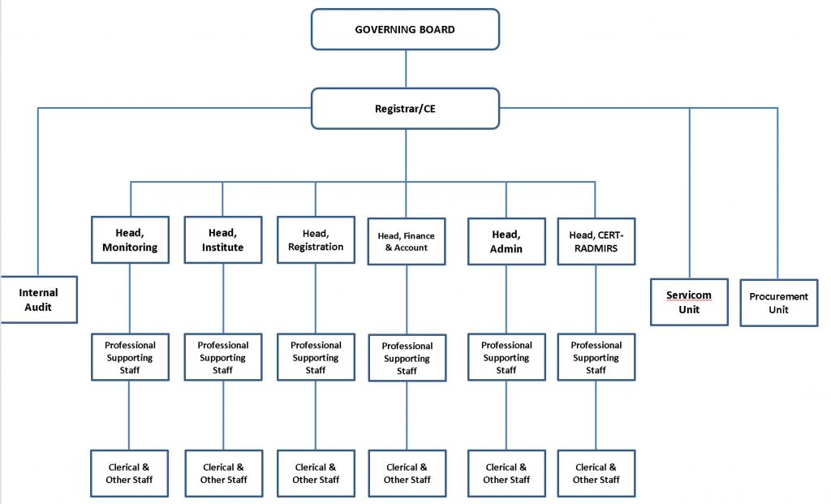

2.3 Station Running Activities
Radio Lagos, operating on 107.5 FM, is a state-owned station in Lagos, Nigeria, known for its Yoruba-language programming and its focus on informing, entertaining, and educating its audience. It aims to be a platform that enriches the lives of "SMART citizens" through balanced reportage and programming, including news, music, and discussions.
Here's a more detailed look at Radio Lagos's activities:
Programming and Content:
- News and Information:
The station provides updates on local and national news, including political events, social issues, and economic developments.
- Cultural Programming:
Radio Lagos features programs that promote and celebrate Yoruba culture and traditions.
- Music:
The station plays a mix of local and international music, catering to a wide range of tastes.
- Educational Programs:
Radio Lagos offers educational content, including discussions on topics like basic education and government initiatives.
- Interactive Programs:
The station hosts game shows, quizzes, and interactive call-in segments to engage with listeners.
Key Features and Initiatives:
- Community Engagement:
Radio Lagos actively seeks to engage with the community through events and partnerships.
- Focus on Lagos:
The station provides extensive coverage of events and developments within Lagos State.
- Target Audience:
Radio Lagos primarily targets Yoruba-speaking adults in Lagos and surrounding states.
- Online Coverage:
The station is also available online, reaching a global audience through platforms like Radio Garden.

CHAPTER THREE

INVOLVEMENT IN THE ORGANIZATION

3.1 Experienced Acquired
I started my SIWES program at Radio Lagos (107.5 FM) on he 8th of August 2024 in the news and current affairs department.
The news department is where news is being processed, produced and given to a caster to road to members of the public.
During my stays at Radio Lagos, news department, I was opportune to know how the news department derived their news from online and how they edit it and how news is being transmitted. Also, some reporter that went out source for news of beat event, gives me some tips on how to write story about an event when I was taken out, but I was not opportune to broadcast it before I was transferred to another department.
Then, the department I was transferred to was programme department, under the supervision of Al-Hawal. Programmed and produced is where a radio programme are packaged and produced for airing. The department comprises varies units such as record room, marketing room and so on.
I was able to know how to produce a programs and also given an explanations on how to control the console, operating system while recording, music ethics to play on a schedule programs and so on.
I was opportune to produce a program called drive time program in the studio and more programs.

3.2 Work Done
I was persuaded to do so many tasks at Radio Lagos, which despite the fact that I was opportune to be working as a new editor.
Accidentally, I used to compile and edit news bulletin such as News updates at 11am and 3pm, Global new at 1pm, and News beam at 7pm in newsroom.
More so, I used to go out with Radio Lagos reporters in other to source for news. They conduct an interview then I transcribe, edit and conpute into or among the news story when get into station.
I was asked to go record a Jumat program which the type of a program was a record program and played in the studio after its schedule time.
There are numerous of my work done in which i experienced a lot at Radio Lagos radio station.

3.3 Importance of Paper in News
The following are the importance of paper in news.
- Available of news
- It will help the producer for the particular day to know which news will go for there time
- It help the producer alignment of a news story

3.4 Instrument Used in the News Room
The following are the instrument used in the news room.
- Table and chair
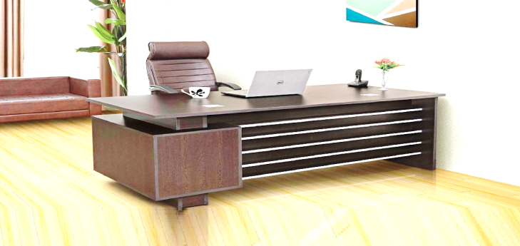

- Consoler
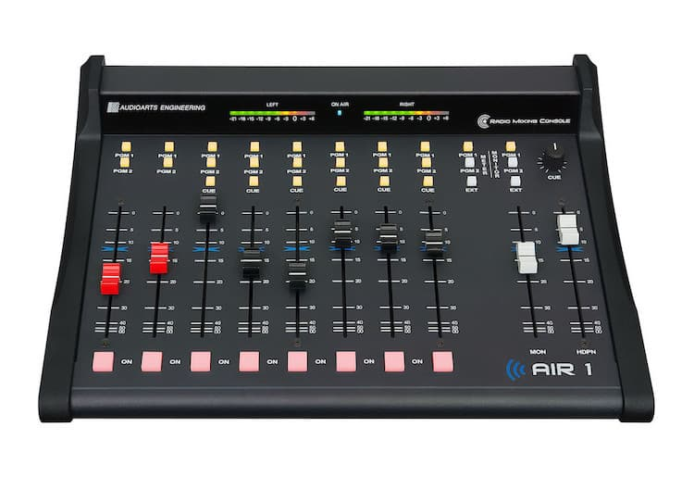

- Camera
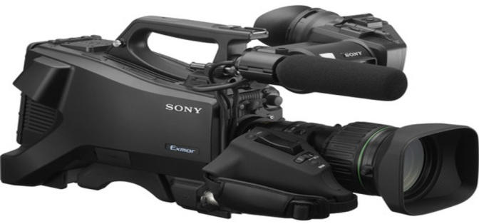
- Processor
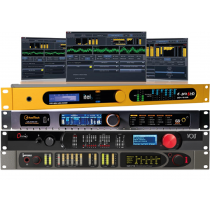
- Computer
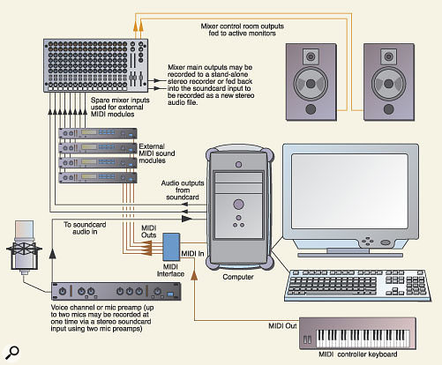

- Microphone
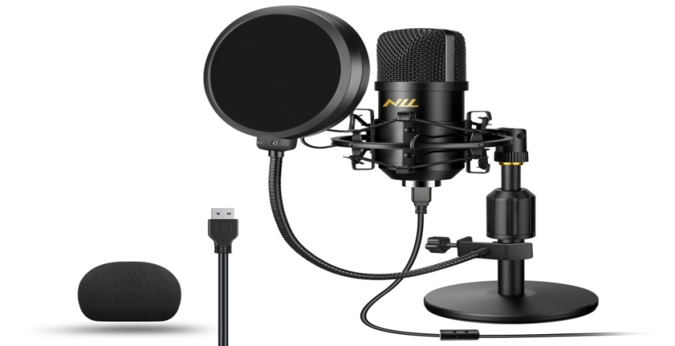

3.5 What is Editing?
Editing means doing all graphics. As a communicator you must know how to handle the system very well.

3.6 Who is a Reporter?
A reporter is also known as journalist who gather information and news to keep public informed.

3.6.1 Types of Reporter
There are three types of reporter know to me.
i. Judicial reporter ii. Education reporter iii. Health reporter

3.7 Sources of News
There are different ways of sourcing for news.
i. Rooting ii. Schedule assignment iii. Searching

3.8 What is Line-Up?
A line-up refers to a list of sequence individual on topic that will be featured on discussed in a news program or publication.

3.9 Rule of Engagement in News Department
The following are the rules of engagement in the news department.
i. Responsibilities of reporter ii. Alignment to responsibility
iii. Ability to work at any time iv. You must have a good news for news

3.10 What is a Newscasters?
A newscaster's job involves presenting current information and news via live radio, television or web broadcasts. While some newscasters may report on a variety of subjects, others specialize in areas like weather reporting, sports, politics, or general news, depending on the size of their news organization and the city in which they work.

3.11 Duties of a Newscaster
A newscaster is both a journalist and a broadcast specialist who communicates the news to a viewing or listening public. Depending on the location and the size of the station for which you work, you may report on international, national or local news.

CHAPTER FOUR

EXPERIENCED GAINED IN THE ORGANIZATION

4.1 What is Microphone
A microphone is a device that translates sound vibrations in the air into electronic signals and scribes them to a recording medium or over a loudspeaker.

4.2 Types of Microphone
There are three primary types of microphones. Those include cardioid, dynamic, and ribbon microphones.
Ideally, they all work the same but are designed to capture different elements. For example, if you're a singer, you may want your microphone to capture your voice while reducing the instruments in the background.

4.2.1 What Is A Condenser Microphone?
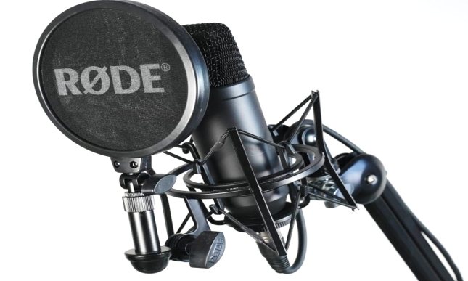
A condenser microphone uses a capacitor to convert sound into an electrical signal. These mics are typically used in studio recordings because they have a higher quality sound than dynamic microphones and are often best for vocals and higher frequencies.

4.2.2 What Is A Dynamic Microphone?
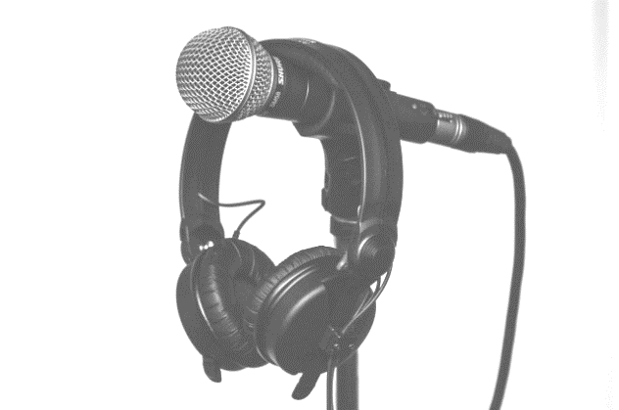
Another type of microphone to consider is a dynamic microphone. They are more rugged and can handle high volumes, making them ideal for live performances.
Some popular dynamic microphones are the Shure SM58, Shure SM7B, the Sennheiser e935, and the Audix i5.
Dynamic microphones are less sensitive than condenser microphones, meaning they can handle more sound without distorting the audio. This also makes them better for capturing louder sounds.

4.2.3 What Is A Ribbon Microphone?
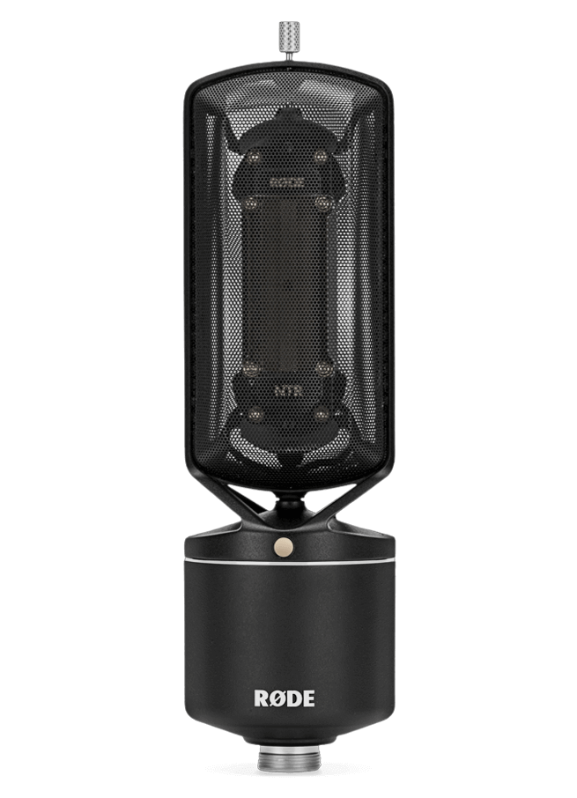
Ribbon microphones are less common but offer a unique sound that can be well-suited for certain genres of music. They use a ribbon of metal to convert vibrations into an electrical signal, and they typically have a figure-8 pattern.
There are a few different types of ribbon microphones available on the market.
Ribbon Kmicrophones are not as common as condenser or dynamic mics. However, they often produce a mellower sound than other microphone types, making them well-suited for certain genres of music. They can also be used for studio recordings for capturing the sound of vocals and acoustic guitars or capturing the sound of a choir or band.

CHAPTER FIVE

CHALLENGES ENCOUNTERED, CONCLUSION AND RECOMMENDATION

5.1 Challenges Encountered
There is nothing on earth that is free on challenges, life itself is full with different kinds of challenges and despite the fact that Radio Lagos staff at news department are not friendly, because of the last spot of student that did then SIWES programme at Radio Lagos, better still I tried my best to cope and cooperate with their activity.
Firstly, there are many insults been placed on its by some of the staff in the organization. In the first week of observing the industrial training in new room where I was posted, some of the staff in the newsroom do ask us if we have data in our mobile phone and if not, they will see us as an incompetent in the field or an unserious element. And at that time, they belittle us by not treating us anything.
Another challenges was that, there were many students from different school doing their SIWES programme also. And we neded to shift period for each other which they divided us into groups.

5.2 Conclusion
Frankly speaking, I will say that during my four (4) months in the SIWES programme at Radio Lagos that I gained a lot of experience, which are:
- I can now understand the different between the theoretical and practical aspects of Mass Communication and other related courses.
- I gained how to present news, edit news, search for news, interrogate people and also know the differences in microphones and other studio gadgets.

5.2 Recommendation
SIWES is an important program that needs to be encouraged because, it provides from for practical knowledge to students in their areas of discipline.
It is important to ensure that student take the programme seriously and the government is to ensure strict supervision and monitoring of both the student and the school and the industry based supervision for better results.

