
DEDICATION
I dedicate this work to the Almighty Allah who had made this training a success for me. I thank all my well-wishers for their support and words of encouragement they offered to me during my training, most especially the entire team of Kwara State Ministry of works for accepting me whole heartedly. May God bless you all, Amen.

ACKNOWLEDGMENT
I am grateful to Almighty Allah for His abundant Grace and guidance throughout m industrial training. It would have been impossible without many people. I remain grateful to my industry-based supervisor, for his untiring effort, taking his time to give me a clear explanation of the things that were difficult for me.
His patience and accurate guidance gave me the impetus to complete this training. I also appreciate my institution lecturer in the department of Civil Engineering.
My appreciation also goes to my parents, uncles, friends and fellow students for their supports and love towards making this task a success.

PREFACE
This booklet contains the details of activities and experience undergone during my four (4) months Student Industrial Work Experience Scheme, also known as SIWES which was held at of KWARA STATE MINISTRY OF WORKS The experience and knowledge acquired during the programme was written in this report which is basically on construction, which is also essential for the fulfilment of National Certificate. It has exposed me to the use of various tools whose operation techniques work only but theoretically explained in the lecture room. I thank the National Board of Technical Education for the introduction of the Student Industrial Work Experience Scheme (SIWES) programmed to the school of learning.

CHAPTER ONE

1.0 INTRODUCTION

1.1 BACKGROUND OF SIWES
Students’ Industrial Work-experience Scheme (SIWES) is one of the Industrial Training Fund (ITF) programme which was introduced in 1974 due to the inability of engineering and technology students in Nigeria universities and polytechnics to meet the practical aspects of their training. That is, the needs to enable students match their theoretical school knowledge with the practical aspect of their training in industry. The Training lasts for six months. According to Ekpenyong (2011), one of the principles underlying any industrial work experience scheme for students in institutions of learning is the desire to marry the practical with the theoretical learning which characterizes conventional classroom situations with a view to striking a balance between theory and practice. The author stressed further that it was in realization of this that the ITF when it was established, set out to study the extent to which the theoretical knowledge that students in engineering technology and other allied fields in Nigerian institutions offering technology based courses related to the kind of work experience expected of them by employers.

1.1.2 BRIEF HISTORY OF SIWES
In recognition of the shortcomings and weakness in the formation of SET graduates, particularly with respect to acquisition of relevant production skills (RPSs), the Industrial Training Fund (which was itself established in 1971 by decree 47) initiated the Students’ Industrial Work experience Scheme (SIWES) in 1973. The scheme was designed to expose students to the industrial environment and enable them develop occupational competencies so that they can readily contribute their quota to national economic and technological development after graduation. Consequently, SIWES is a planned and structured programme based on stated and specific career objectives which are geared toward developing the occupational competencies of participants. In spite of the challenges faced by SIWES in the four decades of its existence, the Scheme has not only raised consciousness and increased awareness about the need for training of SET students, but has also helped in the formation of skilled and competent indigenous manpower which has been manning and managing the technological resources and industrial sectors of the economy. Participation in SIWES has become a necessary condition for the award of degrees and diplomas to SET students graduating from higher institutions in Nigeria. It is therefore, not in doubt that SIWES is a veritable means or tool for National Economic Development. The main thrust of ITF programmes and services is to stimulate human performance, improve productivity, and induce valueadded production in industry and commerce. Through its SIWES and Vocational and Apprentice Training Programmes, the Fund also builds capacity for graduates and youth self-employment, in the context of Small Scale Industrialization, in the economy.

1.1.3 VISION STATEMENT
To be the prime skills training development organization in Nigeria and one of the best in the world.

1.1.4 MISSION STATEMENT
To set and regulate standards and offer direct training intervention in industrial and commercial skills training and development, using a corps of highly competent professional staff, modern techniques and technology.

1.2 AIM OF SIWES
The effort is aimed at helping/training students in the Nigerian tertiary institutions the practical aspect of their field of study by exposing students to machines and equipment, professional work methods and ways of safeguarding the work areas and workers in Industries and other organizations.
- It provides students with the opportunities to apply their educational knowledge in real work and industrial situations, there by bridging the gap between theory and practice.
- The programme teaches the students on how to interact effectively with other workers and supervisors under various conditions in the organization.

1.2.2 IMPORTANCE OF SIWES TO CIVIL ENGINEERING
- It exposes students to more practical work methods and techniques in civil engineering.
- It provides students in civil engineering with an opportunity to apply their theoretical knowledge to real life situations.
CHAPTER TWO

2.0 THEORETICAL FRAMEWORK

2.1 CIVIL ENGINEERING
Civil engineering is a professional engineering discipline that deals with the design, construction, and maintenance of the physical and naturally built environment, including works like roads, bridges, canals, dams, and buildings. Civil engineering is the second-oldest engineering discipline after military engineering, and it is defined to distinguish non-military engineering from military engineering. It is traditionally broken into several sub-disciplines including architectural engineering, environmental engineering, engineering, control, structural engineering, earthquake engineering, transportation engineering, construction surveying, and construction engineering, etc. Civil engineering takes place in the public sector from municipal through to national governments, and in the private sector from individual homeowners through to international companies.

2.1.2 TRANSPORTATION ENGINEERING SYSTEM
Highway engineering is one of the most important branches of transportation system.
(Gupta 2009), in his opinion defines Highway Engineering as the art of planning, design, construction and maintenance of road system. While Rogers (2003) defines Highway Engineering as the application of scientific principle to the planning, design, maintenance of a highway project or system of projects. We conclude that Highway Engineering is the science and technology dealing with road engineering. However, the term road or road ways was called Highway, which refers to a road way constructed on small embankments a little above the general ground level to avoid drainage and maintenance problems.

2.1.4 SIGNIFICANCE OF HIGHWAY
Highways are vitally important to a country’s economic development. The construction of a high quality road network directly increases a nation’s economic output by reducing journey time and cost, making a region more attractive economically. The actual construction process will have the added effect of stimulating the construction market.
- Trunk A Roads: - This form the major network around which other categories of roads are built. They run through the length and breadth of the country. They connect ports, capitals of various states and also provide international links with neighboring countries.
- Trunk B Roads: - These are the highway within the states, as they connect important towns and cities of the states. They also connect the cities of the states to federal highways end serve as the main arteries of traffic to and fro meet district roads.
- Trunk C Roads: - These are also called local government roads. They are constructed with nearly the same specifications as those of the state highways. They are intended to connect areas of production and market with state highways and railways.

2.2 COMPONENTS OF ROAD STRUCTURE
Road Structure Cross Section is composed of the following components:
- Crown
- Camber
- Surface/Wearing Course
- Kerbs
- Shoulder
- Drainage
- Base Course
- Sub-base
- Formation level
- Sub Grade
2.2.1 ROAD AND WATER
The greatest threat to an asphalt road is water. When a road is laid down, it flexes and moves slightly to accommodate changes in temperature and load. All this flexing eventually leads to cracking. Water penetrates those cracks and through processes like freezing, causes damage to the roadway.

2.2.3 ROADWAY EXCAVATION
The work consist of all the required excavation within the limits of the right of way unless covered by other Sections of these Specifications. This shall include excavation of side ditches, where required, the removal, hauling and proper utilisation or disposal of all excavated materials and shaping of excavation and preparation of exposed surfaces of excavation on the entire length of the roadway, in accordance with these Specifications and to the lines, levels, grades, dimensions and cross sections shown on the Drawings or as required by the Engineer. The works specified shall also include operations in part widths and small areas of roadway where directed by the Engineer without any extra cost to the Employer. Roadway excavation shall include the following:
- All excavation indicated on the Drawings within the limits of the cross sections and excavation of all materials for side roads and intersections.
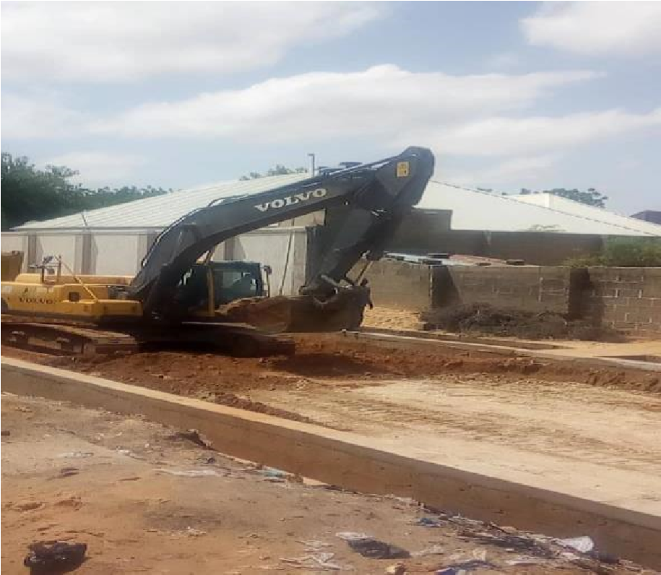

Roadway Excavation

2.2.4 FILLING AND GRADING
Laterite is filled into the cut portion of the road and compacted using sheep foot roller and smooth wheel roller. Laterite is a deep brown soil of cellular structure, easy to excavate, but gets hardened on exposure to air owing to the formation of hydrated iron oxides. The CBR (California Bearing ration) ratio of the laterite on our site is 85%. The laterite is brought form the borrow pit, the borrow pit is a hole dug to a certain depth where laterite of good CBR ratio can be obtained. There are three borrow pits where the

2.3 SPRAYING OF WATER
Water is sprayed on the laterite to give it the required moisture just enough to allow maximum compaction. Also water is sprayed after compaction of laterite when there will be another layer of laterite to be laid on the current layer to create bond between the two layers.
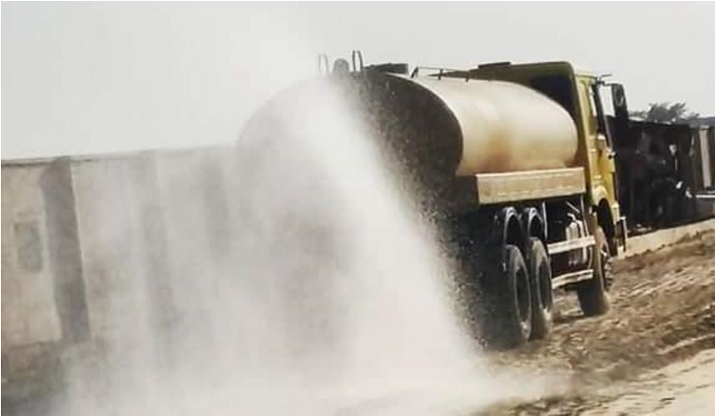
spraying of water by the water bauxer

2.3.2 PRIMING
This is the spraying of MC1 (Medium curing) on the surface of the prepared base course material e.g. laterite or stone base. After spraying the MC1, it should be allowed for about 1-hourto allow it penetrate into the base course material. It is recommended to spray 0.9 l/m2, 1.o l/m2 or 1.1l/m2. MC1 is one of the amongst the product of cutback bitumen. After applying MC1, it should be allowed to cure for a minimum of 48 to 72 hours before asphalt is placed, with no rain in the forecast. The temperature of MC1 during the application process should not be less than 1500C.The main purpose of priming is to;
- To coat and bond loose material particles on the surface of the base,
- To harden or toughen the base surface to provide a work platform for construction equipment,
- To plug capillary voids in the base course surface to prevent migration of moisture,
- To provide adhesion between the base course and the succeeding asphalt course. For the prime coat to be successful, it must be able to penetrate into the base course at least ½inches.

2.3.3 BLINDING
After application of MC1 (prime coat) to the base and the asphalt is not readily available from the Marini, blinding is done. This is the application of river sand OR Quarry dust after priming to;
- Remove the air voids in the MC1,
- To allow vehicles to use the roads immediately after priming and blinding,
- To prevent the MC1 from sticking to the tyres of vehicles thereby cleaning it away from the applied surface.
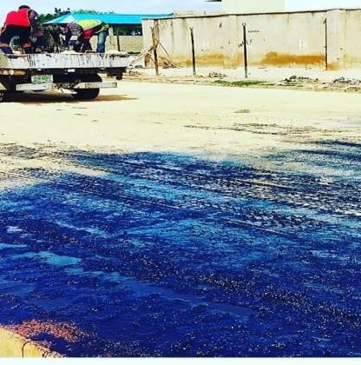
Blinding of the primed surface using quarry dust

2.3.4 ASPHALT OVERLAYING
An asphalt overlaying is simply the process of installing a new layer of hot mix asphalt directly over the existing asphalt on roads. The main aim of overlay is to add structural support to the existing pavement. Overlaying existing asphalt is a good solution when the existing road is still in decent shape and the existing elevations will allow proper drainage without milling of the entire surface.

CHAPTER THREE

3.0 ASPHALT PLANT
This chapter discussed our visit to the drum mixing asphalt plant located along Sango Road. The main purpose of the asphalt plant is to produce Asphalt. We were shown the machines involved in the production of asphalt and the procedure involved was thoroughly explained to us. Some of the equipment used was:
- Hopper: there are about four hoppers at the Marini namely: hopper 1, hopper 2, hopper 3 and hopper 4. The hopper has a conveyor belt used for transporting the aggregates to another section of the production process. The aggregates fall onto the conveyor by gravity.
- Dryer: used to dry moist aggregate that enters it. Its temperature ranges between 1500c and 1700c.
- Bunner fan/Air Blower: this helps in pumping air into the dryer. It also sprays diesel to the dryer and flames it to create fire.
- Mixers: this is used to mixes the aggregates with bitumen by the use of Paddles.
Themixture is then dumped into a bucket.
- Bitumen Storage Tank: this is used for heating the bitumen.

MATERIALS
- Aggregates: the main aggregates used in mixing asphalt at the Marini are⁄ inch, ⁄ inch, inch, Quarry dust, river sand and Bitumen.
- Bitumen: Production of Bitumen: Bitumen is the residue or by-product when the crude petroleum is refined. A wide variety of refinery processes, such as the straight distillation process, solvent extraction process etc. may be used to produce bitumen of different consistency and other desirable properties. Depending on the sources and characteristics of the crude oils and on the properties of bitumen required, more than one processing method may be employed.
3.2 FORMS OF BITUMEN

- Cutback bitumen
Normal practice is to heat bitumen to reduce its viscosity. In some situations preference is given to use liquid binders such as cutback bitumen. In cutback bitumen suitable solvent is used to lower the viscosity of the bitumen. From the environmental point of view also cutback bitumen is preferred. The solvent from the bituminous material will evaporate and the bitumen will bind the aggregate.

3.3 TYPES OF BITUMEN
- Asphalt: This is the product gotten from the mixture of aggregates, river sand and bitumen. The mixture is done in percentage based on the required quality of asphalt needed. E.g. 33% of ½ inch, 33% of 3/8 inch, 36% of ¾ inch, 30% of river sand and 4.0% of bitumen.
Basically, when the entire aggregate particles (including the large aggregate particles) are coated with asphalt, the mix is said to be properly mixed.
- Oil: This is used together with the heater to heat the bitumen and it also helps in preventing the bitumen from flaming during the heating process.

CHAPTER FOUR

4.0 DRAINAGE SYSTEM
One of the most important aspects of the design of a road is the provision made for protecting the road from surface water or ground water. If water is allowed to enter the structure of the road, the pavement will be weakened and it will be much more susceptible to damage by traffic. Water can enter the road as a result of rain penetrating the surface or as a result of the infiltration of ground water.

4.1 SIDE DRAINS
The cost of side drains will normally be calculated as part of the cost of earthworks Side drains should be flat-bottomed if they are to be maintained by hand or 'v'-shaped if they are to be maintained by machine. Wide flat drains, known as 'meadow drains', can be used with advantage if there is room. The longitudinal gradient of side drains should always exceed 0.5 per cent to reduce the possibility of silting up. In hilly terrain, providing side drains with the same gradient as the road may result in water velocities that are too high. It may therefore be necessary to reduce the maximum gradient to an acceptable level by the provision of shallow dams or scour checks. These are often constructed of masonry, but can also be constructed in concrete or even timber. Wide drains are preferred to reduce the velocity and so minimise erosion. The provision of turnouts or cut-off drains should also be considered to reduce or control the amount of water in the side drains. Costing may need to take account of these and the need to line
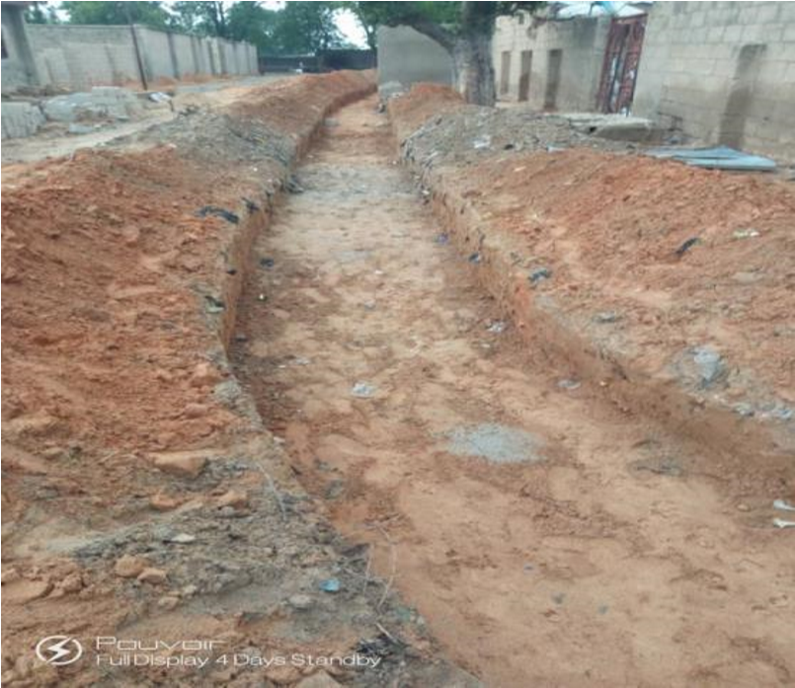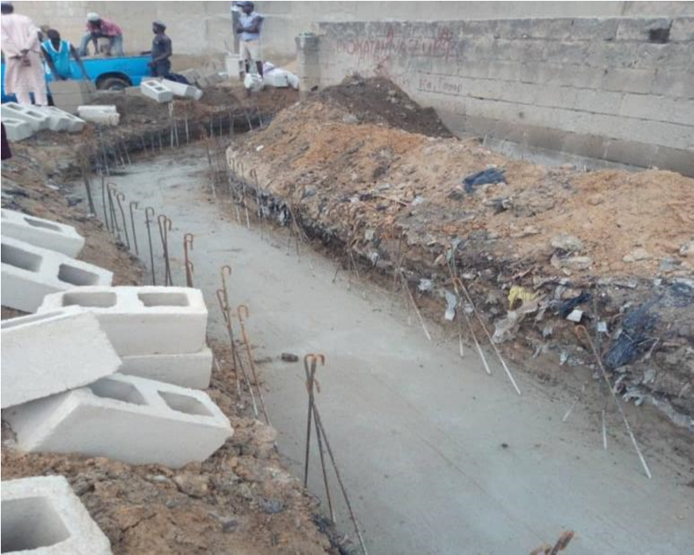
drains with masonr
y or concrete in highly erodible soils.

Excavated Drainage trench Plate

Blinding and concrete base

CHAPTER FIVE

5.0 SUMMARY
I observed that Civil Engineers use their conceptual design method to build a structure for safety, stability, economy and durability. But at the same time supervising the project closely to make sure it is being executed exactly the way the design was and plan. they also accept material base on what the specification comes from the client to avoid using materials of poor quality that may alter their design calculation, for this may result in the failure of their structure.

5.1 CONCLUSION
This report has been able to x-ray an account of the entire work – experience garnered by me at the Jebba Road Maintenance Agency (BORMA) for the past 4 months, I had the opportunity to see practical application of what I learned in my classes that comprises of use of earth moving equipment’s use in excavation, grading earth spreading and piling, soil watering, compaction, spreading of MC1 , asphalt laying. In structural work how scaffolding places.

5.2 RECOMMENDATION
In view of the relevance of the SIWES program, it is important that it is sustained by the government through the Industrial Training Fund (ITF) as it exposes the student to work tools, facilities, and equipment that may not be available in their respective institutions in relation to their course of study. To this end, I recommend that the following under-listed points should be implemented:
- Students’ Industrial Works Experience Scheme (SIWES) needs to be strengthened by all concerned stakeholder in order for its objectives to be fully realized.
- Regular monthly allowances for students on attachment should be paid promptly.

