

A
TECHNICAL REPORT ON INDUSTRIAL ATTACHMENT FOR STUDENT INDUSTIRAL WORK EXPERIENCE SCHEME (SIWES)
HELD AT
LAGOS STATE PHYSICAL PLANNING PERMIT AUTHORITY.
(LASPPPA)

BY

BELLO ROFIAT OMOTOYOSI
ND/23/ACC/FT/0029

DEPARTMENT OF ACCOUNTANCY
INSTITUTE OF FINANCE AND MANAGEMENT STUDIES
KWARA STATE POLYTECHNIC, ILORIN.

IN PARTIAL FULFILLMENT OF THE REQUIREMENT FOR THE AWARD IN NATIONAL DIPLOMA CERTIFICATE IN ACCOUNTANCY.

DECEMBER 2024

CERTIFICATION

This is to certify that this report is original to the author, BELLO ROFIAT OMOTOYOSI of matric number ND/23/ACC/FT/0029 of the Department of Accountancy, Institute of Finance and Management Studies, Kwara State Polytechnic, Ilorin and was supervised accordingly by;

………………………….. …………………………...
SIWES COORDINATOR DATE & SIGNATURE

……………………….. ..………………………..
SIWES SUPERVISOR DATE & SIGNATURE

…………………………… …………………………
HEAD OF DEPARTMENT DATE & SIGNATURE

PREFACE

This is a report of four months industrial training which was done as part of the requirement needed for the award of National Diploma Certificate which was embarked upon by the technical student after their first year of stay in school.
It is also done to enable the student’s to be exposed the practical aspect of their course of study and write down what he/she has gained during the training.
The program is aimed at correcting the incompetence in the school leaving the scientific and technical in country.

DEDICATION
This report is dedicated to the Almighty God, the Beneficent, the merciful, the cherisher of the universe, the uncreated creator of all creatures and the most knowledgeable who seek knowledge just from himself for giving me the opportunity, privilege an understanding to participate in the student industrial work experience scheme (SIWES).
I also dedicate this report to my amiable parent Mr. and Mrs. BELLO for their financial support during the course of the program. May ALLAH continue to bless them (AMIN).

TABLE OF CONTENT
Title
Preface
Dedication
Acknowledgement
Table content
CHAPTER ONE
  - Introduction
  - Background
  - Objective of SIWES
CHAPTER TWO
2.0 Brief History of the Establishment
2.1 Organizational structure
2.2 The various Department/Units in the Establishment
CHAPTER THREE & FOUR
3.0 Experience gained during the SIWES program
3.1 Interactive relationship within the organization
CHAPTER FIVE
4.0 Summary
4.1 Recommendations
4.1 Conclusion

CHAPTER ONE
INTRODUCTION OF SIWES
The Students Industrial Work Experience Scheme (SIWES) for the 2023 /2024 academic session kicked off the month of in August 2023 and was concluded (4) months in the month of December, 2024. The industrial attachment program is solely aimed at improving in working skills of students in tertiary institutions as well as effecting, learning, participation and observation into proactive invariable fields with respect to grasp very useful practical knowledge which not only makes them employable but also aids in the perfect understanding of theories and operation in their different profession. It is a corporative industrial internship program that involves industries, the Federal Government of Nigeria, Industrial Training Fund (ITF), and Nigeria Universities Commission (NUC). The program is of very high importance considering the lack of adequate practical equipment for learning in most Nigeria tertiary institutions and itself proven as it has been part and parcel of the countries system of education for over 28 years.

AIMS OF SIWES
The Industrial Training Funds Policy document Number 1 of 1973, which established SIWES outline the objective of the scheme. The objectives are to:-
- To provide an avenue for Students in Nigerian Tertiary Institutions to acquire Industrial Skills and Experience during their course of Study.
- To prepare Students for the work they are likely to meet after graduation.
- To expose students to work methods and techniques of handling equipment and machinery that may not be available in their Institutions.
- To allow the transition phase from school to the world of working environment easier and facilitate students contact for later job placement.
- To provide students with an opportunity to apply theoretical knowledge in real work situation there by bridging the gap between theory and practice.

Historical Background of SIWES
SIWES (Student Industrial Work Experience Scheme) was set up by the federal government of Nigeria to close the gap between theoretical learning and practical work experience. It was first kicked off and funded by the Industrial Training Fund ITF) in 1973 the scheme has gone through series of reforms. Its management has changed hands from the ITF in 1978 to various regulatory agencies such as National Universities (NUC) and National Board for Technical Education (NBTE) and board to the ITF again in 1985. These are the major stake holders in SIWES. Consequently, SIWES program was introduced into the curriculum of tertiary institution in the country as far back as 1974 with 948 students from two institution of higher earning and the scheme has over the year contributed immensely to the personal development and motivation of their academic programs and what knowledge and skill will be expected of them on professional practice after graduation.

DEFINITION OF TERMS
- SIWES: Student Industrial Work Experience Scheme. The Scheme was established by the Industrial Training Fund (ITF) in 1973 to solve the problem of lack of adequate preparatory for employment in Industrial by Nigeria graduates of tertiary Institution.
- Industrial Training Fund: The fund was established in 1971 and has operated consistently and painstakingly within the context of its.
3. CONSOLE: It is considered as the center piece or the very heart of Radio station Hasan (2013) in Adoyi (2020:54) Says, professionally, a mixing console is an electronic device for combining (Mixing) ,routing, and changing the level, tone and/ or dynamics of audio signals

CHAPTER TWO
DEPARTMENTS IN LAGOS STATE PHYSICAL PLANNING PERMIT AUTHORITY (LASPPPA) AND THEIR FUNCTIONS

​The Lagos State Physical Planning Permit Authority (LASPPPA), established under the Lagos State Urban and Regional Planning and Development Law of 2010, operates as a semi-autonomous agency within the Ministry of Physical Planning and Urban Development. While specific departmental structures within LASPPPA are not publicly detailed, the Authority's core functions encompass several key areas:​

Core Functional Areas of LASPPPA

Planning Permit Processing: Overseeing the assessment and issuance of planning permits in accordance with state regulations and approved development plans.​

Compliance Monitoring: Ensuring that developments adhere to physical planning regulations and approved plans.​

District and Local Planning Offices: Establishing and managing district and local planning permit offices to facilitate decentralized service delivery.​

Development Plan Preparation: Preparing and periodically reviewing various categories of physical development plans, including district, development guide, town, and local plans.​

Record Keeping and Publication: Maintaining records of planning permit applications and publishing relevant information in the State Official Gazette.​

Technical Report Evaluation: Evaluating physical planning technical reports in consultation with the Ministry.​

Brief History of Lagos State Physical Planning Permit Authority (LASPPPA)
The Lagos State Physical Planning Permit Authority (LASPPPA) was established as part of the Lagos State Government’s efforts to regulate physical development and ensure sustainable urban planning within the state. Its creation is rooted in the Lagos State Urban and Regional Planning and Development Law of 2010, which consolidated various planning laws and streamlined building and planning permit processes.
Prior to LASPPPA’s formation, building permit functions were handled by the Development Permit Department (DPD) under the Ministry of Physical Planning and Urban Development. However, to improve efficiency, transparency, and accountability, LASPPPA was created as a semi-autonomous agency to oversee the issuance of planning permits and ensure compliance with building regulations.
Since its inception, LASPPPA has played a crucial role in:
- Processing planning permit applications.
- Ensuring developments comply with approved layouts and zoning regulations.
- Curbing illegal developments.
- Promoting orderly and sustainable urban growth in Lagos State.
The authority operates through district offices across the state to bring services closer to the public and has increasingly integrated technology into its operations to enhance service delivery.

STRUCTURE OF LASPPPA
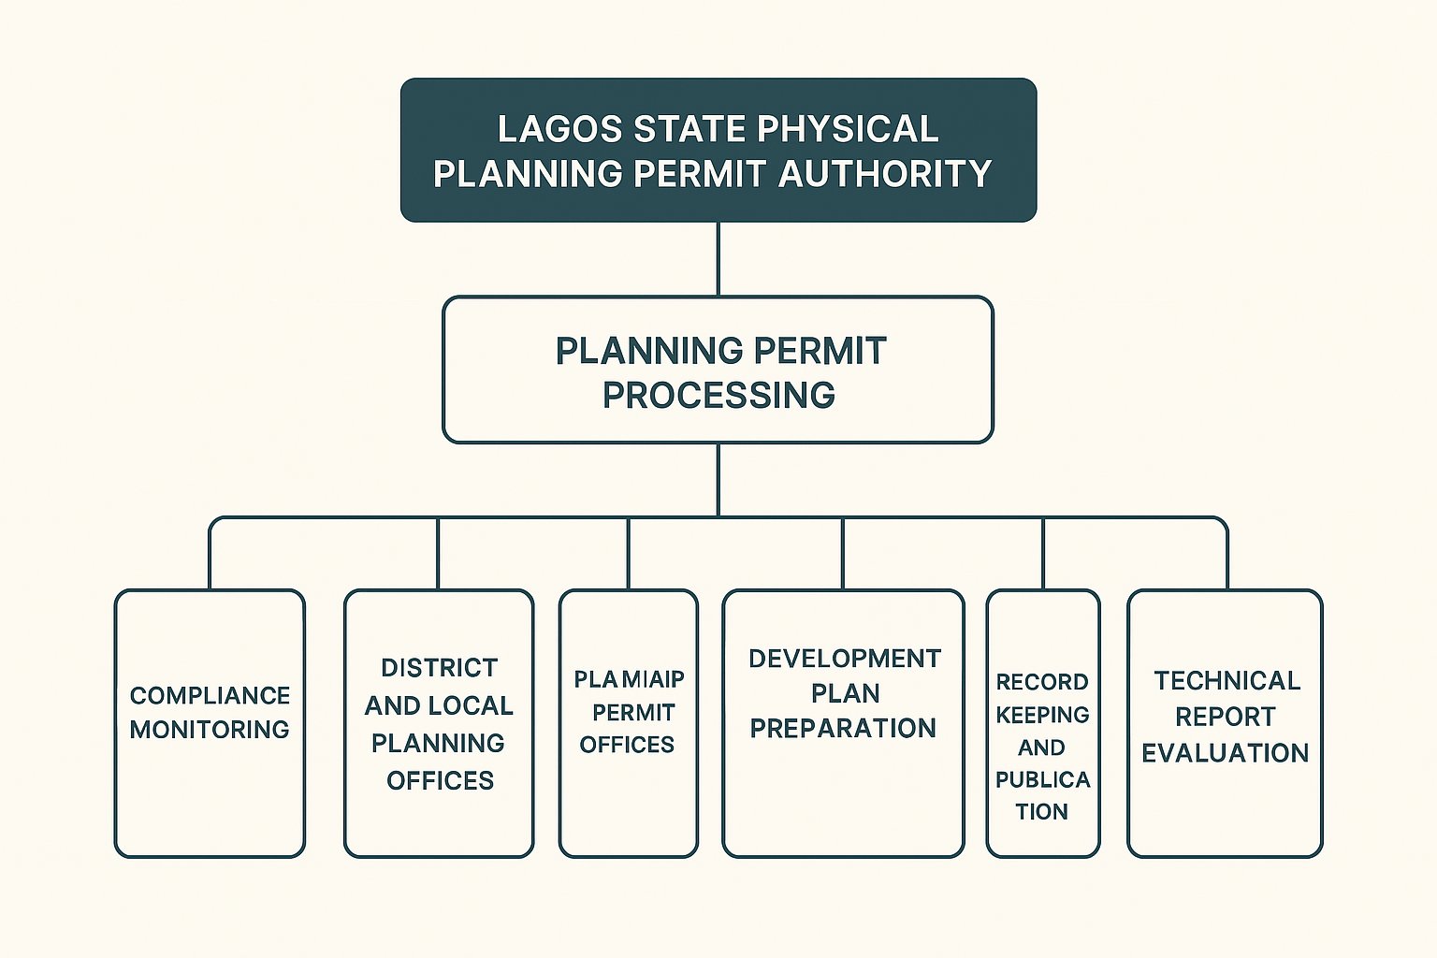

CHAPTER THREE & FOUR
SIWES EXPERIENCE AT LAGOS STATE PHYSICAL PLANNING PERMIT AUTHORITY (LASPPPA)
The Student Industrial Work Experience Scheme (SIWES) is an essential part of the mass communication curriculum, designed to expose students to real-world media operations. This report details my experience at LAGOS STATE PHYSICAL PLANNING PERMIT AUTHORITY (LASPPPA)

Orientation and introduction to the accounts department
On the first day of my industrial training, the Admin Officer welcomed me to the organization and introduced me to the staff in the Accounts Department. This introduction gave me the opportunity to understand the structure of the department and meet the personnel I would be working with. I was also briefed on the organization's mission, office etiquette, communication procedures, and the importance of punctuality, discipline, and confidentiality. This orientation helped me to quickly adapt to the work environment and understand the responsibilities expected of me.
Training on File Sharing
Shortly after my orientation, I was trained on how files are shared within the organization. This involved learning how to receive files from other departments and properly log them in the inward register. I was also taught how to send files out with the correct documentation and ensure that they are recorded in the outward register. This process helped me understand the importance of tracking official documents, maintaining accountability, and ensuring smooth communication between departments.
Proper Way to Document and File
I was trained on the proper method of documenting files, which involves arranging documents in an orderly and retrievable format. Each file was labeled clearly with the appropriate title, reference number, and date. I also learned to organize files chronologically or by department type, depending on the content. Understanding this process improved my ability to manage physical files and maintain a clean, organized filing system.
Understanding the Use of the Outward Register
The outward register is a physical logbook used to record all files or documents that are leaving the department. I was taught how to accurately record each entry by writing down the file name, recipient department or person, date of dispatch, and the sender’s signature. This activity emphasized the need for accurate documentation in tracking official correspondence and avoiding misplaced documents.
Participation in Team Meetings
During my training, I was allowed to attend team meetings within the Accounts Department. In these meetings, financial updates, work progress, and challenges were discussed among the staff. By observing the meeting proceedings, I learned how communication and coordination are essential in achieving department goals. I also saw how decisions were made collectively and how each team member's role contributes to the smooth running of the department.
Logging Incoming Items and Updating the Bin Card
I was taught how to log incoming stock or items into a bin card, which is a stock control tool used in accounting and stores management. The bin card records details such as the item description, quantity received, and the balance in stock. Learning this helped me understand inventory management, as well as how to reconcile physical stock with written records to prevent fraud or discrepancies.
Orientation on the Sensitivity of the Accounts Department
The Accounts Department handles sensitive financial information and transactions. I was given an orientation on the importance of confidentiality, accuracy, and integrity in all tasks. I was made to understand that any error or leakage of information could affect the organization's financial stability. This orientation instilled in me a strong sense of responsibility and professionalism.
File Arrangement
As part of my duties, I assisted in arranging files in both cabinets and shelves. The files were arranged based on categories such as expense records, receipts, memos, and approval documents. I ensured that each document was placed in its correct location and aligned according to the labeling system. This task enhanced my organization and attention-to-detail skills.
Receipt Validation
I was guided through the process of validating receipts, which involves checking that each receipt corresponds with the goods or services rendered and that it has the necessary authorization. I compared the receipts with attached payment vouchers and approval memos. This process helped me develop analytical and verification skills important in auditing and accounting.
Filing After Validation
Once a receipt or document had been validated, I was responsible for filing it back into the appropriate folder or cabinet. I ensured that only verified and approved documents were filed, which helps in keeping the financial records accurate and reliable. This responsibility taught me the importance of maintaining an up-to-date and well-audited filing system.

Skills Acquired During SIWES
- File Management Skills
  - Proper filing, arrangement, and retrieval of accounting documents.
- Communication and Teamwork
  - Improved ability to work in a team environment and participate effectively in meetings.
- Document Handling and Filing Procedures
  - Knowledge of inward and outward register use, file validation, and document control.
- Basic Accounting and Record-Keeping
  - Understanding of how to log transactions and stock entries using bin cards.
- Attention to Detail
  - Accuracy in checking receipts and validating financial documents.
- Confidentiality and Professionalism
  - Awareness of the sensitivity of accounting records and the need for discretion.
- Organizational and Time Management Skills
  - Ability to manage tasks efficiently within a structured office environment.
- Office Ethics and Compliance
  - Understanding of organizational rules, professional behavior, and workplace discipline.
- Analytical Thinking
  - Ability to cross-check documents and identify discrepancies during validation.
- Clerical and Administrative Support
  - Exposure to day-to-day clerical duties such as document dispatching and receiving.

CHAPTER FIVE
SUMMARY, RECOMMENDATION AND CONCLUSION
My experience at LAGOS STATE PHYSICAL PLANNING PERMIT AUTHORITY (LASPPPA), was a wonderful experience and I have come to say that studying Mass Communication without practical, could be regarded as a waste of time, resources and energy because the training has helped me a lot.

RECOMMENDATION
I recommend that the Student Industrial Work Experience Scheme (SIWES) be continually supported and improved by both institutions and organizations. It offers students a unique opportunity to apply theoretical knowledge in a practical setting. Organizations should also continue to provide guidance, mentorship, and hands-on tasks that help students gain relevant skills. Additionally, institutions should ensure regular monitoring and feedback to enhance the learning experience.

CONCLUSION
My SIWES experience at the organization was both enlightening and transformative. It provided me with practical exposure to real-world accounting procedures and office operations beyond what I had learned in the classroom. I gained valuable skills in document management, file sharing, receipt validation, and the proper use of registers such as the bin card and outward register.

