

TECHNICAL REPORT ON THE STUDENTS’ INDUSTRIAL WORK EXPERIENCE SCHEME (SIWES)
HELD AT
GERIN FM 95.5 ILORIN
AbdulSalam plaza, No 1B Ahmad pategi Road, off Ahmadu Bello way, G.R.A Ilorin, Kwara State.

PRESENTED BY
BELLO AL-AMEEN OLANREWAJU
ND/23/MAC/PT/0147

SUBMITTED TO:
THE DEPARTMENT OF MASS COMMUNICATION
KWARA STATE POLYTECHNIC
INSTITUTE OF INFORMATION AND COMMUNICATION TECHNOLOGY (IICT)
P.M.B. 1375 ILORIN, KWARA STATE.
IN PARTIAL FULFILMENT FOR THE AWARD OF NATIONAL DIPLOMA (ND) IN MASS COMMUNICATION.

5TH AUGUST TO 11TH NOVEMBER 2024

DEDICATION
I dedicate this report to God Almighty for His Unlimited Grace, Consistent Love, Immeasurable Faithfulness, and for sparing my life throughout the period of my SIWES programme.
Secondly, I dedicate it to my parents Mr. &Mrs.Bello for their undiminished support and unquantifiable assistance throughout the whole exercise and beyond.

ACKNOWLEDGEMENTS
First and foremost, my deepest acknowledgement goes to God Almighty for His overwhelming love upon my life throughout the Scheme.
I appreciate my parents and friends for their constant help and support.
My special thanks go to my H.O.D and lecturers for inspiring me to be a good broadcaster.
Furthermore, I express my appreciation to, general manager of GerinFm 95.5, for the chance to complete my four month student industrial work experience scheme
I also appreciate all staff members of GerinFm 95.5 especially my supervisor who gave out his tight schedule to attend to men.

TABLE OF CONTENTS
Title……………………………………………………………………………………….i
Dedication…………………………………………………………………………………ii
Acknowledgement……………………………………………………………………….iii
Table of Contents………………………………………………………………………..iv
CHAPTER ONE
- Introduction to SIWES…………………………………………………………......1
  - Aim and objective of SIWES……………………………………………1-2
  - Radio Station rules and safety procedure………………………………….2
  - Brief history of about the organization…………………………………..2-3
  - Organization Chart………………………………………….......……….3
CHAPTER TWO
- Radio broadcasting equipment with their function……………………………...4-8
  - GerinFm 95.5 department and functions…………….………………………...9-11
CHAPTER THREE
- Student specific involvement in various section………………………………….12
  - News and current affairs department………………………………………….12-13
  - Internal structure of news and current affairs department………………………..13
CHAPTER FOUR
4.0 Experienced gained at GerinFm 95.5………………………………………….14
CHAPTER FIVE
5.0 Conclusion………………………………………………………………………..15
5.1 Recommendation…………………………………………………………………15
CHAPTER ONE
- INTRODUCTION TO SIWES
In 1974, the federal government of Nigeria introduced the National policy on industrial training called the student industrial work experience scheme (SIWES).
This program is under the umbrella of the ministry of education through the industrial training fund (ITF), was design to help student acquire the necessary practice education experience in their fields of study and other related professions.
The program was established basically to impact elaborate practical understanding to student with respect to their various discipline. It is also intended that the student through a process of relation to academic knowledge and practical industrial application would understand the underlying principle and become better focused and acquire the practical application toward excellence in his/her discipline.
The student are expected to develop occupational competence that would facilitate their fitting into the world of work after graduation.
  - AIM AND OBJECTIVE OF SIWES
The student industrial work experience scheme (SIWES) has it major aims and objective of establishment. The following are the aim and objective of the program.
- To provide student an opportunity to apply their theoretical knowledge in really work situation, thereby bridging the gap between theory and practical.
- To expose student to working method and techniques in handing equipment and machineries that is not available in their various institutions.
- To make the transition from the institution to the world of work easier and thus enhance student contact for later job placement.
- To prepare student in skill development by participation in field works, particularly in writing in their field of works.
- Enhancing student contact with potential employers while on training.
  - Radio station Rules and Safety Procedures
- Report any injuries to the teacher immediately
- Learn the location of the nearest fire extinguisher
- Never move anything heavy by yourself. Some of the equipment in the station is very large and heavy. Avoid back strain or other bodily harm by working with partner.
- Keep all food and drink out of all studios and thee radio office area.
- Turn off (or airplane mode) all cell phone and other electronic communication device before entering any radio broadcast or production studio.
- Clean up and straighten all areas after use.
- Do not touch anything without explicit instruction
  - Brief history about the organization
The idea of establishing a radio station GerinFm 95.5 came from the concern and passion of some Ilorin patriots for the development of the Emirate Community. Ilorin being the headquarters of both the Ilorin emirate and kwara state; has growm from a pre-colonial town into an expanding metropolis.
Over the years, GerinFm 95.5 has grown to become a popular radio station in ilorin broadcasting a mix of music, news, and shows. The station is run by a team of dedicated volunteers who are passionate about serving the local community and providing a diverse range of programming.
GerinFm 95.5 has also been involved in various community initiatives and events, such as fundraising drives, charity events, and broadcasting live from local festivals and fairs. The station continues to be a valuable resource for residents in Ilorin and the surrounding areas, bringing people together and keeping them informed about local issues and event.
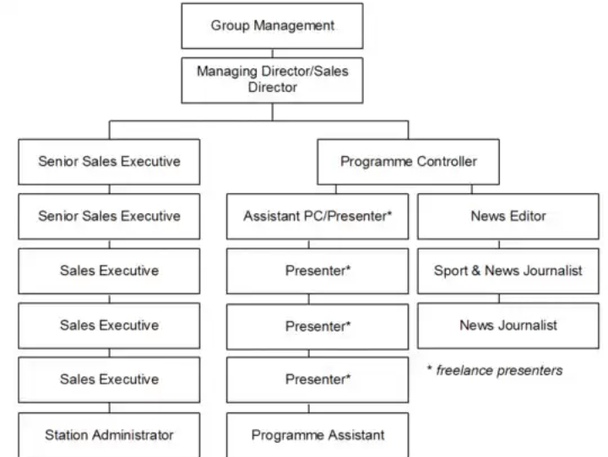
  - Organization Chart

CHAPTER TWO
- Radio broadcasting equipment with their function
Studio and Production Equipment
Your on-air broadcast requires content, and that’s where production equipment comes into play. When most people imagine a radio station, they visualize its studio. This is where the actual recording takes place, and where many of the most iconic pieces of radio broadcast equipment live.
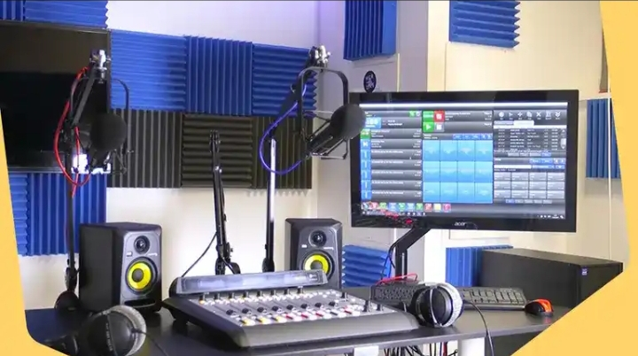

A microphone
A microphone is necessary to capture and record voices, music, sound effects, and other audio. The microphone translates all audio into electrical impulses and is often mounted on a microphone arm to save space.

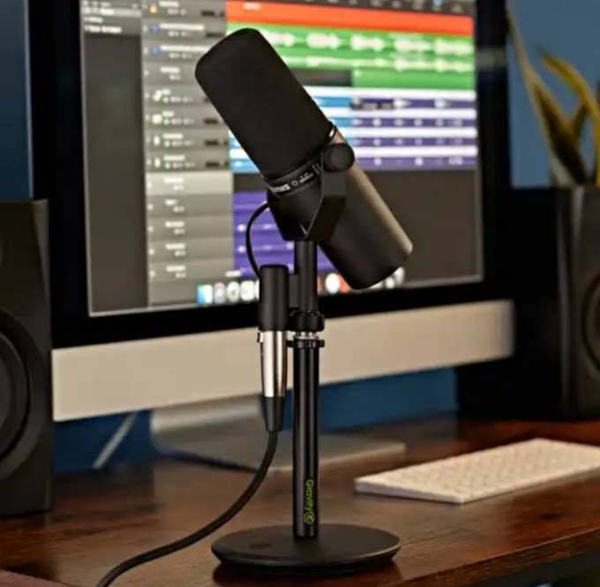

An audio console
An audio console is used to record, equalize, and optimize your program. Sometimes referred to as a sound desk, radio panel, or sound panel, this is the interface that controls exactly what is heard on air. Each of the console’s channels represents a single input, and the fader/slider can be manipulated to adjust the incoming signal.
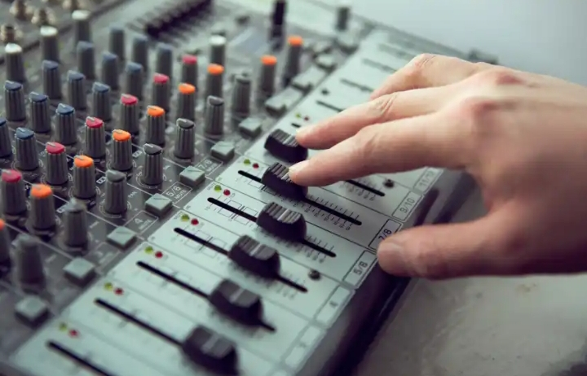

There are analog audio consoles and digital audio consoles, but radio consoles, in general, are specifically designed to be easy for on-air talent to use. In an analog console, the physical audio is actually transmitted through its circuitry. In contrast, digital audio consoles function as a “remote control” for the mix engine (typically located within the rack room).
Studio monitor speakers
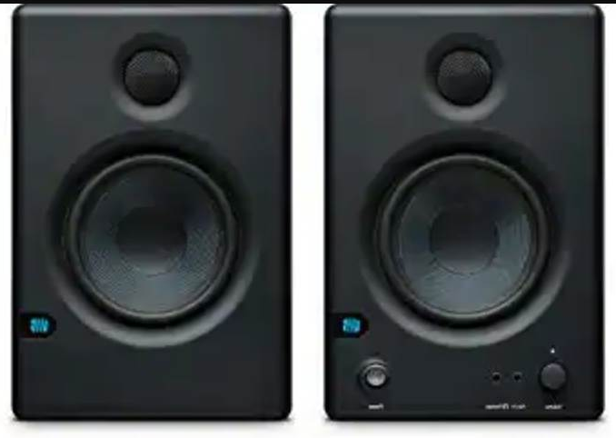
Monitor speakers enable you to hear what’s going on without needing to wear headphones. Most studios use high-quality monitor speakers so that any issues with sound quality are easy to pinpoint

Headphones
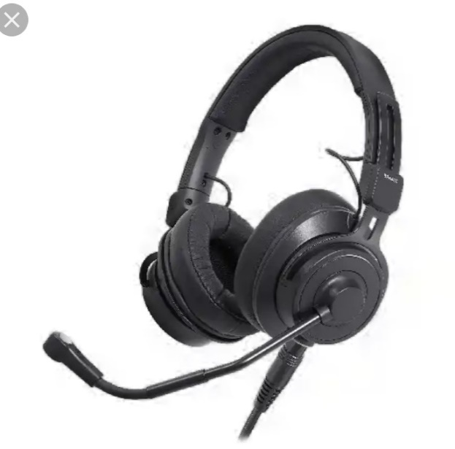
When a microphone is turned on, a studio’s monitor speakers are automatically muted. So, you’ll need headphones to hear the content that will be going to air.

Studio delay (“profanity delay” or “7-second delay”)
If you want to do live broadcasts, you also should consider a studio delay, which commonly provides seven seconds for radio show producers to eliminate unwanted content, such as swearing. That helps to ensure the FCC and local listeners won’t want to shut you down for unsavory content that you never intended to be aired.
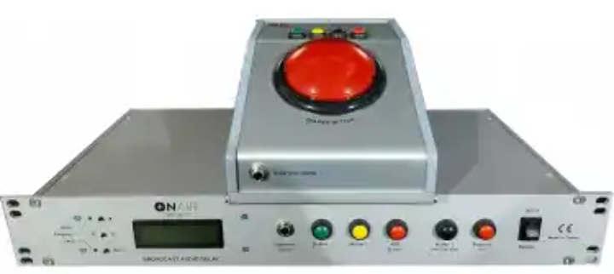

Level meters
A level meter allows the panel operator or on-air talent to monitor the audio volume, so they can ensure it is neither too quiet nor too loud at any point. In most cases, there will be multiple level meters set up for the varying points in the signal chain.
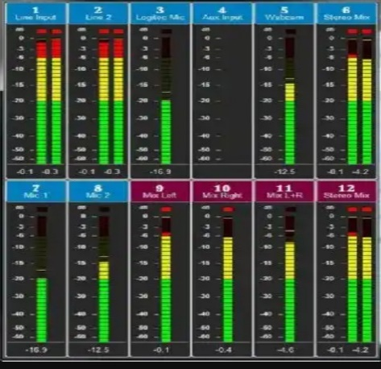
There are also some radio stations that utilize phase meters in addition to level meters. A phase meter works to identify mono content, so you can detect issues with source material and avoid problems with the stereo image.

Rackmounts
Don’t underestimate the usefulness of rackmounts to keep your equipment stored safely.

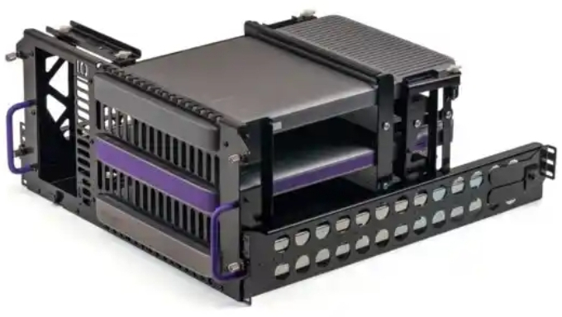

Other equipment are:
- Rack Room Equipment
- An audio mixer (mix engine)
- Protection units
- Transmission Gear
- A transmitter/studio link
- Transmission lines
- An antenna array

2.1 GerinFm 95.5 Departments with their Functions

General Organization of GerinFm 95.5
General Administration
General administration division is the General Manager or station manager, the business manager, the accountants, the secretaries, and other administrative and office staff.
These employees serve various duties such as the payment of wages and salaries, membership fees and subscriptions for industry information, license and other government-imposed fees, taxes, insurance, legal and auditing fees, and contributions to charitable organizations.
In addition, maintenance of the building and of equipment, utilities, office supplies, computers, station automobiles, and other administrative services and supplies are also provided by the general administrative department.
It is not surprising, then, that this department consumes one-third of the total operating expenses of a station, although only about 13 percent of the total staff may be in administration.
Marketing
The sales department at GerinFm 95.5 responsible for generating the revenue for the station to survive. A general sales manager leads a team that is comprised of a national/regional sales manager, a local sales manager, account executives, and at times, a traffic manager.
In most cases, the national/regional sales manager will be a liaison from an outside organization that wins advertising contracts from regional and national advertisers.
The local sales manager, then, is charged with securing advertising accounts with local businesses and organizations.
A staff of account executives helps the local sales manager sell advertising time to local businesses employing solicitation tactics similar to sales businesses. However, the salespeople of television must negotiate advertising sales using a rate card, a definitive list of airtime costs during the various time periods and television programs.
Furthermore, the television account executive can also offer to create the advertisement for a client if the client so chooses, in which case the sales department cooperates with the production and programming departments for this venture.
Programming
The programming department, in conjunction with the production and news departments, acquires and schedules the product that the audience consumes, which in turn allows the sales department to create revenue, which in turn allows the general administration department to facilitate station operations.
The programming department is responsible for filling the entire broadcast day with programming and is therefore saddled with arguably the most challenging job in television. Consequently, this department also works closely with the traffic department in structuring the daily programming schedule.
Programming is second only to general administration in terms ofoperating expenses. The department, if its station is affiliated with anetwork, needs almost 25 percent of the total budget of the station to function. However, an independent station may give as much as half of its total operating budget to the acquisition of programs.
Programming may consist of a program director, a videotape librarian, a ratings researcher, an acquisitions staff, a continuitystandards staff, and on-camera personalities for use in locally originatedprograms.
The program director, helped by the acquisitions personnel, may obtain the majority of the programming of a station from syndicators and other program suppliers. If a station is affiliated with a major television network, then programming will have the luxury of choosing how much programming it will schedule from the network. In a larger market, viewership research may be conducted to help the program director select a programming plan that will attract a substantial audience. Community feedback also aids in planning decisions.
However, all decisions concerning programme acquisition are ultimately controlled by the amount of revenue gained from sales and the resulting budget allotted the programming division.

CHAPTER THREE
3.0 Student Specific Involvement in Various Section
During my Students Industrial Working Experience Scheme (SIWES) at GerinFm 95.5, I was Assign to news and current affair department and I gain a lot of industrial and organizational experience as goes:
I was formally introduced to members of the department for integration into the department. I was then briefed on the established rules of engagements at the News and Current Affairs Department..
3.1 News and Current Affairs Department
News and Current Affairs Department gathers information on daily basis, writes news, reports news, covers events to be disseminated to the general public at specific times
The Department handles Current Affairs Programmes to create public awareness. Information passed from the News and Current Affairs Department is well refined, well referenced and also reliable.
The department performs and ensures the core-values of efficient information management and delivery to members of the public.
News and Current Affairs Department, however, has its uniqueinternal structure in performing the identified responsibilities and duties, which are;
- Reportorial.
- Editorial.
- Current Affairs.
News Room serves as Central Operational points for Reportorial and Editorial while Current Affairs Unit handles current issues, affairs and activities.
3.2 Internal Structure of the News and Current Affairs Department
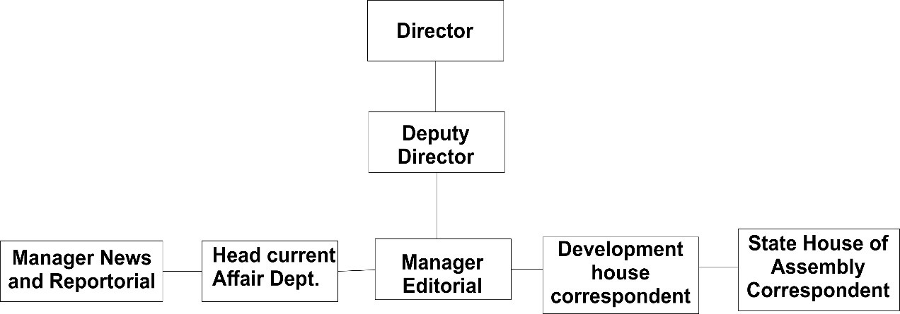

CHAPTER FOUR
4.0 EXPERIENCE GAINED AT GERIN 95.5 FM
I was assigned to News Department to begin my four months stay at GerinFm 95.5.
In the first day I was address by the head of news department and they tell me some rule and regulation of the radio station.
They show me different equipment in the studio like mic, the headphone, audio console, speaker etc. with their function.
During this training I learn the different between the live and recording. These obviously allowed us to gain comprehensive practical knowledge skills in the field which we understood to be core objectives of SIWES.
I also gained some experience on how a console works and how it is being operated. Most importantly, through this SIWES I acquired encompassing knowledge on different strategies involved in broadcasting, and how essential it is for a good professional broadcaster to understand his/her topics under discuss so as to give it effective delivery/judgment.
In overall, it was a great learning experience; and an indication that I am on the right course of learning (Mass Communication).

CHAPTER FIVE
5.0 CONCLUSION
Coordinators and Organizers of the SIWES programme must in earnest compel tertiary institutions to adhere strictly to the duration for SIWES attachment in any industry if they really want to bridge the gap between the theoretical knowledge acquired in tertiary institutions and the practical skills required in today's workplace.
SIWES coordinators should take note that there are some Companies or industries in the country who don't allow industrial attachments, such companies should be penalized under section 8A (2) of Decree No. 47 of 1971 as amended in 2011. By doing this more credence would be given to the Programme.
I urge undergraduates to seize the opportunity given by the SIWES programme to develop their skills and prioritize practical development over theories in their academic pursuit in various field of study.
SIWES has made me to see the other side of my course of study and also afforded me the opportunity to make use and link what I have learnt in the lecture room in the practical field.
- RECOMMENDATION
The experience I gained during my SIWES program cannot be over emphasized, I was practically oriented I humbly recommend that SIWES program should be made compulsory for student of Mass communication, field in order to gain more experience in their course of study.

