

A TECHNICAL REPORT
STUDENT INDUSTRIAL WORKING EXPERIENCE SCHEME
(SIWES)

HELD AT:
TANKE ‘F’ DIVISION ILORIN KWARA STATE

PREPARED BY:
ABDULMUMIN FATIMOH
ND/23/PAD/PT/0096

SUBMITTED TO:

DEPARTMENT OF PUBLIC ADMINISTRATION KWARA STATE POLYTECHNIC, ILORIN

IN PARTIAL FULFILLMENT OF THE REQUIREMENTS FOR THE AWARD OF NATIONAL DIPLOMA (ND) IN PUBLIC ADMINISTRATION

Sept., – Nov., 2024
DEDICATION
I dedicate this technical report to the Almighty GOD, the giver of knowledge, wisdom and who is rich in mercy.

ACKNOWLEDGEMENT
I take this opportunity to express my profound gratitude and deep regards to the creator of heaven and earth, the one who knows the beginning and the end, the alpha and the omega. my sincere gratitude also goes to my guidance MR. & MRS. ABDULMUMIN for their financial support and word of encouragement during my SIWES Programme and also to those who stood by me during my SIWES programme, thank you all. I also take this opportunity to express a deep sense of gratitude to compliment my supervisor at my place of attachment for taking his time for my practical knowledge and for his cordially support, valuable information and guidance which helped me in completing my SIWES through various stages may Almighty God bless you abundantly.
TABLE OF CONTENT
Dedication
Acknowledgement
CHAPTER ONE
  - Introduction to SIWES
  - History of SIWES
  - Objectives of the Programme
  - Objectives of Establishment
CHAPTER TWO
2.1 Activities of place of Attachment
2.2. Precaution Taken in the Place of Attachment
2.3 Uses of the Organization Equipment
CHAPTER THREE
Reporting on Work Carried Out
3.1 Reporting on Daily Work Carried Out
CHAPTER FOUR
Challenges Encounter In Place of Attachment
CHAPTER FIVE
Summary, Conclusion and Recommendations
5.1 Summary
5.2 Conclusion
5.3 Recommendations
CHAPTER ONE
  - INTRODUCTION TO SIWES
Students Industrial Work Experience Scheme (SIWES) is a Skills Training Program designed to prepare and expose Students of Universities, Polytechnics, Colleges of Technology, Colleges of Agriculture and Colleges of Education for the Industrial Work situation they are likely to meet after graduation. The Scheme affords Students the opportunity of familiarizing and exposing themselves handling equipment and machinery that are usually not available in their institutions.

1.2 HISTORY OF SIWES
The Students’ Industrial Work Experience Scheme (SIWES) was initiated in 1973 by the Federal Government of Nigeria under the Industrial Training Fund (ITF) to bridge the gap between theory and practice among products of our tertiary Institutions. It was designed to provide practical training that will expose and prepare students of Universities, Polytechnics, and Colleges of Education for work situation they are likely to meet after graduation.
Before the establishment of the scheme, there was a growing concern among the industrialists that graduates of institutions of higher learning lacked adequate practical background studies preparatory for employment in industries. Thus the employers were of the opinion that the theoretical education going on in higher institutions was not responsive to the needs of the employers of labour.
As a result of the increasing number of students’ enrolment in higher institutions of learning, the administration of this function of funding the scheme became enormous, hence ITF withdrew from the scheme in 1978 and was taken over by the Federal Government and handed to National Universities commission (NUC), National Board for Technical Education (NBTE) and National Commission for Colleges of Education (NCCE). In 1984, the Federal Government reverted back to ITF which took over the scheme officially in 1985 with funding provided by the Federal Government.
1.3 OBJECTIVES OF THE PROGRAMME
The specific objectives of SIWES are to:
- Provide placements in industries for students of higher institutions of learning approved by relevant regulatory authorities (NUC, NBTE, NCCE) to acquire work experience and skills relevant to their course of study
- Prepare students for real work situation they will meet after graduation.
- Expose students to work methods and techniques in the handling of equipment and machinery that may not be available in schools.
- Make transition from school to the labour market smooth and enhance students’ conduct for later job placement
- Provide students with the opportunity to apply their knowledge in real life work situation thereby bridging the gap between theory and practice
- Strengthen employer involvement in the entire educational process and prepare students for employment in industry
- Promote the desired technological knowhow required for the advancement of the nation.
1.4 OBJECTIVES OF ESTABLISHMENT
The specific objectives of establishment are to:
- Law Enforcement: Upholding and enforcing laws to ensure public safety and order.
- Crime Prevention: Implementing strategies to prevent crime through community engagement and proactive policing.
- Investigation: Conducting thorough investigations of crimes to gather evidence and apprehend offenders.
- Public Assistance: Providing assistance to citizens in emergencies or when they require help, including responding to calls for service.
- Community Relations: Building and maintaining positive relationships with the community to foster trust and cooperation.
- Education and Outreach: Offering educational programs on safety, crime prevention, and legal rights to the public.
- Traffic Control: Monitoring and managing traffic to ensure road safety and reduce accidents.
- Crisis Management: Responding to crises, such as natural disasters or public disturbances, to maintain order and safety.
- Support Services: Providing support services such as counseling for victims of crime and resources for community programs.
- Data Collection and Reporting: Gathering and analyzing data related to crime trends to inform policy and improve policing strategies.
CHAPTER TWO
2.1 ACTIVITIES OF PLACE OF ATTACHMENT
The experience, knowledge, skills and exposure acquired during the period of attachment in the industrial exercise cannot be over emphasized. I was exposed to certain areas in my course of study, such as:
- Patrols: Officers regularly patrol neighborhoods to deter crime and respond to incidents.
- Responding to Calls: Handling emergency and non-emergency calls from the public.
- Investigating Crimes: Gathering evidence, interviewing witnesses, and conducting investigations into reported crimes.
- Arrests: Apprehending suspects based on warrants or probable cause.
- Traffic Enforcement: Monitoring traffic laws, issuing citations, and assisting with accidents.
- Community Engagement: Organizing community events, meetings, and outreach programs to build relationships with residents.
- Record Keeping: Maintaining detailed reports on incidents, arrests, and investigations for legal and administrative purposes.
- Interrogations: Interviewing suspects and witnesses to obtain information relevant to investigations.
- Training: Participating in ongoing training for officers on legal updates, new technologies, and policing techniques.
- Crisis Intervention: Responding to situations involving mental health crises or domestic disputes, often coordinating with social services.
2.2. PRECAUTION TAKEN IN THE PLACE OF ATTACHMENT
As a Student Industrial Work Experience Scheme (SIWES) student at a police station, it’s important to take certain precautions to ensure safety and professionalism. Follow Protocols: Familiarize yourself with the station's protocols and procedures. Always follow them closely.
- Maintain Professionalism: Dress appropriately and conduct yourself in a professional manner at all times.
- Stay Aware of Your Surroundings: Be vigilant and aware of your environment, especially in high-stress situations.
- Respect Confidentiality: Handle sensitive information discreetly and respect privacy laws.
- Ask Questions: If unsure about a procedure or situation, ask a supervisor or experienced officer for guidance.
- Avoid Confrontation: Stay calm and avoid engaging in any confrontational situations.
- Use Personal Protective Equipment (PPE): If required, wear appropriate PPE, especially during fieldwork or in potentially hazardous environments.
- Stay with Supervisors: When participating in field activities, stay close to your supervisor or assigned officer.
- Limit Distractions: Avoid using personal devices during work hours to maintain focus on your tasks.
- Report Safety Concerns: Immediately report any safety concerns or suspicious activities to your supervisor.
- Follow Protocols: Familiarize yourself with the station's protocols and procedures. Always follow them closely.
2.3 USES OF THE ORGANIZATIONAL EQUIPMENT

RADIOS
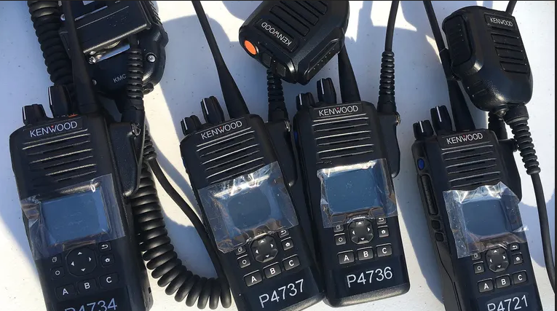

Radios: Used for communication between officers and dispatch to coordinate responses and share information.
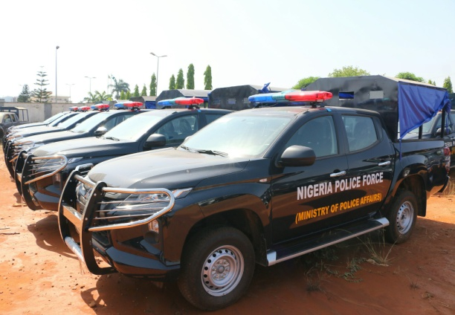
PATROL VEHICLE

Patrol Vehicles: Equipped for transportation, they provide mobility for officers to respond quickly to incidents and patrol neighborhoods.
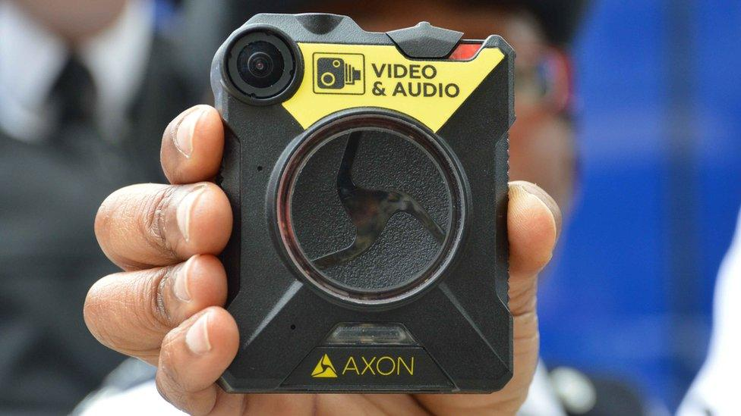
BODY CAMERAS

Body Cameras: Used to record interactions between police and the public, enhancing accountability and transparency.

FIREARMS

Firearms: Carried by officers for self-defense and to protect the public, following strict regulations and training.
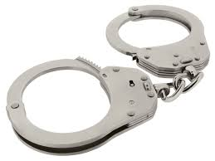
HANDCUFFS

Handcuffs: Used for restraining suspects to ensure officer and public safety during arrests.
BREATHALYZERS
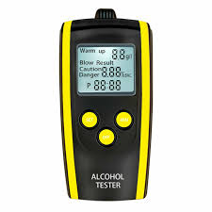

Breathalyzers: Employed to measure blood alcohol content (BAC) in suspected impaired drivers.
EVIDENCE COLLECTION KITS
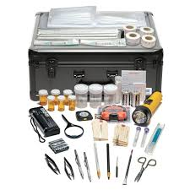

Evidence Collection Kits: Used to gather and preserve evidence at crime scenes, including fingerprinting kits and crime scene tape.

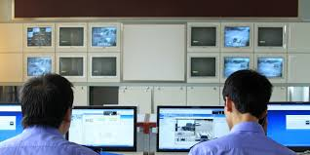
Computers and Software

Computers and Software: Used for data entry, record-keeping, and accessing databases for criminal records and reports.
TRAFFIC CONES AND FLARES
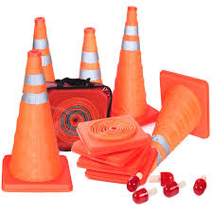
.

Traffic Cones and Flares: Deployed to manage traffic at accident scenes or during road closures.

ORGANIZATION STRUCTURE/ORGANOGRAM
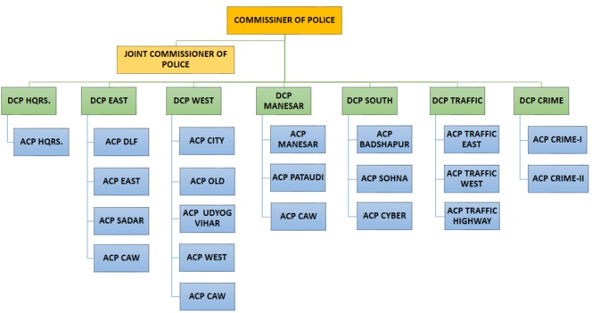

CHAPTER THREE
REPORTING ON WORK CARRIED OUT
3.1 Reporting on Daily Work Carried Out
- Assisting with Administrative Tasks: Helping with data entry, filing reports, and maintaining records.
- Observing Patrols: Accompanying officers on patrol to learn about community policing and response strategies.
- Participating in Investigations: Assisting in gathering and organizing evidence, taking notes during interviews, and learning investigative techniques.
- Supporting Community Outreach: Helping organize and participate in community events, such as safety workshops or public awareness campaigns.
- Learning about Crime Scene Management: Observing how officers secure crime scenes and collect evidence.
- Using Technology: Familiarizing yourself with police databases and software for record-keeping and information retrieval.
- Traffic Management: Assisting with traffic control during events or accidents, learning about traffic laws and enforcement.
- Engaging in Training Activities: Participating in training sessions on various topics related to law enforcement and safety.
- Attending Meetings: Observing staff meetings to understand police operations and decision-making processes.
- Conducting Research: Assisting with research projects related to crime trends or community safety initiatives.
- Data Analysis: Assisting in analyzing crime data and trends to help identify problem areas within the community.
- Witness and Victim Support: Helping to provide information and support to victims and witnesses, ensuring they understand the process and their rights.
- Inventory Management: Assisting with the management of equipment and supplies, including checking in and out of items like firearms and evidence.
- Public Relations: Aiding the public information officer in crafting press releases or community bulletins to disseminate important information.
- Training Participation: Engaging in simulated training exercises or role-playing scenarios to practice response strategies.
- Report Writing: Learning to draft basic reports or summaries based on observations or data collected during your activities.
- Social Media Monitoring: Assisting in monitoring social media for relevant community issues or potential threats.
- Emergency Response Drills: Participating in drills or training exercises that simulate emergency situations to enhance preparedness.
- Learning Legal Procedures: Gaining insights into legal processes, including how warrants are issued and the rights of suspects.
- Field Research: Conducting field visits or surveys to gather information on community concerns related to safety and policing.

CHAPTER FOUR
CHALLENGES AND SOLUTION ENCOUNTER IN PLACE OF ATTACHMENT

Challenges and Solution
- Limited Experience: I felt overwhelmed due to a lack of practical experience in law enforcement.
Solution: Seek guidance from supervisors and ask for training opportunities to build confidence and skills.
- Complex Procedures: Navigating police protocols and legal procedures is confusing.
Solution: Take notes during briefings and ask questions to clarify any uncertainties.
- High-Stress Environment: The nature of police work is been stressful and intimidating.
Solution: Practice stress management techniques, such as deep breathing or mindfulness, and seek support from colleagues.
- Confidentiality Issues: Handling sensitive information requires discretion and understanding of privacy laws.
Solution: Familiarize yourself with confidentiality policies and discuss any concerns with a supervisor.
- Communication Barriers: Interacting with officers and the public is challenging, especially if there are language or cultural differences.
Solution: Develop strong communication skills and be open to learning from diverse interactions.
- Time Management: Balancing internship responsibilities with academic commitments is difficulty.
Solution: Create a schedule to prioritize tasks and manage time effectively.
- Physical Demands: Some tasks may require physical stamina or comfort in unpredictable environments.
Solution: Engage in regular physical activity to build resilience and stamina.
- Limited Responsibilities: I felt underutilized if given minimal tasks.
Solution: Proactively express interest in taking on more responsibilities and learning opportunities.
- Exposure to Trauma: Witnessing or hearing about traumatic events is emotionally challenging.
Solution: Utilize available mental health resources and talk to supervisors about feelings of distress.
- Cultural Adjustment: Adapting to the culture of a police station can be challenging for some students.
Solution: Observe and learn from the behavior of experienced officers, and engage in team-building activities.
CHAPTER FIVE
SUMMARY, CONCLUSION AND RECOMMENDATIONS
5.1 SUMMARY
The Student Industrial Work Experience Scheme (SIWES) provides students with practical exposure to the workplace, particularly in law enforcement settings such as police stations. This experience is crucial for aspiring professionals, as it allows them to apply theoretical knowledge in real-world scenarios, develop essential skills, and understand the dynamics of police work. However, students often encounter various challenges during their internships, from navigating complex procedures to managing the high-stress environment typical of police stations.
During my internship at a police station, I engage a wider range of activities, including assisting with administrative tasks, participating in patrols, supporting community outreach, and learning about crime scene management. I faced challenges such as limited experience, communication barriers, and the emotional impact of exposure to trauma. Despite these difficulties, students can gain valuable insights into law enforcement practices and build professional relationships.
5.2 CONCLUSION
The SIWES program at police stations plays a vital role in preparing students for careers in law enforcement by providing hands-on experience and fostering a deeper understanding of police operations. While challenges are inherent in this environment, they also present opportunities for growth and learning. By addressing these challenges effectively, students can enhance their internship experience and contribute positively to the police force.
5.3 RECOMMENDATIONS
- Siwes supervisors should make sure they visit the students in their place of attachment for proper monitoring, improvement and progress for the benefit of the societies as a whole.
- Implement comprehensive onboarding programs for SIWES students to familiarize them with procedures and expectations.
- Establish mentorship opportunities where experienced officers can guide students through their internship.
- Encourage supervisors to provide constructive feedback regularly, helping students improve their skills and confidence.
- Offer workshops focused on coping strategies and stress management techniques tailored for high-pressure environments.
- : Involve students in community outreach initiatives to enhance their understanding of community policing and build relationships.
- Maintain open lines of communication between students and supervisors to address concerns and foster a supportive environment.

