A TECHNICAL REPORT

ON
STUDENT INDUSTRIAL WORK EXPERIMENCE SCHEME [SIWES]

HELDAT
ILORIN SOUTH LOCAL GOVERNMENT FUFU
WRITTENBY:
OLOYE MODUPEOLUWA BLESSING
ND/23/PAD/PT/0209

SUBMITTED TO THE DEPARTMENTOFPUBLICADMINISTRATION
INSTITUTE OF FINANCE AND MANAGEMENT STUDIES KWARA STATE POLYTECHNIC, ILORIN
IN PARTIAL FULFILLMENT OF THE REQUIREMENTS FOR THE AWARD OF NATIONAL DIPLOMA (ND) IN PUBLIC ADMINISTRATION,
KWARASTATEPOLYTECHNIC,ILORIN.

AUGUST-NOVEMBER 2024

DEDICATION
ThisTechnicalreport isdedicatedto AlmightyGodforsparing mylivesthroughoutthisprogramme. Also to my Parents Mr. & Mrs. OLOYE.

ACKNOWLEDGEMENT
I give thanks to Almighty God for given me the grace and opportunity to participate in this SIWES programme. May his name be praise forever
I want to specially appreciate the effort of my parent Mr. & Mrs. OLOYE for their financial support and their moral support, theywill live to eat the fruit of their labour.
I also acknowledge my amiable and capable SIWES coordinator, I will be an ingrate if I fail to mention my SIWES Supervisor and my Lecturer in Public Administration Department for their tremendous effort in my life and the knowledge they have impacted to me
MygratitudegoestoIndustrialbasesupervisorforthe impartationofknowledgegivento me. Myprofound gratitude goes to my brother and sister for their support during this program.
MayAlmightyGodbless everyoneofyou(AMEN)

TABLEOFCONTENT
Front Page Dedication Acknowledgement Table of Content CHAPTER ONE
IntroductiontoSiwes
DefinitionofSiwes
HistoricalBackground ofSiwes
AimsandObjectivesofSiwes
Reasons forTraining
TheMajor DocumentofITF

CHAPTERTWO
ABriefHistoryoftheCompany

CHAPTERTHREE
Introduction
Types ofBusiness Enterprises
FunctionsofaBusiness Enterprise

CHAPTERONE
1.2 INTRODUCTIONTOSIWES
In the early stages of Business Administration, Nigerian Student were graduating from their respective Institutions without any technical knowledge or working experience. According to Akereloja (2008), acquisition of practical skills is an antidote of meaningful development in any society. In accordance with Akereloja's view, Odiagha (1995) also posits that practical knowledge is learning without which mastery of an area of knowledge may be too difficult to achieve and that practical knowledge involves developing skills through the use of tools or equipment to perform tasks that are related to a field of study.
As a result, the Federal Government of Nigeria introduced the Student Industrial WorkExperience Scheme (SIWES) programme in Tertiary Institutions in 1975to ensure acquisition of field practical knowledge and skills by Students before graduation, and to further expose Students to Industry based skills that are necessary for smooth transition from classroom to the labour world, providing the students with the basic prospects to be part of real work situations outside the lecture room. Thus, it became obligatory for Students in Tertiary Institutions, mostly those studying Business Administration related courses to embark on SIWES programme in order to acquire practical knowledge and working skills prior to graduating from their various institutions of learning. To this end, the Business Administration profession like other course professions require practical skills. Hence it became imperative for Students of Urban and Regional Planning to embark on the SIWES programme so as to acquire the necessary practical skills required for the profession before graduation
DEFINITIONOFSIWES
The student industrialworking experience scheme is a Programthat constitutes immenselyto building of technical skills available to the Nigeria economy, which are needed for the national industrial development.

HISTORICALBACKGROUND OF SIWES
The Student Industrial Work Experience Scheme (SIWES) was established in 1973by the Industrial Training Fund (ITF). Prior to the establishment of the Scheme, there was a growing concern among our Industrialists that graduants of our institutions of higher learning lacked adequate practical background studies preparatoryfor employment in industries. It is against this rationale for initiating and designing the scheme was hinged.
Consequently the scheme affords students the opportunity of familiarizing and exposing themselvesto the needed experience in handling equipmentsand machinerythat are usually not available in their institutions so as to smoothen their entry into industrial practices on completion of their studies and also reduces period spent in training fresh graduates as new employees.

AIMSANDOBJECTIVESOFSIWES
SIWESisstrategized forskillsacquisition,therefore,thekeyaimisto bridgethegap between theoryand practice byexposing students to the industrial environment and enable them to develop occupational competences so that they can readily contribute their quota to national economic development and technological advancement after graduation.
TheSpecificObjectivesoftheSchemeasoutlined intheIndustrialTrainingFundsPolicydocument no.1 of 1993 are as follows:
    - To provide placements in industries for students of higher institutions of learning approved by relevant authorities(NUC,NBTE,NCCE)to acquireexperienceandskillsrelevanttotheircourseof study.
    - PrepareStudentsforthe realworksituationstheywillmeetaftergraduation.
ExposeStudentsto workmethodsandtechniques inhandlingofequipment and machinerythat may not be available in school. Makes transition fromSchoolto the labour World smooth and enhance Student contact for later job placement.
    - ProvidesStudentswiththeopportunityto applytheir knowledge inreallifework situationthereby bridging the gap between theory and practice.
REASONSFORTRAINING
Reasonfortheindustrialtraining areasfollows:
- Theknowledgeacquiredintheclassroomsarenotenoughdueto lackofpractical
- Theprogramhasalsohelpedtodistinguishbetweenclassandpracticalwork
- Classroomtheoriescannotbecompare withthe practicalworkdoneonthefield.
- TheSiwesprogramhasprovedameansofopportunityforstudentstohandlesomesophisticated equipment not found in the school
THEMAJOR DOCUMENTOFITF
- PLACEMENT LETTER:This isthe formalletter oftheplacement to besubmittedto anyemployer by each students
- THE JOB REPORTING FORM: This form is to be completed by students before he/she settle down withthe employer. The informationonthe formwillassist the centraland department during supervision visits. Failure to return this form is taken as non participant in the program.
- THE TRAINING LOG BOOK: This has to be completely filled daily and signed weekly by industrial based supervisor, andthis logbookcarried detailed informationabout work carried out daily, the logbook must be with you daily.

CHAPTERTWO
ABRIEFHISTORYOFTHECOMPANY
Ilorin South local government was created in 1996 with Headquarters at Fufu. It is made up of three districts and has 10 wards. It has anarea of174 km² and a populationof208,691 at the 2006 census. The major Towns: IIota, Fufu, Gaa-Akanbi, Kangie, Gaa Osibi, Omode.

Yoruba and Fulani are the major languages spoken. It also has some important markets, which include Cattle Market Sango, Gada Market, Ogidi Market. Ilorin South is popular for its maize, cereal and cassava farmers. Just like the other side of town, the Yawo Dancers festival is also a major one in Ilorin South LocalGovernment Area. It’s main tourist attraction is the Kwara State Amusement Park.

ORGANOGRAMOFTHE COMPANY

H.O.D OF BUSINESS
H.O.DOFACCOUNT
H.O.D OF ADMINISTRATION
H.O.D AUDITING
StateDirector
Mechanical Unit
Scale of chemical
BookingUnit
H.O.D MARKETING
Blacksmith
Livestock

CHAPTERTHREE
INTRODUCTION
The establishment ofnew industriesand businesses is important for people looking to invest and become part ofthegrowthofacompanyor an industry. Think howmanyearly investorsin Facebookor Amazon, or Apple benefited from investing in these business enterprises.
Furthermore, the profit earned by the investors as a result of the company's successful operation contributes to the accumulation of a greater quantity of savings, which may be used to fund future businesses. As a result, business is crucial in creating investment possibilities.
To sum up, business enterprises produce goods and services in exchange for commercial benefits. As drivers of innovation and investment, problem solvers, creators of jobs, and stimulants to the overall economy, these enterprises serve a vital function in our society.

Businessenterprisemeaning
To understand the meaning of the term business enterprise, you first have to understand the difference between a social enterprise and a business enterprise.
Anenterprise canbe defined asundertaking anactivitythatrequiresalotofeffort todevelop.
Asocialenterprise involveshelping otherswithout receiving a commercialbenefit inreturn. Ontheother hand, a business enterprise consists of producing goods or services in exchange for commercial and financial benefits.
Examples of business enterprises include allthe companies you payto receive a good or service from. These may include your localshop or your Netflix subscription, both of which are business enterprises.
A business provides goods and services to what we call customers. Goods refer to physical goods that usuallygo througha productionprocess. This may involve bicycles, chocolate,orwhatever itemyou pay to receive.
Other businesses provide services instead of physical goods; this involves intangible products, such as a private lesson from a math teacher or personal trainer.
All these goods and services are delivered to customers. A customer refers to anyone who purchasesthese products. Consumers use the product or service but do not necessarily buythem.
For instance, ifyour parentspayfor your Netflix subscription, you arethe consumer and your parentsare thecustomer. Iftheyalso watchNetflixwith you,they becomeconsumersand customerssimultaneously. The business enterprise depends on customers, goods, and services for its very existence. These three components are intrinsically linked to the meaning of business.

TYPESOFBUSINESSENTERPRISES
There are many types of business enterprises providing a wide variety of services or products. Business enterprises can be classified into three main categories, according to the production stage:

BusinessEnterprise:Primarysector
The primary sector involves businesses that are at the beginning of the production processes. These businesses makesurethattherawmaterialsarecreatedandproducedtobeused laterbyothercompanies. Primarycompaniesare mostlymade ofbusiness-to-business(B2B) models, where you have one business supplying to the other. For example, oil exploration companies produce oil that retail companies sell, or other businesses use for production processes. Restaurants use agriculturalgoods produced by this sector to provide meals to their customers.

Advertisement
Thankstothisad,StudySmarterremainsfree.Signupforafreeaccounttoaccessabetterlearning experience.
BusinessEnterprise:Secondarysector
The secondary sector consists of business enterprises at the second stepof the production process. These businesses use raw materials produced from the primary sector to develop into new goods and services. For example, car manufacturers use raw materials to build new cars, which they later supply tocustomers.
Examples of companies in the tertiary sector include banks that help individuals get loans or airline companies that enable one to fly around the world.

FUNCTIONSOFABUSINESS ENTERPRISE
The four basic functions of a business enterprise are Finance, Operations, Human Resources, and Marketing.

BusinessEnterprise: Finance
One of the essential functions of a business is raising and managing money. A business enterprise may use internal or external sources of finance to raise the funds needed to get the business going. Internal sources of finance involve the money that business owners invest in their own business.
Incontrast,externalsourcesoffinance involvecashfromoutsidesources,suchasmoneyfromfamily, banks loans, and investors. Afterthemoneystartsmoving aroundthebusiness,thebusiness managers should manage it cautiouslyso theydon’t have too manycosts, thereby failing to make any sales.

BusinessEnterprise:HumanResources
Another important function of a business enterprise is that of human resources. A business needs to get the right human capital to provide goods or services. This entails hiring people with the necessary expertise and skill set that the production process requires.

Stayorganizedand focused
Collect andmanageallyourstudymaterials inoneplaceintheStudySmarterapp.
Functionsofa businessenterpriseincludeFinance,Operations,HumanResources,and Marketing.

Reasonswhybusinessenterprisesare important:economicdevelopment,solvingproblems,creating jobs, and investment opportunities.

TypesofBusiness/Enterprise
Fromthe perspective ofownership and management, businessenterprisescanbe broadlyclassified under three categories.
- Private Sector Enterprises:Enterprises owned,controlled andmanaged by private individualsfall under this category with the main objective of earning. Contains:
  - Soleproprietorship
  - Participation
  - JointHinduFamilyBusiness
  - Cooperative
  - Company
- PublicSectorEnterprises:Businessenterprisesowned,controlledandoperatedbypublic enterprises, with the primarygoal as secondarygoal and welfare as profit, fall under this category.
Eitherwholeormostoftheinvestmentintheseventures isdonebythegovernmentsuchas:
  - Departmentalundertaking
  - Publiccorporation
  - Governmentcompanies
- Joint Sector Enterprises: As the name suggests, the joint sector is a formofpartnership between the private sector and the government where management is generally in the hands ofthe private sector, and adequaterepresentation bythegovernment ontheboard ofdirectors. is. Resources insuch enterprisesare mostly generated equally.
Thus,oneofthefirst decisionsanentrepreneur must make forhisnewventureishowthebusinessshould be structured.
Fromtheentrepreneur'spointofview,themostcommonlychosen formsforstartinganewventureare:
- Soleproprietorship
- Partnerships
- Company

CHAPTERFOUR

4.1 TOSTARTACLOTHINGBUSINESS

Find YourNiche

The fashion industry is massive, consisting of a myriad of different brands–all with very different styles and niches. It’s importantto identify your niche and stick to it. This willhelp you to create a product line that resonates with your target market and build a solid brand. Remember that as appealing as it may beto tryto be everything to everyone, the best brands have a verydefined niche and theystayin said niche. Here are a few examples of highly successful clothing brands that operate in different niches:
- Wrangler(casual)
- Adidas(athletic)
- H&M(trendy)
- RalphLauren(classic)
Picking a niche means playing to your strengths. If you’re a strong seamster, you’ll spend most of your time designing and constructing pieces. If you’re a visual artist,you might create art that can be printed on T-shirts or other clothing items.

KnowYourAudience

Early on, it’s important to figure out your ideal customer. When you’re working towards establishing your business, fashion makesthingsbotheasier and harder atthe same time. Youcaneasily imagine who wouldwear yourclothes,but youalso havetofind wheretheycongregate(inbrick-and-mortarstoresand online) and how to reach them.
Hereareafewquestionstoconsiderwhendeterminingyour audience:
- Who arethey?
- What aretheirfavoriteclothing brands?
- Dotheyidentifywithcertain brands?
- Wheredotheyshop?
- Howoftendotheyshop?
- Dotheycareabout trends?
- Whatistheirpricepoint?
- Whatinfluencestheirbuyingdecisions?
By answering these questions, you will get a better understanding of your target audience. This enables you to more strategically build your brand, develop products they’ll want, and distribute products so they’re easily discoverable by the people who will buy them.

CreateaMarketingPlan

After defining your nicheand identifying your audience, thenext stepisto puttogether amarketingplan. While it sounds like a lot of work–it doesn’t have to be very comprehensive. But you do need to detail which channels you plan to use to sell your products, such as direct, Amazon, Etsy, boutiques and bigbox stores, as well as how you plan to market your businesses so that you get sales.
Here’sarethemust-haveswhencreatinganewbusiness marketing plan:
- Marketand competition
- Distributionchannels
- Marketingstrategy
- Marketingandadvertisingchannels, suchassocialmediaandpay-per-clickads
- Marketingbudget
A marketing plan essentially establishes how you will market your clothing line, and with that, can greatly guide how you go about product distribution and advertising strategies, which will impact your sales. Learn more about how to write a marketing plan.

NameYourBrand andCreateBrand Assets

If you don’t already have a business name in mind, it’stime to choose one. Clothing business names can vary wildly. For example, Under Armor, ASOS, Banana Republic, L.L. Bean, American Apparel, TopShop, Brooks Brothers, Dickies, Deus Ex Machina, Vardagen, Life is Good, or Salt Life. In short, your clothing business can be named just about anything you want it to be.
Hereareafewtipstokeepinmindwhennamingyourclothingbusiness:
- Makesurethatitiseasytopronounceandspell
- Chooseacatchyor memorablename
- Considerhowittranslatesintootherlanguages
- Checkifitisavailableasadomainname, suchasyourbusinessname.com
Once you have a business name, choose a slogan (optional), a brand color scheme, and createyour logo. Ifyou’re looking for aneasyand affordablewayto createyourownlogo,tryusing Canva, which isa free drag-and-dropdesigntoolthat has dozensofprebuilt logosyou cancustomize. Alternatively, you can get a logo professionally designed for as little as $5 on Fiverr.

RegisterYourBusiness

After choosing a brand name and putting together your brand assets, the next step is to register your business with your state. It’s not a fun step, but it is a necessary step–even for brand new clothing businessesasyouwillneedanEmployerIdentificationNumber(EIN)toacceptpaymentsforyour

products. And to get an EIN, you need to register as a business.Additionally,it also enables you to getwholesale pricing and work with retailers.
The process of registering your business will vary depending on your state, but you will register it withyourstate’sSecretaryofState.SmallbusinessestypicallyopttoregisterasaLimitedLiability Corporation(LLC)whichcostsaround$100onaveragebutcanbeaslittleas$40andover$250.If you’re not sure which is right for you, learn more about what an LLC is and how to set up an LLC.Design and Source Your Products

Chances are you alreadyknow how you’re going to designand source your products. However, ifyou’re on the fence or open to ideas, there are three main ways:
- Buyproductsfrom wholesalers
- Designyourownandhavethemmanufactured
- Designandsewyourownin-house
Of course, which you choose will depend on how you plan to sell your products. For example, if you’re planning to curate collections of clothing to sellonline, saydirectly via your website or on Amazon, you could opt to purchase products from wholesalers or drop shippers. This is a great way to keep upfront costs low–especially if you are dropshipping products. However, it also means your products are not as unique and therefore might require more marketing.

Price YourProducts

Pricing products in fashion is largely determined by two key variables. First, the cost of goods sold (COGS), such as labor expenses and cost of materials, and second, by the niche you’ve chosen to target. For example, the average clothing line uses what is called the keystone markup strategy, where the price is calculated by taking the cost of production and doubling it. However, it may be increased as much as 5X, depending on your niche, such as high-end clothing brands.
Hereareafewkeycoststoinclude whenpricingyour products:
- Costofmaterials
- Time
- Marketingandadvertising
- Packaging
- Shipping
Ifyou’resteppingintotheluxury brandspace,yourproducts shouldbepricedaccordingly.Itemsthat require a lot of attention, care and time in their creation should have premium prices.
On the other hand, a clothing company focused on high volume can have items with lower price points. Encouraging consumers to buymore means adding deals and flashsales to further incentivize purchases.

DistributeYourProducts

Clothing businesses have a number of distribution options available, from selling directly via their own website and selling on third-party sites such as Amazon and Etsy, to selling in-store, through local retailers, or national big box retailers. To maximize your exposure and increase your sales, it’s generally best to plan to distribute and sell your products via multiple channels.
Even if you do not plan to sell products directly or online, you still need to have a website. This helps build your brand and if you’re planning to approach retailers, it gives them a way to check your product catalogs and lookbooks. Learn more about how to make a website or check out thebest e-commerceplatformsthat enable you to easily create an online store where you can sell your products directly to customers.
No matter howyouplantosellthebulkofyour products, youshouldhaveyourownwebsite.
If you’re not ready to sell from your own website, you can look into Etsyor other highly ranked e-commerce platformsto lessen your workload. Thelesstime you have to spend troubleshooting a website, the more time you have to work on designing clothing.

Market YourClothing Brand

Last but not least, you need to market your clothing brand so that it can be discovered by your target market. There are a number of ways to market a clothing business, but ultimately you want to choose marketing channels that reach your particular target market. In other words, be where your target customers are.
Herearesomeofthe mostpopularmarketingchannelsandstrategiesforclothingbrands:
- Organicsocialmediamarketing,suchasPinterestand Instagram
- Paidsocialmediaadvertising,suchasFacebookAdsandYouTubeAds
- Paidsearchadvertising,suchasGoogleAds
- Forums,suchas Reddit
- Contentmarketing
- Influencermarketing
- Paidplacements
- Bannerads,suchasGoogleAdSense
- E-commerceads,suchasAmazonAdsandEtsy Ads
- Searchengineoptimization (SEO)
- Emailmarketing
- Sponsorships
- Localevents

- Localnews
When choosing the right marketing strategies and channels for your clothing business, remember to always keep your brand in mind. Consider if it stays on brand and if it’s likely to be a good use of your marketing budget. As with choosing distribution channels, you will also want to use multiple marketing channels for maximum exposure.

ToStartShoeBusiness
Becomingpart ofthe most successfulshoestoreswillrequireplanning, research, hardwork,andtheright partners. We summarized the process in ten steps, focusing on eCommerce and Print on Demand.

ResearchtheIndustry
Startwithmarket research. Youneedagoodideaofwhat otherbrandsaredoing intheshoe industry. Study the competition and be aware of their strengths and weaknesses. What do they sell?
Researchfashiontrends,best-sellingproducts,targetmarket,location, andprices.
Look for shoe stores on marketplaces like Amazon, eBay, Etsy, and Walmart and type queries as“popular shoes” or “trending footwear.” Try out queries related to your target audience – for example, “trending athletic shoes for women.”
Readtheproductreviewsandnotewhatattractscustomersanddisappoints them.
Get inspiration fromother shoe stores, but add your input and planunique designs that add value toyour target customers.
Repeat the queries fromthe marketplaces, pick the name of preferred products, and look for the terms in free tools like Google Trends.
Survey the related queries, demographics, and trends. Observe trends related to the products you’re planning to sell – do people look for them all year round, is there seasonality, are the queries increasing over time?

FindtheRightNiche
Anicheisaspecific,targetablesegmentof alargeraudience.It’sagroupoflike-mindedpeoplewith particular interests and needs. The narrower the niche, the better.
Defininganicheisessentialtoreachtherightcustomersandoffer customshoestoanswertheir demands.
Use Google Trends and type keywords representing your unique selling proposition (for example, “artsy footwear for men”).
Lookintotherelatedqueries,demographics,andlocations.Understandwhoislookingforproducts similar to your shoe brand, and target them.
Learnmoreaboutnichesandtoolswithourvideo:

ChooseYourBusinessModel
The most crucialdecisionto makewhenstartinga shoecompany–what willyourstructurebe? Choose one of these three models for a shoe store:
- Ownership of production – you design and manufacture the shoes and controla good part ofthe supply chain, assuring quality control and customization. It requires detailed planning, funding, installations, technical capacity, and human resources.
- Wholesale– the shoe store buys products in bulk from a manufacturer, keeps them in a warehouse, and sells the footwear gradually. It demands costs with facilities, managing inventory, and businessinsurance.
- Dropshipping andPrint onDemand –the wayto start ashoe business without worrying abouttheshoe store’s startup costs. The shoe store is the intermediary between the final customer and the manufacturer. Focus on design, marketing, and communication while the print provider takes care of applying the designs, fulfillment, and managing inventory. Theshoesareproduced onlywhenanorder isplaced inthe online store
Startselling
DevelopYourBusinessPlan
ComeUpWithYourBusinessNameandBrand
Your shoe store’s name and brand should reflect the products it sells. Whether the line focuses on luxury boots, artsy sneakers, or athletic shoes, the theme should reflect in the brand name.
A brand name must harmonize with its story. Why the shoe line is named as such, and what story is behind the brand and enterprise? Memorable stories will make a brand unique.
Besides that, ideally, a business name should be short, easy to remember, and not difficult to spell ortype.
Online name generatorsassist in finding the perfect name for your brand. You can type keywords like “luxury shoes” or “minimalist,” and the generator suggests related business names.
Using the same name on your internet domain is a good SEO and marketing practice. So, after deciding onthebrandname,checkifthere’sanavailabledomainnameusingtools like DomainWheel or GoDaddy.
Finally,don’tforgetaboutcopyrightandregisteringatrademark.

Step6:FindaPlaceforYourShoeStoreandFacilities
You have three possibilities to placeyour shoe brand – using a physical location,going fully online, oradopting a mixed approach:
- Aregularretailshoestorerequiresphysicallocationswiththeaccompanyingrequirements,suchas renting, bills, operating costs, and business insurance.

- An online store is less expensive than a physical shop. It has a broader reach, and you can manage it anywhere.
- A business can maintain an online storefront while manufacturing the goods or keeping inventory. The store will have operational costs with a few physical locations in this case.
Ownership over quality control is the main advantage of owning the production and holding inventory. On the other hand, this is the more expensive way of starting a shoe business.
The best way to eliminate extra expenditure with facilities and go fully online is to opt for print on demand. Print providers will deal with the material costs, while the shoe store focuses on design and marketing.
The downside ofPOD is qualitycontrol. Be sure to find the right partner to guarantee consistent quality. WithPrintify,youcancreateanewbusinessonlineandsellshoeswithbuilderslikeShopify,Big Commerce,PrestaShop,WooCommerce,Wix,orSquarespace.Youcanalsosellyourshoebrandin marketplaces such as Etsy, eBay, Walmart, or Amazon.
Each one of theseCommerce platformshas costs with subscriptions, plugins, hosting, or fees. Still, they are more affordable than renting and keeping facilities and human resources.

Step7:RegisterYourFootwearBusiness
Registering a shoe brand differsdepending on the country and state. If you’renot partnering with legalentities, you only have to register as an individual entrepreneur.
Usually, therearetwomainprocessestosolveintheUS:
- Decidingthebusinesstype.The mostcommonare:
  - Soleproprietorship
  - Partnership
  - LLC– limitedliabilitycompany
  - Corporation
- Registeringfortaxes.Therearetwodifferenttypesofregistrationrequired:
  - Federaltaxes–anEmployer IdentificationNumber (EIN)is necessaryforacceptingpaymentsand filing taxes.
  - State taxes – check your state website, as each state will have different procedures to be followed. RegisteringanLCCandsettingtaxescanbeeasilydonewiththeassistanceofthirdparties,suchas ZenBusiness.
Ifyoucreateyourshoelinewith Printify andPOD,ourHelpCenter providesextensive FAQsabouttaxes for the US, EU, and Canada. Find information on registering and collectingsales taxesor lists and links to reputable companies that may assist when you file taxes.

CreateaBusinessBankAccountandMore
Createseparatebusinessaccountsforeverything connected toyourlegalentity.
Use a different bank accountunrelated toyourpersonal assets foryourshoestore business.The same applies to a business credit card.
ForcreatingabusinessbankaccountintheUS,you’llneed:
  - EINoraSocialSecuritynumber(inthecase ofsoleproprietorship)
  - Businesslicenseandotherbusinessregistrationdocuments
  - Anyownershipagreements(for partnershipsand similar)
Acquiring business insurance is recommended to operate safely if you keep a physical inventory and mandatory if you have employees. Consultyour bank on options provided by the institution, or getquotes from reputable insurance companies, like State farm,Hiscox, or Liberty Mutual.
Depending onthe business modeland state,you mayneed additionallicenses and permits. Start looking onthe citycouncil ifany essential document is missing according to city, county, or state requirements.
Create separate accounts for your shoe store when promoting on social media platforms. Most website builders will connect to social platforms.

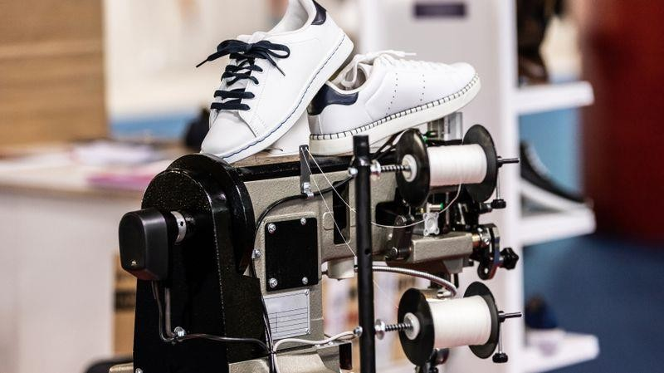
DecideWhatShoestoSell,Design,andProduceThem

Therearetwodistinctapproachesto designingashoeline:
  - Manufacture the footwear from scratch. That will require designing the whole shoe, sourcing materials, manufacturing, and keeping an initial inventory.
  - Focus on the design and outsource the production. Print on demand will allow you to create your shoe line inno time, withno upfront costs. Focusondesigning and creating while print providers willproduce and print the footwear.

Partnering with Printify will make that possible, as we have the largest network of print providers and a catalog withover 750products.Here’showto start acustomshoebusinessusing Printifywithno money: CreateaPrintifyAccount
20
Go tothe Printify homepage, click Start selling, and createanaccount. Use a Google account or anemail address.SignintoPrintifyforfreewithunlimitedproductsanduptofivestoresperaccount.

Small businesses can escalate with the Premium plan($24.99 monthly billed annually), which offers uptotenstoresperaccountanduptoa20%discountonallproducts.

TheEnterpriseplan,formerchantswithmorethan10,000ordersaday,offersunlimitedstores, a 20% discount on all products, and custom pricing.

IntegrateaSalesChannel
Choosethesalechannelwhereyouhaveanonlineshoestore.Printifyintegrates withShopify,Etsy,eBay,PrestaShop,BigCommerce,Wix,WooCommerce,Squarespace,ora custom API.

Depending onthe channel, you may be required to create a standalone website and payfor subscriptions. Shoe selling on marketplaces like Etsy and eBay will demand no such costs, although each listing onEtsy will cost $0.20 to be published.

ChooseandDesignYourCustomFootwear
Pickashoeinourcatalogandselecttheclosestprintprovider.

Sneakers
Get morecustomerswithour classic,low-top,high-top,or sportscustomsneakeroptions.
- ClassicSneakers(polyestercanvas,lowtop) –forwomenandmen

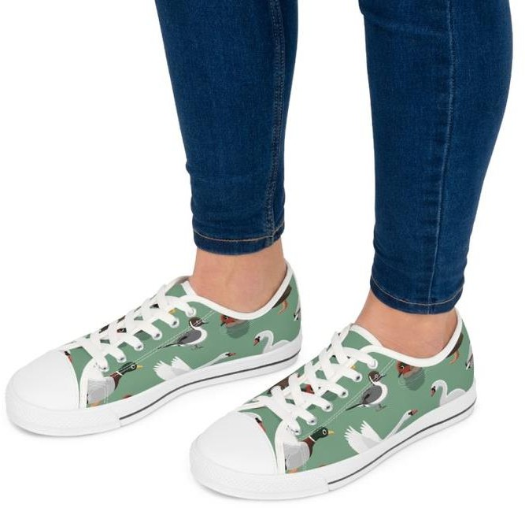

Fullycustomizable, orderthese classic sneakers withwhite orblack laces and soles, while it’s possible to print different images on the left side, right side, and tongue.
21
TherubberoutsolepairswithanEVAshock-absorbinglayerandahi-polydeodorantmemoryfoam insole.
Men’ssneakersrun biggerthanusual–it’ssuggestedtosizedown.
  - From$27.61
- ClassicSneakers(polyestercanvas,5”calfheight)–forwomenandmen
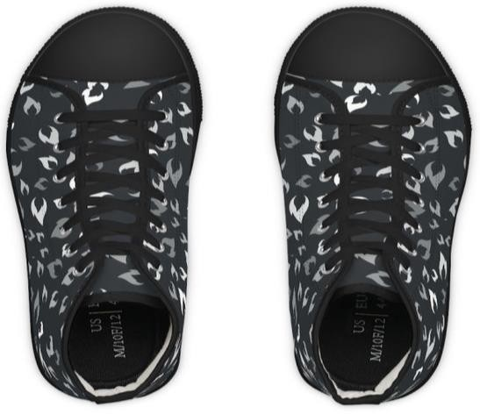

Theseclassichigh-topsneakersarefullycustomizable,canbeorderedwithwhiteorblacklacesand soles, and can be printed differently on the left, right, and tongue.
They come with a rubber outsole, an EVA shock-absorbing layer, and a hi-poly deodorant memory foam insole.
  - From$29.85
- Sneakers(nyloncanvas,lowtop)–forwomenandmen
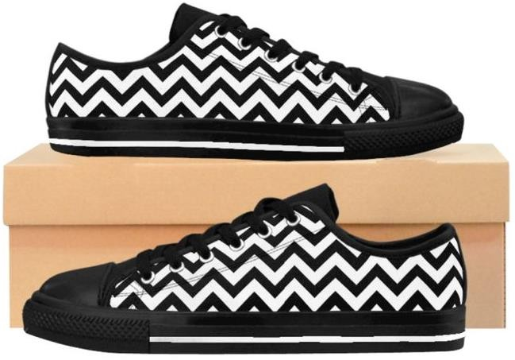

These25.71 oz. nyloncanvassneakersare lightweight andcomfortable. Theycomewitharubber outsole and a black interior. This canvas material is not suitable for smalland detailed prints.
  - For women–from$37.31
  - Formen– runssmallerthanusual,suggested to size up.From$38.81.
- ClassicSneakers(nyloncanvas,5”calfheight)–forwomenandmen

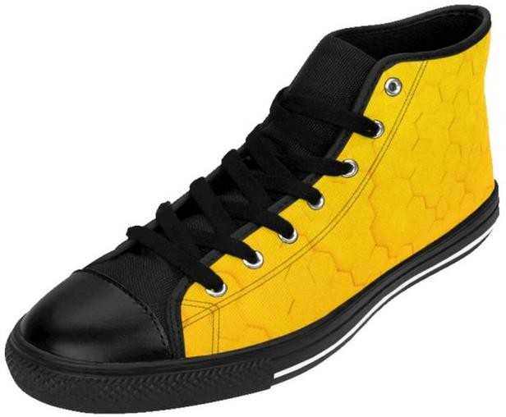

Slightly sturdier thanthe low tops,these sneakers retain comfort and style with a 27.87oz. nyloncanvas. The black inside interior accompanies a rubber outsole. The nylon canvas isn’t suitable for small prints.
For men,thesneakersrunsmallerthanusual–wesuggestsizing up.
  - From$38.81

- Men’s MeshSportsSneakers
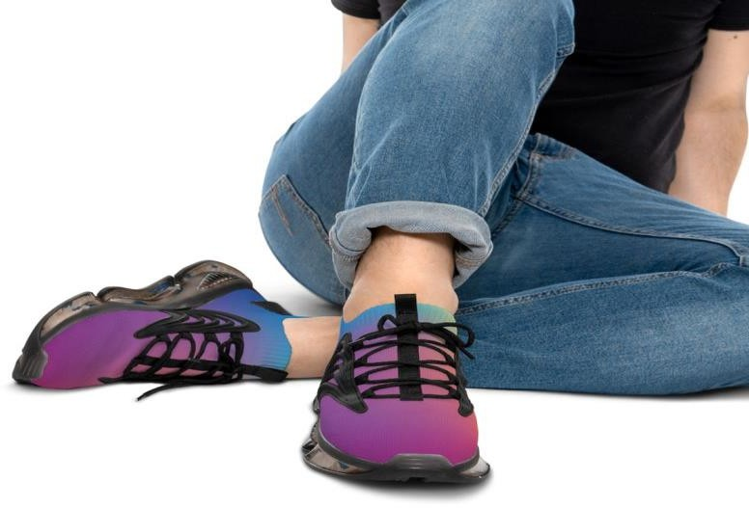

These sports shoes are fabricated with the industry standard material for sports footwear – a breathable meshpolyester and a layered sole fromTPU and EVA for extended durabilityand shock absorption. The insoles are breathable deodorant memory foam.
  - From$34.33

Boots
- MartinCanvasBoots

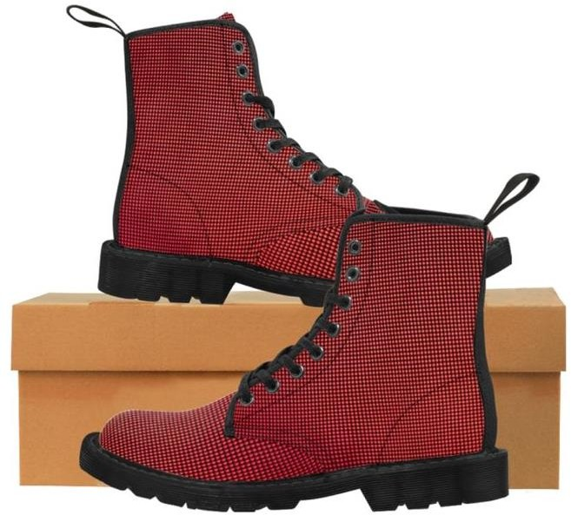

Classicandstylish,theirsurfaceismadefrom amesh nylonfabricandfoamedliningforsoftnessand comfort. The men’s boots fabric is slightly heavier to increase durability.
Theoutsolesarerubber– translucentbrown rubberorblackgum rubber,whilethefoamedinsolesare anti-heat, anti-moisture, and anti-corrosion.
Thebootshaverearpull-loops,black(withtheblacksoles)or yellow(withthebrownsoles).
  - Women– 30.69oz.nyloncanvas.From$61.19
  - Men–37.74oz.nyloncanvas.From$64.18

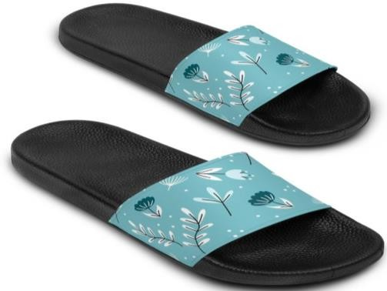
Sandals
SlideSandals

WithoutsolesmadeofdurablePVCfoamandquick-dryingprintablestraps,theseslidesandalsare comfortable, durable, and customizable.

Forwidefeet,werecommendsizingup.
  - Women–from$28.51
  - Men–from$34.33
Wanttogofurther?Checkouroptionsforcustomslippersandflip-flops.

PublishandStartSelling
UsetheProduct Creatorto customizethechosenfootwearandapplydesignsbyclicking StartDesigning. After applying your design and picking the colors, click Save product.

Nowit'stimetoedit thedescriptionsanddefinetheprofit margin.Useappropriate keywordswhen possible.

Finally,choosethemainshoe’smockuppictureandcolor.

Once you’vecompletedthedesigningandproductcreation,click Publish.Theproductwillbedisplayed automatically in the integrated online shoe store.

DevelopanOnlineMarketingStrategyforYourShoeCompany
Digital marketing will be fundamental in promoting your eCommerce business and getting new customers. Explore the marketing resources offered by your eCommerce platform, especially the following:
  - Social media is free. Create integrated business accounts for your shoe brand on several platforms to reach potential customers. Post consistently according to the platform’s audience, alternating between promotional posts and educational content explaining features of your brand.

Instagramreachesaudiences younger thanFacebook. Pinterest isanexcellent place foronline marketing, especially if you own an online storeon Etsy. Consider TikTok, aiming to reach your niche.

Use social media to gather email addresses in exchange for promotional codes, coupons, or free ebooks, but be sure to ask permission before sending emails.
  - Use tools likeMailchimpto createemail marketingcampaigns. Mailchimp’s free plangives a subdomain for free website building in a Mailchimp subdomain, analytics, campaigns, or automations.
Besidessocial media, get emailaddresseson your webpage, always trading them for something ofvalue. Make it easier for the customers to subscribe with widgets on websites and buttons in Facebook shops.

Sendpromotionaland informative emails. Informative emails let the customers know about order status and shipping and are usually automated by any e-Commerce platform. Promotional emails can promote seasonal offers, inform of new products, or bring back lost customers.
  - Lastbutnotleast, optimizingSEOandcontentgeneratesorganictraffic.Researchforkeywordsrelated to your target audience with Google Trends (see Step 2), and apply the keywords in every piece of content, from descriptions of products to alt texts and blog posts.
Different platforms will provide specific marketing possibilities. Stay in the loop with updated articles for:
  - Creatingadsfor Facebook, Instagram
  - ImprovingShopify’s SEO
  - BoostingWooCommerceSEO
  - MarketingstrategiesforEtsy
MultichannelandOmnichannelmarketing strategies

