To


TECHNICAL REPORT
ON
STUDENT INDUSTRIAL WORK EXPERIENCE SCHEME (SIWES)

HELD AT
AKINYELE LOCAL GOVERNMENT
LG SECRETARIAT PREMISES, MONIYA, OYO STATE
PRESENTED BY
IGE SAMSON BAMIDELE
ND/23/PAD/PT/0434
SUBMITTED TO
DEPARTMENT OF PUBLIC ADMINISTRATION,
INSTITUTE OF FINANCE AND MANAGEMENT STUDIES
KWARA STATE POLYTECHNIC, ILORIN

IN PARTIAL FULFILLMENT OF THE AWARD OF NATIONAL DIPLOMA (ND) IN PUBLIC ADMINISTRATION
AUGUST – NOVEMBER 2024
TABLE OF CONTENT
Title page
Dedication
Acknowledgement
Abstract
CHAPTER 1: INTRODUCTION
1.1 Student Industrial Work Experience Scheme
1.2 Aim of the Study
1.3 The Role of the Industrial Training Fund
1.4 The Scope and Importance of SIWES
1.5 The Role of the Student and the Institution
1.6 Relevance to Business Administration
CHAPTER 2: ORGANIZATIONAL PROFILE AND INDUSTRY CONTEXT
2.1 Company Overview
2.2 Historical Background of Akinyele Local Government
2.3 Economic Activities in Akinyele Local Government
2.4 Infrastructure and Facilities in Akinyele Local Government
2.4.1 Road and Transportation Network
2.4.2 Education
2.4.3 Healthcare Services
2.4.4 Hospitality and Recreation
2.5 Administrative Structure of Akinyele Local Government
2.6 Mineral Resources in Akinyele Local Government
2.7 Structure of the Local Government Council
CHAPTER 3: PERSONAL EXPERIENCE AND TASKS PERFORMED
3.1 Overview of Administrative Office Experience
3.2 Administrative Operations and Record-Keeping
3.3 Communication and Stakeholder Engagement
3.4 Customer Service and Public Interaction
3.5 Data Management and Ethical Considerations
3.6 Methods Adopted in Acquiring Practical Industrial Experience
3.7 Jobs Undertaken During SIWES
CHAPTER 4: SUMMARY, CONCLUSION, AND RECOMMENDATIONS
4.1 Analysis of SIWES Experience
4.2 Summary of Skills Acquired
4.2.1 Administrative and Office Management Skills
4.2.2 Communication and Customer Service
4.2.3 Data Management and Ethical Considerations
4.2.4 Time Management and Teamwork
4.2.5 Governmental Structure and Policy Implementation
4.3 Challenges Encountered
4.4 Recommendations
4.5 Conclusion
DEDICATION
This work is dedicated to the Almighty God, for their love, mercies, guidance and protection during and even after this work.
This work is also dedicated to my lovely and caring parents and wonderful brothers and sisters for their love, support and encouragement.

ACKNOWLEDGEMENT
I wish to acknowledge and thank everyone who contributed one way or the other towards the success of my industrial training.
My special thanks goes to the management of and my supervisor for their numerous contribution and effort to make this research a success.
Also my beloved mother and my colleagues for giving me the great opportunity.
I want to say a big thanks to my siblings and my friends for their support and love also my friends for their encouragement and advice.

ABSTRACT
The Student Industrial Work Experience Scheme (SIWES) is a critical initiative designed to bridge the gap between theoretical education and practical workplace experience for students in Nigerian tertiary institutions. This report provides a comprehensive account of my SIWES training at Akinyele Local Government, where I was assigned to the Administrative Department. The objective of the program was to expose students to real-life work environments, develop essential workplace skills, and enhance their understanding of public administration. During the training period, I actively participated in various administrative tasks, including record-keeping, document management, stakeholder communication, data handling, and customer service. The experience allowed me to understand the structure and functions of local government, observe policy implementation processes, and engage with employees and the public. Through these tasks, I developed key skills such as effective communication, time management, teamwork, and ethical data management, all of which are essential for a career in business administration. While the experience was highly beneficial, I encountered challenges such as bureaucratic delays, limited access to digital tools, and high workload due to understaffing. However, I was able to navigate these difficulties by applying problem-solving strategies and observing workplace best practices. The report concludes with an analysis of the skills acquired, the challenges faced, and recommendations for improving SIWES experiences in administrative settings. Key recommendations include digitization of administrative processes, improved interdepartmental communication, provision of modern office infrastructure, and better engagement of SIWES students in decision-making processes.
CHAPTER 1
1.1 STUDENT INDUSTRIAL WORK EXPERIENCE SCHEME
The Students Industrial Work Experience Scheme (SIWES), is a skills Development programme initiated by the Industrial Training Fund (ITF), in 1973 to bridge the gap between theory and practice among students of Engineering and technology in Institutions of Higher Learning in Nigeria. It provides for on-the-job practical experience for students as they are exposed to work methods and techniques in handling equipment and machinery that may not be available in their Institutions.
SIWES was established by ITF in 1973 to solve the problem of lack of adequate practical skills preparatory for employment in industries by Nigerian graduates of tertiary institutions.
The Scheme exposes students to industry based skills necessary for a smooth transition from the classroom to the world of work. It affords students of tertiary institutions the opportunity of being familiarized and exposed to the needed experience in handling machinery and equipment which are usually not available in the educational institutions.
Participation in SIWES has become a necessary pre-condition for the award of Diploma and Degree certificates in specific disciplines in most institutions of higher learning in the country, in accordance with the education policy of government.
Duration – Four months for the Polytechnics.
1.2 AIM OF THE STUDY
The Student Industrial Work Experience Scheme (SIWES) plays a crucial role in bridging the gap between theoretical knowledge acquired in the classroom and the practical demands of the modern workplace. It allows students to immerse themselves in real-world environments, applying their academic learnings to real-life situations.
Practical Application: SIWES provides a platform for students to apply the theoretical concepts they have learned in their academic programs to real-world scenarios. This hands-on experience solidifies their understanding and helps them develop a deeper appreciation for the practical implications of their studies.
Industry Exposure: Through SIWES, students gain valuable exposure to modern technology, tools, and industry processes. They get to witness firsthand how their field of study is applied in the real world, gaining insights into the latest trends and advancements.
Skill Enhancement: SIWES is instrumental in enhancing students' practical skills and preparing them for the challenges of the modern job market. It allows them to develop essential skills such as problem-solving, teamwork, communication, and time management, all of which are highly valued by employers.
IMPORTANCE OF SIWES:
Industry-Academia Collaboration: SIWES fosters a strong relationship between educational institutions, employers, and the Industrial Training Fund (ITF). This collaboration ensures that academic programs are aligned with industry needs, and that students are equipped with the skills and knowledge required by the workforce.
Professional Development: SIWES equips students with practical knowledge and skills that are essential for their professional development. This real-world experience helps them gain confidence, build their resumes, and become more competitive in the job market.
Real-Life Experience: SIWES provides a platform for students to gain valuable real-life experience before entering the workforce. This experience allows them to test their skills, explore different career paths, and gain a better understanding of the industry they are pursuing.
1.3 THE ROLE OF THE INDUSTRIAL TRAINING FUND
The Industrial Training Fund (ITF) was established by the decree 47 of 1971 constitution and charged with the responsibility of promoting and encouraging the acquisition of industrial skills, with the view of generating a collection of indigenous trained manpower, sufficient enough to enhance and meet the needs of the economy so as to promote development. Supervision of students, organizing orientation programs, and disbursing allowances to students are some of the roles played by the industrial training fund in the implementation of SIWES.
1.4 THE SCOPE AND IMPORTANCE OF SIWES
The scheme covers all science and technological based students in monotechnics, polytechnics and universities in Nigeria, resulting in a high population of students which is easily managed because of the public and private industries that partake in the scheme. SIWES enables students acquire industrial know-how in their field of study particularly in technological based courses. It also enables students experience the application of theoretical knowledge in solving real life problems.
1.5 THE ROLE OF THE STUDENT AND THE INSTITUTION
The role of the student is to partake in the program in such a way that he/she will achieve maximum benefit from the program. The student is advised to ask questions, be submissive, and adhere to all the rules and regulations of the organization where he is attached. Identification of placement opportunities, funding of SIWES supervisors and assessment of the student are some of the roles played by the institutions to ensure smooth running of the program.

1.6 RELEVANCE TO BUSINESS ADMINISTRATION
For a Business Administration student, SIWES is an invaluable opportunity to gain insight into how organizations are managed. During my attachment at ADBAQ Information and Technology, I worked in the administrative unit, where I observed and participated in activities central to effective business management. These experiences included document management, human resource functions, financial support tasks, and interdepartmental coordination, all of which are critical to understanding the operational dynamics of a modern organization.
CHAPTER TWO: ORGANIZATIONAL PROFILE AND INDUSTRY CONTEXT
2.1 COMPANY OVERVIEW
This chapter provides a comprehensive overview of Akinyele Local Government, covering its historical background, economic activities, infrastructure, and administrative structure. The following chapters will delve into my SIWES experiences, assignments, skills acquired, and recommendations for improvement.
2.2 HISTORICAL BACKGROUND
Akinyele Local Government was established in 1976 during the military regime of General Murtala-Obasanjo. It was originally carved out of Ibadan Municipal Government. In 1989, Ido Local Government was further created from Akinyele, leaving it with its present structure of 12 wards and its headquarters at Moniya.
The local government is bordered by Lagelu Local Government to the east, Afijio Local Government to the north, Ibadan North Local Government to the south, and Ido Local Government to the west. As of the 2006 census, Akinyele Local Government had a population of 211,811, comprising 105,594 males and 106,217 females, with an annual population growth rate of 4.14%. The local government covers an area of approximately 222 square kilometers.
Akinyele Local Government is highly heterogeneous and metropolitan, particularly in areas such as Ojoo, Orogun, Sasa, Moniya, and Akinyele, where people from various ethnic backgrounds and foreign nationals reside. The local government is also home to several institutions of national and international significance, including:
• Nigeria Institute of Social and Economic Research (NISER)
• International Institute of Tropical Agriculture (IITA)
• Federal School of Statistics
• Proposed Dominican University
• Second Mechanised Division (Odogbo Cantonment)
• University of Ibadan (Apete axis)
2.3 ECONOMIC ACTIVITIES IN AKINYELE LOCAL GOVERNMENT
The primary economic activities in Akinyele Local Government include:
1. Agriculture – The local government is one of the major agricultural hubs in Oyo State, producing crops such as cocoa, palm products, plantain, banana, cassava, yam, maize, and citrus. Poultry farming and animal husbandry are also widely practiced.
2. Artisan and Trade – Many residents engage in craftwork, blacksmithing, carpentry, and trading.
3. Transportation – Due to its strategic location as a gateway to Ibadan Akinyele Local Government has several major transportation hubs, including motor parks and trailer parks.
4. Meat Processing – Akinyele is home to a central butchery and abattoir, which supplies approximately 1,000 metric tons of cow meat daily, contributing significantly to the economy of the state.
5. Tourism – The area boasts several historical and cultural landmarks, including Bowen’s Tomb and Ope Ijaye from the Kurunmi War.2.5
2.4 INFRASTRUCTURE AND FACILITIES IN AKINYELE LOCAL GOVERNMENT
2.4.1 ROAD AND TRANSPORTATION NETWORK
Akinyele Local Government has an extensive road network, including:
• Trunk A Roads – Ibadan–Ilorin Road and Ibadan–Oyo Road.
• Trunk B Road – Ibadan–Iseyin Road.
• Trunk C Roads – Over 500,000 kilometers of local roads.
• Railway Network – The Lagos-Kano/Sokoto railway passes through Akinyele, with plans for a dry port under construction.

1.4.2 EDUCATION
The local government has a well-structured educational system with:
• 123 public primary schools
• 50 private primary schools
• 12 public secondary schools
• 20 private secondary schools
2.4.3 HEALTHCARE SERVICES
The healthcare sector in Akinyele Local Government includes:
• 1 General Hospital
• 28 Primary Health Centers
• 1 Tuberculosis and Leprosy (TBL) Clinic
• 1 Dental Center
• 18 Private Hospitals
• 5 Private Maternity Centers
2.4.4 HOSPITALITY AND RECREATION
There are approximately 50 hotels and guest houses within the local government, catering to visitors and business travelers.
2.5 ADMINISTRATIVE STRUCTURE OF AKINYELE LOCAL GOVERNMENT
Akinyele Local Government has been subdivided into three administrative councils:
1. Akinyele Main Local Government (Headquarters at Moniya)
2. Akinyele East LCDA (Headquarters at Ikereku)
3. Akinyele South LCDA (Headquarters at Igbo Oloyin)
Each of these councils consists of multiple wards:
• Akinyele Local Government (4 wards) – Moniya, Ijaye, Alabata, Olorisaoko.
• Akinyele South LCDA (2 wards) – Igbo Oloyin, Ojoo.
• Akinyele East LCDA (6 wards) – Ikereku, Pade-Olanla, Onidundu, Akinyele, Iwokoto, Iroko.
The local government consists of historic Yoruba settlements such as Ikereku, Iroko, Ijaye, and Akinyele, which were established by ancient warlords from Oyo and Ile-Ife.

2.6 MINERAL RESOURCES IN AKINYELE LOCAL GOVERNMENT
Akinyele Local Government is rich in mineral resources, particularly granite, which is of high quality and suitable for construction. Major granite deposits are found in Sasa, Ijaye, and Mele.
2.7 STRUCTURE OF THE LOCAL GOVERNMENT COUNCIL
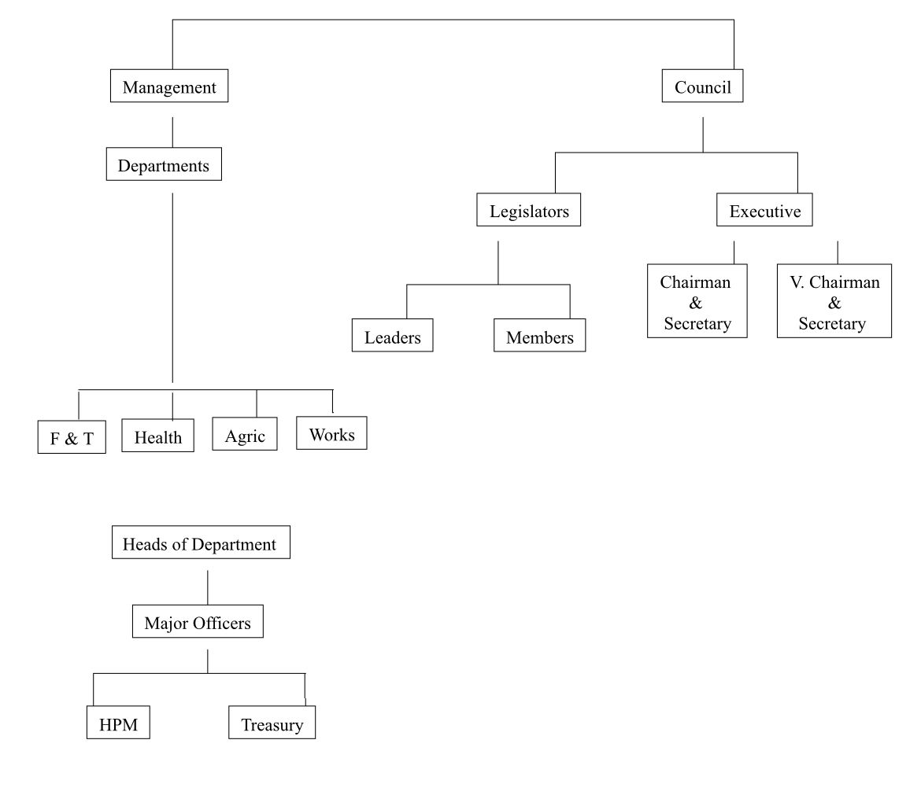
CHAPTER THREE: PERSONAL EXPERIENCE AND TASKS PERFORMED
3.1 OVERVIEW OF ADMINISTRATIVE OFFICE EXPERIENCE
During my SIWES program at Akinyele Local Government, I was assigned to the Administrative Department, where I gained firsthand experience in public administration and office management. My training exposed me to various responsibilities, including record-keeping, communication, stakeholder engagement, customer service, and datamanagement.
3.2 ADMINISTRATIVE OPERATIONS AND RECORD-KEEPING
One of my primary responsibilities was assisting in organizing and managing official documents. I learned how to properly categorize, archive, and retrieve records for efficient decision-making and compliance with government policies. Proper documentation ensures transparency, accountability, and effective service delivery in public administration.
3.3 COMMUNICATION AND STAKEHOLDER ENGAGEMENT
Communication is a critical component of public administration. I had the opportunity to interact with government officials, employees, and community members, improving my ability to communicate clearly and professionally. I observed how effective communication facilitates seamless collaboration between different government units and helps implement policies efficiently.
3.4 CUSTOMER SERVICE AND PUBLIC INTERACTION
A significant part of my work involved assisting the public with inquiries and providing relevant information about government services. This experience reinforced the importance of excellent customer service in building trust between the government and the citizens. I learned to handle complaints, provide solutions, and ensure that citizens received the assistance they needed.
3.5 DATA MANAGEMENT AND ETHICAL CONSIDERATIONS
I was responsible for handling sensitive government data, ensuring confidentiality, accuracy, and integrity. Ethical considerations, such as maintaining transparency and respecting privacy, were emphasized throughout my training.
3.6 METHODS ADOPTED IN ACQUIRING PRACTICAL INDUSTRIAL EXPERIENCE
During my SIWES training, I applied various learning methods, including:
1. Interviews and Discussions – Engaging with senior staff to understand administrative processes.
2. Observation – Studying office procedures, staff interactions, and work ethics.
3. Inspection of Records – Reviewing documents and learning proper filing systems.
4. Participation – Assisting with office tasks such as typing, document sorting, and public service duties.
3.7 JOBS UNDERTAKEN DURING SIWES
I was assigned to the General Administration Division, where I performed tasks such as:
• Receiving and Recording Mails – Handling incoming and outgoing correspondence.
• Dispatching Official Documents – Delivering memos, circulars, and official letters to relevant departments.
• Staff Monthly Verification – Assisting in payroll verification and record updates.
• Assisting in Office Management – Organizing files, maintaining registers, and ensuring proper documentation.

CHAPTER 4: ANALYSIS, SUMMARY CONCLUSION, AND RECOMMENDATIONS
CHAPTER FOUR: ANALYSIS, SUMMARY, CONCLUSION, AND RECOMMENDATIONS
4.1 ANALYSIS OF SIWES EXPERIENCE
The Student Industrial Work Experience Scheme (SIWES) at Akinyele Local Government provided me with invaluable practical exposure to public administration. My engagement in various administrative functions allowed me to bridge the gap between theoretical learning and real-world applications. The experience helped me develop essential workplace skills such as document management, stakeholder communication, customer service, and ethical handling of government records.
One of the most significant aspects of my training was understanding how local government functions in providing essential services to the public. I was actively involved in tasks that contributed to the efficiency of administrative processes, such as filing official documents, responding to inquiries, and ensuring seamless communication between departments. This hands-on experience enhanced my organizational skills and provided a deeper understanding of government policies and procedures.
Moreover, my involvement in record-keeping and office management helped me appreciate the importance of transparency and accountability in public administration. I learned that proper documentation not only enhances efficiency but also prevents bureaucratic delays. The use of structured filing systems and digital records was an eye-opener on how data management contributes to governance and policy implementation.
Interacting with staff and supervisors in different departments also broadened my knowledge of workplace ethics, time management, and professional conduct. The exposure to real-world administrative challenges and their solutions was instrumental in shaping my understanding of public service.

4.2 SUMMARY OF SKILLS ACQUIRED
Throughout my SIWES program, I acquired and improved various skills that are critical in public administration, including:
1. Administrative and Office Management Skills
• Efficient handling of official correspondence and documentation
• Filing and retrieval of government records
• Processing and dispatching official documents
2. Communication and Customer Service
• Effective verbal and written communication
• Engaging with members of the public and government officials
• Providing relevant information and addressing inquiries
3. Data Management and Ethical Considerations
• Maintaining confidentiality in handling government data
• Ensuring accuracy and integrity in record-keeping
• Observing ethical standards in public service
4. Time Management and Teamwork
• Prioritizing tasks to ensure efficiency in daily operations
• Working collaboratively with colleagues and supervisors
• Adapting to a structured office environment
5. Governmental Structure and Policy Implementation
• Understanding the hierarchy and functions of local government
• Observing policy formulation and execution at the grassroots level
• Recognizing the role of local government in community development

4.3 CHALLENGES ENCOUNTERED
Despite the wealth of knowledge and experience gained during my SIWES training, I encountered some challenges that are common in public administrative settings. These included:
1. Limited Access to Digital Tools
• Some aspects of record-keeping were still manually handled, which made data retrieval time-consuming.
2. Bureaucratic Procedures
• Processing official documents often required multiple levels of approval, leading to delays.
3. Inadequate Office Infrastructure
• Insufficient office space and outdated equipment sometimes made tasks challenging.
4. High Workload and Limited Staff
• The volume of administrative work was often overwhelming, and limited staff strength made task execution slower.
5. Communication Barriers
• Some departments had challenges with internal communication, which sometimes delayed information dissemination.
4.4 RECOMMENDATIONS
Based on my experience, I suggest the following improvements to enhance the efficiency of administrative processes in Akinyele Local Government and improve future SIWES training experiences:
1. Integration of Digital Systems
• The government should adopt more digital record-keeping systems to improve efficiency and reduce paperwork.
2. Capacity Building for Staff and Interns
• Regular training programs should be conducted to enhance the skills of government employees and SIWES participants.
3. Infrastructure Improvement
• Provision of modern office equipment, computers, and additional office space will improve work efficiency.
4. Enhancing Interdepartmental Communication
• The use of email and internal messaging systems should be encouraged to ensure quick and seamless communication between departments.
5. More Student Engagement in Decision-Making Processes
• SIWES students should be given opportunities to participate in problem-solving and administrative planning sessions.
6. Provision of Stipends for Interns
• Interns should be given financial incentives to encourage active participation and cover transportation and feeding costs.
7. Encouragement of Public-Private Collaboration
• The local government should explore partnerships with private organizations to improve service delivery and provide additional internship opportunities.

4.5 CONCLUSION
The Student Industrial Work Experience Scheme (SIWES) at Akinyele Local Government was a transformative experience that provided me with practical exposure to public administration. Through this training, I was able to apply my theoretical knowledge in real-world scenarios, enhancing my understanding of governance, office management, and effective service delivery.
Despite the challenges faced, the experience was highly beneficial, as it equipped me with vital skills needed for a career in business administration or public service. The exposure to governmental operations, administrative processes, and stakeholder engagement has broadened my perspective and prepared me for future professional opportunities.
In conclusion, SIWES remains an essential program for bridging the gap between academics and industry practice. With continuous improvements in infrastructure, digital transformation, and better engagement of students, the program will continue to produce well-rounded graduates ready to contribute to national development.

