

A TECHNICAL REPORT
STUDENT INDUSTRIAL WORKING EXPERIENCE SCHEME
(SIWES)

Held at

Prepared by:
SAKARIYAU SULIYAT OMOWUMI
ND/23/PAD/PT/0748

Held at
OLAIYA MULTI-GLOBAL COMPANY (OLAIYA PLAZA)
KM1 OLAIYA PLAZA, OLD JEBBA ROAD, KUNLENDE AREA ILORIN, KWARA STATE
SUBMITTED TO

DEPARTMENT OF PUBLIC ADMINISTRATION
INSTITUTE OF FINANCE AND MANAGEMENT STUDIES
KWARA STATE POLYTECHNIC, ILORIN

INPARTIAL FULFILLMENT OF THE AWARD OF THE REQUIREMENT OF THE AWARD OF NATIONAL DIPLOMA IN PUBLIC ADMINISTRATION

2024/2025

DEDICATION
I dedicate this technical report to the Almighty GOD, the giver of knowledge, wisdom and who is rich in mercy.

TABLE OF CONTENT
Title page
Table of content
Dedication
CHAPTER ONE
  - Background of SIWES
  - History of SIWES
  - Objectives of SIWES
  - Objectives of Establishment
CHAPTER TWO
2.1. Introduction to the Company
CHAPTER THREE
3.1 Some Equipment and Their Uses
CHAPTER FOUR
4.1 Conclusion and Recommendations
4.2 Recommendations

CHAPTER ONE
  - INTRODUCTION TO SIWES
Students Industrial Work Experience Scheme (SIWES) is a Skills Training Program designed to prepare and expose Students of Universities, Polytechnics, Colleges of Technology, Colleges of Agriculture and Colleges of Education for the Industrial Work situation they are likely to meet after graduation. The Scheme affords Students the opportunity of familiarizing and exposing themselves handling equipment and machinery that are usually not available in their institutions.

1.2 HISTORY OF SIWES
The Students’ Industrial Work Experience Scheme (SIWES) was initiated in 1973 by the Federal Government of Nigeria under the Industrial Training Fund (ITF) to bridge the gap between theory and practice among products of our tertiary Institutions. It was designed to provide practical training that will expose and prepare students of Universities, Polytechnics, and Colleges of Education for work situation they are likely to meet after graduation.
Before the establishment of the scheme, there was a growing concern among the industrialists that graduates of institutions of higher learning lacked adequate practical background studies preparatory for employment in industries. Thus the employers were of the opinion that the theoretical education going on in higher institutions was not responsive to the needs of the employers of labour.
As a result of the increasing number of students’ enrolment in higher institutions of learning, the administration of this function of funding the scheme became enormous, hence ITF withdrew from the scheme in 1978 and was taken over by the Federal Government and handed to National Universities commission (NUC), National Board for Technical Education (NBTE) and National Commission for Colleges of Education (NCCE). In 1984, the Federal Government reverted back to ITF which took over the scheme officially in 1985 with funding provided by the Federal Government.

1.3 OBJECTIVES OF THE PROGRAMME
The specific objectives of SIWES are to:
- Provide placements in industries for students of higher institutions of learning approved by relevant regulatory authorities (NUC, NBTE, NCCE) to acquire work experience and skills relevant to their course of study
- Prepare students for real work situation they will meet after graduation.
- Expose students to work methods and techniques in the handling of equipment and machinery that may not be available in schools.
- Make transition from school to the labour market smooth and enhance students’ conduct for later job placement
- Provide students with the opportunity to apply their knowledge in real life work situation thereby bridging the gap between theory and practice
- Strengthen employer involvement in the entire educational process and prepare students for employment in industry
Promote the desired technological knowhow required for the advancement of the nation.
1.4 OBJECTIVES OF ESTABLISHMENT
- Network security
Protecting the network and infrastructure from unauthorized access, disruptions, and other abuses. Companies can use centralized sign-on security systems to prevent unauthorized devices from joining the network.
- Reduce downtime and improve network availability
A well-documented network configuration can help simplify the process of identifying and resolving issues, reducing downtime, and maintaining business continuity
- Performance
Ensuring that the network is delivering by establishing metrics to measure performance. Continuous analysis of performance helps ensure that policies are being followed and business objectives are being met.
- Communication and collaboration
Computer networking services can facilitate communication and collaboration among employees, regardless of their physical location.

CHAPTER TWO
2.1. INTRODUCTION TO THE COMPANY
OLAIYA metal works Nigeria Ltd head office is located at no 4 orilowo avenue old jebba road sango Ilorin Kwara state branch show room at Olaiya plaza kilometer 1 sango old jebba road Ilorin.
Tel: 08033738901 08033861331
Specialized In Furniture, fitting furniture, home


- I was introduce to the customer service
- I was introduced to organization structure, office and their functions
An organizational structure is a system that defines how a company operates, including how employees are grouped, their roles, and how they communicate. It also outlines how tasks are delegated to achieve the company's goals.
TYPES OF ORGANIZATIONAL STRUCTURES
- Centralized: A top-down structure where employees report directly to their manager
- Decentralized: A structure where employees at different levels collaborate to make decisions
- Functional: A structure where employees with similar skills and knowledge work together in departments
- I was thought about manufacture ergonomic and stylish office furniture that promotes productivity, comfort, and employee well-being.
- I was thought about constructs high-quality tanks for various industries, including oil and gas, water treatment, and chemical processing.
- I was thought about rough iron work services, including fabrication, welding, and installation.
- I was thought about school desk chairs that cater to the needs of students and educational institutions.
- I was thought about agricultural machineries that meet the needs of farmers and agricultural businesses.
- I was thought about installs secure and stylish doors and window railings for residential, commercial, and industrial buildings.
- I was thought about burglary-proof solutions, including doors, windows, and grilles.
- I was thought about home interior solutions, including decorative features, railings, and furniture.

CHAPTER THREE
3.1 SOME EQUIPMENT
- Home Interior

- Building of Burglary Proof

- Keys for Various Applications
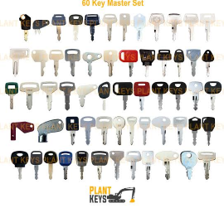
- A Variety of Iron Products
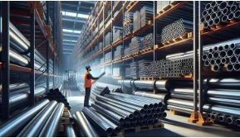

Office Furniture


Construction of Tanks
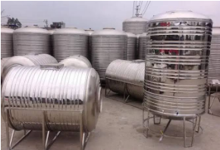

Rough Iron Work


Schools Desk Chairs
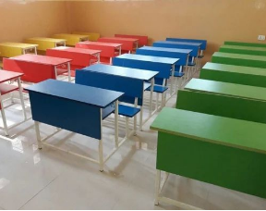
white or color, at the same size, reduced, or enlarged
- Telephones: Used for communication


- Software: Used for word processing, spreadsheets, databases, and email

Record Of Service
A record of service is a collection of documents that record a person's activities and accomplishments while working for an organization. It can be electronic or printed.
Examples of service records:
- Employment records: Records that contain information about an individual's employment history, including length of service, age, and work status
- Client records: Records that contain information about services provided to a client

CHAPTER FOUR
4.0 CONCLUSION AND RECOMMENDATIONS
4.1 CONCLUSION
Having passed through the SIWES training, have been able to discover and explore different things about the microbial world; therefore, its usefulness cannot be over – emphasized. The interesting part of this is that the field of microbiology has gotten answer to most of the infection and disease affecting the world. For the few infections that has not been diagnosed, precautionary measures that can be taken against it has been discovered. The only section left is for people should come out of their ignorance and go for medical check – up instead of relying on self – medication and visiting unqualified practitioners, if people could visit hospitals or health – centers frequently and follow the treatments given to them, mortality rate will drastically be reduced and the health status of the nation will be promoted.
More importantly I have been able to see the various prospects available in the field and also the various challenges that call for quick attention. Indeed, the industrial training program has been impactful; it was never a waste of time and energy.

4.2 RECOMMENDATIONS
The effort of the industrial training fund (ITF) was recommended for bringing up this programme known as student industrial work scheme (SIWES). This has paved way for self practice of the theoretical works that have been taught during lectures.

