

TECHNICAL REPORT

ON

STUDENT INDUSTRIAL WORK EXPERIENCE
SCHEME (SIWES)

HELD AT

KWARA STATE MINISTRY OF ENERGY,
ILORIN
BY

ADEBAYO TOLUWANIMI BOLUWATIFE
ND/23/MCT/FT/0023

SUBMITTED TO

THE DEPARTMENT OF MECHATRONIC ENGINEERING TECHNOLOGY
INSTITUTE OF TECHNOLOGY
KWARA STATE POLYTECHNIC, ILORIN
IN PARTIAL FULFILMENT OF THE REQUIREMENTS FOR THE AWARD OF NATIONAL DIPLOMA IN MECHATRONIC ENGINEERING TECHNOLOGY
.

JANUARY, 2025
CERTIFICATION
This is to certify that the bearer has successfully completed the Student Industrial Work Experience (SIWES).

_________________________ ___________
Department Cordinator Date

________________________ ____________
SIWES Director Date

DEDICATION
This report is dedicated to the almighty God, the giver and sustainer of life, for His unconditional love and mercy granted to me throughout the period of my Industrial Training.
ACKNOWLEDGMENT
I am deeply grateful to Almighty God for granting me the strength and wisdom throughout my SIWES program. My profound appreciation goes to Kwara State Polytechnic , my Department, and the Industrial Training Fund (ITF) for providing the opportunity to undergo this experience. I also extend my gratitude to the management and staff of Kwara State Ministry of Energy, especially my industry-based supervisor, for their guidance and mentorship.
Lastly, I thank my family and friends for their unwavering support.

TABLE OF CONTENTS
Title Page
Certification
Dedication
Acknowledgement

CHAPTER ONE: INTRODUCTION
1.1 Background of the Study
1.2 Objectives of SIWES
1.3 Importance of SIWES
1.4 Scope of the Report
1.5 Brief History of Kwara State Ministry of Energy

CHAPTER TWO: ORGANIZATIONAL STRUCTURE
2.1 Introduction
2.2 Departments in the Ministry
2.3 Roles and Responsibilities of Each Department
2.4 Supervision and Training System

CHAPTER THREE: DESCRIPTION OF ACTIVITIES DURING TRAINING
3.1 Introduction
3.2 Safety Precautions
3.3 Daily and Weekly Activities
3.4 Tasks Handled and Observations
3.5 Description and Functions of Tools/Equipment Used
3.6 Project Participation and Case Studies

CHAPTER FOUR: TOOLS AND EQUIPMENT USED (WITH IMAGES)
4.1 Introduction
4.2 Multimeter
4.3 Megger Tester
4.4 Transformer Tester
4.5 Cable Stripper
4.6 Circuit Breaker Tester
4.7 Protective Equipment (Helmet, Gloves, Boots)
4.8 Switchgear Panel
4.9 Solar Panel System
4.10 Power Cables and Connectors
Each subsection includes:
- Image of the Tool
- Description
- Function
- Safety Handling Procedures

CHAPTER FIVE: SUMMARY, CONCLUSION AND RECOMMENDATIONS
5.1 Summary of Experience
5.2 Challenges Encountered
5.3 Problem Solving Approach
5.4 Lessons Learned
5.5 Conclusion
5.6 Recommendations

CHAPTER ONE:
INTRODUCTION
1.1 Background of the Study
The Student Industrial Work Experience Scheme (SIWES) is a skills development program designed to expose and prepare students of tertiary institutions for the industrial work situation they are likely to meet after graduation. It enables students to bridge the gap between theory and practical knowledge. The scheme is a planned and supervised training effort that provides students with the opportunity to apply their knowledge and acquire practical experience in real working environments.
The Kwara State Ministry of Energy, headquarters in Ilorin, is responsible for formulating and implementing policies related to power generation, transmission, distribution, and the promotion of renewable energy within the state. The ministry ensures that energy is available and accessible to residents while working towards sustainability and economic development.
1.2 Objectives of SIWES
- To provide an avenue for students to acquire industrial skills and experience during their course of study.
- To expose students to work methods and techniques in handling equipment and machinery that may not be available in their institutions.
- To provide students with the opportunity to apply theoretical knowledge in real-life situations.
- To prepare students for employment and entrepreneurial ventures.

1.3 Importance of SIWES
SIWES plays a critical role in preparing students for employment and making them ready to contribute meaningfully to national development. Through SIWES, students gain firsthand knowledge and experience in their respective fields of study. It enhances their understanding of the industry and provides them with the necessary skills to solve industrial problems.
1.4 Scope of the Report
This report covers the student’s industrial training experience at the Kwara State Ministry of Energy Headquarters. It includes the organizational structure, departments visited, tasks performed, tools and equipment used, safety practices observed, and challenges encountered during the training period.
1.5 Brief History of Kwara State Ministry of Energy
The Kwara State Ministry of Energy was established to provide sustainable energy solutions for the state’s socio-economic development. It has been instrumental in improving electricity access through partnerships with federal agencies, private companies, and international donors. The ministry also plays a key role in promoting solar energy and energy-efficient technologies in both urban and rural areas.

CHAPTER TWO:
ORGANIZATIONAL STRUCTURE
2.1 Introduction
The organizational structure of the Kwara State Ministry of Energy is designed to facilitate effective management and efficient service delivery. The ministry is headed by the Commissioner for Energy, who oversees the activities of various departments and units.
2.2 Departments in the Ministry
- Electrical Department
- Renewable Energy Department
- Planning and Research Department
- Administration and Finance Department
- Monitoring and Evaluation Unit
- Public Relations Unit
2.3Roles and Responsibilities of Each Department
- Electrical Department: Responsible for electrical infrastructure development, maintenance, and supervision of public electrification projects.
- Renewable Energy Department: Focuses on the development and deployment of renewable energy sources such as solar and wind.
- Planning and Research Department: Handles policy formulation, project planning, feasibility studies, and research.
- Administration and Finance: Manages human resources, budgeting, and overall financial operations.
- Monitoring and Evaluation Unit: Ensures that projects and activities are carried out according to specifications.
- Public Relations Unit: Manages internal and external communication and public engagement.
2.4 Supervision and Training System
During the SIWES period, students are assigned to supervisors in each department. These supervisors provide guidance, assign tasks, monitor performance, and ensure that the students adhere to safety and operational standards.

CHAPTER THREE:
DESCRIPTION OF ACTIVITIES DURING TRAINING
3.1 Introduction
This chapter highlights the activities performed and the knowledge gained during the industrial training period. It describes daily and weekly tasks, safety practices, and project involvement.
3.2 Safety Precautions
- Wearing of safety boots, helmets, and gloves when on site
- Adherence to lock-out/tag-out procedures
- Ensuring all tools are in good working condition
- Avoiding contact with live wires
- Following proper lifting techniques
3.3 Daily and Weekly Activities
- Site inspection of ongoing electrification projects
- Wiring of public facilities
- Monitoring installation of transformers and solar panels
- Participating in energy audit and data collection
- Attending departmental meetings and training sessions
3.4 Tasks Handled and Observations
Some of the key tasks handled during the training include:
- Assisting engineers with transformer testing and installation
- Cable laying and termination
- Performing load calculation for rural electrification
- Testing continuity and insulation resistance with megger testers
- Identifying and rectifying electrical faults

3.5 Description and Functions of Tools/Equipment Used
Each tool used during training had a specific function. Some of the major tools include:
- Multimeter: Measuring voltage, current, and resistance
- Megger Tester: Checking insulation resistance
- Cable Stripper: Removing insulation from wires
- Circuit Breaker Tester: Testing functionality of breakers
3.6 Project Participation and Case Studies
- Participated in the rural solar electrification project in Asa LGA
- Conducted energy audits in public secondary schools
- Supported the team during the upgrade of a community power substation

CHAPTER FOUR:
TOOLS AND EQUIPMENT USED (WITH IMAGES)
4.1 Introduction
This chapter focuses on the tools and equipment used during the training, including their descriptions, uses, and safety measures. Images are included for clarity.
4.2 Multimeter
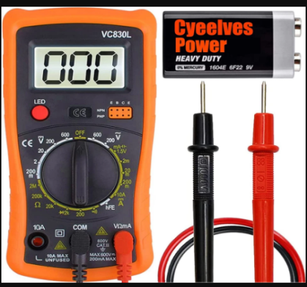

- Description: A digital device used for measuring voltage, current, and resistance.
- Function: Useful in troubleshooting circuits and verifying electrical values.
4.3 Megger Tester
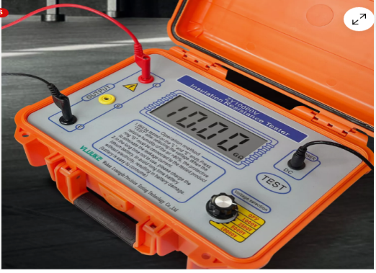

- Description: An instrument used to test insulation resistance.
- Function: Ensures cables and machines are well insulated.
4.4 Transformer Tester
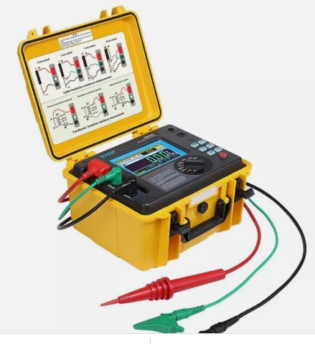

- Description: Equipment used to test the integrity and performance of transformers.
- Function: Helps in assessing voltage ratio, winding resistance, and insulation.
4.5 Cable Stripper
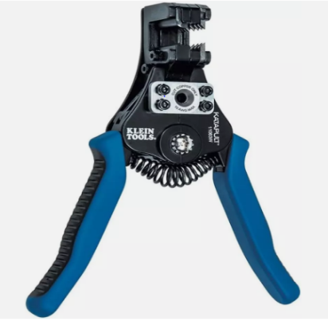

- Description: A hand-held tool used for removing insulation from electric wires.
- Function: Essential for making secure electrical connections.
4.6 Circuit Breaker Tester
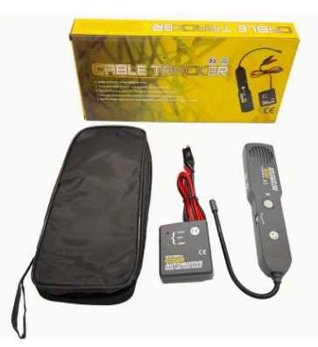
- Description: A device used to assess the performance of circuit breakers.
- Function: Ensures circuit breakers trip appropriately during faults.
4.7 Protective Equipment
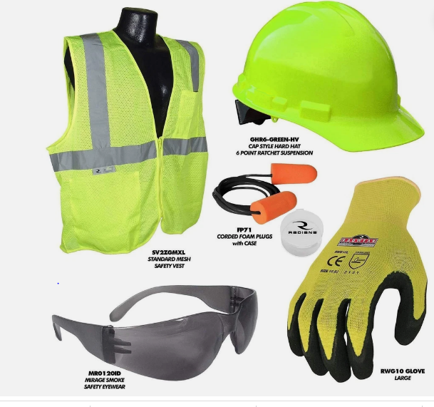

- Description: Safety gear worn to prevent injuries.
- Function: Protection against electrical hazards and falling objects.

4.8 Switchgear Panel
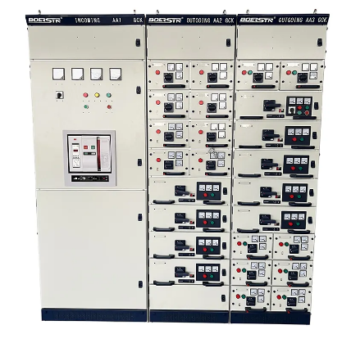
- Description: Assemblies of circuit breakers, fuses, and switches.
- Function: Controls, protects, and isolates electrical equipment.
4.9 Solar Panel System
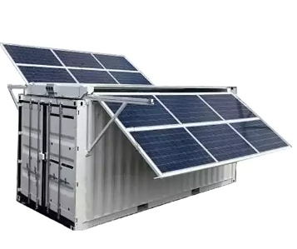
- Description: Equipment for harnessing solar energy.
- Function: Converts sunlight into electricity for off-grid power supply.
4.10 Power Cables and Connectors
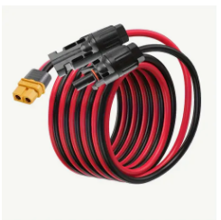
- Description: Wires and connectors for transmitting electricity.
- Function: Used in electrical installations and maintenance.
CHAPTER FIVE:
SUMMARY, CONCLUSION AND RECOMMENDATIONS
5.1 Summary of Experience
The SIWES training at the Kwara State Ministry of Energy provided invaluable hands-on experience in energy policy implementation, project supervision, and electrical engineering tasks. It bridged the gap between classroom learning and real-world applications.
5.2 Challenges Encountered
- Difficulty adapting to field work initially
- Limited access to some advanced testing equipment
- Weather-related delays on outdoor projects
5.3 Problem Solving Approach
- Engaged in additional learning and self-study
- Sought guidance from experienced engineers
- Adapted to team-based project execution
5.4 Lessons Learned
- Importance of teamwork and communication
- Need for adherence to safety standards
- Real-world electrical work requires patience and precision
5.5 Conclusion
The SIWES experience was enlightening and productive. It offered practical insights into energy management and infrastructural development in Kwara State. The exposure has enhanced my skills, confidence, and professional outlook.
5.6 Recommendations
- More training tools should be made available to interns
- Orientation programs should be improved
- SIWES duration should be extended for deeper learning

