

A TECHNICAL REPORT
ON:
STUDENT INDUSTRIAL WORK EXPERIENCE SCHEME (SIWES)
HELD AT:
hope ville hotel
11, onajimi, pedro road vi banga, lagos

PRESENTED BY:

kehinde jenrola titilayo
ND/23/HMT/PT/0093

SUBMITTED TO:
DEPARTMENT OF HOSPITALITY MANAGEMENT
INSTITUTE OF APPLIED SCIENCE (IAS)
IN PARTIAL FULFILLMENT OF THE REQUIREMENT FOR THE AWARD OF NATIONAL DIPLOMA (ND) IN HOSPITALITY MANAGEMENT

AUGUST - nOVEMBER, 2024

DEDICATION
This SIWES report is dedicated to Almighty God. I also dedicate it to my parent Mr. and Mrs. Kehinde for their support on this programme.

ACKNOLEDGEMENT
First and foremost, my enormous gratitude goes directly to Almighty God who made things possible to whom he will with easy hand. My profound gratitude goes to my lovely parent MR. & MRS. Kehinde may God continue to shower his perpetual blessing upon them.

INTRODUCTION
The Industrial Training is a training Scheme by which a student can undergo practical training within an approved Industrial undertaking having specific amount of fixed assets or turnover of paid up share capital. The scheme is a participatory program involving Universities, Polytechnics and Technical Colleges and students of carious Institutions of Nigeria.
The Student Industrial Work Experience Scheme (SIWES) is funded jointly by Industrial Training Fund (ITF). The Scheme completes part of the academics requirement standards in pursing the award of the National Diploma in Hospitality Management. The training lasts for six months. The theory and the practical aspect are being joined together in the programme in order to find out how things are being done. In theory, we are to read electronic guidance, books, novels which concern deeply with sense of belonging especially in course of concern them in practical we have to know how to do things by ourselves to enhance spirits of commitment in all we do. That is why, for efficient moving of this programme in conjunction with ministry of education has set a step that students should be going for these programme. Hospitality Management Departments has seen it as a step forward of progress by sending their student to embark on it.
OBJECTIVES OF THE PROGRAMME OF STUDENT
1. Training in an Industrial/Commercial/financial environment provides the trainees with the opportunity to develop a problem solving attitude and to have an insight into the functioning of the Accounts Department.
2. It also diversifies their practical experience and helps them in developing the attributes of team work and correlation with members of their professions and disciplines.
3. It is intended to provide the trainees with a new dimension to their experience.
4. This would necessarily involve exposure of trainees to the entire gaunt of activities of Industrial establishment in a phased and systematic manner.

DESCRIPTION OF THE ESTABLISHMENT OF THE ATTACHMENT
BRIEF HISTORY OF THE ESTABLISHMENT
Hope Ville Hotel was established to provide a luxurious and comfortable retreat for travelers seeking quality hospitality. Located in a prime area, the hotel was founded with the vision of blending modern elegance with warm, personalized service. Over the years, it has grown into a well-regarded destination, offering top-notch accommodation, fine dining, and excellent customer service.
With a commitment to excellence, Hope Ville Hotel has continually upgraded its facilities to meet international standards, making it a preferred choice for business and leisure travelers alike. Its reputation for hospitality and comfort has made it a landmark in the region, attracting guests from all walks of life.
Terms and Conditions
Check in : from 2:00pm
Check out: by 12:00pm
Payment: Cash
Children: free lodging provided they are under the age of 15 years.
Terms and Conditions about Hope Ville Hotel
Check in : from 2:00pm
Check out: by 12:00pm
Payment: Cash
OBJECTIVE OF THE ESTABLISHMENT
1. It provides a lodging centre for individuals
2. For event planning and social function organizing centres
3. It provides laundry services
4. It provides gymnastic house for exercises and watch of weight.
5. Its kitchen provides food and other edible substances for human consumption

ORGANIZATIONAL CHART OF HOPE VILLE HOTEL
EXECUTIVE DIRECTOR
HEAD OF DEPARTMENT FRONT OFFICE
HEAD OF DEPARTMENT (F&B)
HEAD OF DEPARTMENT HOUSE KEEPING
CLEANER
WAITER
CHEF
ACCOUNTANT
MANAGER
PORTAL
RECEPTIONIST
F&B SUPERVISOR

THE VARIOUS SECTIONS IN THE ESTABLISHMENT AND THEIR FUNCTION
1. MANAGING DIRECTOR (MD): The Managing Director is the decision maker, he says what happen in the establishment and other staff takes order from him. He is the one that finances the company and assign payment for staffs.
2. GENERAL MANAGER: The General Manager is the second in command. He is the most senior employee in the Company. The Manager reports directly to the Managing Director, he is responsible for the overall strategy, planning coordination and management of business affairs of an organization.
3. SUPERVISOR: The supervisor supervises the work been done in the various sections, he/she tries to find out where wrongs are been done and does correction where necessary, and penalizes when necessary.
4. ACCOUNTANT: The accountant is in charge of keeping records of all the expenditure and income earned in a company and responsible for payment of workers.
5. CHEF: The chef is the most senior cook in the Hotel, she gives directives to the other cooks, and she is in charge of the activity that takes place in the kitchen.
6. HEAD OF RECEPTION: The head of reception is in charge of the activities that is been run in the reception.
7. HEAD OF HOUSE KEEPING: The head of housekeeping is in charge of the activities in the rooms, he makes sure that things are the way they should be in the various rooms.
8. COOK: The cook specialize in various duties like producing, Manufacturing, preparing different dishes to the Hotel.
9. CLEANERS: The cleaner keeps the environment tidy, they clean the rooms and other places, they cut grasses, sweep and wash the places.
10. DRY CLEANER: The dry cleaner, washes, dry and Irons the clothes of quests, they also wash the towels and bed spreads used in the rooms.
11. RESTAURANT: The restaurant server the prepared food to the customers, they are the people that also give information to the kitchen on what to prepare.
12. BARMAN: The Barman serve drinks to customers. Bartenders work directly with customers by mixing and serving drink orders. Their responsibilities include verifying age requirements, knowing alcohol pairing and tastes, knowing how to make traditional and classy drinks, processing payments, managing inventory and cleaning bar supplies.
THE VARIOUS DEPARTMENT OR SECTIONS IN THE ESTABLISHMENT AND THEIR FUNCTIONS
1. Front Office/Reception
2. House Keeping
3. Kitchen
4. Restaurant
5. Laundry
6. Gymnastic House

- FRONT OFFICE / RECEPTION: "reception" typically refers to the area where visitors or clients are received upon arrival. This area often includes a reception desk or counter where administrative staff or receptionists manage inquiries, check-ins, and direct visitors to their intended destinations. This is the place where guest and visitors go first when they arrive in the Hotel; they show the rooms to the guests and give them the attention needed for comfort ability. They know when the guest checks in and checks outs.
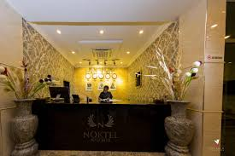
FRONT OFFICE
- HOUSE KEEPING:
Housekeeping in a hotel refers to the department responsible for maintaining cleanliness, order, and overall upkeep of guest rooms, public areas, and other facilities within the hotel premises. The primary responsibilities of the housekeeping department include:
1. Cleaning Guest Rooms: This involves thoroughly cleaning and tidying guest rooms, including making beds, vacuuming carpets, dusting furniture, cleaning bathrooms, and replenishing amenities such as towels, toiletries, and refreshments.
2. Public Area Cleaning: Housekeeping staff also clean and maintain common areas such as lobbies, hallways, elevators, and restrooms to ensure they are presentable and inviting to guests.
3. Laundry Services: Housekeeping oversees the collection, laundering, and delivery of linens, towels, and other textiles used throughout the hotel.
4. Maintenance Reporting: Housekeeping staff often identify and report maintenance issues or damages in guest rooms or public areas so that they can be promptly addressed by the maintenance department.

5. Inventory Management: Monitoring and replenishing cleaning supplies, toiletries, and other guest amenities to ensure that there are an adequate stock and variety available for guests.
6. Lost and Found: Managing lost and found items, ensuring that lost belongings are properly logged, stored, and returned to guests when claimed.
7. Training and Supervision: Providing training to housekeeping staff on cleaning techniques, safety protocols, and customer service standards. Supervisors oversee the work of cleaning staff to ensure that tasks are completed efficiently and to the hotel's standards.
8. Guest Requests: Fulfilling special requests from guests, such as extra towels, pillows, or room amenities, and ensuring that any guest complaints or concerns regarding cleanliness are addressed promptly and effectively.
- KITCHEN:
The Kitchen is the place where all kinds of dishes like fried rice, boiled yam egg sauce, Afang Soup, Egusi Soup, Vegetable Soup etc are produced. The restaurants do the serving of the dish to the guest, while the bars serve drinks to the guest, alcoholic and non alcoholic drinks are sold there as well.
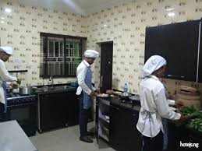
KITCHEN
- RESTAURANT
A restaurant is a business establishment that prepares and serves food and drinks to customers. Restaurants vary widely in terms of cuisine, ambiance, and pricing. They may offer a casual dining experience, such as fast food or a café, or a more formal setting with fine dining options. Restaurants can specialize in specific types of cuisine, or they may offer a diverse menu with various dishes from different culinary traditions. The dining experience at a restaurant typically involves customers ordering from a menu, being served by waitstaff, and enjoying their meals in the restaurant's dining area.
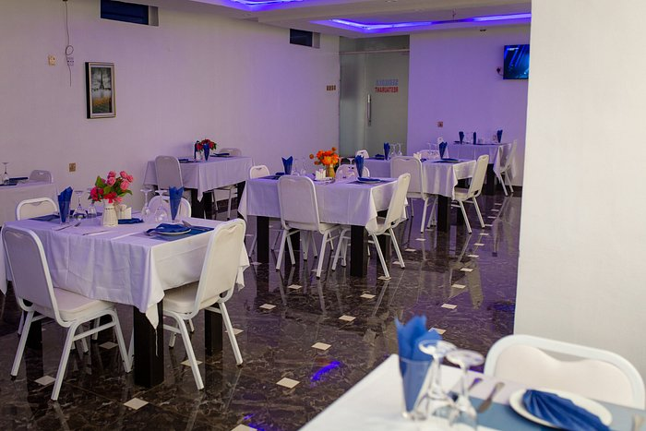
RESTAURANT
- LAUNDRY: Laundry refers to the clothes and bedding that you can wash in your washing machine or at the laundromat. Nothing smells quite as good as clean laundry. The Laundry section is where the clothes of the guests are been laundered including the bed spreads.
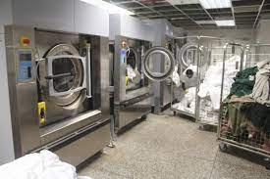
LAUNDRY
- GYMNASTIC HOUSE: "Gym house" typically refers to a building or structure that is specifically designed and equipped for physical exercise and fitness activities. It usually contains various exercise machines, free weights, cardio equipment, and sometimes group fitness areas. Gym houses are commonly used by individuals seeking to improve their physical health, strength, and endurance through regular exercise routines.The gymnastic house (gym house) is where exercise are been done, there are machines that are been used for exercises in the Gymnastic House.
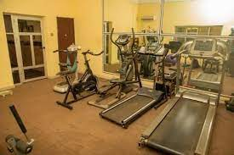
GYM HOUSE

REPORT CLEARLY ON WORK ACTUALLY CARRIED OUT WITH CLEAR STATEMENT ON EXPERIENCED GROUND
My having the true facts about the practice carried out at Hope Ville Hotel has exposed me to a lot of great experience after participating majorly as a source of assistance in various units mostly in the Kitchen and Restaurant Sections.
At the Kitchen section, I assisted in producing the following dishes; Boiled Yam, Egg Sauce, Fried rice, A fang Soup Egusi Soup Ora Soup, Bitter leaf Soup, Yam Portage, Unripe Plantain Portage, Garnished Indomie with plain Omelette, Offal (Goatmeat) Pepper soup, Ogbono Soup, Jellof Rice, White Rice and Stew, Yam Chips with Egg Sauce.
Finally, I can produce the above mentioned dishes.
GENERAL EXPERIENCE ACQUIRED
Kitchen
- We where taught how to prepare sunset egg with vegetable oil
- jollof rice preparation was taught
- Fried rice and omelet egg preparation was done
Bar
- I was taught how to record sales that are sold
- I learn how to wash utensils that are used in the bar
- Cleaning of the bar is important
Restaurant
- Welcoming of the guest and showing them the menu list to check wat he/she needs
- Wait around to take or write bills of the guest

House keeping
- I was taught how to use light card to open the room and dispose waste from the room
- I was taught how to arrange all the room appliances and laying of the bed
MAKING OF DISHES
BOILED YAM EGG SAUCE RECIPES:
4 slices of yam, 2 fresh eggs, 5 seeds of fresh tomatoes, 2 seeds of pepper, ¼ teaspoonful of salt, a cube of maggi, ½ onions, carrots, green beans, groundnut oil, some quantity of water.

BOILED YAM EGG SAUCE
METHODS OF PREPARATION
Peel the slices of yam, wash and boil. Slice the tomatoes, onions, and pepper. Cut the carrot and green beans. Then put the groundnut oil on fire, allow to heat, add the salt, put the onion and allow to fry a bit then pour the tomatoes, and allow to fry, then put the carrot and green beans and allow to fry then pour the beated egg into it and stir, then add the maggi and allow to fry for 2 minutes, then remove from the heat dish into a flat plate with the boiled yam.
WHITE RICE WITH STEW
Recipes:
3 cups of Rice, a tin of tomatoes, 8 seeds of fresh tomatoes, 4 seeds of pepper, 1 onion, groundnut oil, 11/2 teaspoonful of salt, ½ kilogram of meat, curry leave, curry powder, thyme, 2 cubes of maggi, some quantity of water.
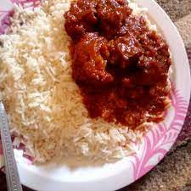
WHITE RICE WITH STEW

METHODS OF PREPARATION:
Wash the rice and parboil it, the boil finally put the groundnut oil on fire and add salt, onions and allow to fry, then put the grinded tomatoes and pepper and allow to fry, then add the tin tomatoes and allow to fry, then spice the stew with curry and thyme, after that you add the stewed meat, and add the curry leave and allow to boil, dish into a plate with white rice.
JOLLOF RICE
Recipes:
3 cups of rice, a tin of tomatoes, 4 seeds of fresh tomatoes, 2 seeds of pepper, 1 onions, groundnut oil, 1 teaspoonful of salt, ¼ kilogram of meat, curry powder, thyme, 2 cubes of maggi cube, carrot, green beans, and some quantities of water.

JOLLOF RICE
METHODS OF PREPARATION:
Wash the rice and parboil it, then heat the groundnut oil and add salt, onion and allow to fry. put the grinded tomatoes and pepper and allow to fry, then add the tin tomatoes and allow to fry, spice the stew with curry and thyme, maggi cube after pour the stew and rice with the stock (meat water) and stir, then allow it to boil, then fry the stewed meat, dish the rice with meat.
FRIED RICE
Recipes:
3 cups of rice, carrot, green beans, green pepper, 1 onions, ¼ nutmeg grinded, groundnut oil, butter, 2 cubes of maggi cube, thyme, ginger, curry, ½ kg of meat, and 1 teaspoonful of salt, some quantity of water, green peas, cabbage.


FRIED RICE
METHODS OF PREPARATION
Wash and parboil rice, wash and cut the carrots, green beans, green pepper, cabbage, ginger, onions, stewed the meat, with the liver. Then pour the parboiled rice into the stock (meat water) and allow to boiled, then heat the butter and groundnut oil add the carrot, green beans, green peas, green pepper, onion, ginger and allow to fry, then add maggi cube, curry and thyme, pure the cooked rice and stir then add the liver and cabbage and stir, dish in a plate.
YAM AND PLANTAIN CHIPS
Recipes:
2 slices of yam, 2 plantain, groundnut oil, ¼ onion, ¼ teaspoonful of salt, some quantity of water
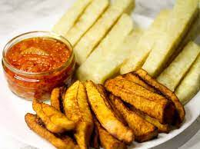
YAM AND PLANTAIN CHIPS
METHODS OF PREPARATION:
Peel the sliced yam and plantain, cut the yam in a small rectangular shape and cut the plantain in cylindrical shape, salt the plantain and yam the heat the groundnut oil and pour the onions allow to fry and pour the yam after frying the yam, then fry the plantain, then dish in a plate and serve with Egg sauce.

YAM PORTAGE:
Recipes:
5 slices of yam, pumpkin leave, 1 onion, 1 dry fish, a seed of fresh tomatoes, 2 seeds of flesh pepper, red oil, small quantity of Cray fish, 1 teaspoonful of salt, a cube of maggi, some quantity of water, ½ cut of ripe plantain.

YAM PORTAGE
METHODS OF PREPARATION:
Peel the sliced yam and put in a pot and put on fire, then add water onions, fresh tomatoes, salt, Cray fish, pepper and allow to boil, then cut the ripe plantain and add to the boiling yam after 20 minutes cut the pumpkin leaves and add to the yam, then remove from heat and dish.
UNRIPE PLANTAIN PORTAGE:
Recipes:
4 unripe plantain, pumpkin leave, 1 onion, 1 dry fish, a seed of fresh tomatoes, 2 seeds of fresh pepper, red oil, small quantity of Crayfish, 1 teaspoonful of salt, a cube of maggi, some quantity of water.
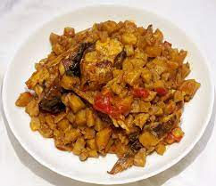
UNRIPE PLANTAIN PORTAGE

METHODS OF PREPARATION:
Peel the plantain, put in a pot and add heat to it, then add water onions, tomatoes pepper, red oil, maggi, salt, Crayfish, dry fish, and allow to boil for 30 minutes then cut the pumpkin leave and add to the boiling plantain, then remove from heat and dish in a plate.
GARNISHED INDOMIE WITH PLAIN OMELETTE
Recipe:
2 Sachet of indomie, 1 fresh tomato, 1 fresh pepper, ¼ onion, groundnut oil, 2 Eggs, carrot, green beans, water.

GARNISHED INDOMIE WITH PLAIN OMELETTE
METHODS OF PREPARATION:
Add water to the pot and apply heat, then allow it to heat very well, then add the indomie and allow to boil, then sieve it and put the empty pot on fire and add groundnut oil, onions, tomatoes, pepper, carrot, green beans, then the spices off the indomie and allow to fry then add the parboiled indomie and stir, then fry the Egg an remove from heat dish the garnished indomie with the plain omelette in a plate.
COSLOW SALAD
Recipes:
Cabbage, carrot, fresh tomatoes, green pepper, mayonnaise.

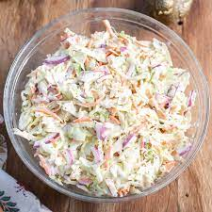
COSLOW SALAD
METHOD OF PREPARATION
Wash the cabbage, carrot, fresh tomatoes, green pepper in salty water. Then cut the cabbage, the carrot will not be cut in cubes but will be grated (sliced with grater), the fresh tomatoes will be sliced and the green pepper cut in cubes. Then the cabbage, carrot, fresh tomatoes, green pepper will be mixed together with the margarine and stir, then serve with either, Jellof rice or Fried rice
VEGETABLE SALAD
Recipes:
Mayonnaise, sweet corn, carrot, cabbage, cucumber, baked beans peas, green pepper, tomatoes.
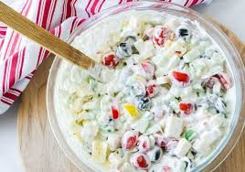
VEGETABLE SALAD
METHODS OF PREPARATION
Wash your vegetable with little salt and slice into small sizes then after slicing arrange it finely by putting green peas, sweet corn, cabbage, green beans, green pepper, tomatoes, cucumber and mayonnaise and mix it properly so that it will be together.

SUMMARY OF ATTACHMENT ACTIVITIES
The Industrial attachment programme also known as Student Industrial Work Experience Scheme (SIWES) is an appreciable skills acquisition programme designed to expose students to the real life working experience. The programme exposes students to the practical oriented aspects of their chosen professions so as to achieve the much needed technological advancement for the nation.
This report gives and contains a full explanation of all the activities carried out by me Hope Ville Hotel establishment in Ilorin Kwara State.
The report explains the details of the events and activities with each project been involved and outlined under each chapter. It started with an introduction, objectives of the programme of the programme. Section Two talks about the establishment and the different sections and their functions. Section three/four explains the activities been carried out during the programme, finally Section five being the last chapter highlighted problems, then the report was concluded with summary.
PROBLEMS ENCOUNTERED DURING SIWES
I encountered numerous problems during my Industrial Training programme at Hope Ville Hotel.
1. PROBLEM OF LIGHT: light is the major thing an establishment needs for proper running, and also for comfort of the guest and functioning of the facilities and equipment in an establishment but the absent of light bring about discomfort of guest and poor management of the establishment.
2. INADEQUATE FACILITIES: The establishment didn’t provide any accommodation for the SIWES students.
3. COMMUNICATION: There was poor and ineffectual information dissemination due to complex links in the establishment.
5. PROBLEM OF SECURING A PLACE OF ATTACHMENT: I had most of problem searching for a place of attachment for my Industrial Training because most establishments refused my placement request.

CONCLUSION
Industrial Training is important, Educative and Interesting, it is a programme that exposes undergraduate to world of paid. It makes an individual to have as sense of responsibility and be diligent to work.
Extending the programme to more than six months will be better for the student to have more time to learn and gain all the practical experiences needed.
RECOMMENDATIONS
1. The establishment should provide a very good security in the establishment for the comfort of the SIWES students, the guest and their main staffs.
2. The establishment should provide adequate light for the establishment, for the comfort of guest, SIWES students, staffs and for proper functioning of equipments and facilities.
3. The establishment should make sure that before the end of each month that the salary should be paid, so that the SIWES student will be care of their transportation to work.
4. The establishment should provide a good accommodation for the SIWES students in their establishment.
5. The Industrial Training Fund should compile list of employers and available training places for industrial attachment and forward such lists to the coordinating agencies.
6. The Federal Government should make it mandatory for all Ministries, companies and government parastatals to provide attachment places for students.

