

TECHNICAL REPORT ON STUDENT INDUSTRIAL WORK EXPERIENCE SCHEME (SIWES)

Siwes Report
UNDERTAKEN AT
IFAKO IJAIYE LOCAL GOVERNMENT
NO. 61, IFAKO IJAIYE LOCAL GOVERNMENT, COLLEGE ROAD, LAGOS STATE
By:
OROGBADE TEMITOPE OLADIMEJI
ND/23/CEC/PT/0229

SUBMITTED TO:
DEPARTMENT OF CIVIL ENGINEERING, INSTITUTE OF TECHNOLOGY KWARA STATE POLYTECHNIC, ILORIN
IN PARTIAL FULFILMENT OF THE REQUIREMENT FOR THE AWARD OF NATIONAL DIPLOMA (ND) IN CIVIL ENGINEERING
AUGUST, 2024

CERTIFICATION
This is to certify that this report is original to the author, Orogbade Temitope Oladimeji with Matric No. ND/23/CEC/PT/0229 the Department of Civil Engineering Department, Institute of Technology, Kwara Polytechnic, Ilorin and was supervised accordingly by;

ENGR. AWAL YUNUS

Signature

DEDICATION

This report is dedicated to Almighty GOD for His divine mercy on me and my family who has given me the strength, wisdom, knowledge and understanding in working toward my success, I also dedicate this report to my parent and the family for their support and to my supervisor for the success of this report.

ACKNOWLEDGEMENT

To God who owns life, I wish to express my sincere appreciation and gratitude for seeing me throughout my Siwes Report in Kwara State Polytechnic and for making my vision come to reality, also for His Goodness, Mercy, Provision and Grace upon my life.
My profound gratitude goes to my sincere appreciation goes to My Dear Parent Mr and Mrs. Orogbade may GOD Almight be with you.
My special thanks goes to the head of Department and the Entire staff of Civil Engineering Department, Kwara State Polytechnic for sharing wealth of experience with me in my course of study.
Furthermore, thanks goes to my honorable and diligent supervisor for his advice, guidance and adequate encouragement relish from him which has contribute in no small measure to the success of completion of this report.
Finally, my sincere gratitude also goes to my lovely friend both within and outside the institution,

ABSTRACT

This report gives a good account of the training and experience which exposed student during the student industrial work experience (SIWES) at Kwara State Ministry works.

CHAPTER ONE

  - INTRODUCTION

The Student Industrial Work Experience Scheme (SIWES), also known as Industrial Training is a compulsory skill training program designed to expose and prepare students of Nigerian Universities, Polytechnics, Colleges of Education, Colleges of Technology and Colleges of Agriculture, for the industrial work situation they’re likely to meet after graduation.
Before the establishment of the scheme, there was a growing concern among industrialists, that graduates of institutions of higher learning lacked adequate practical background studies preparatory for employment in industries. Thus, employers were of the opinion that the theoretical education in higher institutions wasn’t responsive to the needs of the employers of labor.
SIWES introduction, initiation and design was done by the Industrial Training Fund (I.T.F) in 1993 to acquaint students with the skills of handling employer’s equipment and machinery. The Industrial Training Fund (I.T.F) solely funded the scheme during its formative years. However, due to financial constraints, the fund withdrew from the scheme in 1978.
The Federal Government, noting the significance of the skills training handed the management of the scheme to both the National Universities Commission (N.U.C) and the National Board for Technical Education (N.B.T.E) in 1979.
The management and implementation of the scheme was however reverted to the I.T.F by the Federal Government in November, 1984 and the administration was effectively taken over by the Industrial Training Fund in July 1985, with the funding solely borne by the Federal Government.

BACKGROUND ON SIWES
The Students’ Industrial Work Experience Scheme (SIWES) was jointly designed by the Federal Government of Nigeria, Industrial Training Fund (ITF), tertiary institutions, and other agencies like National Universities Commission (NUC), National Polytechnics Commission, and National Board for Technical Education and National Council for Colleges of Education. The program was established in the year 1973 under the Industrial Training Fund with the main aim of preparing and helping students of tertiary institutions to acquire exposure on practical fields with respect to their profession. Through this exposure, students are expected to have better understanding of their career and develop practical skills in addition to the theoretical skills which they have expectedly gotten

from their institutions. Students are also exposed to some of the challenges in the industries and are supervised during their period of attachment to various organizations.

OBJECTIVES AND IMPORTANCE OF STUDENTS’ INDUSTRIAL WORK EXPERIENCE SCHEME (SIWES)

The Scheme exposes students to industry-based skills necessary for smooth and unparalleled transition from the classroom to the field of work. It affords students the opportunity of being familiar with and exposed to the required know-how in handling machinery and equipment which are usually not available in the educational institutions.

    - It exposes students to both the theoretical and practical aspects of their discipline, thus promoting creativity and skills in students.
    - It enhances employment and scholarship opportunities among students who can exhibit immense industrial skills and perform exceptionally well during training.
    - It establishes a relatively uniform national professional and apprenticeship training scheme in the country.
    - It creates opportunities for students to have a direct contact with the intermediate and senior professional staff in the industry.
    - It reduces the introduction of expatriate Engineers, technologists and other professional personnel due to the quality training derived by students.
    - It encourages the involvement of employers especially the small scale industries in the organization and development of training programs and facilities including the establishment of group training scheme center in some critical areas of the economy.
    - It creates awareness to students of work related problems and how to cope positively in difficult situations.

BODIES INVOLVED IN THE MANAGEMENT OF SIWES

The bodies involved are:

    - The Federal Government.

    - Industrial Training Fund (ITF) Other supervising agents are:
    - National University Commission (NUC) National Board for Technical Education
(NBTE)
    - National Council for Colleges of Education (NCE).
The functions of these Agencies above include.

    - Establish SIWES and accredit SIWES unit in the approved institutions.

    - Formulate policies and guideline for participating bodies and institutions as well as appointing
    - SIWES coordinators and supporting staff.

    - Supervise students at their places of attachment and sign their lob-book and IT forms.
    - Ensure payment of allowances for the students and supervisors.

    - Ensure adequate funding of the scheme.

SCOPE OF TRAINING
In the course of the SIWES undertaken at Kwara Sate Ministry of Public Works and Transport, the trainee was acquainted with:
    - Introduction of materials used for Road construction

    - Casting of slab (precast) and demolition of existing box culvert

    - Grading with Grading machine

    - Excavation of drainage trench

    - Construction of median form work

    - Desilting of silt up drainage

    - Laying of asphalt with the use of paver machine

CHAPTER TWO
  - ORGANIZATIONAL BACKGROUND
The Ifako-Ijaiye Local Government was created along with 183 other local governments on October 1, 1996, by General Sani Abacha, the then military head of state. It was carved out of Agege Local Government, with headquarters in Ifako, and predominantly populated by the Egba Yoruba people.
Ifako-Ijaiye Local Government is a border suburb town as it shares border with Ogun State. The major settlements are Ogba-Ijaiye, Ifako, Oke-Ira, Iju-Ishaga, Obawole, Iju-Ogundimu, Fagba, Agege Pen Cinema, Ojokoro^{[4]} among others.
The past leaders of the Local Government are: Engr. Richard Akinpelu (late), Alh. Ma'rufdeen Adeola Adefolabi (late), Hon. Demola Doherty, Hon. (Apostle) Oloruntoba Oke (2011-2014), Hon Akinwunmi Nurudeen Olaitan (2014-2016), Hon Babatunde I.Q. Rajh-Label (2016-2017).
The Former Governor of Lagos State, Mr. Akinwunmi Ambode, appointed Babatunde I.Q. Rajh-Label as Sole Administrator of the Local Government in June 2016. The election was held on July 22, 2017, throughout the 20 Local Government Areas and 37 Local Council Development Areas of Lagos State. Hon (Apostle) Oloruntoba Oke was elected and sworn in as the Executive Chairman for a second term by the former State Governor, His Excellency, Gov. Akinwunmi Ambode.
The Local Government is at present being led by Hon. (Prince) Usman Akanbi Hamzat as the Executive Chairman, after a local government election held in July 2021.

2.2 TRANSPORT
The city is served by Agbado station, located in the Local Council of Agbado-Oke Odo and part of the Lagos Rail Mass Transit project.

2.3 CURRENT EXECUTIVES
Prince Usman Akanbi Hamzat - Executive Chairman
Hon. Mrs. Oluwatoyin Awoniyi Akerele - Vice Chairman

2.4 PAST CHAIRMAN & SOLE ADMINISTRATORS OF IFAKO IJAIYE LOCAL GOVERNMENT
- Engineer Adeoye Ogundipe - Acting Chairman - October 1996
- Hon. Aremu Akindele - 1st Executive Chairman - March 1997
- Hon. Ademola Taiwo - Sole Administrator - June 1998
- Hon. Adeola Adefolabi - 2nd Executive Chairman - June 1998
- Hon. Babatunde Odele - Executive Secretary - June 2002
- Hon. Dr. Elijah Olu Adewale - Executive Secretary - April 2003
- Hon. Richard A.A. Akinpelu - 3rd Executive Chairman - April 2004
- Hon. Muzemil Olajide Tairu - Sole Administrator - August 2008
- Hon. Demola Doherty - 4th Executive Chairman - October 2009
- Apostle (Dr.) Oloruntoba Oke - 5th Executive Chairman - October 2011
- Hon. Adeleye Rotimi - Executive Secretary - January 2015
- Hon. B.I.Q. Rajh Label - Sole Administrator - June 2016

2.5 SOLE ADMINISTRATOR'S ACTIVITIES SO FAR
- Commencement of The Local Government Headquarters Building in Ifako
- Handed Over Landed Property For Primary School Development In Obawole
- Commemoration of 20th Anniversary of The Local Government's Existence
- Free Computer Training Programme For Primary School Pupils
- Rehabilitation of Bore Hole Water for School Students
- Free Skill Acquisition Training Programme for Residents
- Routine Peace And Security Meeting
- Routine Management Meeting
- Monthly Environmental Sanitation Inspection Exercise
- Grading of Local Roads
- Training of Staff amongst others.

CHAPTER THREE WORK EXPERIENCE
  - INTRODUCTION

Civil Engineering as a whole is distributed into several sections i.e., highway engineering, geotechnical engineering, structural engineering, water resources and environmental engineering, etc. I was opportune to work at one of the different sections which is the highway engineering.

HIGHWAY ENGINEERING
Highway engineering is a specialized branch of civil engineering focused on the planning, design, construction, operation, and maintenance of roads, highways, and related infrastructure. The primary goal of highway engineering is to ensure the safe and efficient movement of people and goods across road networks. It plays a critical role in connecting communities, supporting economic growth, and facilitating transportation.

LAYING ASPHALT USING A PAVER MACHINE

The process of laying asphalt using a paver machine. It's a fascinating blend of engineering and precision, this is a comprehensive look at the process, from preparation to finishing:

Preparation: The Foundation for Success

  - Site Preparation:
    - Clearing and Grubbing: Removing vegetation, debris, and any obstructions from the area to be paved.
    - Grading: Creating the desired slope and elevation using graders and other earthmoving equipment. Proper drainage is crucial.
    - Compaction: Ensuring the subgrade (the layer of earth below the pavement) is sufficiently compacted using rollers. This provides a stable base and prevents future settling.

Base Layer Preparation:
    - Aggregate Placement: Laying a layer of crushed stone or gravel (the base course) to provide additional support and drainage.
    - Base Compaction: Compacting the base course to the required density.

    - Tack Coat Application (Optional): Applying a thin layer of asphalt emulsion (tack coat) to the compacted base. This helps the asphalt layer adhere properly and prevents slippage.

Asphalt Mix Delivery and Loading:

  - Asphalt Mix Production: The asphalt mix is prepared at an asphalt plant, heated to the appropriate temperature, and transported in dump trucks.
  - Truck Unloading: The dump trucks carefully deliver the hot asphalt mix to the paver's receiving hopper.

The Paver Machine: The Heart of the Operation

  - Paver Components:
    - Receiving Hopper: A large hopper at the front of the paver that receives the asphalt mix from the dump trucks.
    - Conveyor System: A system of conveyors carries the hot mix from the hopper to the augers. o Augers: Spiraled devices that distribute the asphalt mix evenly across the width of the paver.
    - Screed: A hydraulically adjustable steel plate that levels and smooths the asphalt mix as it's laid down. The screed can be heated to prevent the mix from sticking.
    - Tamping Bar (Optional): Some pavers have tamping bars that pre-compact the asphalt mix before the screed.
    - Control System: Computerized controls monitor and adjust the paving process, including material flow, speed, and screed position.

Paver Operation:
    - Loading: The dump truck carefully dumps the hot mix into the paver's hopper.
    - Distribution: The paver's conveyor and augers distribute the asphalt mix evenly in front of the screed.
    - Laying: The screed precisely levels and compacts the asphalt mix as the paver moves forward, leaving a smooth, consistent layer.

    - Grade Control: The paver uses a system of automatic leveling to maintain the desired slope and elevation. This can be done using string lines, sensors, or GPS.
    - Speed Control: The paver typically moves at a slow, consistent pace to ensure proper compaction and a smooth finish.

Compaction and Finishing:

  - Initial Compaction: Breakdown rollers (typically smooth-drum rollers) follow closely behind the paver to begin the compaction process while the asphalt is still hot and pliable.
  - Intermediate Compaction: Pneumatic tire rollers are used to further compact the asphalt and seal the surface.
  - Final Compaction: Finish rollers (typically vibratory rollers) are used to achieve the final required density and smoothness.
  - Joint Compaction: Special attention is given to compacting the joints between adjacent paving lanes.
  - Quality Control: Regular testing is conducted to ensure the asphalt has achieved the required density and smoothness.
  - Cooling Down: The asphalt is allowed to cool down before traffic can be allowed on the new pavement.

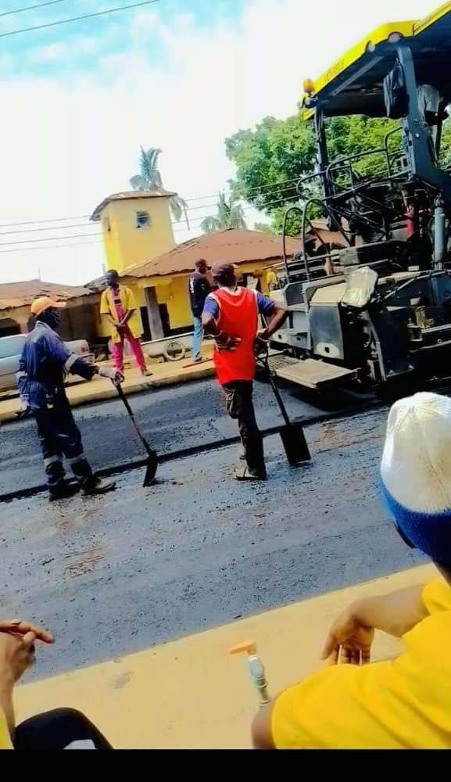

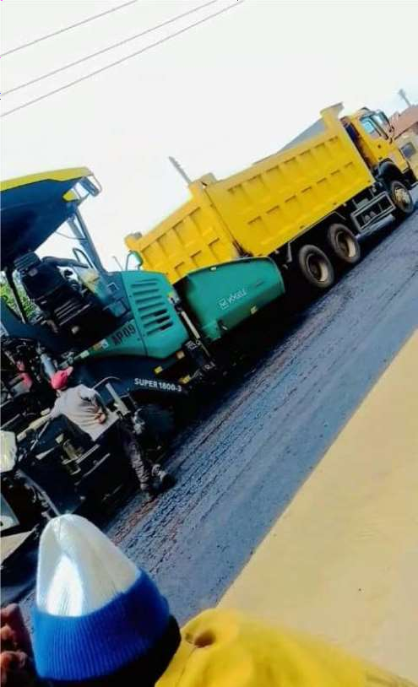

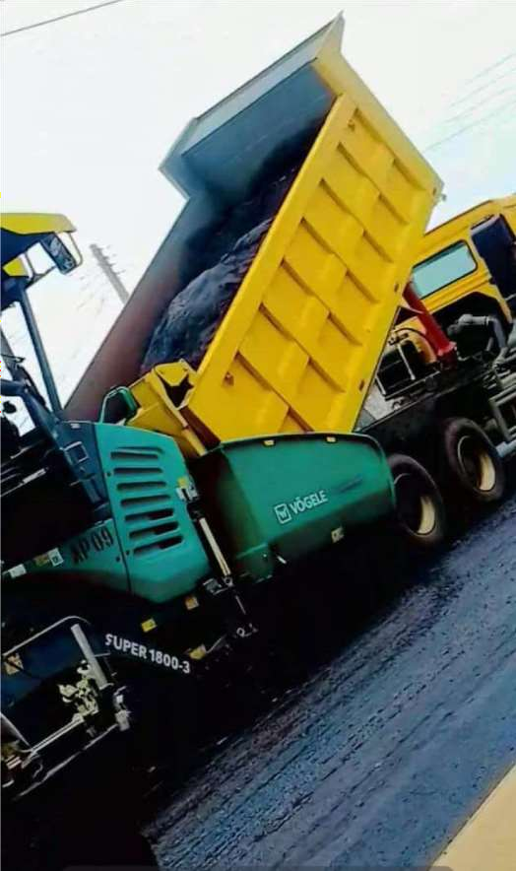

CONSTRUCTION OF MEDIAN FORMWORK
This are the crucial steps in building concrete medians – those structures that separate lanes of traffic. Here's a detailed explanation, covering planning, materials, construction process, and important considerations:

Planning and Preparation

- Project Specifications: The first step is to thoroughly understand the project specifications. This includes:
  - Median Dimensions: Length, width, height, and any specific shapes (e.g., chamfers, curves, tapers).
  - Concrete Mix: Strength requirements, slump, and any additives needed. o Reinforcement: Type, size, and placement of steel reinforcing bars (rebar). o Required Finish: Smooth formed finish, textured finish, or exposed aggregate. o Tolerances: Acceptable variations in dimensions and alignment.
  - Location: Consideration of traffic flow, drainage, and utilities.
- Lay Out: Accurately mark the median's location on the ground using string lines, stakes, or paint. This is critical for maintaining correct alignment.
- Ground Preparation: Ensure the ground surface where the median will be built is properly prepared. This may include:
  - Excavation: Removing topsoil, vegetation, or other unsuitable materials.
  - Compaction: Compacting the subgrade to ensure a stable base for the formwork.
  - Leveling: Creating a level surface to avoid inconsistent median heights.
- Safety: Develop a safe work plan, including:
  - Traffic Control: Implementing appropriate measures to protect workers from passing vehicles.
  - Personal Protective Equipment (PPE): Ensuring all workers wear required PPE (hard hats, safety glasses, gloves, etc.).
  - Safe Lifting: Using proper techniques or equipment to lift heavy materials.

Materials

The choice of materials depends on the project's scale and requirements. Common materials include:

- Forming Lumber: o Dimensional Lumber (e.g., 2x4s, 2x6s): Used for studs, walers, and bracing.
  - Plywood or Oriented Strand Board (OSB): Used for forming panels that create the concrete surface.
- Form Ties: These hold the forms together and maintain their correct spacing. Common types include:
  - Snap Ties: Broken off after the concrete sets. o She Bolts: Can be removed and reused.
  - Coil Ties: Used for heavier applications.
- Form Release Agent: Prevents the concrete from bonding to the formwork, making removal easier.
- Reinforcement (Rebar): Steel bars used to strengthen the concrete.
- Fasteners: Nails, screws, or bolts used to assemble the formwork.
- Spacers/Chairs: Used to ensure proper rebar spacing and maintain concrete cover.
- Concrete: Ready-mix or on-site mixed concrete.

Tools:
  - Measuring tools (tape measure, level, string line) o Cutting tools (saw, handsaw) o Hammer, drill, wrenches o Fastening tools (nail gun, screw gun) o Concrete vibrator (to consolidate concrete)

Construction Process

- Setting the Base:
  - Place and secure the bottom plates of the formwork along the marked layout.
  - Use stakes or pins to keep the base in place.

Erecting the Form Panels:

  - Cut and assemble the form panels to the desired shape and dimensions. o Install form ties to maintain the required spacing. o Ensure the form panels are plumb and level.

Adding Supports:
  - Install studs, walers, and bracing to support the form panels against the pressure of the concrete.
  - This is critical to prevent forms from bulging or failing.
- Reinforcement Placement: o Install the rebar according to the project specifications. o
Use spacers/chairs to maintain proper rebar placement within the formwork and provide adequate concrete cover.

Final Inspection:
  - Double-check the alignment, dimensions, and spacing of the formwork. o Ensure all fasteners are secure and all ties are in place.
  - Confirm the form is free of debris.
- Concrete Pouring: o Pour the concrete in layers, using a vibrator to consolidate it.
  - Fill the formwork evenly to prevent uneven pressure.
- Curing: o Allow the concrete to cure for the specified time, usually several days.
  - Protect from extreme temperatures and drying out.
- Form Removal: o Once the concrete has cured sufficiently, carefully remove the formwork.
  - Use form release agent to make form removal easier.

Finishing:
  - Perform any necessary finishing work, such as patching, grinding, or texturing.

Important Considerations

- Radius and Curves: Formwork for curved medians requires more complex construction. Using flexible plywood or pre-fabricated radius forms may be necessary.
- Drainage: Ensure proper drainage is accounted for. You may need to integrate drainage outlets, weep holes, or create slight slopes to prevent water accumulation.
- Expansion Joints: Include expansion joints at specific intervals to accommodate concrete expansion and contraction.

- Tie Placement: Properly locate ties so they are not visible or difficult to deal with after form removal.
- Multiple Pours: If the median is too long to pour in one session, consider pour breaks. You will need formwork details for joining the successive pours.
- Reusability: Consider formwork designs that can be reused for multiple medians to save time and materials.
- Formwork Maintenance: Clean and maintain formwork to ensure its longevity. Form release agents should be used to ease removal and prevent damage.
- Quality Control: Regular quality checks are necessary to ensure the median is constructed correctly.

In summary, building median formwork requires careful planning, accurate layout, proper materials, and precise construction techniques. Focusing on safety and following project specifications are critical for a successful project.

CHALLENGES FACED DURING THE COURSE OF MY TRAINING

    - Transportation: The distance from my residence to the place of work was quite far, which makes going to work on a daily basis was quite challenging with factors such as; cost of transportation and traffic jams that likely reduced my productivity.

    - Restricted Access: There was restriction to some company software and books, only some of them are high official have access to them

    - It was sometimes difficult to keep up with pace when assigned time-constrained projects.
This ensured increased speed to match the pace of the assignments. iv. Little Time with the ministry: Most of the projects were not met at the early stage and it was quite challenging to experience the full process of project inceptions.

CHAPTER FOUR CONCLUSION AND RECOMMENDATION
  - CONCLUSION

As a civil engineering intern, I have had the opportunity to learn and grow within the field with experienced engineers and supervisors. Through tasks, guidance and feedback, I have gained valuable experience in analysing, designing, and testing various structural systems. I have also had the chance to work with different software tools used in the industry, cross- compare theories with real applications and also collaborate with other engineers and professionals.
Through the valuable experience of the internship, I now appreciate my course of study more and in conclusion, I have acquired better knowledge, skills and attributes that will equip me with excellence in the Structural Engineering career journey.

RECOMMENDATION

    - It is strongly advised that undergraduates preparing for industrial training should ensure good understanding of theories taught in classrooms to fully enjoy the industry experience.
    - I recommend bridging the gap between the ITF and public/private firms to allow for the early placement of trainees in industries and companies.
    - It would also be appropriate if public-private partnership between ITF and private firms can be created, by providing assistance in terms of financial assistance and provision of necessary materials that will aid the fulfilment of the objectives stated for the SIWES programme.
    - And lastly, trainees should endeavour to be grossly involved in the Industrial training in any of the areas of specialisation of the course as this goes a long way in ensuring perfection in one’s profession.

REFERENCES

American Public Works Association (APWA). (2008). Public Works Management Practices Manual.
Asphalt Institute. (2020). MS-16: Asphalt in Pavement Maintenance. Lexington, KY: Asphalt Institute.

Cold Mix Asphalt Manufacturers Association (CMAMA). (2021). Cold Mix Asphalt: Application and Best Practices.

Engineering Cadres (2006). Retrieved from<http://www.coren.gov.ng/portal/engineering- cadres/> 14 February, 2016.
Federal Highway Administration (FHWA). (1998). Materials and Procedures for Repair of Potholes in Asphalt-Surfaced Pavements. FHWA-RD-99-168.

Kwara State Government. (n.d.). Ministry of Works and Transport. Retrieved from https://www.kwarastate.gov.ng

MacGinley T.J. and Choo B.S. (2003). Reinforced Concrete Design Theory and Examples, 2nd ed. E & FN Spon, London.
Nash, W.G. (1983), “Brickwork 1”, 3rd edition. The Anchor Press Limited, Great Britain. Nash, National Asphalt Pavement Association (NAPA). (2019). The Basics of Pothole Repair.

National Asphalt Pavement Association. (n.d.). Pothole repair techniques. Retrieved from https://www.asphaltpavement.org

Occupational Safety and Health Administration (OSHA). (2020). Construction Industry Standards.

Road Engineering Journal. (2020). Innovative Techniques in Pothole Repair. Volume 15, Issue 3, pp.
34–41.

SIWES (1975). Retrieved from <http://odich.com/itfnig/siwes.php/> 12 January, 2016.

Transportation Research Board. (2001). Innovative materials and equipment for pavement surface repairs. Washington, D.C.: National Research Council.

Unpublished lecture note, Department of Civil Engineering, The Polytechnic Ibadana

