

A TECHNICAL REPORT
STUDENT INDUSTRIAL WORKING EXPERIENCE SCHEME
(SIWES)

Held at
MINISTRY OF WORK AND TRANSPORT ILORIN.
AHMADU BELLO WAY PMB 1342, ILORIN, KWARA STATE

Prepared by:
KOLAWOLE FARUK KELVIN
ND/23/TPM/FT/0024

SUBMITTED TO

DEPARTMENT OF TRANSPORT MANAMGEMENT
INSTITUTE OF ENVIRONMETAL STUDIES
KWARA STATE POLYTECHNIC, ILORIN

INPARTIAL FULFILLMENT OF THE AWARD OF THE REQUIREMENT OF THE AWARD OF NATIONAL DIPLOMA IN TRANSPORT MANAMGEMENT

DEDICATION
I dedicate this technical report to the Almighty ALLAH, the giver of knowledge, wisdom and who is rich in mercy.

ACKNOWLEDGEMENT
I take this opportunity to express my profound gratitude and deep regards to the creator of heaven and earth, the one who knows the beginning and the end, the alpha and the omega, the Almighty Allah and also to my guides (MR & MRS KOLAWOLE), and to all those who has helped me during my SIWES programme. The blessings, help and guidance given by them, time to time has carry me so this far and shall carry on the journey of life on which I am about to embark. I also take this opportunity to express a deep sense of gratitude to compliment my mentor for his cordial support valuable information and guidance which helped me in completing my SIWES through various stages.

TABLE OF CONTENT
Title page i
Table of content ii
Dedication iii
Acknowledgements iv
CHAPTER ONE
  - Background of SIWES
  - History of SIWES
  - Objectives of SIWES
CHAPTER TWO
2.1. History of Ministry of Work and Transport Ilorin
2.2 Meaning of V I O
2.3 Meaning of Transport Manager
2.4 Qualities of A Good Transport Manager
CHAPTER THREE
3.1 What Is Road
3.2 Road Infrastructure
3.3 What Is Vehicle
CHAPTER FOUR
4.1 Road Signs And Traffic Lights
4.2 Image Of Traffic Lights

CHAPTER FIVE
5.1 conclusion
5.2 Recommendation

CHAPTER ONE
  - INTRODUCTION TO SIWES
Students Industrial Work Experience Scheme (SIWES) is a Skills Training Program designed to prepare and expose Students of Universities, Polytechnics, Colleges of Technology, Colleges of Agriculture and Colleges of Education for the Industrial Work situation they are likely to meet after graduation. The Scheme affords Students the opportunity of familiarizing and exposing themselves handling equipment and machinery that are usually not available in their institutions.

1.2 HISTORY OF SIWES
The Students’ Industrial Work Experience Scheme (SIWES) was initiated in 1973 by the Federal Government of Nigeria under the Industrial Training Fund (ITF) to bridge the gap between theory and practice among products of our tertiary Institutions. It was designed to provide practical training that will expose and prepare students of Universities, Polytechnics, and Colleges of Education for work situation they are likely to meet after graduation.
Before the establishment of the scheme, there was a growing concern among the industrialists that graduates of institutions of higher learning lacked adequate practical background studies preparatory for employment in industries. Thus the employers were of the opinion that the theoretical education going on in higher institutions was not responsive to the needs of the employers of labour.
As a result of the increasing number of students’ enrolment in higher institutions of learning, the administration of this function of funding the scheme became enormous, hence ITF withdrew from the scheme in 1978 and was taken over by the Federal Government and handed to National Universities commission (NUC), National Board for Technical Education (NBTE) and National Commission for Colleges of Education (NCCE). In 1984, the Federal Government reverted back to ITF which took over the scheme officially in 1985 with funding provided by the Federal Government.

1.3 OBJECTIVES OF THE PROGRAMME
The specific objectives of SIWES are to:
- Provide placements in industries for students of higher institutions of learning approved by relevant regulatory authorities (NUC, NBTE, NCCE) to acquire work experience and skills relevant to their course of study
- Prepare students for real work situation they will meet after graduation.
- Expose students to work methods and techniques in the handling of equipment and machinery that may not be available in schools.
- Make transition from school to the labour market smooth and enhance students’ conduct for later job placement
- Provide students with the opportunity to apply their knowledge in real life work situation thereby bridging the gap between theory and practice
- Strengthen employer involvement in the entire educational process and prepare students for employment in industry
Promote the desired technological knowhow required for the advancement of the nation.

CHAPTER TWO
2.1. HISTORY OF MINISTRY OF WORK AND TRANSPORT ILORIN
The Ministry of Works and Transport in Ilorin, Kwara State, likely emerged from the merger of the Ministry of Works and the Ministry of Transport, a common practice in many Nigerian states, with the aim of improving infrastructure and transportation within the metropolis.
Here's a more detailed look at the likely history and objectives:
- Formation and Objectives:
The Ministry of Works and Transport in Ilorin, like similar ministries in other states, was likely formed by merging the Ministry of Works and the Ministry of Transport.
- Focus on Infrastructure:
The ministry's primary focus would be on developing and maintaining infrastructure, including roads, bridges, and other public works.
- Transportation:
The ministry would also be responsible for overseeing transportation systems, including public transit, road networks, and potentially, in the future, other modes of transportation.
- Master Plan Development:
Ilorin has a master plan that includes provisions for sustainable waste management, mass transit, a better road network, expanded internet access, and improved electricity and water infrastructure.
- Stakeholder Engagement:
The development of the master plan involved extensive consultation with local government officials, community representatives, and stakeholders to ensure it meets the needs of the people of Ilorin.
- Example of a similar ministry in Lagos:
In Lagos State, the Ministry of Transportation was merged with the Ministry of Works in 1984 under Governor Gbolahan Mudasiru, with the aim of setting up a centralized transit system within the metropolis.
- Ilorin's Historical Context:
Ilorin, founded by the Yoruba people in 1450, became a provincial military headquarters of the ancient Oyo Empire and later part of the Northern Nigeria protectorate.
- Current Activities:
The ministry likely continues to work on projects outlined in the master plan, focusing on improving infrastructure and transportation to enhance the quality of life for residents of Ilorin.

ORGANIZATION STRUCTURE
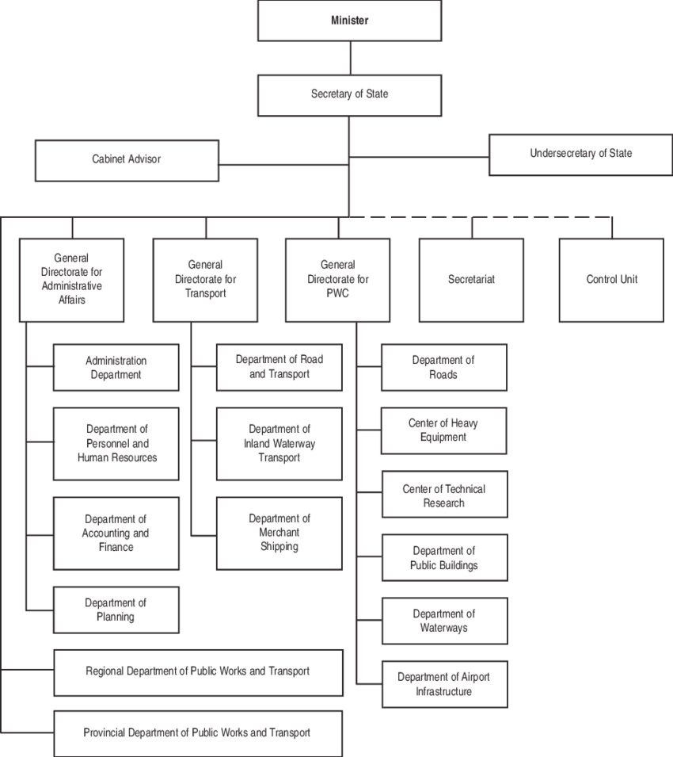

2.2 MEANING OF V I O

In the context of Lagos, "VIO" typically refers to Vehicle Inspection Officer, a role within the transport sector responsible for enforcing vehicle safety and road regulations.
Here's a more detailed explanation:
- Meaning:
VIO stands for Vehicle Inspection Officer.
- Role:
VIOs are responsible for inspecting vehicles to ensure they meet safety standards and are roadworthy.
- Function:
They enforce traffic regulations, including those related to vehicle conditions, licensing, and other road safety measures.
- Legal Authority:
In Lagos, the powers and duties of VIOs are established under the Transport Sector Reform Law of 2018.
- Example:
The Lagos State Ministry of Transport website mentions the VIO's role in ensuring road safety.

2.3 MEANING OF TRANSPORT MANAGER

A transport manager, also known as a traffic manager or transport supervisor, is a professional responsible for directing, coordinating, planning, and overseeing transportation activities within an organization, ensuring the efficient and safe movement of goods or passengers.
Here's a more detailed breakdown of what a transport manager does:
- Planning and Coordination:
They plan routes, schedules, and logistics to optimize transportation operations, ensuring timely and cost-effective delivery of goods or passengers.
- Resource Management:
They manage human and material resources, including vehicles, equipment, and personnel, to ensure smooth operations.
- Safety and Compliance:
They are responsible for ensuring all transportation activities comply with relevant regulations and safety standards.
- Negotiation and Cost Control:
They negotiate rates and schedules with carriers and other stakeholders, aiming to minimize transportation costs.
- Supervision and Control:
They supervise and control the means of transport, ensuring they are maintained and operated efficiently.
- Problem Solving:
They address any issues or delays that may arise during transportation operations.
- Data Analysis and Reporting:
They collect and analyze data to identify areas for improvement in transportation operations and prepare reports for management.

Function Transport Manager
A Transport Manager's primary function is to ensure the safe, efficient, and cost-effective movement of goods and/or people, encompassing tasks like route planning, vehicle maintenance, driver management, and compliance with regulations.
Here's a more detailed breakdown of a Transport Manager's functions:
Key Responsibilities and Duties:
- Planning and Optimization:
  - Route Planning: Developing and optimizing routes for efficient and timely deliveries or transportation.
  - Scheduling: Creating and managing schedules for vehicles and drivers to ensure on-time performance.
  - Transportation Strategy: Developing and implementing transportation strategies to meet business needs and objectives.

- Vehicle Management:
  - Maintenance: Ensuring vehicles are properly maintained and in good working order.
  - Fleet Management: Managing a fleet of vehicles, including monitoring fuel consumption, coordinating repairs, and servicing schedules.
  - Vehicle Inspections: Conducting regular vehicle inspections to identify potential issues and ensure safety.

- Driver Management:
  - Recruitment and Training: Recruiting, training, and managing drivers, ensuring they have the necessary qualifications and licenses.
  - Compliance: Ensuring drivers adhere to regulations and guidelines.

- Operational Efficiency:
  - Load Planning: Ensuring vehicles are loaded safely and effectively to maximize space and reduce waste.
  - Cost Control: Monitoring and controlling transportation costs, identifying areas for improvement.
  - Record Keeping: Maintaining accurate records of transportation activities, including deliveries, routes, and expenses.

- Compliance and Safety:
  - Regulatory Compliance: Ensuring compliance with all relevant regulations and laws related to transportation.
  - Safety: Prioritizing safety in all transportation operations, including vehicle maintenance, driver training, and route planning.
- Communication and Coordination:
  - Stakeholder Communication: Communicating with internal and external stakeholders, such as drivers, customers, and suppliers, to ensure smooth operations.
  - Problem Solving: Addressing and resolving transportation-related issues and challenges.

Function Transport Officer
A Transport Officer's primary function is to oversee and manage the efficient and safe movement of people, goods, or materials, ensuring compliance with regulations and optimizing transportation services.
Here's a more detailed breakdown:
Key Responsibilities:
- Planning and Coordination:
Transport officers plan and coordinate transportation services, including scheduling, route optimization, and resource allocation.
- Safety and Compliance:
They ensure that all transportation activities adhere to safety regulations, security protocols, and relevant legal frameworks.
- Vehicle Maintenance:
Managing vehicle maintenance, ensuring vehicles are in good working order, and coordinating repairs.
- Budget Management:
Managing the transportation budget, including fuel, maintenance, and other related expenses.
- Driver Supervision:
Supervising drivers, providing training, and evaluating their performance.
- Communication:
Maintaining clear communication with drivers, staff, and other stakeholders.
- Reporting:
Preparing reports on transportation activities, performance, and costs.
- Procurement:
Participating in the procurement process for vehicles, fuel, and other transportation-related supplies.
- Problem-Solving:
Addressing transportation-related issues and finding solutions to ensure smooth operations.
- Policy Implementation:
Implementing and adhering to organizational transport and security policies.

Function Transport Director
A Transport Director's primary function is to oversee and manage all aspects of an organization's transportation activities, ensuring efficient and cost-effective movement of goods and/or people while adhering to regulations and safety standards.
Here's a more detailed breakdown of the key functions:
- Strategic Planning and Development:
  - Develop and implement transportation strategies that align with the organization's goals.
  - Analyze current and future transportation needs, evaluating available resources and options.
  - Design optimal routes and schedules.

- Operations Management:
  - Direct and coordinate transportation operations, including vehicle maintenance, scheduling, and driver management.
  - Ensure compliance with relevant regulations and safety standards.
  - Monitor and evaluate transportation performance, identifying areas for improvement.

- Resource Management:

  - Manage the company's transportation fleet, including vehicle acquisition, maintenance, and disposal.
  - Negotiate contracts with transportation providers.
  - Control transportation costs and ensure budget adherence.

- Team Leadership:

  - Lead and motivate a team of transportation professionals, including drivers, dispatchers, and other support staff.
  - Provide training and development opportunities for employees.

- Other duties

  - Manage vehicle compliance with regulations like Department of Transportation requirements and passenger safety laws.
  - Manage company vehicles, coordinating maintenance and upgrading when necessary.

2.4 QUALITIES OF A GOOD TRANSPORT MANAGER
Communication skills
Leadership
Problem solving
Analytical skills
Computer skills
Adaptability
Attention to detail
Communication
Customer satisfaction
Team leadership
Develop transportation skills
Excellent geographical knowledge
Organisational skills
Teamwork skills
Ability to make decisions under pressure
Budget management
Business management skills
Ensure transportation compliance
Extensive industry knowledge
Extensive knowledge of the transportation industry
Forward thinking
Good interpersonal skills
Good number skills
Keeping records

CHAPTER THREE
3.1 WHAT IS ROAD
A road is a thoroughfare or route, typically surfaced or improved, designed for travel by vehicles, people, or animals, connecting two or more places.
Here's a more detailed explanation:
- Definition:
A road is a path or way, often with a hard surface like asphalt or concrete, that allows for the movement of people and vehicles.
- Purpose:
Roads serve as a primary means of transportation, connecting communities, facilitating commerce, and enabling access to various locations.
- Types:
Roads can be classified based on their function, surface material, or location (e.g., highways, streets, dirt roads, etc.).
- Examples:
  - Highways: Major roads designed for high-speed traffic.
  - Streets: Roads within urban areas, often used for local traffic and pedestrian access.
  - Dirt Roads: Unpaved roads, often used in rural areas or for temporary access.
  - Private Driveways: Roads leading to individual homes or properties.
- Importance:
Roads are essential infrastructure for modern societies, supporting economic growth, connecting people, and enabling access to essential services.

Categories of Road Users
Road users can be broadly categorized as pedestrians, drivers (of various vehicles), cyclists, and riders (of animals), with some road users considered vulnerable due to their age or mobility.
Here's a more detailed breakdown:
- Pedestrians:
Individuals walking on foot, including those using sidewalks or crosswalks.
- Drivers:
People operating motor vehicles, including cars, trucks, buses, and motorcycles.
- Cyclists:
Individuals riding bicycles or other pedal-powered vehicles.
- Riders:
People who are riding animals, which are considered vehicles under road rules.
- Vulnerable Road Users:
This category includes pedestrians, cyclists, motorcyclists, and people with disabilities or reduced mobility, who are often at greater risk in traffic.
- Young Road Users:
Individuals who are new to driving or riding, who may lack experience and be more prone to accidents.
- Animals:
Animals on the road, including those being ridden or pulling vehicles, are also considered road users.

3.2 ROAD INFRASTRUCTURE

Road infrastructure encompasses the physical assets like roads, bridges, tunnels, and related elements like signage, drainage, and bus stops, which are crucial for transportation and economic activity.
Here's a more detailed explanation:
- Definition:
Road infrastructure refers to the physical components and systems that facilitate road transportation, including the roads themselves, as well as associated elements like bridges, tunnels, signage, drainage systems, and facilities like bus stops and trucking terminals.
- Importance:
Road infrastructure is vital for economic development and daily life, connecting people and goods, supporting businesses, and enabling access to jobs, markets, and schools.
- Types of Roads:
Roads can be classified as private drive pathways, two-lane highways, or dual carriageways.
- Economic Impact:
Good road infrastructure streamlines the movement of goods and people, which is essential for supply chains, production processes, and the efficient distribution of finished products.
- Sustainability:
Modern road design increasingly emphasizes sustainability, using eco-friendly materials, optimizing energy efficiency, and minimizing environmental impact.
- Infrastructure in Nigeria:
Nigeria has developed an extensive national network of roads and bridges, carrying more than 90% of domestic passengers and freight.

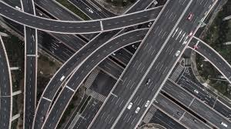

3.3 WHAT IS VEHICLE
A vehicle is a machine, typically with wheels and an engine, used for transporting people or goods, especially on land, and can include cars, buses, trucks, and other similar devices.
Here's a more detailed explanation:
- Definition:
A vehicle is a device or machine designed to carry or convey people or objects, especially on land.
- Examples:
Common examples of vehicles include cars, buses, trucks, motorcycles, and even bicycles or carts.
- Purpose:
The primary purpose of a vehicle is to facilitate transportation, allowing people and goods to move from one place to another.
- Types of Vehicles:
There are many different types of vehicles, each designed for specific purposes, such as passenger vehicles, commercial vehicles, and specialized vehicles like tractors or construction equipment.
- Motor Vehicles:
A motor vehicle is a type of vehicle that is powered by a motor or engine, such as a car or truck.
- Other Uses:
The word "vehicle" can also be used metaphorically to describe something that serves as a means or medium for achieving something else, such as an "investment vehicle".

CHAPTER FOUR

4.1 ROAD SIGNS AND TRAFFIC LIGHTS

Road signs and traffic lights are crucial for safe and efficient road traffic management, providing drivers with instructions and warnings. Road signs, categorized as regulatory, warning, guide, and information, convey rules, hazards, directions, and locations, while traffic lights signal when to stop, proceed, or yield.
Road Signs:
- Regulatory Signs:
These signs establish rules and regulations that all road users must follow, such as speed limits, parking restrictions, and mandatory directions.
  - Examples: Stop signs, yield signs, speed limit signs, one-way signs.

- Warning Signs:

These signs alert drivers to potential hazards or changes in road conditions, such as curves, hills, or construction zones.
  - Examples: Curve ahead, slippery when wet, school zone.

- Guide Signs:

These signs provide directions and information to help drivers navigate, such as route numbers, distance to destinations, and service areas.
  - Examples: Interstate highway signs, exit signs, service area signs.

- Information Signs:

These signs provide additional information to drivers, such as traffic regulations, parking regulations, or points of interest.
  - Examples: No parking signs, pedestrian crossing signs, rest area signs.
Traffic Lights:
- Red Light:
Indicates that drivers must stop and wait for the light to change to green.
- Yellow Light:
Indicates that drivers should prepare to stop, but if they are close enough to the intersection, they may proceed through it.
- Green Light:
Indicates that drivers may proceed through the intersection if it is safe to do so.
- Green Arrow:
Indicates that drivers can travel in a particular direction, even if the main lights for that approach are red.
- Flashing Amber Arrows:
Indicate that road users must give way (to other drivers and pedestrians) before making a movement in the direction of the arrow.

4.2 IMAGE OF TRAFFIC LIGHTS

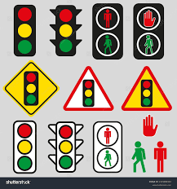 Traffic Signal Sign

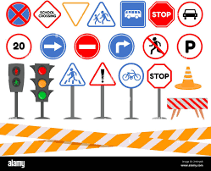 Cartoon Traffic Light and Road Sign

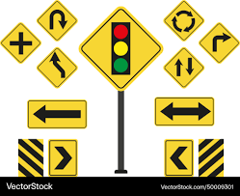 road sign for kids for vehicle

CHAPTER FIVE

5.1 CONCLUSION

The Student Industrial Work Experience Scheme (SIWES) plays a significant role in human resource development, it helps students develop new skills and enlightens them of what the present society holds for them after graduation and helps them adapt accordingly. As a result of the programme, I am now more confident to build my future, My four (4) months industrial attachment with Radio Kwara has been one of the most interesting, productive and instructive experience in my life. Through this training, I have gained new insight and more comprehensive understanding.

5.2 RECOMMENDATION

The following are the suggested recommendation for the program
i. The company should remain friendly and accommodating to future IT student.
ii. The SIWES coordinator and school should where organized enlightenment program for IT student in order to know the important of SIWES.
iii. The school (Polytechnics) should consider the four months mandatory SIWES while drafting the calendar for a successive session in a way that will affect the returning IT Student.

