A TECHNICAL REPORT ON
STUDENT INDUSTRIAL WORKING EXPERIENCE SCHEME (SIWES)
HELD AT
QUEENSWAY HOSPITAL LAGOS
KM15, LEKKI EPE EXPRESS WAY IKOTA AJAH LAGOS NIGERIA

PRESENTED BY
ABDULWAHAB MUDASHIR OMOBOLAJI
ND/23/STA/FT/0110
SUBMITTED TO
DEPARTMENT OF STATISTICS, INSTITUTE OF APPLIED SCIENCE (IAS) KWARA STATE POLYTECHNIC, ILORIN.
IN PARTIAL FULFILMENT OF THE REQUIREMENTS FOR THE AWARD OF NATIONAL DIPLOMA (ND) IN STATISTICS DEPARTMENT.

SEPTEMBER 2024 TO DECEMBER, 2024
TABLE OF CONTENTS
Introduction to SIWES
History of SIWES
Aims and Objective of SIWES
Various Department
Organogram Queensway Hospital Lagos
Library Department
Ways of Data Collection
Objective of Data Collection
Problem of Data Collection
Stages of Data Collection
Section / Unit of the Organisation and their specific functions
Selection Procedure with the aid of random table number
Method of Data Analysis
Data Presentation and Analysis
Data Presentation
Data Analysis (Descriptive Statistics)
Problems encountered during the programme
Experience Gained
Conclusion
Recommendations

1.1 INTRODUCTION/MEANING OF SIWES
The student industrial working experience scheme (SIWES) is an accepted skill training program which forms part of approved minimum academic standards in the various degrees program of the Nigeria tertiary institutions.
This scheme help student in their various field to know or have knowledge and clear picture of what they have been studying in school which enables the student to practice the theoretical aspect of his or her profession. This scheme contributes to the large way of preparing the student for any future engagement, exposing him or her to atmosphere of versatility and adaption.
1.2 HISTORY OF SIWES
Student industrial experience scheme SIWES was established by ITF in 1973 to solve the problem of lack of adequate practical skills preparatory for employment in industrial by Nigerian graduates of tertiary institutions. The scheme exposes student to industry based skills necessary for a smooth transition from the classroom to the world of work it affords students of tertiary institutions the opportunity of being familiarized and exposed to the needed experience in handling machinery and equipment which are usually not available in the educational institutions.
Participation in SIWES has become a necessary pre-condition for the award of Diploma and Degree certificate in specific discipline in most institutions of higher learning in the country, in accordance with the education policy of government.
Operators: - The ITF, the coordinating agencies (NUE, NCCE, NBTE) employers of labour and the institutions.
Funding: - The federal Government of Nigeria
Duration: - Four months for Polytechnic and College of Education, and six months for the University.
1.3 AIMS OF SIWES
- Student Industrial Work experience scheme (SIWES) provide avenue for student to acquire industrial skill and experience in their choose course of study.
- It prepares student for their industrial work experience which they are likely to meet after graduation.
OBJECTIVE OF SIWES
- To provides avenue for students in institutions of higher learning to acquire industrial skills and experience in their course of study.
- It prepares students for post graduation working situation.
- To expose students to working methods and techniques in handling equipments and machinery that may not be available in educational institution.
- To provide opportunity for students to apply their knowledge in working situation, thereby bridging the gap between theory and practice
- To ease the transition from school and labour market, which enhances students contact for later job.
- For Ernest placement and strengthens employees involvement in the educational process of preparing student for employment in industries.
2.1 ORGANOGRAM QUEENSWAY HOSPITAL LAGOS
The organogram below shows the current management structure, hierarchy of Queensway Hospital Lagos
RECEPTION

PHARMACY
DRESSING ROOM
CONSULTING ROOM
LABORATORY
SCAN ROOM
TOILET
MEDICAL DIRECTOR
C.E.O

NURSING BASE
WARDS
WARDS

MANAGER OFFICE
LABOUR ROOM
WARD ATTENDANT ROOM
THEATRE

2.2 LIBRARY DEPARTMENT
Health records library is. designed to assist physicians, patients, health professionals, medical researchers and. information specialists find health and specific information to improve, update asses or. evaluate health care.
Types of register in library
The Registration Instruments use in the Department.

- Labour and Delivery Register
This register is used to document Labour and Delivery services provided to women in the health facility. The register is kept at the facility in the section that provides Labour and Delivery and the information contained in it pertains only to Labour and Delivery (LD) services provided at the facility.
- Family Planning Register
This register is used to document Family Planning services provided to clients in the health facility. The register is filled from the Family Planning/Patient card and the register is kept in the Family Planning (FP) clinic or at any point where FP services is being offered. It is expected that information in the FP card is confidential, access to it should be limited to authorised persons.
- Daily Immunization Register
This register is used to document immunization services provided daily in the health facility. This register is filled only when immunization services are provided using information obtained from the child health card. This register is kept at the facility in the section that provides immunization services. The register shows the immunization status of children seen in the health facilities, it helps the health worker to ensure the children receive the appropriate immunization services and is used to prepare the monthly immunization summaries.
- Daily General Attendance Register
This register is used to collect information on the utilization of health facility and aids follow-up of the patients attending for care at the facility. This register shows the distribution of people utilizing the facility by age and sex and it is used for planning activities at the health facility.
- Daily Ante Natal Clinic Attendance Register
The daily antenatal clinic (ANC) attendance register is used to document ANC health services provided to mothers in the health facility. The register is used to prepare summary forms for onward transmission to the L.G.A (local Government Area). It provides in a single location data on ANC services.
- Out-Patient Register
This is a register of patients that do not presently need/require hospital administration or continuous medical or nursing services. This register is kept at the out-patient department. The register is used in collecting information on the utilization of health services at the facility, it is used for planning activities of the Out-patient Department (OPD), it shows the drugs needs/used at the OPD, it exposes the disease pattern at the health facility and it aids follow-up of the patients attending for care at the facility.
- In-Patient or Admission/Discharge Register
This register is used to record information about patient who have undergone due admission formalities of the hospital and stayed in that part of the hospital bed for medical and nursing care. From this register, a daily list of all admissions is made on discharge, date of discharge and diagnosis is also entered into the same register. While some countries admission register is different from discharge register but it is better to have them in one place.
Library track card
It is a method used to replace the folders to avoid misfiling or to monitor where the folder is going. For easing refilling method, there is a patient folder is been arranged in terminal or straight method and how to retrieved folder.
Different unit in library
Tracing session
Appointment session
Documentation session
Registration session
Antenatal care
Antenatal care (ANC) coverage is an indicator of access and use of health care during pregnancy. The antenatal period presents opportunities for reaching pregnant women with interventions that may be vital to their health and wellbeing and that of their infants.
Types of Antenatal
- Early pregnancy
- Lamaze Classes (involving breathing techniques, relaxation and support)
- Active Birth (learning birthing techniques and positions)
- Calmbirth (childbirth education program based on understanding of the birth process)
- Hypnobirthing (a form of deep meditation and relaxation)
- Aqua antenatal classes
- Antenatal yoga or pilates
- Preparation for breastfeeding
3.0 WAYS OF DATA COLLECTION
There are different ways or means of collecting data in QUEENSWAY HOSPITAL LAGOS which are;
CENSUS: It is a complete enumeration or total counting of population of an element/unit
SAMPLE: this is a fractional part of a population
SYSTEM ADMINISTRATIVE STATISTICS (S.A.S): This is statistical data generated from administrative record of activities such as vital statistics e.g. birth rate, death rate of number of both etc.
INSTRUMENT USED IN DATA COLLECTION IN QUEENSWAY HOSPITAL LAGOS
Questionnaire
- Instrument Manual: it can be Supervisor or Enumerator manual
- Forms and format (it may be in tabular from)
3.1 OBJECTIVE OF DATA COLLECTION
- To have a good quality data
- Data must be timely i.e. up to date
- Data must be comprehensive
- Data must be reliable
3.2 PROBLEM OF DATA COLLECTION
- Difficult respondent
- Language barrier
- Problem of respondent not available
- Poor funding
- Illiteracy
- Land Terrain
- Lack of Publicity e.t.c.
3.3 STAGES OF DATA COLLECTION
- Set the Aim and Objective of the survey
- Population to be studied
- Sample frame
- Sample selection
- Information to be collected
- Method of data collection
- Design questionnaire
- Recruitment and training of staff
- Collection and Collation of data
- Analysis of data
- Report writing
- Publication of data collected
SECTION / UNIT OF THE ORGANISATION AND THEIR SPECIFIC FUNCTIONS
There are different sections or units in which data are captured and their functions in the hospital, sections or units in which data are captured are stated below:
- GENERAL OUTPATIENT DEPARTMENT (GOPD)
Data captured from this section shows the total numbers of visited patients during the reporting period
- SPECIAL OUTPATIENT DEPARTMENT (SOPD)
This department is a combination of the SUB units which include ENT, NEURO, ORTH, B/S, PAED, G/S, CARDIO, NEPH, UROLOGY and HAEMATOLOGY units. These are various units that the patients came for treatment, irrespective of all units.
- ACCIDENTS & EMERGENCY DEPARTMENT (A&E)
This department is one of the integral departments of the hospital which proper and accurate data must be captured during the month, a total number of 2389 patient attended for medical attention
- MATERNITY DEPARTMENT
This is another department of the hospital which are care for women during pregnancy and child birth, data captured cannot be exempted
- SPECIAL CARE BABY UNIT (SCBU)
Babies were brought to the unit during the report training to collect special treatment.
- EMERGENCY PAEDIATRIC UNIT (EPU)
The Emergency Pediatric unit has a pivotal role in managing sick children arriving to the hospital, during the reporting a total number of 223 were admitted
- LABORATORY DEPARTMENT
This is a unit that carried out the experiment in the hospital
- DENTAL DEPARTMENT
This is a unit that takes care of dentist teeth and major problem that can affect the teeth.
- PHYSIOTHERAPY DEPARTMENT
The functions of this department include assessing, diagnosis and treating injures and conditions that affect movement and function in people in all age and social group
- IMMUNIZATION DEPARTMENT
This unit is in charge of general and special immunization injection for both children and adults
3.4 SELECTION PROCEDURE WITH THE AID OF RANDOM TABLE NUMBER
In giving accurate and reliable data in, the selection is done by the application of systematic probability sampling (SPS) which have the following term:
N Total population
n sample population
K It is the total population divided by sample population. It is also called sample interval (S.I) that is K or S.I=N/n
SAMPLE SELECTION
DATE | PAGE TO USE
1-5 | 1
6-10 | 2
11-15 | 3
16-20 | 4
21-25 | 5
26-31 | 6
In the selection procedure, a given data is used to select page of random table number to be used e.g 23/04/2018 is given, the page of random table no to be use is “5” and column is “23”.
In case, if a given date of selection falls between 26 to 31, in the random number table, the total column in the random table number is 25, therefore, we subtract the actual date from the selection date. For example, if the selection date is 27, then 28-25=3. then column 3 will be used in the random number table in page 1.
EXAMPLE
N=52
n=10
Date=12/09/2019
K=N/n =52/10=5.2
Page of R/T=3
Column used=12
R/S=0.2
Master sample Number | Computation of selection | Selected household/housing unit | Name of selected house head
1 | 0.2 | - | TOHEEB
2 | 0.2+5.2=5.4 | 5 | KUNLE
3 | 5.4+5.2=10.6 | 10 | FEMI
4 | 10.6+5.2=15.8 | 15 | ADENIJI
5 | 15.8+5.2=21.0 | 21 | BOLANLE
6 | 21.0+5.2=26.2 | 26 | DARAMOLA
7 | 26.2+5.2=31.4 | 31 | FUNMILAYO
8 | 31.4+5.2=36.6 | 36 | TUNDE
9 | 36.6+5.2=41.8 | 41 | OLAMIDE
10 | 41.8+5.2=47.0 | 47 | SHAKIRAT
11 | 47.0+5.2=52.2 | 52 | BARAKAT

3.5 METHOD OF DATA ANALYSIS
There are several modes of analyzing data depending on the mode of the type of the data we are working with, I employed Descriptive statistics such as frequency and percentage as well as drawing Bar chart, also inferential statistics using Chi-square test with the use of SPSS as my mode of analyzing the data. Since there are different computer package that are useful in analyzing data such as:
Mat lab
Microsoft Excel
Statistical program for social student (SPSS)
I employed SPSS package in analyzing my data and the results obtained is presented in the next chapter.
4.0 DATA PRESENTATION AND ANALYSIS
The table below shows the data obtained on Malaria disease patients from the record of Queensway Hospital over a period of 4 months (September 2024 to December 2024).
4.1 DATA PRESENTATION
 | GENDER
MONTH |  | MALE |  | FEMALE | TOTAL
SEPTEMBER |  | 50 |  | 40 | 90
OCTOBER |  | 65 |  | 50 | 115
NOVEMBER |  | 60 |  | 45 | 105
DECEMBER |  | 75 |  | 65 | 140
TOTAL |  | 250 | 200 |  | 450
Source: Queensway Hospital Lagos
 |  | MALARIA TYPES
GENDER | PLASMODIUM FALCIPERUN |  | SEVERE | NON SEVERE | TOTAL
MALE | 110 |  | 80 | 60 | 250
FEMALE | 90 |  | 65 | 45 | 200
TOTAL | 200 |  | 145 | 105 | 450
Source: Queensway Hospital Lagos
4.2 DATA ANALYSIS (DESCRIPTIVE STATISTICS)
Table 1 showing the frequency and percentage of Malaria Patients in mobolaji hospital Ibadan from September to December with respect to Gender.
Gender
 |  | Frequency | Percent | Valid Percent | Cumulative Percent
Valid | Male | 250 | 55.6 | 55.6 | 55.6
Valid | Female | 200 | 44.4 | 44.4 | 100.0
Valid | Total | 450 | 100.0 | 100.0

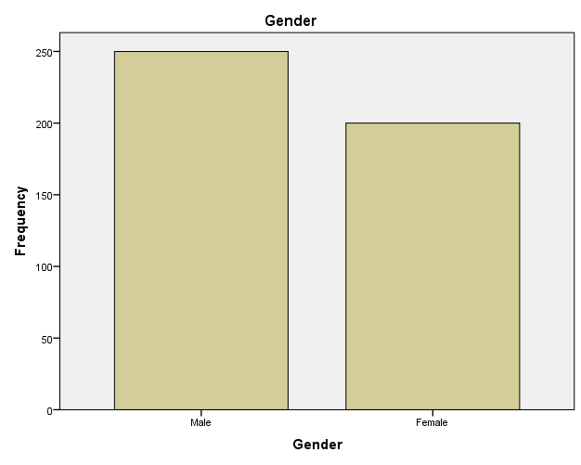
Fig 1
Comment: from the table 1 and fig 1, it could be seen clearly that Male Malaria patients has the highest frequency and percentage within the period of September to November
Table 2 showing the three types of malaria treated in Queensway Hospital Lagos
Malaria Types
 |  | Frequency | Percent | Valid Percent | Cumulative Percent
Valid | Plasmodium Falciperun | 200 | 44.4 | 44.4 | 44.4
Valid | Severe | 145 | 32.2 | 32.2 | 76.7
Valid | Non Severe | 105 | 23.3 | 23.3 | 100.0
Valid | Total | 450 | 100.0 | 100.0

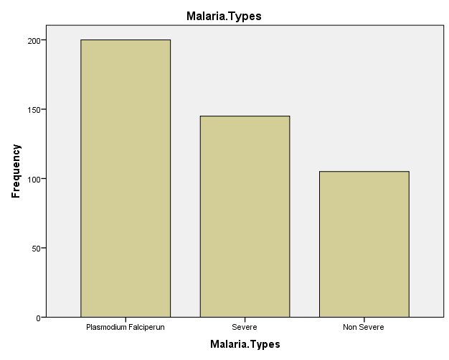
Fig 2
Comment: from table 2 and fig 2, it could be seen clearly that patients with Plasmodium falciperun malaria type has the highest frequency and percentage
- INFERENTIAL STATISTICS (CHI-SQUARE TEST ANALYSIS)
Table 3 showing the cross tab of Gender against Malaria types
Gender * Malaria Types Cross tabulation
 |  |  | Malaria Types |  |  | Total
 |  |  | Plasmodium Falciperun | Severe | Non Severe | Total
Gender | Male | Count | 200 | 50 | 0 | 250
Gender | Male | Expected Count | 111.1 | 80.6 | 58.3 | 250.0
Gender | Female | Count | 0 | 95 | 105 | 200
Gender | Female | Expected Count | 88.9 | 64.4 | 46.7 | 200.0
Total |  | Count | 200 | 145 | 105 | 450
 |  | Expected Count | 200.0 | 145.0 | 105.0 | 450.0
Table 4
H₀: The Gender and the Malaria types are dependent
H₁: The Gender and the Malaria types are Independent
Chi-Square Tests
 | Value | df | Asymptotic Significance (2-sided)
Pearson Chi-Square | 317.328ª | 2 | .000
Likelihood Ratio | 431.452 | 2 | .000
Linear-by-Linear Association | 307.380 | 1 | .000
N of Valid Cases | 450
Comment: from table 4 above, since the P-value is less than α, (0.000 < 0.05), we hereby reject the null hypothesis and conclude that The Gender and the Malaria types are Independent.
5.0 PROBLEMS ENCOUNTERED DURING THE PROGRAMME
However, I encountered a little problem in funding during my three months attachment.
Firstly, I was overloaded, I worked from Monday to Friday and it was difficult for me to transport myself to and fro. This is because I wasn’t officially paid. Also, the inconsistent power supply made learning quiet slow for me, because sometimes there wouldn’t be power supply to charge the system.
5.1 EXPERIENCE GAINED
Discipline in the operation department of Queensway Hospital Lagos, I`ve get to realized the Efficiency of statistics in an organization, Also it help me a lot in the practical aspect of my course of study, I learnt how to be patient when collecting the data from members of the public and it also enable me to know how to deal with real calculations on statistics, and it also enhances my ability and integrity and it also enable me to know more on each topics and different analysis in statistics. I learnt a lot during my SIWES, not only in academic field but I also learnt how to interact and associate with elderly people most especially strangers. The student industrial work experience scheme (SIWES) program had been so helpful to student irrespective of their course of study.
  - CONCLUSION
With the little experience gained during the course of my SIWES program bought me great knowledge in such a way that it exposed me to various aspects of data collection, organization, summarization, presentation, analyzing and interpretation with statistical terms.
5.3 RECOMMENDATIONS
So far, it is believed that statistics cannot skip- through in the activities of our co- existence. Therefore, the organization should continue to give room for students more comprehensive practical training by having permanent professional statistics.
The industrial training program is an import aspect and on educating scheme, however wishes to recommend that:
- Other student in management field should give an ultimate taste of this benefit for more and office practice experience.
- The school should take adequate provision of transport for the supervisors so that they can be visiting the student field and most in office alone
- The industrial training fund (ITF) officers are implored to make a brilliant arrangement for the payment of the allowance in appropriate time preferable every month so that the string of the student who is doing this programmed will not be in vain.
- Provision of adequate funds for the I.T and SIWES students for at least transportation fare.
- This programme is actually relevant to all course of study, it has really exposed me to the reality of practical aspect of the theoretical work I have been taught in school.
- Therefore, I hereby recommend that the Industrial Training officials should also this SIWES programme.

