TECHNICAL REPORT ON STUDENT INDUSTRIAL WORK
EXPERIENCE SCHEME (SIWES)
HELD AT
SUCCESS AUTOMOTIVE

OJATUNTUN ILORIN
WRITTEN BY
Ibrahim Abdulmalik
ND/23/MEC/PT/0098

SUBMITTED TO
DEPARTMENT OF MECHANICAL ENGINEERING TECHNOLOGY,
INSTITUTEOF TECHNOLOGY,
KWARA STATE POLYTECHNIC, ILORIN

IN PARTIAL FULFILLMENT OF THE REQUIREMENT FOR THE
AWARD OF NATIONAL DIPLOMA (ND) IN TECHNOLOGY

AUGUST –NOVEMBER 2024

CHAPTER ONE
1.0 INTRODUCTION
The student industrial works experience scheme (SIWES) was established by the industrial training fund (I.T.F) in 1973 and control by the national board for technical education (NBTE). The aims and objectives are to develop student skill and to expose students in the school of engineering, technology, environment, science and agriculture and medical science to the working experience in which they will found themselves in future.
It is integral part of degree and National Diploma Programme institute of higher learning in Nigeria. This privilege programme would definitely broaden student chance of learning and would empower his/her academic efficiency.
During my three months Student Industrial Work Experience Scheme (SIWES) at Kwara State Polytechnic Ilorin, Institute of Technology, Mechanical Workshop, the usefulness of maintenance in automobile and welding and fabrication was proved and lot of experience was gained.
1.1 DEFINITION OF SIWES
Student Industrial Work Experience Scheme (SIWES) is a skill acquisition training programme set up by the Federal and State government across the Nation in collaboration with the body known as Industrial Training Fund (I.T.F) for student to have a working experience and a feel of what it takes to be genius in one discipline before challenges ahead.
1.2 AIMS AND OBJECTIVES OF SIWES
1. It exposes the prepare students of higher institution for the industrial working situation they can likely to meet in the future.
2. It enables student to apply what they have learn theoretically in class into practice in the real world.
3. It makes student to understand the technical implication of their profession.
4. It helps student to express their initiatives, competence and standard in task they have chosen.
5. It enables student to be technically and morally oriented
6. It helps to make transition from school to the working environment easier and to enhance students contact for later job placement

CHAPTER TWO
2.0 HISTORICAL BACKGROUND OF THE ORGANIZATION
Success automotive located at ojatuntun
Name of the chairman is Mr junior
Tye company was establish on 200
2.1 Organization Chart
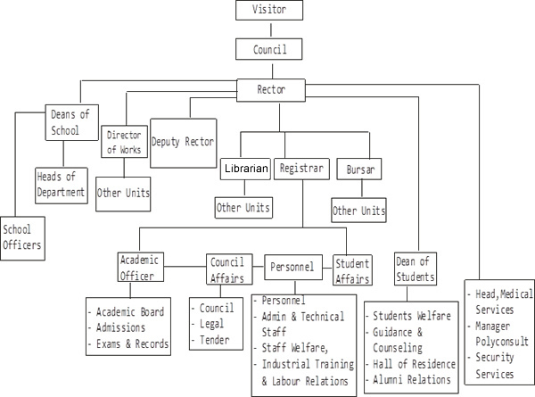

CHAPTER THREE
3.0 RELEVANT EXPERIENCED GAINED
3.1 WELDING
Arc welding is process of joining two metal pieces by the application of heat either with or without filler materials.
Arc welding can be defined as type of welding that uses a welding power supply to create on electric arc between an electrode the bases material to melt the metals at the welding point.
FUCTIONS OF ARC WELDING
- It has the ability to join a wide range of metals and thicknesses.
- All position welding capability means you can weld on vertical and overhanging surface with ease.
- A good weld bead, with the right settings.
- A minimal amount of welding splatter.
- It is easy to learn.
PERSONAL SAFETY
- Welding helmet should be worn
- Welding jacket should also be worn
- Safety gloves
- Safety glasses
- Face mask should be used
- Safety boot should be worn
PRECAUTIONS
- Avoid pouring down of oil or any other slippery materials that can cause an accident.
- Avoid melting sparking of wire which can cause an accident.
- Care must be taken while welding to prevent damages.
- Avoid water which can cause shock.
3.2 MATERIALS USED IN ARC WELDING
- Tong
- Electrode
- Wire
- Welding wire
3.3 TOOLS
- Plier
- Hammer
- Chisel
- Hacksaw
- Winches
Measuring and marking tools
- Meter rule
- Squaring tools
- Permanent maker
- Scribe
- Angle of Measurement

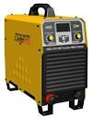
Hand glove Welding machine
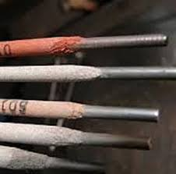
Electrode Welding glass
3.4 GRINDING MACHINE
Grinding machine can be defined as an abrasive process that uses a grinding wheel as the cutting tool; is capable of marking precision cut and producing very fine finishes.
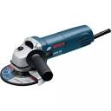
Grinding machine
FUNCTIONS OF GRINDING MACHINE
- Angle grinding machine is used to finish the grinding process. Construction industry, also for quick removing trimming.
- It is simple grinding machine which can be used to perform so many works and will make the work short.
- It is very fast to operate.
- It can alsobeused to cut metals stone or wood.
- When using a grinding machine, you can adjust to your desired angle.
Working principle of grinding machine
- Cutting disc: it is used to cut metals, and steels for a various size needed.
- Grinding disc: it is used to reduce the surface of an object, it can be used in furniture to smooth the surface of wood and it also used to reduce the surface of metal and steel.

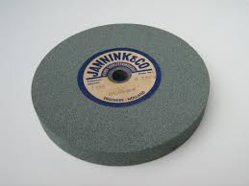
Cutting Disc Grinding Disc
USES OF GRINDING MACHINE
- It is used for removing excess metal from a piece.
- It is widely used in metal working and construction as well as in emergency rescues. They are commonly found in workshop.
- It’s standard equipment in metal fabrication shop and construction sites.
- It is also used to reduce object to flat object.
PRECAUTION
- Angle grinder should be used carefully to prevent accident and damages.
- Cutting disc should not be used for grinding and grinding disc should not be used for cutting.
- Glass should be worn while operating the machine.
- When operating the machine makes sure the machine is well tight and holds before start any operation.
- Look at the spark flow.
Angle grinders are available in different size of grinding/cutting disc voltages and wattages.
Angle grinders are typically available for grinding discs of the following sizes
- 4 $1/2$inch -115mm
- 5 inch -125mm
- 6 inch – 150mm
- 7 inch -180mm
- 9 inch -230mm

3.5 WORKSHOP TOOLS

Cutting Tools
Ordinary scissors, box cutters, and a hacksaw. You can use the hacksaw when the box cutter fails to do its job, otherwise, I would just keep the hacksaw in a safe place away from humans as it can be a hazard if not stored properly.
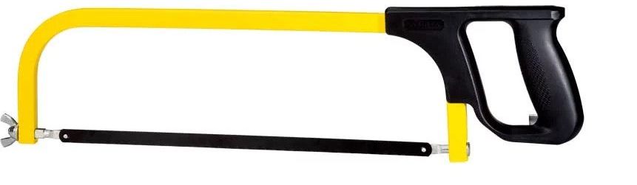

Grabbing and Clamping Tools
I would suggest you curate a set of different pliers, such as needle-nosed, the kind that cut, as well as the flat stubbed ones. They are some of the most multipurpose and helpful mechanical tools ever. Apart from the pliers if you have one c-clamp like holding device. you should be all set. Bench vices are overkill but are useful to have in some situations. You can always go to the local hardware store if you need one.

Measuring Tools
This is a very important category, you should ensure that you have at least one proper ruler with visible markings and if possible, get your hands on one of those cool retractable measuring tapes that you see in the hands of your interior decorator every now and then. PS: I got mine from him.
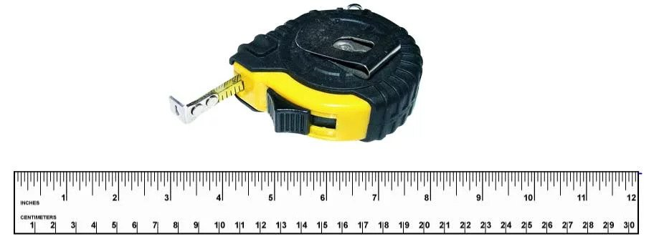

Writing Tools
Obviously, no justification required for these. Get yourself a pen, pencil, sharpie, or whatever you fancy and stick it behind your ear unless you want to lose it!

Hammers and Mallets
Every now and then you might need to scavenge for parts from waste material and break some parts off. This is when hammers and mallets will come handy.
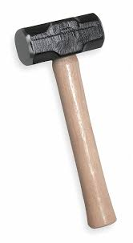

Screwdrivers and Fasteners
Of course, you will need a good collection of screwdrivers so that you can open all the screws you can find around your house. Household E-waste is extremely useful, learn to hoard it and harvest it for free motors, power electronics, and other such things.
Also, try to curate an assortment of nuts and bolts from all these things that you unscrew. They can be extremely helpful at times.
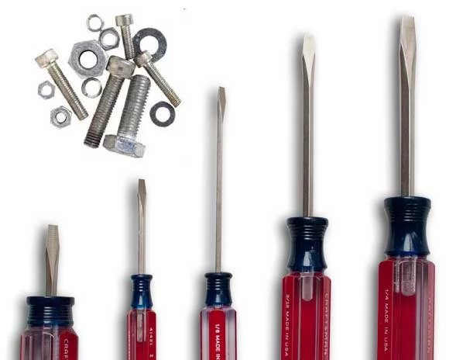

Power Tools
These are mechanical tools such as drills, hand cutters, and dremels. They are rarely required and can always be borrowed from your local mechanic. This approach saves you a lot of money as well as space.
Spanner
A spanner is a tool used to provide grip and mechanical advantage in applying torque to turn objects—usually rotary fasteners, such as nuts and bolts—or keep them from turning. In the UK, Ireland, Australia, and New Zealand spanner is the standard term.
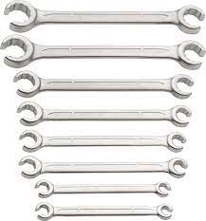
Pliers
Pliers are a hand tool used to hold objects firmly, possibly developed from tongs used to handle hot metal in Bronze Age Europe. They are also useful for bending and compressing a wide range of materials.
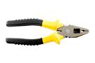

3.6 LATHE MACHINE
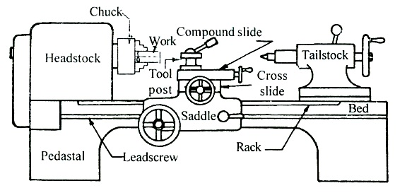
A lathe (/leɪð/) is a machine tool that rotates a workpiece about an axis of rotation to perform various operations such as cutting, sanding, knurling, drilling, deformation, facing, and turning, with tools that are applied to the workpiece to create an object with symmetry about that axis.
Lathes are used in woodturning, metalworking, metal spinning, thermal spraying, parts reclamation, and glass-working. Lathes can be used to shape pottery, the best-known design being the Potter's wheel. Most suitably equipped metalworking lathes can also be used to produce most solids of revolution, plane surfaces and screw threads or helices. Ornamental lathes can produce three-dimensional solids of incredible complexity. The workpiece is usually held in place by either one or two centers, at least one of which can typically be moved horizontally to accommodate varying workpiece lengths. Other work-holding methods include clamping the work about the axis of rotation using a chuck or collet, or to a faceplate, using clamps or dog clutch.
Examples of objects that can be produced on a lathe include screws, candlesticks, gun barrels, cue sticks, table legs, bowls, baseball bats, pens, musical instruments (especially woodwind instruments), and crankshafts.
A metalworking lathe from 1911, showing component parts:
a: bed
b: carriage (with cross-slide and tool post)
c: headstock
d: back gear (other gear train nearby drives lead screw)
e: cone pulley for a belt drive from an external power source
f: faceplate mounted on spindle
g: tailstock
h: leadscrew
Safety Precaution of Lathe Machine
- Do not wear gloves, rings, watches or loose clothing.
- Do not lean on machine.
- Do not adjust while the machine is operating.
- Do not place hands on work turning in the lathe.
- Do not use calipers or gauges on a workpiece while machine is moving.
Working principle of lathe machine
Lathe machine is one of the most important machine tools which is used in the metalworking industry. It operates on the principle of a rotating work piece and a fixed cutting tool. The cutting tool is feed into the work piece which rotates about its own axis causing the workpiece to form the desired shape.
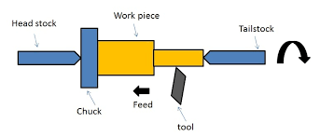
3.7 TURNING OPERATION
Turning is the most common lathe machining operation. During the turning process, a cutting tool removes material from the outer diameter of a rotating workpiece. The main objective of turning is to reduce the workpiece diameter to the desired dimension.

1. TURNING
Turning is the most common lathe machining operation. During the turning process, a cutting tool removes material from the outer diameter of a rotating workpiece. The main objective of turning is to reduce the workpiece diameter to the desired dimension. There are two types of turning operations, rough and finish.
Rough turning operation aims to machine a piece to within a predefined thickness, by removing the maximum amount of material in the shortest possible time, disregarding the accuracy and surface finish. Finish turning produces a smooth surface finish and the workpiece with final accurate dimensions.
Different sections of the turned parts may have different outer dimensions. The transition between the surfaces with two different diameters can have several topological features, namely step, taper, chamfer, and contour. To produce these features, multiple passes at a small radial depth of cut may be necessary.
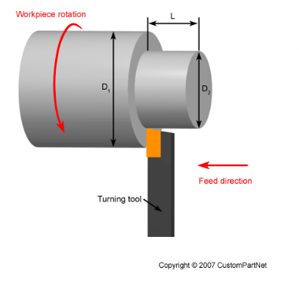

STEP TURNING
Step turning creates two surfaces with an abrupt change in diameters between them. The final feature resembles a step.
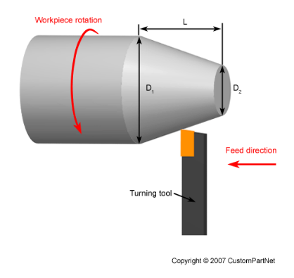

TAPER TURNING
Taper turning produces a ramp transition between the two surfaces with different diameters due to the angled motion between the workpiece and a cutting tool.
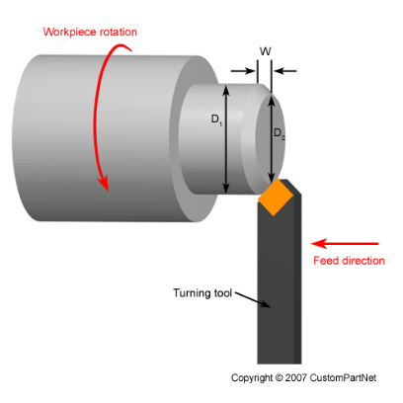

CHAMFER TURNING
Similar to the step turning, chamfer turning creates angled transition of an otherwise square edge between two surfaces with different turned diameters.

3.8. SENSITIVE DRILLING MACHINE
Sensitive drilling machine which are of light and simple construction are used or the drilling of small holes where it is essential that the machine operator shall ‘feel’ the passage of the drill through the work to prevent excessive drill breakages.

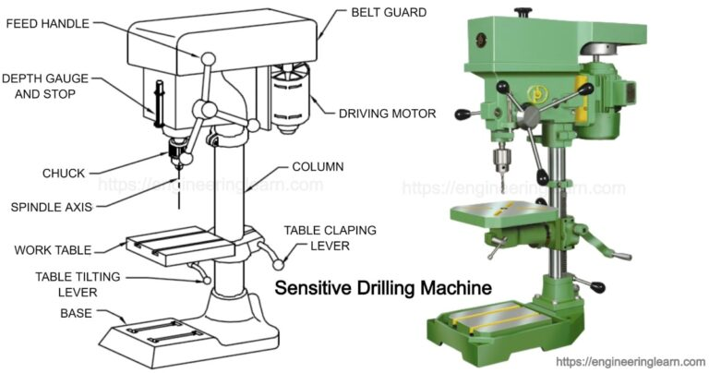

CHAPTER FOUR
4.0 AUTOMOBILE
Automobile: is a self-propelled vehicle by an internal combustion engine and is usual for transportation of passengers and goods on ground
Example: bus, cars, jeep, truck, motorcycle
Parts of automobile
- Machine portion
- Carriage portion i.e. body
DIFFERENT PARTS OF I.C ENGINES
A. parts common to both petrol and diesel engine
(1) Cylinder
(2) Cylinder head
(3) Piston
(4) Piston rings
(5. Gudgeon pin
(6) Connecting rod
(7) Crankshaft
(8) Crank
(9) Engine bearing
(10) Flywheel
1. CYLINDER: It contains gas under pressure and guide the piston the movement of the piston or stroke bearing in most case, longer than the bore. It is known as the stroke bore ratio. The upper end consists of a combustion or clearance space in which the ignition and combustion of the change take place.
2. CYLINDER HEAD: It helps to seal the working ends of the cylinders and not to permit entry and exist of gases on cover head valve engines. The inside cavity head is called the combustion chamber. It Is usually made by cast-iron or aluminum
3. PISTON: A piston is filled to each cylinder as a face to receive gas pressure and transmit the thrust to the connecting rod
4. GUDGEON PIN: it is hard steel parallel spindles filled through the piston bosses and the small end bushes or eyes to allow the connecting rod to swivel.
5. CONNECTING ROD: It transmits the piston load to the cranks causing the latter to turn.
B. parts for petrol engine only
1. Spark plug (2) Carburetor (3) Fuel pump
Spark plug: It helps to conduct the high potential from the ignition system into the combustion chamber
Carburetor: it helps to atomize and meter the high fuel and mix it with the air as it enters the induction system of the engine
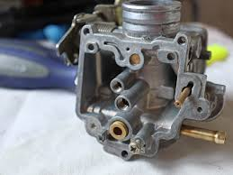
Fuel Pump: it is use in petrol engine to supply fuel to the carburetor/ injector
4.1 SYSTEM IN A VEHICLE
1. Fuel system: it helps to deliver the best performance with lowest emission it is a system that transfer fuel from the fuel tank and pass it through the fuel filter for straining before it arrives at the agents (carburetor)
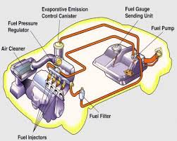
2. Brake system: it helps to slow and stop a vehicle when you push the brake pedal. The force generated hydraulic pressure in the master cylinder this pressure flows through the hydraulic line and hoses to the wheel cylinder and calipers. Forcing the shows against the brake down or pads against the rotor or disc
i. Brake Pedal: this is a rod (pedal) inside a vehicle, commonly use to control the speed/motion of a car.
ii. Brake Servo/Brake Air Box: this is a box that helps the effectiveness of the brake when the car is on motion, because when the servo is bad, air been pump to the brake system may not return which will make the brake sticky and have no effect on the brake disc, i.e. affect the halting of the brake pad.
iii. Master Brake: this is the brake fluid distributor in which the fluid is kept and passes this fluid through the brake holes to the caliper.
iv. Brake Disc: this function whenever the piston is shoot out which is gripped by the brake pads. The gripness of the brake pad help the movement of the brake disc to stop.
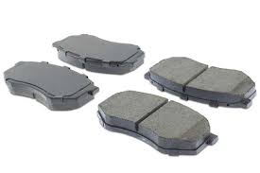
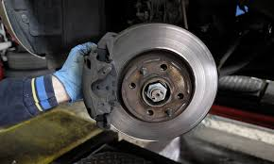

CHAPTER FIVE
5.0 CONCLUSION
The SIWES programme is an efficient an effective program which has bring much improvement to my field of study. I have gained a lot of experience from the various works done on field such as automobile and welding. It is a programme that bridges the gap between theory and practical aspect, so therefore it has made me to have technical knowledge about what I have learnt theoretically in class.
It is a unique privilege for me to undergo this training, for it enables me to know the service to render as a agricultural and bio system engineer. I here appreciate the effort to the Federal Government and Industrial Training Fund (I.T.F) for improving the technological development of this country.
5.1 PERSONAL IMPRESSION ABOUT THE ORGANIZATION
I was highly impressed about the organization towards the acceptance of my SIWES letter in their organization. Also, what impressed me most about the organization is the experience gained during my training under mechanical Engineering department at the Kwara State Polytechnic Ilorin, Institute of Technology Mechanical Workshop. This will help me facing the future challenges that may likely to occur in my field of study.
5.2 RECOMMENDATION TO THE ORGANIZATION CONCERNING THE SIWES PROGRAMME
I would recommend that the organization should appeal to the federal government to make provision for necessary equipment for the effectiveness of the programme.
I will like to implore the organization to continue in their well accommodative standard.
I would recommend that the organization should provide transport facilities for SIWES students so as to move/carry them from the office to the site off construction.
5.3 RECOMMENDATION TO THE POLYTECHNIC CONCERNING THE SIWES PROGRAMME
I would recommend that the polytechnic should try to get a placement for the student by contacting all engineering organization to admit any student for their SIWES programme.
I would recommend that the polytechnic should try to give adequate supervision to the student in their place of attachment for student assessment before the completion of the programme.

