A REPORT ON
STUDENTS INDUSTRIAL WORK EXPERIENCE SCHEME
(SIWES)

UNDERTAKEN AT

SPLASH FM (106.7)


BY
OJEKUNLE AISHAT DAMILOLA
ND/23/MAC/PT/0087

SUBMITTED TO
THE DEPARTMENT OF MASS COMMUNICATION, INSTITUTE OF INFORMATION AND COMMUNICATION TECHNOLOGY, KWARA STATE POLYTECHNIC, ILORIN.

IN PARTIAL FULFILMENT OF THE REQUIREMENT FOR THE
AWARD OF NATIONAL DIPLOMA (ND) IN MASS COMMUNICATION.

AUGUST- NOVEMBER, 2024
DEDICATION
I dedicate this Students Industrial Work Experience Scheme (SIWES) report to Almighty Allah for his grace and mercy towards the completion of the SIWES programme.

ACKNOWLEDGEMENT
I thank Almighty Allah for the glory, honor, adoration and mercy I received during the course of my study and when undergoing my industrial Training
My appreciation also goes to my supervisor Mr. Ayomide Adetunji (Quality and Mr Oluwatobiloba), and to my parent Mr&Mrs Ojekunle during my training, who accessibility, untiring effort, patience and guidance and suggestions fabulously contributed to the completion of this report. Who do not just teach me but makes me understood all his teaching, may God Almighty continue to guide and protect him and his house hold.

REPORT OVERVIEW
This is an industrial attachment report for the Students’ Industrial Work Experience (siwes) programme carried out at Spalsh fm , Abeokuta
Ogun State within the period of four months from August, 2024 to November, 2024.
The report comprises the background of SIWES, the description of the organization, its aims and objectives, the experiences gained as an industrial training student and the summary, conclusions and recommendations.
It has a total of 5 chapters with sub-chapters. It also has the preliminary pages, such as the title page, report overview and table of contents and recommendations on the improvement of scheme.

TABLE OF CONTENT
Title Page i
Dedication ii
Acknowledgement iii
Report Overview iv
Table of Contents v

CHAPTER ONE: Introduction
1.1 Background to the Study
1.2 Objectives of SIWES

CHAPTER TWO: Description of Establishment of Attachment
2.1 Location and Brief History of Establishment
2.2 Objectives and Core Values of the Establishment
2.3 Functions of the Establishment
2.4 Organizational Structure of Establishment
2.5 The Various Departments and Units

CHAPTER THREE: Actual Work Done with Experience Gained
3.1 Gathering of News
3.1.1 Observation
3.1.2 Telephone Conversations
3.1.3 Research
3.2 Granting of Interview
3.2.1 Types of Interviews
3.3 Writing of News

CHAPTER FOUR: Actual Work Done with Experience Gained (Cont’d)
4.1 Covering of Events
4.2 Photo News and Captions

CHAPTER FIVE: Summary and Conclusion
5.1 Summary of Attachment Activities
5.2 Problems Encountered
5.3 Suggestions for Improvement of the Scheme
5.4 Conclusion

CHAPTER ONE

INTRODUCTION
The Students’ Industrial Work Experience Scheme (SIWES) is a scheme established by the Industrial Training Fund (ITF) in 1973 to help students of tertiary institution in Nigeria acquire technical skills and practical exposure in an industrial environment based on various course of study.
Prior to the Establishment of SIWES, science and technology education in Nigeria was marred with the problem of lack of adequate practical and industrial skills and working experience that will prepare students of tertiary institution in Nigeria for employment opportunities in industries. It was in this view that the scheme was established and students in tertiary institution of Nigeria studying sciences and technology related courses were mandated to participate in the program to enable them have technical knowledge and working experience before graduating from their prospective institution and makes it a smooth transition from the lecture room to the world of work.
1.1 BACKGROUND TO THE STUDY
SIWES was established by industrial training fund to solve the problem of lack of adequate practical skills in preparation for employment in industries by Nigerian graduates of tertiary institutions.
The Students’ Industrial Work Experience Scheme (SIWES) was designed, established and implemented by the Industrial Training Fund (ITF) in 1974 to ensure acquisition of field practical knowledge and skills by students before graduation, mainly coordinated by the National University Commission (NUC). The NUC recognizing the importance of job specifications in the scheme did set the necessary machinery in motion soon after the resolution was taken in 1998. However, from 1989-1993, the drawing up of the minimum academic standards documents (a major statutory of commission) owe resultant accreditation exercise and the movement of the commission secretariat to Abuja did not leave sufficient time to actualize this goal.
It was not until January 1996 at a 3 days national workshop in Jos that specification was drawn for the entire program that had industrial attachment component in the minimum academic standard documents. Participants were drawn from senior academic from universities across the country, SIWES coordinators and officers in all nine panels, each headed by a senior academic officer were constituted for the entire forty-six program. Prior to drawing job specification, however, a one-day meeting was held at which a five-day meeting was presented and the procedure content and format for presentation of the specification documents were decided.
SIWES commenced in 1974 in the aim of making education more relevant to bridge the gap between the theory and the practice of agriculture, engineering, technology and science related discipline in tertiary institutions in Nigeria.
For students in polytechnics and mono-technics and college of education, the duration of SIWES is for 4 months while university undergraduates go for a 6 months duration. Each institution is expected to have a SIWES coordinator who is in charge of all activities that pertains to students industrial training in the institution.
The production of SIWES job specification is without doubt a milestone in the development of academic activities in the national university system. The benefit derivable by the employer, universities and the students alike are immense and will go a long way to move the country forward technologically.
Operators:The ITF, the coordinating agencies (NUC, NCCE, NBTE), the employers of labor and institution.
Funding: The Federal Government of Nigeria.
Beneficiaries:Undergraduate students of the following; Agriculture, Engineering, Technology, Environmental, Sciences, Education, Medical sciences and Pure and applied sciences.

1.2 OBJECTIVES OF SIWES
- It helps students to develop skills and techniques directly applicable to their careers.
- It helps students develop skills in the application of theory to practical work situations.
- It increases a student’s sense of responsibilities
- It prepares students to enter into full time employment in their area of specialization upon graduation.
- It provides students the opportunity to understand informal organizational interrelationships.
- Makes the transition from school to the world of work easier and enhances students contacts for later job placement.
- It provides students the opportunity to develop attitudes conducive to effective interpersonal relationships.
- It provides students the opportunity to test their interest in a particular career before permanent commitments are made.
- It provides an avenue for students in tertiary institutions to acquire industrial skills and work experience in their course of study.

CHAPTER TWO
2.0 ORGANISATION PROFILE
Splash FM (106.7FM) is a radio station in Abeokuta, Ogun state, Nigeria. The station broadcasts a full-service format with local news, talk programmes and music. It is owned by West Midlands Communications Limited.
Fig2.1The organization logo

Mission statement
Promote positive values, build relationships with the local community, and provide quality programming:
2.1 QUALITY POLICY
Total commitment to infusing our core values of integrity and excellence to drive quality aim that the audience delight, satisfaction and loyalty.
COREVALUES
Accountability and ownership
Teamwork
Consumer focused
Courtesy and respect for individual
Loyalty

2.2 DEPARTMENT AT THE ORGANIZATION
PROGRAMMING DEPARTMENT
ADMINISTRATION DEPARTMENT
SOCIAL MEDIA DEPARTMENT
PRODUCTION DEPARTMENT
ENGINEERING DEPARTMENT
ICT DEPARTMENT
NEWSROOM DEPARTMENT
SALES AND MARKETING DEPARTMENT
DATA AND TRAFFIC DEPARTMENT
DEPARTMENT I WORKED IN AND THEIR FUNCTIONS
PROGRAMMING DEPARTMENT
Function: I was able to observe how to be responsible for creating and scheduling programs and content including shows, commercial, and music in the studio.
SOCIAL MEDIA DEPARTMENT
Function: I was taught on how to develops and designs visual elements, such as logos, branding, and social media graphics. Over sees the station’s online presence, including website management, social media, and Live streaming.
2.3 FUNCTIONS OF THE ESTABLISHMENT
The following are functions of the establishment:
1. Information:
This is obviously the most important function but the other ones must be paid equal attention if a newspaper is to make a lasting appeal to the public. The first channel of information is the leading article or what is called, the editorial which is the best medium at the newspaper’s disposal for the interpretation of the news of the moment. The leader writer today may not have quite the same influence on the reader that he had when there were few newspapers but, nonetheless, a popular newspaper even today guides the public opinion by interpreting the news and elaborating the opinions for creating an impact on the readers.
2. To give Comments on Daily Happenings:
In twenty-four hours, circumstances change in a short while and events happen every second after second. Newspapers present not only news regarding an event but views also. For that purpose, a special page is used in the form of editorial, column and feature. In these pages, newspaper presents different views about a news but this doesn't mean that newspaper agrees with their point of view. In this connection, only the editorial carries the responsibility of the newspaper as it also shows the policy of the newspaper.
3. Platform for People Discussion:
Newspapers form the public opinion, on the other hand, provide a comprehensive platform for people discussion. Newspaper is an open invitation to all to unite for or against any problem, event or policy. Hence, by providing such facility, newspaper enables the society to see the lighter and darker part of the picture.
4. Entertainment:
Modern newspapers tend to carry many light materials including articles written in light vein. These features not only indirectly influence the opinions of the readers but also fulfill the entertainment function.
Every paper by a process of trial and error must discover what form of entertainment pleases most of its readers for the greater part of the time. The tastes of the readers of different journals vary considerably. Even serious newspapers and magazines nowadays are expected to carry strip cartoons or topical comics here and there.
5. Spokesman of Society:
Apart from other functions, newspaper plays a positive role to promote the thoughts, customs and traditions of the society. But it does not affect impartiality. She has to promote only the good and the most flourish-able additions of the society, which really needs wide projection for the progress and prosperity.
6. To Present Information:
The chief and fundamental function of a newspaper is to provide information, guidance, help and entertainment to the general public. Newspapers make the common man aware of the happening of an event, even all around the world as an information. We know detail of any event through the Press, e.g., Hindu-Muslim riots in India, apartheid in South Africa, Communism degeneration in Russia, war between Arabs and Israel in Middle East, sports of Barcelona, Amsterdam or London, etc.
7. Truth and Reality:
Newspapers have to produce news-cause or any kind of information based on truth and reality as the foremost function of newspaper is to bring out truth and reality before the people. By inducing these universals, newspaper has solved many tangible problems.
2.5 ORGANIZATIONAL STRUCTURE OF ESTABLISHMENT
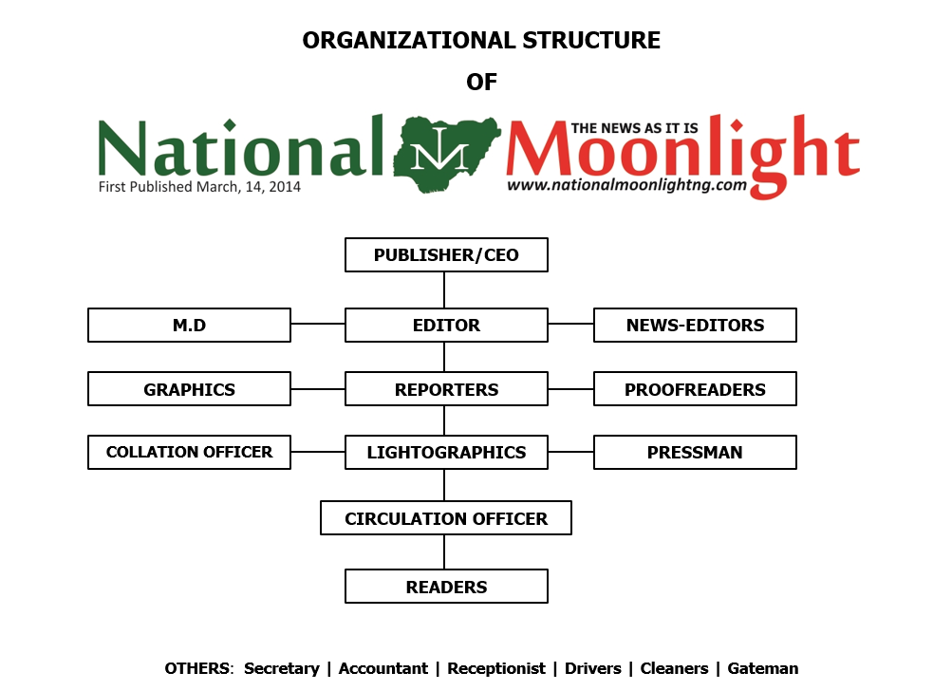
Splash fm ORGANIZATION CHAT

CHAPTER THREE

ACTUAL WORKDONE WITH EXPERIENCE GAINED
During my Students Industrial Working Experience Scheme (SIWES) at splash Fm ,Abeokuta Ogun State, I was able to learn and gain a lot of industrial and organizational experience as goes:
3.1 NEWS GATHERING
Recognize the most commonly used methods of gathering news. The four most commonly used methods in news gathering used by journalists are observation, telephone conversations, research and interviews.
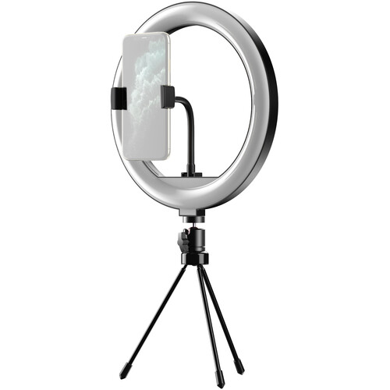

3.1.1 OBSERVATION
Observation consists of your actually seeing an event take place and then reporting what you have seen in the form of a news story. The difference between a good story and a poor one is often in the skill of the observer. Skilled observers use their eyes, ears, mind, notebooks and tape recorders. They make sure they get the concrete facts, specific figures and accurate information. They look for the colorful, the dramatic or the unusual in any situation.
3.1.2 TELEPHONE CONVERSATIONS
Telephone conversations may range from full-scale interviews to brief queries to verify or amplify information. But regardless of how often you use this method of news gathering, you should keep the following points in mind:
- Know what information you want before you dial. Keep your pencil and paper handy. Do not call someone and then ask that person to wait while you look for writing materials.
- Speak politely indistinct, well-modulated tones.
- Be cheerful and businesslike.
- Make sure you get your facts straight. Ask the other person to repeat figures or spell out names.
- Avoid three-way conversations among yourself, the person on the telephone and somebody else in your office.
- Recheck your information by reading it back to the person who has given it to you.
- Do not discuss classified information.

Although a telephone is a very useful instrument, remember it is not the only, and not necessarily the best, method of gathering news. It should supplement, but not replace, all other methods. Whenever it is proper and convenient, use the telephone, but do not be afraid to engage in a little legwork.

3.1.3 RESEARCH
Research is nothing more than digging out information from files and reference works. Research is used to verify or amplify facts in news stories and to give depth to feature stories and magazine articles.
3.2 GRANTING OF INTERVIEW
About 90 percent of everything in a news story is based on some form of interviewing - either in person, by telephone or occasionally by correspondence.
FEW IMPORTANT EQUIPMENTS USED
In the digital age, radio broadcasting has evolved to incorporate cutting-edge technology, enhancing the listener experience and streamlining production work flows. A well-equipped radio studio is essential for producing high-quality content and maintaining a professional on-air presence.
This chapter will explore the fundamental equipment used in a modern radio studio, highlighting their functions, benefits, and applications in live broadcasting and content creation.”
CONSOLE/MIXER
The console/mixer also known as a mixing console or sound board, is a machine that controls sound in a studio. It plays a crucial role in managing and perfecting the audio output. The console helps mix different sounds together, control volume levels, send sound to speakers or recording devices, and add effects like echo or reverb. This allows studio professionals to create a balanced and polished audio mix. Additionally, the console helps monitor sound quality, allowing professionals to make adjustments in real-time and deliver high-quality audio to their audience.
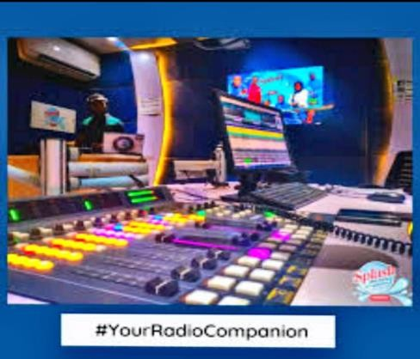

FIG 3.1

MICROPHONE AND HEADSET
In a studio setting, microphones and headsets are essential tools for capturing and monitoring high-quality audio. These devices play a crucial role in ensuring that audio recordings are clear, crisp, and free from interference.
The Use of Microphones
Microphones are used to capture audio signals in the studio. They convert sound waves into electrical signals, which are then transmitted to the studio console for mixing and processing. Microphones are used for various applications, including recording vocals, instruments, and voiceovers.

The Use of Headsets
Headsets are used in the studio to monitor audio playback and communicate with other studio professionals. They provide a private and accurate listening experience, allowing users to focus on the audio mix without distractions. Headsets are also used for real-time communication between the presenter, engineer, and producer.
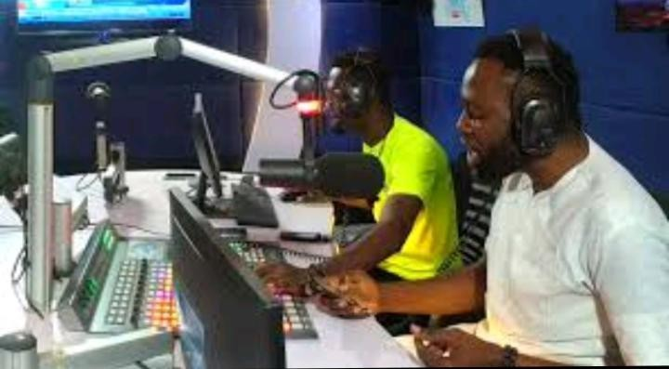

FIG 3.2
Mevo Camera and Tripod
In a studio setting, capturing high-quality video is essential for producing professional content. The Mevo camera and tripod are two crucial tools that enable studio professionals to record crisp and stable video footage.
The Use of Mevo Camera
The Mevo camera is a compact, high-definition camera designed for live streaming and video recording. Its primary function is to capture wide-angle, high-quality video footage. The Mevo camera is ideal for studio applications, such as:
Live streaming
Video recording
Virtual events
Conference streaming
The Use of Tripod
A tripod is a three-legged stand designed to stabilize and support cameras, ensuring smooth and steady footage. In a studio setting, a tripod is essential for:
Reducing camera shake and movement
Enabling smooth panning and tilting
Providing a stable platform for camera placement
Allowing for precise camera positioning
FIG 3.3
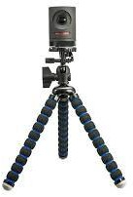

CHAPTER FOUR

ACTUAL WORKDONE WITH EXPERIENCE GAINED (Cont’d)
4.1 COVERING OF EVENTS
Writing about live events such as meetings, press conferences, and speeches can be tricky even for seasoned reporters. Such events are often unstructured and even a bit chaotic, and the reporter, on deadline, has to make sense of what happened and present it in a story that has structure, order, and meaning. Not always easy. Here are some basic do's and don'ts for good reporting of live events:
FIND YOUR LEAD
The lead of a live event story should center on the most newsworthy and interesting thing that occurs at that event. Sometimes that's obvious: If a congressional leader announces a vote to raise income taxes, chances are that's your lead. But if it's not clear to you what's most important, or even what just happened, after the event interview knowledgeable people who can give you insight and perspective. It may be something you didn't even fully understand or a combination of a few things. Don't be afraid to ask.
AVOID LEADS THAT SAY NOTHING
Whatever the story—even a boring one, and sometimes those happen, find a way to write an interesting lead. "The Centerville City Council met last night to discuss the budget" does not pass muster, nor does, "A visiting expert on dinosaurs gave a talk last night at Centerville College."
Your lead should give readers specific information about something interesting, important, funny, or catchy that happened or was said. For example, "Members of the Centerville town council argued bitterly last night over whether to cut services or raise your taxes." Or, "A giant meteorite was probably responsible for the extinction of dinosaurs 65 million years ago, an expert said last night at Centerville College."
WATCH FOR THE UNEXPECTED
No matter how it was sold, sometimes what you expected would be the most important story of a live event turns out to be dull: a non-event. Perhaps a side story—a protest or something said unexpectedly by someone noteworthy—rises to center stage and becomes the better story. Grasp it.
Keep your ears and eyes tuned and your mind open. Be willing to shift your focus, start over and reorganize.
DON'T COVER EVENTS CHRONOLOGICALLY
When enthusiastic newbie reporters cover their first live events, they often feel an urge to tell their readers everything: Afraid of missing something important, they cover the event as it happens, from beginning to end, starting with the roll call and the approval of the minutes. This is a classic mistake that most reporters quickly learn to avoid.
INCLUDE PLENTY OF DIRECT QUOTES​
Good direct quotes are like a spice in a dish: They take the readers right there on the spot, give them a sense of the person who is speaking, and lend the story flavor, energy, and music. They also lend authoritativeness and credibility to stories involving public officials (whose career a quote can break). So, great quotes are essential to the fabric of a great story.
ADD COLOR AND LEAVE OUT THE BORING STUFF
Remember, you're a reporter, not a stenographer. You're under no obligation to include in your story absolutely everything that happens at an event. If the school board members discuss the weather, it's probably not worth mentioning (though if it's all they discuss, that might be a good story). On the other hand, you are your readers' eyes and ears: Color that gives the reader a sense of the scene can take your story from ordinary to memorable. Report with your senses.
EXPERIENCE GAINED
My Internship experience
During my internship, I faced initial challenges adjusting to an early morning routine, arriving at work by 7 am and often working late until 7 pm or 11 pm on certain days. Fortunately, accommodation was provided for late nights.
Through this experience, I gained hands-on skills in graphics and video editing, meeting deadlines, and understanding the importance of silence during live broadcasts to prevent echo and disruption.
I also learned about the ethics of live streaming, including being attentive to guests, managing program transitions, and adhering to broadcast guidelines.
Additionally, I received comprehensive training in video editing, covering essential skills such as cutting, color grading, and mastering basics before applying effects.
Lastly ,I developed a strong appreciation for punctuality and time management.
Overall, my internship experience was invaluable, providing me with practical skills, industry insights, and a deeper understanding of the broadcasting profession.

CHAPTER FIVE
SUMMARY, PROBLEMS ENCOUNTERED AND RECOMMENDATIONS
SUMMARY
My internship experience provided valuable skills and insights in broadcasting, video editing, and time management. I gained hands- on experience in graphics and video editing, live streaming, and adhering to broadcast guidelines. Key takeaways include the importance of punctuality, meeting deadlines, and attention to detail. Overall, the internship was a comprehensive learning experience that prepared me for a career in broadcasting.
Problems Encountered
Adjusting to Early Mornings and Long Hours: I found it hard to wake up early and work long hours. Sometimes, I had to stay until 11 pm.
Adapting to the Studio’s Air –Conditioned Environment: Because of my health issues, I had a tough time getting used to the cold air in the studio. It took me a while to adjust.
Meeting Deadlines: I had to work fast to meet deadlines .This was challenging, but I learned to manage my time better.
Learning New Skills and Equipment: At first, it was hard to learn new software and equipment for graphics and video editing. But with practice, I got better.
RECOMMENDATIONS TO SIWES
To the SIWES management, I recommend the following:
Provide clear guidelines and expectations to students before the commencement of the program.
Ensure that students are placed in relevant industries that align with their course of study.
Provide regular monitoring and supervision to ensure students are meeting their learning objectives.
Offer work shops and training sessions to students to enhance their skills and knowledge.
Encourage students to provide feed back and suggestions for improving the program.

RECOMMENDATION TO STUDENTS
To future students undertaking an internship, I offer the following advice:
Be open- minded and willing to learn new skills.
Take initiative and ask questions to clarify any doubts.
Develop strong time management skills to meet deadlines.
Be proactive and seek feed back to improve performance.
Stay organized, focused, and committed to your goals.
Build positive relationships with colleagues and supervisors.
Stay flexible and adapt to new challenges and responsibilities.
By following these recommendations, students can make the most of their internship experience, gain valuable skills and knowledge, and set themselves up for success in their future careers.
Conclusion
In conclusion, my SIWES experience was a valuable and enriching one. I gained practical skills and knowledge in broadcasting, video editing, and time management. Despite the challenges I faced, I was able to adapt and learn from them. I am grateful for the opportunity to have undertaken this experience and I believe it has prepared me well for my future career.

