


TECHNICAL REPORT
STUDENT INDUSTRIAL WORK EXPERIENCE SCHEME (S.I.W.E.S)

HELD AT:
SUCCESS AUTOMOTIVE WORKSHOP KWARA STATE
Behind Badmus Warehouse Okin Avenue Along Oja Tuntun Route Ilorin, Kwara State.

WRITTEN BY:
ISIAKA RIDWAN AYINDE
ND/23/MEC/PT/0186

SUBMITTED TO THE DEPARTMENT OF MECHANICAL ENGINEERING
INSTITUTE OF TECHNOLOGY (I.O.T) KWARA STATE POLYTECHNIC
P.M.B 1375, ILORIN

IN PARTIAL FULFILLMENT OF THE REQUIREMENT FOR THE AWARD OF
NATIONAL DIPLOMA (ND) IN MECHANICAL DEPARTMENT

OCTOBER – DECEMBER 2024

DEDICATION
This report is dedicated to Almighty Allah, the author and maker of the whole universe, the giver of wisdom, knowledge and understanding for guiding and protecting me throughout this program.

ACKNOWLEDGEMENT
All glory, honor, adoration, praises and thanks goes to Almighty Allah the creator of the universe for keeping me save throughout the course of this study.
I sincerely give glory to him for the power and good health he has given me to be able to complete the program successfully.
My unreserved thanks and appreciation goes to my amicable parents for their unflinching support, financially and morally in academic pursuit.
My special gratitude’s goes to my able S.I.W.E.S coordinator and to the Head of Department (H.O.D) of Mechanical Engineering, may God bless your families.

TABLE OF CONTENT
TITLE PAGE i
DEDICATION ii
ACKNOWLEDGEMENT iii
TABLE OF CONTENT iv
CHAPTER ONE
- INTRODUCTION TO SIWES 1
  - DEFINITION OF SIWES 1
  - PURPOSE OF SIWES 1
  - AIM AND OBJECTIVES OF SIWES 2
  - HISTORICAL BACKGROUND OF SIWES 2
1.5 PLACE OF ATTACHMENTS 3
1.6 ORGANIZATION CHART 3
1.7 WORKSHOP SAFETY 4
1.8 PERSONAL SAFETY 4
CHAPTER TWO
2.0 INTRODUCTION TO MECHANICAL ENGINEERING TOOLS 5
2.1 THE SPANNER SET 5
2.2 BREAKER BAR & SOCKET SET 5

2.3 HAMMERS 6

2.4 PLIERS 6
2.5 SCREW DRIVER 7
2.6 OTHER TOOLS 7
CHAPTER THREE
3.0 WHEEL ALIGNMENT 8
3.1 JACKS AND TYPES OF JACKS 8
3.2 CHANGING OF CAR WHEELS (TYRE) 11
3.3 PARTS OF THE WHEEL 13
CHAPTER FOUR
4.0 AUTOMOBILE ENGINE AND ITS PARTS 14
CHAPTER FIVE
5.0 RECOMMENDATION 16
5.1CONCLUSION 16

CHAPTER ONE
- INTRODUCTION
The students Industrial Work Experience Scheme (SIWES) is a skills Training program designed to expose and prepare students of universities, polytechnics/colleges of technology/colleges of agriculture and colleges of education for the industrial work situation they are likely to meet after graduation.
The scheme also affords students the opportunity of familiarizing and exposing themselves to the needed experience in handling equipment and machinery that are usually not available in their institutions.
Before the establishment of the scheme, there was a growing concern among our industrialists that graduates of our institutions of Higher learning lacked adequate practical background studies preparatory for employment in Industries. Thus, the employers were of opinion that the theorical education going on in higher institutions was not responsive to the needs of the employers of labour.
  - DEFINITION OF SIWES
SIWES MEANS Student Industrial Work Experience Scheme. It is a course by which students are exposed to practical training in their respective field of study. SIWES is the acceptable skill training programmed set up as the requirement for the award of National Diploma (ND) certificate for studying Engineering and applied science.
Its effort is to bridge the gap existing between theory and practical aspect of engineering and some applied science.
  - PURPOSE OF SIWES
The student Industrial Work Experience (S.I.W.E.S.) was purposely to afford students the opportunity of familiarizing and exposing themselves to the necessary experience in the handling equipment’s and machines that are usually not available in their institution and also to help students on how to safe guide and set up their own industry and organization in future.
1.3 AIM AND OBJECTIVES OF SIWES.
The following are the aim and objectives of Student Industrial Work Experience Scheme (S.I.W.E.S):
- To give students full experience in exhibiting what they have acquired in their area of subject or discipline.
- To prepare student about the future of themselves.
- To gives the experience and additional opportunity to know much about their field of study.
- To provide students with the opportunity to apply what has been learnt in the school to real practical
- To provide student interpret some conventional symbols especially engineering and architectural terms more easily.
- To also help students to acquire industrial skills and experience in their course of study.
1.4 HISTORICAL BACKGROUND OF THE ORGANIZATION. AUTOMOBILE ENGINEERING WORKS
Taiwo Onaolapo Technical Service, No. 10 Old Cemetery Road Sabo-Oke Ilorin, Kwara State as been in existence since 2011 when engineer Taiwo (organization director) attain his experience certificate in Technical services at Ilorin Kwara State.
He established his own organization named TAIWO ONAOLAPO TECHNICAL SERVICE..

1.5 PLACE OF ATTACHMENTS
The field of attachments is Technical where they only deal with gasoline engines. The areas of specialization are to repair, servicing and dealer in original Automobile spare parts.

1.6 ORGANIZATION CHART
MANAGING DIRECTOR
APPRENTICE
I.T STUDENTS
1.7 WORKSHOP SAFETY
Safety is one of the most important things to consider when it comes to an engineering field.
This means that engineers cannot do without knowing the safety role that guide the welfare of the people. It is very important that engineers and other individuals working in the workshop abide with the rules and regulation in the workshop in other to secure the life of the people and also for perfect production.
1.8 PERSONAL SAFETY
To avoid injuries to yourself and other workers in the workshop the following point form part of generation code of behavior.
- Do not act foolishly in the workshop.
- Always be tidy in the workshop.
- Do not wear loose clothing in the workshop.
- Do not use hand tool that are not in good condition.
- No horseplay in the workshop.
- Avoid throwing of object in the workshop.
- There should be no smoking in the workshop

CHAPTER TWO
2.0 BASIC WORKSHOP HAND TOOLS AND EQUIPMENT WITH THEIR FUNCTIONS

2.1 THE SPANNER SET

Spanners are use in tighten and loosing bolt and nut, they are of different type like the flat, ring, socket, open ended

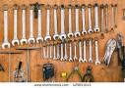
2.2 BREAKER BAR & SOCKET SET:
This tool has different size, which is used for tightening or losing bolt and nut particularly while servicing of motor vehicle.
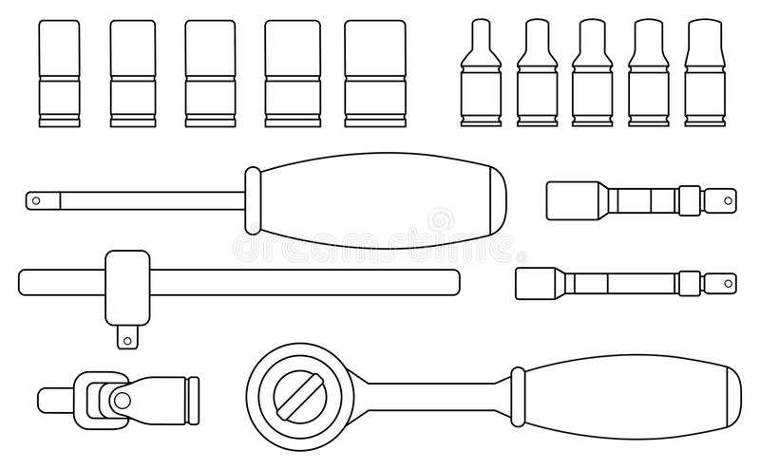

2.3 Hammers

Hammer is mainly use in hitting, driving and pulling some part of the motor vehicle out. They are of different type which includes: cross pane hammer, ball pane hammer straight pane hammer, double face sledge hammer.
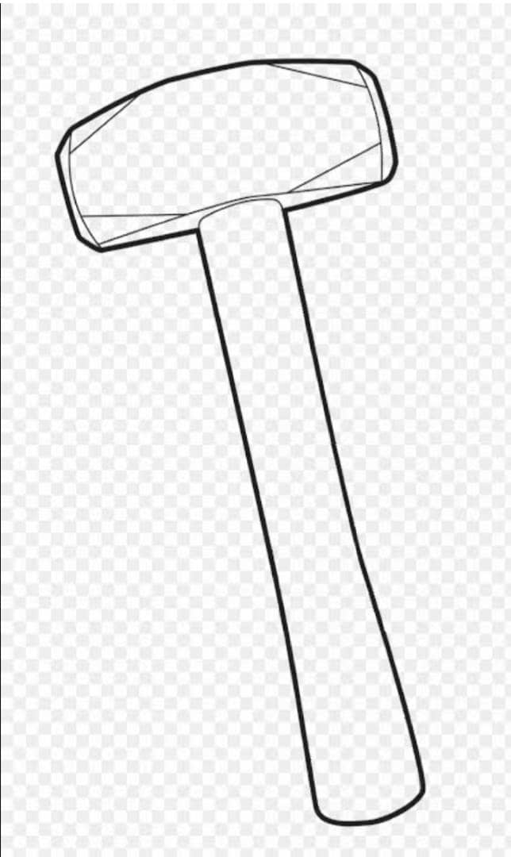

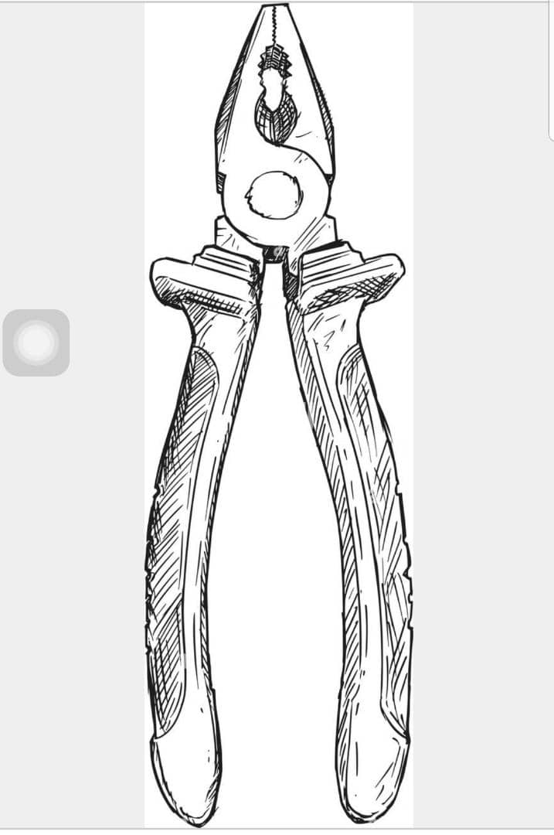
2.4 Pliers
Pliers are use for griping, cutting small flat or round materials

2.5 Screw driver: is used in driving out screws from a particular surface
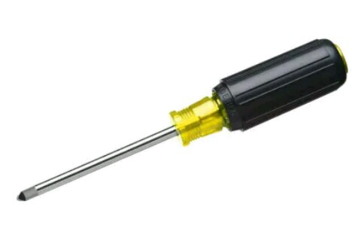

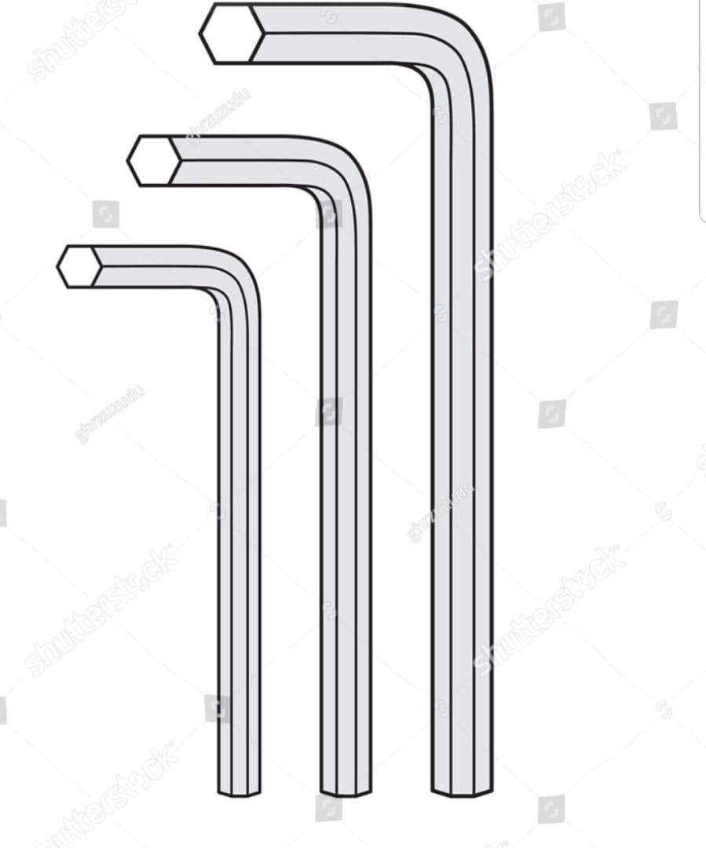
Other tools:
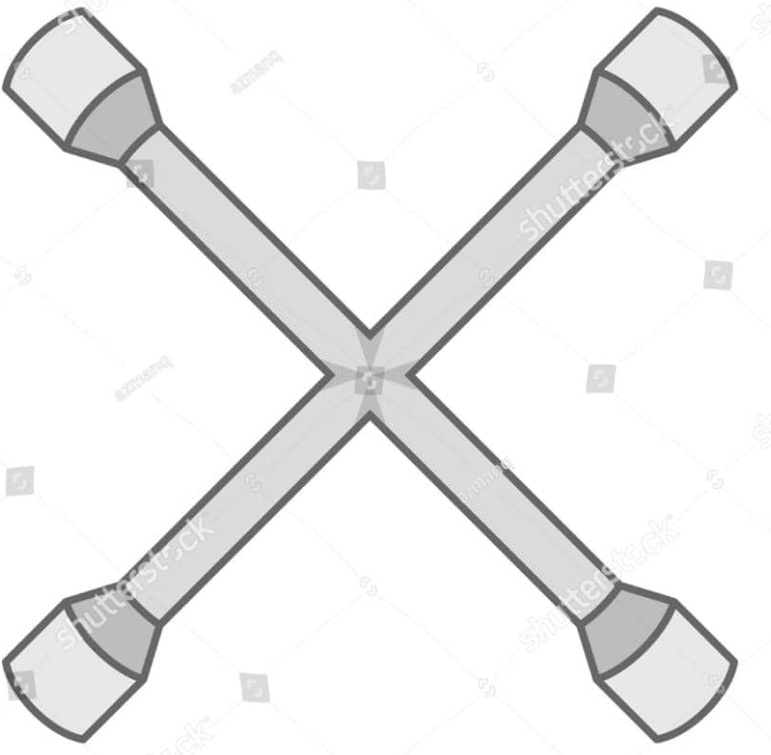

Wheel Spanner Alien Key & Set
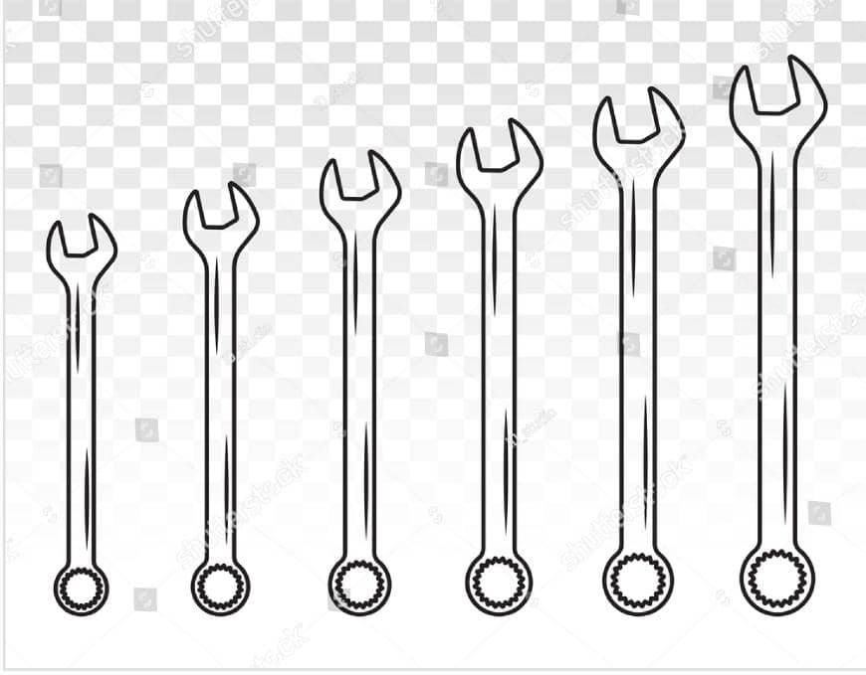
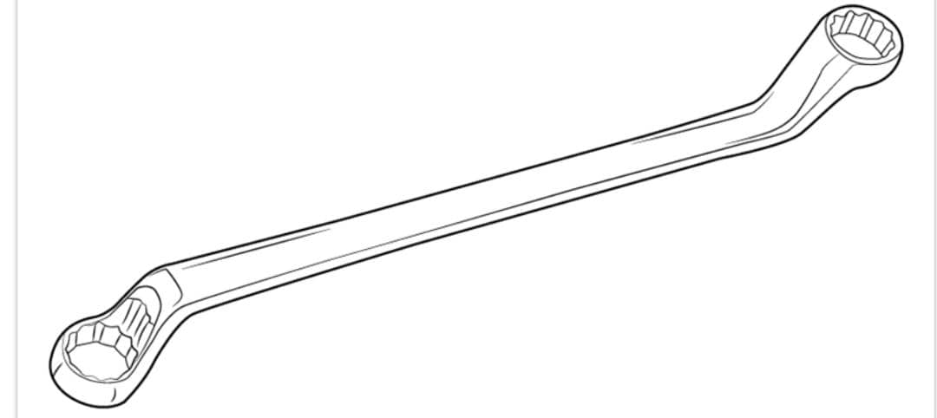
Ring and Flat Spanner
CHAPTER THREE
3.0 WHEEL ALIGNMENT
3.1 JACKS AND TYPES OF JACK
A car jack is needed whenever you need to raise your car to carry out a repair – such as to change a wheel – or if you need to carry out a task such as renewing the engine oil or replacing the exhaust system.
TYPES OF JACK
There are three main types of car jack: the trolley jack, bottle jack and scissor jack. They all do the same thing, but in a slightly different way, and some types are more stable than others.
Scissor jack(Roll jack) and how do I use it?
A scissor jack is the one you'll usually find in your boot, together with a spare wheel. It's the cheapest and smallest option available and comes with a handle to wind the arms apart, which then lifts the car up.
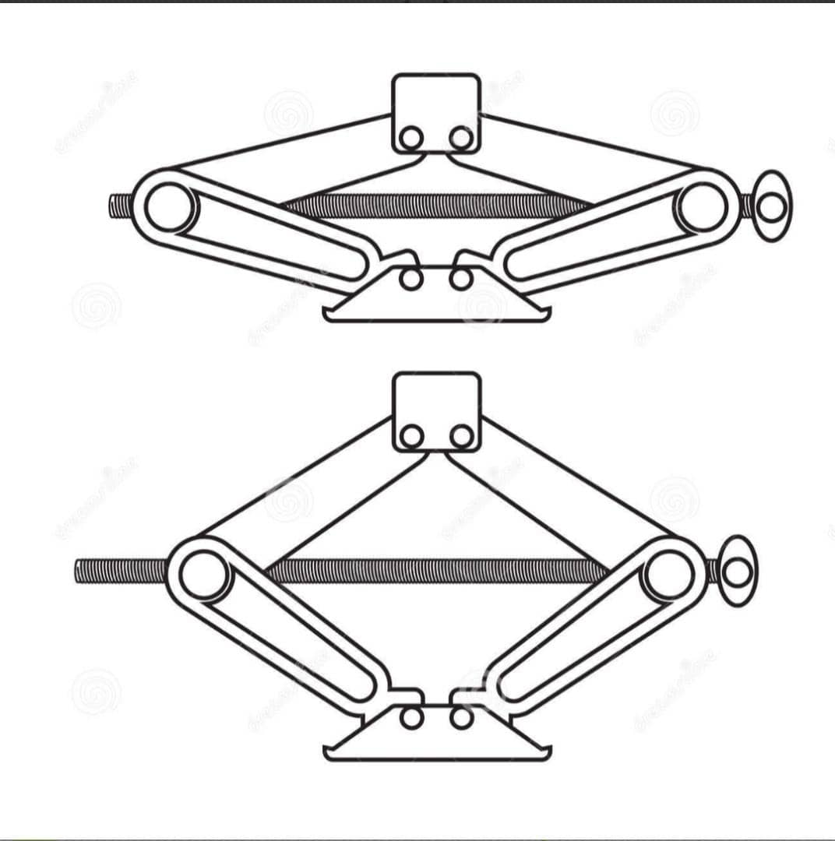
Position it under the jacking point and wind it clockwise until the car is lifted off the ground. To lower it back down, it is simply a case of winding the handle the other way.

Trolley Jack and how to use it.
A trolley jack is a safer, more stable and quicker option and is the choice of professional mechanics. Its wheels mean you can roll it into position easily, but before you do, start by making sure the relief valve is closed – refer to your jack's instructions but this is usually done by using the end of the removable handle.
Then it is simply a case of inserting the handle and pumping it until the cradle reaches the jacking point. To lower it back down, take the handle out and twist the relief valve anti-clockwise to open it, taking care to do so steadily to lower the car slowly.
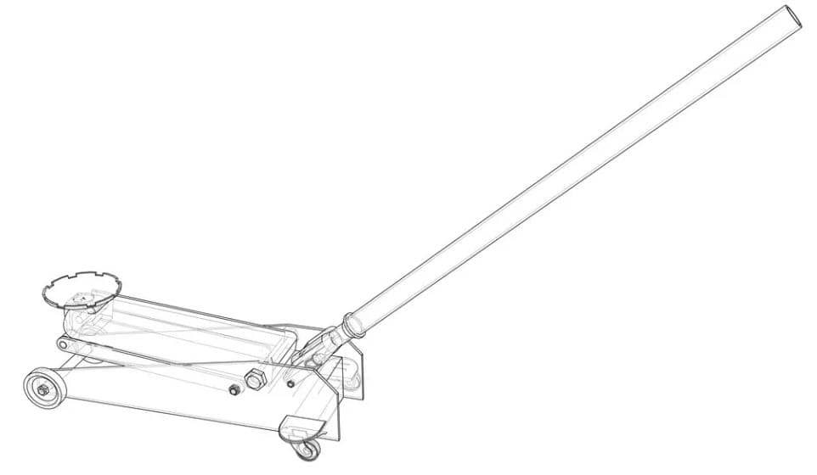

Bottle Jack(Hydraulic pump jack) and how to use it.
The bottle jack works in much the same way as a trolley jack, using hydraulic force to lift the car. It has the bonus of being smaller and easier to store than a trolley (so you may be able to carry it in your car boot) but this means it isn’t quite as stable.
Again, make sure the relief valve is closed, then unscrew the top of the jack to the correct length – the instructions should tell you how far you need to extend it. Then position it under the jacking point, insert the handle and pump until the car is raised. Lower it again in the same way as the trolley jack.
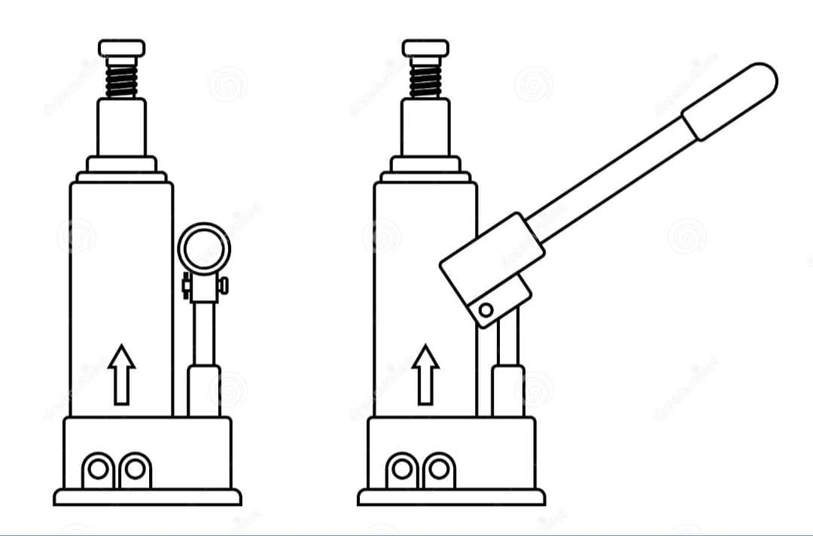

HOW TO FILL A HYDRAULIC BOTTLE JACK
- Place Your Jack on a Flat Ground:
- Placing your jack on level ground prevents the jack from tilting over while working. It also helps to level the oil in the chamber, preventing oil from spreading.
- To ensure cleanliness, it’s necessary to place a rag or a cloth under the jack. It will keep the ground or working place clean if some oil gets spilled in any case.
- Rotate the Release Valve of Your Jack:
- Open the release valve of your jack to have access to the filler hole. Depending on your jack’s model, the valve may be a press release valve, or it may open with rotation. If the latter case, rotate the valve counter-clockwise with your jack’s handle and keep it open during the filling process.
- Remove the Filler Plug:
- Next, find the filler plug on your bottle jack. It is on the top side of the cylinder. In some bottle jacks, the filler plug may have a rubber cover. If your jack has it, remove the rubber. You’ll see a screw behind the veil. Then drive out the screw as well.
- Squeeze in the Oil with the Funnel or Plastic Squeeze Bottle:
- If you have enough oil to fill the reservoir, remove all the old oil from the pool. For the unfilling purpose, hold the jack in a horizontal position, and the hole should be towards the ground or any pot in which you want to put the oil.
- Once you’ve emptied the bottle, place the jack back on the ground vertically. Take your plastic squeeze bottle and fill it with the new oil. It should have a long tip opening, which can quickly get into the hole.
- Replace the Filler Plug: Since you’ve filled the bottle now, clean the area around the hole and place the screw back in its position and turn it clockwise. If it had a cover on it, put back that as well.
- Try the Jack
After the jack has been filled, give it a few strokes to see whether it operates or not. If the filling is done well, you would notice
3.2 CHANGING OF CAR WHEELS (TYRE)
- By keeping the wheel on the ground when you first loosen the nuts, you'll make sure that you're turning the nuts instead of the wheel.
- Slide the jack under the frame of the car,place the pivot of the jack directly under the metal rim of the frame.
- Use the jack to raise your tire 4–6 inches (10–15 cm) off of the ground. Turn the handle of the jack clockwise to begin raising the platform up. Once the platform on the jack makes contact with the vehicle, take a look at the point where the jack meets the frame to confirm it’s on your frame.
- Pop the nuts off by hand and pull the tire off.
- Align the tire with the wheel hub. Press the tire and wheel against the hub so that it sits completely flushed and symmetrical with the hub bearing (this is important for tightening reasons). Keep your foot pressed onto the tire to secure it.
- Begin screwing the lug nuts back on. First, you want to make sure that you're hub cap is securely placed back on. Start with one lug nut and thread it all the way down on the wheel stud to help hold the tire on the hub.
- Don’t tighten the nuts using the tire iron just yet. Gently slide each over the bolt and tighten it by hand to partially lock them in place. You will tighten the lug nuts again once the car is down and there is no risk of it falling.
- Turn the handle or bolt on the jack counterclockwise to begin lowering the vehicle. Continue lowering the vehicle until the tire is comfortably back on the ground. Then, carefully remove the jack from underneath and set it back in your trunk.
- Completely tighten the nuts until they won’t turn any further.
- Remove the jack stands from under the vehicle. remove the old tire and wheel assembly. Release the pressure from the floor jack by slowly turning the lever to the left and you will start to see the vehicle slowly fall to the ground. Once the vehicle is fully on the ground. Remove the floor jack. Remove wheel chocks.
3.3 PARTS OF THE WHEEL
- Tie- Rod
- Brake Pad
- Shock Absorber
- Leakage
- Shaft
- Steering Rack
- Caliper
- Brake Disc
- Clutch Disc
- Ball Joint
- Lower Control Arm
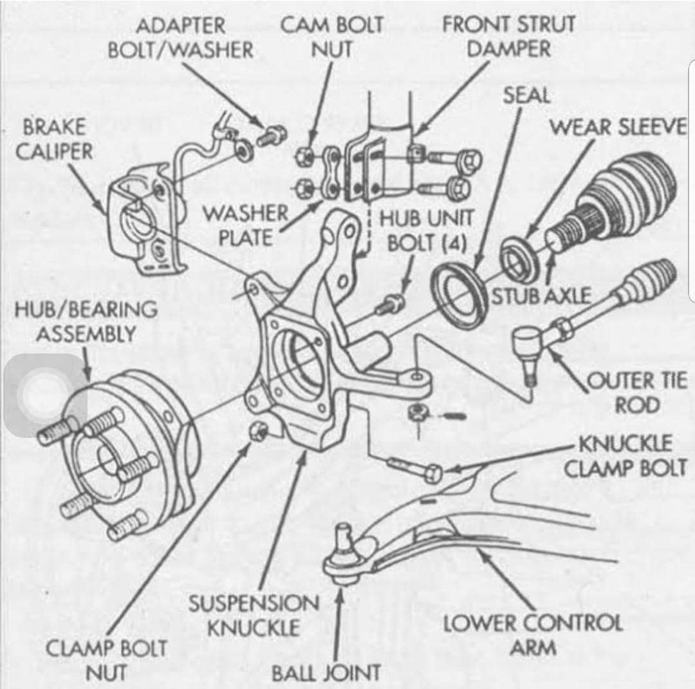
CHAPTER FOUR
4.0 AUTOMOBILE ENGINE (CAR ENGINE) AND ITS PARTS
- Piston and Piston Rings
Piston are most important engine parts compared to others. The piston is a cylindrical plug that moves up and down in the cylinder.
- Crankshaft
The crankshaft is the engine component from which the power is taken. It is one of the main power transmission sources in all engine parts.
- Cam Shaft
A camshaft is a shaft on which cams are mounted. A cam is a device that changes the rotary motion of the camshaft into the linear motion of the follower. A camshaft is responsible for the opening of the valves.
- Cylinder Block
It is the basic framework for the engine. and one of the main in engine parts. Cylinder block, cylinder head and crankcase these three parts form the foundation and main stationary body of the automobile engine.
- Flywheel
Flywheel means fluctuation of energy, it reserves the energy and uses this energy when requires it. A Flywheel is an inertial (force) energy storage device.
- Radiator :
The radiator is used in engine cooling systems for heat transfer where it helps to transfer thermal energy from one medium to another medium for cooling and heating purpose.
A radiator is a heat exchanger which eliminates excess heat from the system.

- Spark Plug
The spark plug is a device that is used to generate the spark between the two electrodes and ignited the combustible mixture within the combustion chamber. It should be able to withstand fluctuating pressure and temperature.
So its main function is to conduct the high potential from the ignition system into the combustion chamber.
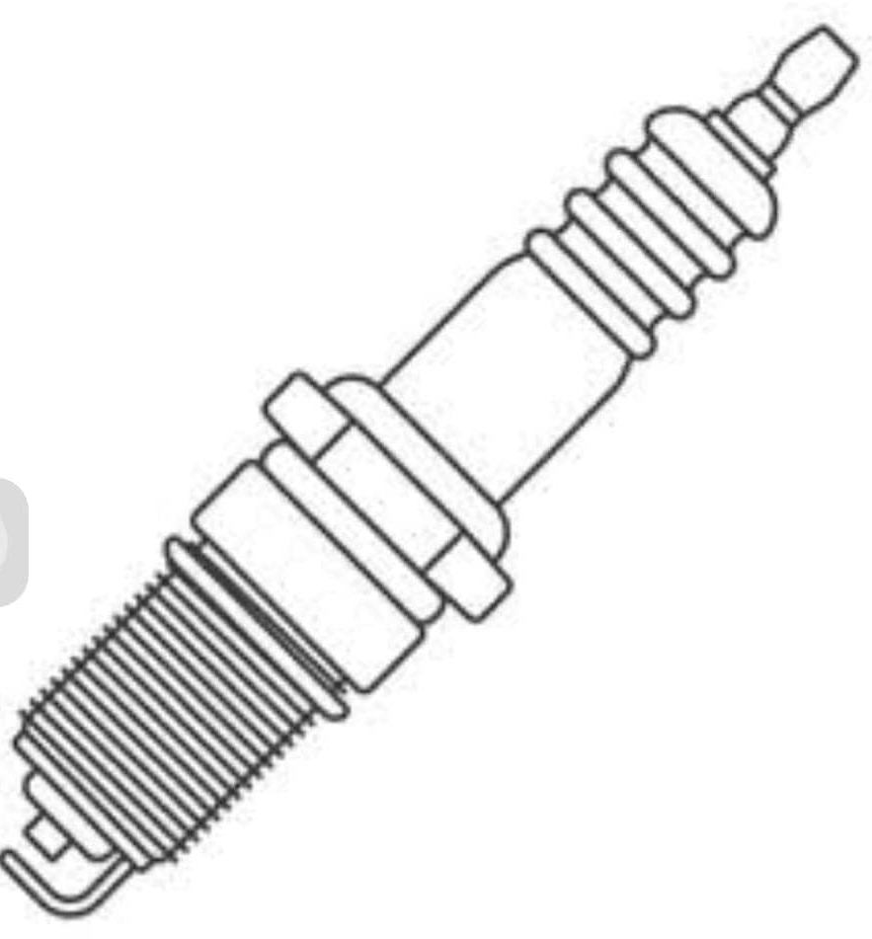
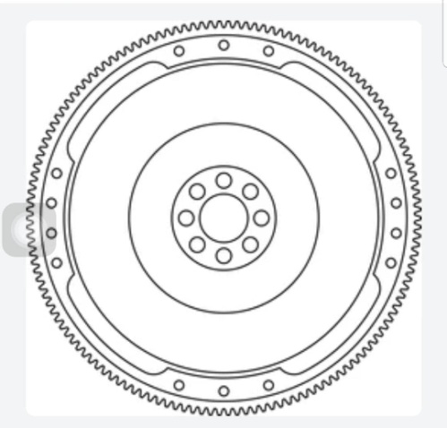

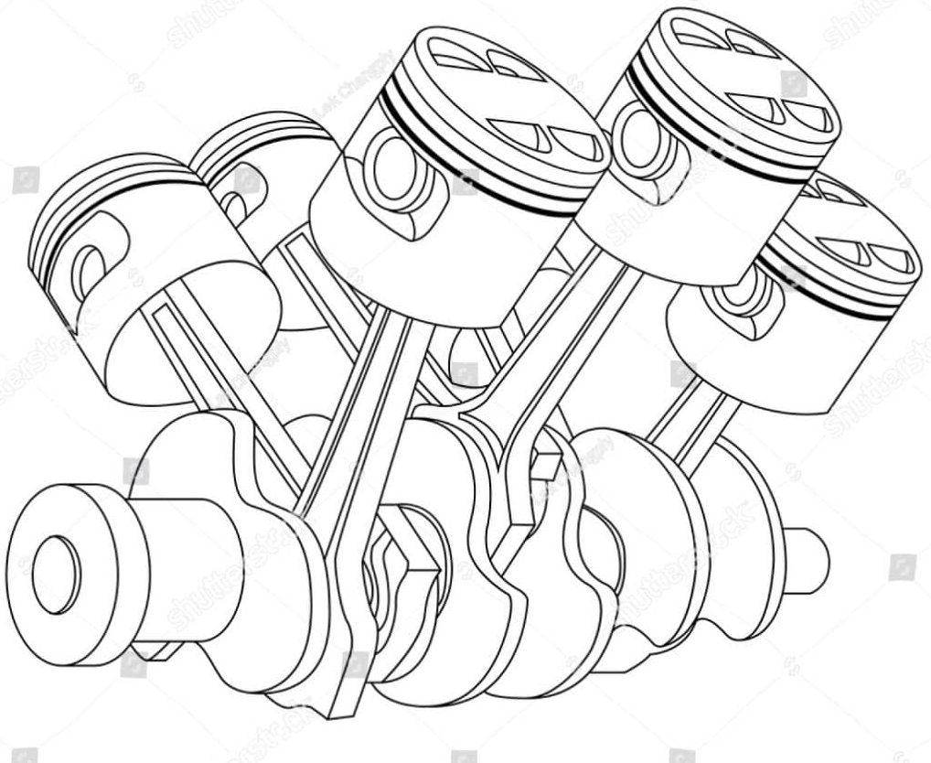
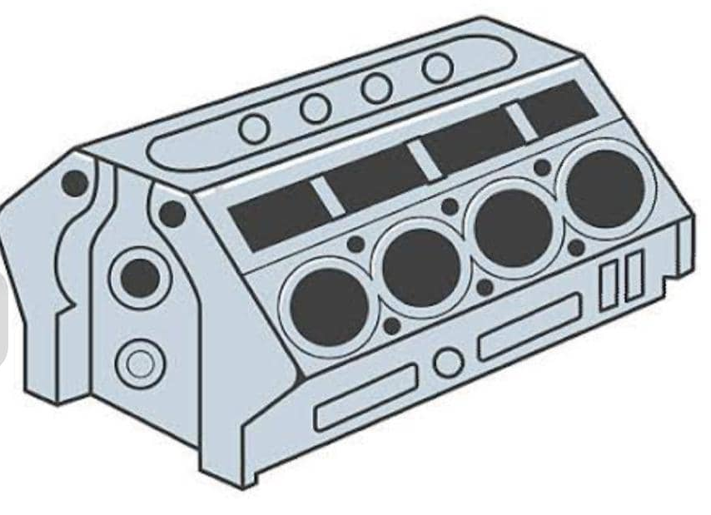

CHAPTER FIVE
5.0 RECOMMENDATION
Siwes is very important to every student in higher level of learning. It gives the student a practical knowledge of what they had learnt in theoretical aspect. Student should be encouraged to stay and be punctual in their place of attachment.
I hereby pleaded to the government prestart to equip the institution with practical facilities so as to improve student’s practical knowledge.
5.1 CONCLUSION
The student Industrial Work Experience Scheme (SIWES) is a beneficial and necessary program for all Engineering and science student in our Tertiary Institution. It exposes me as a Mechanical engineering student to understand various parts of the engine and their working principle. I have achieve a lots of experience in my place of attachment, like how to service an Engine, periodic maintenance and equipment maintenance of Automobile and maintenance of tools

