

STUDENTS INDUSTRIAL WORK EXPERIENCE SCHEME
(SIWES)
HELD AT
PRUDENT ICT CENTRE ILORIN,
KWARA STATE

PRESENTED BY
JEMILOHUN DAVID ADEMOLA
ND/23/COM/FT/0061

DEPARTMENT OF COMPUTER SCIENCE
KWARA STATE POLYTECHNIC ILORIN, KWARA STATE
IN PARTIAL FUILFILMENT FOR THE REQUIREMENT FOR
AWARD NATIONAL DIPLOMA IN COMPUTER SCIENCE

MARCH 2025

DEDICATION
I dedicate this students industrial work experience scheme (SIWES) report to God Almighty for his grace and mercy towards the completion of the siwes programme.

ACKNOWLEDGMENT
My acknowledgment goes to Almighty God, my parents , kwara state polytechnic Ilorin, my supervisor and also to my friends may we all excel in life and may Almighty God continue to be with everyone Amin.

REPORT OVERVIEW
This is an industrial attachment report for the Students' Industrial Work Experience (SIWES) programme carried out within the period of three months. The report comprises the background of SIWES, the description of the organization, its aims and objectives, the experiences gained as an industrial training student and the summary, conclusions and recommendations. It has a total of 5 chapters with sub-chapters. It also has the preliminary pages, such as the title page, report overview and table of contents and recommendations on the improvement of scheme.

TABLE OF CONTENT
Tittle page
Dedication
Acknowledgement
Report over view
Table of content
CHAPTER ONE: INTRODUCTION
- Background of the study
  - Advent Of Siwes
  - Organization And Operation Of Siwes
  - Objectives Of Siwes
  - Aims Of Siwes
CHAPTER TWO: DESCRIPTION OF ESTABLISHMENT ATTACHMENT
2.1 History of the firm.
2.2 Organisational chart.
2.3 Various departments and functions
CHAPTER THREE: JOB DESCRIPTION AND RESPONSIBILITIES
3.1 Job Description And Responsibilities
3.2 challenges and lesson learned
CHAPTER FOUR: ACTUAL WORK DONE WITH EXPERIENCE GAINED
4.1 Conclusion
4.2 Recommendation

CHAPTER ONE
1.1 INTRODUCTION
The students industrial work experience scheme (SIWES) is a skills training programme designed to expose and prepare students of Universities, Polytechnics/Colleges of Technology/Colleges of Agriculture and Colleges of Education for the industrial work situation they are likely to meet after graduation. The scheme also affords students the opportunity of familiarizing and exposing themselves to the needed experience in handling equipment and machinery that are usually not available in their institutions. It is a cooperative industrial internship program that involves institutions of higher learning, industries, the Federal Government of Nigeria, Industrial Training Fund (ITF), and Nigerian Universities Commission (NUC).
1.2 THE OBJECTIVES OF THE SCHEME ARE TO:
(i) Provide avenues for students to acquire industrial skills and experience during their course of study.
(ii) Prepare students for industrial work situation they are likely to meet after graduation.
(iii) Expose students to work methods and techniques in handling equipment and machineries that may not be available in the university;
(iv) Provide students with the opportunities to apply their educational knowledge in real
1.3 OBJECTIVES OF SIWES
Specifically, the objectives of the students industrial work experience scheme are to:
- Prepare students for the work situation they are likely to meet.
- Provide an avenue for students in the Nigerian Universities to acquire industrial skills and experience in their course of study
- Make the transition from the university to the world of work easier, and thus enhance students contacts for later job placements;
1.4 IMPORTANCE OF SIWES
i. It provides students with an opportunity to apply their theoretical knowledge in real life situations.
ii. It exposes students to more practical work methods and techniques.
iii. It strengthens links between the employers, universities and industrial training fund (ITF)
1.5 THE ROLE OF FEDERAL GOVERNMENT
i. Make it mandatory for all ministries, companies and government parastatals, to offer attachment places to students;
ii. Make it a policy to include a clause in every major contract lasting over six to nine months being awarded for contractors to take student on attachment
iii. Make adequate funds available to the federal ministry of industry to fund the Scheme.

CHAPTER TWO
2.0 DESCRIPTION OF THE ESTABLISHMENT OF ATTACHMENT
Prudent ICT Centre is a fully indigenous Nigerian company that provides clients with quality, cost effective and innovative IT and security solutions. Prudent ICT Centre focuses on total client satisfaction. The Company has built reputable standard over the years from her vast technical knowledge and competence, in project management and execution.
2.1 Vision of the Company
To be a first choice Information and Communication Technology (ICT) company with the idea of rendering unmatchable excellent professional solution to our clients in line with emerging technology.
2.2 Mission of the Company
Our reason for existing as a company is to provide unbeatable first choice consistent professional service solution.
2.3 Core Values
- Integrity
- Services
- Commitment
- Excellence
- Professionalism

2.4 ORGANOGRAM OF PRUDENT ICT CENTRE
CEO
MANAGER
HEAD OF SOFTWARE DEPERTMENT
HEAD OF NETWORKING DEPARTMENT
INTERNS
HEAD OF GRAPHICS AND ADVERTING
RECEPTIONIST

2.5 COMPANY AREA OF SPECIALIZATION
With a team of professional Computer programmers, Graphic designers and Networkers, the Company has a reputable recognition in the following areas:

Software Development
Their customer-centered approach enables their developers to capture your business requirements and develop a fully customized software solution that solves your unique business needs. If you are looking for a reliable software development company to enhance your business performance, that differentiates you from your competitors and helps you become more cost efficient, they are in a better position to do that. Their software services have helped their clients achieve the following:
- High quality solutions that tailor fit the business requirements
- Scalable solution that grows with client requirement
- Streamlining customer business work-flow
- Productivity Improvement
Website Design
They are set to work as a professional that helps both individuals and companies create and manage their online presence in a dynamic, efficient and unique way which makes you, your product or company stand tall in this virtual world. Your website is the vehicle that targets, attracts, and qualifies your visitors before turning those visitors into monetized customers. The pages and applications that make up your web presence are critical to your web strategy, and Roystech can help you create a solution that accomplishes your goals. From site redesigns to end to end custom applications, they can put together a solution that you can be confident in from all sides of your web marketing strategy.
Networking
They provide both network structured cabling and wireless networking. The whole project is managed by in house network engineering team.
They plan, design, develop and implement your network design both Local Area Network (LAN) and Wide Area Network (WAN). Following your initial contact and at your request they will send out their network design planning team to do a site survey and provide recommendation on the best way to meet your networking needs taking into consideration your existing network infrastructure and design.

CHAPTER THREE
3.0 INDUSTRIAL EXPERIENCE
- Front-end web development through the use of HTML, CSS, Bootstrap.
- Teaching
- Graphics Designing

3.1 HYPER TEXT MARKUP LANGUAGE (HTML)

Hypertext markup language (HTML) is the backbone of any website development process, without which a web page doesn't exist. Hypertext means that text has links, termed hyperlinks, embedded in it. When a user clicks on a word or a phrase that has a hyperlink, it will bring another web-page. A markup language indicates text can be turned into images, tables, links, and other representations. It is the HTML code that provides an overall framework of how the site will look.
Below is an example of HTML used to define a basic webpage with a title and a single paragraph of text
<!DOCTYPE html>
<html>
<head>
<meta charset =”UTF – 8”
<title></title>
</head>
<boby>
<p>This is a report written by Ibejih Chikwuka Daniel </p>
</body>
</html>
The first line defines what type of contents the document contains. "<!DOCTYPE html>" means the page is written in HTML5. Properly formatted HTML pages should include <html>, <head>, and <body> tags, which are all included in the example above. The page title, metadata, and link to referenced files are placed between the <head> tags. The actual contents of the page go between the <body> tags.
The web has gone through many changes over the past few decades, but HTML has always been the fundamental language used to develop webpages. Interestingly, while websites have become more advanced and interactive, HTML has actually gotten simpler. If you compare the source of an HTML5 page with a similar page written in HTML 4.01 or XHTML 1.0, the HTML5 page would probably contain less code. This is because modern HTML relies on cascading style sheets or Java Script to format nearly all the elements within a page.
3.2 BOOT STRAP
Bootstrap is a framework to help you design websites faster and easier. It includes HTML and CSS based design templates for typography, forms, buttons, tables, navigation, modals, image carousels, etc. It also gives you support for JavaScript plugins. The basic file structure looks like this:
bootstrap/
├── css/
│ ├── bootstrap.css
│ ├── bootstrap.css.map
│ ├── bootstrap.min.css
│ ├── bootstrap-theme.css
│ ├── bootstrap-theme.css.map
│ └── bootstrap-theme.min.css
├── js/
│ ├── bootstrap.js
│ └── bootstrap.min.js
└── fonts/
├── glyphicons-halflings-regular.eot
├── glyphicons-halflings-regular.svg
├── glyphicons-halflings-regular.ttf
├── glyphicons-halflings-regular.woff
└── glyphicons-halflings-regular.woff2
The Bootstrap structure is pretty simple and self-explanatory. It includes precompiled files that enable quick usage in any web project. Besides compiled and minified CSS and JS files, it also includes fonts from Glyphicons, and the optional starting Bootstrap theme.
This structure can be easily incorporated in your own project’s file structure by just including the Bootstrap files exactly as they come out of the zip archive, or if it suits your project better, you can rearrange these files and place them anywhere you like. Just be sure that the Glyphicons fonts folder is on the same level as the CSS folder.
At the end of the program the student of Platform Schools were able to build their personal website, buy a domain name and host it. Visit www.platformgeeks.tk
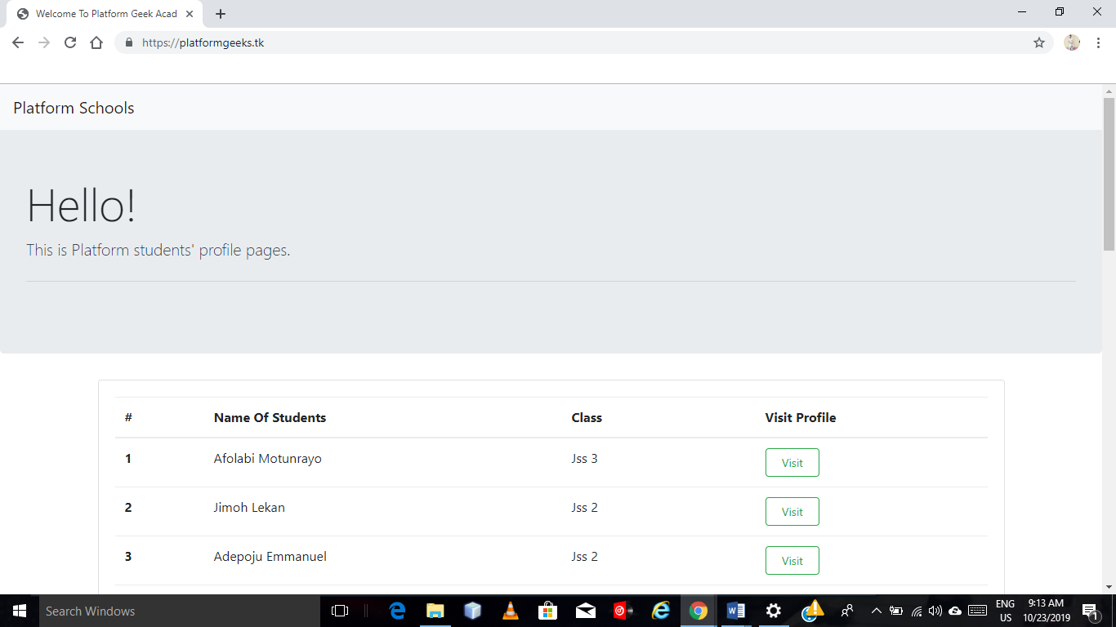

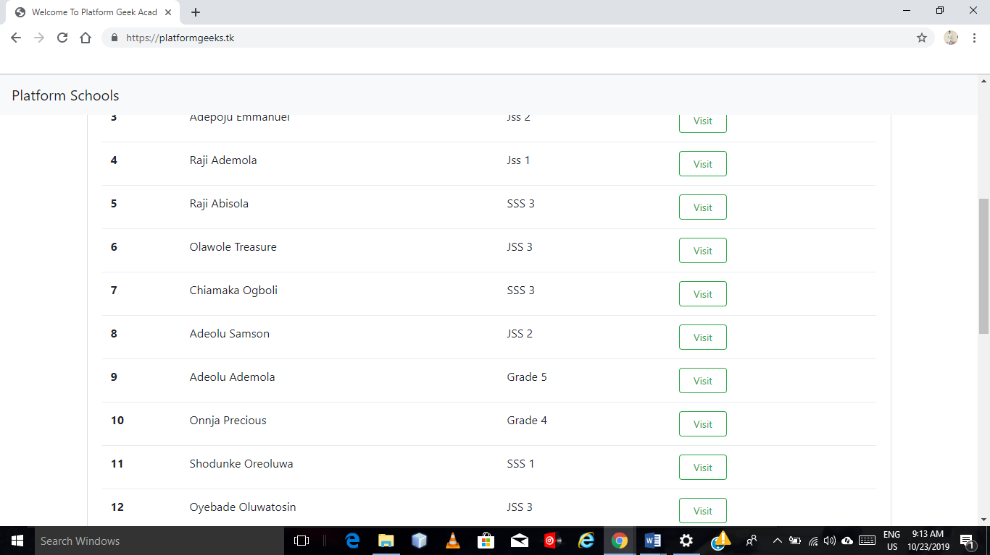
3.3 GRAPHICS DESIGNIG
My experience in graphics designing was mainly focused on Golden ratio and how its applied in graphics designing.
The Golden ratio mathematically calculate the ratio using the formula for Phi: A/B = (A+B)/A = 1.618033987
The applications for print and web design projects are often less precise than that 1 to 1.618. Designers round numbers when creating a mathematic golden ratio for grids that are easier to work with.
When it comes to applying the concept, it’s often represented using a spiral, circles or triangles.
And it’s not “just a design thing.” The golden ratio is found in nature (nautilus shell), art (the Mona Lisa), architecture (the Eiffel Tower) as well as design.

CHAPTER FOUR
4.0 CHALLENGES
The intense traffic on my way home was a serious challenge, most times I spend almost 2 hours in traffic and I have to get up early the next morning. During my one month teaching at Platforms school, I had JSS1 and Jss2 students in my class and it was a bit of a challenge to make them understand programming and its terminologies. Despite these challenges I gained a lot of experience from the program.
4.1 RECOMMENDATIONS
I urge the Federal Government to take the SIWES program more seriously especially for I.T students and Applied Sciences because the world is drifting towards I.T. The Government should ensure a proper supervision of SIWES students so that the purpose of the program will be archived. The Federal Government should also make adequate provision in the annual budget for proper funding of SIWES in view of the potential of the program to contribute to enhancing the quality of the pool I.T skills available to the country. A comprehensive and detailed directory of who accepts students for SIWES is urgently required to facilitate placement for SIWES student in industry. The ITF also should ensure that the payment of the student allowance is paid on time in other to keep the SIWES students zealous and motivated.
I recommend that the Nigerian educational system should be reviewed as what is taught in the classroom totally contradicts with what is needed the in the actual work place.
4.2 CONCLUSION
My SIWES was a very successful one, I had an insight of the information technology world. I have now known the power of programming and graphics designing. With this, I will be able set a goal for myself to build a complete website and write codes for different programs. SIWES as a course has truly exposed me to the challenges faced in a growing I.T world that is dependent on computers.

