

A
TECHNICAL REPORT
ON

STUDENT INDUSTRIAL WORK EXPERIENCED SCHEME
(SIWES)

HELD AT
KWARA STATE TELEVISION AUTHORITY [KWTV]
APATA YAKUBA, ILORIN KWARA STATE.

PRESENTED BY
ABDULWASIU MISTURAH GBEMISOLA
ND/23/MAC/PT/1112

SUBMITED TO:
THE DEPARTMENT OF MASS COMMUNICATION
INSTITUTE OF INFORMATION AND COMMUNICATION TECHNOLOGY
KWARA STATE POLYTECHNIC, ILORIN
IN PARTIAL FULFILMEN OF AWARD ON NATIONAL DIPLOMA.

2023/2024 SESSION

DEDICATION
This technical report is dedicated to the almighty God who gave me the life, strength, ability to acquire the knowledge and practical experience for the period of my attachment of my SIWES on my field of study.

ACKNOWLEGEMENT
I’m indebted to several people who at various stages contributed towards making this industrial training programme a success. My special thanks first and foremost goes to Almighty God for the grace and enablement He gave to me during the period of my attachment and during the period of writing this technical report.
I also wish to appreciate my parent in persons of Mr. and Mrs. Abdulwasiu who has helped me in all aspect of my life. You will reap the fruit of your labour. Thank you

TABLE OF CONTENT
Title page
Dedication
Acknowledgement
Table of content
CHAPTER ONE
1.0 Introduction to Siwes
1.1 Background of Siwes
1.2 Objectives OF Siwes
1.3 Description of The Establishment of Attachment
CHAPTER TWO
2.0 Location and Brief History of KWTV Ilorin
2.1 Organization Chart
2.2 Objectives of Establishment.
CHAPTER THREE

3.0 The Studio
3.1 The Television Studio
3.2 Studio Terminologies.
3.3 Equipment That Was Found In The Studio And Their Function
3.4 Items That Can Be Find In A Television Studio
CHAPTER FOUR
4.0 Difficulties Encountered During the Programme
4.1 Summary of Attachment Activities
CHAPTER FIVE
5.0 Summary
5.1 Conclusion
5.2 Recommendation

CHAPTER ONE
1.0 INTRODUCTION TO SIWES
The student industrial work experience scheme (SIWES) can be defined as a technical skill and acquisition of knowledge from the organization, industrial sector. It also serves as a motive that compliments the learning which student have acquired in the classroom or theoretically.
The student industrial work experience scheme is in practical fulfillment of TCS 210 of becoming a competent student in the field. It is a major work which is to expose student to the practical aspect of what they are been thought in class. During the course of study, I was posted to the programs department of the establishment.
1.1 BACKGROUND OF SIWES
The student industrial work experience scheme (SIWES) was established by ITF in 1973 to solve the problem of lack of adequate practical skill preparatory for employment in various industries by Nigerian graduates of tertiary institution.
The purpose of the scheme is to expose student to different kinds of industrial based skills necessary for a smooth transition from classroom to the world of labor. It afford the student of tertiary institution the opportunity of being engaged, familiarized and expose to the needed experience in handling various kinds of equipment and machine which are usually not available in the educational environment or institution.
However, participation in siwes has becomes a necessary pre-condition for the award of diploma in most institution of higher learning in the country, in accordance with the education policy of the government.
1.2 OBJECTIVES OF SIWES
The objectives of the student industrial work experience scheme (SIWES) as a follow:

- It improves student’s knowledge about the industrial sector or organization.
- It enable the student to practicalised different test form what they have learnt theoretical in the classroom.
- It relates the student to the labor market and how it’s being operated.
- It also enlighten student to various division of industries or organization of work in which their course of study can be practicalised.
- It enable student to know more the technological innovation in course of study, and some equipment which are or involved.
- It enable student to know the practical aspect of chosen field of study.

CHAPTER TWO
2.0 DESCRIPTION OF THE ESTABLISHMENT OF ATTACHMENT
Television broadcasting or station operations generally consist of two primary types of services: VHF (very high frequency) and UHF (ultra high frequency). There are at least two television stations in every state in Nigeria. In Ilorin, Kwara State, there are number of television stations part of which is Kwara state television [KWTV] where I acquired skills in the field of journalism. Kwara State television operates on ultra high frequency. KWTV currently have staff strength of 90 workers.
Its mission statement is to sustain and build a television station that promotes stakeholders relationship through professionalism and innovative quality programming.
Its vision statement is to be the medium transforming the world through broadcasting by upholding our heritage using global best practice.
2.1 LOCATION AND BRIEF HISTORY OF KWTV
Kwara state television authority [KWTV] is a state established station situated at television house PMB 1520, along Kwara state polytechnic Apata Yakuba Ilorin, Kwara State, Nigeria.
KWTV is an indigenous television station in Ilorin, Kwara State, and North Central Nigeria operating on frequency 25 UHF. It operates a license type of terrestrial television. The station broadcast educative, informative and entertaining programmes almost round the clock.
Successive government in kwara state has stated their desire to set up a television station in the state since the early 7os. However the first attempt to actualize the dream was aborted in 1977 with the promulgation of the Nigeria television decree no 24 of 1977 which brought all the state television station under a single federal authority.
A technical committee was however set up in 1991 by the then military administration to study and justify the desire for the establishment of kwara state television when a federal government television was already on ground which is the Nigerian Television Authority [NTA].
The committee’s recommendations had to wait till 1992 when the third civilian governor of the state Alhaji Mohammed Sha'aba Lafiagi set up an implementation committee and later awarded the contract for the station in July 1992.After installation, KWTV began test transmission with films on April 26 1994 while it commenced news and other programs in April 1995
It then began full transmission on Wednesday march 12, 1997 under the able leadership of Mallam Ishaq Moddibo Kawu who was the pioneer general manager. The establishment was promulgated into a decree in 1999.
After the tenure of Mall.Moddibo, the former state governor Mohammed Lawal merged both radio and television broadcasting corporation together and appointed Alhaji Meiro Mustapha as the director general of the two stations.
Alhaji Salami Ayinla Ayilara was appointed as the chairman for three month after the tenure of mall. Moddibo. Lasisi Bello who was a former director programme was then appointed as the general manager after salami Ayinla.
Lasisi Bello took over the mantle of leadership and was there till the year 2005 when mall. Tajudeen kareem was appointed to lead corporation. His tenure was short lived as he was removed by Governor Bukola Saraki's administration.
Engr. Kolawole Tomori [MNSE] was appointed as the assistant general manager after the exit of Mall. Tajudeen kareem of which after two years another general manager was appointed in person of Mallam Nurudeen Imam Abdulrahim who is now the assistant general manager and became the general manager of kwara state television authority,
Ilorin with effect from 3th June,2008. With the exits Mallam Nurudeen Imam Abdulrahim on 16th June 2010, Barrister Mahmud Abdulraheem was subsequently appointed as the new general manager and the appointment was with immediate effect. Barrister Mahmud Abdulraheem resigned his appointment with the station on 31st October, 2011.
On 27th February 2012, Alhaji AbdulLateef Adebowale Adedeji was appointed as the assistant General Manager for the station. On 1st November, 2012 Alhaji Abdulfatai Adewale Adebowale was appointed as the General Manager for Kwara State Television Authority and his appointment was with immediate effect and he remain so up till date. The signals of the station are received in most part of the state as well as Kogi, Niger, Ekiti, Oyo, Ondo and Osun State.
The television station is designed as the station choice for the indigenous people of kwara state both young and old including the people outside the state. The station is trying to go now from analogue to digital. Programmes on the station are designed to encourage local content and launch indigenous starts into international and national limelight leveraging the use of ICT.
  - OBJECTIVES OF KWTV
- To be the channel transforming the world through broadcasting by upholding our heritage using global best practice.
- To raise and sustain a television station that promotes stakeholders mutual relation and agreement through professionalism and innovative quality programming.
- To put information and classic entertainment music at listener’s fingertips
- To enable audience to be aware/involve in certain issue.
- To make a tour to the station’s site in the cyberspace presents a programming promise that is focused on a package of culture that is rich in local content, news, education and youth entertainment.
- To ensure that its main core values are practiced to provide quality service and to enable satisfaction from its audience. The core values of kwara state television authority is explained below;
K knowledge of the job
W wealth of experience
A awareness
R respect for individuals
A ability
T total commitment
E excellence
L lively entertainment
E enriching societal values
V viewers satisfaction
I innovation
S Service
I Insight
O Objectivity
N Newness
2.3 ORGANIZATIONAL STRUCTURE
An organizational structure is the typically hierarchical arrangement of lines of authority, communications, rights and duties of an organization. It determines how the roles, power and responsibilities are assigned, controlled, and coordinated, and how information flows between the different levels of management.
It provides for explicit and implicit institutional rules and policies designed to provide a structure where various work roles and responsibilities are delegated, controlled and coordinated. Organizational structure also determines how information flows from level to level within the company. In a centralized structure, decisions flow from the top down. In a decentralized structure, the decisions are made at various different levels.
In most organizations, the organizational structure is often referred to as organogram. The head of KWTV is the General Manager. The explanation below is how KWTV structure is being arranged.
- GENERAL MANAGER
A general manager or GM is the chief executive officer of a television station. This person manages the budget for the station, set human resources policies, hires and fires staff and also oversees all programming and sales initiatives. This or these individuals create a strategic plan for organization and set benchmarks for achieving goals. They often have a high profile in the community and form strategic partnership with local organization to raise the visibility of the station within the market.
As for KWTV, the general manager is Alhaji Abdulfatai Adewale Adebowale, who was appointed on the 1st November, 2012.
- SALES MANAGER
Most television stations rely on advertising to generate revenue. The station sales manager works with the ad sales staff on lead generation, sales techniques and client relations to sell station's available commercial time. The best sales opportunities are searched for. This individual works closely with the general manager to determine the station's revenue needs and the best methods to meet those needs.
- PRODUCTION MANAGER
The production manager supervises each live local newscast and assigns news stories to anchor. The tasks of the production manager includes, setting the order of stories for each newscast and selecting when and where any live remote reports occur. The production manager works in the operations booth, alongside the director and technical staff to ensure that the lights, camera angle and sound cues all work together to present a professional and informative program.

However, the structure of KWTV is in this order.
MANAGEMENT STRUCTURE

ADMINISTRATIVE OFFICER

CORPORATION SECRETARY

HEAD OF ENGINEERING

MANAGER OF NEWS AND CURRENT AFFAIRS

HEAD OF MARKETING

KWTV ORGANOGRAM
GENERAL MANAGER

Chief engineer
Operations
News director
Business manager
Transmitter manager
Talents
Reporters
Engineers
Accounting
Building maintenance
Traffic manager

Maintenance supervisor

2.4 DEPARTMENTS IN KWTV AND THEIR FUNCTIONS
KWTV has the following departments:
- Administrative and human resource department: This department handles the day to day business of a television station .They see to staff recruitment, training, promotions, etc. This department is also responsible for smooth management of the processes in KW TV. Also they consult with other department heads regarding cash flow and expenditures. In KWTV the branch manager oversees the activities of other departments and ensures proper working condition for staffs, hiring employees and ensures a safe workplace in all departments.
- News and current affairs department: This department is the local face of any television station. They are responsible for the compilation of news and keeping up to date with trending information, news, events and so on. In this department; there are various beat reporters who are assigned to different locations in Ilorin. Therefore, this department sees to the generation and presentation of news items and current affairs material as well as editing, writing/typing and printing the news in the station’s house-style. The department carries out research everyday as events/occurrences unfold to have their facts and figures as well as having accurate report for their listener. News anchors, reporters, meteorologists and sports anchors usually become recognizable personalities in their communities.
- Programmes /programming/production department: This department is sub-divided into two: programmes and production sections. The programmes department is in charge of programming while the production unit is made up of producers who produce programmes and presenters that do the presentations. In this department, there are the English and Yoruba newscasters as well as the sports broadcaster. The production department consists of the manager and assistant staff, e.g production staff, operations staff and on-air personalities. The production department in KWTV makes certain that all program contents and commercials are timely produced and lined up for timely broadcast.
- Engineering department: This department handles the technical aspects of broadcasting and on air time. It ensures broadcast signals are transmitted to the audience as well as see to the proper functioning of the studio equipment. Therefore, the department is in charge of all the technological and electronic machines/equipment in the radio station be it the transmitter, monitor, mixer and so on. Some of the engineers in this department record, work on and edit recorded materials in the recording studio before it is being broadcast. Under a chief engineer otherwise known as director of broadcasting operations, there are host of managers like engineers and studio crew members including show directors, cameramen, audio board operators, photographers, videographers, tape room editors and engineering technicians.
- Sales and marketing department: This department generate revenue. They are responsible for generating direct revenue for the broadcast station by selling air time to advertisers. Also they includes staffs like the voice talent, art directors etc
- Finance/account department: this department is in charge of handling all revenues and expenses in the TV station. The primary function is to ensure that dues from advertisers are collected in a timely manner and similarly all payments like utilities, salary and others are done on time.

CHAPTER THREE

3.0 THE STUDIO
The word studio is derived from the Italian word; studio, from Latin: stadium, from studere: meaning to study or zeal.
A studio is an artists or workers workroom, or the catchall term for an artist and his or her employees who work within the studio. This can be for the purpose of Architecture, painting, pottery (Ceramics), sculpture, scrap booking, photography, graphic design, film making, animation, radio or television production broadcasting or the making of music.
3.1 THE TELEVISION STUDIO
A television studio is an installation in which a video production takes place, either for the recording of live television to video tape, or for the acquisition of raw foot age for post-production. The design of a studio is similar to, and derived from, movie studios, with a few amendment of the special requirement of television production. A professional television studio generally has several rooms. Which are kept separate for noise and for particular reasons. These rooms are connected via inter com, and personnel will be divided among these workplace.
3.2 STUDIO TERMINOLOGIES.
- Tracking: this is a studio term use to control the camera man to move the entire camera along with the tripod to another position. Tracking is for moving in relation to the thing filming or recording.
- Zoom in and out: this is a studio term use to control the camera man to show the object that is being filming and recording from close or further away with the use of a zooming lens.
- Pan left and right: this is a studio term use to control the camera man to turn the camera without moving the entire camera with the tripod to get a good picture or emotional picture.
- Tip up and down: this is a studio term use to control the camera man to bring up or down the camera without moving the whole camera.
- Cue: this is a studio term that the camera man use to command the presenter to start action, the camera man give a signal to the presenter to start.
- Cut: a cut is a term use in a production to stop filming or recording, each stopping in a filming or recording is called a cut.
EQUIPMENT THAT WAS FOUND IN THE STUDIO AND THEIR FUNCTION
- Micro phone: it is use in changing physical/natural voice to electronic voice.
- Console mixer: basic units of all equipment to control the each programme.
- Computer system: to keep a file, songs and typing news.
- Aquatic wall: to present sound and hear.
- Que light: it enable the people to known whether there is a live programme going on or not.
- Disk: it is use to record some programme.
- UPS: it enable the programme to be continue when the light is off.
- Phone: the serve as a means of which audience get through to the presenter.
- Air condition: it make all the equipment in the studio to be cool.
- Dictionary: it help the newscaster to be able to pronounce words correctly.
- Speaker: this change electronic voice to physical voice for the people to hear clearly.
3.3 ITEMS THAT CAN BE FIND IN A TELEVISION STUDIO
The studio floor is the actual stage on which the actions that will be recording take place. A studio floor has the following characteristics and installations:
- SETS CONTRUCTION: I s the process by which a set designer works in collaboration with the director of a production to create the set of a theatrical film, or television production. The set designer produces a scale model, scale drawing, paint elevation and research props, textures, and so on. Model and paint elevation are frequently hand produced through in recent years, many designers and most commercial theatres have begun production scale drawing with the aid of computer drafting programs such as AUTO CARD or VECTOR works.
PRODUTION LIGHT
Studio lightening it enables the camera to see and take clear picture and to provide the viewer with important virtual information about an event such as space area, time of the day and even mood of an event.

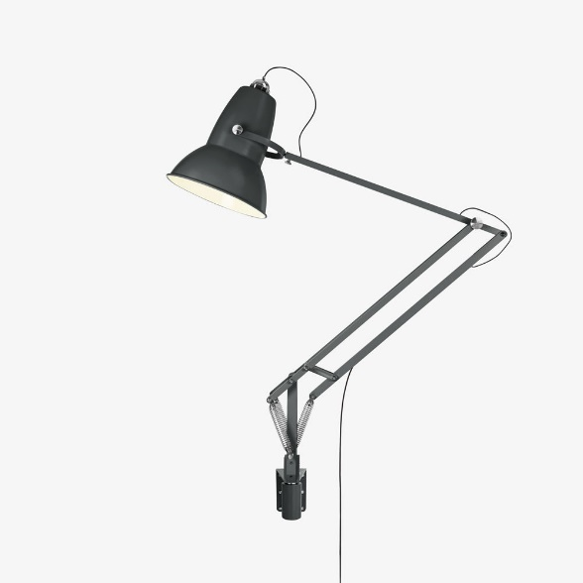

TYPES OF PRODUCTION LIGHT
- Base lightening: this is general studio lightening which is soft and not hard, it is directed to any particular place and therefore does not create much shadow. However the lightening is enough for a television camera to transmit acceptable picture.
- Modern lightening: this lightening usually directed toward a specific sense or performance. It contain three base light namely; key light, fill light, back light.
  - The key lights are directional, very strong and illuminate the subject, but one disadvantage is that it creates shadow.
  - Fill light reduce the hardness of the shadow.
  - The backs light on the other hand outline the subject and separate him/her from the background.
- Red harded lightening: this is usually use to change the color of a particular background with the help of using gel of any color and the color will infect in the object, for a particular purpose.
HEADPHONES

Studio Monitor Speakers are automatically muted whenever a microphone is turned on. As a result, anyone in a studio needs headphones to hear what is going to air. Headphone selection is often a very personal decision based on your preferences in comfort and frequency response.
MICROPHONE
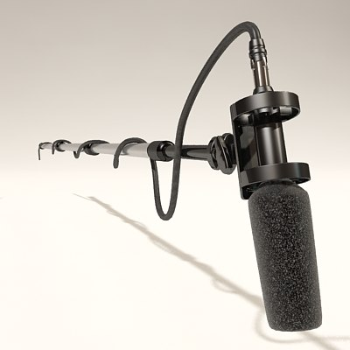
The microphone is also important equipment needed by broadcaster in the discharge of their daily duties. Microphones are several type but they perform one function that of magnifying the voice of the artist as fear as program production is concerned. Microphone converts sound energy into electrical energy.

A Boom Mic
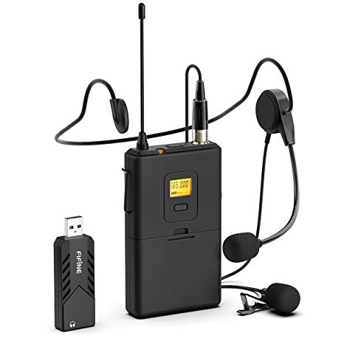

Lapel mic
TYPES OF MICROPHONE
- Uni-directional microphone: this type of microphone can be used in one direction. It can only handle about two person ant not more than that and the person must position in one direction.
- Omni-directional microphone: this type of microphone usually has a long cable and be extended over a considerable space within a given area. It can be easily use for outside broadcasting.
- Bi-directional microphone: this kind of microphone can be directed at the voice from different direction at the same time. This type is most suitable for interview and group discussion program.
- Nick microphone: this is a small electronic cup-on the microphone which is extensively use for speech pick up, it can be use to libel, shirt or tie and may be hidden beneath the clothing.
- Hanging microphone: this type of microphone, it is suspended over the action area and is effective for area sound pick such as choir or orchestra.
THE VIDEO CAMERA
A video camera (often called a television camera even through the use has spread beyond television) is a high-end device for creating electronic moving images that record the originally developed for use in television station, they are now commonly use for corporate and education videos, music videos and direct-to-video movies. There are two types of professional video camera:
- Television studio camera: which link the recording capability of a camcorder, and are often fixed on studio pedestal, or tripod to get a good caption for the viewers.
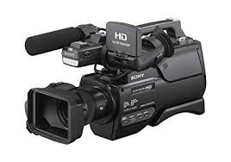
- High end portable recording camera (essentially, high end tapeless camcorders) use for electronic news gathering (ENG) and electronic field production (EFP) portable professional camera are generally much large then the consumers and are designed to be carried on the shoulder.

COPY EDITING
Copy editing, is the process of examining writing or visual work for any error, it is a work that an editor does to improve the quality of writing or visual material. No matter what you are publishing, no matter the medium, the copy editor must ensure that the copy is accurate, clear, concise, correct, clean, complete, and consistent.
Copy editing involves not only great attention to detail for issues of punctuation, grammar, style, and spelling, but also the ability to transform writer based content into reader or virtual based document that resonate with the audience.
Playout & Automation Software
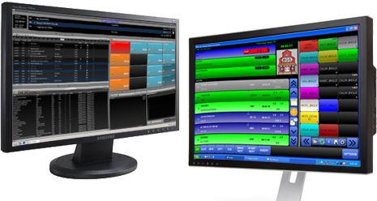
The computer system that plays back music, spots (ads, promos, etc.) and sweepers (the little voice-overs played between songs) is called a Playout System or Automation Software. These are specially designed computer programs that allow for continuous playback of audio, with a lot of granular control for Announcers and Programme Directors.
At the heart of any Automation System is the “log”. This is a sequential list of all audio files and commands that need to be played at certain times. All music played on a commercial radio station will be pre-programmed by the Music Director and loaded into the log. A separate person will often load all advertisements into the same log.
TYPES OF EDITIG
- Self editing: this is the process where by writer or reporter securitizes or checks his/her work to correct mistake before submitting it to the editor for formal processing. This first responsibility for editing lies with the writer or reporter. This is regardless of the general rule that a writer/reporter does edit his own work.
- Substantive editing: also called maximal editing. This type of editing deals with rewriting and restricting text in depth. It deals with elimination, unity, inconsistency of style etc.
- Comprehensive editing: this is a multi-stage process that deals with an analysis of how the document as a whole will be read and used; it deals with the content it self and must be completed before substantial or copy editing occurs (actual, content, organization and design of the material). It involves document planning, suitability for reader, viewer, purpose, budget, style, tone, diction, sentence, organization, and visual design, illustrations, and cultural edit, legal and ethical edit.
- Manual editing: this type of editing involves s copy editor reading a printed or written manuscript, and making it with editing symbols by hand rather than by any electronic device. It involves mush paper handling especially writing and editing on paper. This is also known as the traditional approach to copy editing.
- Electronic editing: unlike manual editing, electronic editing involves the reading of a manuscript or typed materials on a computer display (video display terminal- VDT) and corrections are entered dir

CHAPTER FOUR
4.1 Difficulties Encountered During the Programme
Life they say is not a bed of roses and whatsoever that has advantages also have its disadvantages. In as much as the SIWES Programme is a wonderful programme which has been designed to help the students have a practical knowledge of their various courses of study, it is note-worthy to also mention some of the problems encountered during the programme.
1. Problems of Securing a Place of Attachment
Securing a place of attachment for industrial training programme was a very big challenge to me. This is due to the fact that there are very limited establishment that accepts students undergoing industrial training. While I was searching for a place of attachments, I got to find out most of the establishments that accepts students had already taken the maximum number of students needed, while others would just reject the request giving one reason or the other.
2. Working Time
As an SIWES student working in KWTV, I was meant to work for twelve (8) hours in a day, five days in a week (i.e. Mondays to Friday). I barely had time to attend to my personal needs. Not just that SIWES students had to work all day, but also, the work load was quite much. Most times SIWES students would be asked to work overtime even without any incentive attached to it and students have no option but to comply every given instruction.
3. Finance
Stipends given to me during my industrial training programme is nothing to write home about. The stipend was so little that it could not even cover up for my daily transportation fair not to even mention my feeding fee; therefore, making me spent more from my personal savings. Despite the fact that the stipend was little, it was delayed. Most students ended their programme without receiving their complete stipend due to late payment from firm and we are also asked to pay for the practical we are going to conduct which makes student loose interest in participating.
4. Inaccessible Machines
In KWTV, industrial training students were not opportune to access most of the automated analyzers because they are not available Instead, we were being told to make research of such machine which does not assist us in learning better going with the saying “practice makes perfect” and not “plain research makes one perfect”. One of the objectives of SIWES is to expose students to work methods and techniques in handling equipment’s and machineries that may not be available in their universities, thus, the above stated objective of SIWES is not been fulfilled completely.
The difficulties encountered during the programme among others include;
- Inadequate monitoring of students on industrial training;
- Lack of cooperation and support from organization;
- Delay in release of fund for supervision and student’s industrial training allowances;
4.2 Summary of Attachment Activities
The gains of this exercise are immense; that it was worth the while is grossly an understatement. Being accorded another opportunity in life to be exposed to the rudiments of work places outside the class room teaching is an experience of a life time.
Furthermore, the exposure to practical tools, and working features had engendered better understanding of lessons thought in the class room and charted a course for career development in food science.

CHAPTER FIVE
5.0 SUMMARY
Having passed through my four months of industrial training at the socially responsible station, Kwara State Television Authourity (KWTV) Ilorin, one should see that thousands of people are transformed with this medium.
The work of broadcast station is to inform, educate and also entertain it audience. As a student that had undergo the training mainly on programmes which had a lot of experiences and knowledge concerning production of programs.
5.1 CONCLUSION
This industrial training has afforded me the basic practical and theoretical knowledge that I may not have gotten from the lecture room. It also gave me the opportunity to have a feel of what it would be like after graduation when I start working.
What made learning faster for me apart from the theoretical background I had in school. I was also shown recognition and was loved by everyone due to my hard work. Other benefits included opportunity to observe is access to the recording studios. I never for once was useless at the TV station during my SIWES because there is access to the internet which facilitated my work, research, had opportunity of accessing social network, sites, blogs and so on.
Finally the internship has bridged the gap between academic theory and practical and has built a good degree of confidence especially in my abilities to perform. It has also given me a first-hand experience of the entire broadcast media especially TV. I can confidently say that the experience gotten from this training was a worthwhile experience.

5.3 RECOMMENDATION
My recommendation is that student should endeavour to partake in the SIWES programme and make sure they keep every record of whatever they have learnt from their area of attachment because it will be relevant in the nearest future.
The school management should also support the students by producing constant supervisors to monitor the student at their area of attachment. The school should also support the student with a little payment amount, at least every month to sustain students throughout the programme.
5.3 SUGGESTIONS FOR THE IMPROVEMENT OF THE SCHEME
- Payment should be included with the industrial training of students; this will go a long way in augmenting the money spent during the period of industrial training. This will serve as an encouragement to the interns.
- Also, industrial training supervisors should be increased so as to see to all interns in their training field, identifying their challenges, putting them through and so on.
- SIWES should mandate every organization to allow interns finish their training before asking them to go and any organization that fails to comply with this should be sanctioned or given penalty.

