

A TECHNICAL REPORT
ON
STUDENT INDUSTRIAL WORK EXPERIENCE SCHEME
(SIWES)

HELD AT
KWARA STATE GEOGRAPHIC INFORMATION SERVICE
GRA, ILORIN, KWARA STATE

BY
ABDULKAREEM BASIT OLAMILEKAN
ND/23/QTS/PT/0016

SUBMITTED TO:
DEPARTMENT OF QUANTITY SURVEY, INSTITUTE OF TECHNOLOGY (I.O.T), KWARA STATE POLYTECHNIC, ILORIN

IN PARTIAL FULFILLMENT OF REQUIREMENT FOR THE AWARD OF NATIONAL DIPLOMA (ND) IN QUANTITY SURVEY

SEPTEMBER - DECEMBER 2023

DEDICATION
I dedicate this report first and foremost to Almighty God who has been their right from the beginning to this very point. Special dedication also to my ever supportive parents, for their relentless support and compassion towards me during the course of my three months SIWES training.
ACKNOWLEDGEMENTS
I thank God Almighty for the glory, honor, adoration and mercy I received during the course of my study and when undergoing my industrial training.
My appreciation also goes to my industrial based lecturer, whose accessibility, untiring effort, patients and guidance and suggestions fabulously contribution to the completion of this report.
Mostly, my application goes to the director of administration, for accepting me into the organisation and support, may God Almighty be with him and his household.

PREFACE
The student industrial work experience scheme (SIWES) helps in exposing students to the practical application of their course and to get used to equipment and machines used in the organization. The SIWES was established to promote student skills in industrial practice and pre-expose them to working experience in industrial setting.
The SIWES program covered a period of four months from September to December 2024 and it is a partial fulfilment of a two years academic program to obtain an OND certification in Engineering. The report explains the description of the work done.

TABLE OF CONTENTS
Title Page
Dedication i
Acknowledgements ii
Preface iii
Table of contents iv

CHAPTER ONE: INTRODUCTION ON STUDENTS INDUSTRIAL WORK EXPERIENCE SCHEME (SIWES)
  - Background on SIWES
  - Aim and Objectives of SIWES

CHAPTER TWO: DESCRIPTION OF THE ESTABLISHMENT OF ATTACHMENT
2.1 Location and brief history of establishment
2.2 Objectives of establishment
2.3 Organization Structure/Organogram of The Establishment
2.5 Department Posted to and My Duties Over There

CHAPTER THREE: WORK DONE AND EXPERIENCE GAINED AT THE PLACE OF ATTACHMENT
3.1 Site Investigation
3.2 Method of Land Measurement
3.3 Type of Surveying Equipment and their uses
CHAPTER FOUR: SUMMARY, CONCLUSION AND RECOMMENDATION
4.1 Summary of attachment activities
4.2 Problems encountered during the program
4.3 Conclusion
4.4 Recommendation

CHAPTER 1
- INTRODUCTION
1.1 BACKGROUND OF SIWES
SIWES was established by industrial training fund (ITF) in 1973 to solve the problem of lack of adequate practical skills preparatory for employment in industries by Nigerian graduates of tertiary of institutions. That is, the needs to enable students match their theoretical school knowledge with the practical aspect of their training industry. The author stressed further that it was in realization of this that the ITF when it was established, set out to study the extent to which the theoretical knowledge that students in engineering technology and other allied fields In Nigerian Institutions offering technology-based courses related to the kind of work experience expected of them by employers. Also, it prepares student for employment and makes the transition from school to the world of work easier after graduation.
Over the years, SIWES has contributed immensely to building the common pool and allied skills available to the Nigerian economy which are needed for the nation’s industrial development.

1.2 AIMS AND OBJECTIVES OF SIWES
Industrial Training (IT) provides an avenue for students in an institution higher learning to acquire industries skills and experience in their course of study.

THE OBJECTIVES ARE AS FOLLOWS:
- It provides an avenue for students in institution of higher learning to acquire industrial skill and experience during their course of study
- The program teaches the students on how to interact effectively with other workers and supervisors under various conditions in organization
- It expose students to work methods and techniques in handling equipment and machine that may not be available in educational institution
- Introduce students to real work atmosphere so that they know what they would most likely meet once they graduate
- It makes the transition from school to the world of work easier and enhance students contact for later jobs placements and a chance to evaluate companies for which they might wish to work

AIMS OF SIWES
The SIWES is aimed at helping/training students in the Nigerian tertiary institution the practical aspect of their field of study by exposing students to machines and equipment, professional work.

CHAPTER 2
- DESCRIPTION OF THE ESTABLISHMENT OF ATTACHMENT
2.1 LOCATION AND BRIEF HISTORY OF THE ESTABLISHMENT
Kwara State Geographic Information Service, Ilorin is a parastate under the state affairs and been controlled by the state.
The Department is located at Ahmadu Bello Way, Ilorin East, Ilorin, Kwara State.

2.2 OBJECTIVES OF ESTABLISHMENT
The objectives of Kwara State Geographic Information Service includes provision of adequate amenities such as Site Allocation, Measurement and Building Construction within the state in other for the citizen to enjoy the betterment of the Government.

2.3 ORGANIZATION STRUCTURE/ORGANOGRAM OF THE ESTABLISHMENT
Director

Managing Director
Secretary

Surveyor
Builder
Architect
Engineer
SECURITIES
ATTENDANTS

Labourer

2.4 DEPARTMENT POSTED TO AND MY DUTIES OVER THERE
I was posted to the field operation department throughout my programme in the company and my duties there is to observe how measurement is being carried out, observing the materials used on site, the functions of the machine used on site, supervise machine operators and giving report to the site engineers, taking road measurement from one drainage to another, assisting the engineer to take records of daily activities of whatever happens on sites and observe the test result carried out.

CHAPTER THREE
3.0 WORK DONE AND EXPERIENCE GAINED AT THE PLACE OF ATTACHMENT
3.1 Site Investigation
One of the experienced gained after been recognized and introduced to the workers on site was:
Method of Land Measurement
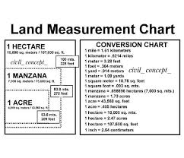
To measure land, surveyors typically use a method called land surveying, which involves physically measuring the boundaries and dimensions of a piece of land using tools like measuring tapes, theodolites, and GPS, then calculating the area using geometry and trigonometry, often converting the measurements to a standard unit like acres or hectares depending on the location; this process usually includes identifying reference points and marking boundaries on the land itself.

3.2 Type of Surveying Equipment and their uses;

A land surveyor uses instruments to make precise measurements of the earth’s surface. From determining property boundaries to preparing construction sites, surveyors rely on certain equipment to do their jobs properly.

Below is a summary of eight different types of surveying equipment and their uses:

1. Levels

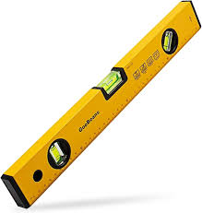
A level can be used to read an elevation and determine differences in elevation between two points. These tools can be handheld, optical or digital, and are typically used in conjunction with level rods or tripods.

2. Safety Gear

Land surveyors work in all kinds of conditions and climates, but safety is always the primary concern. High-visibility gear and safety headwear are a must for all outdoor work crews.

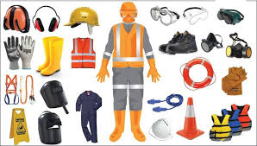

Compasses and Clinometers

A compass is an essential piece of equipment when surveying in unfamiliar territory, backcountry, or just orienting your position on a map. Compasses can be used to measure distances between two points while clinometers are used to measure the angle or elevation of slopes.
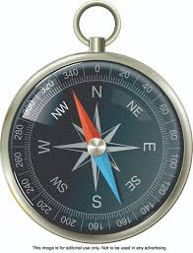

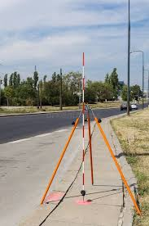
- Ranging Rod: A ranging rod, or range rod, is a surveying instrument used for marking the position of stations, and for sightings of those stations, as well as for ranging.

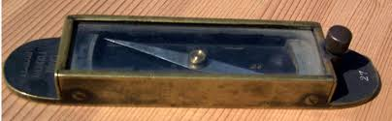
- Trough compass: is a rectangular compass used in surveying and navigation to determine magnetic north and orient instruments like plane tables and theodolites accurately.

- A dot/plumb laser: is a type of laser level that projects one or more dots or plumb points, rather than a line. Dot lasers project a small dot of laser light onto a surface, while plumb lasers project a vertical dot or line to establish a straight, vertical reference line.
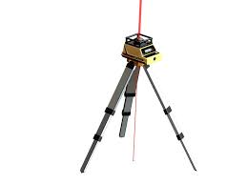

CHAPTER 4
4.0 Summary, Conclusion and Recommendation
4.1 Summary of attachment activities
As aforementioned above, activities done in the Kwara State Geographic Information Service is to enhance the welfarism of the citizen in provision of the following social amenities;
- Building construction guide
- Road construction measurement.
Demolition of building and structure within the road alignment at the phase 2 of the project.

4.2 Problems encountered during the program
The major problems encountered during my stay at the Geographic Information Service are the longevity of working hours, working from 8am to 6pm with only an hour rest.

4.3 Conclusion
Geographic Information Service initiate Survey students into knowing the key importance in making proper measurement of roads and building and more so how to set a foundation right in all construction.

4.4 Recommendation
Geographic Information Service which happen to be a state government firm should be encourage in all states and also the citizen should embrace them for better construction of roads and building and also their should be reduce to what an individual can afford since it’s a government operative for all to enjoy.

