CHAPTER ONE
INTRODUCTION OF STUDENT INDUSTRIAL WORK EXPERIENCE SCHEME (SIWES)
The student work experience scheme programme prepares students for the labour market. It has been established to widen up the student’s mind on the practical aspects of his career. It has become an innovative programme in human resources development and training in Nigeria.
The contemporary environment indication expressed the need to educate and train students as suitable professional to acquire adequate skills and training in the appropriate.
NATURE AND SCOPE OF SIWES
Practical knowledge is putting into action of knowledge derived from learning. It is referred to as doing according to learning. It involves the use of equipments needed to perform a task that is related to a field study. For instance, journalist needs equipment like pen, jotter, midget camera e.t.c to perform his duty.
Progress cannot be attained in a country if the youths are not encouraged to acquire necessary practical skill which will assist in the development of industrialization to meet the need of the society. With this knowledge, SIWES was introduced in Nigeria tertiary institution.
SIWES is a skill development programme designed to prepared students for universities polytechnic, monotechnics and college of education for transition from the school environment to the practical work. This work experience programme gives the student the opportunity to relate with professional in the field.
It is a course mandatory for students studying pure sciences, engineering, vocational technologies and related courses.
SIWES forms part of the approved minimum academic standards in the institutions. It is a core academic requirement carrying four (4) credit unit.
GOALS AND OBJECTIVE OF SIWES
Specially, the major objective of SIWES is to provide an avenue for students in the institutions acquire industrial skills and experience in their course of study.
However, its aims are highlighted below
- To prepare student for the industrial work situations they are likely to face after graduation.
- It affords students the opportunity of a familiarizing and exposing themselves to the needed experience in handling equipment and machines that are usually not available in the institution.
- To provide students with the chance if applying their knowledge in a real work situation thereby birding the gap between theory and practical.
- To enlist educational process and prepared student for employment opportunities in the organization.
- To make transition from the school to the world of world easier and enhance student contact for later job placement.

CHAPTER TWO
HISTORY OF RADIO KWARA
The Kwara State broadcasting corporation Ilorin with broadcasting identification. Radio Kwara stated broadcasting service in Ilorin in 1956 as a radio station. I was then known as provincial broadcasting house (the ¼ Kilowatt (kw) medium wave transmitter which was then used covered only about 8 kilometer radius of Ilorin.
However, Kwara State broadcasting corporation as constituted today, formally came into being with the enactment of the Kwara edict no 3 of 1999 but with retrospective effect from April 1st 1978. this was one of the beneficial by a product of the first state creation in Nigeria.
On the creation of the state in 1967 a master plan was drawn up and approved for the country as to the number capacity of transmitter and mode of transmission to be sited in each location. Owing to the topography of Kwara State, it was decided that should be covered with both medium and short wave transmitter.
In 1974, construction work started on then modern studio. Broadcasting house, the 10kw short wave and 20kw medium wave transmitting station sites. These facilities were put ion use as from 19th December 1976.
However, following the directive of the federal government the short wave transmitter was closed down in 1978.
On 1st April 1978, incompliance with federal government’s directive, which transferred, all radio Nigeria stationed in the state to their respective host state. The formal handling over of the station NBC of the Kwara State government was performed by Mr. Narration Agedeh of federal radio corporation, Lagos on 5th September, 1978, all the existing staff then was given the option of either staying with the corporation or going to the federal radio corporation. Those who opted to sty were retained.
At the time of take over by the state government, this station had a broadcasting house situated at the present premises and transmitting station located at Apata Yakuba along Jebba road, Ilorin. It then had two 10kilowatts medium wave transmitter, short wave transmitter at Apata Yakuba station. The two inherent 10kw transmitter were very old. In fact only one of them was working satisfactorily at the time of take over in 1978.
In 1984, the federal government boosted the transmitting capacity of radio Kwara through the directive that transferred the deal radio station in Ilorin to the Kwara State Government.
The station then hand two (2) 50kw medium wave transmitters at Budo Efo. With this development, the state government approved the recommendation of the corporation to install the cour imported to 10km medium wave transmitter in the fringe area of the then Kwara State for effective coverage. To of the wave were installed at Egbe, one at Otite near Okene (both now in Kogi State) and fourth at Koro in New Bussa crow in Niger State. All the three booster stations were completed and commissioned.

ORGANOGRAM OF RADIO KWARA

BOARD OF DIRECTOR

GENERAL MANAGER

FINANCE
DIRECTOR

ENGINEERING
DIRECTOR

CORPORATING SECRETARY

NEW & CURRENT AFFAIRS DIRECTOR

DNCA

CHIEF
REPORTER

CHIEF CURRENT AFFAIR OFFICE

CONTROLLER

MANAGER NEWS

CONTROLLER

CONTROLLER

PROGRAMMES
DIRECTOR

INTERNAL AUDIT DIRECTOR

COMMERCIAL / MARKETING DIRECTOR

FUNCTIONS OF EACH UNIT
i. ADMINISTRATION DEPARTMENT
This department sees to the affairs of the organization and its staff. It also deals with the keeping of records. It is also a department that deals with the recruitment new staff.
ii. NEWS AND CURRENT AFFAIRS DEPARTMENT
This department gives adequate information activities. It also informs ad enlighten public on current issues. It also generates revenue for the organization.
iii. ENGINEERING DEPARTMENT
This department is in charge of all equipment in corporate and ensures proper maintenance of them.
iv. MARKETING / COMMERCIAL DEPARTMENT
This department s responsible for getting revenue and securing adverts for the corporation.
v. FINANCIAL DEPARTMENT
This department is responsible for all the financial activities of the corporation.
vi. PROGRAMMES DEPARTMENT
This department is in charge of reading programme and also plan predication for corporation. The department gets sponsorship in conjunction with the marketing department.
CHAPTER THREE
EQUIPMENT THAT WAS FOUND IN THE STUDIO
Audio Console
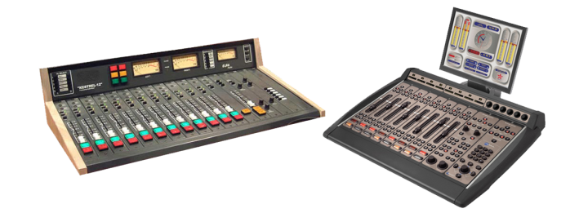
At the heart of any studio is the audio console (sometimes called a radio panel, sound panel, or sound desk). This is the interface the radio announcer (or panel operator) uses to control what’s heard on air. Every channel represents one “input”. The fader (slider) attenuates or amplifies the incoming signal.
Radio Audio Consoles are very different from a regular PA or Live Sound audio console, and are often more expensive than PA audio consoles as they are purpose-built for on-air talent ease of use. When you turn a microphone on or off, a radio console will mute any speakers and illuminate an “on air” light. When you turn a CD Player, Phone or Computer channel on, often it will “trigger” that input so it starts playing immediately.
Microphone
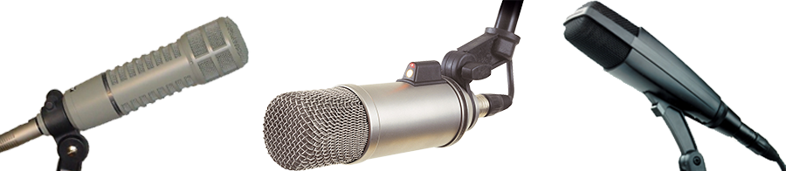
A microphone captures sounds from the studio and turn it into electrical impulses. Broadcast microphones are designed a little differently to PA microphones, as issues such as feedback (the squealing sound that can come through speakers) isn’t an issue in a studio.
Experienced audio announcers will often have a favourite microphone. Common microphones include ElectroVoie RE20, Sennheiser MD421, and Rode Broadcaster.

Microphone Arm
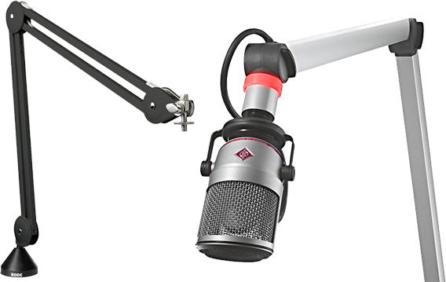
Studio microphones are often mounted on a special arm that keeps the microphone at the correct height. These arms often extend over the audio console, computer monitors, and other equipment – leaving plenty of table space free for equipment and paper.
Playout & Automation Software
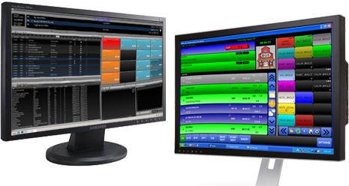
The computer system that plays back music, spots (ads, promos, etc.) and sweepers (the little voice-overs played between songs) is called a Playout System or Automation Software. These are specially designed computer programs that allow for continuous playback of audio, with a lot of granular control for Announcers and Programme Directors.
At the heart of any Automation System is the “log”. This is a sequential list of all audio files and commands that need to be played at certain times. All music played on a commercial radio station will be pre-programmed by the Music Director and loaded into the log. A separate person will often load all advertisements into the same log.
Most automation systems also contain a music database, hot keys (to play ad-hoc audio), an audio editor, segue editor (to change the mix between different elements), interfaces for website and RDS data, and a lot more.

Level Meters
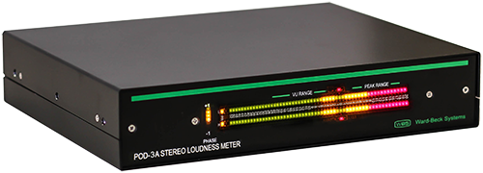
To ensure output of a station is somewhat consistent, radio studios contain different Level Meters. These allow the announcer or panel operator to see if their audio is too loud or too quiet at any given time. Often, you’ll have multiple meters showing the levels at different points in the signal chain.
Some radio stations also provide phase meters along side level meters. This helps you detect mono content, and spot any problems in source material that are likely to cause issues with the stereo image.
Studio Monitor Speakers
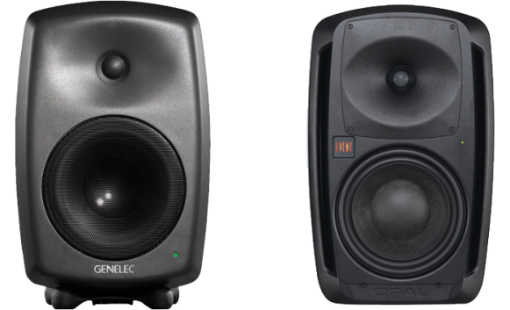
Studio Monitor Speakers provide an easy way to hear what’s going to air without headphones. Often, these are very high quality speakers so any abnormalities in sound quality can be detected.
Cue/Preview Speaker
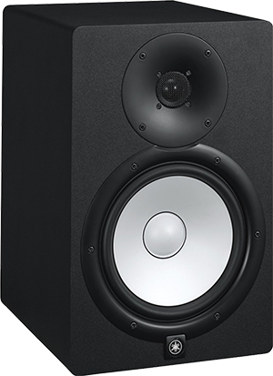
A separate speaker is often provided for the announcer hear all audio that isn’t going to air, such as the preview output from your audio console or the feed from your audio editor. By having a separate speaker for this, announcers can be sure their “preview” audio isn’t going to air.
Headphones
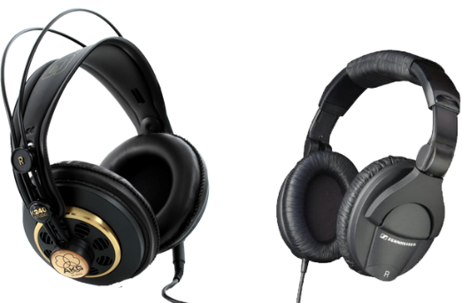
Studio Monitor Speakers are automatically muted whenever a microphone is turned on. As a result, anyone in a studio needs headphones to hear what is going to air. Headphone selection is often a very personal decision based on your preferences in comfort and frequency response.

Talent Panel
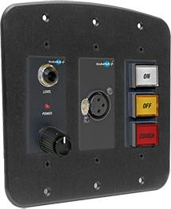
While the main announcer or panel operator can control everything via the audio console, guests often need their own individual control for headphone levels, a cough mute and mic on/off. These panels are generally mounted in front of each guest microphone, usually recessed into the table. Most panels include a headphone jack, and some also contain an XLR connector for the microphone.
On Air Light
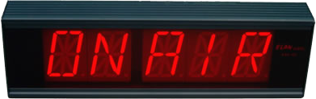
How do you know a mic in the studio is live? There’s a light especially for that! This light is automatically turned on/off by the audio console whenever a microphone channel is turned on. Usually you’d have at least one light inside the studio, and one outside.
Button Panel (GPIO)
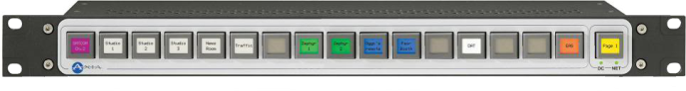
Sometimes you need to control settings not available from the audio console itself. This is why many consoles can have at least one row of configurable buttons. These can be physically wired to other equipment (in analog audio consoles), or configured via software (in digital audio consoles).
These buttons will often control studio delegation (which studio goes to air), phone systems, automation systems, or even remote triggering for networked radio stations.
P.S. GPIO stands for General Purpose Input/Output.
Phone Talkback System
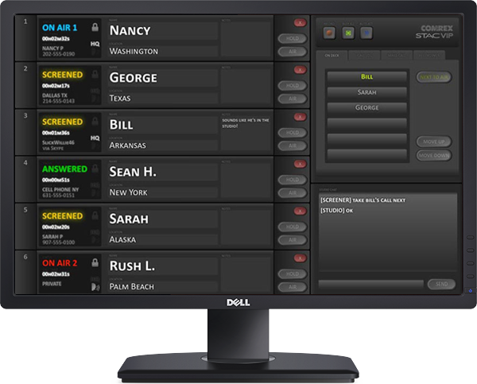
If you want to take a lot of calls on air, you’re going to need a Phone Talkback/Talkshow System. This is a software program or physical controller that shows you every call coming in on each line, and allows you to send this caller to a specific studio or audio channel.
Most systems allow you to track callers (a phone book with history), chat between the studio and producers and “conference” multiple callers together. The talkback system often doesn’t connect directly to a phone system, but instead interfaces to a PABX and/or Phone Hybrid.

DEFINITION OF NEWS
News is an accurate account and timely delivery of recent events. This is a generally accepted definition.

SOURCES OF NEWS
Press release can be defined statement purposely compose to send a message on a particular subject situation and event. It is also aim at creating public reaction for such a specific course. It contains information idea.
BEAT: Assign place of work for practicing newsmen or journalist. News could be specific aims in generating useful idea.
MONITORING:- A situation by which you monitor information from another station or accessing information fro the interest, monitor other media to get information.
Press conference:- It falls within coverage of event.
Mails:- You receives mail electronically you can receive information through email message. It can be receive in hard copy.
INTERNET:- Through the internet we receive information form the source of national and international information the major sources of new are .
NATURAL OCCURRENCE:- natural disaster like earthquake snow and outbreak.
ORGANIZE EVENT:- Accident, bomb blast Instinct and perspective to issue around you to create or elicit public reaction.
QUALITIES OF GOOD NEWS
The major qualities of news are
OBJECTIVITY:- It means being factual, it being bias. It also determines the transparency in news reporting. It stresses accountability in news writing. It must be reported as it happened.
SIMPLICITY:- Using word that an average listener or reader can understand. News must be simple in terms of language, expression, arrangement of ideas e.t.c
CLARITY:- Encodes the decoders on news it deals with breaking of ideas in to the simplest form of communication. It also encourages effective clarification. It entrendes expanded explanation in the news.
TIMELINESS:- It deals with processing (writing and delivery (reports) of reports that are current. Timeliness is the al mark in news writing and reporting.
BRIEFING:- The news must be brief avoid length sentences or compound sentences. Arrange ideas in the simplest from of writing.
COMPONENT OF GOODS NEWS
CAPTION:- Is a catchword that summary what the story is all about. It is usually at the left hand side of the paper.
Date:- This is the date in which the news was written
Lead:- Should contain all element of a headline lead. Contain the critical, valuable useful, beneficial idea contained in the news. It contain the essential part of SW’s and it confirms and establishes has the beauty of new writing.
Attribution tells who said a thing, it also accommodates other aspect of SW’s and H. attribution could be promote or delayed.
AFFIRMATION:- It is the combination of the lead and attribution. It affirms the statement contain in the lead.
RE-AFFIRMATION:- It untwines the listeners, raising anther super.
ADDITIONAL INFORMATION:- These are other information related to the story.
IDENTIFICATION OF THE SOURCE:- After writing the news the reporter must state the source of his news; for example if the story was from a mail, he write “mail” at the left hand side of the paper.
NAME OF THE WRITE:- The reported must state his name or initial before ending the story.
DETERMINANT OF GOOD NEWS
Prominence:- It deals with the critical value of the personality place and issue involved in the story. It deal with how important, relevant and current the personality. Place or issue is.
Proximity:- Nearness or closeness of the information to the people.
TYPES OF PROXIMITY
- Physical proximity
- Strategic proximity
- Psychological proximity
Public Interest:- It deals with the interest of the public on issues like, polities, agenda setting, new policy e.t.c
Human interest:- from other stories that might interest surprises and unexpected happening.
Nation Interest:- From other stories that might interest surprises and unexpected happening.
Conflict or controversy story:- Funny stories, love, hatred e.t.c
Impact and significance to the life of the people
Relevance of the story
Oddity / absorbing: when some thing strange happens e.g man bites dogs.
Breaking news
Timeliness
Attribution of good news attribution tells who gives the information. It established the source of information. It identify who which where and how the information was given.
Attribution may be a person groups of people research conducted, observation of the information. Attribution is necessary for the credibility of the news. It makes the news sound authoritative and real. Attribution may be promoted or delayed.
Attribution of personality title
Post + name e.g Nigeria president, Dr. Goodluck Jonathan.
Do not use initials, give name in details
Attribution authenticate the story, it uses title, name and pronoun e.g the state governor said, he said
Attribution tat deals with document.
They should presented in present forms of verbs e.g indicate, suggest, highlight. Recommends, stimulate e.t.c
When there is more than one speaker in a story, treat each speaker separately.

CHAPTER FOUR
WORK EXPERIENCE
I resumed to Radio Kwara on the first week of August, 2024 at news department of the station. The director of the department taught me on how to be a good broadcaster, presenter, and their qualities.
She taught me how to pronounce word correctly and encourage me that I can do it that when I develop those qualities of being a presenter/announcer.
She taught me on how to broadcast news in the process he took me to a live broadcasting news which I witness.
During my 8th week training period at reportorial unit, I was taught how to write good news stories, catch word for news stories, rewriting of press release in news stories form and different ways to ends the news story that can be used for broadcast.
I was also taught the alignment of broadcast news bulleting, I had the opportunity of conveying live event on various issues like & doing vox-pop on school resumption, market situation, monitoring of mosquito net distributed by the state government.
I always participated in the weekly management meeting the department which serves as interactive session between the SIWES student and the management. Question and assignment given out to SIWES student during the session.
NEWS AND CURRENT AFFAIRS UNIT ACTIVITIES
News and current affairs unit is one of the units under the news current affairs department of the station. The unit has been assigned to write type & tags commentaries and also directed listening to the various ongoing programme of the station, so that an assigned Rapoteur will work on detected errors or mistakes observed during the course of broadcasting.
During my four weeks training period at news and current affairs unit, I was taught how to write a good Tag about the necessary attribute from commentary that a good commentaries must posses.
Step1: it should talk about current affairs.
Step2: it should not be more twenty paragraphs.
Step 3: it should be in analysis form.
Step 4: it should be factional.
Step5: it must be fully research.
Step 6: suggestion should be made in it.
Step 7: it should contain and advice.
I also participated in the weekly management meeting of the department and always involved in the days activities of the unit.
CHALLENGES ENCOUNTERED DURING THE SIWES.
Challenges encountered during the siwes training were numerous but to mention a few.
Firstly, the major challenge I face during my training was that trying to get people who grant an interview on an event or public issues was very difficult, because those people regards me as ancub reporter. Also I was not familiar with the equipment used in the department such as miget, digital recorder etc. to use equipment one will need proper orientation about them.
In addition, the environment of the station was new to me to the extent that I was sometimes ask for direction within the station.
Lastly, I had challenge on the transportation to office because my resident is a bit far from the place of work, I had to leave house early so as to get to the office on time not talk of my transport fare for every working day.

CHAPTER FIVE
EXPERIENCE GAINED
In my four months of my SIWES training at the Kwara State broadcasting corporation, my first and most challenging experience, is how to broadcast news and to be a presenter of a live programme.
We did a live programme to discuss environment and prevention of cholera in a platform tagged “peoples’s programme”.
We were taught on how to conduct a case study interview for media house by some of us which are design, pilot, data collection and data analysis reporting.
I and my group later did two more recording programme one is discussing programme and the other is musical programme which make our recording to be three.
I participated on a live programe at the studio, (throw back Thursday).
I was taught on what news alignmwent and importance of mathematics bulleting is all about .
CONCLUSION
It is necessary to understand at this point in time that success is not measured by the height in which one finds himself, but can greatly be measured by what you can achieve through your own initiative.
With the experience gained, my advice to the school management is to add some months to the SIWES programme so as to build professional in their field of study.

RECOMMENDATION
My recommendation is that student should endeavour to partake in the SIWES programme and make sure they keep every record of whatever they have learnt from their area of attachment because it will be relevant in the nearest future.
The school management should also support the students by producing constant supervisors to monitor the student at their area of attachment. The school should also support the student with a little payment amount, at least every month to sustain students throughout the programme.


A

TECHNICAL REPORT

ON

STUDENT INDUSTRIAL WORK EXPERIENCED SCHEME
(SIWES)

HELD AT

KWARA STATE BROADCASTING COPORATION (RADIO KWARA)
N0 2 Police Road G.R.A, Ilorin, Kwara State.

PRESENTED BY

ZAKARIYAH OPEYEMI SAMSONDEEN
ND/23/MAC/PT/1131

SUBMITED TO:
THE DEPARTMENT OF MASS COMMUNICATION
INSTITUTE OF INFORMATION AND COMMUNICATION TECHNOLOGY
KWARA STATE POLYTECHNIC, ILORIN
IN PARTIAL FULFILMENT OF AWARD ON NATIONAL DIPLOMA.

2024/2025 SESSION
DEDICATION
I dedicate this programme to Almighty Allah the creator of heaven and earth, the soul giver and the father of wisdom for being there for me always and also I dedicate it to my parent (Mr. & Mrs. Zakariyah) who has always being there for me for his financial support in my education sector and to my lovely brothers and Sisters, I also desiccated this to my one and only friends who has also being there for me. To God I give all the glory.

ACKNOWLEDGEMENT
Thanks goes to Almighty Allah the creator of the universe and all-knowing of everything both on earth and in heaven. He alone deserve being praised for his mercies and his mankind for me to a accomplish my siwes report.
Special thanks goes to the mirror of my life my parent (Mr. & Mrs. Zakariyah) for their support support throughout my siwes programme.
Special thanks goes to all the staff in department of mass communication in Kwara state Polytechnic Ilorin.
My sincere gratitude goes to my brother and sister and a friends indeed to me for their gratitude support.

TABLE OF CONTENT
Title page
Dedication
Acknowledgement
Table of content
CHAPTER ONE
1.0 Introduction to Siwes
1.1 Advent of Siwes
1.2 The objective
1.3 Mission |
1.4 Vision
1.5 Benefit of industrial Training
CHAPTER TWO
2.0 Brief History of KSBC
2.1 Mission And Objectives Of Establishment
2.2 Functions And Duties
2.3 Departments
CHAPTER THREE
3.0 Jobs Done / Experience Gained
3.1 Safety Rules and Regulations
3.2 equipment used at KSBC
3.3 The Emergence of Broadcast Communication
CHAPTER FOUR
4.0 News And Current Affairs Unit Activities
4.1 Challenges Encountered During the Siwes.
CHAPTER FIVE
5.0 Summary
5.1 Conclusion
5.2 Recommendation

