

A TECHNICAL REPORT ON
STUDENT INDUSTRIAL WORK EXPERIENCE SCHEME (SIWES)

HELD AT
KWARA TELEVISION
APATA YAKUBA, ILORIN, KWARA STATE.

BY

AFOLABI OLABISI BEATRICE
MATRIC NO: ND/22/MAC/PT/0624

SUBMITTED TO
DEPARTMENT OF MASS COMMUNICATION,
INSTITUTE OF COMMUNICATION (I.I.C.T)
KWARA STATE POLYTECHNIC, PMB 1375 ILORIN KWARA STATE

AUGUST – NOVEMBER, 2024.

DEDICATION
This report is dedicated to Almighty GOD for making everything easy for me throughout my Student Industrial Work Experience Scheme (SIWES) programme and to my parent Mr & Mrs Arisu for their contribution to the success of this project. May Almighty God give you long life and prosperity (Amen)

ACKNOWLEDGEMENT
All praise, glory, honour and adoration to Almighty GOD, the author and the giver of wisdom, knowledge and understanding for the success of this programme.
I appreciate my parents which are my source to this world Mr & Mrs ARISU for their parental and spiritual support because without their maximum understanding and support, this experience would have not come into existence including my brother and sister for their support.

PREFACE
The Student Industrial Work Experience Scheme (SIWES) is a National Diploma Curriculum of the Department of Mass Communication, Kwara State Polytechnic Ilorin.
The programme was established by the Industrial Training Fund (ITF) in 1973 to 1974.
It is designed to acquire the student with life situation in industries as well as supplies in a more practical manner and their knowledge in practical activities and other practical field during their course of study.

TABLE OF CONTENTS
Title page
Dedication
Acknowledgement
Abstract
Table of contents
CHAPTER ONE
- INTRODUCTION
1.1 MEANING OF SIWES
1.2 GOALS OF THE SIWES

CHAPTER TWO
2.0 HISTORICAL BACKGROUND OF THE COMPANY/ORGANIZATION OF
KWARA TELEVISION
2.1 DESCRIPTION OF THE ESTABLISHMENT OF ATTACHMENT
2.2 LOCATION AND BRIEF HISTORY OF KWTV
2.3 OBJECTIVES OF KWTV
2.4 ORGANIZATIONAL STRUCTURE
2.5 DEPARTMENTS IN KWTV AND THEIR FUNCTIONS
CHAPTER THREE
3.1 STUDIO EQUIPMENT
3.2 Studio Room
3.3 TRANSMISSION
CHAPTER FOUR
4.0 REPORT ON WORK ACTUALLY CARRIED OUT: PROGRAMME/PROGRAMING
DEPARTMENT
CHAPTER FIVE
SUMMARY, CONCLUSION AND RECCOMMENDATION
5.1 Summary
5.2 Problems Encountered During the Exercise
5.3 CONCLUSION
5.4 RECOMMENDATION
5.5 SUGGESTIONS FOR THE IMPROVEMENT OF THE SCHEME

CHAPTER ONE
1.0 INTRODUCTION
The student industrial works experience scheme (SIWES) was established by the industrial training fund (I.T.F) in 1973 and control by the national board for technical education (NBTE). The aims and objectives is to develop student skill and to expose students in the school of engineering, technology, environment, science and agriculture and medical science to the working experience in which they will found themselves in future.
It is integral part of degree and National Diploma programme institute of higher learning in Nigeria. This privilege programme would definitely broaden student chance of learning and would empower his/her academic efficiency.
1.1 MEANING OF SIWES
Student Industrial Work Experience (SIWES) is a programme set up the institution particularly, the institute of learning for both science and technology student. Students must engage in this programme by giving various department of technology access of imparting practical knowledge to the students by moving to various company and industry etc. to attach themselves in order to assist them on their theoretical aspect.
1.2 GOALS OF THE SIWES
- It serves a lot of opportunity to the student in the sense that, students are able to gain the practical knowledge.
- It assist on how to behave in any sector
- It help us to know about different department
- It assist us to know how the different component of building function
- It enlightens us to know the rules and regulation of any sector.

CHAPTER TWO
2.0 HISTORICAL BACKGROUND OF THE COMPANY/ORGANIZATION OF KWARA TELEVISION
Successive governments in Kwara State had stated their desire to set up a television station in the State since the early 70s.
However the first attempt to actualize the dream was aborted in 1977 with the promulgation of the Nigeria Television decree No 24 of 1977 which brought all the State Television station under a single federal Authority.
A technical committee was however set up in 1991 by the then Military Administration to study and justify the desire for the establishment of Kwara State Television when a Federal Government television station was already on ground.
The committee’s recommendations had to wait till 1992 when the third civilian governor of the state, Alhaji Mohammed Sha’aba Lafiagi set up an implementation committee and later awarded the contract for the station in July 1992.
After all installations, Kwara Tv began test transmission with films on April 26 1994 while it commenced News and other programs in April 1995.
The station began full transmission on Wednesday March 12, 1997 with the setting up of a pioneering management team led by Modibbo Ishaq Kawu.
The signals of the station were received in most parts of the state, as well as in Kogi, Niger, Ekiti, Oyo, Ondo and Osun States, Nigeria.
CURRENT STAFF STRENGTH – 90
VISION STATEMENT
“To be the medium transforming the world through Broadcasting by upholding our Heritage using Global Best practice”
MISSION STATEMENT
“To build and sustain a television station that promotes stakeholders’ relationships through professionalism and innovative quality programming”.
2.1 DESCRIPTION OF THE ESTABLISHMENT OF ATTACHMENT
Television broadcasting or station operations generally consist of two primary types of services: VHF (very high frequency) and UHF (ultra-high frequency). There are at least two television stations in every state in Nigeria. In Ilorin, Kwara State, there are number of television stations part of which is Kwara state television [KWTV] where I acquired skills in the field of journalism. Kwara State television operates on ultra-high frequency. KWTV currently have staff strength of 90 workers.
Its mission statement is to sustain and build a television station that promotes stakeholders relationship through professionalism and innovative quality programming.
Its vision statement is to be the medium transforming the world through broadcasting by upholding our heritage using global best practice.
2.2 LOCATION AND BRIEF HISTORY OF KWTV
Kwara state television authority [KWTV] is a state established station situated at television house PMB 1520, along Kwara state polytechnic Apata Yakuba Ilorin, Kwara State, Nigeria.
KWTV is an indigenous television station in Ilorin, Kwara State, and North Central Nigeria operating on frequency 25 UHF. It operates a license type of terrestrial television. The station broadcast educative, informative and entertaining programmes almost round the clock.
Successive government in Kwara state has stated their desire to set up a television station in the state since the early 70s. However the first attempt to actualize the dream was aborted in 1977 with the promulgation of the Nigeria television decree no 24 of 1977 which brought all the state television station under a single federal authority.
A technical committee was however set up in 1991 by the then military administration to study and justify the desire for the establishment of kwara state television when a federal government television was already on ground which is the Nigerian Television Authority [NTA].
The committee’s recommendations had to wait till 1992 when the third civilian governor of the state Alhaji Mohammed Sha'aba Lafiagi set up an implementation committee and later awarded the contract for the station in July 1992.After installation, KWTV began test transmission with films on April 26 1994 while it commenced news and other programs in April 1995
. It then began full transmission on Wednesday march 12, 1997 under the able leadership of Mallam Ishaq Moddibo Kawu who was the pioneer general manager. The establishment was promulgated into a decree in 1999.
After the tenure of Mall.Moddibo, the former state governor Mohammed Lawal merged both radio and television broadcasting corporation together and appointed Alhaji Meiro Mustapha as the director general of the two stations.
The television station is designed as the station choice for the indigenous people of kwara state both young and old including the people outside the state. The station is trying to go now from analogue to digital. Programmes on the station are designed to encourage local content and launch indigenous starts into international and national limelight leveraging the use of ICT.
2.3 OBJECTIVES OF KWTV
- To be the channel transforming the world through broadcasting by upholding our heritage using global best practice.
- To raise and sustain a television station that promotes stakeholders mutual relation and agreement through professionalism and innovative quality programming.
- To put information and classic entertainment music at listener’s fingertips
- To enable audience to be aware/involve in certain issue.
- To make a tour to the station’s site in the cyberspace presents a programming promise that is focused on a package of culture that is rich in local content, news, education and youth entertainment.
- To ensure that its main core values are practiced to provide quality service and to enable satisfaction from its audience. The core values of kwara state television authority is explained below;
K knowledge of the job
W wealth of experience
A awareness
R respect for individuals
A ability
T total commitment
E excellence
L lively entertainment
E enriching societal values
V viewers satisfaction
I innovation
S service
I insight
O objectivity
N newness

2.4 ORGANIZATIONAL STRUCTURE
An organizational structure is the typically hierarchical arrangement of lines of authority, communications, rights and duties of an organization. It determines how the roles, power and responsibilities are assigned, controlled, and coordinated, and how information flows between the different levels of management.
It provides for explicit and implicit institutional rules and policies designed to provide a structure where various work roles and responsibilities are delegated, controlled and coordinated. Organizational structure also determines how information flows from level to level within the company. In a centralized structure, decisions flow from the top down. In a decentralized structure, the decisions are made at various different levels.
In most organizations, the organizational structure is often referred to as organogram. The head of KWTV is the General Manager. The explanation below is how KWTV structure is being arranged.
- GENERAL MANAGER
A general manager or GM is the chief executive officer of a television station. This person manages the budget for the station, set human resources policies, hires and fires staff and also oversees all programming and sales initiatives. This or these individuals create a strategic plan for organization and set benchmarks for achieving goals. They often have a high profile in the community and form strategic partnership with local organization to raise the visibility of the station within the market.
- SALES MANAGER
Most television stations rely on advertising to generate revenue. The station sales manager works with the ad sales staff on lead generation, sales techniques and client relations to sell station's available commercial time. The best sales opportunities are searched for. This individual works closely with the general manager to determine the station's revenue needs and the best methods to meet those needs.
- PRODUCTION MANAGER
The production manager supervises each live local newscast and assigns news stories to anchor. The tasks of the production manager includes, setting the order of stories for each newscast and selecting when and where any live remote reports occur. The production manager works in the operations booth, alongside the director and technical staff to ensure that the lights, camera angle and sound cues all work together to present a professional and informative program.

However, the structure of KWTV is in this order.
MANAGEMENT STRUCTURE

ADMINISTRATIVE OFFICER

CORPORATION SECRETARY

HEAD OF ENGINEERING

MANAGER OF NEWS AND CURRENT AFFAIRS

HEAD OF MARKETING

KWTV ORGANOGRAM;
GENERAL MANAGER

Chief Engineer
Operations
News director
Business manager
Talents
Transmitter manager
Accounting
Reporters
Engineers
Traffic manager

Technicians
Building maintenance
Maintenance supervisor

2.5 DEPARTMENTS IN KWTV AND THEIR FUNCTIONS
KWTV has the following departments:
- Administrative and human resource department: This department handles the day to day business of a television station .They see to staff recruitment, training, promotions, etc. This department is also responsible for smooth management of the processes in KW TV. Also they consult with other department heads regarding cash flow and expenditures. In KWTV the branch manager oversees the activities of other departments and ensures proper working condition for staffs, hiring employees and ensures a safe workplace in all departments.
- News and current affairs department: This department is the local face of any television station. They are responsible for the compilation of news and keeping up to date with trending information, news, events and so on. In this department; there are various beat reporters who are assigned to different locations in Ilorin. Therefore, this department sees to the generation and presentation of news items and current affairs material as well as editing, writing/typing and printing the news in the station’s house-style. The department carries out research everyday as events/occurrences unfold to have their facts and figures as well as having accurate report for their listener. News anchors, reporters, meteorologists and sports anchors usually become recognizable personalities in their communities.
- Programmes/programming/production department: This department is sub-divided into two: programmes and production sections. The programmes department is in charge of programming while the production unit is made up of producers who produce programmes and presenters that do the presentations. In this department, there are the English and Yoruba newscasters as well as the sports broadcaster. The production department consists of the manager and assistant staff, e.g production staff, operations staff and on-air personalities. The production department in KWTV makes certain that all program contents and commercials are timely produced and lined up for timely broadcast.
- Engineering Department: This department handles the technical aspects of broadcasting and on air time. It ensures broadcast signals are transmitted to the audience as well as see to the proper functioning of the studio equipment. Therefore, the department is in charge of all the technological and electronic machines/equipment in the radio station be it the transmitter, monitor, mixer and so on. Some of the engineers in this department record, work on and edit recorded materials in the recording studio before it is being broadcast. Under a chief engineer otherwise known as director of broadcasting operations, there are host of managers like engineers and studio crew members including show directors, cameramen, audio board operators, photographers, videographers, tape room editors and engineering technicians.
- Sales and Marketing Department: This department generate revenue. They are responsible for generating direct revenue for the broadcast station by selling air time to advertisers. Also they includes staffs like the voice talent, art directors etc
- Finance/Account Department: this department is in charge of handling all revenues and expenses in the TV station. The primary function is to ensure that dues from advertisers are collected in a timely manner and similarly all payments like utilities, salary and others are done on time.

CHAPTER THREE
3.1 STUDIO EQUIPMENT
3.2 Studio Room
The studio is where the action takes place. A good studio set up includes the studio cameras, studio lights and microphones. Attached to the studio is the control room where trhe quality of signal is being controlled. The control room as the name implies is a room where all the activities happening in the studio, downlink, news, are monitored and controlled before transmission. There are some equipment found in the control room which helps in the control of signals to be transmitted and they are:
- Monitors
- Cameras control unit (CCU)
- System
- Teleprompter
- Audio mixer
- Vision mixer
- Monitor speaker
- High definition video (HDV) recorder
3.2.1 Monitors
Monitors are display screens mounted in the control room to help monitor signals. A monitor or a display is an electronic visual for computers. The monitor comprises the display device, circuitry and an enclosure. Monitors are placed strategically in different sections in order to monitor where faults and issues are likely to come up from. There is the pre transmission monitor that displays the waveform of the ongoing transmission signal. The camera monitor displays the captured image from each camera in the studio. The monitor helps to detects frozen video (patent pending) and black video.
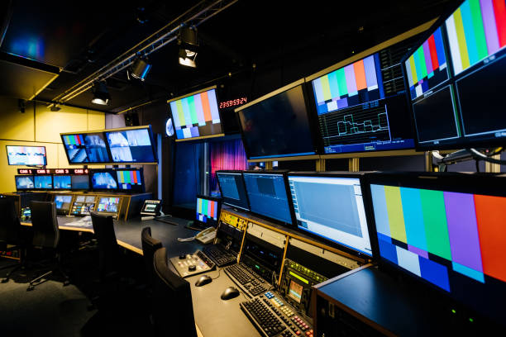

3.2.2 Camera Control Unit (CCU)
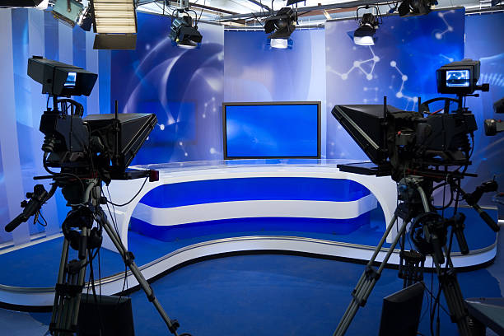
The camera control unit is a special equipment used in the control room to adjust the brightness, contract, and sharpness of the display image from the camera. It brings about a standard image quality to be transmitted.

3.2.3 Systems Unit
Apart from live studio collections, there are a number of saved files being transmitted, these file are housed in the system. Therefore the system unit is an equipment that plays files to be transmitted.
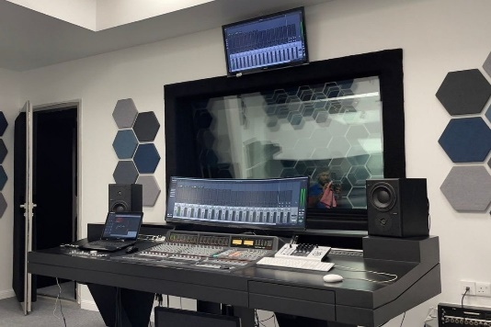

3.2.4 Teleprompter
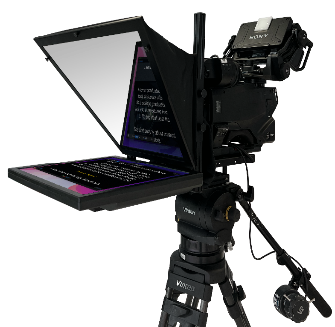
A teleprompter, or autocue, is a display device that prompts the person speaking with an electronic visual text of a speech or a script. It make the presenter look as if he has memorize the whole text.

3.2.5 Audio Mixer
An audio mixer or a mixing console is an electronic device for combining, routing, and changing the level, timbre and/or dynamics of audio signals. The modified audio signals are summed up to produce the combined output signals.

3.2.6 Vision Mixer
A vision mixer or a video switcher is a device used to select between several different video sources and in some cases compositing (mixing) video sources to create special effects.
3.2.7 Monitor Speaker
A monitor speaker is placed in the control room to monitor the effect of the audio mixer for proper and better audio transmission.
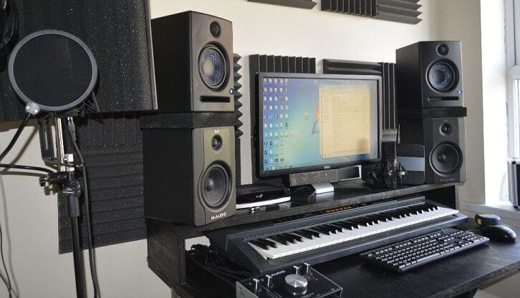

3.3 TRANSMISSION
The transmission room is a room that houses the transmitter, cooling system, the outlet waveguide, and the antenna.
A television transmitter is a device which broadcasts an electromagnetic signal to the television receivers. Television transmitters may be analog or digital.

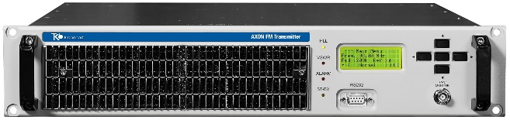
CHAPTER FOUR
4.0 REPORT ON WORK ACTUALLY CARRIED OUT: PROGRAMME/PROGRAMING DEPARTMENT
On the 1TH August, 2024, I started my four month SIWES program at Kwara State Television Authority, television house apata yakuba Ilorin, Kwara State Nigeria.
I was assigned by the Head of Administration HOA, in the person of Mrs B. A. Adebayo to work and gain skills at the programme and programming department where I spent 16 weeks.
On getting to the department I was welcome by the assistant DNCA. She introduced me to the other staff members. I was then put in care of a casual staff that also work in library.

.

CHAPTER FIVE
SUMMARY, CONCLUSION AND RECCOMMENDATION
5.1 Summary
It is observed that all efforts of this report is mostly concentrated on activities done and part of what the corporation means. Examining critically, I discovered how news is being sourced from, how it is put in manuscript using the organization in house style, how it is arranged and printed into bulletin and how it is lined up.
During the course of my SIWES program, I discovered that major news stories use is that obtained locally and few of national news and international news.
5.2 Problems Encountered During the Exercise
They are as follows;
- Inability to follow the beat reporter to cover events: throughout my stay at the TV station I was not opportune to go out to cover news/event with a beat reporter though I was assigned to one beat reporter.
- NO accessibility to the programs department’s activities: I was not opportune to go to the programming department at all.
- Lack of proper SIWES trainer at the establishment: all experience gained is as a result of my discovery. There was very little or no teaching.
5.3 CONCLUSION
This industrial training has afforded me the basic practical and theoretical knowledge that I may not have gotten from the lecture room. It also gave me the opportunity to have a feel of what it would be like after graduation when I start working.
At the conclusion of my internship at KWTV, I can effectively source for news in their print form and edit in the proper TV format.
What made learning faster for me apart from the theoretical background I had in school. I was also shown recognition and was loved by everyone due to my hard work. Other benefits included opportunity to observe is access to the recording studios. I never for once was useless at the TV station during my SIWES because there is access to the internet which facilitated my work, research, had opportunity of accessing social network, sites, blogs and so on.
Finally the internship has bridged the gap between academic theory and practical and has built a good degree of confidence especially in my abilities to perform. It has also given me a first-hand experience of the entire broadcast media especially TV. I can confidently say that the experience gotten from this training was a worthwhile experience.
5.4 RECOMMENDATION
In case of next time, I.T supervisors should try their best in visiting I.T students to know how they are faring and observe them rather than not going at all or just visit once.
Also, SIWES supervisors should see to ensuring students go out on their fields by making it mandatory for every organizations
5.5 SUGGESTIONS FOR THE IMPROVEMENT OF THE SCHEME
Payment should be included with the industrial training of students; this will go a long way in augmenting the money spent during the period of industrial training. This will serve as an encouragement to the interns.
Also, industrial training supervisors should be increased so as to see to all interns in their training field, identifying their challenges, putting them through and so on.
SIWES should mandate every organization to allow interns finish their training before asking them to go and any organization that fails to comply with this should be sanctioned or given penalty.

