

A TECHNICAL REPORT ON
STUDENT INDUSTRIAL WORK EXPERIENCE SCHEME
(SIWES)

HELD AT:
EXCEEDING GRACE BUILDING CONSTRUCTION
No 25, Oluwafemi Street Oju-Elegba Surulere, Lagos State.

WRITTEN BY

POPOOLA WAHAB AFOLABI
MATRIC NO: ND/23/CEC/PT/0132

SUBMITTED TO
DEPARTMENT OF CIVIL ENGINEERING, INSTITUTE OF
TECHNOLOGY (I.O.T), KWARA STATE POLYTECHNIC,
ILORIN

IN PARTIAL FULFILLMENT OF THE REQUIREMENTS FOR THE
AWARD OF NATIONAL DIPLOMA (ND) IN CIVILENGINEERING.

AUGUST –DECEMBER, 2024

DEDICATION
I dedicate this report to God, the source of my strength and ability. To my parents Mr. &. Mrs. Popoola.

ACKNOWLEDGEMENT
My profound gratitude goes to all those that contributed in one way or the other for the realization of this long term dream of contributing my own little quota to anyone reading this SIWES report.
I acknowledge the work done by the various staffs of Exceeding Grace Building Construction for giving me the opportunity to be in their midst to achieve my objectives and I also appreciate my parents (MR. and MRS. Ibrahim] for their full financial and spiritual support to make this come to pass.
Finally my special thanks to Almighty God for giving me the privilege to write this report.

PREFACE
This report contains all experience gained during the time of my student industrial work experience scheme (SIWES).Thus it vividly gives a comprehensive summary report of the engaged and experience gained at EXCEEDING GRACE BUILDING CONSTRUCTION.

TABLE OF CONTENTS
Title page i
Dedication iii
Acknowledgement iv
Preface ii
Table of Contents iv
CHAPTER ONE
1.0 Introduction 1
1.1 Definition of student industrial work Experience scheme (S.I.W.E.S) 1
1.2 Aims and Objectives of S.I.W.E.S 2
CHAPTER TWO: Description of the Establishment of Attachment
2.1 Location and Brief Historical of Establishment 3
2.2 Objective of the Establishment
2.3 Organization Chart 4
  - The Various department/unit in the Establishment
CHAPTER THREE: ACTUAL WORK CARRIED OUT
- Actual Work Done 6
3.1 Structural and Component of Road profile 6
3.2 Culverts 8
3.3 Reinforcement Concrete 8
3.4 Strip Foundation 8
CHAPTER FOUR:
4.1 Experience Gained 10
CHAPTER FIVE
5.0 Conclusion 12
5.1 Recommendation to the Organisation 15
CHAPTER ONE
1.0 INTRODUCTION
The student industrial work experience scheme (S.I.W.E.S) is a four month program usually commences between August to December, which is setup by the Federal Government for practical improvement of student in engineering, socials sciences and other related courses in order to expose the learners to what they are expected to meet in the professional market after graduation.
In fulfillment of mandatory four month training, I did my Student Industrial Work Experience Scheme (S.I.W.E.S) at EXCEEDING GRACE BUILDING CONSTRUCTION.
1.1 DEFINITION OF STUDENT INDUSTRIAL WORK EXPERIENCE SCHEME (S.I.W.E.S)
S.I.W.E.S is an abbreviated word which means Student Industrial Work Experience Scheme. The scheme was established by the Industrial Training Fund (I.T.F) in 1973 to solve the problem of lack of adequate practical skills needed for employment in industries by Nigerian graduates of tertiary or higher institutions. This program mainly focuses on development of the individual student in the field of work and it is based on how the student can relate theory to practical in their course of study.
In addition, it is a decision for students in tertiary institutions to gain an experience in his/her workplace during the period of attachment.
Finally, it is a program setup by NABTEB for the practical improvement of the engineering, social sciences and other related course.
1.2 AIMS AND OBJECTIVES OF S.I.W.E.S
The aims and objectives of Student Industrial Work Experience Scheme (S.I.W.E.S) are outlined as follows:
- To install in the students, self-confidence and self-reliability in their fields of operation.
- To expose students to work methods and techniques in handling equipment and machineries that may not be show to them in their various schools.
- To prepare students for their work situation that they are likely to meet after graduation from school.
- To make the students practically oriented on what they were thought in class.
- To enlighten the students about the various aspects of the course of study.
- To expose the students to some safety precautions while working with machines or equipment.

CHAPTER TWO
DESCRIPTION OF THE ESTABLISHMENT OF ATTACHMENT
2.1 Location and Brief Historical of Establishment EXCEEDING GRACE BUILDING CONSTRUCTION was Founded in Ojuelegba, Lagos State, Nigeria in June 2000, is an indigenous building and civil engineering construction company.
Starting as a small 2-man organization carryout minor revolution works, we have grown to come a national force in the Nigeria construction industry. It established the Ojuelegba office in 2000 and the Lagos region office in 2008 having successfully executed various project in the south-south and south-eastern parts of country prior to the expansion.
It undertakes residential commercial and industrial engineering construction projects in different geopolitical zones of the country. We currently have staff strength of 200, about half of when are direct industrial professionals.
The company is managed by the Eng. Christopher Emannuel which is the CEO of the organization. The company retains quality delivery and clients’ satisfaction as it coe value and has remained its key success factors over the years. Our repeat clients are a testimony to our quality delivery.
Mission
To meet the construction and real estate needs of our customers in a manner that maximizes value for all stake holder.
Vision
To be the leading provide of construction and real estate products and service in Nigeria and regional markets.

2.2 Organization Chart
CEO
Manager 1
Manager 2
Design
Sectary
Sectary
Design
Engineer
Records tools
Machine director
Worker
Workers
Workers
Worker
IT
SIWES

2.3 SECTIONS/ UNITS OF THE ORGANIZATION AND THEIR SPECIFIC FUNCTION
- Construction engineering department
- Architectural department
- Surveying department
- Store keeping department
- Auditing section
2.3.1 Construction Engineering Department
This department or section is one of the most important section In the organization, whereby it deals with the practical construction of civil engineering project and serve as the supervisor, director and as the site engineer. This group are the experienced and educated people that direct and instruct during any construction in the organization.
2.3.2 Architectural Department
This section deals with the sketching, drafting and drawing of plans) giving instruction on the plan drawn and designing of the structure that has to be erect on the earth surface.
2.3.3 Surveying Department
This section deals mainly with taking of the general view of the size level, position and features of any civil engineering construction project. It is the act of examine the area of the site by measuring of the land in order to produce the plan or map of the site by the architectural department. That is after the surveying work the architectural work is taken place.
2.3.4 Store Keeping Department
This is one of the major departments of the organization responsible for keeping machine and equipment such as surveying instrument and construction instrument.
2.3.5 Auditing Department:- This section has overall responsible to audit all financial transaction carryout in their organization such as amount spent on labour) amount spent on purchasing of equipmentetc.
CHAPTER THREE
- Actual Work Done
3.1 Structural and Component of Road profile
A road profile's structural components, from top to bottom, are the wearing course (top layer for traffic), stone base course (for load distribution and drainage), sub-base course (for structural support and drainage), and subgrade (the natural ground)
1. Wearing Course (Surface Course):
- Function: The uppermost layer, directly exposed to traffic, designed for durability, skid resistance, and water penetration resistance.
- Materials: Typically made of asphalt concrete or other durable materials.
- Purpose: To provide a smooth, safe, and long-lasting surface for vehicles.
2. Stone Base Course (Base Course):
- Function:
Provides additional load distribution and contributes to sub-surface drainage.
- Materials:
Usually composed of crushed stone, crushed slag, or other untreated or stabilized materials.
- Purpose:
To transfer traffic loads to the sub-base and prevent subgrade soil intrusion.
3. Sub-Base Course:
- Function: Provides structural support, improves drainage, and reduces the intrusion of fines from the subgrade into the pavement structure.
- Materials: Typically made of crushed aggregate or engineered fill.
- Purpose: To enhance the bearing capacity of the road and prevent soil migration.
4. Subgrade:
- Function: The natural ground or foundation upon which the road pavement is constructed.
- Materials: The soil or earth that exists naturally at the site.
- Purpose: To provide a stable and uniform base for the road structure.

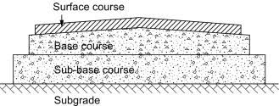

3.2 Culverts
A culvert is a structure that channels water past an obstacle or to a subterranean waterway. Typically embedded so as to be surrounded by soil, a culvert may be made from a pipe, reinforced concrete or other material. In the United Kingdom, the word can also be used for a longer artificially buried watercourse.

Materials for Culvert Construction
Culverts are like pipes but very large in size. They are made of many materials like
- Concrete
- Steel
- Plastic
- Aluminum
- high density polyethylene
In most cases concrete culverts are preferred. Concrete culverts may be reinforced or non-reinforced. In some cases culverts are constructed in site called cast in situ culverts. Precast culverts are also available. By the combination above materials we can also get composite culvert types.

Types of Culverts
Following are the types of culverts generally used in construction:

1. Pipe Culvert (Single or Multiple)
Pipe culverts are widely used culverts and rounded in shape. The culverts may be of single in number or multiple. If single pipe culvert is used then larger diameter culvert is installed. If the width of channel is greater than we will go for multiple pipe culverts. They are suitable for larger flows very well. The diameter of pipe culverts ranges from 1 meter to 6m. These are made of concrete or steel etc..

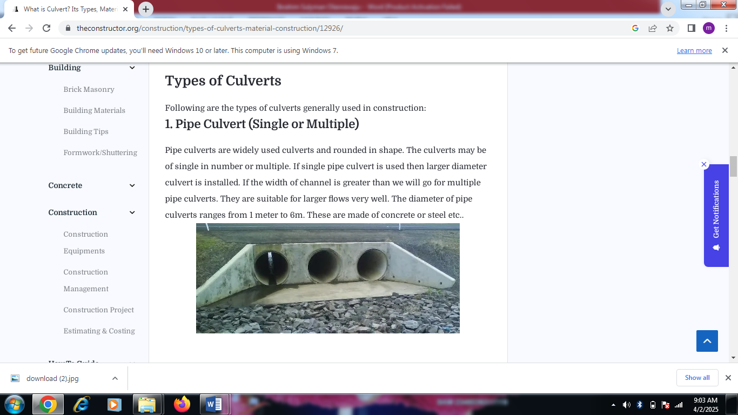

2. Pipe Arch Culvert (Single or Multiple)
Pipe arch culverts means nothing but they looks like half circle shaped culverts. Pipe arch culverts are suitable for larger water flows but the flow should be stable. Because of arch shape fishes or sewage in the drainage easily carried to the outlet without stocking at the inlet or bottom of channel. This type of culverts can also be provided in multiple numbers based on the requirement. They also enhance beautiful appearance.

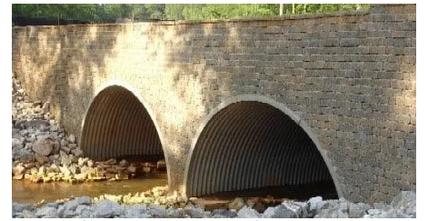

3. Box Culvert (Single or Multiple)
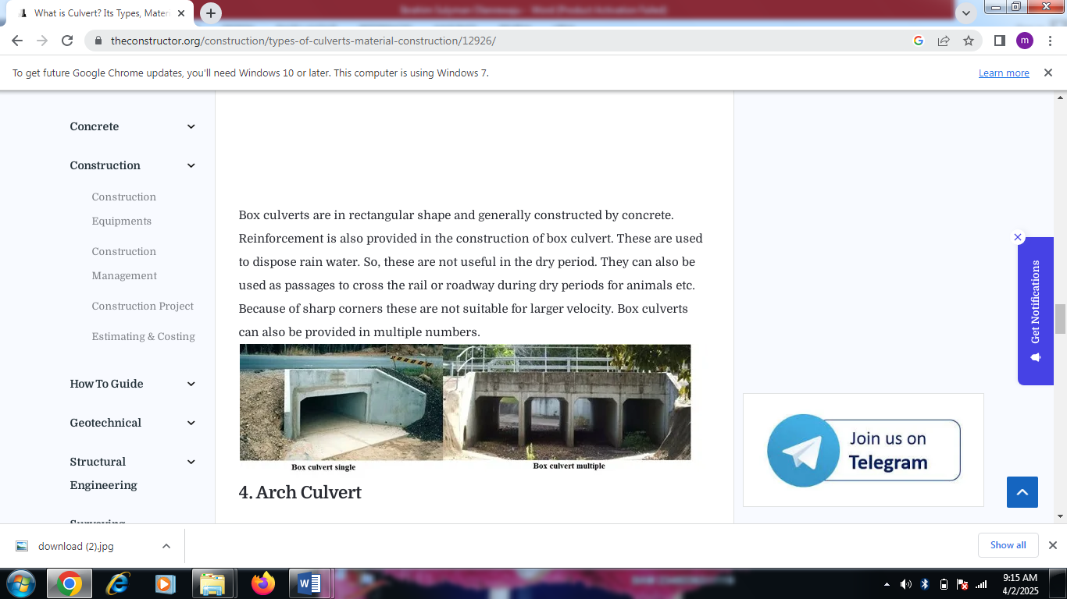
Box culverts are in rectangular shape and generally constructed by concrete. Reinforcement is also provided in the construction of box culvert. These are used to dispose rain water. So, these are not useful in the dry period. They can also be used as passages to cross the rail or roadway during dry periods for animals etc. Because of sharp corners these are not suitable for larger velocity. Box culverts can also be provided in multiple numbers.

4. Arch Culvert
Arch culvert is similar to pipe arch culvert but in this case an artificial floor is provided below the arch. For narrow passages it is widely used. The artificial floor is made of concrete and arch also made of concrete. Steel arch culverts are also available but very expensive.

5. Bridge Culvert
Bridge culverts are provided on canals or rivers and also used as road bridges for vehicles. For this culverts a foundation is laid under the ground surface. A series of culverts are laid and pavement surface is laid on top this series of culverts. Generally these are rectangular shaped culverts these can replace the box culverts if artificial floor is not necessary.
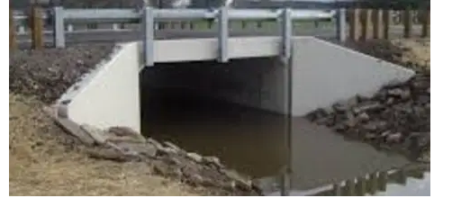

3.3 Reinforcement Concrete
Reinforcement in the shape of the drainage channel (when you cut a section through the channel). Example, for a rectangular open drain, our reinforcement will be like “U” shape and then we control the reinforcement to be at the center of concrete during casting (I.e. reinforcement will be at the center of right wall, it will be at the center of left wall, and center of drain fall) to prevent corrosion of the reinforcement.

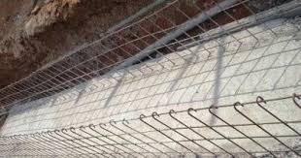

Construction of Reinforced Concrete Drainage
3.4 STRIP FOUNDATION
The majority of buildings up to two storey in height have strip foundation , in which a continuous strip of concrete provides a continuous ground bearing under the load bearing walls. This type of foundation is placed centrally under the walls and is generally composed of plain concrete often to a ratio of 1:3:6 by volume i.e 1 part of cement, 3 part of sand and 6 parts of coarse aggregate, usually gravel , with thethickness being not less than the projection of foundation and in no case less than 150mm.
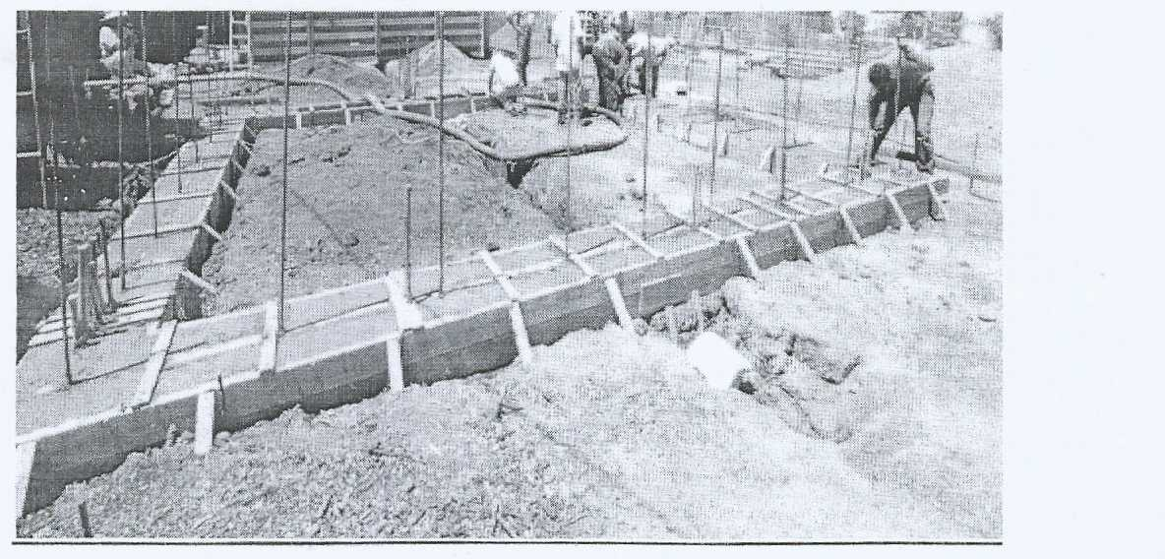

RAFT FOUNDATION
This cover the whole area of the building and usually extended beyond it. it consists primarily of a reinforced concrete slab up to 300mm thick which is often thickened under load bearing walls. The level of the base of the raft is usually within 300mm of the surface of the ground and the reinforcement is often in the form of two layers offabric reinforcement one being near the top and the other near the bottom of the slab.
Raft foundations are best suited for use on soft natural ground or fill or on ground that is liable to subsidence as in mining areas.
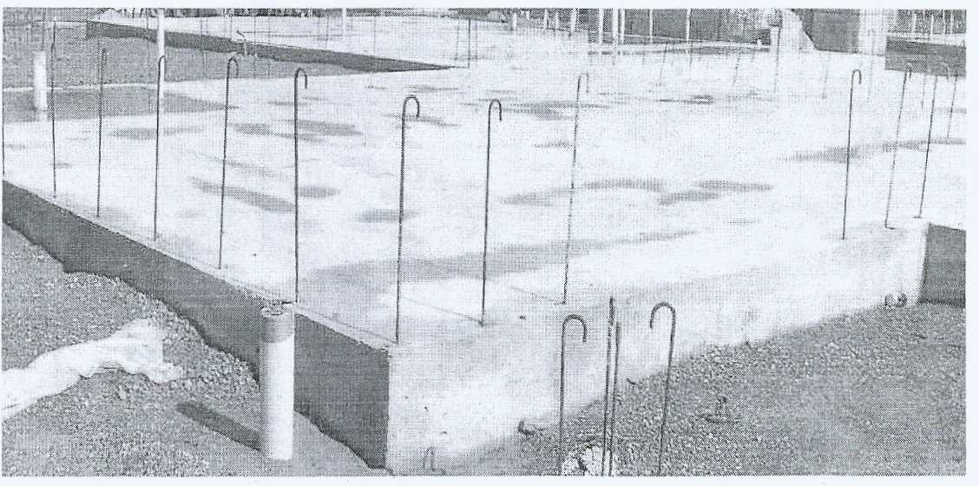

PAD FOUNDATION
These are isolated foundation to support columns,the column load plus the weight of the foundation by the allowable bearing pressure ground. The thickness of the foundation must not be less than the projection from the column (unless reinforced) and must in no case be less than 150mm , the size of foundation can be reduced by providing steel reinforcement towards the bottom of the foundation running in both in directions.

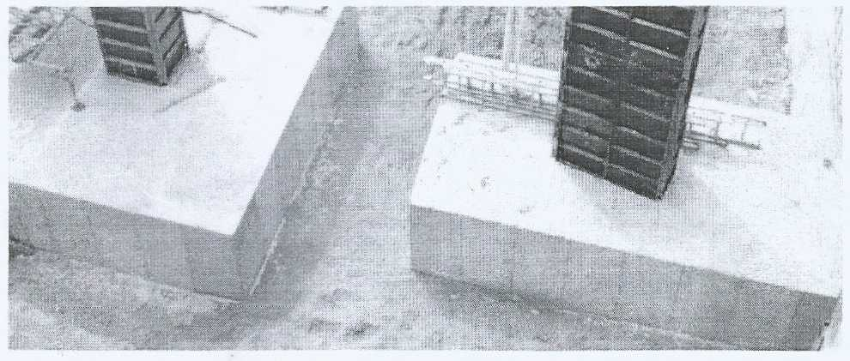
PILE FOUNDATION
The word pile is used to describe columns usually of reinforced concrete , driven or cast into the ground in order to carry foundation loads to some deep underlying firm stratum or to transmit loads to the soil by friction of their surfaces in con tact with the soil, The piles are classified by reference to the way in which they mainly transmit load to the sub soil or by the way in which they are placed.
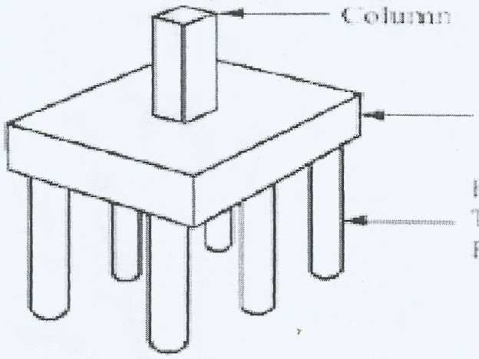
Various Personal Protective Equipment


Helmet goggles coat boat gloves ear protector


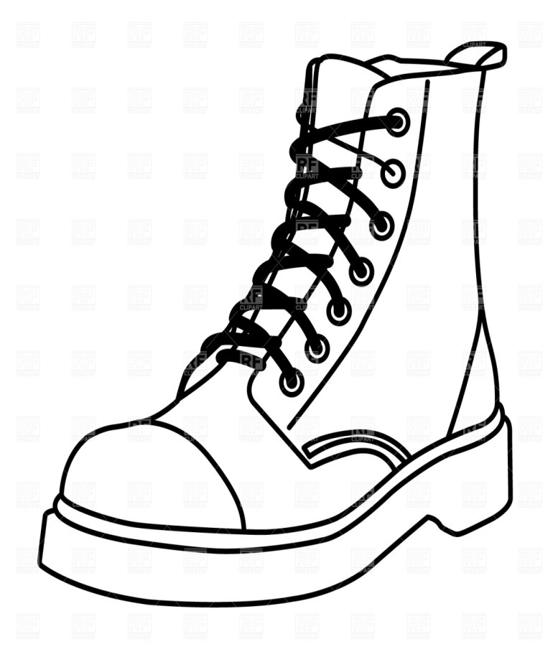

Helmet Goggles Gloves Coat

CHAPTER FOUR
EXPERIENCED GAINED
In summary, this program has exposed me to some practical aspect in relation to my course of study (Civil Engineering) and I benefitted greatly from the program. What I learnt at various site involves the following
- Civil Engineering construction
- Civil Engineering material management
- Civil Engineering building and highway set up

CHAPTER FIVE
5.0 CONCLUSION
The organisation to which i was attached gave me more impression about my course of study. The engineers are hard-working, they always in team which make the organisation. I am also impressed about the way they always plans their work which make thing easier and faster. Also the industrial based supervisor on student industrial work experience scheme programme always give special assistance to the SIWES student for them to archived their goals.
5.2 RECOMMENDATION TO THE INSTITUTION ON SIWES PROGRAMME
I will suggest that the institution should be make sure each student on SIWES programme is attached to an organisation which is relevant to their cause of study so as to achieved their goal after the programme. More so the institution should find a way of amending the period of SIWES programme so that it will not affect the school academic calendar. The institution should also give proper enlightenment to student for them to know that SIWES is all about and for them to behave and their industrial attachment. Also the institution supervisor should always visit student at their industrial attachment places for proper checking, balance and punctuality to the organisation.

