
TECHNICAL REPORT
ON
STUDENT INDUSTRIAL WORK EXPERIENCE SCHEME
(SIWES)

HELD AT

ABDUL SULE & CO. OPPOSITE TUYIL PHARMARCEUTICAL INDUSTRY LIMITED, NEW YIDI ROAD, ILORIN, KWARA STATE

BY

Badmus khaleed ayomide
ND/23/ETM/FT/0078

SUBMITTED TO
THE DEPARTMENT OF ESTATE MANAGEMENT & VALUATION, INSTITUTE OF ENVIRONMENTAL STUDIES (I.E.S)
KWARA STATE POLYTECHNIC, ILORIN
IN PARTIAL FULFILMENT OF THE REQUIREMENTS FOR THE AWARD OF NATIONAL DIPLOMA (ND) IN
ESTATE MANAGEMENT AND VALUATION
CERTIFICATION
This is to certify that the bearer has successfully completed the Student Industrial Work Experience (SIWES).

Department Coordinator Date

SIWES Director Date

DEDICATION
This Technical report is dedicated to the Almighty Allah for His mercies and loving kindness which endures forever. It is also dedicated to my beloved Parents; Mr. and Mrs. Badmus.

ACKNOWLEDGEMENTS
In the course of executing this work, I received a lot of help in various forms from many individuals and organizations. I hereby express my profound gratitude to them.
Firstly, my sincere recognition goes to the Principal Consultant of ABDUL SULE & CO. in person of ESV SULE AYINLA ABDUL (ANUS/RSD) for his inspiration, constructive criticisms and materials supplied.
My cogent and deep appreciation goes to my parent for their effort both financially and morally to see that I have succeeded through all the odds and even to the attainment of my ambitions. it's my usual and special prayer that Allah SWT should give peaceful long life to my parent so that they would be able to reap the fruit of their labour.
I also extend my appreciation to my Department SIWES Supervisor.

TABLE OF CONTENTS
Cover Page i
Certification ii
Dedication iii
Acknowledgement iv
Table of contents v
Chapter One
1.0 Introduction 1
1.1 Overview of ITF 2
1.2 Definition of Siwes 2
1.3 Aims of Siwes 3
1.4 Objectives of Siwes 3
1.5 Benefits Derived from Siwes 4
1.6 History of Siwes 4
Chapter Two
2.0 Brief Company Profile 7
2.1 Introduction 7
2.2 Company Head Address 7
2.3 Organizational Structure 8
Chapter Three
3.1 Services Rendered by the Firm 9
3.1.1 Property Valuation 9
3.1.2 Property Agency 12
3.1.3 Roles of An Estate Agent in A Property Management 12
3.1.4 Property Management 13
3.1.5 Feasibility and Viability Studies 14
3.1.6 Property Rating and Assessment 15
3.1.7 Processing of Certificate 15
3.1.8 Property Investment, Development and Project
Management 15
Chapter Four
4.0 Experience Acquired 16
4.1 Agency/Sourcing for Property 16
4.2 Methods of Sourcing Tenant 16
4.3 Facility Management 16
4.4 Property Management 17
4.5 Service Charge 17
4.6 Routine Management Inspection 18
4.7 Valuation Inspection 18
4.8 Inventory Taking 19
4.9 Constructional Details 19
4.10 Computation in Valuation Report 19
4.11 Autocad 20
Chapter Five
5.0 Summary 24
5.1 Recommendation 24
5.2 Conclusion 25
CHAPTER ONE
  - Introduction
The Students Industrial Work Experience Scheme (SIWES) is a skill training program designed to equip and prepare students of universities and other tertiary institutions for the Industrial Work situation they are likely to come across after graduation. It is also a planned and structured program based on stated and specific career objectives which are geared towards developing the occupational competence of participants (Mafe, 2009). Consequently, the SIWES program is a compulsory graduation requirement for all Nigerian university students offering certain courses.
The Students Industrial Work Experience Scheme (SIWES) is the most accepted training program, which is part of the approved and considered Minimum Academic Standard in the various degree programs for all Nigerian Universities. The scheme is basically aimed at bridging the existing gap between theory and practice of Sciences, Agriculture, Medical Sciences (including Nursing), Engineering, Environmental Sciences and Technology, Management, Information and Communication Technology and other professional educational programs in the Nigerian tertiary institutions. (Duration: Four months for polytechnics and colleges of Education, and six (6) months for universities). Also, it is aimed at exposing students to machines and equipment, professional work methods/ethics and ways of safeguarding the work areas and workers in industries, offices, laboratories, hospitals and other organizations. Prior to establishing the Scheme, industrialists and other employers of labor felt concerned that graduates of Nigerian Universities were deficient in practical background knowledge preparatory for employment in Industries and other organizations. The employers thus concluded that the theoretical education being received in our higher institutions was not responsive to the needs of the employers of labor.
The fundamental reasons or purpose of SIWES is to expose students to machines and equipment and to equip students for future employment in the chosen discipline of their undergraduate studies.
The scheme is a tripartite program involving the students, the universities and the employers of labor. It is funded by the Federal Government and jointly coordinated by the Industrial Training Fund (ITF) and the National Universities Commission (NUC).
  - Overview of ITF
Student Industrial Work Experience Scheme (SIWES) has a valuable asset of our learning because it enhances and provides a practical training field of a student. The SIWES aim was to introduce student in part of practical that he compiled which may not be available in the institutions.
It also expose student to the Industrial situation that they likely face after graduation. This scheme also exposes students to know how to handle equipment that may not be available in educational institutions and to equip them with necessary notation and capabilities to specific system requirements and prove that these requirements are fulfilled by practical implementation. Finally it serves as a good training and preparation for future careers.
  - Definition of S.I.W.E.S
S.I.W.E.S can be simply be defined as an academic exercise which serves as an assignment to all students and it is part of the requirement for the award of certificate in all Universities, Polytechnics, as well as Colleges of educations.
It provides an opportunity to the student to interact with industrial working environment where ever they find themselves and also to enable the student to acquire practical skills.
  - Aims of S.I.W.E.S
    - SIWES prepare the student for a business oriented organization, theoretical knowledge and practical experience.
    - To improve the student on their relevant practical aspect of expectation.
    - Enables the student to gain the necessary practical experience and skills in order to be conversant with their course of study.
    - The student will know how to communicate with responsible people.
    - To improve the student on human relation with their colleagues during the training.
  - Objectives of SIWES
- Making transition from school to the world of work easier and enhance student’s contacts for later job placement.
- Providing students with opportunity to apply their knowledge in real work situations thereby, bridging the gap between theory and practice.
- Enlisting and strengthening employer’s involvement in the entire educational process and preparing students for employment in industry and commerce.
- Providing avenue for student in institution of Higher learning to acquire industrial skills and experience.
- Preparing students for industrial work situation they are likely to meet after graduation.
- Exposing students to work method and techniques in handling equipments and machinery that may not be available in their intuition.
  - Benefit Derived From SIWES
- SIWES enables me with an opportunity to apply my theoretical knowledge acquired in the class to real life situation.
- It exposes me to more practical work method and techniques.
- It gives me an insight of the job prospect that are available in my profession
- It also Prepare me to face the labor market after graduation.
  - History of ITF
SIWES was established by ITF in 1973 to solve the problem of inadequate practical skills preparatory for employment in industries by Nigerian graduates of tertiary institutions.
The scheme exposes student to industry based skills necessary for smooth transition from classroom to the world of work. It affords students of tertiary institution the opportunity of being familiarize and exposed to the needed experience in handling machinery and equipment which are usually not available in the educational institutions. Participation in SWIES has become a necessary pre-condition for the award of Diploma and Degree certificates in specific disciplines in most institutions of higher learning in the country, in accordance with the education policy of government.
Organizations Involved in the Management of SIWES Programme and Their Roles
The Federal Government, the Industrial Training Fund (ITF), the Supervising Agency, National Universities Commission, NUC, Employers of labor and Institutions have specific roles to play in the management of SIWES. The roles are:
The Federal Government
To provide adequate funds to the ITF through the Federal Ministry of Industry for the scheme;
To make it mandatory for all ministries, companies and Parastatals to offer places to students in accordance with the provisions of Decree No. 47 of 1971 as amended in 1990;
Formulate policies to guide the running of the scheme nationally. THE INDUSTRIAL TRUST FUND (ITF)
This agency is to;
- Formulate policies and guidelines on SIWES for distribution to all the SIWES participating bodies;
- Provide logistic material needed to administer the scheme;
- Organize orientation program for students prior to attachment;
- Provide information on companies for attachment and assist in industrial placement of students;
- Supervise students on Industrial attachment;
- Accept and process Master and Placement lists from institutions and supervising agencies;
- Vet and process students’ log books and ITF Forms.
The Supervisory Agencies (NUC, NBTE, NABTEB, etc)
- To vet and approve Master and Placement lists of students from participating and forward same to ITF;
- Fund SIWES Directorate adequately in participating institutions;
- To ensure the establishment and accreditation of SIWES unit/Directorate in institutions under their jurisdiction; To direct for the appointment of full-time
- SIWES Coordinator/Director;
- Review program qualified from SIWES regularly

CHAPTER TWO
  - Brief Company Profile
  - Introduction
ABDUL SULE & CO. is a firm of qualified and experienced Estate Surveyors and Valuers registered under the Companies and Allied Matters Decree of 1990, Serving Industry, Commerce, Governments and Individual Persons or Groups. The firm was established with Corporate Head Office in Kwara and branches in Kebbi, Kogi, Lagos, Yobe, Bauchi, Gombe and Zamfara states. The firm, as a Corporate Member of the Nigerian Institution of Estate Surveyors and Valuers (NIESV) Established by Decree Number 24 of 1975, is also registered by the Estate Surveyors and Valuers Registration Board of Nigeria (ESVARBON). The firm is forward looking, committed to consistently achieving the highest standards of service and professionalism in the whole diverse range of Property Services. The firm’s Specialist Professional Departments are growing strongly based on the principles of professionalism which are aimed at satisfying the needs of clients in all property matters, including property skill development and education. The firm’s pool of skilled, knowledgeable and experienced staff makes it possible to view projects from wide range of angles approaching them with broad mission.
  - Company Head Address:
OPPOSITE TUYIL PHARMACEUTICAL INDUSTRY LIMITED, NEW YIDI ROAD, ILORIN, KWARA STATE.
08033111900, 08099596600
WEBSITE: abdulsule@yahoo.com, b2r.bmc@gmail.com
  - Organizational Structure of the Firm/Company Organogram
Processing of Certificate of Occupancy & Land
Investment & Development Services Department
Sales, Purchase (Agency) & Acquisition Services
Valuation & Inventory Services Department
Property & Facility Mgt Services Department
Managing
Principal Consultant

CHAPTER THREE
  - Services Rendered by the Firm
The services rendered by the firm are tailored to meet the specific needs of individual clients and to deliver the required result at a competitive price. The firm have dedicated team of highly qualified professionals brings years of extensive international and national business experience together to benefit you.
The firm offers the following major services:-
- Property Valuation and Inventory for all purposes
- Property and Facilities Management
- Property Agency (Brokerage), Auctioning, Acquisition, Sales and Relocation
- Property Investment, Development and Project Management.
- Feasibility and Viability Studies
- Property Rating and Assessment
- Processing of Certificate of Occupancy and Land Documentation
    - Property Valuation
This is the art and science of determining the value of property for a specific purpose at some specific date and the monetary worth of a particular interest or right encompasses in an ownership of a property for a Valuer to Value a property. Before the value of a property can be determined the Valuer have to inspect the property.
Inspection is the act of visiting the site/ property to take certain details, which include:

      - Physical measurement of property
      - Taking constructional details
      - Taking inventory
      - Taking locational sketch and site layout sketch
      - Taking pictures
      - Noting the services available e.t.c
Materials Used For Inspection
- Measuring tape (30meter or 50meter)
- A clip file folder
- A4 Size plain white sheet of paper
- Pencil (clutch pencil preferable)
- Eraser
- Calculator
- Digital camera or a phone
Function of Valuation
Valuation seeks to provide answer to the following question:
- How much loan can I obtain from the bank using property/asset as collateral in a mortgage valuation
- How much this property/asset should be purchased if offered for sale which is the open market value
- What should I charge as rent for use of property in rental Valuation.
- How much this property should be insured? This is insurance valuation.
- What is fair claim for property that is compulsorily acquired by government agency? This is Valuation for compensation.
- What is this property worth to me personally? This is Investment valuation.
- What is the value of my real estate in my current business operation? This is going concern Valuation.
- What is my tax liability for capital gains, probate or property taxes etc? Valuation for Rating Purpose.
Types of Valuation
  - Statutory valuation
  - Non-statutory valuation
Statutory Valuation
This type of valuation is carried out in conformity with statute, i.e laid down rules and regulations stipulated in the law guiding them. This is when a statute specifies the method that should be adopted in carrying out valuation for example when a government takes over possession of another person for overriding public interest like (provision of road, hospitals, schools, market etc for public use). In this case the service of the Valuer is needed for compensation.
Non-Statutory Valuation
This type of valuation is carried out without statutory laid down rules (law) guiding them. It is valuation carried out on a natural event for individual or cooperate bodies to determine open market value, mortgage, insurance etc.

Method of Valuation
    - Contractors or Cost method
    - Investment or Income method
    - Residual or Development method
    - Profit or Account method
    - Comparative or Market approach method
    - Property Agency
Is the act of liaising between a property owner and a purchaser or interested party whose interest is found in the property or asset of the real property owner. An Estate agent performs action according to the instruction received from the Principal. An Estate agent is sometimes regarded as the middle man between the contacts or both parties. This contract can be either in form of lease, sub-lease or outright sale or disposal of property. It is the estate agent that brings both buyer and seller together; make them agree in terms and conditions for the contract to be hold.
Need for Agency
- Problem of absentee landlord
- Technological change in building construction
- The growth of cooperate ownership in real property
- Problem of urbanization
- Tax factors
    - Roles of An Estate Agent in A Property Management
- He provide necessary information about available for transactions in a property market
- He ensures protection of the interest of both seller and buyer in a property market.
- He manages the transaction that goes between the buyer and seller of interest and also gives his professional advice to both parties.
- Apart from exploring and exposing prospects for classes of buildings, he also observes and monitors the activities going on in a property market.
    - Property Management
Property Management is said to be one of the most challenging aspect of Estate Management.
Property Management is the application of skills in the curing of a property, its surrounding & amenities in developing a sound relationship between the tenant and the landlord and between tenants so that a property can give its fullest benefit value to both the landlord and the tenants.
However, Sango Sanya (1986) defined property management as a profession and as a business. As a profession because it involves acquisition of knowledge and special skills in a particular field of endeavor. As a business because it is about the management of resources for the attainment of targeted goals and objectives.
Function of an Estate Manager
- Negotiation of terms and conditions with tenants
- Periodic inspection of the premises
- Liaising with client solicitors in advising on the appropriate lease agreement
- Periodic collection of rent and rendering same to client
- Dealing with branches in lease agreements
- Attending to tenant complaints
- Dealing with matters requiring landlord’s attention
- Disbursement of necessary outgoing on time
- Arrangement of renewal extension or surrender of leases
- Advising an adequate insurance policy
- Designing and supervising of progressive maintenance program
- Keeping proper record and accounts including capital and revenue account and budget
- Estimating capital value of property being managed; where the value’s client is a corporate body with lots of assets, like building ,land, plant and machinery
    - Feasibility and Viability Studies
We carry out feasibility and viability studies for proposed development ranging from private residential building to large industrial estates. This involve cash flow forecast, cost benefit analysis, comparison of profit margins etc. This is done to determine the practicability and profitability of the project. It also gives the developer or promoter the opportunity to choose between alternative developments.
It equally determines the type of development to which a particular piece of land could be putting and the intensity of use. Our reports are generally used by clients for critical cost benefit decision before embarking on project
    - Property Rating and Assessment
This is the act of Estate Surveyors to asses an income generating property for taxation. The estate surveyors assess the property and determine the amount that the government charges on that property.
    - Processing of Certificate
The Estate Surveyors act to assist a client that wants to acquire the Certificate of occupancy (C of O). Whereby the Estate Surveyors checks his client document to make sure the documents is up to date. If it is not, the estate surveyors try to update his client’s document.
3.1.7 Property Investment, Development and Project Management
The Estate Surveyors give advice to his/her client on how to invest in his/her property, where he/she can build or react a building that will earn him/her income flow.

CHAPTER FOUR
- Experience Acquired
  - Agency/Sourcing for Property: It is the art of liaising among two parties that agree on a transaction of an interest in land and landed property either by outright assignment or the creation of an interest in the form of lease or term of year. This involves a situation whereby a firm goes to another firm to seek or search for vacant property for sales or to let for his client.
I was sent by my industrial based supervisor to scout for 3 bedroom and 2 bedroom flat respectively in various firms which I went to Wole Kajola & associate, Bunmi Ogundiya & co, Hassan Baba & Co, Aminu & partners, Lord Maseli and Partners and A.A Abraham & Co.
  - Methods of Sourcing Tenant:
    - World wide web
    - Billboard
    - Personal contact
    - Newspaper
    - Bulletin.
  - Facility Management: IFMA defined Facility Management as involving the task of design, construction, maintenance and management of the physical environment as it relates to the work process.
Facilities Management involves the entire building as a whole, its structures, fabrics, component, services, space dimension, storey height and its special attachment from substructure to the apex superstructure.
I participated in the inspections and maintenance of facilities of several properties under our firm management portfolio.
  - Property Management: Property Management is the application of skills in the curing of a property, its surrounding & amenities in developing a sound relationship between the tenant and the landlord and between tenants so that a property can give its fullest benefit value to both the landlord and the tenants.
However, Sango Sanya (1986) defined property management as a profession and as a business. As a profession because it involves acquisition of knowledge and special skills in a particular field of endeavor. As a business because it is about the management of resources for the attainment of targeted goals and objectives.
I participated in inspection and management of properties managed by our firm to check if there is need for repairs or replacement of facilities in the properties to ensure that it is in habitable and tenantable condition
I also participated actively in the typing of letter of quick notice, reminder’s letter and rent renewal letter for rent.
  - Service Charge: Is the amount of money paid by the tenant to the estate surveyor and Valuer for the services he/she enjoyed in the property and so as to maintain the property in a habitable and tenantable condition.
The services include:
- Air conditioning
- Lift/Elevator or escalator
- Security
- Cleaning
- Firefighting equipment such as fire extinguisher, water sprinkler and sand.
WAYS/ METHOD OF APPORTIONING SERVICE CHARGE
- Flat rate
- Percentage of rent paid
- Percentage of Space occupied.
- Rateable value
  - Routine Management Inspection: This are activities to be carried out from time to time which includes Rent collection, Record keeping, Remittance of proceeds that accrued from the property, periodic inspections to ensure or ascertain whether there is a breach of covenant by the tenant occupying the subject property.
While in Bature Muhammad and Co. I alongside my IT colleagues actively participated in inspection of properties managed by the firm to check if there is need for repairs or replacement of facilities, or alterations in the properties so as to ensure that the properties are in habitable and tenantable condition.
  - Valuation Inspection: This is the process whereby an estate surveyor goes for inspection, to take measurement of landed property. The full details of valuation inspection which involve; Constructional details, sketching of the site layout, floor plan and locational sketch of the property which will be use in preparing the valuation report. I participated fully in Tape reading, handling and measuring.
  - Inventory Taking: This is an act of taking a complete list of items in a building to determine the value of the property. Inventory for purpose of valuation includes furniture, fixtures, fittings, plants and machinery to know the worth of the property.
I participated in taking inventory of assets of Messrs Bature Muhammad and Co. Estate Surveyors and facilities Managers located at No 5D, Kanta Road Kaduna state.
  - Constructional Details: This is the act of taking the details of the kind of materials used in the construction of a building. Such as the kind of material used in floor, the kind of material used in wall, the kind of door, window, ceiling and roof of the building.
During my training, I participated in taking constructional details of several properties inspected with my industrial based supervisor.
  - Computation In Valuation Report: This is an act or method Involved in computation or analysis of valuation report.
I participated in calculating the gross floor area (GFA), Net floor area (NFA), and summing of the current value (CV) and force sales value (FSV) of various schedules.
34.23m

412.47m²

12.05m

Solution
Gross Floor Area= L X B
=34.23 X 12.05
=412.47m2
  - AutoCad: This is a commercial computer-aided design and drafting software application. And its use to develop a design plan of buildings.

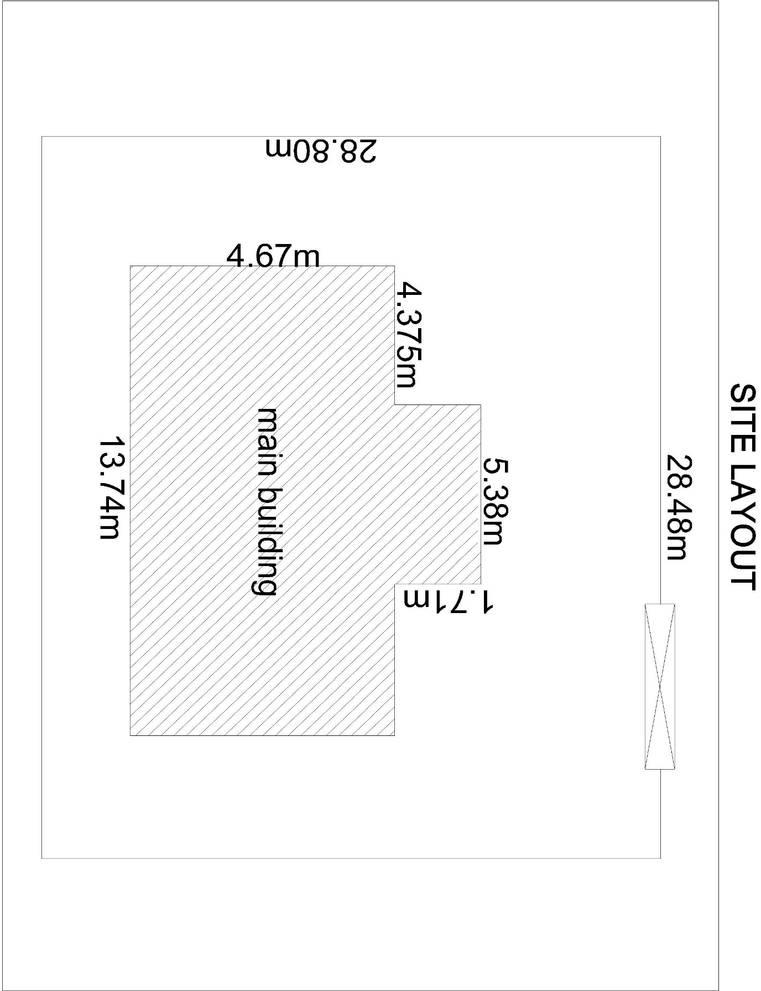

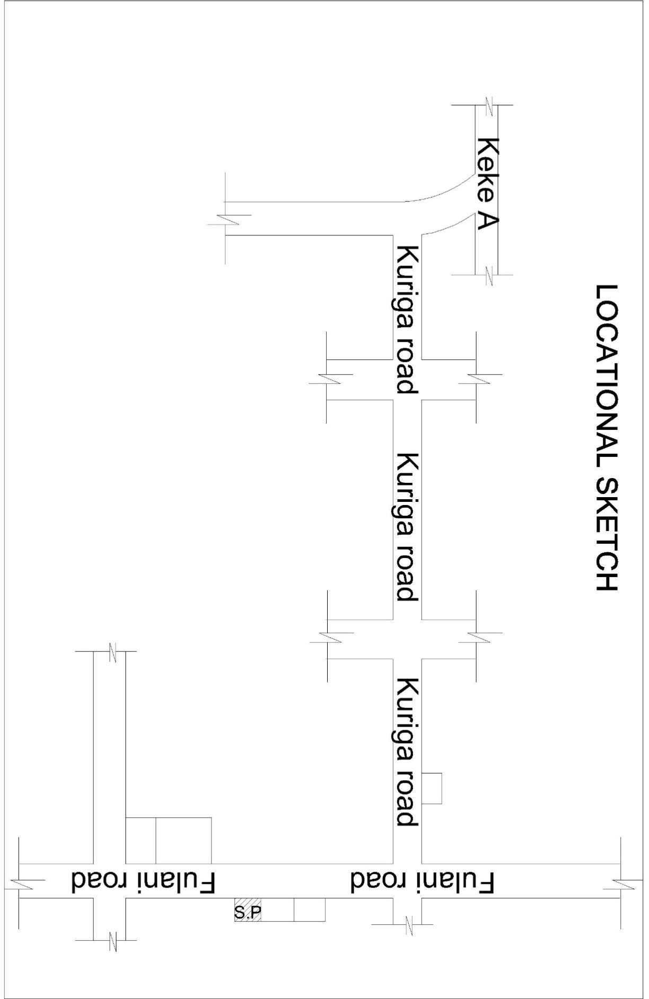

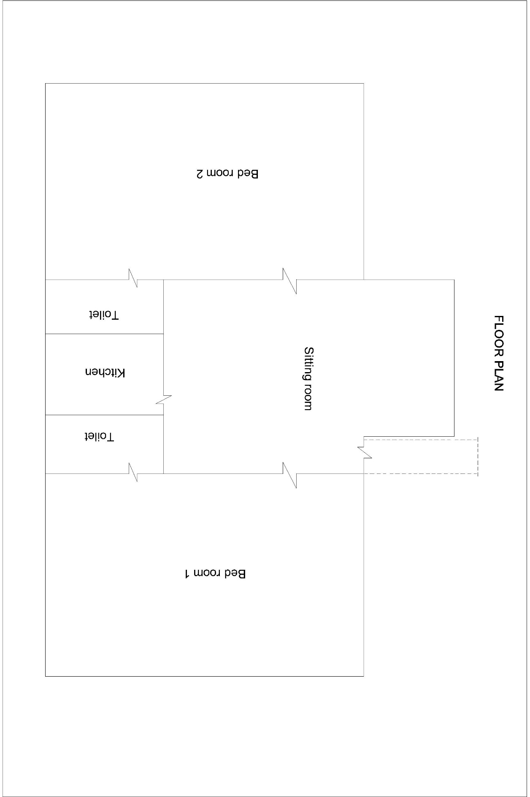

CHAPTER FIVE
- Summary
In summary of the course of my SIWES for six (6) month with MESSRS BATURE MUHAMMAD AND CO. No 5D Kanta road Kaduna State, I acquired the experience of valuation inspection (for Land and building, furniture’s fixtures and fittings), agency & sourcing for property, property Management, service charge, taking inventory/constructional details of a property as well as computation in valuation report.
And generally I also have the knowledge on how to be smart, hardworking, committed, diligent and punctual and above all I also learnt how to communicate, how to tolerate as well as how to accommodate one another.
  - Recommendation
- I so recommend that the Department should make a move to assure that the students have choosing the right and reliable firm for their Industrial training (IT), so that the aim of the program can be ascertain.
- I also recommend that unauthorized Engineers, lawyers, Quantity Surveyors, local agents, and other bodies that encroach into our profession and acted as an estate surveyors and Valuers should be stopped because they demand more than 10% for agent fees.
- Finally I will also recommend that firms and organization should try to provide allowance for I.T students because most of us student encounters lots of challenges when it comes to transporting ourselves to our various PPA.

  - Conclusion
In Conclusion, as a Student of Estate Management, I have been able to obtain the most relevant and effective practical training and experience during the period of my attachment, having been exposed to practical on site situations and Office activities.
This industrial training gave me the opportunity to know more on how practical Estate Management looks like and it also exposed me to many things that are involved. In a nutshell, this program helped me to understand that lawyers also act as an Estate Agents.

