

A TECHNICAL REPORT ON
STUDENT INDUSTRIAL WORK EXPERIENCE SCHEME (SIWES)

HELD AT
SOBI 101.9 FM
OFF SHAO ROAD SOBI AREA, ILORIN, KWARA STATE.

BY

ALAWODE USMAN OLADIMEJI
MATRIC NO: ND/23/MAC/PT/0323

SUBMITTED TO
DEPARTMENT OF MASS COMMUNICATION, INSTITUTE OF COMMUNICATION TECHNOLOGY (I.I.C.T)
KWARA STATE POLYTECHNIC, PMB 1375 ILORIN KWARA STATE

AUGUST – NOVEMBER, 2024.
DEDICATION
This report is dedicated to Almighty Allah for making everything easy for me throughout my Student Industrial Work Experience Scheme (SIWES) programme and to my parent Mr & Mrs ALAWODE for their contribution to the success of this project. May Almighty God give you long life and prosperity (Amen).

ACKNOWLEDGEMENT
All praise, glory, honour and adoration to Almighty Allah the author and the giver of wisdom, knowledge and understanding for the success of this programme.
I appreciate my parents which are my source to this world Mr & Mrs ALAWODE for their parental and spiritual support because without their maximum understanding and support, this experience would have not come into existence including my brother and sister for their support.

PREFACE
The Student Industrial Work Experience Scheme (SIWES) is a National Diploma Curriculum of the Department of Mass Communication, Kwara State Polytechnic Ilorin.
The programme was established by the Industrial Training Fund (ITF) in 1973 to 1974. It is designed to acquire the student with life situation in industries as well as supplies in a more practical manner and their knowledge in practical activities and other practical field during their course of study.

CHAPTER ONE
INTRODUCTION
1.1 ABOUT SIWES
SIWES stands for acronym for Student Industrial Work Experience Scheme.
The Student Industrial Work-Experience Scheme (SIWES) is a planned and supervised training intervention based on stated and specific learning and career objectives, and geared towards developing the occupational competencies of the participants. It is a programme required to be undertaken by all students of tertiary institutions in Nigeria pursuing courses in “specialized engineering, technical, business, applied sciences and applied arts”. The federal government on 8th October 1971 established the industrial training (ITF) in order to acquaint the students on the industrial work method. The SIWES which is a subsidiary formed in 1973 was initiated to improve the students’ technical abilities to expose them to industrial culture thereby getting the acquainted with the role to play towards the technological advancement of the nation. It creates an avenue on environment in which the students are being exposed to areas of their various disciplines which enhances their mental and creative minds in the aspects of technology and development. . It creates an avenue on environment in which the students are being exposed to areas of their various disciplines which enhances their mental and creative minds in the aspects of technology and development. It is therefore a practical aspect of the academic work, which students may not be opportune to carry out throughout their stay in the higher institution.
1.1 IMPORTANCE AND OBJECTIVES OF SIWES
The Students Industrial Work Experience Scheme (SIWES) is the accepted skills training programme, which forms part of the approved minimum academic standards in the various degree programmes for all the Nigerian universities. It is an effort to bridge the gap existing between theory and practice of engineering and technology, science, agriculture, medial, management and other professional educational programmes in the Nigerian tertiary institutions. It is aimed at exposing students to machines and equipment, professional work methods and ways of safe-guarding the work area s and workers in industries and other organization.
1.2 OBJECTIVES OF SIWES
Specifically, the objectives of the students’ industrial work experience scheme are to
- Prepare students for the work situation they are likely to meet after graduation.
- Provide an avenue for students in the Nigerian Universities to acquire industrial skills and experience in their course of study.
- Make the transition from the university to the world of work easier, and thus enhance students’ contacts for later job placements;
- Enlist and strengthen employers’ involvement in the entire educational process of preparing university graduates for employment in industry.
- Provide students with an opportunity to apply their theoretical knowledge in real work situation, thereby bridging the gap between university work and actual practices; and Expose students to work methods and techniques in handling equipment and machinery that may not be available in the universities.
1.3 IMPORTANCE OF SIWES
- It provides students with an opportunity to apply their theoretical knowledge in real life situations.
- It exposes students to more practical work methods and techniques.
- It strengthens links between the employers, universities and industrial training fund (ITF)
- It also prepares the students for the labour market after graduation.

CHAPTER TWO
HISTORICAL BACKGROUND OF SOBI 101.9 FM STATION
Sobi FM Ilorin is an indigenous radio station based in the city of Ilorin, Kwara State, Nigeria. The radio station broadcasts on a frequency of "101.9 Mega Hertz". The radio station was established on 10 July 2017. Sobi FM Ilorin is located on top of Sobi Hill, about 390 meters above sea level, the commissioning ceremony of this new radio station, SOBI FM 101.9FM, on this truly historic site in our hometown of Ilorin. Those of us who are genuine sons and daughters of this community, know the importance of this hill, in our history, culture and identity. It is only a bona fide child of the Ilorin community, that could have been sufficiently inspired, not only to dream at the height that midwifed this new radio station, but to also find the remarkable inspiration of patriotism and love of our community, to choose the name of our hill, as well as its location, for an endeavor, as grand as SOBI FM 101.9. These are worrisome times, when what seems to be the common theme is to just take away from our communities; so we must be very proud of the fact, that Lukman Mustapha, has baulked the trend. He showed his genuine love for our hometown and our state, by coming to put in an investment of this magnitude, in Ilorin.
This humble, sincere and innocent efforts, has made them see him and the new radio station SOBI 101.9 FM as a big threat to their selfish political ambitions and has therefore resulted to cheap blackmail. Ironically, this new media outfit situated in his home state and specifically, his country home, Ilorin, is another pointer that the Mallam Lukman Mustapha is a die-hard lover and believer in Ilorin and kwara as a whole.
The radio station is a pride to all true born of ilorin emirate and kwara state as a whole, this is the first radio station to be owned by bonafide offspring of Sheikh Alimi. How else can one prove his love and affection for his kinsmen than bring home multi-million naira investment, which has helped placed the historic Sobi hill on the lips of all and sundry Nationwide.
All true sons of ilorin knows the attachment Ilorin emirate has with SOBI hill, therefore, it was well thought out by Mallam Lukman Mustapha to situate this ultra-modern station on top the hill. This radio station is not just here to entrench information balance and enhance social awareness, but also stimulate economic activities through the creation of employment opportunities for our Army of unemployed youths and other operational externalities.
This station couldn’t have come at any other time than now, when social vices is at its peak in Ilorin metropolis, thereby robbing us of our values and respect as the bastion of peace and strict adherence to Islamic tenets.
It should be on record that as a Kwaran and seasoned banker whom has served in the capacity of Regional Manager (South west) covering Kwara, Ekiti, among others, whatever relationship that might have existed between Mall Lukman Mustapha and Kwara state government and its agents was purely official and not personal nor shady.
Mall Lukman Mustapha has been a revered professional with an unblemished record of excellence and any attempt to discredit his humble personality by linking him or his business to any politician or political office holder is an abuse to the sensibilities of all well meaning ilorite.
The incorporation records are at the Corporate Affairs Commission for whoever wishes to authenticate the fact as against the malicious inuendos being circulated against Sobi FM and its Boss by some enemy of ilorin and progress. We’ve unmasked the personality of those behind the charade, we enjoin them to desist from soiling the name of prominent ilorites, else they meet their Waterloo. We also use this opportunity to advise other privileged Sons and daughters of ilorin not to be discouraged by this malicious column, as we won’t hesitate to tackle fronterly anybody or group of persons that form clog in the wheel of progress of the development of Ilorin Emirate.

ORGANIZATIONAL CHART
GENERAL MANAGER
Director of New
& Current Affairs
Corporation Secretary
Director of Programmes
Chief Administrative Officer
Siwes Trainee
Programme Manager
Finance Controller
Engineering Manager
Marketing Manager
Auditor

VARIOUS DEPARTMENTS IN THE CORPORATION
Sobi 101.9 FM radio station has various departments through which it operates it day-to-day broadcasting activities.
The corporation is divided into six broad departments, where it carryout the smooth running of its programmes and coordinating all its activities. The available departments are;
- News & Current Affairs Department
- Administrative Department
- News and Current Affairs Department
- Programme Department
- Engineering Department
- Finance and Marketing department
1. NEWS & CURRENT AFFAIRS DEPARTMENT
This is an important department in the broadcasting organization that solely responsible for the day-to-day preparation of news story report, information and current affairs for the public audience.
In Sobi 101.9 fm, this department is headed by a director and it is divided into two units viz: News unit and Current affairs unit.
- News Unit
This is the unit that solely responsible for the daily preparation of news, commentaries and broadcast it to the heterogeneous audience. They are in charge of news production and it comprise different staffs among whom the editors, reporter, proof reader, re-writers, desk-editor, news-caster and those that will align the news bulletin (from local to foreign), compu-graphist, typist, etc and it is being held by an Editor-in-Chief.
- Current Affairs Unit
This is the unit that specializes on current affairs programmes such as political talk, sport review, public enlightenment, environmental, highlight etc some of this programme are not live programme, they were recorded and played later, some of which guest were invited. After such recording, the programme is then edited by expert and producer before broadcasting.
The main objectives of this unit are to enlighten the audience more on the various issues of interest currently happening in the society.

2. PROGRAMME DEPARTMENT
This department consists of seasoned broadcasters, producers and presenters of high standard of productions. It is been divided into four different units viz: Audio Unit, Presentation Unit, Entertainment and Public enlightenment units.
- Audio Unit
This consists of Audio console operators, audio assistants, technicians, transmission directors and DJ’s who operates the audio-console and help in the smooth operation of the station programmes, either by laying jingles, public and personal paid announcement (PPA), commercial and adverts, recorded programmes, music etc. at the appropriate times and they also involved in the opening and closing of the station transmission at the end of the day programme in midnight. They usually operate and work in shifts.
- Presentation Units
This is the units that consists different skilled and seasoned presenters, announcers etc. that works in shifts.
They presented programmes, announcement etc
- Entertainment Units
This is the unit of notable entertainers, presenters, showbiz etc who organized and present entertainment programmes where music are played and sometimes audience can call in to make shout-out or greet their families and associates.
- Public Enlightenment Unit
This is the unit where public enlightenment and information where passed across to the audience by some skillful presenter and researchers who talk and discuss basically on public events and information an incident occurs in our societies to enlighten the audience.
3. MARKETING AND COMMERCIAL DEPARTMENT
As the soul of every organization, marketing and commercial department in Sobi 101.9 fm, is the department where most of the station revenue is been generated through the selling of airtime on radio, receiving adverts and commercial etc.
4. RESEARCH PLANNING LOGIC AND STATISTIC DEPARTMENT
This is department that is in charge of the station statistical plans, logic and research projects. It stands responsible for the documentation and presentation of modern and digital information materials such as Audio Compact Disc (CD) both empty and recorded, cassettes, records, newspaper, journal, magazines etc.
The department also provides a standard internet service for the station especially in the studio and newsrooms where the presenters and reporter can browse through to grab recent information needed for smooth running and delivering of standard programme on radio.
5. ENGINEERING DEPARTMENT
This is another important department that consists of the station and studio engineer, installation engineering, technicians etc whose responsibility is to provide better services to the station machineries, maintain and repair the station equipment. The department stands to put all the equipment’s in good conditions for smooth and excellent transmission of the station.
Engineers works in shift and their services round the clock rectify all fault discovered on any machineries needed for transmission and broadcasting. It is been divided into sub-unit of transmission, generating house, Radio workshop, Automobile and Air Conditioning Workshop units among others, each unit is head by a supervisor.
6. ADMINISTRATIVE DEPARTMENT
This is a newly created formed department that involves in organizing training for staffs, interview for new applicants and employees, conduct and recommends staffs for promotions, etc as well as perform corporate services.
It is also deals in maintaining standard welfare and wellbeing of the station managements and staffs. They works inter-dependent.
CHAPTER THREE
Radio
Radio is the radiation (wireless transmission) of electromagnetic energy through space. The biggest use of radio waves is to carry information, such as sound, by systematically changing (modulating) some property of the radiated waves, such as their amplitude, frequency, phase, or pulse width. When radio waves strike an electrical conductor, the oscillating fields induce an alternating current in the conductor. The information in the waves can be extracted and transformed back into its original form. Radio systems need a transmitter to modulate (change) some property of the energy produced to impress a signal on it, for example using amplitude modulation or angle modulation (which can be frequency modulation or phase modulation). Radio systems also need an antenna to convert electric currents into radio waves, and vice versa.
An antenna can be used for both transmitting and receiving. The electrical resonance of tuned circuits in radios allows individual stations to be selected. The electromagnetic wave is intercepted by a tuned receiving antenna. A radio receiver receives its input from an antenna and converts it into a form usable for the consumer, such as sound, pictures, digital data, measurement values, navigational positions, etc. Radio frequencies occupy the range from a 3 kHz to 300 GHz, although commercially important uses of radio use only a small part of this spectrum.
A radio communication system sends signals by radio. The radio equipment involved in communication systems includes a transmitter and a receiver, each having an antenna and appropriate terminal equipment such as a microphone at the transmitter and a loudspeaker at the receiver in the case of a voice-communication system.
Processes
Radio communication. Information such as sound is converted by a transducer such as a microphone to an electrical signal, which modulates a radio wave sent from a transmitter. A receiver intercepts the radio wave and extracts the information-bearing electronic signal, which is converted back using another transducer such as a speaker. Radio systems used for communication have the following elements. With more than 100 years of development, each process is implemented by a wide range of methods, specialized for different communications purposes.

Transmitter and modulation
Each system contains a transmitter; this consists of a source of electrical energy, producing alternating current of a desired frequency of oscillation. The transmitter contains a system to modulate (change) some property of the energy produced to impress a signal on it. This modulation might be as simple as turning the energy on and off, or altering more subtle properties such as amplitude, frequency, phase, or combinations of these properties. The transmitter sends the modulated electrical energy to a tuned resonant antenna; this structure converts the rapidly changing alternating current into an electromagnetic wave that can move through free space (sometimes with a particular polarization).
An audio signal (top) may be carried by an AM or FM radio wave.
Amplitude modulation of a carrier wave works by varying the strength of the transmitted signal in proportion to the information being sent. For example, changes in the signal strength can be used to reflect the sounds to be reproduced by a speaker, or to specify the light intensity of television pixels. It was the method used for the first audio radio transmissions, and remains in use today. "AM" is often used to refer to the medium wave broadcast band (see AM radio), but it is used in various radiotelephone services such as the Citizen Band, amateur radio and especially in aviation, due to its ability to be received under very weak signal conditions and its immunity to capture effect, allowing more than one signal to be heard simultaneously.
Frequency modulation varies the frequency of the carrier. The instantaneous frequency of the carrier is directly proportional to the instantaneous value of the input signal. FM has the "capture effect" whereby a receiver only receives the strongest signal, even when others are present. Digital data can be sent by shifting the carrier's frequency among a set of discrete values, a technique known as frequency-shift keying. FM is commonly used at Very high frequency (VHF) radio frequencies for high-fidelity broadcasts of music and speech (see FM broadcasting).
Analog TV sound is also broadcast using FM.
Angle modulation alters the instantaneous phase of the carrier wave to transmit a signal. It may be either FM or phase modulation (PM).
Antenna.
Rooftop television antennas. Yagi-Uda antennas like these six are widely used at VHF and UHF frequencies.
An antenna (or aerial) is an electrical device which converts electric currents into radio waves, and vice versa. It is usually used with a radio transmitter or radio receiver. In transmission, a radio transmitter supplies an electric current oscillating at radio frequency (i.e. high frequency AC) to the antenna's terminals, and the antenna radiates the energy from the current as electromagnetic waves (radio waves). In reception, an antenna intercepts some of the power of an electromagnetic wave in order to produce a tiny voltage at its terminals that is applied to a receiver to be amplified. Some antennas can be used for both transmitting and receiving, even simultaneously, depending on the connected equipment.
Resonance
Electrical resonance of tuned circuits in radios allow individual stations to be selected. A resonant circuit will respond strongly to a particular frequency, and much less so to differing frequencies. This allows the radio receiver to discriminate between multiple signals differing in frequency.
Receiver and demodulation
A crystal receiver, consisting of an antenna, adjustable electromagnetic coil, crystal rectifier, capacitor, headphones and ground connection.
The electromagnetic wave is intercepted by a tuned receiving antenna; this structure captures some of the energy of the wave and returns it to the form of oscillating electrical currents. At the receiver, these currents are demodulated, which is conversion to a usable signal form by a detector sub-system. The receiver is "tuned" to respond preferentially to the desired signals, and reject undesired signals.
A radio receiver receives its input from an antenna, uses electronic filters to separate a wanted radio signal from all other signals picked up by this antenna, amplifies it to a level suitable for further processing, and finally converts through demodulation and decoding the signal into a form usable for the consumer, such as sound, pictures, digital data, measurement values, navigational positions, etc.
Radio band
Light comparison
Name | Frequency
Gamma ray | > 30 EHz (0.01 nm) | 124 keV - 300+ GeV
X-Ray | 30 EHz - 30 PHz (0.01 nm - 10 nm) | 124 eV to 120 keV
Ultraviolet | 30 PHz - 750 THz (10 nm - 400 nm) | 3.1 eV to 124 eV
Visible | 750 THz - 428.5 THz (400 nm - 700 nm) | 1.7 eV - 3.1 eV
Infrared | 428.5 THz - 300 GHz (700 nm - 1 mm) | 1.24 meV - 1.7 eV
Microwave | 300 GHz - 300 MHz (1 mm - 1 m) | 1.24 µeV - 1.24 meV
Radio | 300 MHz - 3 kHz (1 m - 100 km) | 12.4 feV - 1.24 meV
Radio frequencies occupy the range from a 3 kHz to 300 GHz, although commercially important uses of radio use only a small part of this spectrum.Other types of electromagnetic radiation, with frequencies above the RF range, are infrared, visible light, ultraviolet, X-rays and gamma rays. Since the energy of an individual photon of radio frequency is too low to remove an electron from an atom, radio waves are classified as non-ionizing radiation.
Communication systems
A radio communication system sends signals by radio. Types of radio communication systems deployed depend on technology, standards, regulations, radio spectrum allocation, user requirements, service positioning, and investment.
The radio equipment involved in communication systems includes a transmitter and a receiver, each having an antenna and appropriate terminal equipment such as a microphone at the transmitter and a loudspeaker at the receiver in the case of a voice-communication system.
The power consumed in a transmitting station varies depending on the distance of communication and the transmission conditions.
Classical radio communications systems use frequency-division multiplexing (FDM) as a strategy to split up and share the available radio-frequency bandwidth for use by different parties’ communications concurrently.
Coverage
There are several factors influencing the coverage area:
- Location of the transmitter in relation to the desired coverage area
- Type and ‘pattern’ of the transmitting aerial
- Height of the transmitting aerial
- Power of the transmitter (and this is regulated in most countries)
- Terrain (how hilly is the area to be covered).
Transmitters
Transmitters are available with powers of a few Watts to several thousand Watts. A 50W transmitter may cover a small village or town (if the aerial is high enough), whereas to cover a large city may require 5kW.
When selecting a transmitter the following parameters should be considered:
- Efficiency (there is no point paying for power which does not go into the aerial)
- Robustness (a modular design makes sense – a single failure will not render the whole unit inoperative)
- Remote control and diagnostics (often transmitters are sited in remote locations, difficult to get to)
WORK DONE
I was introduced to the head of department who took me to program department I went to the studio for News at 4pm to observe and Mrs Olatorera Kareem is assigned as my supervisor.
I was taught what broadcasting is all about, difference between print media and broadcast. I was exposed to the various terms applicable to broadcasting media. This includes frequency mode (fm), medium wave (mv). Introduction to how media houses generate funds. This include paid advert, sponsored program and commercial news. One of the paid advert format which is the personal paid announcer (ppa) also practice.
I was introduced to an aspect of news in language ages translation. Basic rule of translation were learnt and I practiced with a couple of news items. Another terms of news translation was brought to view; news lifting: this is a situation where news items are taken directly without prior written translation.
To enhance my translation skills, some special or prevailing words were brought to my knowledge for translation. These includes political titles such as go Vernon, Senate President, leaders of the House of Representatives etc.
I was taught what voice over is, and the importance of voice in media and had a practical experience on voice over and it uses especially in jingle production, my mistakes were corrected by my supervisor.
Program Ethnic
Types of program
- Feelance program
- Sponsor program
- Station based program
Freelance program: It anchor by outsider and its free and they don’t based on one radio station and they must be bringing income which will be the jingle. The jingle is bringing income.
Sponsor program: Is where people come to the radio station and buy airtime. It may be 30minutes or more than that and the program will be played by the person that paid for the airtime.
Station based program is owned by the station. It is owned by the radio program
Example of station based program
- Ogbona feli feli
- Oro Olu
Example of sponsor program
- The health care
- Religious program
I was expose to some steps needs to be taken in writing news story (i) organize your feet (ii) organizing the way you tell any story (3) getting ready to work: good reporter to write good story (iii) choosing a structure. I learnt what tautology to rhetorical device or a logical statement in which a certain ideal or preposition is respected or restated.
Qualities of a good presenter
(i) Diction (ii) eye contact (iii) competence (iv) facial composure (v) mood and emotion
Types of radio broadcasting
(i) Public service (2) commercial radio (3) community radio (4) internet radio
Meaning of Studio
Studio is designed to accommodate the personel and equipment necessary to produce accountability controlled programme materials. Every studio radio or television had basically two area regardless of their make-up other complex or simple verse are the performance areas and the control area.
How to program and edit some big word and how to edit news to change pass one word to active words.
Types of communication
- Formal communication.
- Informal communication
Qualities of a good reporter
- They must have a nose for news
- A good reporter must be accurate
- A good reporter must have nose for news
- A good reporter must have the ability to address well and speak fluently
- A good reporter must be creative
- A good reporter must be a good mixer
- A good report most be discipline
- A good reporter must be high level
Who is a correspondent: A correspondent is a reporter who write or record stones on a topic or from on region.
Observation – I observed a program which is Kajose – the program started around 4:30pm to 6:pm every Tuesday.
The anchor of the program was M.A Oluwafemi Oparinde, the program is all about entertainment, the first 30minutes is all about advert, program starts by 5pm to 6pm and the recap of cast program and we also have people that won Ankara from the laat program Adalu-Adalu is all about advertisement for o dara is 5:30 – 6pm and the first caller is Abdulraseq from Tanke.
Terms applicable to broadcast media
Frequency mode (fm)
Medium wave (mv)
Audio processor: it improves the sound quality of your radio. It is a unique sound with its own character.
Types of audio console
- Mixing console for some studio
- Best mixing console
- Analog mixing console
Functions of audio console is Studio mixing console.
Studio equipment
- Active monitor speaker
- Audio processor
- Mixer console
- Headphone
- Mic arm
- Microphone processor
- Microphone
Broadcasting
Broadcasting has been defined as the transmission through radio waves from a radio or television station to the audience in a far and near place through the receiver which helps in decoding such information.
Types of broadcasting
- Privates broadcasting
- Public broadcasting
- Community broadcasting
Forms of broadcasting
- Direct broad casting
- Television broadcasting
- Radio broadcasting
Basic function of broadcasting
- To promote
- To educate
- To inform
- To entertain
Functions of radio/television
- Entertainment function
- Education function
- News function
- Commercial function
Types of radio program
- Radio news
- Read discussion
- News bulletin
- Current affairs mission
Radio program is a team work that involves a combination of a creativity technology and social mission.

STUDIO EQUIPMENT
The Microphone
The seed, the origin, where everything is born: this is The Microphone. Technically, the Microphone captures the sound and converts it into electrical impulses, its primary responsibility is to carry the voice through to the listeners. On the microphone depend: timbre, depth, clarity, body and softness of voice.


Headphones
Headphones allow you to listen carefully to the audio you broadcast. It is connected to the same audio channel that feeds the speakers: when you plug in the headphones, the speakers will mute automatically.
If you want to have complete control over your audio, you need to be able to monitor it using headphones, otherwise be able to monitor what the audio is like as well as ensure that your setup is working properly.
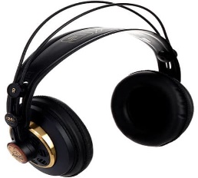

Active Monitor Speakers
Studio Monitor Speakers show you how the music sounds without headphones. It must be of high quality, so that all the abnormal sounds can be detected. It is also advisable to have another speaker, small and of low quality, to cross-check how the sound is even in this kind of speakers. Ultimately, the sound must be good but also understandable for every type of audience.
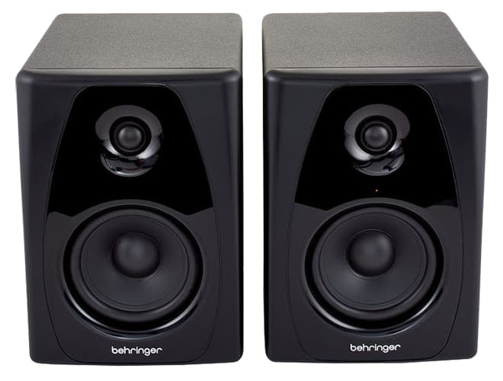

Audio Mixer Console
At the heart of any studio is the Audio Mixer Console. This is the interface used to control what’s heard on air, and to choose which sounds should be broadcasted.
Each channel represents an “input”. The fader (slider) attenuates or amplifies the incoming signal; it can change the volume and the dynamics of the sources, and combine the various audio signals. The Audio Mixer Console is the device that allows us to monitor and control the audio.
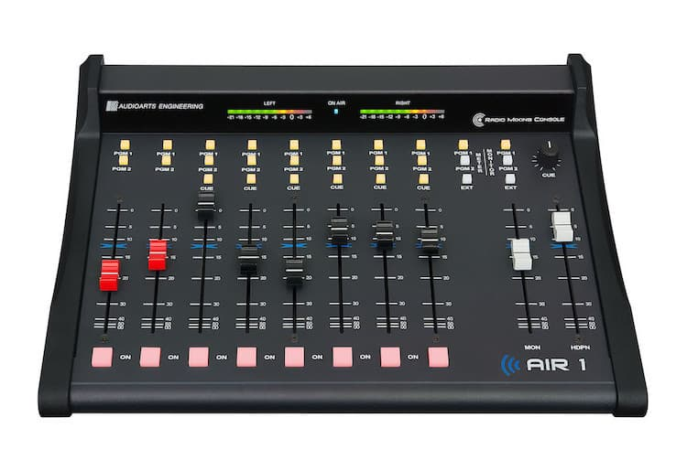

Computer
You also need a Computer with an Automation Software. This computer system makes it possible to play background music and commercials. The software is called Automation Software or “Playout”, and it is designed to continually play music in the background.
The heart of these programs is the Playlist – which is a list with all the audio files that need to be played. Most automation systems also contain a Music Database, Hot Keys (to play ad-hoc audio), an Audio Editor, a Segue Editor (to change the mix between the different elements), Interfaces for Website and RDS data, and a lot more.
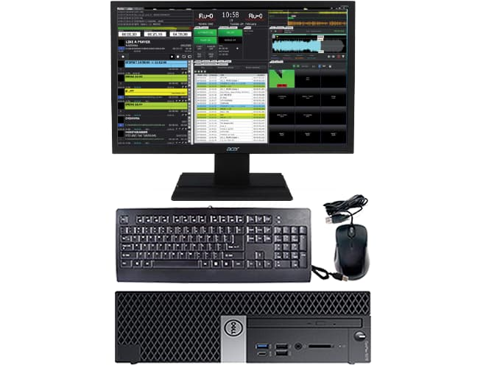

Tuner FM Receiver (good quality)
To monitor the real sound you are broadcasting a good quality Tuner is necessary.
This will also help you compare your on-air sound with that of your competitors.
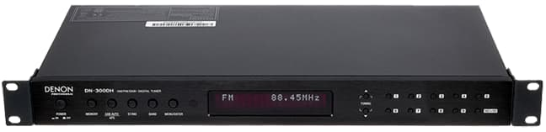

SAFETY RULES AND REGULATIONS
General safety rules and regulation when using the studio for broadcast or production.
- Learn the location of the nearest fire extinguisher
- Never enter a studio above which the “on air” light is illuminated. The studio is meant to accommodate three talent on mic.
- The studio doors must always be closed when broadcasting.

CHAPTER FOUR
4.1 CONCLUSION
Simply with the above aforementioned events I’ve undergone in the Sobi 101.9 fm in Ilorin during my training, I surely known and belief that you will reasoned with me that I’ve acquired all necessary practical and professional skill I needed to proceed in my study under this profession; contrary to the theoretical knowledge I took down to the training ground in the last four months before my trainee.
The training have exposed me to many practical areas of my profession, it is a worthwhile experience in life.
4.2 RECOMMENDATIONS
Though the corporation serves the audience satisfactorily in the area of modern infotainment broadcasting and educational development in our society through all its programmes and news delivery. I hereby recommend that the organization need to improve in employing skill and trained journalists, reporters and broadcasters that will assist the station news-gathering and presentation team to the better expectation of the audience/listeners.
4.3 EXPERIENCE AND OBSERVATION
Life experience is going on till the end of human life. An adage says “the more you leave the more you learn” when I started my media attachment at Sobi 101.9 fm Ilorin, I gain enormous experience
I observed how to interview people of dignitaries in political leaders, business man etc editorial in different newspaper (tribune, punch, herald e.t.c).
I also visited the studio of the station and I realize how programme and news were been broadcast.
Finally, I gained the experience of house styles of Sobi 101.9 fm Ilorin during my SIWES (IT Programmed

