

A TECHNICAL REPORT ON THE STUDENT INDUSTRIAL WORK EXPERIENCE SCHEME (SIWES)

HELD AT
PARROT F.M
OGBOMOSO, OYO STATE

PRESENTED BY
AJALA BOLUWATIFE ISREAL
ND/23/MAC/PT/0264

SUBMITTED TO
THE DEPARTMENT OF MASS COMMUNICATION INSTITUTE OF INFORMATION COMMUNICATION TECHNOLOGY KWARA STATE POLYTECHNIC P.M.B 1375 ILORIN NIGERIA

IN PARTIAL FULFILLMENT OF THE REQUIREMENT FOR THE AWARD OF NATIONAL DIPLOMA (ND) IN MASS COMMUNICATION DEPARTMENT KWARA STATE POLYTECHNIC ILORIN, NIGERIA

AUGUST – NOVEMBER, 2024

DEDICATION
This report is dedicated to Almighty God, the fulfiller of destiny. I thank Him for his guidance, protection and for been there for me throughout my industrial training programme.
It is also dedicated to my beloved parents Mr. and Mrs. Ajala and my friends

ACKNOWLEDGEMENT
My appreciation goes to Almighty God, who made me to choose Mass Communication as my discipline.
However, I will like to thank Industrial Training Fund for their foresight in putting these program and also to the Building Technology Department, Kwara State Polytechnic Ilorin Kwara State for providing the platform on which was engage in the training.
I want to thanks my mother Mr. and Mrs. Ajala, my brothers and sister and my friends for the encouragement they gave me throughout the industrial training period and for their support.
TABLE OF CONTENTS
Title page i
Certification ii
Dedication iii
Acknowledgment iv
Table of Contents vi
CHAPTER ONE
1.1 Introduction to SIWES 1
1.2 Background to the Siwes 1
1.3 Objectives of SIWES 2
CHAPTER TWO
2.1 History of the Organization 3
2.2 Organization Structure of Orisun Fm 3
2.3 Rule of Engagement in News Department 3
CHAPTER THREE
3.0 INVOLVEMENT IN THE ORGANIZATION 5
3.1 Instrument Used in the News Room 5
3.2 What is a Producer? 7
3.3 What is a Newscasters? 7
3.4 Duties of a Newscaster 7
CHAPTER FOUR
4.0 EXPERIENCED GAINED IN THE ORGANIZATION 8
4.1 Importance of Paper in News 8
4.2 What is Scroll? 8
4.3 What is Editing? 8
4.4 What is a Reporter? 8
4.4.1 Types of Reporter 8
4.5 Sources of News 8
4.6 What is Line-Up? 8
4.7 Types of Microphone 9
4.7.1 What Is A Condenser Microphone? 9
4.7.2 What Is A Dynamic Microphone? 10
4.7.3 What Is A Ribbon Microphone? 10
CHAPTER FIVE
5.0 CONCLUSION AND RECOMMENDATION 11
5.1 Conclusion 11
5.2 Recommendation 11

CHAPTER ONE

1.1 Introduction to SIWES
The Student Industrial Work Experience Scheme (SIWES) exposes students to industry based skills necessary for a smooth transition from the classroom to the world of work. It affords students of tertiary institutions the opportunity of being familiarized and exposed to the needed experience in handling machinery and equipment which are usually not available in the educational institutions and seeing firsthand the practical experience of some theoretical knowledge gained in the course of study.
Participation in SIWES has become a necessary pre-condition for the award of Diploma and Degree certificates in specific disciplines in most institutions of higher learning in the country, in accordance with the education policy of government.

1.2 Background to the SIWES
The Student Industrial Work Experience Scheme (SIWES) is an initiative which was established in 1973 by the Industrial Training Fund (ITF) to help bridge the gap between acquired classroom education and skills necessary for work in the industry.
Before the inception of the scheme in 1973, there was glaring evidence that inadequate practical exposure of students in tertiary institutions posed serious challenges to both the quality and standard of engineering and technological education in our nation. This resulted in half-baked engineering graduates who needed to undergo a form of training (Industrial Training) to be suitable for employment in industries and firms.
In order to forestall this threat that could bring about industrial regression, the Federal Government through the Industrial Training Fund (ITF) which was established by decree 47 of 1971 introduced the Student Industrial Work Experience Scheme (SIWES) in 1973.
SIWES exposes students to machines and equipment, professional work methods and ways of safe guarding the work areas and workers in industries and other organizations. It helps the student to know the link between what is learnt in the university and what is actually practiced on site. It further helps students to appreciate their field of study better, thereby also determining which area of specialization to go into to contribute to technological development of this nation.
The scheme involves the students, the universities and the industry (employers). It is funded by the Federal Government of Nigeria and jointly coordinated by the National Universities Commission (NUC) and the ITF.
SIWES orientation is usually done to intimate students with the rudiments of industrial training before they are being employed. At the end of the industrial training (IT), successful students whose log books were verified and approved by ITF officials are paid SIWES severance allowance.

1.3 Objectives of SIWES
- Provides the student with an opportunity to apply their theoretical knowledge in real work situation thereby bridging the gap between theory and Practical.
- Provides an avenue for students in tertiary institutions to acquire industrial skills and experience in their course of study.
- Expose students to work methods and techniques in handling equipment and machinery that may not be available in universities.
- Familiarizing the student for the working conditions they are likely to meet after graduation; and
- Make the transition from the university to the world of work easier and thus enhance student’s contacts for later job placement.

CHAPTER TWO

2.1 History of the Organization
Parrot FM is an indigenous radio station in Ogbomoso, Oyo State Nigeria. It was established and inaugurated by His Excellency, Otunba Dr. C. Adebayo Alao-Akala and other reputable personnel.
Parrot FM 101.1, Ogbomoso was established and inaugurated by His Excellency, Otunba Dr. C. Adebayo Alao-Akala, JP, PSC on the First Day of October, 2014.
It got licensed by the National Broadcasting Commission on the 27th day of April, 2015 as a private commercial FM station to operate from Ogbomoso on 2 kilowatts transmitter. Ogbomoso, a cosmopolitan and the second largest city in Oyo state is a melting pot of various tribes, nationalities, religious beliefs and cultures and home to many tertiary institutions and other educational institutions

2.2 Organization Structure of Parrot Fm
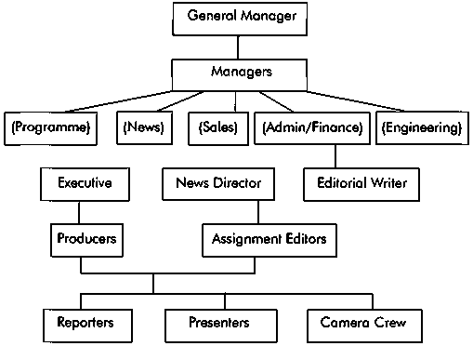

2.3 Rule of Engagement in News Department
The following are the rules of engagement in the news department.
- Responsibilities of reporter
- Alignment to responsibility
- Ability to work at any time
- You must have a good news for news

CHAPTER THREE

3.0 INVOLVEMENT IN THE ORGANIZATION

3.1 Instrument Used in the News Room
The following are the instrument used in the news room.
- Table and chair


- Camera
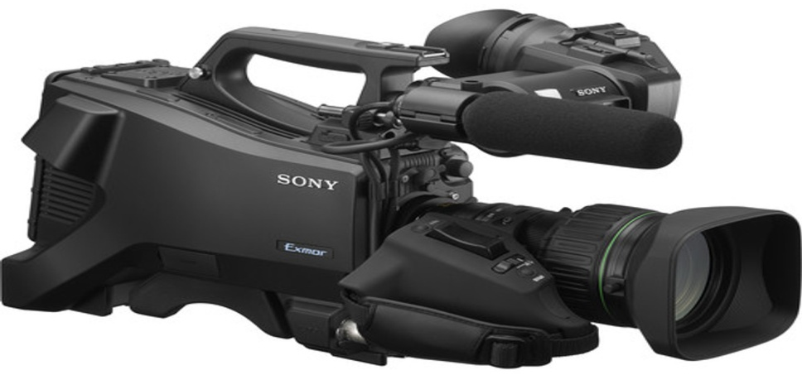
- Mouse


- Computer
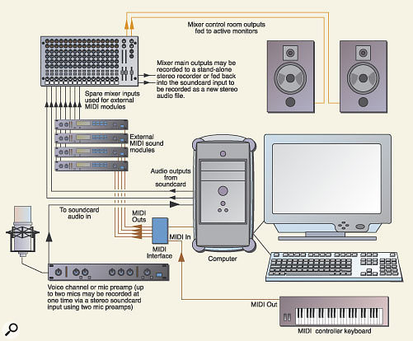
- Microphone
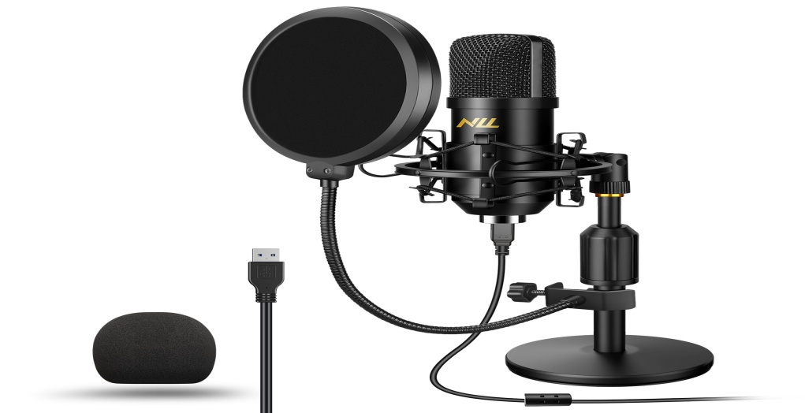

3.2 What is a Producer?
They are the one that usually responsible for the bulleting every day. Producing is a very serious affair in news department.

3.3 What is a Newscasters?
A newscaster's job involves presenting current information and news via live radio, television or web broadcasts. While some newscasters may report on a variety of subjects, others specialize in areas like weather reporting, sports, politics, or general news, depending on the size of their news organization and the city in which they work. More and more today, newscasters have an active social media presence in order to better keep in touch with their audience.

3.4 Duties of a Newscaster
A newscaster is both a journalist and a broadcast specialist who communicates the news to a viewing or listening public. Depending on the location and the size of the station for which you work, you may report on international, national or local news. Your responsibilities might encompass performing research, interviewing guests, reporting, writing and giving on-air news presentations. Sometimes, you might go to the scene of a story and remotely assemble a report for broadcast. In other instances, you might verbally set the stage for a taped segment or react to a breaking news report.

CHAPTER FOUR

4.0 EXPERIENCED GAINED IN THE ORGANIZATION

4.1 Importance of Paper in News
The following are the importance of paper in news.
- Available of news
- It will help the producer for the particular day to know which news will go for there time
- It help the producer alignment of a news story

4.2 What is Scroll?
Once the scroll is perfect, it is sent to the (MCR) master control room.

4.3 What is Editing?
Editing means doing all graphics. As a communicator you must know how to handle the system very well.

4.4 What is a Reporter?
A reporter is also known as journalist who gather information and news to keep public informed.

4.4.1 Types of Reporter
There are three types of reporter know to me.
- Judicial reporter
- Education reporter
- Health reporter

4.5 Sources of News
There are different ways of sourcing for news.
- Rooting
- Schedule assignment
- Searching

4.6 What is Line-Up?
A line-up refers to a list of sequence individual on topic that will be featured on discussed in a news program or publication.

4.7 Types of Microphone
There are three primary types of microphones. Those include cardioid, dynamic, and ribbon microphones.
Ideally, they all work the same but are designed to capture different elements. For example, if you're a singer, you may want your microphone to capture your voice while reducing the instruments in the background.

4.7.1 What Is A Condenser Microphone?
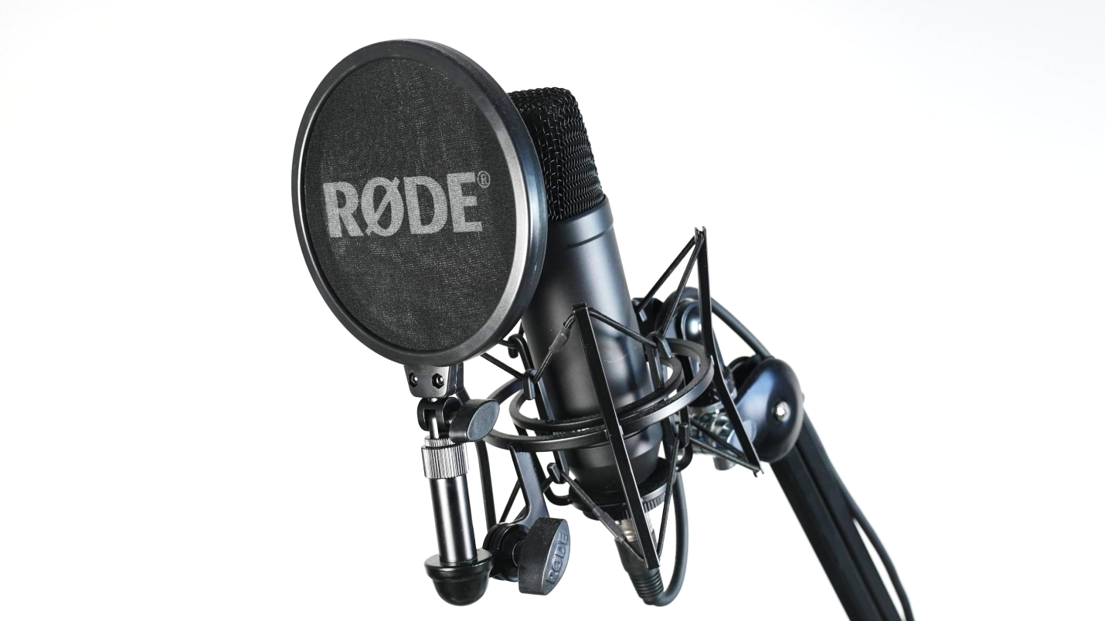
A condenser microphone uses a capacitor to convert sound into an electrical signal. These mics are typically used in studio recordings because they have a higher quality sound than dynamic microphones and are often best for vocals and higher frequencies.
Besides recording vocals, you would also use a condenser mic to record acoustic guitars, piano, orchestral instruments, etc.
Condenser microphones come in two main types: small-diaphragm and large-diaphragm. Small-diaphragm condenser microphones are more common and are generally used for recording instruments. They are also great for capturing the sound of vocals and acoustic guitars.
On the other hand, large-diaphragm condenser microphones work well for studio recordings. They have a higher quality sound than small diaphragm condenser microphones.

4.7.2 What Is A Dynamic Microphone?

Another type of microphone to consider is a dynamic microphone. They are more rugged and can handle high volumes, making them ideal for live performances.
Some popular dynamic microphones are the Shure SM58, Shure SM7B, the Sennheiser e935, and the Audix i5.
Dynamic microphones are less sensitive than condenser microphones, meaning they can handle more sound without distorting the audio. This also makes them better for capturing louder sounds.
You would use a dynamic mic for general recording, live streaming, voice chat when streaming your gameplay, interviews, and more.

4.7.3 What Is A Ribbon Microphone?
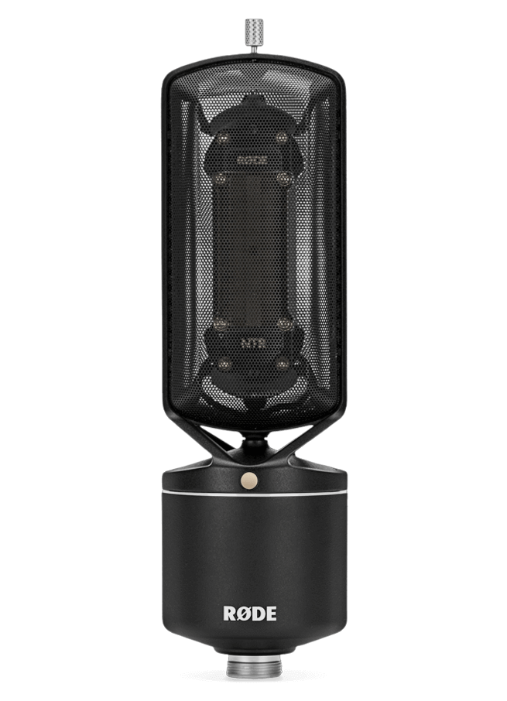
Ribbon microphones are less common but offer a unique sound that can be well-suited for certain genres of music. They use a ribbon of metal to convert vibrations into an electrical signal, and they typically have a figure-8 pattern.
There are a few different types of ribbon microphones available on the market.
Ribbon microphones are not as common as condenser or dynamic mics. However, they often produce a mellower sound than other microphone types, making them well-suited for certain genres of music. They can also be used for studio recordings for capturing the sound of vocals and acoustic guitars or capturing the sound of a choir or band.

CHAPTER FIVE

5.0 CONCLUSION AND RECOMMENDATION

5.1 Conclusion
Frankly speaking, I will say that during my four (4) months in the SIWES programme at Parrot Fm, Ogbomoso, Oyo State that I gained a lot of experience, which are:
- I can now understand the different between the theoretical and practical aspects of Mass Communication and other related courses.
- I gained how to carryout all the aforementioned news and studio described in my chapter four of this report.
- I gained how to present news, edit news, search for news, interrogate people and also know the differences in microphones and other studio gadgets.

5.2 Recommendation
Industrial training is an important programme that is necessary for all undergraduates. It exposed students to practical aspect of the theories been thought in the classroom. It also gives students insight of what is happening in the labour market.
I will recommend the followings;
- That the school should be monitoring the welfare of the students while they are in the SIWES programme.
- That the ITF should provide necessary placement for the students so that there will be more space/placement for the students to do their SIWES programme.
- The government should invest more in the SIWES programme by building companies so that student can get more placement.

