

A TECHNICAL REPORT ON
STUDENT INDUSTRIAL WORK EXPERIENCE SCHEME (SIWES)
HELD AT

GREEN SUIT VILLA HOTEL

KADUNA STATE NIGERIA.

BY
RASHEED AISHA TEMITOPE
ND/23/TMT/FT/0017
SUBMITTED TO

DEPARTMENT OF TOURISM MANAGEMENT TECHNOLOGY,

INSTITUTE OF APPLIED SCIENCE,

KWARA STATE POLYTECHNIC ILORIN KWARA STATE.

IN PARTIAL FULFILMENT OF THE REQUIREMENT FOR THE AWARD OF NATIONAL DIPLOMA (ND) IN TOURISM MANAGEMENT TECHNOLOGY.

AUGUST – NOVEMBER, 2024
CERTIFICATION
This is to certify that the report was based on SIWES experience gained by RASHEED AISHA TEMITOPE with matric. number ND/23/TMT/FT/0017 of Department of Tourism Management Technology, Applied Science, Kwara State Polytechnic, Ilorin, Held at GREEN SUIT VILLA HOTEL, KADUNA STATE, NIGERIA as Part of the requirement of the course.

DEDICATION
This Technical report is dedicated to Almighty GOD, the Author of all Knowledge and it is equally dedicated my Parent (MR. AND MRS. RASHEED) and all my family members for their Spiritual, Moral and Financial Support throughout the period of this programme, wishing them long life and a healthy life (Amen).

ACKNOWLEDGEMENT
I acknowledge the Highest GOD for His power and mighty work of love in my life helping me through the years of my studies.
My sincere gratitude and appreciation to my Parent (MR. AND MRS. RASHEED) and all my other family for their moral and financial assistance at all times.
To all my lecturer goes this gratitude creating time to impact knowledge and making understand the importance of studying.
Finally, to my SIWES coordinator who has find time to help me out during the course of the programme.

PREFACE

The writing of this report was motivated by the experience gained during my SIWES attachment GREEN SUIT VILLA HOTEL, KADUNA STATE, NIGERIA. This report is meant to be a guideline to every student.

The purpose of writing this report is to relate the various area which I participated during the Industrial Training Attachment in my place of work. It is indeed very encouraging that all students to get acquainted with what is been done in class, so as to be familiar with what is been done in the practical field.

Finally, This Industrial Training Attachment is required for every student because it tends to backup and build the students physically, morally and educationally for the task after graduation.

TABLE OF CONTENT
Cover page
Certification
Dedication
Acknowledgement
Preface
Table of content
CHAPTER ONE
1.1 Introduction
1.2 Definition of SIWES
1.3 General Objectives of SIWES
CHAPTER TWO
2.1 Historical Background of ORGANIZATION
2.2 Organogram of ORGANIZATION
CHAPTER THREE
  - Technical Training Experience
CHAPTER FOUR
4.1 Relevance of experience gained to student field of study
4.2 Application of Theoretical Knowledge
4.3 Development of Practical Skills
4.4 Enhanced Understanding of Industry
CHAPTER FIVE
  - Conclusion and Recommendation
5.2 Personal impression about the organization
5.3 Suggestion and recommendation to the organization and the polytechnic concerning the SIWES programme

CHAPTER ONE
1.1 INTRODUCTION
Student industrial work experience scheme (SIWES) is set for the development by the federal government for student to facilitate them with basic practical knowledge to deviate from predominant dependence on foreign experience and be self-reliable and creative through the training rendered by the organization in question
1.2 DEFINATION OF SIWES
SIWES can be defined as an organized body basically to equip student with basic knowledge through industrial training
1.3 AIMS AND OBJECTIVES OF SIWES
The aims and objectives of industrial training are as follows:
- It enables student to know their possible area of employment when graduated from school.
- To access students’ interest and their ability in the course they have chosen.
- To expose students to modern equipment while they do not access to.
- To make student know the meaning and application of their cause of study.
- To give maximum experience to the student.
- To connect students professionally.

CHAPTER TWO
BACKGROUND INFORMATION
2.1 HISTORICAL BACKGROUND OF THE ORGANIZATION
Green Suit Villa Hotel, located in Kaduna State, Nigeria, has a rich history that dates back to its establishment. The hotel was founded with the vision of providing comfortable and luxurious accommodations to travelers and locals alike.
Early Years
The hotel's early years were marked by its humble beginnings as a small guesthouse. Over time, it gained popularity and reputation for its excellent service and amenities. As the demand for accommodations grew, the hotel underwent several expansions and renovations to increase its capacity and improve its facilities. Amenities
1. Air-conditioned rooms: Comfortable rooms with modern amenities.
2. Free Wi-Fi: Stay connected during your stay.
3. Outdoor pool: Relax and unwind by the pool.
4. Restaurant: Enjoy local and international cuisine.
5. Bar: Savor a variety of drinks and cocktails.
6. Event hall: Host conferences, weddings, and other events.

Room Options
1. Standard rooms: Comfortable and well-equipped.
2. Presidential suites: Luxurious and spacious.
3. Diplomatic suites: Elegant and well-appointed.
Services
1. 24-hour front desk: Assistance whenever you need it.
2. Room service: Convenient dining in the comfort of your room.
3. Laundry service: Keep your clothes fresh and clean..
2.2 ORGANOGRAM OF THE ORGANIZATION
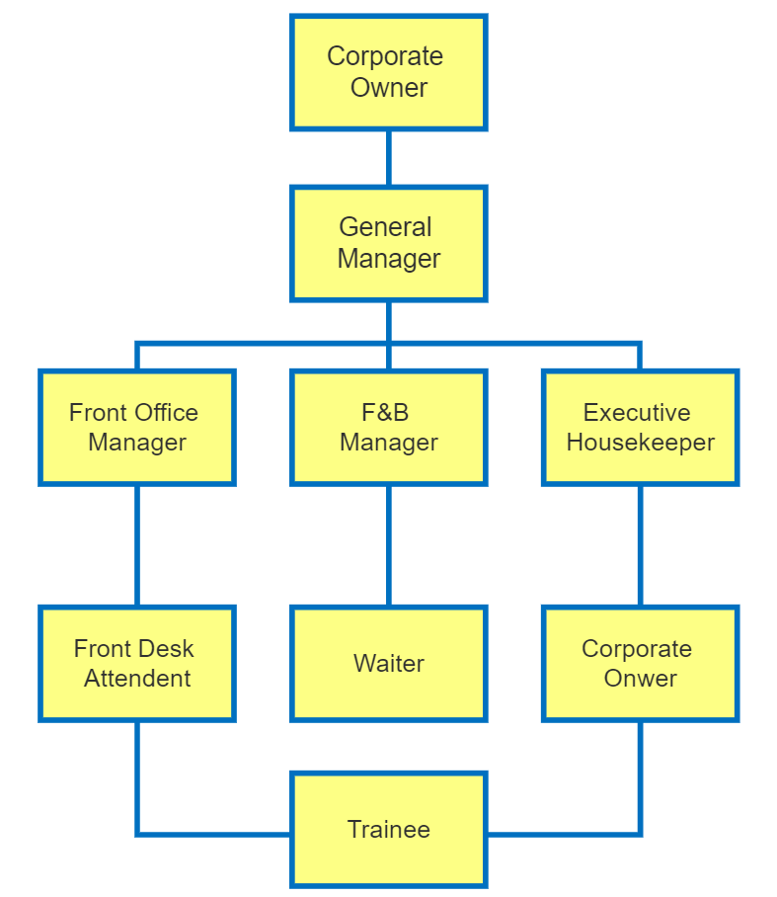

VARIOUS DEPARTMENT OF THE ORGANIZATION
- Front Desk/Reception: Provides 24-hour service, handling check-ins, check-outs, and guest inquiries.
- Housekeeping: Ensures rooms are clean and well-maintained, providing toiletries and other essentials.
- Restaurant and Bar: Offers local and international cuisine, as well as a variety of drinks and cocktails.
- Event Planning: Helps plan and coordinate events, such as weddings and conferences, in the hotel's 2000-capacity multipurpose hall.
- Laundry Service: Provides convenient laundry services for guests.
- Security: Ensures the safety and security of guests and their belongings.
- Concierge: Assists guests with various requests, such as car rentals and airport shuttles.

CHAPTER THREE
TECHNICAL TRAINING EXPERIENCE
During my attachment at Green Suit Villa Hotel, I received technical training in various aspects of hotel operations. The training was designed to equip me with the skills and knowledge necessary to perform my duties effectively.
Areas of Training
The technical training I received covered the following areas:
- Front Office Operations: I received training on front office procedures, including check-in and check-out, reservations, and guest services.
- Food and Beverage Service: I received training on food and beverage service, including serving guests, taking orders, and handling cash and credit transactions.
- Housekeeping and Laundry Services: I received training on housekeeping and laundry procedures, including cleaning rooms, doing laundry, and maintaining cleanliness and hygiene standards.
- Maintenance and Engineering Services: I received training on maintenance and engineering procedures, including performing routine maintenance tasks and troubleshooting common issues.

Training Methods
The training methods used during my attachment included:
- On-the-job training: I received hands-on training from experienced staff members.
- Classroom training: I attended training sessions and workshops to learn about hotel operations and procedures.
- Mentorship: I was assigned a mentor who provided guidance and support throughout my training.
Skills and Knowledge Acquired
Through the technical training, I acquired the following skills and knowledge:
- Front office procedures: I learned how to check-in and check-out guests, handle reservations, and provide guest services.
- Food and beverage service: I learned how to serve guests, take orders, and handle cash and credit transactions.
- Housekeeping and laundry procedures: I learned how to clean rooms, do laundry, and maintain cleanliness and hygiene standards.
- Maintenance and engineering procedures: I learned how to perform routine maintenance tasks and troubleshoot common issues.
Application of Skills and Knowledge
I was able to apply the skills and knowledge I acquired during my training to real-world situations. For example, I was able to:
- Check-in and check-out guests: I was able to check-in and check-out guests efficiently and effectively.
- Serve guests: I was able to serve guests in the restaurant and bar areas.
- Clean rooms: I was able to clean rooms and maintain cleanliness and hygiene standards.
- Perform routine maintenance tasks: I was able to perform routine maintenance tasks and troubleshoot common issues.
CHAPTER FOUR
4.1 RELEVANCE EXPERIENCE GAINED TO STUDENT FIELD OF STUDY
The experience I gained during my attachment at Green Suit Villa Hotel is highly relevant to my field of study in Tourism Management. The training and hands-on experience I received in various aspects of hotel operations have provided me with a comprehensive understanding of the tourism industry and equipped me with the skills and knowledge necessary to succeed in my future career.
Application of Theoretical Knowledge
The experience I gained during my attachment allowed me to apply theoretical knowledge I acquired in the classroom to real-world situations. For example:
- Tourism industry operations: I was able to apply my knowledge of tourism industry operations to understand the role of hotels and other tourism-related businesses in the industry.
- Customer service: I was able to apply my knowledge of customer service to provide excellent service to guests and ensure that they had a memorable experience.
- Tourism marketing: I was able to apply my knowledge of tourism marketing to understand how hotels and other tourism-related businesses promote their products and services.

Development of Practical Skills
The experience I gained during my attachment also allowed me to develop practical skills that are essential in the tourism industry. For example:
- Communication skills: I developed effective communication skills, which are critical in providing excellent customer service and working with colleagues and clients.
- Problem-solving skills: I developed problem-solving skills, which are essential in handling guest complaints and resolving issues.
- Time management skills: I developed time management skills, which are critical in ensuring that tasks are completed efficiently and effectively.
Enhanced Understanding of Industry
The experience I gained during my attachment has enhanced my understanding of the tourism industry and the various aspects of hotel operations. I have gained a deeper understanding of the importance of providing excellent customer service, maintaining cleanliness and hygiene standards, and ensuring that guests have a memorable experience.
Career Opportunities
The experience I gained during my attachment has also opened up career opportunities for me in the tourism industry. I am confident that the skills and knowledge I acquired during my attachment will enable me to secure a job in a reputable tourism-related organization and succeed in my future career.
Specific Skills and Knowledge
Some specific skills and knowledge I gained during my attachment include:
- Hotel operations: I gained knowledge of hotel operations, including front office, food and beverage service, and housekeeping.
- Customer service: I gained knowledge of customer service principles and practices.
- Tourism marketing: I gained knowledge of tourism marketing principles and practices.
- Time management: I developed time management skills, which are critical in ensuring that tasks are completed efficiently and effectively.

CHAPTER FIVE
SUMMARY, CONCLUSION AND RECOMMENDATIONS
5.1 CONCLUSION
Even though there was a little hardship especially when the work of the organization is pilled up on me and payment was very meager for transportation.
The SIWES program at the organization give me a wonderful and everlasting experience. The program is readily helped to bridge the gap between theoretical aspect and practical work in the industrial training.
5.2 RECOMMENDATION TO THE ORGANIZATION
Since the SIWES cannot be overemphasized in all aspects in the recent times, I therefore think it is standard enough for any student of agricultural Technology to be giving opportunity after school in this organization to serve and possible employed if he/she deem it.
5.3 SUGGESTION FOR IMPROVEMENT OF THE SCHEME
Base on the experience and knowledge acquired at the course of the SIWES training, I hereby give the following recommendation base on my observations;
• Proper orientation should be given to the students by the Polytechnic before they go on SIWES.
• The placement letter should be given to students early enough so as to avoid attachment in irrelevant organization.
• Institution should ensure that students are attached at relevant establishment for effective training, experience and exposure.
• Government, ITF and the Institution should ensure that students do not pay any amount of money before accepted in any organization. This organization should be sensitized on the objective of SIWES training and the need why they should not collect money before accepting students.

