

A TECHNICAL REPORT
ON
STUDENT INDUSTRIAL WORK EXPERIENCE SCHEME
(SIWES)

HELD AT
OLANREWAJU ENGINEERING CONSTRUCTION WORKS
SHOP 15, SABOJO COMPLEX OPP. QUEEN ELIZABETH SCHOOL, ILORIN, KWARA STATE

BY
TAIWO OLASUBOMI TESTIMONY
ND/23/MET/PT/0006

SUBMITTED TO:
DEPARTMENT OF METALLURGICAL ENGINEERING, INSTITUTE OF TECHNOLOGY (I.O.T), KWARA STATE POLYTECHNIC, ILORIN

IN PARTIAL FULFILLMENT OF REQUIREMENT FOR THE AWARD OF NATIONAL DIPLOMA (ND) IN METALLURGICAL ENGINEERING

SEPTEMBER - DECEMBER 2023

DEDICATION
This Siwes report is dedicated to Almighty God for his protection, kindness, strength over my life and also to my parents for their financial support and moral care towards me.

ACKNOWLEDGEMENT
I acknowledge with gratitude to Almighty GOD for the successful completion of this Siwes.
My Appreciation goes to all staffs and H.O.D of Metallurgical Engineering Department who has contributed in one way or the other to the completion of this Siwes.
I also appreciate the effort of my parent in person of Mr. and Mrs. Taiwo for their morally, spiritually and financially support, i pray that almighty God should be with them.
Lastly i extend and express my appreciation to my friends for their moral support during the write up i say thank you to Olanrewaju Engineering and all my lecturers may God continue to bless you all abundantly.

PREFACE
The student industrial work experience scheme (SIWES) helps in exposing students to the practical application of their course and to get used to equipment and machines used in the factory. The SIWES was established to promote student skills in industrial practice and pre-expose them to working experience in industrial setting.
The SIWES program covered a period of four months from September to December 2024 and it is a partial fulfillment of a two years academic program to obtain an OND certification in Engineering. The report explains the description of the work done.

TABLE OF CONTENTS
Title Page
Dedication i
Acknowledgements ii
Preface iii
Table of contents iv

CHAPTER ONE: INTRODUCTION ON STUDENTS INDUSTRIAL WORK EXPERIENCE SCHEME (SIWES)
  - Background on SIWES
  - Aim and Objectives of SIWES

CHAPTER TWO: DESCRIPTION OF THE ESTABLISHMENT OF ATTACHMENT
2.1 Location and brief history of establishment
2.2 Objectives of establishment
2.3 Organization Structure/Organogram of The Establishment
2.4 Various Departments/Units and Their Function
2.5 Department Posted to and My Duties Over There

CHAPTER THREE: WORK DONE AND EXPERIENCE GAINED AT THE PLACE OF ATTACHMENT
3.1 Tasks carried out on Welding
3.2 Type of Welding Equipment and their uses
CHAPTER FOUR: SUMMARY, CONCLUSION AND RECOMMENDATION
4.1 Summary of attachment activities
4.2 Problems encountered during the program
4.3 Conclusion
4.4 Recommendation

CHAPTER 1
1.0 INTRODUCTION
1.1 BACKGROUND ON SIWES
The student industrial scheme (SIWES) is a skill training programme designed to prepare and expose student of tertiary institution to the industrial work situation they are likely to meet after graduation. The scheme afford students the opportunity to familiarizing and exposing themselves to handling equipment and machinery that are usually not available in the institutions.
It’s to this effect that the industrial training fund (ITF) initiated, designed and introduced SIWES scheme in 1973 to acquaint student with the skills of handling industrial equipment and machinery. The ITF solely funded the scheme during its formative years. But as the financial involvement became unbearable to the fund, it withdrew from the scheme in 1978. The federal government handed over the scheme in 1979 to both the National Universities Commission (NUC) and the National Board for Technical Education (NBTE). Later, the federal government in November 1984 reverted the management and implementation of the scheme to ITF and it was effectively taken over by the Industrial Training Fund (ITF) in July 1985 with the funding being solely borne by the federal government.
1.2 AIM AND OBJECTIVES OF SIWES
- It orients student practically
- It helps to be self employed
- It helps students to be self confidence
- It prepare students for the work situated they are likely to meet after graduation

CHAPTER 2
- DESCRIPTION OF THE ESTABLISHMENT OF ATTACHMENT
2.1 LOCATION AND BRIEF HISTORY OF THE ESTABLISHMENT
Olanrewaju Engineering Construction Works, Ilorin is a Non-Governmental Business. A sole Proprietorship Business been operated in Ilorin, Kwara State.
The Department is located at Shop 15, Sabojo Complex Opp. Queen Elizabeth School, Ilorin, Kwara State.
2.2 OBJECTIVES OF ESTABLISHMENT
The objectives of Olanrewaju Engineering Construction Works includes provision of adequate amenities such as sales of lands and contract work (I.e building contract and lots more) within the state in other for the citizen to enjoy the betterment of the Non-Government operation.
2.3 ORGANIZATION STRUCTURE
MECHANICAL ENGINEERING
WORKSHOP
PRODUCTION
WELDING & FABRICATION
ALIGNMENT & FITTING
AUTOMOTIVE

2.4 DEPARTMENTS/UNITS IN THE ORGANISATION
There are numerous departments in the organization and each with their various functions, but I was posted in the welding workshop based on my field of study in the institution. Various activities are carried out in the workshop, from maintenance to production of different machines and devices used in the organization.

CHAPTER 3
3.0 WORKDONE AND EXPERIENCE GAINED AT THE PLACE OF ATTACHMENT
3.1 Equipment and their uses;
Here's a more detailed breakdown of common tools used by welders:
Essential Tools:
- Welding Machine: This is the primary tool for generating the heat needed to fuse metals together.
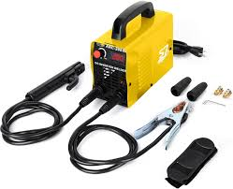
- Welding Helmet/Hood: Protects the welder's eyes and skin from harmful UV and infrared rays, as well as sparks.

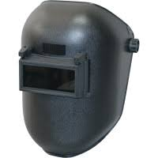

- Welding Gloves: Protect the welder's hands from heat and sparks.
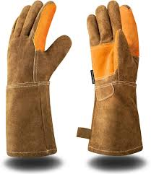

- Welding Clamps: Securely hold metal pieces together during the welding process, ensuring precision and stability.
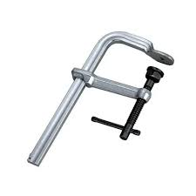

5. Chipping Hammer: Used to remove slag and spatter from welds.
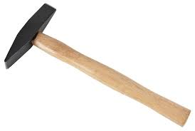

6. Angle Grinder: A versatile tool for cleaning, grinding, and cutting metal.
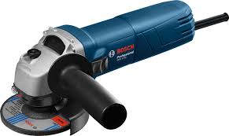

7. Wire Brush: Used to clean metal surfaces before and after welding, removing rust, paint, and other contaminants.
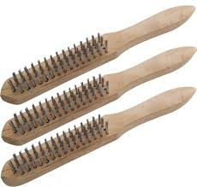

8. Metal File: Used for smoothing edges and cleaning up welds.
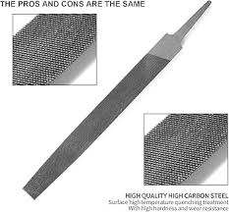

Other Useful Tools:
- Welding Pliers: Multifunctional tools for cleaning welds, removing spatter, and cutting wires.
- Welding Magnets: Hold metal pieces in place during welding, especially useful for 90-degree angles.
- Safety Glasses: Protect the eyes from stray sparks and hot metal.
- Speed Square: Helps with accurate measurements and marking angles.
- Welding Apron: Protects the welder's body from sparks and heat.
- Welding Boots: Protect the welder's feet from heat and debris.
- Welding Jacket: Protects the welder's body from sparks and heat.

CHAPTER 4
4.0 SUMMARY AND CONCLUSION
4.1 SUMMARY OF ATTACHMENT ACTIVITIES
In summary, working with machines can be quite tasking and demanding, especially when both with the use of strength but it is very interesting as doing such daily helps to improve the thinking state of the mind. One would be able to develop different ideas to tackle and fix the errors occurring in the machine.
4.2 CONCLUSION
In conclusion, I would commend all bodies responsible for the SIWES program as it helps to open the eyes of many students and prepare them ahead of the real job they would face in their various field of study after graduating from the institution. I thereby recommend that there be extension in the duration allocated for the program as there’s a lot to be learnt in the current stipulated period for running the program.
4.3 RECOMMENDATION
Engineering Construction Works which happen to be a Non-Government firm should be encourage in all states and also the citizen should embrace them for better welding construction.

