

A TECHNICAL REPORT
ON
STUDENT INDUSTRIAL WORK EXPERIENCE SCHEME (SIWES)

ATTACHMENT HELD AT:
PRACTOIL LIMITED

PREPARED BY:
JIMOH JIBOLA ABDULQUDUS
ND/22/TPM/FT/014

SUBMITTED TO:
DEPARTMENT OF ARCHITECTURAL TECHNOLOGY
INSTITUTE OF ENVIRONMENT STUDIES (I.E.S), KWARA STATE POLYTECHNIC, ILORIN.

IN PARTIAL FULFILLMENT OF THE REQUIREMENT FOR THE AWARD OF THE NATIONAL DIPLOMA (ND) IN TRANSPORTATION PLANNING AND MANAGEMENT

SUPERVISED BY:
MR. YAHYAH
DEDICATION
I reference all praise and adoration to Almighty Allah, who has shown me immeasurable mercies all through the duration of my SIWES programme and also my beloved parent Mr. & Mrs. Jimoh who has endlessly given me their purport to ensure the successive achievement in my academic career.

ACKNOWLEDGMENT
My gratitude goes the creator and controller of the whole universe, the most powerful, great and most beneficent being Almighty God who has never failed at any point of my life. Am greatly indebted to my loving and caring parent Mr. & Mrs. Jimoh and my brothers and sisters for their remarkable support, financially, morally spiritually to ensure my success academically.

Furthermore, I am grateful to my lecturer and SIWES coordinator and supervisor in the great Kwara State Polytechnic for their responsible impartation of knowledge on me.

However, I equally want to show my appreciation to all friends and SIWES colleagues at PRACTOIL LIMITED. I cherished the little time spend with you all.

TABLE OF CONTENTS
TITLE PAGE
PREFACE
DEDICATION
ACKNOWLEDGEMENT
TABLE OF CONTENTS

CHAPTER ONE
1.0 INTRODUCTION
1.1 DEFINITION OF SWIES
1.2 AIM AND OBJECTIVES OF SWIES

CHAPTER TWO
2.0 HISTORICAL BACKGROUND
2.1 SECTION OF THE ORGANIZATION AND THEIR FUNCTION

CHAPTER THREE
3.0 STUDENT SPECIFIC INVOLVEMENT AT THE VARIOUS SECTION/UNITS
3.1 EXPLANATION OF WORK DONE

CHAPTER FOUR
4.0 DISCUSSION
4.1 RELEVANT EXPERIENCE GAINED

CHAPTER FIVE
5.0 CONCLUSION
5.1 PERSONAL IMPRESSIONS ABOUT THE ORGANISATION

CHAPTER ONE
- INTRODUCTION
Student industrial work experience scheme as a programme was established by ITF in 1973 in order to seek a lasting solution to the problem of inefficiency and lack of practicable skill and the technical know-how required of graduates after graduation.

The scheme exposes students to industry based skills necessary for a smooth transition from the classroom to the world of work. It affords student of tertiary institution the opportunity of being familiarized and exposed to the needed experience in handling machinery and equipment which are usually not available in the education institution and also serve as a preparatory employment training and enhancement of the theoretical lectures they have being taught in the confines of the classroom walls.

The scheme is commission by the Federal Government and funded through the Industrial Trust Fund (ITF) and the duration of the programmed spans for months.

Training is a key factor in enhancing efficiency and expertise of the workforce. The SIWES program therefore prepares students for the world of work. The scheme is therefore a skill training oriented program so as to expose the student on work they would meet after graduation.

  - DEFINITION OF SIWES
SIWES is an acronym of the Student Industrial Work Experience Scheme. It is a practical skill program development and design to prepare student to gain more practical experience and for transition and enhancement of the theoretical lecturing in the classroom experience to practical experience.

  - AIM OF SIWES
The purpose of SIWES is to promote industrialization in Nigeria, and an advance between the world of teaching, learning industrial experience and work with reference to a field of study.

  - OBJECTIVES OF SIWES
The specific objectives of SIWES as summarized by the Federal Government Gazette of April 1978 are listed below:

- To provide an avenue for the student in institution of the higher learning to acquire industrial skill and experience in their course of study.
- To make the transaction from school to the world of work easier.
- To enhance student contact for later job replacement. And actual practice.
- To provide student with an opportunity to supply their knowledge in real work actual practice.

CHAPTER TWO
- HISTORICAL BACKGROUND OF THE COMPANY
PRACT OIL LIMITED was founded by Mr. Jimoh Alabi in the year 1997.

The company is located at 1 Old Wharf Road Apapa, Lagos State. At PRACTOIL Limited, the Importation, Exportation, Processing, and distribution of petroleum products are the engine of our business operations.

OUR ORGANIZATIONAL STRUCTURE
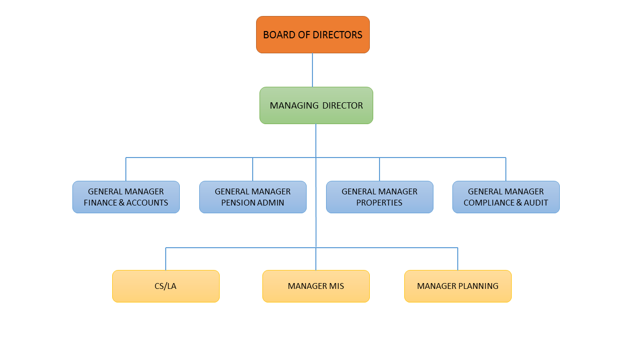

  - SECTION/UNIT OF ORGANIZATION AND THEIR FUCTIONS TRANSPORTATION PLANNING AND MANAGEMENT UNIT.
This is the department that handles oil and transportation planning and development. The responsibility of this unit includes:
- Imports
- Export
- Stores
- Distributions of petroleum and edible oil
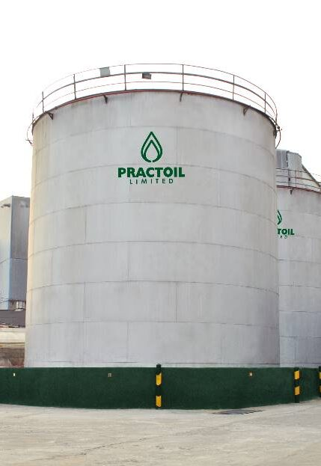

CHAPTER THREE

INTRODUCTION TO LOGISTIC DEPARTMENT
In the process of my work experience program I was taught how to take record of stock inflow and outflow and also interact and clear trucks from NUPENG to enable truck have access to our deport.

MATERIALS
Example of materials used in logistics department is as follows;
- Pumping machine
- Oil Hoes
- System
- Trucks
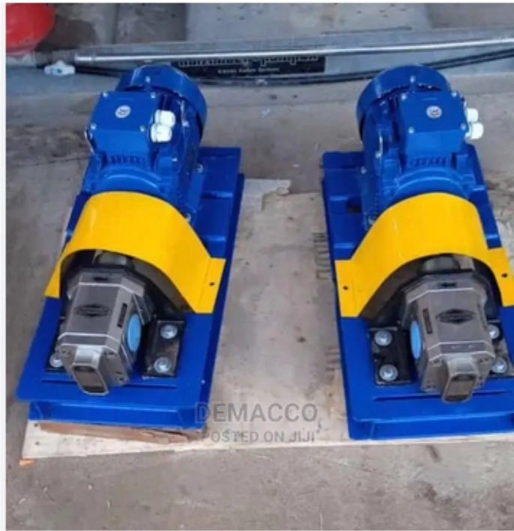

Oil Pumping Machine

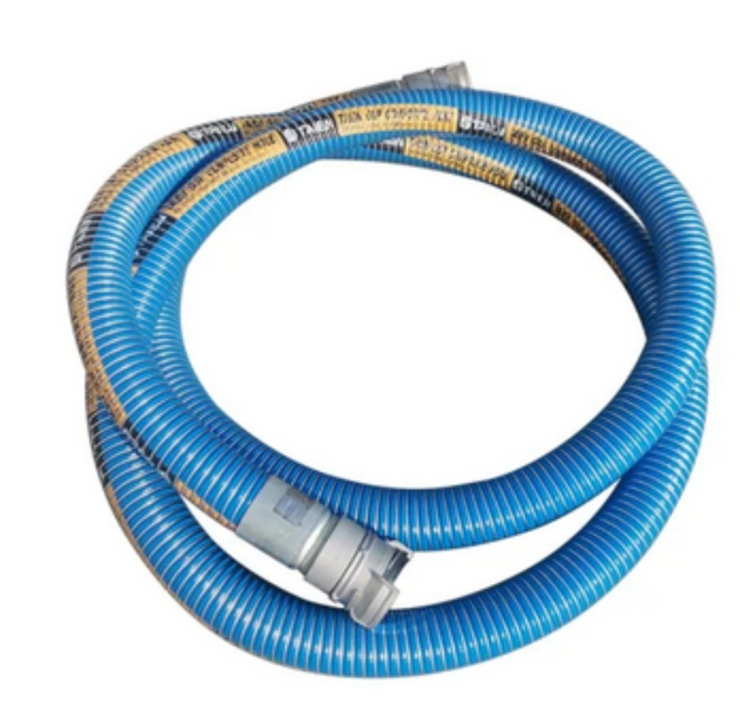

Oil Hoes

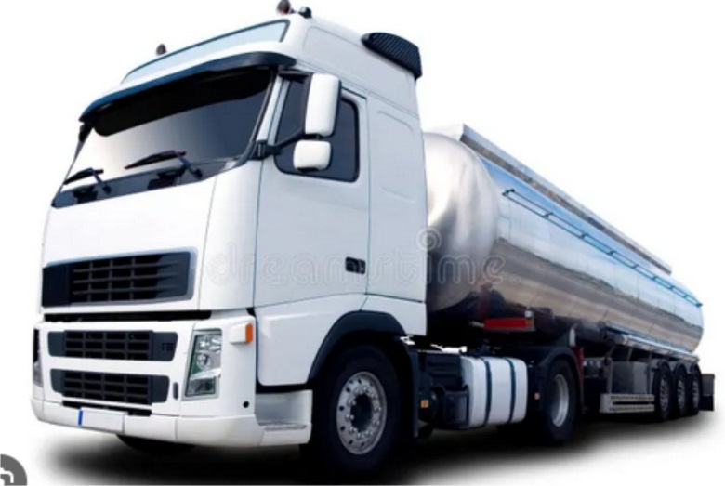

Oil Truck

CHAPTER FOUR
- DISCUSSIONS
I have gained an exposure and enlightenment which could not have been possible without the program.

The SIWES program has really influence my understanding positively as related to my field study and have imbibe in the courage, audacity and confidence to be competent and consistent in the disposition of my responsibilities as a transportation planning and management.

  - RELEVANCE OF EXPERIENCE GAINED DURING SIWES
I was introduced by my industrial based supervisor to the proposed Practoil Ltd and the ongoing maintenance works, which includes; how to daily records of all truck of loaded quantity which they submit to the head of logistic daily. I also with logistic agent to check truck entry to depot. My duties were to observe and report the weekly inflow and outflow of trucks, and also observation of shipping oil through pipeline, from each department of the company and report to office for further actions.

CHAPTER FIVE
5.0 CONCLUSION
To conclude my report I have seen the essence of going through the student industrial work experience scheme (SIWES) the impact of the training on me cannot be over emphasized in the sense that I have been able to understand practically the importance aspect of the course of my study which might not have possible without this program.

    - PERSONAL IMPRESSION ABOUT THE ORGANIZATION
One of the reason why I was personally impress about the organization
I was attached to this because the firms that undertake service that is relevant to my field of study.

Another reason why I was impressed about the organization was because head of logistics is ready to train me and I go out with him for an inspection and supervisor of the organization properties undergoing repair so he had the time to train me. Also I was in a position to stay in the office to do office work. Again I was given guideline by the staff of the organization in any work given to me and how to do it well. I was impressed because of the interaction I had with all other members of the organization during the four months training so with all that has been said above I can say that I was personally impressed about the organization that I was attached during my four months industrial training.

    - SUGGESTIONS/RECOMMENDATION
I hereby suggest to the organization to expand more time and energy to. I.T student, so as for them to take more serious on their SIWES programme. To this end, as practicing and prospective practicing transportation planning and managment, my admonition “do not sacrifice honesty, integrity and devotion” to the Polytechnic, I suggest institution and the industrial training fund office to find a suitable solution to the problem that the student are facing during industrial attachment programme the Federal Government should urge the prospective corporation and company were student normal undertakes SIWES programme to pay more attention to them and also assist them wherever their assistant id required, the industrial training fund office and institution should ensure that the delay in given student their entitlement, so that the oncoming student will be able to appreciate more the essence of going for industrial training scheme (I.T.S)

