

KWARA STATE POLYTEHNIC, ILORIN

REPORT ON STUDENT INDUSTRIAL WORK EXPERIENCE SCHEME
(SIWES)
UNDERTAKEN AT
NATIONAL ASSEMBLY ABUJA
THREE-ARMS ZONE, P.M.B 141, ABUJA
PERIOD OF ATTACHMENT:
August 2024 to November 2024
By
FAOLA ISAAC OLUWATOBILOBA
ND/23/COM/FT/0006
SUBMITTED TO
DEPARTMENT OF COMPUTER SCIENCE
INSTITUTION OF INFORMATION COMMUNICATION TECHNOLOGY
KWARA STATE POLYTEHNIC, ILORIN
NOVEMBER, 2024.
CERIFICATION
This is to certify that this work was undertake by FAOLA ISAAC OLUWATOBILOBA
with matric number ND/23/COM/FT/0006 at NATIONAL ASSEMBLY ABUJA ICT DEPARTMENT. The report submitted to the department of computer science Kwara State Polytechnic, Ilorin, Nigeria during the 2024/2025 Students Industry Work Experience Scheme

DEDICATION
I dedicate this SIWES report to almighty God for the opportunity and grace given to me during the period of this piece of work to my wonderful parent and as many that have contributed greatly to the success of my industrial Training

ACKNOWLEDGEMENT
Any achievement, be it scholastic or otherwise does not depend solely on the individual efforts but on the guidance and strength of Almighty God. Also, encouragement and cooperation of intellectuals of elders and friends. A number of personalities, in their own capacities have helped me in carrying out this SIWES exercise. I would like to take this opportunity to thank them all. Firstly, my profound gratitude goes to all the members or staff of NATIONAL ASSEMBLY ICT DEPARTMENT who gave me training, encouragement, guide and provided a conducive environment for the exercise. Secondly and finally many more appreciation goes to my supervisor MR AFOLABI SANMUEL who also gave me the opportunity to be part of IT student team to know more about the ISP (Internet Service Provider). He took me as his younger brother and gave me thoroughly supervision throughout the exercise, I also send out my appreciation to my lecturers, friends and Coworkers for their moral support. My special thanks to my wonderful and lovely parents Mr. and Mrs. FAOLA ISOLA who were there for me in terms of care, prayers, financial support and others.
However, I am highly indebted to my reputable supervisor DR. OLATUNJI JOHN ADEBISI.

REPORT OVERVIEW
This report gives detailed description of the Students Industrial Work Experience Scheme (SIWES), which commenced from August 1ST 2024, and ended by November 31TH 2024 at National Assembly ICT, Three-Arms zone P.M.B 141, Abuja State.
NATIONAL ASSEMBLY ICT department formed to meet the communication and Network demands of the legislative management systems. The SIWES program me has provided me a training ground where I acquired skills relating to Internet Service Provider (ISP) i.e., it has provided me knowledge on Computer Networking and also provided me with more ideas on the usage and setting up of Internet Network Components and many more. This has gone a long way in equipping me in merging what was being taught in the lecture room to what was actually learnt during the SIWES program me.

TABLE OF CONTENTS
CHAPTER ONE
1: INTRODUCTION
1.1: BACKGROUND
FUNCTIONS OF THE SIWES UNIT
1.2.THE OBJECTIVES OF THE SIWES
CHAPTER TWO
2.0. LOCATION AND BRIEF HISTORY OF NATIONAL ASSEMBLY ICT
2.1. OBJECTIVE OF NATIONAL ASSEMBLY ICT
2.2 NATIONAL ASSEMBLY ICT ORGANIZATIONAL OF THE NETWORK STRUCTURE
2.3 THE VARIOUS DEPARTMENTS/ SECTIONS AND THEIR FUNCTIONS
CHAPTER THREE
3.0 THE KNOWLEDGE GAINED AND ACTUAL WORK DONE
3.1 KNOWLEDGE GAINED
3.1.1 NETWORKING
3.1.2 NETWORKING TOPOLOGY
3.1.3 NETWORKING PROTOCOL
3.1.4 LOCAL AREA NETWORK
3.1.5 TROUBLESHOOTING A PROBLEM WITH A LOCAL AREA NETWORK
3.1.6 TROUBLESHOOTING THE WIDE AREA NETWORK
3.1.7 IP ADDRESSING
3.1.8 PARCTICAL WORK CARRIED OUT
CHAPTER FOUR
4.0 NETWORKING EQUIOMENT USED AT WORK TECH
4.1 ROUTERS
4.2 SWITCHES
4.3 CRIMPER
4.4 CONNECTORS.
4.5 LAN CABLE TESTER
4.6 ACCESS POINTS (AP)
4.7. PATCH PANEL
4.8 CISCO PACKET TRACE
CHAPTER FIVE
5.0. SUMMARY OF ATTACHEMENT ACTIVITIES
5.1. PROBLEM ENCOUNTERED DURING THE PROGAMME
5.2. CONCLUSION
5.3 RECOMMEDATION
CHAPTER ONE

- INTRODUCTION
The unit started in the Faculty of Engineering Technology in 1979 as an Industrial Co-ordinating unit catering for engineering students on industrial Attachment. The foundation staff comprised of an Industrial Co-Ordinator, a Secretary/ Typist and an Office Assistant until 1993 when an Assistant Industrial Co-Ordinator was engaged. As an accreditation requirement by the National universities commission (NUC), the Unit was formally upgraded to a Directorate in the Office if the Vice - Chancellor in August 1999. Over the years, the student population has increased from 49 engineering students in 1979 to over 2400 students from 26 disciplines spread across seven Faculties of the University. The staff strength has also increased to 10 members.
In the earlier stage of science and technology education in Nigeria, students were graduating from their respective institutions without any technical knowledge or working experience. It was in this view that students undergoing science and technology related courses were mandated for students in different institution in view of widening their horizons so as to enable them have technical knowledge or working experience before graduating from their various institutions.
The Student Industrial Work Experience Scheme (SIWES) was established by the Industrial Training Fund (ITF) in 1973 to enable students of tertiary institution have technical knowledge of industrial work base on their course of study before the completion of their program in their respective institutions. The scheme was designed to expose students to industrial environment and enable them develop occupational competencies so that they can readily contribute their quota to national economic and technological development after graduation. The major background behind the embankment of students in SIWES was to expose them to the industrial environment and enable them develop occupational competencies so that they can readily contribute their quota to national economic and technological development after graduation. The major benefit accruing to students who participate conscientiously in Students Industrial Work Experience Scheme (SIWES) are the skills and competencies they acquire. The relevant production skills remain a part of the recipients of industrial training as life-long assets which cannot be taken away from them. This is because the knowledge and skills acquired through training are internalized and become relevant when required to perform jobs or functions.

  - FUNCTIONS OF THE SIWES UNIT
By the Directorate of the National Universities Commission (NUC) and Industrial Training Fund (ITF), the Unit is mandated to carry out the following functions:
i. Seeking of industrial placement for undergraduate students enrolled in disciplines scheduled for participation in SIWES.
ii. Processing of students’ logbooks, ITF forms and industrial attachment reports upon which is based on the Federal Government funding of supervision and students' allowances.
iii. Fostering of close links between Universities or Polytechnic and industries participating in SIWES programme.
iv. Monitoring of compliance with the requirements of SIWES on the part of students in eligible disciplines as a condition for graduation.
V. Facilitation of the students' allowances to deserving students through e-payment.
Students' Industrial Work Experience Scheme (SIWES) is a mandatory skills acquisition and training programme. It is designed to expose students to the industrial workplace environment in their respective disciplines during their course of study. The students are also expected to develop occupational competences that would facilitate their fitting into the world of work after graduation.

  - THE OBJECTIVES OF THE SIWES

The Industrial Training Funds Policy Document No. 1 of 1973 which established SIWES outlined the objectives of the scheme. The objectives are to:
1. Provide an avenue for students in higher institutions of learning to acquire industrial skills and experiences during their course of study.
2. Prepare students for industrial work situations that they are likely to meet after graduation.
3. Expose students to work methods and techniques in handling equipment and machinery that may not be available in their institutions.
4. Make the transition from school to the world of work easier and enhance students' contacts for later job placements.
5. Provide students with the opportunities to apply their educational knowledge in real work situations, thereby bridging the gap between theory and practice.

CHAPTER TWO
2.0 LOCATION AND BRIEF HISTORY OF NATIONAL ASSEMBLY ICT
National Assembly located at Three- Arms Zone P.M.B 141, Abuja.
The Information and Communication Technology (ICT) Department of Nigeria's National Assembly plays a crucial role in supporting legislative activities through technology. The ICT Department remains critical to the modernization and efficiency of Nigeria's legislative system, fostering transparency, accessibility, and productivity. Here's a brief history and development of ICT within the National Assembly
In 1990s, the National Assembly operated with minimal reliance on ICT. Legislative processes were predominantly manual, including documentation, communication, and record-keeping. The ICT transformation in the National Assembly began as part of broader modernization efforts after Nigeria's return to democracy in 1999.
Initial focus:
- Basic computerization of legislative offices.
- Creation of digital archives for legislative records.
- Provision of email and basic internet services for lawmakers and staff.
A formal ICT Department was established to oversee technology integration and operations.
The department focused :
Deploying ICT infrastructure, including networks, servers, and workstations.
Training lawmakers and staff to adopt digital tools for legislative work.

2.1 OBJECTIVE OF NATIONAL ASSEMBLY ICT
The objective of ICT in the National Assembly of Nigeria focus on leveraging technology to enhance legislative functions, promote transparency, and ensure efficiency in governance. These objectives aim to transform the National Assembly into a modern, technology-driven institution that meets the demands of contemporary governance.
THESE OBJECTIVES INCLUDE:
- Digitalization of Legislative Processes
To automate and streamline legislative workflows such as drafting, reviewing, and tracking bills, motions, and resolutions.
To create a digital repository of legislative documents for ease of access and management.
- Improved Communication and Collaboration
To enhance communication between lawmakers, committees, and staff through email systems, video conferencing, and other digital tools.
To facilitate virtual and hybrid legislative sessions, ensuring continuity of operations under all circumstances.
- Transparency and Public Engagement
To provide citizens with online access to legislative activities, including proceedings, bills, and decisions, fostering transparency.
To create platforms for public participation and feedback on legislative issues.
- Efficient Data Management
To establish systems for secure storage, retrieval, and management of legislative records and data.
To implement robust cybersecurity measures to protect sensitive information.
To promote a culture of innovation and adaptability to emerging technologies.
- Legislative Accountability
To enable real-time tracking and reporting of legislative performance and activities.
To support oversight functions by providing data analysis tools for monitoring government activities.
- Alignment with Global Standards
To adopt international best practices in e-legislation and ICT infrastructure to modernize Nigeria’s legislative system.
To facilitate collaboration with international legislative bodies through shared ICT platforms.
- Operational Efficiency
To reduce paper-based processes, saving time and resources.
To enhance the overall productivity of legislative and administrative functions.

2.2 NATIONAL ASSEMBLY ICT ORGANIZATIONAL OF THE NETWORK STRUCTURE
The organizational structure of the ICT Department in Nigeria's National Assembly is designed to support the efficient management of technology services, infrastructure, and digital transformation initiatives. Below is an outline of its typical organizational structure, followed by a description of roles: The ICT department is often structured into divisions or units that align with specific functions. These include:
A. Leadership
Director of ICT: Heads the department and oversees all ICT operations and strategic planning. Reports to the Clerk of the National Assembly or a higher administrative authority.
B. Core Units/Divisions
- Network and Infrastructure Unit: Manages physical and digital networks, servers, and communication infrastructure.
- Application Development and Maintenance Unit: Develops, maintains, and supports software applications, including legislative management systems.
- Support and Operations Unit: Provides technical support to lawmakers and staff; handles troubleshooting and helpdesk services.
- 556Cybersecurity and Data Management Unit: Focuses on data protection, cybersecurity policies, and the secure storage and retrieval of information.
- E-Legislative and Public Access Unit: Oversees digital platforms for public engagement, online legislative tools, and transparency initiatives.
- Training and Capacity Building Unit: Conducts ICT training for legislators and staff to improve digital skills.
Below is a simplified organogram for the ICT Department of the National Assembly:

Director of ICT
|
----------------------------------------------------------------------------------------
| | | |
Network & Application Support & Cybersecurity &
Infrastructure Development Operations Data Management
Maintenance
| |
Training & Capacity E-Legislative
Building & Public Access

2.3 THE VARIOUS DEPARTMENTS/ SECTIONS AND THEIR FUNCTIONS
- Director of ICT: Provides strategic leadership for ICT initiatives and ensures alignment with legislative goals.
- Deputy/Assistant Directors: Assist the Director in managing specific units or projects.
- Network Engineers: Maintain and troubleshoot the assembly’s ICT infrastructure.
- Software Developers: Develop and maintain legislative management applications.
- ICT Support Staff: Provide technical support and resolve user issues.
- Cybersecurity Analysts: Ensure the protection of ICT systems against cyber threats.
- Trainers: Conduct workshops and training sessions to build ICT competency.
- Public Access Coordinators: Manage citizen-facing digital platforms and public information systems.

CHAPTER THREE

3.0 THE KNOWLEDGE GAINED AND ACTUAL WORK DONE
This chapter tell in detail the actual work carried out. During the duration of SIWES program in National Assembly ICT. Serving as a field engineer, I gained experienced on computer networking, setting up of internet links, configuring of network device and troubleshooting on client’s computer networks or internet link when is down. I was mostly involved in carrying out this engineer service as well as support service. Highlighted below is the
3.1 KNOWLEDGE GAINED
How to monitor network traffic What are optics fibers?
Twisted pair cable and it uses How to crimp twisted pair cable
How to ping What switch is
How to configuration switch What router is
The use of packet tracer Ip addressing
Troubleshooting of network
How to use the wire tracker to test and scan LAN cable

3.1.1 NETWORKING
Network are component involve in connecting computer and application across small and large distance.
Each computer on the network has access to the files and peripheral device (Such as printers or modems) on all the other computers on the network.
3.1.2 NETWORK TOPOLOGY
Common topology found in networking includes mesh topology, star topology, bus topology, ring topology, and others.
Network topology refers to the layout of the transmission medium and devices on a network. Topologies use either a point to point or multipoint connection scheme.
A connection scheme indicates how many devices are connected to a transmission media segment or an individual cable.
An example of point-to-point connection scheme is a modem/ printer connected to computer, direct cable connection between two computers.
An example of a multi-point connection scheme is a star or bus topology network.

STAR TOPOLOGY
This is a local area network topology where all the nodes are connected individually to a central connecting device called a hub or switch. Signals travel from the nodes to the hub which then sends signals to other nodes on the network. A star topology network is scale able –i.e., it can be design
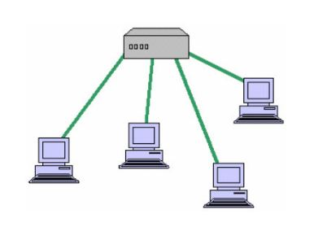
and redesign easily

.
BUS TOPOLOGY
A LAN topology where each node is connected to a single main bus cable, is transmits data to all the nodes on the network. The bus is actually a series of cable segments running from one node to the other. Break or faulty piece of cable anywhere on the segment prevents all the computers on the segment from being able to communicate.
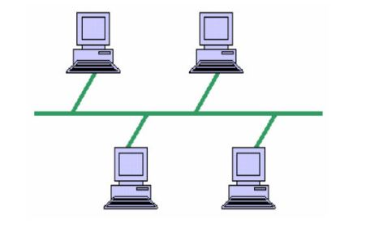

MESH TOPOLOGY
This is a network topology where every node on the network has a separate wire connecting it to every other node on the network. It provides each device with a point-to-point connection to every other device in the network. This type of network has a high fault tolerance because failure of one node does not affect
data transmission between other nodes.
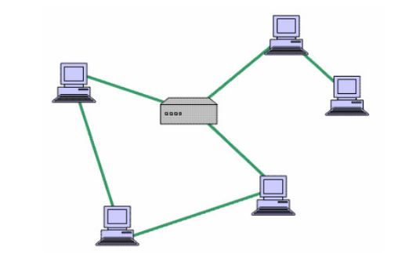

3.1.3 NETWORK PROTOCOLS
TCP/IP: The primary protocol suite used on the internet, responsible for communication between devices.
OSI Model: A conceptual model that describes how network communications are organized into layers.
IP Address: A unique numerical address assigned to each device on a network.
DNS (Domain Name System): Translates domain names (like google.com) into IP addresses.
HTTP (Hypertext Transfer Protocol): The protocol used for transferring web pages.
FTP (File Transfer Protocol): The protocol used for transferring files.
SMTP (Simple Mail Transfer Protocol): The protocol used for sending email.

3.1.4 LOCAL AREA NETWORK
A local area network (LAN) is a group of devices connected in a limited area, such as a home, office, or school, that allows users to share resources and communicate
TRANSMISSION MEDIA
- Wired media
- Wireless media
WIRED MEDIA
These are media which require the use of wires, lines and cables to transmit communication signals. During my industrial training at NATIONAL ASSEMBLY, I encountered majorly three different types of wired network media namely:
COAXIAL CABLE
A coaxial cable is an alternative for protecting data from noise. Coaxial cables do not produce external electric and magnetic fields and are not affected by them. This makes them ideally suited, although more expensive, for transmitting signal
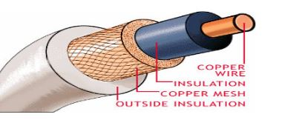

TWISTED PAIR CABLE
In a twisted pair there are eight copper wire that are coated with different
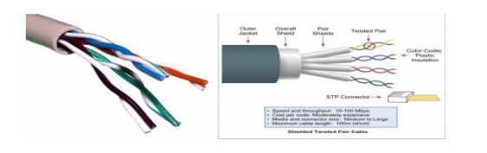
colours; the colours are mix/orange, orange, mix/blue, blue, mix/green, green, mix/brown and brown.

Unshielded twisted

The unshielded twisted pair cable has categories which include
Category 1 | Voice only telephone
Category 2 | Data to 4mbp (local talk)
Category 3 | Data to 10mbps (ethernet talk )
Category 4 | Data to 20mbps (token ring)
Category 5 | Data to 100mbp (fast Ethernet)
Category 5e | Data to 1000mbp (Gigabit Ethernet)
Category 6 | Data to 2500mbps (Gigabit Ethernet)

The Cat 5e run up to 90meter and it’s a solid core cable ideal for structural installation (PVC) or plenum
It terminated with RJ-45 Connector
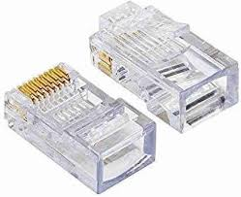

I was able to terminate cable that are very essential in networking, The two cable I terminated were
- Straight through that connect dissimilar device
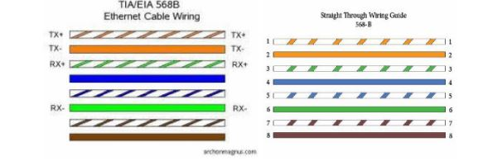

- Cross-over that connects similar device
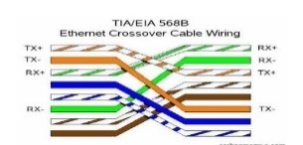

In straight-through method, in any way you put in your cable, the colour adopted at both ends must be the same.
In a cross-over method all you need to do is to terminate one end with a straight rule method and the other end would be that pin ‘1’ goes to pin ‘3’ and vice- versa, the pin ‘2’ then goes to pin ‘6’ and also vice-versa.
I got to know that a cross-over cable is used to connect two similar devices like a PC to a PC while a straight through cable is used to connect different devices e.g. a PC to a router

Before termination the are necessary tool needed to do the job right and they are
- Cat5e cable,
- RJ-45 connector,
- Cable stripper,
- Cutter,
- Crimping tool
Steps to follow when making connection /termination
- Strip cable end,
- Untwist wire ends,
- Arrange wire,
- Trim wire to size,
- Attach connection,
- Check,
- Crimp,
- Test
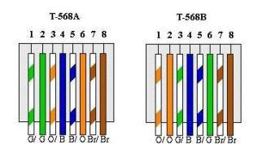
Arrangement of wires is done following standards there are standards A and B

Standard A: (Green white), Green, (Orange white), Blue, (Blue White), Orange, (Brown white), Brown
Standard B: ((Orange white), Orange, (Green white), Blue, (Blue white), Green, (Brown white), Brown.
Then they should be trimmed to the right size which is 1/2”
The colour order should be maintain when are being fixed into the RJ-45 connector and the connector should be facing downwards, make sure all the wires extend to the end of the connector
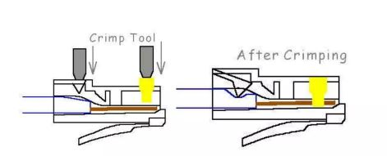
Squeeze firmly to crimp connector onto cable end

Then finally test the cable with cable tester
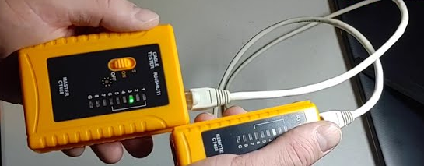

FIBRE OPTIC CABLE
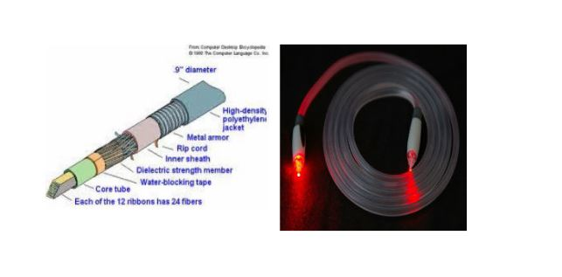
At NOC the backbone upon which the network is built is fibre optic. It is made of glass fibres instead of wire; it consists of a Centre glass core surrounded by several layers of protective material. The outer insulating jacket is made of Teflon or PVC. The fibre optic cables transmit light rather than electronic signals, thereby eliminating the problem of electrical interference

Optical fibres come in two types:
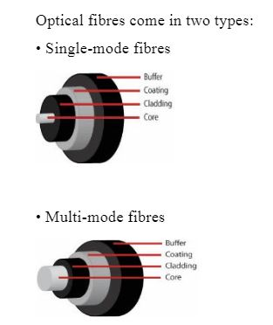
- Single-mode fibres

- Multi-mode fibres

Single-mode fibres have small cores while
Multi-mode fibres have larger cores. Used for short-distance communication links.
WIRELESS MEDIA
To fully explore the wireless added dimension, Communication system designers have sought to use wireless media to reduce infrastructure cost and complexity, when compared to wired communication systems. There is no need to construct miles of telephone line poles or cable trenches.

3.1.5 TROUBLESHOOTIN A PROBLEM WITH A LOCAL AREA NETWORK
It is pertinent that the process of troubleshooting a network is discussed as it will be needed at one point or the other. Usually, issues could arise whereby a computer refuse to send or receive data over a network and at such time necessary troubleshooting steps must be carried out to eradicate this problem. The common steps of troubleshooting are listed and explained below in appropriate order from the first thing back to the thinkable thing to do.
Checking The Computer LAN Port: if a computer fails to receive or send data, the port through which the computer connect to the network must be checked for presence of activity light. If the computer has no light indicator, then the network icon on the computer screen should be used for confirmation. Once the light is confirmed off and the connection seems appropriate, the cable can be changed or tested elsewhere. If the cable tests okay and the LAN port of the computer or the device at the other end might be damaged – this rarely happens though unless affected by a lightning strike from an outdoor unit.
Checking The internet protocol (IP) Address: In some case, the port might be active but there won’t be any data activity. This can be caused by a problem with the IP. The IP is a protocol used by network devices to assign a unique sequence of numbers used to identify a particular computer (or domain name in the case of the internet.) it helps to identify the location of a computer to which data is sent or received. If two IP’s are accidentally assigned in a network, then only one will be communicate in the network and the other not active. This situation is referred to as IP conflict another IP must be assigned to such conflicting computer
Checking the Server or Switch or Router: Since the connection of computer is aided by a central device, problem may arise from a source of connection such as the server or switch. These problems may be due to power cut on the device, error in configuration of the device or disconnection of the central cable connecting such central device to the computers.
The Ping Test: Since all device including computer have unique addresses, it is easy to test if a computer in a network is responding or not. The method of carrying out this test is carried out by sending a message from one computer to another to check whether it is reachable and active. This test is called Ping. It is carried out on the command prompt interface of computer by inputting the command, “ping 192.168.4.1(note command enclosed in ellipses). This is shown in the figure below
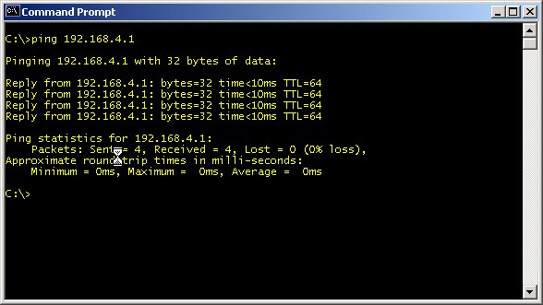

A snapshot of a ping test carried out from a host in a network
The time shown in the figure to be 1millisecond show that it takes just that time to reach the computer with the IP 192.168.4.1. Four packets were sent and all four were received with no loss of data.
It is imperative to note that the ping test is not limited to the LAN alone but also used in a WAN and on the internet as long as the destination host an IP address-local IP address in a LAN and a global IP address on the internet.

3.1.6 TROUBLESHOOTING THE WIDE AREA NETWORK
The troubleshooting processes in a WAN is similar to that of the LAN. The Network tools discussed above help to make these troubleshooting process easier since they tell information about where to look first, However, the processes in troubleshooting a WAN would be discussed below
The Ping Test:
Ping is a command-line program that test the connectivity and availability of device on a network, It is fundamental tool for network administrator to troubleshoot issues like reachability name resolution and latency
Pinging seems to be the first thing to do both in a LAN or WAN. As explained in LAN earlier, every device has its unique IP address and can therefore be pinged from any host in the network. The ping test can also be used to monitor the reply time over a long period of time. The command remains the same but ‘-t’ is added after the IP to make the ping test continuous and not just four packet test as shown earlier. The ping can be cancelled later pressing ‘ctrl C’ on the keyboard of a host.
Telnet:
This is similar to the ping test as it is also carried out in the command prompt interface of a computer. The difference however, is that telnet enable certain configuration and changes be made on the accessed device. If the frequency of operation of a client’s radio at a distance 50km away from the service provider office were to be changed, there won’t be a need to send an engineer over. Once the client’s radio is on, the radio can be “telneted” into and then the frequency modified by inputting the correct command
If a Ping Test fails and a Telnet fails to respond:
In thus occasion, one thing must have been the problem; power cut at the destination device/host. If a computer or device in a separate location to reply to a ping test and/or telnet, the computer /device might be turned off at that time and this has to be confirmed. If the device is powered then there might not be an established link between the source of test and the destination and the data route must be traced. Trace routing is done on the command interface by entering the command line, ‘tracert’ followed by the destination IP, say 41.223.67.50. The subsequent appearing line show how the data flow from the source system toward the destination and a failure at a point tell where the connection had been broken.
3.1.7 IP ADDRESSING
An IP address is a unique identifier that is assigned to a host on a network. It is also a unique identifier for a host or a node on a network. We have IPv4 and IPv6. The most used being IPv4 (with 32bits).
Functions of IP Addressing
• For location of a device on the network
• It is assigned to allow hosts on one network to communicate to hosts on another network
• IPv4 address is 32 bits divided in to four octets or bytes using dot ’.
Classes of IPv4 Addresses
IPv4 which is 32bits has class ranges from class A-E
Class A : This Class address can only be between 0 and 127. All 0’s reserved for default route and ‘127’ is reserved for trouble shooting –loop back, therefore in reality
Class A valid address range that can be assigned to host on a network is 10- 126
Class B : Class B address can only be between 172 – 191
Class C : Class address can only be between 192 – 223
Class A-C is used for uncast.
Class D (224-239) used for multicasting
Class E (240-255) for research purposes
Subnet Mask
The subnet mask for class A ranges from 255.0.0.0
The subnet mask for class B ranges from 255.255.0.0
The subnet mask for class C ranges from 255.255.255.0
The first octet determines the class.
The ‘255’ above represent the network portion and the zeros represent the host
portion.
3.1.8 PARCTICAL WORK CARRIED OUT
I carried out an unaccounted number of resolved network issues, among few I still remember are:
- I configure a brand-new switch for CNA national assembly
- Resolved the LAN port in Honorable office Houses of representatively
- Resolved networking issues in server room of House of representatively
- Installation of switch into the rack
- Troubleshoot network issues in ELV ROOM senate building in national assembly
CHAPTER FOUR

4.0 NETWORKING EQUIOMENT USED AT WORK TECH
4.1 ROUTERS
A router is a device that forward data packets along network. A device that forwards data packet between computer network, creating an overlay internetwork. A router is connected to at least two networks, commonly two LANs or WANs or a LANs and its ISP’s network. When a data packet comes in one of the lines, the router reads the address information in the packet to determine its ultimate destination. Then using information in its routing table or routing policy, it directs the packet to the next network on its journey. Router are located at gateways, the place where two or more network connect.
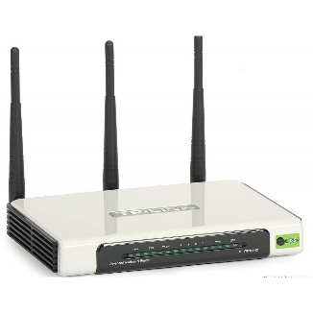
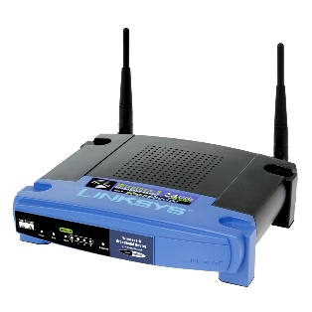
Router use headers and forwarding table to determine the best path for forwarding the packet and they use protocol such as ICMP to communicate with each other and configure the best route between any two hosts. A router is connected to two or more data lines from different networks
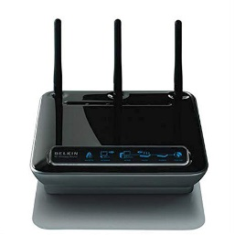

FUL1-F5D8231-4 Router Linksys wireless G-router tp-link-tiwr940n-tplink-router

4.2 SWITCHES
Switches allow communication between devices on the same local network (LAN). They operate on Layer 2 (Data Link Layer) of the OSI model, using MAC addresses to forward data to the correct device.
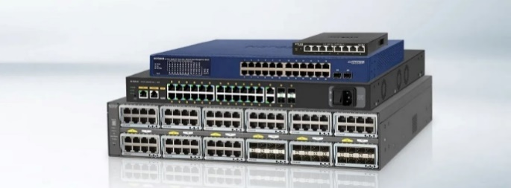

Types:
Core Switch: found at the data center of a network, handing large data flows and usually within large organization
A Distribution: Refers to switches in the distribution layer of a network architecture.
Managed Switches: Provide advanced features, like VLANs (Virtual LANs), quality of service (QoS), and network traffic monitoring.
Unmanaged Switches: Basic switches that don’t offer advanced features and are typically used in smaller setups.

4.3 CRIMPER
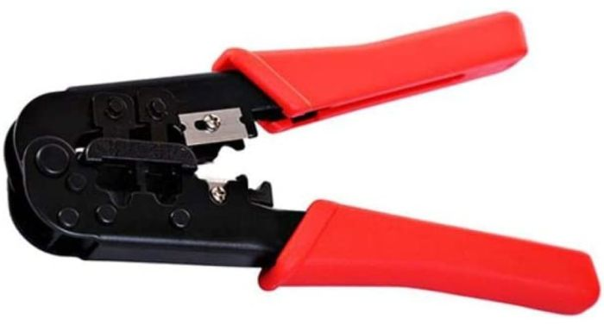
This is a RJ45 crimper tool, which is use for crimping of twisted pair cables or LAN cable such as cross cable and straight cables

4.4 CONNECTORS
Rj-45 plug is the common name for an 8P8C modular connector using 8 conductors which pin down wires in a twisted pair cable

4.5 LAN CABLE TESTER
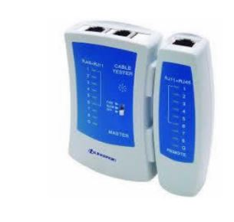
This is used to test if a category cable has been well terminated, or develop a fault.

4.6 ACCESS POINTS (AP)
An Access Points provide wireless connectivity, allowing devices to connect to the network without cables. WiSM (Wireless Service Module) is hardware module that help to management wireless local area network . There two type of Access point
Standalone Access Points: Simple devices that provide Wi-Fi to a limited number of devices.
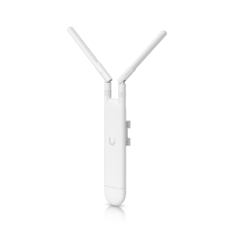
Controller-Based Access Points: Centralized management for large environments where multiple APs are deployed. Multiple AP, is SSIDs (Service Set Identifiers) for different groups of users (e.g., guest, employees).
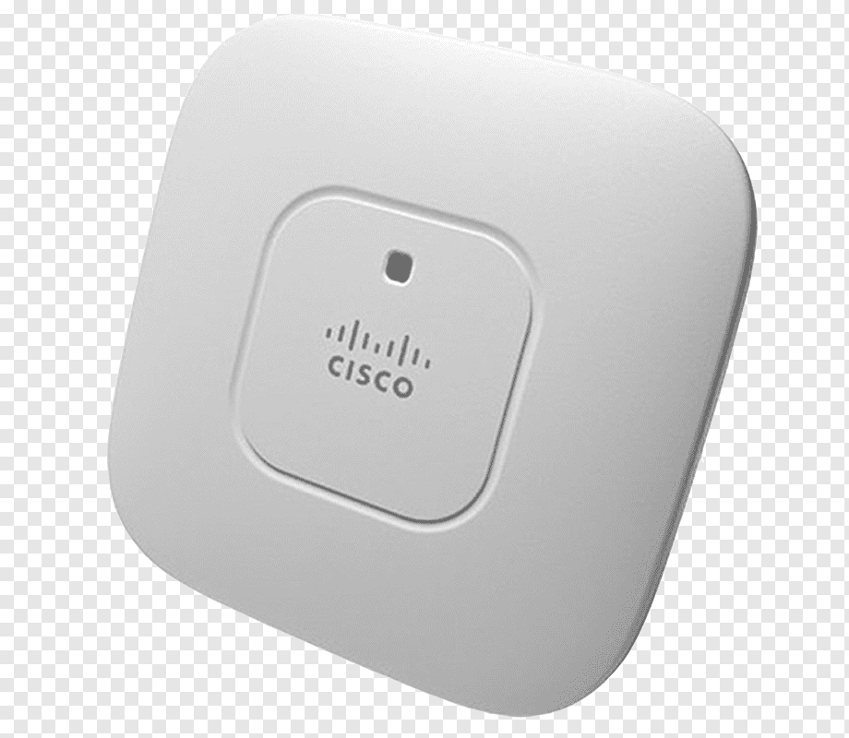

4.7 PATCH PANELS
A Patch panels organize and centralize network cables, making it easier to manage and maintain network connections.
Type of patch panel
Ethernet Patch Panels: Support twisted-pair cables for Ethernet networks.
Fiber Patch Panels: Support fiber optic connections. Color-Coding for easy identification,
Modular Design for easy expansion and reconfiguration, Cable Management to reduce tangling and wear. loss of connectors and splices, and other events such as sharp bends that may have been incurred during cable installation.
4.8 CISCO PACKET TRACER
Cisco packet Tracer is an innovative network simulation and visualization tool. Packet Tracer provide an easy way to design and build network of varying size without expensive lab equipment Packet Tracer is a tool that allows you to simulate real network packet Tracer
VlANs
Within a switch internetwork, VLANs provide segmentation and organizational flexibility. VLANs provide a way to group device within a LAN. A group of devices within a VLAN communicate as if they were attached to the same wire. VLANs are based on logical connections, instead of physical connection. VLAN allow an administrator to segment network based on factors such as function, project team, or application, without regard for the physical location of the user or device. Device within a VLAN act as if they are in their own independent network even if they share a common infrastructure with other VLAN s. Any switch port can belong to a VLAN, and unicast, broadcast, and multicast packets are forward and flooded only to end station within the VLAN where the packet are sourced. Each VLAN is considered a separate logical network, and packet destined for station that do not belong to the VLAN must be forwarded through a device that support routing.
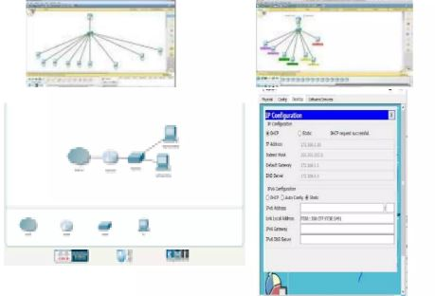

CHAPTER FIVE
5.0. SUMMARY OF ATTACHEMENT ACTIVITIES
Chapter one of these reports is about introduction to the work experience gained while on the industrial training at NATIONAL ASSEMBLY ICT Abuja. And also about the background and objectives of the scheme (SIWES) that was established by ITF in 1993/1994, in order to promote the acquisition of practical skill in industrial and commerce sector of the economy.
Chapter two gives detail about the establishment and its objectives, the various Departments and their function
Chapter three and four is about some of the works/activities and experience gained at IT department in NATIONAL ASSEMBLY ICT Abuja which is basically on networking
Chapter five which is the last chapter of this report contain summary, problem encountered, recommendation and conclusion
After my four month of student industrial working Experience Scheme (SIWES) at NATIONAL ASSEMBLY ICT Abuja, I was able to familiarize myself with networking, their basic tool and also up internet links and also more about Cisco company and their certification which am intending to partake in soon.
5.1 PROBLEM ENCOUNTERED DURING THE PROGAMME
Too many SIWES students;
Limited staffs to take us all
Problem of pass LAN cable through celling from management switch to office
Problem of getting the right company that will absorb the IT student
5.2. CONCLUSION
I really appreciate the effort of the Government for embarking and keeping alive this training. it was not only to be practically oriented but to also expose student to working experience, how to relate with people at work and installing of discipline into students, and I want to advice the next SIWES student to really take this program with all seriousness and not just do it because of the grade involved through it’s a large grade should take it seriously because this would make them standout as practical computer scientist
5.3 RECOMMEDATION
The operation of SIWES lies on the proper supervision. Thus, it becomes necessary that something must be done at the operational level to enhance adequate functioning of the programme. Also, ITF should be providing insurance cover to students on attachment, improve on paying students supervisor allowance for motivation and probably pay the student before the commencement of the programme the help with any financial challenge.
From the full details on the experience which I had during the training programme which give me the privilege to relate with IT guru and other student from different institution. I should say that SIEWS should build up a more efficient body to achieve aims and objective

