
A REPORT ON
STUDENTS INDUSTRIAL WORK EXPERIENCE SCHEME
(SIWES)
UNDERTAKEN AT
PROMINENT CONSULTANT SERVICE
NO. 12, ODUNDIRAN STREET, ALIMOSHO LAGOS STATE.

BY
ABDULATEEF OLUMIDE
ND/23/BLD/FT/0063

SUBMITTED TO:
THE DEPARTMENT OF BUILDING TECHNOLOGY, INSTITUTE OF ENVIRONMENTAL STUDEIS, KWARA STATE POLYTECHNIC, ILORIN.
IN PARTIAL FULFILMENT OF THE REQUIREMENT FOR THE AWARD OF NATIONAL DIPLOMA (ND) IN BUILDING TECHOLOGY.

ACKNOWLEDGMENT
All praise and adoration is due to Almighty God, who has keep me alive till this present moment.

TABLE OF CONTENT
Title page
Acknowledgment
Table of content
CHAPTER ONE: INTRODUCTION
  - Introduction
  - Definition of Siwes
1.2 Aims and Objectives of Siwes
CHAPTER TWO
2.0 Location and Brief History
2.1 Organizational Structure
2.2 Function of various dept/unit
CHAPTER THREE:

3.0 Report on work actually carried out
CHAPTER FOUR:
4.1 Challenges Encounter
4.2 Suggestion to Improvement of the Scheme
4.3 Recommendation
4.4 Conclusion

CHAPTER ONE
1.1 INTRODUCTION
The Industrial Training is a training Scheme by which a student can undergo practical training within an approved Industrial undertaking having specific amount of fixed assets or turnover of paid up share capital. The scheme is a participatory program involving Universities, Polytechnics and Technical Colleges and students of carious Institutions of Nigeria.
The Student Industrial Work Experience Scheme (SIWES) is funded jointly by Industrial Training Fund (ITF). The Scheme completes part of the academics requirement standards in pursing the award of the National Diploma in Office Technology Management. The training lasts for six months. The theory and the practical aspect are being joined together in the programme in order to find out how things are being done. In theory, we are to read electronic guidance, books, novels which concern deeply with sense of belonging especially in course of concern them in practical we have to know how to do things by ourselves to enhance spirits of commitment in all we do. That is why, for efficient moving of this programme in conjunction with ministry of education has set a step that students should be going for these programme. Office Technology Management Departments has seen it as a step forward of progress by sending their student to embark on it.
  - DEFINITION OF SIWES
Student industrial working experience scheme (Siwes) is a program organized by industrial training fund (ITF) for National Diploma science student after their first year (ITF) for National Diploma science student after their first year on campus , to help them known more about the practical aspect of what they have been thought in the school, thou will do practical in the school but we still have some area where we have to know, that it will help us in future to be able to call ourself a computer operator , programmer a system analyst.
  - AIMS AND OBJECTIVE OF SIWES
- It promotes interaction between student in training and the company staffs.
- It helps us to gain moiré to what to customer.
- It help us to know how to relate to customer
- It help us to be perfect in our course of study
- It help us to know how the computer system is been operate
- It help us to know more about practical aspect of what we have being taught in the school

CHAPTER TWO
DESCRIPTION OF THE ESTABLISHMENT OF ATTACHMENT
2.1 LOCATION AND BRIEF HISTORY OF EXTERTECH
2.2 ORGANIZATIONAL STRUCTUREOF EXPERTECH
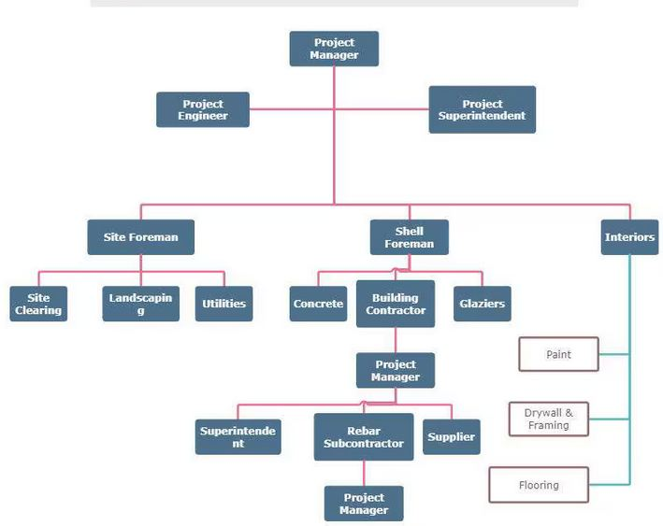
2.3 FUNCTION OF VARIOUS DEPT/UNIT

1. Project Manager
- Oversees the entire project from planning to completion.
- Manages budget, timeline, and project scope.
- Coordinates with stakeholders, clients, and team members.
- Ensures compliance with regulations and quality standards.

2. Project Engineer
- Provides technical support for project execution.
- Reviews engineering designs, blueprints, and specifications.
- Ensures construction follows technical and safety standards.
- Solves engineering-related issues on-site.

3. Project Superintendent
- Supervises daily on-site construction activities.
- Ensures work progresses according to schedule and plans.
- Manages subcontractors and site personnel.
- Enforces safety and quality control.

4. Site Foreman
- Directly oversees construction crews.
- Assigns tasks and ensures proper execution.
- Maintains worksite safety and productivity.
- Reports progress to the superintendent or project manager.

5. Shell Foreman
- Supervises the construction of structural elements (foundation, walls, floors, roofs).
- Ensures proper execution of formwork, concrete, and steel reinforcements.
- Coordinates with concrete and rebar subcontractors.

6. Interiors
- Manages interior finishes such as painting, flooring, ceilings, and fixtures.
- Ensures compliance with design specifications.
- Works with designers and suppliers to enhance aesthetics and functionality.

7. Site Clearing
- Prepares the construction site by removing debris, trees, and obstacles.
- Ensures proper ground leveling and soil preparation.
- Sets the foundation for construction activities.

8. Landscaping
- Enhances the outdoor appearance of the project through planting, paving, and site beautification.
- Ensures proper drainage and environmental sustainability.
- Works on both functional and decorative outdoor elements.

9. Utilities
- Handles installation of essential services like water, sewage, gas, and electricity.
- Coordinates with municipal authorities for service connections.
- Ensures compliance with utility regulations and safety standards.

10. Concrete
- Oversees concrete mixing, pouring, curing, and finishing.
- Ensures the structural integrity of foundations, columns, and slabs.
- Works with rebar subcontractors to reinforce structures.

11. Building Contractor
- Executes the construction project as per contract terms.
- Manages labor, materials, equipment, and subcontractors.
- Ensures compliance with safety, legal, and regulatory requirements.

12. Glaziers
- Install glass in windows, doors, and facades.
- Ensure proper sealing, insulation, and safety of glass components.
- Work with architects and engineers on glazing specifications.

13. Rebar Subcontractor
- Specializes in reinforcing steel (rebar) installation in concrete structures.
- Ensures steel reinforcement is placed according to design specifications.
- Works closely with concrete teams for structural integrity.

14. Supplier
- Provides construction materials, tools, and equipment.
- Ensures timely delivery of quality products.
CHAPTER THREE
REPORT ON WORK ACTUALLY CARRIED OUT WITH CLEAR STATEMENT
3.0 WORK EXPERIENCED DURING ATTACHMENT
I was introduced by my industrial based supervisor to the proposed buildings and the ongoing maintenance works, which includes; the rehabilitations of some of the buildings, raising of fallen fences, repair of roof leakages, a walkway and an ongoing construction of a new building. My duties were to observe and report the weekly construction activities and work progress carried out on site, and also to execute a brief inspection of the complaint with respect to building.
3.1 INTRODUCTIONTO SITE MATERIALS, EQUIPMENT AND MACHINERIES
In the process of my work experience program I was introduced to various materials, equipments and machineries used in the construction and development of a building.
MATERIALS
Example of materials used in building construction is as follows;
Cement: This is a powdered substance that develops strong adhesive properties when mixed with water. It is used in Block work, Plastering, Rendering and Concreting. The establishment of Cement is achieved by burning a mixture of clay and chalk or limestone in a kiln. A proportion of the raw materials in a definite proportion are converted into liquid state by grinding, mixing and watering, termed Slurry. The slurry is then conveyed through a set of pipes to rotary kiln which dry and burn the constituent in a high temperature to form hard lumps.
This process changes the slurry to hard lumps called Clinker, which afterwards pass on through a conveyor belt to the grinding mills for grinding to a fine powder in its final process. During the final grinding, small quantity of gypsum of between 2 and 5% of the whole materials is added to retard the setting time. Tests are usually carried out on the finished product occasionally to ensure high quality.
This process is mainly on Ordinary Portland Cement (OPC) used for general purposes. There are other types of cement made for special purposes, including Rapid Hardening Portland Cement (RHPC), Sulphate resisting Portland cement and Low Heat Portland Cement, Water repellent Portland Cement, and other varieties of cement such as; higher alumina cement, quick setting cement, white cement and so on.

CEMENT
Reinforcement: Reinforcement is provided in concrete structures to enhance its tensile strength. Therefore in all structural elements, the reinforcement is provided in the region of the element that will be subjected to tension.Standard bar diameters ~ 6, 8, 10, 12, 16, 20, 25, 32 and 40 mm.
Aggregates: This consists of sand, ground crushed stone, pebbles, broken blocks and similar such materials. Aggregates may either be light or heavy weight and also All-in-Aggregates. Aggregates must be clean, structural sound, well graded, weather resistance and inert in the presence of water.
Aggregates are of two types:
Fine Aggregate; this should be clean, sharp and passes through the sieve size of 4.5mm.
Coarse Aggregate; aggregate which consists largely of particles over 5mm in diameter. This is usually gravel or crushed stones.

Mineral Fibre Felt: a waterproofing membrane consisting of a thin fibrous mat of polyester or glass fibres saturated with bitumen or a bitumen-polymer, it lies between the actual roof and the house and the layer of protection from the element. It is always 36” wide and they come in a rectangular shape (roll).The mineral fibre felt was used during the repair of roof slabs leakages, it was applied after the roof slabs has been primed, this was carried out by heating the primed surface and the felt together with the aid of gas.
EQUIPMENTS
The following are examples of various tools used in construction;
Trowel: This is a flat metal blade fixed to a short handle used for the application, jointing, smoothing and shaping of mortar in masonry. It is also used in the trimming of block/bricks. Trowel sizes ranges from 225-350mm measuring from the blade.

Building Square: refers to tools used to ensure accuracy and precision in construction, particularly for creating and checking right angles, measuring, and marking lines, such as framing squares, combination squares, and speed squares.
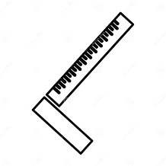
Pegging and profiling: are methods used for setting out a building or structure, where pegs mark the location of key points and profile boards, attached to the pegs, provide a stable, horizontal reference for accurate measurements and construction.
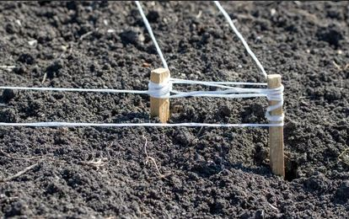

Tape measures: is used to measure distance and alignments essential tools for accurate length and distance measurements.

MACHINERIES
The machineries that were used on site were brought into considerations so as to promote high standards required particularly in the context of structural engineering works. Machineries are used on site to eliminate heavy manual work thus reducing fatigue and as a consequence increasing productivity. Such machineries that were used include;
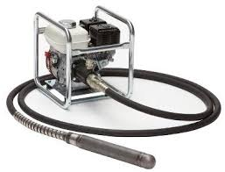
Tilting Drum Concrete Mixer: This is a type of concrete mixer with a rotating hinged drum in which the constituent materials are mixed thoroughly and can be tilted to enable emptying. Choice of Mixer ~ the factors to be taken into consideration when selecting the type of concrete mixer required are …
1. Maximum output required (m3/ hour).
2. Total output required (m3).
3. Type or method of transporting the mixed concrete.
4. Discharge height of mixer (compatibility with transporting method).
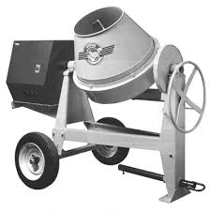

Poker Vibrator: This consist of a hollow steel tube casing in which is a rotating impellor which generates vibrations as its head comes into contact with the casing. It is immersed in fresh concrete to provide compaction through gentle agitation.

Pic; poker vibrator

Block molding machine: The block molding machine has a demountable mould which determines the size of the blocks to be molded. It is either powered by a diesel engine or electricity. The engine enables the machine to induce the desired vibration to the mix placed in the mould in order to enhance the strength of the blocks.

pic; Block molding machine
CONCRETING
This is generally referred to as Casting. It is a process of working with freshly mixed concrete especially the placing of concrete. Before the establishment of the second floor some procedures where undertaken. Such procedures include;
- Material Supply and Storage: This is the receiving on site of the basic materials namely cement, fine aggregate and coarse aggregate and storing them under satisfactory conditions.
Cement is supplied in bags form and was stored on racks to prevent moisture penetration from the ground in a dry store free from draughts which can introduce moist air and cause air set of the material. Cement should not be stored on the site for long period of time on site; therefore provision should be made for rotational use so that the material being used comes from older stock.
Aggregates were stored in Bays on a clean firm base to ensure that foreign matter is not included when extracting materials from the base of the stock pile.
- Batching: Before mixing was carried out, the ingredients have to be measured in their correct proportion to enhance the quality of the concrete. Volume batching was used in this process with the aid of a head pan with a ratio of 1:2:4 and 1:3:6 and this was supervised by the site engineer.
- Mixing: The purpose of mixing is to coat the surfaces of Aggregate particles with cement paste and to make it a uniform mass. The quality of mixture depends on the accuracy of proportioning of the materials and the method of mixing. The method of mixing was carried out mechanically through the use of a Tilting Drum concrete mixer.
- Transportation: This involves the means of conveying concrete from the point of mixing to the point of placement. The choice of transportation depends on the size and complexity of the site, weather condition and the height of the placement of the concrete. The mode of transportation used was the manual method with the use of head pans and labour. A mason’s ladder made of both bamboo and timber was constructed to enhance vertical/inclined movements.
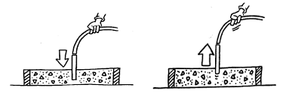
- Placing: Before the concrete was placed in the formwork, the inside of the formwork is thoroughly cleaned and a release agent (lubricant) was applied after the formwork was blown off of dust. The concrete was placed at a reasonable height of not more than 1m so as to avoid the segregation of its component materials.

- Compacting: The Compacting of freshly placed concrete is to make it a unit mass by eliminating voids within it. The method and the type of compaction given to concrete depend on the nature of work. Poker Vibrator was used for the compacting of concrete during the construction of the floors of the new university hostel while the concretes of small works were compacted using tapping rod.
- Curing: After the placing and compacting of the concrete it is allowed to sufficiently harden for a day then the curing process comes in which involves the prevention of the evaporation of moisture in the concrete. The concrete was watered for 7days with use of a hose pipe connected to a tank. This was done to avoid shrinkage of the concrete and cause a more permanent and durable material produced.
After 21 days the formwork are removed completely to enhance the full setting of the reinforced concrete floor.
Hence, concreting was carried out on almost all the construction work during my period of attachment.
BRICK BOND
Brick bonding is a crucial technique in masonry construction that involves arranging bricks in a specific pattern to ensure structural stability, strength, and aesthetic appeal. The method of laying bricks influences the durability and strength of walls, helping distribute loads effectively. The choice of brick bond depends on the type of structure, load requirements, and visual appeal.
Brick bonds are patterns in which bricks are arranged to ensure strength, stability, and aesthetic appeal in masonry walls. Among the most commonly used bonds in construction are Stretcher Bond, English Bond, and Flemish Bond. Each of these bonds has unique structural and visual properties, making them suitable for different applications.

1. Stretcher Bond (Running Bond)
A Stretcher Bond, also known as a Running Bond, is a brick bonding pattern where bricks are laid with their longer face (stretcher) visible on the outer surface of the wall. Each course of bricks is placed in such a way that the vertical joints (perpendicular joints) of one course are staggered by half the length of a brick in the adjacent course.

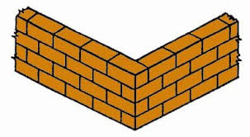

Features of Stretcher Bond
- Only the stretcher (long face) of the brick is visible.
- Each brick is laid lengthwise along the wall.
- The vertical joints are staggered to improve bonding.
- It is not suitable for thick walls (more than one brick thick).
- It is economical and easy to construct.

Advantages of Stretcher Bond
- Simple and Cost-Effective: Requires minimal brick-cutting and is easy to construct.
- Suitable for Thin Walls: Works well for half-brick (100mm thick) walls.
- Ideal for Non-Load-Bearing Walls: Commonly used for partition walls, facades, and boundary walls.
- Efficient Use of Materials: Reduces wastage of bricks.

Disadvantages of Stretcher Bond
- Weak Load-Bearing Capacity: Since bricks are laid lengthwise, there is no strong interlocking between layers.
- Not Suitable for Thick Walls: Cannot be used for one-brick-thick or stronger load-bearing walls.
- Requires Additional Support: Needs piers or reinforcement for structural stability.

Applications of Stretcher Bond
- Partition Walls
- Facades of Buildings
- Boundary and Garden Walls
- Interior Decorative Walls

2. English Bond
An English Bond is a traditional and strong brick bonding pattern where alternating courses of stretchers and headers are laid. This arrangement provides excellent strength and is widely used in load-bearing walls.
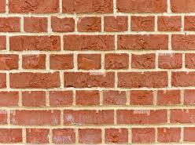

Features of English Bond
- Alternating courses of stretchers and headers.
- Header bricks are centered over the stretcher bricks below.
- A queen closer (a brick cut lengthwise in half) is placed after the first header in each header course to break vertical joints alignment.
- Provides strong interlocking, making it one of the strongest brick bonds.
- Used for walls that are at least one brick thick (215mm and above).

Advantages of English Bond
- High Strength and Durability: Suitable for load-bearing structures.
- Good Bonding Between Bricks: Strong interlocking prevents cracks.
- Resists Lateral Forces: Can withstand heavy loads and wind pressure.
- Versatile for Thick Walls: Can be used for one-brick-thick and thicker walls.

Disadvantages of English Bond
- More Material Usage: Requires more bricks and mortar, making it more expensive.
- Requires Skilled Labor: Needs precision in placing headers and stretchers.
- Less Decorative Appearance: Looks plain compared to Flemish Bond.

Applications of English Bond
- Load-Bearing Walls
- Retaining Walls
- Bridge Piers and Foundation Walls
- Thick Masonry Walls (Minimum One Brick Thick)

3. Flemish Bond
A Flemish Bond is a decorative and structurally strong bond where each course consists of alternating stretchers and headers. This arrangement provides both aesthetic appeal and strength, making it a widely used bond for walls that are visible and require strength.

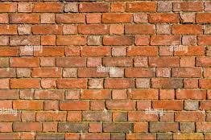

Types of Flemish Bond
- Single Flemish Bond:
  - The outer face is built with Flemish Bond (alternating stretchers and headers).
  - The inner face is constructed using English Bond (alternating stretcher and header courses).
  - Used where appearance and strength are both important.
- Double Flemish Bond:
  - The same Flemish Bond pattern (alternating stretchers and headers) is applied on both the inner and outer faces.
  - This bond provides uniform appearance and strength.

Features of Flemish Bond
- Each course has alternating stretchers and headers.
- Vertical joints are staggered to ensure a strong bond.
- Provides both strength and aesthetic appeal.
- Requires skilled workmanship to align headers and stretchers properly.
- Queen closers are used at the ends of alternate courses to maintain proper bonding.

Advantages of Flemish Bond
- Aesthetic Appearance: More attractive than English Bond.
- Good Structural Strength: Provides moderate strength suitable for both load-bearing and non-load-bearing walls.
- Balanced Load Distribution: Ensures uniform load transfer.

Disadvantages of Flemish Bond
- Difficult to Construct: Requires precise placement of stretchers and headers.
- More Bricks and Labor Required: Involves higher construction cost.
- Less Strong than English Bond: Though strong, it is not as strong as English Bond for heavy load-bearing walls.

Applications of Flemish Bond
- External Walls of Buildings
- Aesthetic Load-Bearing Walls
- Boundary Walls
CHAPTER FOUR
SUMMARY, RECOMMENDATION AND CONCLUSION
4.1 CHALENGES ENCOUNTERED
The programme was requiring more than usually expected, especially great patient effort and skills. The challenges was finance: owing to the fact that the organization does not give me any grant of financial support, transportation became a major source of expenditure. I never encounter any difficulties based on my programme, they monitor and taught me what I needed to know and I put them into practice. It wasn’t an easy task to undergo, only God in Heaven saw me through.
The success of my training is undisputed, but it was not devoid of rough edges. I experienced some challenges, among these are:
    - The issue of expensive transportation was the problem of transportation because my place of attachment was a little bit far from my.
    - The bureaucratic system is rigid and before things are done its takes so much time. This affected the conducive working environment for the members of staff in that whenever machines are bad and need repairs it takes so much time before it gets attended to. This system made work so tedious and cumbersome.
Lastly the issue of industrial base I was unable to get in touch with my survive till I ended my program which gave me a lot of worry and concern.
4.2 SUGGESTION TO IMPROVEMENT OF THE SCHEME
I suggested that polytechnic should make Siwes compulsory for every science and technology student so that it will make them perfect in practical aspect in their study.
- Visiting of students during the program should be ensured by the ITF
- Students should be paid their allowance on time to ensure motivation
- Selection of placement should not be left to students. Polytechnics should make a means of allocating students to related companies
- Seminars should be organized for establishments to acquaint them with their roles towards students on training
- Government should participate fully in the provision of equipment in the placement centers
4.3 RECOMMENDATION
Early approved of Siwes report is the most important factor to be considered by the polytechnic authority because the siwes might need a huge amount of money which the students might not be able to get as once and also to avoid delayed of the siwes.
Unstable power supply is another major problem encountered during the construction of the siwes.
Finally, I will appeal to the polytechnic that school should before to use any of the technological tools during course of study. In as such that such tools can not cause damage to them.
4.4 CONCLUSION
My three month student industrial work experience scheme has been one of the most interesting, productive and instructive experience in my life. Through this training. I have gained new insight and more comprehensive understanding about the real industrial working condition and practice; it has also improved my soft and functional skills. All these valuable experiences and knowledge’s that I have gained were not only acquired through the direct involvement in task but also through other aspects of the training such as: work observation, interaction with colleagues, superior and other people related to the field.
1.3 DEPARTMENTS AND THEIR FUNCTIONS
Executive director: He owns the company and has power to select,
evaluate and make decision in the company.
Managing director: He is in charge of the day to day activities of the
company.
Administrative manager: He is in charge of making the organisation
operate smoothly and run the business affairs.
Quality control manager: He is in charge of laboratory, supervises all the
analysis carried out in the laboratory making sure that the finished
product is of good quality.
Production manager: He is in charge of all the production that takes
place in the industry.
Account manager: He keeps record of all the financial account of the
company giving detail account of its expenditure and profit.
Marketing manager: He is in charge of advertising and selling the
product.
Chief engineer: He makes sure that the machines and equipments are
kept in good condition by servicing and checking them re

