TECHNICAL REPORT AND
PRESENTATION

ON
STUDENT INDUSTRIAL WORKING EXPERIENCE SCHEME (SIWES)

HELD
AT
IGRO FISHERIES VENTURES
Located at Community Area Araromi Owode Ede, Osun State.

DONE BY:-

OLALEKAN SAMUEL TOPE
ND/23/AGT/PT/0027

DEPARTMENT OF AGRICULTURE
KWARA STATE POLYTECHNIC ILORIN

OCTOBER-NOVEMBER, 2024
DEDICATION
This report is dedicated to Almighty God for his mercy and protection over me throughout the period of my SIWES. Also to my parents Mr. & Mrs. Olalekan for their financial and moral support and their care which can never be forgotten.

PREFACE
This report was written for the partial fulfillment for the (SIWES) program. The execution of the SIWES program had given more knowledge of tackling more difficult assignments relating to the field of breed fish and poultry birds. It has also widened my knowledge and scope in term of agricultural work.

ACKNOWLEDGEMENT
An assignment of this magnitude definitely involved more than just my hard work alone in respect to that, it is important that the effort of those who contributed to the success of this program be acknowledge.
Firstly, I will like to appreciate my precious parents Mr. and Mrs. Olalekan for their moral and financial support, may Almighty God continue to shower his mercy upon them.
My thanks goes to my relative for their support throughout the period of my SIWES program and also to all my friends who stood by me during my program, I appreciate you all. (God bless you).
Lastly my profound gratitude also goes to all the directors and officers in Igro fisheries ventures, Located at Community Area Araromi Owode Ede, Osun State for the knowledge they impacted on me. May God Almighty reward you abundantly (Amen).

TABLE OF CONTENTS
Tittles page
Dedication
Acknowledgement
Preface
Table of content
CHAPTER ONE
  - INTRODUCTION
  - ADVENT OF SIWES
  - OBJECTIVE OF SIWES
CHAPTER TWO
2.1 HISTORY OF ESTABLISHMENT AND VISION AND MISSION
2.2 OBJECTIVE OF ESTABLISHMENT
2.3 THE UNITS IN THE COMPANY
CHAPTER THREE
3.1 SIWES EXPERIENCE
CHAPTER FOUR
4.1 CHALLENGES
4.2 RELEVANCE TO SIWES
CHAPTER FIVE
5.1 RECOMMENDATION
5.2 CONCLUSION

CHAPTER ONE
  - INTRODUCTION
The impact of education on human development cannot be over emphasized as it exposes and improve the hidden potential of man. Peter (1997) defines education as the process by which impartation and acquisition of knowledge is done through teaching and learning, especially at schools or similar institution. Education is of various types, it includes formal, informal and semi-formal. University education falls into the category of formal education and avail students opportunity to learn from their widely read lectures. As good as this type of formal education is, it is not complete when students are not exposed to the practical aspect of their various courses. Industrial training gives students the opportunity to merge what they are taught in the field, hence providing proficiency of work.
This report is based on industrial training attachment carried out at Igro fisheries ventures, Located at Community Area Araromi Owode Ede, Osun State. The student industrial work experience scheme was designed to bridge the gap between theory and practical, thereby making it possible to get them exposed to actual job situation most especially at any industrial section in Nigeria.
The training program lasted for four months (16 weeks), from October till November 2024. During this period student are expected to blend theoretically understanding received from classes or lecture rooms with practical experience.
  - ADVENT OF SIWES
Student industrial work experience scheme (SIWES) was establish by ITF in 1973 to solve the problem of lack of adequate practical skills preparatory for employment in industries by Nigeria graduates of tertiary institutions.
The scheme exposes necessary for smooth transition from the classroom to the world of work. It affords student of being familiarized in handling machinery and equipment which are usually not available in the educational institutions.
Participation in SIWES has become a necessary pre-condition for the award of diploma and degree certificates in specific disciplines in most institutions of higher learning in the country, in accordance with the education policy of government.
  - OBJECTIVE OF SIWES
The objective of student industrial work experience scheme (SIWES) is to expose student to the practical aspect of their discipline and also to raise the student technical to tackling problems with professional thereby combining both academic and practical competence with a view to achieving the desired result. The industrial training fund (ITF) in other to reach out to student came with the student industrial work experience scheme to achieve following objective listed bellow
- To provide student with relevant practical experience in their field.
- To afford student the opportunity of seeing the practical application of their discipline and consequently bridging the gap between the classroom and real work situation.
- To develop and strengthen the participant both in theoretical and practical aspects which will serve as an added advantage to knowledge and human capacity development.
- To assess the chosen occupation and the interest of student.
- To expose student to work method and enrich their experience in acceptance method of handling equipment and machinery that may not be available in educational institution.
- To enlist and strengthen employers involvement in the entire educational process preparing student for employment.

CHAPTER TWO
2.1 BRIEF HISTORY OF IGRO FISHERIES VENTURES
The IGRO fisheries ventures and consultant was established on March 7th 2006. under the Department Fisheries Management before the wildlife and domestic farm was established in two year after. The farm is located at Community Area Araromi Owode Ede, Osun State. The farm covers about 5-6 hectares of land with perennial stream flowing through it in the orientation north-south. The IGRO farm experienced evolution that made it among the renowned fisheries and aquaculture management institution in Africa after an unprecedented flooding of the farm in 2005. The commitment, passion and working ethics of the staff attracts the attention of the federal government in funding and equipping the establishment the more to meet the climax standard.
The farm carries out the following activities;
✓ Research on the genetically improved fish seed production
✓ On the improvement of fish feed that are economically and environmentally friendly on fish production.
✓ Study of the socio-economic importance of fisheries in the Nigerian economy
✓ Integrated Aquaculture practices
✓ Study of fish diseases control, prevention and management.
✓ Fisheries education and training
✓ And any other challenges relating to fisheries managements.
VISION STATEMENT
“Goals to increase food security, reduce poverty, and protect the environment”
MISSION STATEMENT
“Growing global concerns over food security and environmental degradation have thrown the spotlight on agricultural issues”.

2.3 OBJECTIVE OF ORGANIZATION
​ The objectives of SIWES training include the following:
1. To expose students to working method and techniques in handling equipment and machinery that may not be available in the University.
2. To provide avenue for Nigeria University to acquire industrial skills and experience in their course of study.
3. To enlist and strengthen employers involvement in the entire educational process of preparing University graduates for employment in their industry.
4. To provide student with an opportunity to apply their theoretical knowledge in real work situation, there by bridging the gap between University work and actual practice.
5. To prepare students for work situation they may likely meet after graduation.
6. To make transition from University to the world of work easier and thus enhance eligibility for job placement.
7. To improve the inherent entrepreneurial skills in students.
8. To provide avenue for students to mingle with professionals of different fields thereby help the students to acquire more industrial skills and experience, especially in their chosen field of study.
2.3 THE UNITS IN THE COMPANY
For efficient and effective delivery of its services the farm is structured into different units which includes;
➢ THE HATCHERY UNIT
➢ THE GENERAL UNIT
➢ PROCESSING UNIT
➢ PIGGERY AND POULTRY UNIT
➢ MAGGOT UNIT
➢ FISH FEED PRODUCTION UNIT
➢ MARKETING UNIT
CHAPTER THREE
3.1 SIWES EXPERIENCE
The industrial training was a quite laudable scheme that has absolutely helped by bringing into reality, my curiosity to unravel the obscurity that has been encountered under the roof of the lecture rooms by experiencing the practical experimentation of the theoretical knowledge needed for an absolute academic development and continuity in my course of study. This training has exposed me to the following:
To the maintenance and operating of several machines and equipment that I will need when managing a farm. This training has taught me how to manage a farm with small capital and limited workers and be self employed. Finally, it exposed me to this interesting aspect of fisheries which are:
FISH BREEDING: This training enlightened me about the genetics of fish, how they can be bred especially these genetic tools.
➢ Hybridization: This can be a cross of 2different species,(inter-specific),same specie with different eco-region(intra-specific) or 2different genus(intra-generic).The reason behind this might be for better trait, dominance characteristics and high growth rate.
➢ Triploidization: This involves increasing the number of chromosomes from the conventional 2 to 3.Triploid hybrid can’t reproduce (i.e. sterile), but have high growth rate. While diploid hybrid converts its energy into reproduction, triploid hybrid converts its own into growth. Triploid hybrid can be used to stock natural waters. They are produced by either cold or warm shocking or by applying chemicals (e.g. cytochalasin) or pressure shocking. The polar body can be shocked by temperature and not hormone in a thermo-regulated water-bath. For Heterobranchussp and Clarias sp, the warm shock temperature is set at 39°C and 5°C for cold shocking. The bath is then filled with water to a level and the thermostat is set to the desired temperature. As the alarm rings, the fertilized eggs are set in it and left for 4minutes (warm shocking) and 40minutes (cold shocking).Research has it that cold shocking is preferable because warm shocking can deform some other genes, thereby bringing about phenotypic variations.
➢ Tetraploidization: There is movement of chromosomes at gametogenesis. Fertilization of tetraploid and diploid hybrid gives a triploid hybrid which is sterile but with high growth rate.
➢ Gynogenesis: This is the production of an all-female fish. The sperm from the male is exposed to an ultraviolet light, thus destroying all the genetic maleness and take all genetic make-up only from the female. The sperm is then introduced on the eggs which will later produce an all-female fish offspring after fertilization. Now I can breed any sex of fish I wish to have on my farm according to the demand of my customers.
GLOSSARY OF WORDS
* Dragging: This is the act of harvesting or catching of fishes with a dragging net
* Dyke: The surrounding of pond filled with grasses to prevent flooding or erosion
* Impounding: This is the act of introducing a quality water into a pond
* De silting: this is the removal of silt from a pond
* Gutting: this is the removal of all internal organ of a fish to prevent early spoilage or the growth of microbes in the fish
* Silt: This is the fine sand or clay deposited by running water and the waste products of fish
* Pelletizing: This is the act of reforming a feed into a long small size according to the size of the fish that will eat the food with the use of pelletizing machine.
* Fingerlings: A young immature fish
* Grader: This is used to grade fishes into different sizes into a pond
* Liming: This is the act of applying lime to a pond that does not contain fish to increase the pond’s alkalinity and to kill all predators on the pond
* Brood stock: This is the matured fish (parent fish) that can be used for breeding. It can also be called the reproductive fish
* Mortality: A dead fish
* Nursery tank: A tank use for nurturing or nursing of fish seed
* Kakaban: This is the net on which fertilized eggs are laid until the eggs hatch
* Draining: The act of releasing or allowing water to escape from a pond
* Elodea: An aquatic weed found under a pond
* Hatchlings: This is a newly hatched fish that just emerged from an egg
* Condition: To subject to the process of acclimatization
* Spawn: To produce or deposit eggs inside a water
* Decant: To remove the saline water on top of the eggs after fertilization or to pour off gently so as not to disturb the sediment
* Stripping: To press the abdominal part of the gravid female fish so that the eggs can come out
* Shooter: These are the bigger sizes of fish that are found in the pond of the smaller fish and these cannibalize the smaller fish
* Stocking: The act of introducing fish into a pond
* Flow through: The amount of water moving in and out of a pond especially a breeding trough
* Stunning: The act of killing a fish by breaking its backbone with a stunning rod
* Wean: To stop the piglet from sucking its mother’s breast and start eating food
* Levee: To use bag of sand to repair a flooded dyke and to prevent concurrent flooding
* Dead zone: An area in a large water where oxygen levels are extremely low
* Fish seed: These are fishes in their early stage e.g. fry and juveniles
* Test cropping: The act of dragging almost 30% of the fish in a pond and weighing them to discover their average weight and to know the amount of feed that must be given to them daily.
* Latency Period: This is the period between the time female broodstock is induced and the time the eggs are released
* Feeding and Provision of Portable Water: The sheep is an herbivore and the system of rearing adopted for sheep and goat is semi extensive. Sheep are fed twice daily with compounded feed, 45pounds (3kg) in the morning and evening. Feed ingredients include barley shaft, broken soya and others. The drinkers were washed daily and the water is replaced with clean portable water morning and evening.
Cleaning: Sweeping of the sheep pens to prevent diseases that are feacal borne. I was involved in the cleaning of the sheep pen,
Record Keeping: Records of the number of sheep, number of new born. Quantity of feed and water is kept coupled with the disease condition of the sheep/goat are kept.
Disease Management and Control: Vitamin supplement is added to water, administration of drugs and injections by a Vet is done when necessary.
There is a relationship between the two systems (fish, and sheep/goat farming) in which the sheep droppings are used in fertilizing the pond.
INTEGRATED FISH FARMING UNIT
This unit was created with the aim of incorporating other forms of agriculture like rearing of Ostrich, geese, sheep and goat with fish farming. Horizontal form of integration is the method practiced at the IGRO Farm.
I spent weeks in this units and I was involved in the Sheep and goat section of the integrated farming unit.
​​ Sheep and Goat
The system adopt in rearing of sheep is semi intensive because it easy to manage and less expensive is also serve as major source of income to the farm.
Breed of sheep
There are many breed of sheep and goat in IGRO Farm include the Balami, Sudanis and huda and for the goat Sahel savanna breed
General Characteristics of sheep
* they have medium body size with long legs
* they are ruminant
* only the male have horns but female with polled
* the earlope are long and dropping
* the gestation period is between 151-153

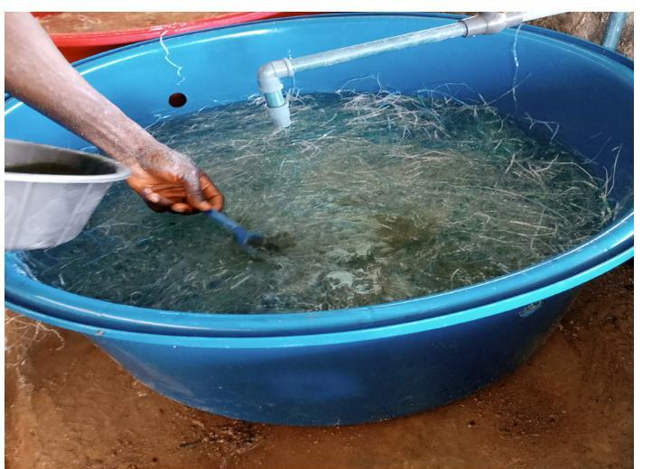
Laying of the fertilized eggs on a netted substrate in a tank

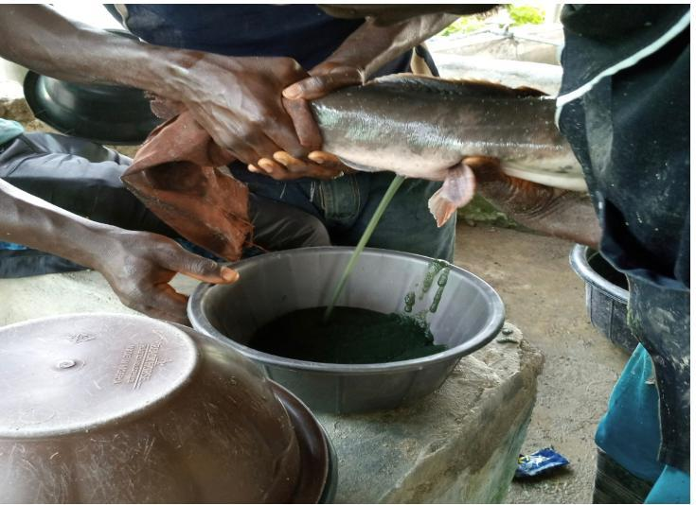
Stripping of eggs
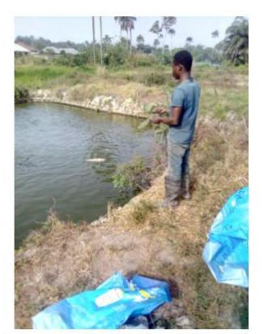
Feeding of stocked fishes in the production pond

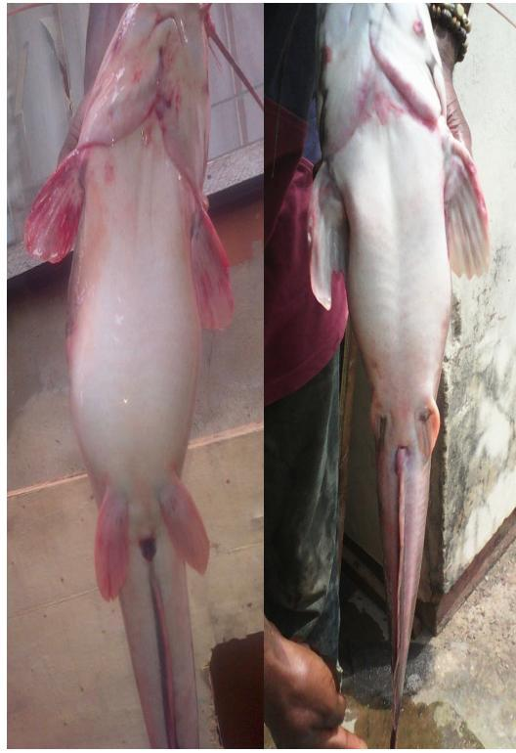
Male and female Brooder

CHAPTER FOUR
4.1 CHALLENGES FACING DURING SIWES
There are many challenges faced during my (SIWES) but few are to be mention. It not easy for because we worked like a slave, working from day till night without payment and I spent lot of money on transportation.
Practical knowledge in other hands is also a task because practical knowledge is learning without mastery of an area of knowledge may be too difficult to achieve. Practical knowledge involves developing skills through the use of tools or equipments to perform task that are related to my field of study.
4.2 RELEVANCE OF SIWES
Student industrial work experience scheme (SIWES) help to provide an opportunity to apply theoretical knowledge in real life situation and it expose students to move practical works method and techniques. Also, it prepares students for the labor market after graduation.

CHAPTER FIVE
5.1 RECOMMENDATION
I recommend that student industrial working experience is good program that has played a vital role in the development of skillful graduates in various disciplines and which ensure that student are exposed to the practicality of their professions. Practical knowledge is being added to theoretical knowledge in the course of the training and such knowledge and skills enable student to harness available resources to meet the needs of society.
This program gives me foresight and availed me to know more about the profession journalist. As a matter of responsibilities, the federal government to contribute, immensely to the uplift of this program by putting in place a considerable compensation for the student that embark on this kind of stressful and time devoted program.
5.2 CONCLUSION
SIWES plays a significant role in human resource development in Nigeria. ICT developments have put more pressure on the SIWES program to help students develop new skill. Student should be aware of what the present society hold for them and adapt accordingly. This can only be facilitated by LIS educator and practitioners, with adequate provision of ICT infrastructure.
The federal government of Nigeria should therefore not relent on their effort in reinforcing the body that controls and monitor the program as it adding more knowledge to student especially those that were not taught in their classrooms. Also, ways to improve the program should be sought, so that the students would be better off at the end of the program.

