


TECHNICAL REPORT
ON

STUDENT INDUSTRIAL WORK EXPERIENCE
SCHEME (SIWES)

DONE AT

CHINESE GROUP OF COMPANY NIGERIA LIMITED

BY:

ADEWALE MAYOWA SAHEED
ND\23\CEC\FT\009

TO:

CIVIL ENGINEERING DEPARTMENT, INSTITUTE OF TECHNOLOGY, KWARA STATE POLYTECHNIC,
ILORIN, KWARA STATE.

IN PARTIAL FULFILLMENTS OF THE REQUIREMENT FOR AWARD OF NATIONAL DIPLOMA CERTIFICATE IN CIVIL ENGINEERING.

PREFACE
This is a report of four months industrial training which was done as part of the requirements needed for the award of National Diploma Certificate which was embarked upon by the technically student after their first year of stay in school.
It is also done to enable the student's to be exposed to the practical aspect of their course of study and write down what he/she has gained during the training. The program is aimed at correcting the incompetence in the school leaving the scientific and technical in the country.
DEDICATION
This report is dedicated to Almighty Allah, the most Beneficent, Merciful, the Cherisher of the universe, the Uncreated creator of all creatures and the most Knowledgeable who seeks knowledge just from himself for giving me the opportunity, privilege and understanding to participate in this Student Industrial Work Experience Scheme (SIWES)
I also dedicate this report to my amiable parents Mr and Mrs SOGBESAN ADEWALE for their financial support during the course of the program. May Allah continue to bless them (AMIN)

ACKNOWLEDGEMENT
My gratitude first goes to Almighty God for is protection throughout my SIWES programme.
My special thanks go to my parent Mr. and Mrs. Adewale who has been very supportive to me with their unconditional love throughout my programme. May God grant them all their heart desire and let them reap the fruit of their labour in Jesus Name (Amen).
My appreciation goes to my siblings, friends and family for the moral support and contributions towards the success of this programme.
My profound gratitude goes to my industrial based supervisor the person of Miss Shuaib Babaata Aisha for his time that he devoted for me throughout my SIWES programme to make sure that I gain and have experience that benefitted me during the programme.
TABLE OF CONTENTS
Title i
Preface ii
Dedication iii
Acknowledgment iv
Table of Contents v
CHAPTER ONE:
1.1: Introduction 1
1.2 Background 1
1.3 Objectives of SIWES 2
CHAPTER TWO:
2.1: Location and Brief History of establishment 3
2.2 Objectives of establishment 3
2.3 Organization Structure and the various departments/unit in the establishment and their functions 3
CHAPTER THREE & FOUR:
3.1 Two chapters reporting on work actually carried out with clear statement on experiences gained 5-24
CHAPTER FIVE
5.1: Summary of attachment activities 23
5.2: Problems encountered during the program 24
5.3 Suggestions for the improvement of the scheme 24
REFERENCES
CHAPTER ONE
1.0 INTRODUCTION TO SIWES
The Students' Industrial Work Experience Scheme (SIWES) is a vital component of Nigerian university education, particularly for students pursuing science, engineering, technology, and other related courses. The scheme was established by the Industrial Training Fund (ITF) in 1973, with the primary objective of providing students with practical work experience in their chosen field.
The Students' Industrial Work Experience Scheme (SIWES) is a mandatory program designed for Nigerian university students pursuing science, engineering, technology, and other related courses. The program aims to provide students with practical work experience in their chosen field, bridging the gap between theoretical knowledge and practical skills.
Prior to the introduction of SIWES, Nigerian university graduates often lacked the practical skills and experience required by industries. This led to a significant gap between theoretical knowledge and practical application, making it challenging for graduates to secure employment or start their own businesses. The government, in collaboration with the ITF, recognized the need to bridge this gap and established SIWES to provide students with hands-on experience in their chosen profession.
1.1 BACKGROUND OF SIWES
The Student Industrial Work Experience Scheme (SIWES) is a skill training program designed to expose and prepare students of Universities, Polytechnics, Colleges of Technology, Colleges of Agriculture, or Colleges of Education for the Industrial work experience they likely to meet after graduation. The scheme also affords students the opportunity of familiarizing and exposing themselves to the needed experience in handling equipments and machineries that are not usually available in their institute. Before the establishment of the scheme, there was a growing concern among industrialists the graduates of tertiary institution lack adequate practical background ( studies) preparatory for employment in industries. Thus, the employers were of the the opinion that theoretical education going on in institutions of higher learning was not responsive to their needs. It is against this background that the rationale for initiating and designing the scheme by the fund during it formative years 1973/74 was introduced to acquaint students with the skills of handling employer's equipment and machinery. The ITF solely funded the scheme during its formative years but as the financial involvement became unbearable to fund, it withdrew from the scheme. The Federal Government handed over the scheme in 1979 to both the National Universities Commission (NUC) and the National Board for Technical Education (NBTE). Later, the Federal Government in November 1984 reverted the management and implementation of SIWES programme to ITF and effectively taken over by ITF in July 1985 with the funding being solely borne by the Federal Government.
SIWES is a tripartite programme involving the students, the Polytechnic and the Imdustry (employer of labor). The programme is funded by the Federal Government of Nigeria and jointly coordinated by the Industrial Training Funds (ITF) and Nationall Board for Technical Education (NBTE) t
1.2 OBJECTIVES OF SIWES
The main objectives of the Students' Industrial Work Experience Scheme (SIWES) are:
1. To provide students with practical work experience: SIWES aims to equip students with hands-on experience in their chosen profession.
2. To bridge the gap between theoretical knowledge and practical application*: SIWES helps students apply theoretical concepts to real-world problems.
3. To develop students' problem-solving and critical thinking skills: SIWES enhances students' ability to analyze problems, think critically, and develop practical solutions.
4. To enhance students' employability: SIWES provides students with relevant work experience, making them more attractive to potential employers.
5. To foster collaboration between institutions, industry partners, and government agencies: SIWES promotes partnerships between stakeholders, ensuring that students receive relevant, industry-specific training.
CHAPTER TWO
2.0 LOCATION AND BRIEF HISTORY OF ESTABLISHMENT
The company I underwent my SIWES program with is CGC Nigeria Limited. Located at Km 29, Shao Olooru-Bode Saadi Expressway, Ilorin, Kwara State. CGC Nigeria Ltd. is a leading construction firm in Nigeria specializing in building construction, civil engineering and project management.
CGC Nigeria Ltd. was founded by CGCOC company in 2002, it became part of CGC Overseas Construction Group Co, Ltd. CGCOC group is an engineering firm that works in Civil engineering. It has developed from a single project construction business into four business area: Consulting Planning, Investment Operation, Logistics and Trade and has employed in nearly 25 countries with over 90% of them being foreign nationals with over 200 workers.
2.1 OBJECTIVES OF ESTABLISHMENT
The primary objectives of CGC Nigeria Limited are:
- To provide high quality construction service to clients.
- To maintain a strong reputation in the construction industry.
- To ensure timely completion of projects within budgets.
- Prioritize safety and environmental sustainability
2.2 ORGANIZATION STRUCTURE AND DEPARTMENTS
The company has a hierarchical structure with the managing director at the top, followed by the project managers, engineers and technicians. The company also has a quality control department which ensure that all project meets the required standards.
- Managing Director: Overall responsibility for the company's operations and strategic directions
- Project Manager: Responsible for overseeing specific projects, ensuring timely completion and budget adherence
- Department Heads: Leads various departments.
Departments and Functions
- The company has several departments, each with distinct functions:
- Engineering Department: Designs and develops building plans, conduct site inspections and ensure compliance with regulations.
- Finance Department: Manages financial transactions, prepares budgets and ensures timely payments
- Procurement Department: Sources materials, equipments and services, ensuring quality and cost effectiveness
- Quality Control Department: Monitors construction activities ensuring compliance with quality standards and regulations
- Safety Departments: Develops and implements safety protocols and ensures a safe working environment
- Laborers: Assists in construction activities such as site preparation, excavation and building assembly

CHAPTER THREE
3.0 WORK CARRIED OUT
During my SIWES program, I worked as a Civil Engineering Intern under the supervision of Engr Muhammed Nazeer. During my program I had the opportunity to work closely with the Engineering and Safety departments gaining hands on experiences. I was involved in the constructions of U drainage, trapezoidal drainage, ring pipe culverts, crash barrier construction and road constructions.
U Drainage Construction
I assisted the survey teams in conducting surveys, setting out and staking with the use of the GPS surveying instrument. I partook in the laying of formwork after the soil was excavated with the use of an excavator of 1.75m difference between the asphalt top and digging level of the excavated drainage and the blinding of the excavated surface with cement of 5cm. The formwork were laid and reinforcements were inserted and tightened appropriately amd the base was firstly casted of 20cm and the walls of 90cm as the height and 15cm width were also casted. After undergoing casting, the top of the walls were attached with a string to check alignment and the process was called "string lining".
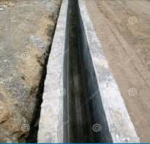

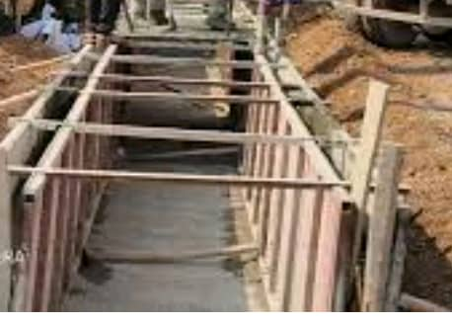

Crash Barrier Construction
The crash barrier was designed to prevent vehicles from crossing over to the opposite lane in the event of a crash. The construction process began with the surveying, setting of stakes and stringing between the stakes to define the alignment of the crash barrier and verify the accuracy as necessary. The panels were firstly set on the asphalt tops and insertion of reinforcements before casting of the panels of height 78cm, breadth 15cm and width 60cm and the use of a vibrator machine to vibrate the concrete in the panel to ensure even distribution of concrete


CRASH BARRIER
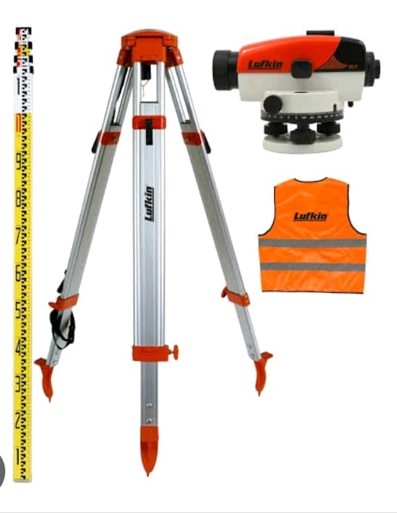

LEVELLING MACHINE
Trapezoidal Drainage Construction:
The project aimed to provide an efficient and effective drainage system to prevent flooding and erosion. The construction process began with the surveying and setting of stakes to define alignment and elevation and stringing between stakes to verify the accuracy of stakes. Excavation of stakes was carried out of 1.45m to accommodate the trapezoidal drainage channel. The excavated soil was then set aside for backfilling. The BRC wire mesh was then laid at the bottom of the excavated area to provide reinforcement to the comcrete. The wire mesh was cut to size and laid in accordance with design specifications. The drainage base was blinded along with the laid BRC wire mesh of 15cm. Cement was cast into the area covering the BRC wire mesh. The walls were casted first of 70cm and then the base of 60cm and then trowelled. After the concrete had set, the excavated area was backfilled with soil.

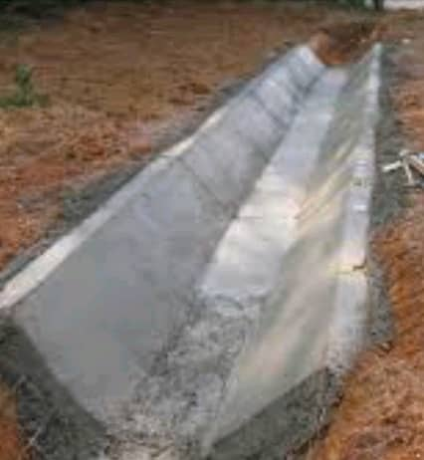

Ring Pipe Culvert Construction
The project aimed to provide a safe and efficient passage for water to flow under the road. The construction process began with the setting out process, conducting a site survey to establish reference points, marking the culverts centerline, inlet and outlet points. Excavation was firstly carries out to a depth of 4.1m to accommodate the ring pipe culvert. The excavated surface was blinded of 0.14m and the toe beam was casted of 1.85m and the rings were placed on the beam after it had set of 25cm thickness and cement were used to bind the rings together. Formwork were laid for the head and wing walls of 0.20m and 0.36m and casted. The slab of 1.55m was casted too. The excavated soil was backfilled around the culvert pipe and compacted to prevent settlement. The area around the culvert was finished with a layer of concrete and road was reinstalled.

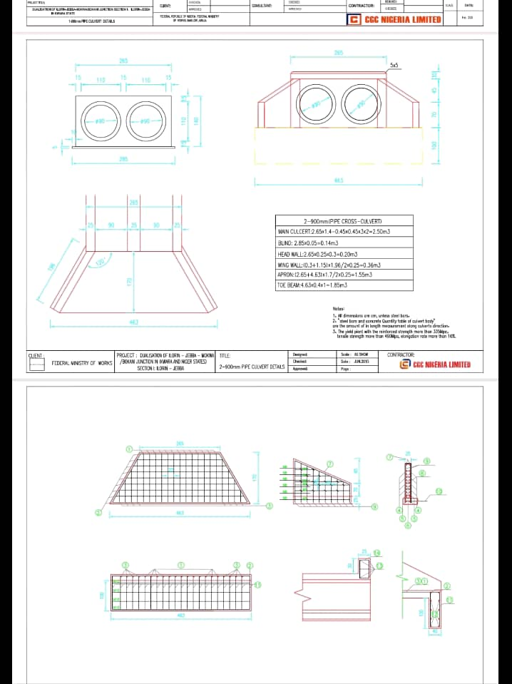

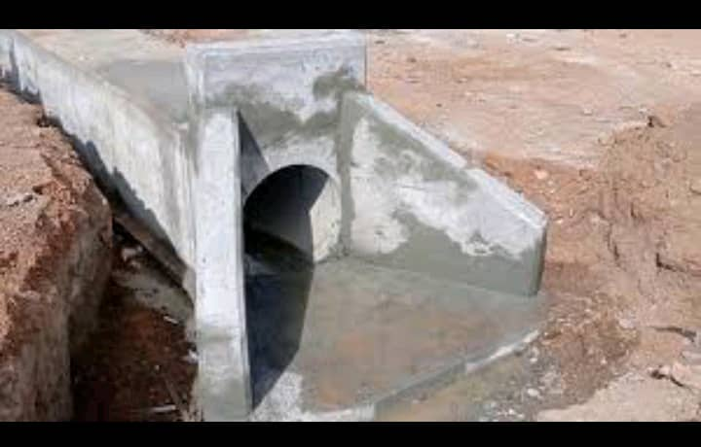

Road Construction
I had the opportunity to observe and participate in the construction of a road project. The construction process began with site clearance and preparation. The site was then graded to the required level and the soil was compacted to provide a stable base for the road. After the site preparation, the next stage was setting out. This involved marking the centerline and edges of the road using pegs and strings. Excavation was carried out to the required depth and subgrade was prepared by compacting fill material (laterite). The subbase layer was also prepared of 20cm, it involved compacting with a smooth roller and pad foot roller, scarifying of the surface with a grader and creation of a flat surface before compacting with a smooth roller in a toe and fro manner. The laying of the stone base was carried out after the subbase and subgrade had been prepared. Water was firstly sprayed on the prepared pavement before laying stone base of 40cm with an asphalt paver being supplied by a pay loader. The component of the stone base were: stone dust, stone and gravel. It was then compacted with a smooth and pneumatic roller in a toe and fro manner. Water was sprayed on it and the lab unit were tasked with carrying out the degree of compaction test to check the moisture content of the stone base.
The last stages involved the laying of bitumen on the prepared stone base. Hot bitumen was laid using a distributor truck. After the bitumen had set. A tack coat called MC one was sprayed on the bitumen surface and then the hot mixed asphalt was laid on the bitumen surface using an asphalt paver and immediately after laying, it was compacted using smooth and pneumatic rollers to remove air void.
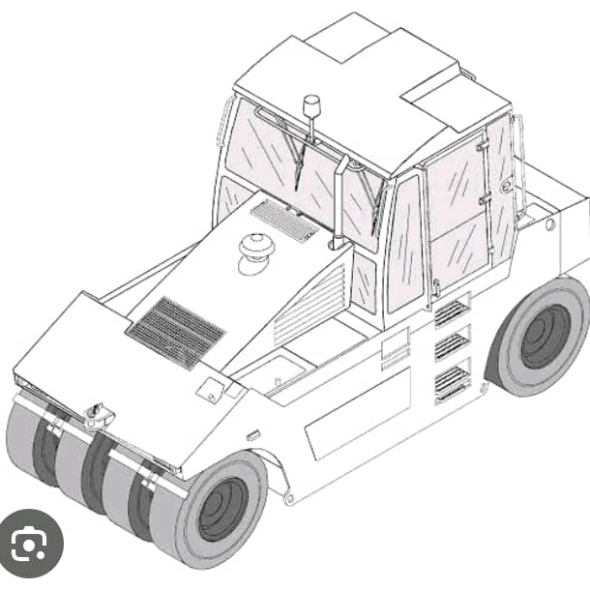

PNEUMATIC ROLLER
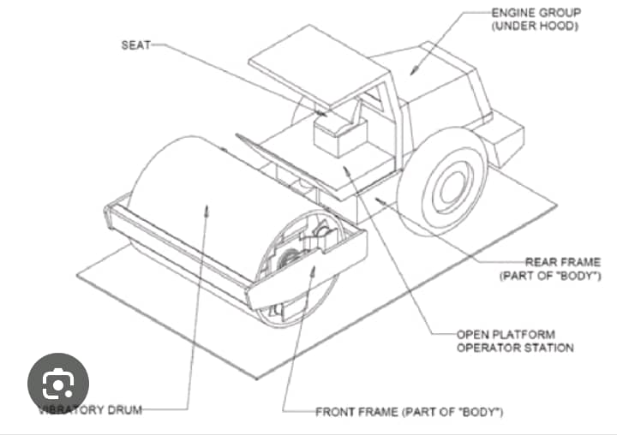

SMOOTH ROLLER

MACHINES USED DURING CONSTRUCTION
Excavator
An excavator is a heavy equipment vehicle used for:
Primary Use
1. Digging and excavation: Excavators are designed to dig and excavate soil, rocks, and other materials.
2. Heavy lifting and moving: Excavators can lift and move heavy objects, such as pipes, logs, and construction materials.
3. Demolition and breaking: Excavators can be equipped with attachments like hydraulic hammers or wrecking balls for demolition and breaking tasks.
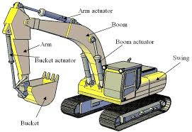

Excavator
Description
An excavator typically consists of:
1. Boom: A long, articulated arm that allows the excavator to reach and dig at various depths and angles.
2. Stick: A hydraulic cylinder that extends and retracts the boom.
3. Bucket: A detachable bucket or attachment that can be used for digging, excavation, and other tasks.
4. Cab: The operator's compartment, which provides a comfortable and safe working environment.
5. Undercarriage: The excavator's base, which can be equipped with tracks or wheels, depending on the terrain and application.
Asphalt paver:
An asphalt paver is a heavy equipment vehicle used for:
Primary Use
1. _Laying asphalt_: Asphalt pavers are designed to lay down hot mix asphalt (HMA) on roads, highways, parking lots, and other surfaces.
2. _Road construction and maintenance_: Asphalt pavers are used for new road construction, resurfacing, and maintenance projects.
Description
An asphalt paver typically consists of:
1. Hopper: A container that holds the hot mix asphalt.
2. Conveyor system: A system of belts and chains that transports the asphalt from the hopper to the screed.
3. Screed: A heated, adjustable plate that spreads and smooths the asphalt.
4. Track or wheel system: A system that allows the paver to move forward and backward
5. Control system: A system that regulates the temperature, flow rate, and distribution of the asphalt.

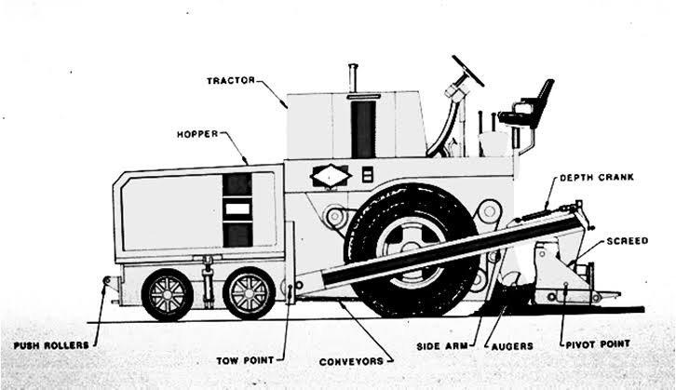

Asphalt Paver
Smooth roller & Pneumatic roller
Pneumatic Roller
Primary Use
1. Compacting soil, aggregate bases, and asphalt surfaces.
2. Compacting clay soils and other cohesive materials.
Description
A pneumatic roller is a type of compaction equipment that uses pneumatic tires to compact materials. It features:
1. Pneumatic tires with a flexible sidewall and tread pattern.
2. A ballast system to adjust the weight of the roller.
3. Optional vibration system for increased compaction efficiency.
Smooth Roller
Primary Use
1. Compacting and finishing asphalt surfaces.
2. Compacting granular materials, such as aggregate bases and sand.
Description
A smooth roller is a type of compaction equipment that uses a smooth, cylindrical drum to compact materials. It features:
1. A smooth, steel drum with a diameter of 3-6 feet.
2. A vibratory system to increase compaction efficiency.
3. Optional hydraulic or mechanical drive systems
Padfoot roller
Primary Use
1. Compacting clay soils and other cohesive materials.
2. Compacting soil and aggregate bases for roads, highways, and building foundations.
3. Compacting backfill materials in trenches and excavations.

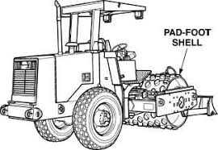

Pad Foot Roller
Description
A pad foot roller is a type of compaction equipment that features:
1. A drum with pad-like protrusions, called "feet," that provide kneading action.
2. A vibratory system to increase compaction efficiency.
3. A hydraulic or mechanical drive system.
4. Adjustable compaction force to suit different soil types and conditions
Bulldozer
Primary Use
1. Land clearing and grading: Bulldozers are used to clear land, remove debris, and grade the soil to prepare it for construction.
2. Earthmoving*: Bulldozers are used to move large amounts of soil, sand, and other materials during construction, mining, and other projects.
3. Demolition: Bulldozers can be used for demolition work, such as tearing down buildings and other structures.

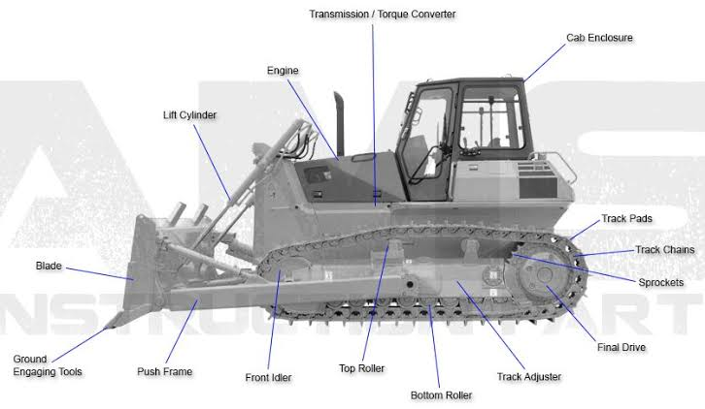

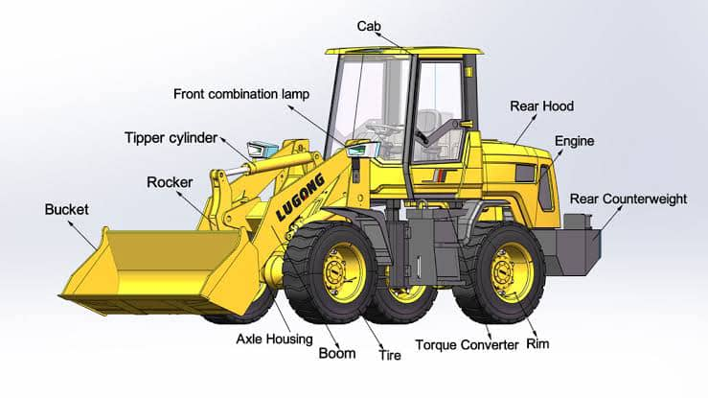
Bulldozer
Description
A bulldozer is a heavy equipment vehicle that features:
1. Blade: A large, flat blade that is used to push and move materials.
2. Tracks or wheels: Bulldozers can be equipped with tracks or wheels, depending on the terrain and application.
3. Hydraulic system: A hydraulic system that powers the blade and other attachments.
4. Cab: The operator's compartment, which provides a comfortable and safe working environment.

Grader
Primary Use
1. Grading and leveling: Graders are used to grade and level surfaces, such as roads, highways, and airport runways.
2.Soil preparation: Graders are used to prepare soil for construction, landscaping, and other projects.
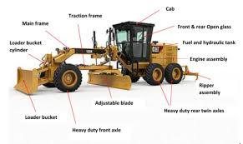
3.Snow removal: Graders can be equipped with snowplows and other attachments for snow removal.

Grader
Description
A grader is a heavy equipment vehicle that features:
1. Blade: A long, adjustable blade that is used to grade and level surfaces.
2. Circle and moldboard: The blade is mounted on a circle and moldboard, which allows for precise control and adjustment.
3. Articulated frame: Graders have an articulated frame, which allows the front and rear axles to move independently.
4. Hydraulic system: A hydraulic system that powers the blade and other attachments.
Pay loader
Primary Use
1. Loading and unloading materials: Pay loaders are used to load and unload materials such as soil, sand, gravel, and debris.
2. Material handling: Pay loaders are used to handle materials around construction sites, warehouses, and other industrial settings.
3. Earthmoving: Pay loaders can be used for earthmoving tasks such as digging, filling, and grading.

Pay Loader
Description
A pay loader is a heavy equipment vehicle that features:
1. Hydraulic boom: A hydraulic system that powers the loader arm.
2. Bucket: A detachable bucket or attachment that can be used for loading and unloading materials.
3. Cab: The operator's compartment, which provides a comfortable and safe working environment.
4. Tires or tracks: Pay loaders can be equipped with tires or tracks, depending on the terrain and application.
Water distributor truck
Primary Use
1. Dust control: Water distributor trucks are used to control dust on construction sites, roads, and other areas where dust is a problem.
2. Soil compaction: Water distributor trucks are used to help compact soil and stabilize bases on construction sites.
3. Firefighting: Water distributor trucks can be used to fight fires in areas where water is scarce.
Description
A water distributor truck is a specialized vehicle that features:
1. Water tank: A large tank that holds water, typically ranging from 1,000 to 4,000 gallons.
2. Spray system: A system of pipes, pumps, and spray nozzles that distribute water evenly over a wide area.
3. Control system: A system that allows the operator to control the flow rate, spray pattern, and other parameters.
4. Chassis and cab: A heavy-duty chassis and cab that provide a stable platform for the water tank and spray system.
Concrete truck
Primary Use
1. Transporting concrete: Concrete trucks, also known as concrete mixers or cement mixers, are used to transport and deliver mixed concrete from a batching plant to construction sites.
2. Mixing and agitating: Concrete trucks are equipped with a mixing drum that agitates and mixes the concrete during transport to prevent segregation and ensure a uniform mix.
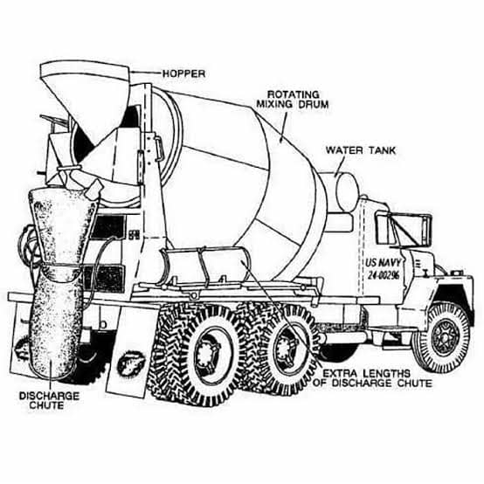

Concrete mixer
Description
A concrete truck typically consists of:
1. Chassis and cab: A heavy-duty chassis and cab that provide a stable platform for the mixing drum.
2. Mixing drum: A large, cylindrical drum that rotates to mix and agitate the concrete.
3. Hydraulic system: A hydraulic system that powers the mixing drum and other components
CHAPTER FOUR
4.0 Experienced Gained
During my SIWES program, I gained invaluable hands on experiences I'm construction working with CGC Nigeria Ltd. My experience spanned in various aspects of construction, including:
I learnt about and practiced safety procedures including wearing personal protective equipments (PPE) and following safety protocols. I assisted in receiving, inspecting and storing construction materials. I observed the importance of proper material and instrument handling and storage techniques. I observed the construction of pavement layers including sub grade and sub base. I learnt about the different types of pavements. I witnessed the laying of aspahlt including tack coat application and compaction using rollers. I worked collaboratively with site engineers and laborers developing essential teamwork and communication skills. I learnt the importance of effective time management, ensuring that tasks were completed efficiently and to a high standard.
CHAPTER FIVE
5.0 Summary of attachment activities
During my SIWES attachment, I gained invaluable experiences in various aspects of construction focusing on road, drainage, crash barrier, and ring pipe culvert projects. The activities are summarized below:
I assisted in earthwork operations, observing subgrade and sub base preparation including grading and compaction, witnessed the laying of asphalt layers, observed and assisted in backfilling and compacting materials around culvert, witnessed the installation of culverts ,headwalls, and wing walls, participated in daily site meetings, understanding the importance of communication and coordination among team members.
This attachment has provided me with valuable practical experience and has deepened my understanding of construction principles. I am confident that this experience will contribute significantly to my future career prospects.
5.1 Problems encountered during the program.
During my SIWES program, we encountered several challenges under construction that hindered the progress of the project. Some of the problem we encountered included:
- Material Shortage: Delays in material delivery, particularly asphalt and aggregates, led to idle time and affected the project timeline
- Weather conditions: Inclement weathers including heavy rainfalls and extreme temperatures, affected the construction schedule and required adjustment to the work plan.
- Equipment malfunction: Malfunctioning equipments including excavators, payloaders led to delays and required replacements.
5.2 Suggestion for improvement of scheme
Based on my experience during the SIWES program, I have identified areas that required improvement to enhance the effectiveness and efficiency of the scheme. The following are my suggestions:
1. Better Coordination between Institutions and Industry Partners
1. Standardized placement process: Develop a clear, standardized process for placing students with industry partners.
2. Regular communication: Establish regular communication channels between institutions and industry partners to ensure smooth placement and supervision.
3. Clear roles and responsibilities: Define clear roles and responsibilities for institutions, industry partners, and students to avoid confusion.
2. Enhanced Supervision and Mentoring
1. Training for supervisors: Provide regular training and workshops for supervisors to enhance their guidance and support for students.
2. Regular feedback: Encourage supervisors to provide regular, constructive feedback to students.
3. Mentorship programs: Establish mentorship programs that pair students with experienced professionals.
3. Improved Safety Measures
1. Regular safety audits: Conduct regular safety audits and risk assessments to identify potential hazards.
2. Comprehensive safety training: Provide students with comprehensive safety training and ensure they have access to PPE.

3. Emergency response plans: Develop and communicate emergency response plans to students and supervisors.
4. Increased Industry Involvement
1. *More practical experiences*: Encourage industry partners to provide more opportunities for students to engage in hands-on learning.
2. Curriculum relevance: Foster closer relationships between institutions and industry partners to ensure curriculum relevance and alignment with industry needs.
3. Guest lectures and workshops: Invite industry professionals to deliver guest lectures and workshops.
5. Evaluation and Feedback Mechanisms
1. Robust evaluation framework: Establish a robust evaluation framework to assess the effectiveness of the SIWES program.
2. Student feedback: Solicit feedback from students to identify areas for improvement.
3. Industry partner feedback: Solicit feedback from industry partners to ensure the program meets their needs.
6. Capacity Building and Development
1. Staff development: Provide training and development opportunities for staff involved in the SIWES program.
2. Infrastructure development: Invest in infrastructure development to support the SIWES program.
3. Technology integration: Integrate technology to enhance the SIWES experience.

7. Collaboration and Partnerships
1. Inter-institutional collaboration: Foster collaboration between institutions to share best practices.
2. Industry partnerships: Develop partnerships with industry partners to provide more opportunities for students.
3. Government agency collaboration: Collaborate with government agencies to access resources and funding.
By implementing these suggestions, the SIWES scheme can be improved to provide students with more meaningful and relevant practical experiences, better preparing them for the workforce.

REFERENCE
Construction Industry Institute (CII)_. (2019). Best Practices in Construction Site Management.
Federal Ministry of Works and Housing_. (2018). Nigerian Building Code.
American Society of Civil Engineers (ASCE)_. (2020). Construction Engineering and Management.
National Bureau of Statistics (NBS)_. (2020). Construction Statistics Report.
International Labour Organization (ILO)_. (2019). Safety and Health in Construction.
Nigerian Society of Engineers (NSE)_. (2019). Code of Ethics for Engineers.
Construction Management Association of America (CMAA)_. (2020).Construction Management Standards of Practice.

