

A TECHNICAL REPORT
ON
STUDENT INDUSTRIAL WORK EXPERIENCE SCHEME
(SIWES)

HELD AT
MINISTRY OF HOUSING AND URBAN DEVELOPMENT
GRA, ILORIN, KWARA STATE

BY
LUKMAN SODIQ
ND/23/QTS/PT/0015

SUBMITTED TO:
DEPARTMENT OF QUANTITY SURVEY, INSTITUTE OF TECHNOLOGY (I.O.T), KWARA STATE POLYTECHNIC, ILORIN

IN PARTIAL FULFILLMENT OF REQUIREMENT FOR THE AWARD OF NATIONAL DIPLOMA (ND) IN QUANTITY SURVEY

SEPTEMBER - DECEMBER 2023

DEDICATION
I dedicate this report first and foremost to Almighty God who has been their right from the beginning to this very point. Special dedication also to my ever supportive parents, for their relentless support and compassion towards me during the course of my three months SIWES training.
ACKNOWLEDGEMENTS
I thank God Almighty for the glory, honor, adoration and mercy I received during the course of my study and when undergoing my industrial training.
My appreciation also goes to my industrial based lecturer, whose accessibility, untiring effort, patients and guidance and suggestions fabulously contribution to the completion of this report.
Mostly, my application goes to the director of administration, for accepting me into the organisation and support, may God Almighty be with him and his household.

PREFACE
The student industrial work experience scheme (SIWES) helps in exposing students to the practical application of their course and to get used to equipment and machines used in the organization. The SIWES was established to promote student skills in industrial practice and pre-expose them to working experience in industrial setting.
The SIWES program covered a period of four months from September to December 2024 and it is a partial fulfilment of a two years academic program to obtain an OND certification in Engineering. The report explains the description of the work done.

TABLE OF CONTENTS
Title Page
Dedication i
Acknowledgements ii
Preface iii
Table of contents iv

CHAPTER ONE: INTRODUCTION ON STUDENTS INDUSTRIAL WORK EXPERIENCE SCHEME (SIWES)
  - Background on SIWES
  - Aim and Objectives of SIWES

CHAPTER TWO: DESCRIPTION OF THE ESTABLISHMENT OF ATTACHMENT
2.1 Location and brief history of establishment
2.2 Objectives of establishment
2.3 Organization Structure/Organogram of The Establishment
2.5 Department Posted to and My Duties Over There

CHAPTER THREE: WORK DONE AND EXPERIENCE GAINED AT THE PLACE OF ATTACHMENT
3.1 Site Investigation
3.2 Method of Land Measurement
3.3 Type of Surveying Equipment and their uses
CHAPTER FOUR: SUMMARY, CONCLUSION AND RECOMMENDATION
4.1 Summary of attachment activities
4.2 Problems encountered during the program
4.3 Conclusion
4.4 Recommendation

CHAPTER ONE
1.1. INTRODUCTION/MEANING OF SIWES
The Students' Industrial Work Experience Scheme (SIWES) was founded to be a skill training program to help expose and prepare students of universities, Polytechnics and colleges of education for the industrial work situation to be met after graduation. The Scheme affords Students the opportunity of familiarizing and exposing themselves handling equipment and machinery that are usually not available in their institutions
Before the establishment of the Scheme, there was a growing concern that graduates of our Institutions of higher learning lacked adequate practical knowledge and that the theoretical education in Higher Institutions was not responsive to the needs of the Employers ‘of Labour.

1.2. BRIEF HISTORY OF SIWES
SIWES was founded in 1973 by ITF (Industrial Training Funds) to address the problem of tertiary institution graduates' lack of appropriate skills for employment in Nigerian industries.
The ITF (Industrial Training Fund) organization decided to aid all interested Nigerian students and created the SIWES program. The federal government officially approved and presented it in 1974. During its early years, the scheme was entirely supported by the ITF, but as the financial commitment became too much for the fund, it withdrew in 1978. The National Universities Commission (NUC) and the National Board for Technical Education (NBTE) were given control of the scheme by the federal government in 1979. The federal government handed over supervision and implementation of the scheme to ITF in November 1984. It was taken over by the Industrial Training Fund (ITF) in July 1985, with the federal government bearing entire responsibility for funding.

1.3. AIMS/OBJECTIVES OF SIWES
The Industrial Training Fund’s Policy Document No. 1 of 1973 which established SIWES outlined the objectives of the scheme as:
- Provide an avenue for students in Institutions of higher learning to acquire
industrial skills and experience in their respective courses of study.
- Prepare students for the Industrial Work situation they are likely to experience
after graduation.
- Expose students to work methods and techniques of handling equipment and
machinery that may not be available in their
Institutions.
- Make the transition from school to the world of work easier; and enhance
students’ networks for later job placements.
- Provide students with an opportunity to apply their knowledge to real work
situations, thereby bridging the gap between theory and practice; and
- Enlist and strengthen Employers’ involvement in the entire educational
process; thereby preparing the students for employment in Industry and Commerce.

CHAPTER 2
- DESCRIPTION OF THE ESTABLISHMENT OF ATTACHMENT
2.1 LOCATION AND BRIEF HISTORY OF THE ESTABLISHMENT
Ministry of Housing and Urban Development, Ilorin is a parastate under the state affairs and been controlled by the state.
The Department is located at Ahmadu Bello Way, Ilorin East, Ilorin, Kwara State.

2.2 OBJECTIVES OF ESTABLISHMENT
The objectives of Ministry of Housing and Urban Development includes provision of adequate amenities such as Site Allocation, Measurement and Building Construction within the state in other for the citizen to enjoy the betterment of the Government.

2.3 ORGANIZATION STRUCTURE/ORGANOGRAM OF THE ESTABLISHMENT
Director

Managing Director
Secretary

Surveyor
Builder
Architect
Engineer
SECURITIES
ATTENDANTS

Labourer

2.4 DEPARTMENT POSTED TO AND MY DUTIES OVER THERE
I was posted to the field operation department throughout my programme in the company and my duties there is to observe how measurement is being carried out, observing the materials used on site, the functions of the machine used on site, supervise machine operators and giving report to the site engineers, taking road measurement from one drainage to another, assisting the engineer to take records of daily activities of whatever happens on sites and observe the test result carried out.

CHAPTER THREE
3.0 WORK DONE AND EXPERIENCE GAINED AT THE PLACE OF ATTACHMENT
3.1 Site Investigation
One of the experienced gained after been recognized and introduced to the workers on site was:
a. How to make building and structure within the road alignment at the phase 2 of the project (Contage 2+200 – 4 +700).
b. Demolition of building and structure within the road alignment at the phase 2 of the project.
c. Making of the road profile up to base level.
3.2 Type of Surveying Equipment and their uses;

A land surveyor uses instruments to make precise measurements of the earth’s surface. From determining property boundaries to preparing construction sites, surveyors rely on certain equipment to do their jobs properly.

Below is a summary of eight different types of surveying equipment and their uses:

1. Chains and Tapes

Taking accurate measurements is one of the most important tasks a land surveyor must complete. There is a variety of tools that can be used to take measurements including tapes, rulers, chains, and laser devices. Pocket tapes are ideal for small-scale measurements while measuring wheels, nylon coated steel tapes (Nyclad tapes), and fiberglass tape measures can be used for larger distances.

Nyclad Tape Measures – Ideal for jobs requiring accurate measurements in harsh climates or inclement weather, nylon-coated steel tapes offer a flexible and durable option with the added benefit of an expansion coefficient similar to that of a steel drag chain.

Fiberglass Tape Measures – Available in a variety of lengths, fiberglass tape measures are plastic-coated for durability but remain lightweight enough for easy portability and are less likely to kink the way a steel tape can.

Measuring Wheels – Also known as a surveyor’s wheel, measuring wheels feature a rotating wheel that measures the distance between two points while walking and is best suited for inspection or estimation work.

Laser Measuring Devices – For the ultimate in precise measurement, laser technology is capable of measuring inclination, slope distance, and azimuth, in addition to making both vertical and horizontal calculations.

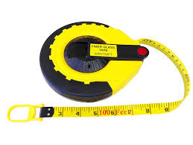
View Laser Technology, Inc. products for utilities inspection and forestry work.

2. Levels

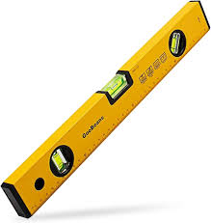
A level can be used to read an elevation and determine differences in elevation between two points. These tools can be handheld, optical or digital, and are typically used in conjunction with level rods or tripods.

3. Safety Gear

Land surveyors work in all kinds of conditions and climates, but safety is always the primary concern. High-visibility gear and safety headwear are a must for all outdoor work crews.

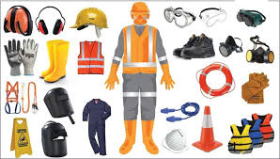

Compasses and Clinometers

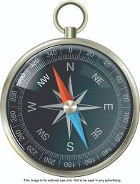
A compass is an essential piece of equipment when surveying in unfamiliar territory, backcountry, or just orienting your position on a map. Compasses can be used to measure distances between two points while clinometers are used to measure the angle or elevation of slopes.

5. Transits and Theodolites

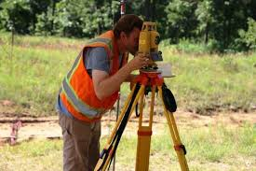
These tools are used to measure both horizontal and vertical angles. Both tools have a minimum accuracy of one minute of angle, though the theodolite is generally recognized as the more accurate of the two, measuring angles to an accuracy of one-tenth of a second angle.

6. Poles, Tripods, and Mounts

Even the most precise of surveying instruments can be thrown off by an unstable mount. Poles, tripods, and other mounting accessories are essential for surveyors to ensure solid, stable readings. These mounts can be used for all kinds of surveying equipment, including prisms, lasers, and levels.

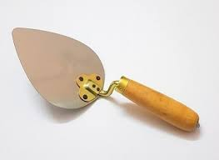
Masonry Trowel; It is a hand tool used in brickwork, stonework, or plastering for placing, leveling, shaping, and smoothing mortar or concrete. They are available in various shapes and sizes depending upon the work.

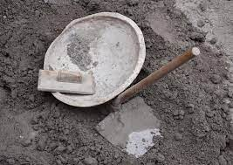
8. Head Pan: It is a round container, like a bowl used to transport construction materials.

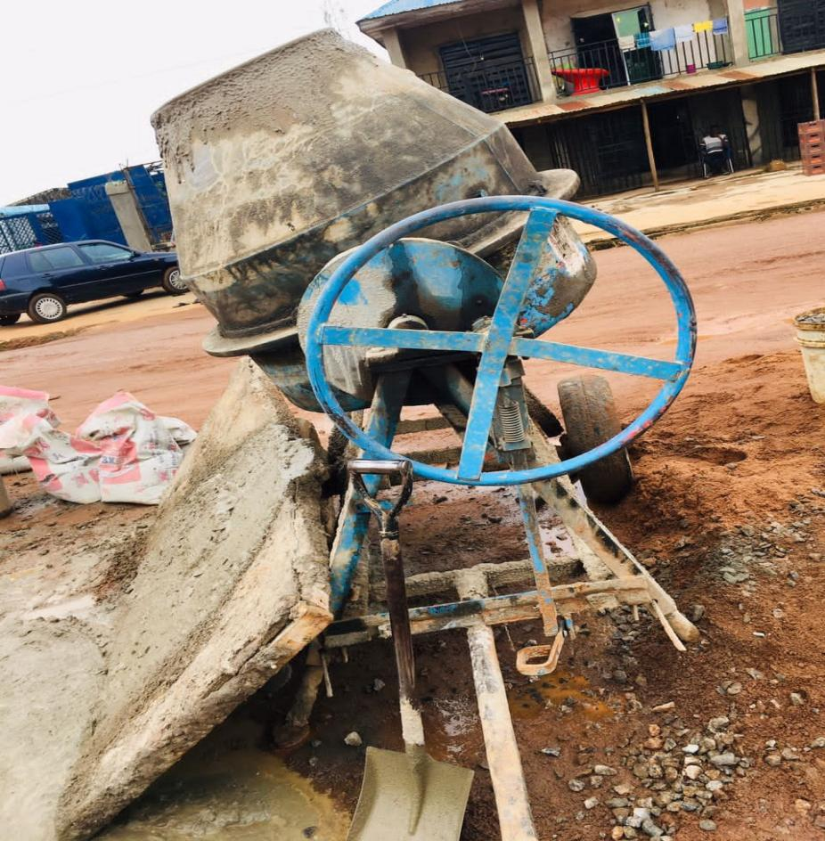
9. Concrete Mixer: This machine is used to mix together cement, gravel, sand and water in other to make it strong and hard to make a concrete cube.

10. Excavator Machine and Tipper Trucks:
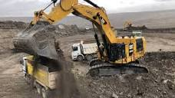
Excavator Machine is used in packing sands from the ground on a lorry for easy drainage trench.

CHAPTER 4
4.0 Summary, Conclusion and Recommendation
4.1 Summary of attachment activities
As aforementioned above, activities done in the Ministry of Housing and Urban Development is to enhance the welfarism of the citizen in provision of the following social amenities;
- Building construction guide
- Road construction measurement.
One of the experienced gained after been recognized and introduced to the workers on site was:
a. How to make building and structure within the road alignment at the phase 2 of the project (Contage 2+200 – 4 +700).
b. Demolition of building and structure within the road alignment at the phase 2 of the project.
c. Making of the road profile up to base level.
4.2 Problems encountered during the program
The major problems encountered during my stay at the Ministry of Housing and Urban Development are the longevity of working hours, working from 8am to 6pm with only an hour rest.
4.3 Conclusion
Ministry of Housing and Urban Development initiate Survey students into knowing the key importance in making proper measurement of roads and building and more so how to set a foundation right in all construction.

4.4 Recommendation
Ministry of Housing and Urban Development which happen to be a state government firm should be encourage in all states and also the citizen should embrace them for better construction of roads and building and also their should be reduce to what an individual can afford since it’s a government operative for all to enjoy.

