

A SIWES REPORT
HELD AT
OLORUNSOGO LOCAL GOVERNMENT SECRETARIAT IGBETI
BY
ADEDOTUN MOSES KAYODE
ND/23/CEC/FT/0002
SUBMITTED TO THE DEPARTMENT OF CIVIL ENGINEERING TECHNOLOGY, INSTITUTE OF TECHNOLOGY, KWARA STATE POLYTECHNIC ILORIN

IN PARTIAL FULFILLMENT OF THE AWARD OF NATIONAL DIPLOMA IN CIVIL ENGINEERING TECHNOLOGY

TABLE OF CONTENTS

TITLE PAGE

Dedication
Acknowledgement
CHAPTER ONE
1.1 Introduction to SIWES
1.2 Aims and Objectives of SIWES
CHAPTER TWO
2.1 Historical background of organization
2.2 ORGANIZATIONAL STRUCTURE OF WORKS DEPARTMENT
CHAPTER THREE
3.0 EXPERIENCES BY STUDENT GAINED DURING SIWES

3.1 Introduction to Technical Units
3.2 SHOVELS
3.3 DIGGERS
3.4 HAND CORES
3,5 CASTING OVERSITE CONCRETE
3.6 SETTING BLOCK WALLS
CHAPTER FOUR
4.1 CONCLUSION
4.2 PERSONAL IMPRESSIONS ABOUT THE ORGANIZATION
4.3 RECOMMENDATION
DEDICATION
This siwes report is dedicated to Almighty God for giving me the opportunity and strength to complete this siwes program and also to my parent for their love, support and parental care throughout the siwes program.

PREFACE
This report is aimed at giving introduction to what was achieved during the siwes program which will be useful to Civil Engineering Technology. The technical written to improve the standard of learning and create for continuing education in tertiary institution.
This report is written in chapter and each chapter has individual sib ending which indicate the direction of the focus.

ACKNOWLEGEMENT
First and foremost I am most grateful to God Almighty. I appreciate my parents Mr. and Mrs. Adedotun who has been my backbone since my inception into this world your care and love towards me is beyond description.
My gratitude also goes to My siblings who supported me financially and morally during my SIWES. Thanks you very much.

CHAPTER ONE
1.1 INTRODUCTION TO SIWES
The Student Industrial Work Experience Scheme (SIWES) is an essential program designed to provide students in higher institutions with the opportunity to gain practical experience in their respective fields of study. The scheme, which was introduced by the Nigerian government, aims to bridge the gap between theoretical knowledge acquired in the classroom and the practical skills required in the workforce. SIWES serves as a platform for students to apply their academic knowledge in real-life industrial and professional settings, fostering a deeper understanding of their chosen career paths. It is an important part of the academic curriculum in Nigerian polytechnics, universities, and other higher education institutions.
During the SIWES program, students are placed in relevant industries or organizations related to their field of study, where they are supervised and given hands-on training. This work experience not only helps students develop technical skills but also exposes them to the dynamics and challenges of the professional world, better preparing them for future employment.
1.2 AIMS AND OBJECTIVES OF SIWES
The primary aims and objectives of the SIWES program are as follows:
- Practical Skills Development: To provide students with the opportunity to gain practical experience and develop the technical skills necessary for their future careers, complementing their academic knowledge.
- Exposure to the Workplace Environment: To expose students to the actual working environment in their chosen fields, helping them understand industry practices, protocols, and expectations.
- Bridging the Gap Between Theory and Practice: To bridge the gap between theoretical knowledge gained in the classroom and the practical knowledge required in the real world, enhancing the employability of students.
- Promotion of Self-Reliance: To prepare students for self-reliance and entrepreneurship by providing them with skills that are relevant to the modern workforce and that will help them excel in their professional endeavors.
- Enhancing Career Prospects: To improve students' career prospects by equipping them with industry-relevant skills and experience that employers look for when hiring.
- Promote National Development: To contribute to national development by producing a skilled workforce capable of meeting the developmental needs of the country, especially in the context of industry, technology, and infrastructure.
- Networking Opportunities: To enable students to build professional relationships with industry experts, mentors, and colleagues, which can lead to job opportunities and career advancements.

CHAPTER TWO
2.1 HISTORICAL BACKGROUND OF ORGANIZATION
Igbeti, often referred to as the "Marble City" due to its rich marble deposits, serves as the central hub for the local government's administrative activities.
The Olorunsogo Local Government Secretariat in Igbeti functions as the administrative nucleus of the LGA, coordinating various developmental projects and public services to enhance the well-being of its residents.
Over the years, the secretariat has been instrumental in implementing policies aimed at improving infrastructure, healthcare, education, and economic development within the region.
The leadership of the local government has seen various chairpersons, including Honourable Qozeem Olayanju, who has engaged in initiatives to foster unity and development by hosting meetings with past chairmen to discuss the progress and future of the LGA.
Additionally, the secretariat has been involved in commissioning significant projects, such as the newly constructed Police Area Command Headquarters, to bolster security and public safety in the area.
The Olorunsogo Local Government Secretariat continues to play a pivotal role in the administration and development of the Igbeti region, striving to meet the needs of its populace and promote sustainable growth.

2.2 ORGANIZATIONAL STRUCTURE OF WORKS DEPARTMENT
DIRECTOR OF WORKS

DEPUT DIRECTOR OF WORKS

ENGINEERS

TECHNICAL OFFICERS

WORKS ASSISTANT

WORS SUPERINTENDENTS
FOREMEN
ARTISANSSS

CHAPTER THREE
3.0 EXPERIENCES BY STUDENT GAINED DURING SIWES
This chapter base on the relevant of the experience gained in student field of study and the interpersonal relationship within the organization.
I was introduced to various tools and technologies commonly used in Civil Engineering, including automobiles, technical units, computer engineering units, shovels, and diggers. I also received practical training on essential construction techniques such as arranging hand cores, casting oversite concrete, setting block walls, erecting walls, preparing formwork for lintels, and casting lintels. These experiences enhanced my understanding of construction processes and provided hands-on exposure to the practical aspects of civil engineering.

3.1 Introduction to Technical Units
Technical units are specialized divisions or systems within an organization or field of study designed to handle specific technical functions, processes, or tasks. In the context of engineering, construction, and other technical industries, technical units play a critical role in ensuring the successful execution of projects, the maintenance of equipment, and the delivery of specialized services. These units are composed of skilled professionals, tools, and technologies tailored to meet the technical demands of a given project or operation.
In civil engineering and related disciplines, technical units may encompass various areas, including:
- Automotive Units: Focused on the maintenance and operation of vehicles and heavy machinery used in construction projects, such as bulldozers, excavators, and transport trucks.
- Mechanical Units: Responsible for the maintenance, repair, and operation of mechanical systems, including generators, pumps, and other construction equipment.
- Electrical Units: Handling electrical installations, wiring, and power supply systems to ensure the smooth operation of construction sites and facilities.
- Computer and Design Units: Utilizing specialized software such as AutoCAD, Revit, and other design tools for project planning, drafting, and modeling.
- Surveying and Measurement Units: Focused on land surveying, leveling, and measurements critical for site preparation and construction accuracy.
- Structural and Formwork Units: Responsible for the preparation, assembly, and inspection of formwork and reinforcement for structural elements such as beams, columns, and slabs.
Technical units not only streamline operations but also ensure that projects are executed with precision, safety, and efficiency. Their contributions are vital for the successful completion of engineering and construction endeavors.
3.2 SHOVELS
Shovels are versatile tools primarily used for excavating, moving, and handling materials such as soil, sand, gravel, concrete, and other construction materials. They are essential in both manual and mechanized forms across various civil engineering applications.

SHOVEL
3.3 DIGGERS
In civil engineering, diggers (also called excavators or digging machines) are essential equipment used for excavation, material handling, and site preparation. They are a critical part of any construction project that requires the removal of soil, rock, or other materials.

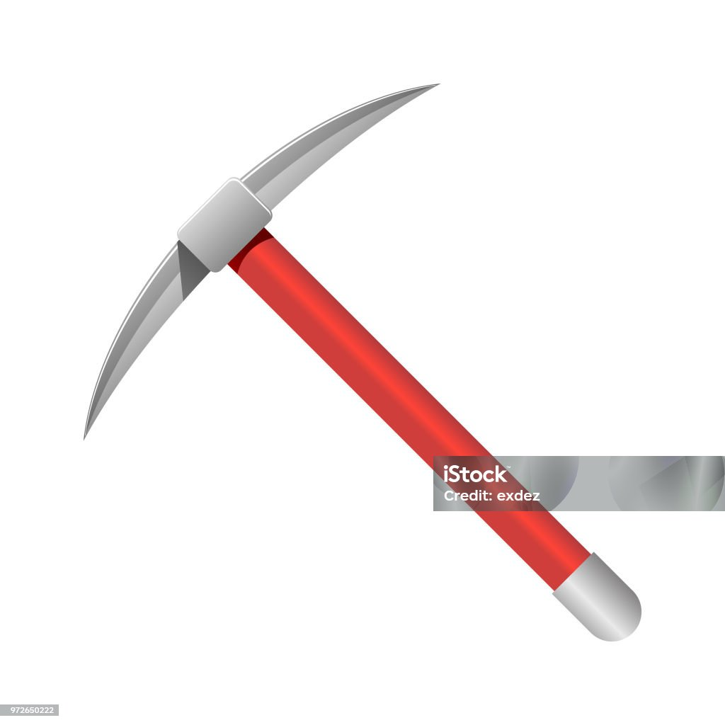
DIGGER

3.4 HAND CORES
In civil engineering and construction projects, hand cores refer to small cylindrical samples of materials like concrete, asphalt, or rock, extracted using core drilling machines or handheld coring tools. Arranging these hand cores is critical for proper analysis, documentation, and storage.

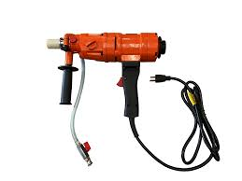
HAND CORES

3.5 CASTING OVERSITE CONCRETE
Casting oversite concrete involves laying a layer of concrete to form a stable, level, and clean base for a building’s ground floor or as a foundation for other structural elements. This process is critical in providing a durable surface and ensuring proper load distribution.

Steps to Cast Oversite Concrete
- Preparation of the Site
  - Clear the Area: Remove vegetation, debris, and loose soil.
  - Excavate: Dig to the required depth according to the design specification.
  - Compact the Ground: Use a mechanical compactor to ensure the soil is firm and stable.
- Installation of Hardcore Layer
  - Spread Hardcore: Lay a 150–225 mm layer of compacted hardcore (crushed stones or gravel).
  - Compact the Hardcore: Use a vibrating plate or roller to compress the layer.
  - Blind the Hardcore: Apply a thin layer of sand to fill gaps and level the surface.
- Placement of Damp Proof Membrane (DPM)
  - Lay the DPM: Spread a polyethylene sheet over the hardcore to prevent moisture ingress.
  - Overlap Joints: Ensure overlaps are at least 150 mm and tape them securely.
  - Extend the DPM: Let the membrane run up the sides of the foundation walls for extra protection.
- Formwork and Levelling Guides
  - Set Up Formwork: Use wooden or metal formwork to define the edges and ensure proper thickness.
  - Install Levelling Guides: Place level pegs or guides to maintain consistent concrete thickness.
- Mixing Concrete
  - Prepare the Mix: Use a concrete grade (e.g., C25 or C30) as specified in the design. The mix typically includes cement, sand, aggregates, and water in proper ratios.
  - Use Ready-Mix Concrete: Alternatively, order pre-mixed concrete for consistency and efficiency.
- Pouring the Concrete
  - Start Pouring: Pour the concrete onto the prepared base starting from one end.
  - Spread Evenly: Use shovels and rakes to distribute the concrete.
- Levelling and Compacting
  - Compact the Concrete: Use a vibrating plate or poker vibrator to remove air pockets and ensure uniform compaction.
  - Screed the Surface: Drag a straight edge across the concrete to level it.
- Finishing the Surface
  - Smooth the Surface: Use a trowel or float to achieve the desired finish (e.g., rough for adhesion or smooth for aesthetics).
  - Add Slip Resistance: If required, apply a broom finish for non-slip surfaces.
- Curing
  - Cover the Concrete: Use wet hessian, plastic sheeting, or curing compound to prevent moisture loss.
  - Maintain Moisture: Cure the concrete for at least 7 days to achieve optimum strength.
- Final Checks
  - Inspect for cracks, uneven areas, or weak spots.
  - Ensure the thickness matches the design specifications.

Tools and Materials Needed
- Tools: Shovels, rakes, screeds, trowels, compactors, vibrators.
- Materials: Cement, sand, aggregates, water, hardcore, damp-proof membrane.
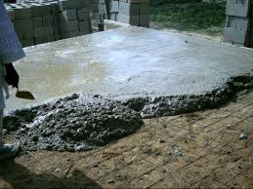

3.6 SETTING BLOCK WALLS
Setting block walls is a common task in masonry construction, used for building structures like walls, foundations, and partitions. The process involves laying blocks (typically concrete or cinder blocks) in a stable and precise manner to ensure structural integrity.
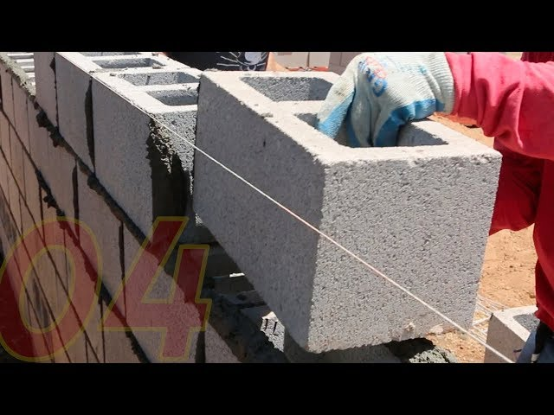

CHAPTER FOUR
4.1 CONCLUSION
In Conclusion It’s Good To Understand At This Contemporary Stage In Life That “Success As We All Understand Is Not Measured By The Height At Which One Find Himself, But It Can Be Measured By What You Can Achieved With Your Initiative”.
The organization has been able to import knowledge like now what are in jet age where knowledge is mostly needed in the running of daily life. My coming out of the organization has increased my knowledge of the computer practically and theorically which is an eye opener.
4.2 PERSONAL IMPRESSIONS ABOUT THE ORGANIZATION
The introduction of the students industrial worked experience scheme (SIWES) is highly appreciated has applied to the part of fundamental learning of students.
As discussed thoroughly, the idea of students industrial worked experience scheme is a great opportunity to student who is ready to achieve and to gain more in the area of specialization course of study.
4.3 RECOMMENDATION
With the opportunity of the students industrial worked experience scheme (SIWES) effective facilities are here by demanded to equip trainee for effective performance and standard.
The implementation of the students industrial worked experience scheme(SIWES) should be made a stronger exercise so as to improve the level of exercise.

