
TECHNICAL REPORT ON THE STUDENT
INDUSTRIAL WORK EXPERIENCE SCHEME
(SIWES)

HELD AT
SOLID TECH POWER SERVICE
S.O.J Street Saw Mill Area Ilorin Kwara State

PRESENTED BY:

MUDASHIR MUKODAS OLAKUNLE
ND/23/EEE/PT/0068

SUBMITTED TO
DEPARTMENT OF ELECTRICAL/ELECTRONICS ENGINEERING
INSTITUTE OF TECHNOLOGY (I.O.T) KWARA STATE POLYTECHNIC ILORIN, KWARA STATE.
P.M.B. 1375, ILORIN, KWARA STATE.

IN PARTIAL FULFILMENT OF THE REQUIREMENT FOR AWARD OF NATIONAL DIPLOMA (ND) CERTIFICATION IN ELECTRICAL/ELECTRONICS ENGINEERING

MARCH - APRIL, 2025

PREFACE
This report contains all experience gained during the time of my student industrial work experience scheme (SIWES). Thus it vividly gives a comprehensive summary report of the engaged and experience gained at the company.

DEDICATION
I am delight to dedicate this report to Almighty ALLAH who gave me the grace and opportunity to complete this program.
I also dedicate it to my lovely parent Mr. and Mrs. MUDASHIR. Who gave me the grace and opportunity for the period of my industrial training, and throughout my ND Program, may God Almighty be with you forever.

ACKNOWLEDGEMENT
All praises, adoration and gratitude are all due to Almighty ALLAH. My gratitude also goes to my industrial supervisors who devoted his time for me throughout my stay in the company to make sure I attained maximum knowledge during my program.
My special thanks to my lovely caring and hearted parents, my Mr. and Mrs. MUDASHIR who stood by me that do not let me fall also for their moral and financial assistance rendered throughout my ND program.
Also to my unforgettable siblings, may God Almighty ALLAH be with you all.
Also to my always hardworking engineers in the department of Mineral Resources and Petroleum Engineeringstarting from my HOD of the Department, the Exam coordinator, and all the entire lectures in the great department for their effort and knowledge they impacted on us throughout the ND program may God Almighty be with you all.
And also to all my amiable friends in the department and in the school entirely, may how friendship leads us all to janatu-l-firidaos Amin.
ABSTRACT
This technical report is based on four months compressive industrial training exercise.
The report comprises of five chapters, chapter one: focuses on general introduction to work, chapter two; gives the description of establishment, chapter three and four explain the experience gain and gathered during the programme, chapter five gives the summary conclusion of the report and recommendation needed to the organization and to the polytechnic and development of student’s industrial work experience scheme (SIWES).

TABLE OF CONTENT
Title page
Prefacei
Dedication ii
Acknowledgment iii
Abstract iv
Table of content v
Chapter One
- Introduction 1
1.1 Aims And Objectives Of Siwes 2
1.2 Statement Of Problem 3
1.3 Scope Of The Study 4
1.4 Justification 4
Chapter Two
- Historical Background Of The Organization 9
2.1 Organization Chat 10
Chapter Three
- Experienced Gained 12
3.1 Experience Gained with explanation 13

3.2 How to repair invertor 15

3.3 Sales centre department 16

3.4 Different between Maximum power point tracker and pulse width modulation 15

3.5 Different between monocrystalline and polycrystalline solar panel 17

Chapter Four

4.0 Tools and equipments 18

4.1 Tools and equipments used at service centre department and technical department 19
Chapter Five
5.0 Concussion 20
5.1 Personal impression About The Organization 20
5.2.1 Recommendations To The Polytechnic Concerning The Siwes Programme. 21

CHAPTER ONE
1.0 INTRODUCTION
SIWES was established by ITE in 1973 to solve the problem of lack of adequate practical skills preparatory for employment in industries by Nigerian graduates of tertiary institution.
The scheme exposes students to industry based skills necessary for a smooth transition from the classroom to the world of work. It affords students of tertiary institution the opportunity of being familiarized and exposed to the needed experience in handling machinery and equipment’s which are usually not available in the educational institutions.
The student Industrial Work Experience Scheme (SIWES) was established for Nigerian Higher institution especially Polytechnics and Universities, in order to bring all what they have been taught in the lecture room into practical. Therefore, Polytechnics Universities education will be incomplete if it ends in the lecture room, It is highly experience for student particularly science student to put the lecture room theory into practical.
The Student Industrial Work Experience Scheme (SIWES) is the accepted skills training programme, which form part of the approved minimum academic standards in various degree programme for all the gap existing between theory and practical of Engineering and Technology, Science, Agriculture, Medical, Management and other professional work methods and ways of safeguarding the work areas and workers in industries and other organizations. The minimum duration of the SIWES should normally be 24 weeks except for Engineering and Technology programmes. The programme involving the students, the university and the industries (employers) is found by the federal government of Nigeria and jointly coordinated by the Industrial Training Fund (ITF) and National Universities.
1.1 DEFINITION OF SIWES
SIWES is an acronym of the student industrial work experience scheme. It is a practical skill program developed and designed to prepare student to gain more practical experience and for transition and enhancement of the theory lecturing in the classroom experience to practical experience.
1.2 AIMS AND OBJECTIVES OF SIWES
SIWES programme is therefore aimed at giving the student the opportunity to relate and translate their theoretical knowledge to the real world of work.
The specific objectives of SIWES as summarized by the federal government Gazette of April 1978 are listed below....
1. SIWES provide avenue for student in an institution of higher learning to acquire industrial skills and experience in their course of study.
2. Help student to gain increased maturity and understanding of the workplace.
3. The program teaches the student on how to interact with other workers and supervisors under various conditions in the organization.
4. The student will have chance to evaluate companies for which they might wish to work.
5. It exposes student to the work methods and techniques in handling equipment and machines that might not be available in educational institution.
6. It makes the transaction from school to the world of work easier.
1.3 HISTORICAL BACKGROUND OF THE ORGANIZATION
The company was established with the aim and objective of improving and broadcasting Nigeria engineering and mores to make Electrical Engineering work easier to human being.
However, this company was owned and controlled by an individual private controller and management.
As at starting, started with an average worker of five (5) working and by now, being an automatic pen, they convert by operating various departments in which each department consist of two constant workers.
1.4 ORGANIZATION CHART OF THE ORGANIZATION
ENGINEER
PROJECT MANAGER
ADMIN OFFICER
SECRETARY
MANAGING DIRECTOR
GENERAL MANAGER
SUPERVISING ENGINEER
FINACIAL OFFICER
TECHNICAL OFFICER
LABOURER
FOREMAN

CHAPTER TWO
2.0 SECTIONS / UNITS OF THE ORGANIZATION AND THEIR SPECIFIC FUNCTION
- Electrical section
- Auditing section
2.2 ELECTRICAL DEPARTMENT
This section foresees the proper maintenance and efficiency of the organization, electrification project and also electronics. This section is coordinate by the Director of Electrical Engineering Department.
2.3 AUDITING DEPARTMENT
This section has overall responsible to audit all financial transaction carryout in their organization such as amount spent on labor amount spent on purchasing of equipment’s etc

CHAPTER THREE
- EXPERIENCE GAINED
One of the experience gained during the training is introduction to solar panel, type of solar panel and its benefit, battery maintenance and voltage etc.
3.1 WORK EXPERIENCE
The work activities and experience gained at technical department are:
- Maintenance of battery
- Battery voltage
- Racking of solar panel battery
- Maintenance of battery: -I learnt how to monitor the state of battery during charging is the first responsibility of a charge system controller.
- Battery voltage: voltage meter is used to indicate the battery life and it is easy to use.
- Racking of solar panel battery: -it means to avoid the risk from falling from ladder and also to avoid electric shock by using safety jacket, helmet, belt, slippers.
3.2 HOW TO REPAIR INVERTER
Repair is determined by the problem shows on the screen which when it shows normal means the system status is overloaded and when it is not charging the system status will show battery low and at high voltage the status system shows high voltage all this enable us to know what exactly the problem is when the inverter is faulty
Three parts of inverter are:
- Transformer Unit
- Amplifying unit
- Control unit
- Transformer unit: - It increase or decrease alternating current (AC) electricity from one voltage to another
- Amplifying unit: - Is the main and integral parts of inverter
- Control Unit: - It shows battery status, voltage, AC output voltage, power output and alarm function
Classification of Battery
- C_{10:} are the battery that can charge for 20hours but will exceed 10hours
- C_{20:} are the battery that can charge for 10hours and work for 20hours
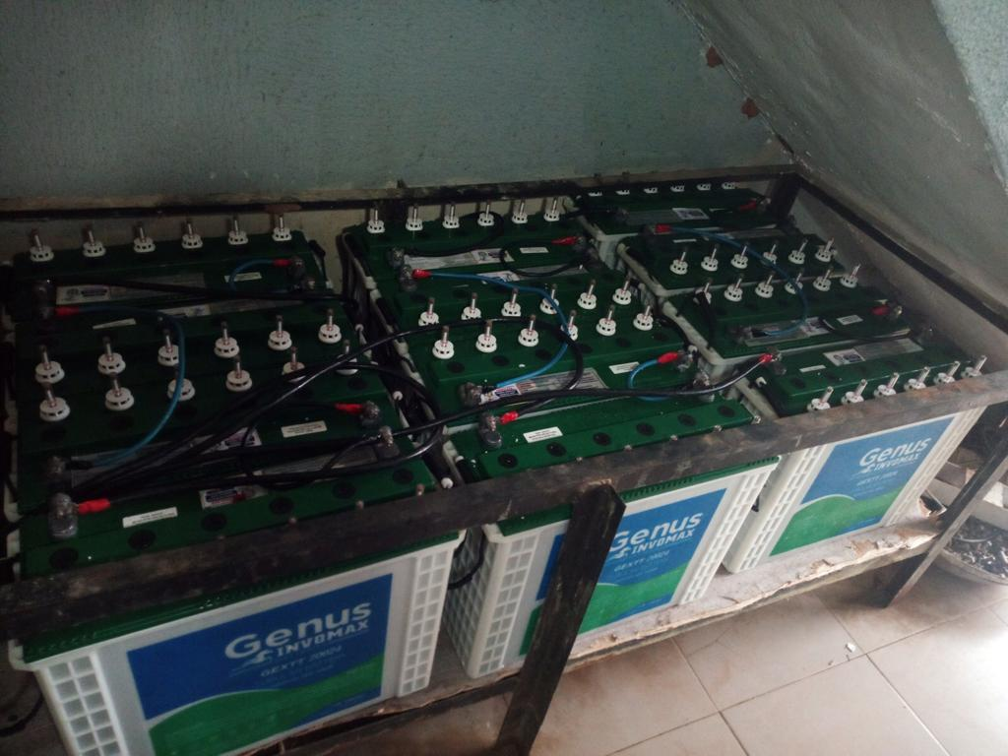
3.3 SALES CENTRE DEPARTMENT
This department is the one that attend to customer and also go for site survey.
Definition of some terms:
- Inverter means conversion which means a system that convert energy from AC to DC and DC to AC
- Charge controller:- is a voltage or current regulator that keeps battery from open charging. It regulated the voltage and current coming from solar panel to the battery.
- Mppt: maximum power point tracking
- Pwm : pulse width modulation
- Solar panel: are used to convert light from sun, which is composed of particles of energy called photons for powering electric load
- Monocrystalline: the cell is made up of cylindrical silicon grown from a single crystal of silicon of high purity
- Polycrystalline: it consists of several crystal of silicon in a single pv cell.
3.3.1 ADVANTAGES OF LOW FREQUENCY INVERTER
- It has peak power capacity
- Reliability
- Design to deal with high power spikes for long period of time.
3.3.2 ADVANTAGES OF HIGH FREQUENCY INVERTER
- Less expensive
- It has smaller footprints
- It has lower tolerance for industrial load.

3.4 DIFFERENT BETWEEN MAXIMUM POWER POINT TRACKING AND PULSE WIDTH MODULATION
MPPT | PWM
It is expensive | It is cheap
It has high performance | It has low performance
It has longer hours to charge | It has lower limit
It protect battery life | Do not protect battery life
It is bigger in design | Relatively small in design
It is made of metal | It is made of plastic

3.5 DIFFERENT BETWEEN MONOCRYSTALLINE AND POLYCRYSTALLINE SOLAR PANEL
Monocrystalline | Polycrystalline
It support hot weather | It support cloudy weather
The edges are not cut | The edges are cut
It has better yield | Ithas lower yield
It is expensive | It is cheap
It has only one color | It has different color

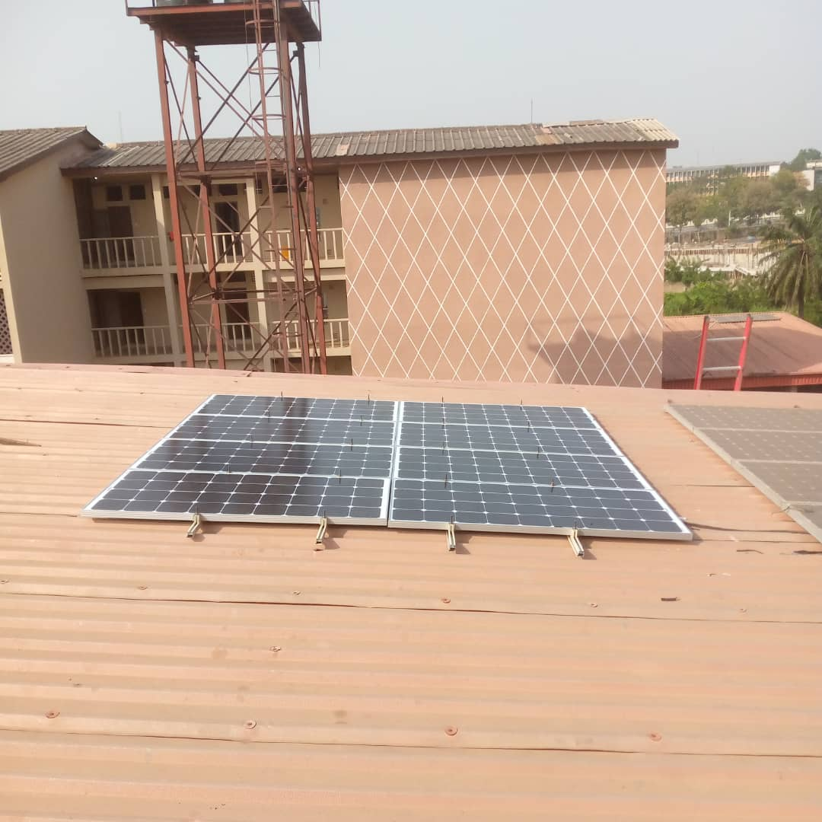
Figure 2:- solar panel
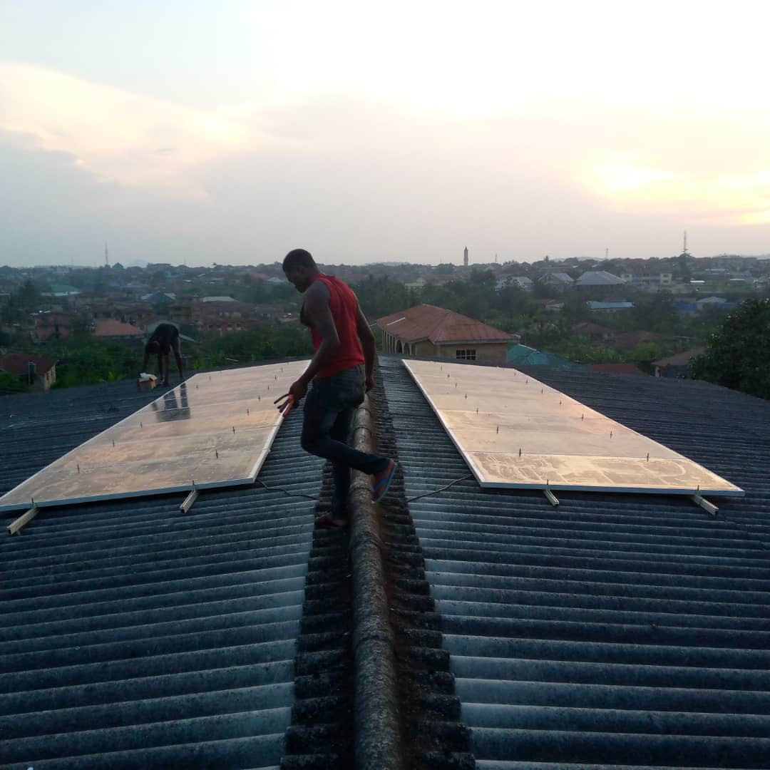
Figure 3:
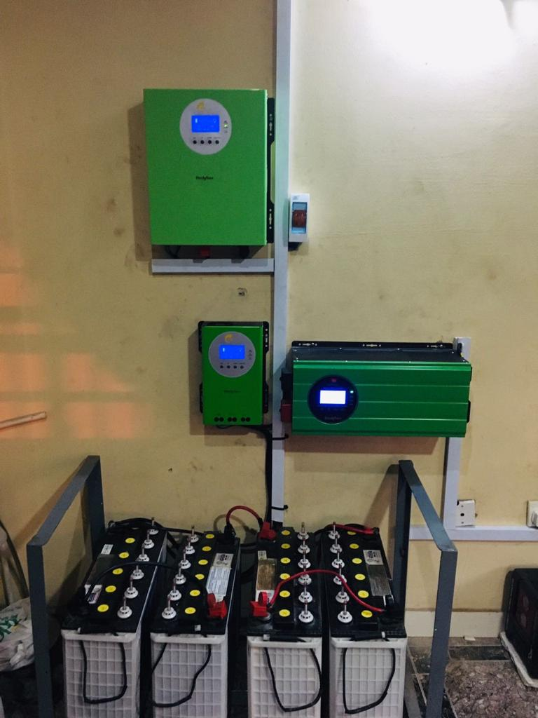
Figure 4:

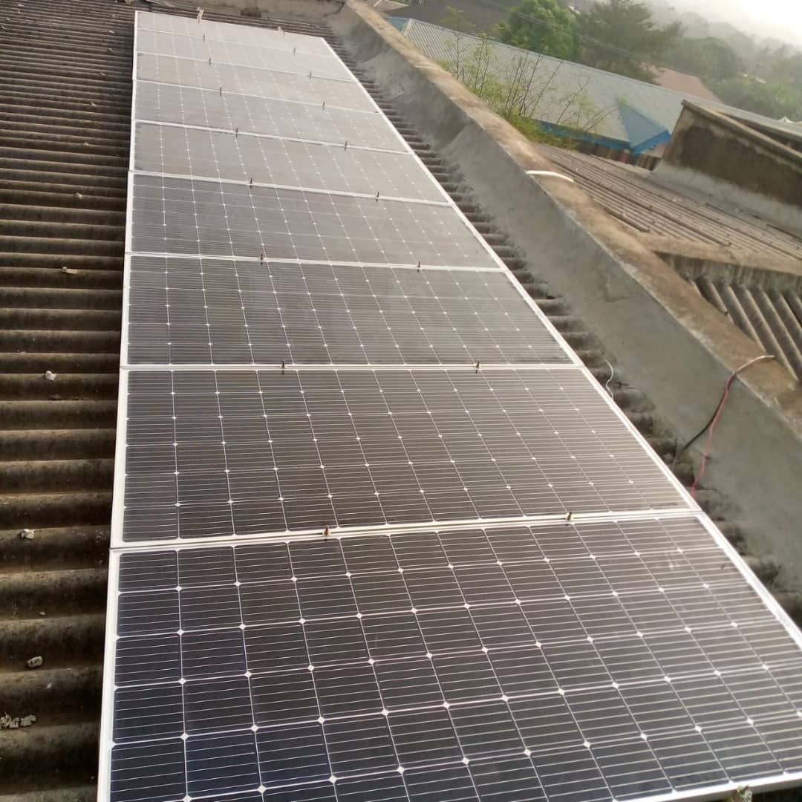
Figure 6:-

CHAPTER FOUR
4.0 TOOLS AND EQUIPMENT
4.1 TOOLS AND EQUIPMENT USED AT SERVICE CENTRE DEPARTMENT AND TECHNICAL DEPARTMENT
The tools and equipment mainly utilized in this department during work are:
- Spanner :-It is used to dismantle or tight nut or bolts of a specific size.
- Hammer :- It is used for conjunction with effective grounding
- Screwdriver :- It is used to tighten grounding lugs and opening the sealant tubes
- Petroleum Jelly:-It is used to improves the value of sunlight absorbed by the panel
- Funnel :- It is used to pour water into the battery
- Cup:- To hold water by pouring into the funnel
- Allen Key :- To lose the screw
- Guage :- To know the level of water in the battery
- Clamp Meter :- It is used to verify correct voltage
- Tester :- For testing the efficiency and operation condition of solar panel
- Plier :- Is use for repositioning, bending, sniping wires
- Box: As described earlier, this is a box containing various work tools.

CHAPTER FIVE
- CHALLENGES ENCOUNTERED DURING THE SIWES, CONCLUSION AND RECOMMENDATION
5.1 CHALLENGES ENCOUNTERED DURING THE SIWES
Some problems experienced during the course of the training are stated below:
- The cost of transportation was not convenient either. More so at the first place of placement, especially as little to no form of payments were made to interns to ease the expenses during the entire course of the training.
- Safety wears were sometimes inadequate..
5.2 CONCLUSION
The training broadened my knowledge and understanding of certain aspects and concepts in solar and inverter engineering, especially pertaining to power. It helped bridge the gap between theory and practical, as it offered exposure to real and basic practical skills, and to real life application of various theoretical concepts learnt in the classroom. The program also helped expand my knowledge and understanding to solar and inverter power system.

5.3 RECOMMENDATION
Based on personal experiences and observations during the course of the training, the following recommendations are stated below;
- Solar panel with inverter should be recommended since was a noiseless, it does not use fuel.
- The solar power system was a convenient way of producing an alternative means to power supply to supplement the main failure.

