

TECHNICAL REPORT ON STUDENT INDUSTRIAL WORK EXPERIENCE SCHEME (SIWES)

Siwes Report

UNDERTAKEN AT:

FEDERAL AIRPORT AUTHORITY OF NIGERIA (FAAN) HEADQUARTER, IKEJA LAGOS.

BY

ABDULRASAQ QUWAMDEEN ONAOPEMIPO

ND/23/CEC/PT/0065

SUBMITTED TO:

DEPARTMENT OF CIVIL ENGINEERING, INSTITUTE OF TECHNOLOGY, KWARA STATE POLYTECHNIC, ILORIN.
IN PARTIAL FULFILLMENT OF THE REQUIREMENT FOR THE AWARD OF NATIONAL DIPLOMA (ND) IN CIVIL ENGINEERING.

AUGUST – NOVEMBER, 2024.

CERTIFICATION
This is to certify that this report is original to the author, ABDULRASAQ QUWAMDEEN ONAOPEMI with Matric No. ND/23/CEC/PT/0065 in the Department of Civil Engineering, Institute of Technology, Kwara state Polytechnic, Ilorin and was and was supervised according by Dr. Fakayode T.E of Social Department.

…………………………………. ………………………………….
Signature Date

CHAPTER ONE

INTRODUCTION
1.1 Background
Students’ Industrial Work Experience Scheme (SIWES) is one of the Industrial Training Fund (ITF) programs introduced in 1974 due to the inability of engineering and technology students in Nigerian universities and polytechnics to meet the practical aspects of their training. It aims to bridge the gap between theoretical knowledge and practical skills, equipping students with the necessary experience to function effectively in the world of work. It is also a planned and structured program based on stated and specific career objectives which are geared towards developing the occupational competencies of participants (Mafe, 2009).
1.2 VISION AND MISSION STATEMENT
- VISION STATEMENT
To be the prime Skills Training Development Organization in Nigeria and one of the best in the world.
- MISSION STATEMENT
To set and regulate standards and offer direct training intervention in industrial and commercial skills training and development, using a corps of highly competent professional staff, modern techniques, and technology.
1.3. BACKGROUND AND INITIATION
Before establishing the Scheme, industrialists and other employers of labor felt concerned that graduates of Nigerian universities were deficient in practical background studies preparatory for employment in industries and other organizations. This concern led to the initiation and design of the SIWES program by the Industrial Training Fund (ITF) in 1973.
1.4. COORDINATION AND FUNDING
The scheme is a tripartite program involving students, universities, and employers of labor. It is funded by the Federal Government and jointly coordinated by the Industrial Training Fund (ITF) and the National Universities Commission (NUC).
1.5 AIMS AND OBJECTIVES
The aims and objectives of the SIWES are:
- To provide an avenue for students in Nigerian universities to acquire industrial skills and experience during their course of study.
- To prepare students for the work situation they are likely to meet after graduation.
- To expose the students to work methods and techniques in handling equipment and machinery that may not be available in their universities.
- To make the transition phase from school to the world of working environment easier and facilitate students’ contact for later job placements.
- To provide students with an opportunity to apply their theoretical knowledge in real work situations thereby bridging the gap between theory and practice.

1.6 COMPANY PROFILE:
FEDERAL AIRPORTS AUTHORITY OF NIGERIA (FAAN)

Plate 1 FAAN Logo
The organization's goal is stated in its vision and mission statements:
1.7 MISSION AND VISION STATEMENT
- MISSION STATEMENT
To develop and profitably manage customer-centric airport facilities for safe, secure and efficient carriage of passengers and goods at world-class standards of quality.
- VISION STATEMENT
To be amongst the best airport groups in the world.
1.8. CORE VALUES OF FAAN:
- SAFETY
- SECURITY
- COMFORT
1.9 HISTORICAL BACKGROUND OF FAAN:
Federal Airports Authority of Nigeria (FAAN) is one of the parastatals of government, under the supervision of Federal Ministry of Aviation and Aerospace Development.
Decree 45, which established the Nigerian Airports Authority (NAA), was promulgated by the Federal Military Government under the regime of General Murtala/General Olusegun Obasanjo in 1976 but activities of the Authority did not take of until 1978. Its first board of directors was inaugurated in Lagos on July 11,1978.
The Nigerian Airports Authority (NAA) continued to perform its functions as outlined by the decree establishing it until August 1995 when a civil aviation reform was carried out by the then Federal Military Government. The reforms led to the realignment of some of the functions of the Federal Civil Aviation Authority (FCAA) with those of the Nigerian Airports Authority to bring about a new body called "Federal Airports Authority of Nigeria”.(Amendment) Act No.52 of 1999 which formally brought FAAN into existence is an offshoot of Decree 9 of 1996.
1.10 Services of FAAN
- Airport Management: Operates and manages airports across Nigeria, including international, regional, and domestic facilities.
- Safety and Security: Ensures passenger, aircraft, and facility safety through strict standards and regulations.
- Passenger Services: Enhances the passenger experience with modern terminals, efficient check-in, and amenities.
- Air Traffic Management: Collaborates with agencies to facilitate smooth air traffic flow and communication.
- Infrastructure Development: Invests in airport infrastructure to meet increasing demand and international standards.
- Commercial Services: Oversees concessions, retail, and commercial operations at airports.
- Environmental Sustainability: Committed to minimizing the environmental impact of aviation.
- Training and Development: Provides training to the workforce to ensure competency and professionalism.
1.11 CIVIL ENGINEERING DEPARTMENT RESPONSIBILITIES
- Oversees the planning and execution of construction projects, including terminal and runway expansions.
- Implements safety measures to ensure compliance with international standards, safeguarding aircraft, passengers, and airport personnel.
- Addresses environmental concerns related to construction and maintenance by striving for eco-friendly solutions.

1.12 STRUCTURE AND HIERARCHY
The Federal Airport Authority of Nigeria (FAAN) operates under the supervision of the Federal Ministry of Aviation and the State Ministry for Aviation, with a structure led by a Managing Director/Chief Executive Officer (MD/CEO) who reports to the Board; it includes various Directorates and service departments, each managed by Executive Directors and Airport Managers, to effectively oversee and coordinate airport operations and ensure safety and efficiency in aviation services across Nigeria.
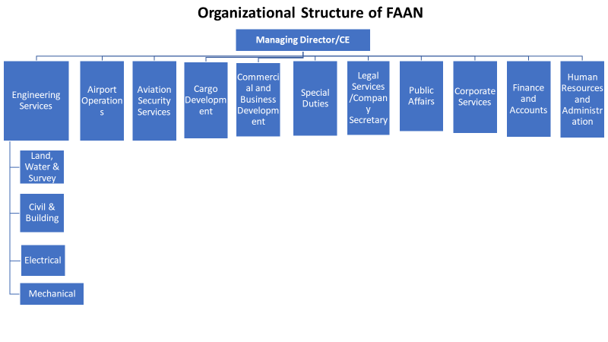
Plate 2 Organization structure of FAAN

CHAPTER TWO
EXPERIENCE GAINED.
2.1 FACILITIES PROVIDED
The Civil Engineering Department within the Federal Airports Authority of Nigeria (FAAN) plays a vital role in planning, designing, and maintaining critical airport infrastructure projects, which range from tens of millions to hundreds of millions of naira. The Engineering Technology Division is essential in ensuring the success and cost-effectiveness of these projects by utilizing advanced tools and technologies, including AutoCAD, Revit, the Bill of Engineering Measurement and Evaluation (BEME), and firefighting systems.
2.2 AUTOCAD AND REVIT DRAWINGS
AutoCAD is a key tool in our civil engineering efforts, enabling engineers to create precise and detailed drawings necessary for architectural and structural planning. This software helps the department meet high industry standards in design.
2.3 SITE WORK AND EXPERIENCE
Site work allows engineers to apply theoretical knowledge in real-world situations, facing unforeseen challenges that require quick thinking and innovative solutions. This experience enhances teamwork and communication skills as engineers collaborate with architects, contractors, and clients.
2.4 BILL OF ENGINEERING MEASUREMENT AND EVALUATION (BEME)
Preparing the BEME is crucial for civil engineering projects, involving detailed calculations of materials, quantities, and costs. My experience with BEME, particularly using Excel, highlighted the importance of accuracy in cost estimation, as even minor errors can lead to significant financial impacts. The Engineering Technology Division reconciles contractor valuations with FAAN's estimates to ensure projects are completed on budget and to high standards.
2.5 FIREFIGHTING AND PREVENTION
Firefighting and prevention are critical aspects of safety engineering, enabling professionals to apply theoretical knowledge to real-world emergencies. This field fosters collaboration with stakeholders, enhancing teamwork and communication skills essential for effective emergency response. Hands-on experience in fire safety deepens the understanding of safety protocols and the importance of preparedness in mitigating hazards.
2.6 QUALITY OF COMPANY-BASED SUPERVISORS
The quality of supervisors significantly enhances the internship experience. My supervisors, Engr. Ibrahim, Engr. Lekan, Engr. Abbas, Engr. Bayo, Engr. Gambo and Arc Abdul, provided exemplary guidance and mentorship. Their expertise in engineering and architecture offered invaluable insights and fostered a holistic understanding of project interconnections. They effectively broke down complex projects into manageable tasks, promoting a sense of ownership and responsibility.
Furthermore, they created a collaborative environment that encouraged questions and critical thinking, which facilitated my professional growth. Their leadership in project planning, execution, and monitoring emphasized the importance of timelines, budgets, and quality standards, broadening my skill set and preparing me for future challenges. Constructive feedback from them has been vital for my continuous improvement.
2.7 KNOWLEDGE GAINED
My internship in FAAN's Civil Engineering Department provided a dynamic environment where I gained invaluable knowledge and skills, laying a foundation for my career in civil engineering and technology. Key components of my experience included the application of BEME, proficiency in AutoCAD and Revit, and knowledge of fire safety.
2.8 SKILLS GAINED
During my internship, I developed several key skills relevant to civil engineering:
- Effective Communication: Engaging with colleagues and supervisors improved my verbal and written communication skills, essential for collaboration and clear information exchange.
- Teamwork: Collaborating with diverse teams reinforced the importance of collective efforts in achieving project goals and fostered innovative problem-solving.
- Time Management: Balancing multiple tasks honed my ability to prioritize, set deadlines, and manage workloads efficiently, critical for meeting project timelines.
- Adaptability: Exposure to dynamic work conditions cultivated my flexibility and resilience, enabling me to respond effectively to unexpected challenges.
- Problem Solving: Engaging with real-world engineering challenges improved my ability to assess problems and develop effective solutions.

CHAPTER THREE
OFFICE DAILY ACTIVITIES
3.1 INDUSTRIAL TRAINING OVERVIEW
I completed my Industrial Training at the Federal Airports Authority of Nigeria (FAAN) headquarters in Ikeja, Lagos. The headquarters primarily managed paperwork for major construction projects, which included:
- Preparing Bills of Quantities (BOQ) and Bills of Engineering Measurements and Evaluations (BEME).
- Reviewing and approving BOQs and BEMEs for significant external projects submitted by contractors and companies.
- Assessing and correcting architectural drawings and building plans.
- Conducting site inspections to ensure that concessionaire projects adhere to specifications and standards.
- Performing maintenance and inspections on existing buildings.
- Using AutoCAD for assignments related to building plans.
In addition to these tasks, we utilized Microsoft Office skills to draft internal memos regarding project meeting schedules with concessionaires, major contractors, audit departments, and project implementation teams. We also issued contractors' award letters and approval letters for site work, employing Excel for managing BOQs and BEMEs.
3.2 PREPARATION OF BILLS OF QUANTITIES AND ENGINEERING MEASUREMENTS
A Bill of Quantities (BOQ) is a detailed document listing the materials, labor, and equipment needed for a construction project, along with their estimated costs. It serves as a foundation for procurement, pricing, and tracking project progress and expenses. The BOQ outlines specific materials, components, and labor required to complete the project, providing descriptions, quantities, units of measure, and cost estimates. This is essential for keeping the project within budget and resolving cost disputes.
Typically, the preparation of BOQs is conducted by quantity surveyors or estimators, and they are used throughout the project lifecycle to monitor progress, adjust budgets, and handle disputes.
3.3 PURPOSE OF PREPARING BILLS OF QUANTITIES
The primary aim of creating a BOQ is to provide an accurate and detailed overview of project requirements, including quantities and costs of materials, labor, and equipment. The BOQ serves several vital functions:
- Cost Estimation: Assists in estimating the total project cost to assess feasibility within the budget.
- Tender Documentation: Acts as a basis for procurement and tendering, enabling contractors to submit competitive quotes.
- Cost Control: Monitors and controls expenditures during construction to keep the project within budget.
- Contract Administration: Serves as the basis for the contract between client and contractor, helping to resolve disputes.
- Record Keeping: Provides a detailed record of project requirements for future reference, aiding maintenance or future expansions
3.4 FORMAT OF BILL OF QUANTITIES
The format of a BOQ can vary based on project complexity and client needs, but it typically includes:
- Introduction: An overview of the project, scope of work, location, and date of the BOQ.
- Items and Descriptions: A detailed list of required items, including materials, labor, and equipment.
- Units of Measurement: Definitions of the measurement units for each item (e.g., square meters, linear meters).
- Quantities: Estimated quantities for each item.
- Unit Prices: Estimated costs per unit for each item.
- Total Prices: Total costs for each item, calculated by multiplying quantity by unit price.
- Summary: A breakdown of total project costs.
- Terms and Conditions: Important project information, including payment terms and warranties.

FIELD WORK
4.1 BUILDING
A building is a permanent structure characterized by a roof and walls, found in various forms such as homes or factories. Buildings vary widely in size, shape, and purpose, evolving over time due to factors like available materials, climate, land costs, ground conditions, intended use, and aesthetic considerations. The main components of a building are the superstructure and the substructure. The superstructure comprises all visible elements above ground level, extending from the ground floor to the roof. In contrast, the substructure includes everything below ground, primarily the foundation.

4.2 SUBSTRUCTURE
The substructure is the part of the building that lies beneath the ground surface. It is responsible for transferring the building's weight to the underlying soil. The superstructure is then constructed directly above this base. The integrity of the substructure is vital; it requires careful collaboration with structural engineers to ensure that elements like piers, support beams, and foundations are secure and stable. Typically, the base of the substructure is made from either reinforced cement concrete or plain cement concrete. This concrete is then covered with bricks or stones, along with additional concrete, until it reaches the desired plinth level. A damp-proof membrane is installed on top to prevent moisture from seeping into the substructure.
4.3 PROJECT OVERVIEW
- Project Name: Revaluation of the Hotel Development
- Client: Marblegate Properties Limited
- Architect: Buildout Designs
- Structural Engineer: Yetosol Association
- Approval Number: DCB/DO/2130/IK
- Contractor: Vita Construction Limited
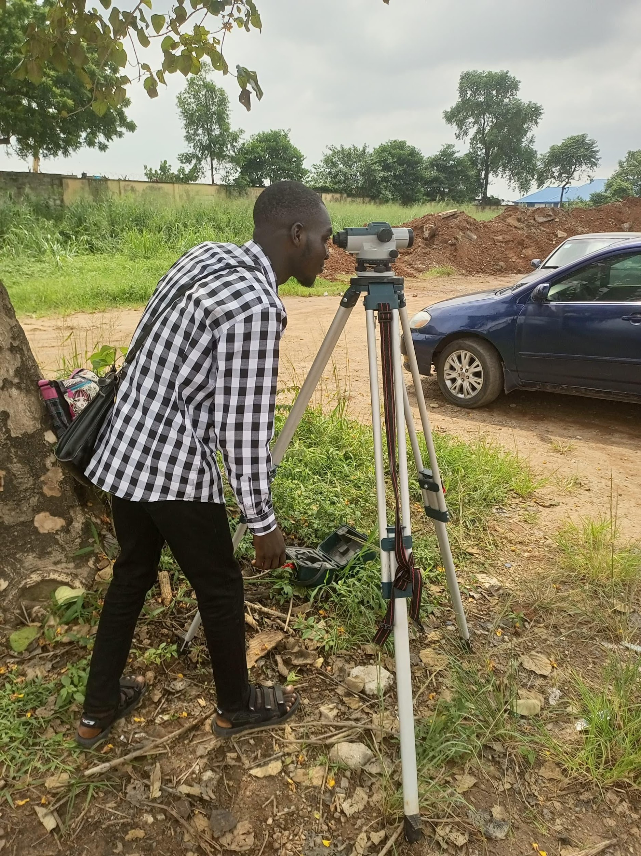
Plate 6 Construction Site Name Plate 7: Field work

CHAPTER FIVE

CHALLENGES, SOLUTIONS AND CONTRIBUTIONS

7.1 Challenges in FAAN Civil Engineering Department
During my internship at the Federal Airports Authority of Nigeria (FAAN) Civil Engineering Department, I faced several challenges that offered valuable learning opportunities:

7.1.1 Challenges Faced
- Limited Site Visits: Infrequent visits to project sites hindered my ability to monitor progress and address issues in real time.
- Complex Technical Issues: Navigating intricate structural and design challenges was initially overwhelming.
- Diverse Project Demands: Adapting to various project requirements, from structural integrity to environmental assessments, proved challenging.
- Communication Gaps: Effectively conveying technical information to non-technical stakeholders was difficult.
- Time Management: Balancing multiple tasks and ensuring timely project completion was a significant challenge.
- Continuous Learning: Keeping up with evolving engineering practices created pressure to learn quickly.
- Documentation Burden: Maintaining accurate project records was time-consuming but essential for quality assurance.
- Team Collaboration: Collaborating with diverse team members required patience and adaptability.
- Client Interactions: Managing client dissatisfaction in project outcomes was emotionally taxing.
- Project Diversity: Adapting skills to meet the varied specifications of different projects was necessary.

7.1.2 Solutions Implemented
- Improved Communication: I enhanced my ability to explain complex ideas clearly to non-technical stakeholders.
- Systematic Problem-Solving: I adopted a structured approach to address project issues effectively.
- Time Management Tools: I used task lists and prioritization to ensure project tasks were completed on schedule.
- Continuous Learning: I pursued online courses and mentorship to stay updated on industry trends.
- Efficient Documentation: Digital tools and templates streamlined the documentation process.
- Enhanced Team Collaboration: I fostered open communication and knowledge-sharing among team members.
- Client Relations: I practiced active listening and empathy in client interactions to address concerns professionally.
These strategies helped me navigate the challenges during my internship, contributing to my growth and the successful completion of projects.

7.2 CONTRIBUTIONS
I assisted management with filing reports, typing internal memos, and vetting bills of quantities and engineering evaluations. I also learned the basics of AutoCAD and gained insights into construction techniques through site inspections.
CONCLUSION
My internship at the Federal Airports Authority of Nigeria (FAAN) provided invaluable exposure to civil engineering. This report outlines the skills I acquired, challenges I faced, and solutions I implemented.
Working on real-world projects showcased the department’s commitment to quality, safety, and collaboration. Challenges such as limited site visits and communication gaps became opportunities for growth. I enhanced my communication skills, adopted effective problem-solving strategies, and improved time management.
Overall, this transformative experience equipped me with practical skills and adaptability in a dynamic field. I am grateful for the opportunity and look forward to applying my knowledge to make a positive impact in civil engineering.

REFERENCES

About Us, Federal Airport Authority of Nigeria, https://faan.gov.ng/our-history/

Aims and objectives of SIWES, Student Industrial Work Scheme

Information and guidelines for SIWES,(2002),http://www.itf.gov.ng.

Alabi F.S, (2009), The Relevance of work experience scheme program to students.

Structural foundation designer's manual. W.G Curtin, G Shaw, G. I Parkinson, J.M Golding

http://www.wikipedia.org.

www.learnityourself.com/software/AutoCAD

www.learnityourself.com/software/REVIT

www.learnityourself.com/software/PROSTASTRUCTURE

"Sub-disciplines of civil engineering faculty of engineering" Islamic university.

