TECHNICAL REPORT ON THE STUDENT INDUSTRIAL WORK EXPERIENCE SCHEME (SIWES)

HELD AT

ZAINAB AJOKE FARM
ADDRESS: APATA YAKUBA, ILORIN KWARA STATE

BY

IDRIS MARIAM BUSAYO
ND/23/PSM/PT/0036

SUBMITTED TO:
DEPARTMENT OF PROCUREMENT AND SUPPLY CHAIN MANAGEMENT
INSTITUTE OF FINANCE AND MANAGEMENT STUDIES (I.F.M.S)
KWARA STATE POLYTECHNIC, ILORIN,
KWARA STATE

AUGUST – NOVEMBER, 2024

DEDICATION
I dedicated this report of my SIWES program to Almighty Allah that made it a successful one for me.
Also to my lovely parents in person of MR. & MRS. IDRIS for their support both morally and financially they gave me, may Almighty ALLAH reward them abundantly with long life and good health.
Also to my SIWES coordinator who didn’t make the twelve weeks program went in vain and also to the school authority who accepted me in school for the program.

ACKNOWLEDGEMENT
I wish to express my profound gratitude and sincere appreciation to my lovely and caring parents in persons of MR and MRS. IDRIS may God bless you. I also appreciate the effort of my Brothers and Sisters may God help you all.

TABLE OF CONTENT
Title page i
Dedication ii
Acknowledgement iii
Table of content iv
CHAPTER ONE
1.0 INTRODUCTION 1
1.1 DEFINITION OF SIWES 1
1.2 AIM AND OBJECTIVES SIWES 1
1.3 HISTORICAL BACKGROUND OF AJOKE FARM 2
1.4 GEOGRAPHICAL LOCATION
CHAPTER TWO
3.0 ACTUAL WORKDONE
3.1 VEGETABLES: CORCHORUS OLITORUS, CELOSIA ARGENTAE, ZEA MAYS, CUCUMIS SATIVUS, ABELMOSCHUS ESCULENTUS, SOLANUM MELONGENA.
3.2 AGRO PROCESSING
3.3 HERBAL USE OF PAPAYA LEAF
3.4 GRAFTING AND BUDDING
3.5 INTRODUCTION TO GREEN HOUSE FARMING
3.6 HERBICIDES
CHAPTER THREE
4.1 EXPERIENCE GAINED
4.2 SUMMARY

CHAPTER ONE
- HISTORY OF SIWES
SIWES was introduced in 1973 by the Federal Government of Nigeria. It is an effort to bridge the gap existing between theory and practical in the sciences, Engineering, Agriculture and other professional educational programmes in Nigerian tertiary institutions. Students in their penultimate year are attached to reputable establishments as part of Government efforts towards providing adequate skills and training for students of higher institutions of learning. The Federal government provides funds through the ITF in an attempt to sustain the industrial training programme (spanning from 3-18 months). The scheme is a programme involving institution-based supervisors, the students and industry-based supervisors. The industrial period is for the whole of the second semester of the fourth year of the Undergraduate programme.
1.1 Objectives of Industrial Training Scheme
Objectives of the student industrial work experience scheme are:
- To promote and encourage the acquisition of skill in industries.
- It affords students the opportunity of being familiarized and exposed to the needed experience in handling machineries and equipment which are usually not available in the educational institutions.
- To expose student to new industrial development and innovations.
- To appreciate the importance of good communication skills and to develop the skills.
- To enable educational institutions to produce highly qualified graduates with sound theoretical and practical knowledge in their respective disciplines.
1.2 Objectives of SIWES report
1. To provide students additional opportunities on how to write field reports.
2. To match classroom theories with the practical experience acquired during the industrial attachment programme.
3. Make known all the practical experiences and knowledge gained during the period of training
4. Present a detailed technical report on the work done and the activities of the establishment and to keep the report for future as a good reference material.
5. And finally, offer useful recommendations for further improvement of the programme.

1.3 History of Ajoke Farm
My SIWES site, Ajoke Farm, started in the year 2000 before it was purchased by the current managing director, Mrs. Zainab Ajoke in the year 2000 with about 3,000 layers.
Presently, the farm had increased tremendously and there are many sections in the farm. Operations like, poultry, hatchery, feedmill, piggery, ruminants, fishery, sales/marketing of Agricultural products and health care/services.
1.4 Geographical Location
Ajoke Farm has her headquarter situated at Yakuba Area, Ilorin Kwara State.
MANAGING DIRECTOR

HEAD DOCTOR
ADMINISTRATIVE/ACCOUNT MANAGER
FARM MANAGER

VETERINARY DOCTORS
AUDITOR
UNITS SUPERVISORS

VETERINARY ASSISTANTS
UNITS ATTENDANTS

SALES CLERKS
SECURITY MEN
DRIVERS
CASHIERS

Figure 1.1 Organizational chart of Ajoke Farm.
1.5 Infrastructural Facilities on the Farm
There were several infrastructural facilities in Ajoke Farm. These are; Farm building, administrative block, Poultry pens, Hatchery building, Pig pens, Fish ponds, Feed mill house, Stores, Generating plants, Lorries, Cars, Trucks, Vulcanizing machines, Pumping machines, Tankers e.t.c.
1.6 Sections on the site
The following are the different sections on the farm
- POULTRY
- VETERINARY

CHAPTER TWO
- DEPARTMENTS IN AJOKE FARM
There are various departments in Ajoke Farm and they are listed below.
- HATCHERY
- LIVESTOCK
- FEEDMILL
- VETERINARY
- ADMINISTRATIVE

2.1 Hatchery Department
A Hatchery is a special building where fertile or hatchable eggs can be hatched into day old chicks.
2.1.1 Operations at Hatchery
- Collection of eggs from breeders’ farm.
- Eggs storage
- Selection and traying of Eggs
- Fumigation
- Eggs candling and transfer
- Cleaning and disinfection after hatching

2.1.1.1 Collection of eggs from Breeders’ Farm
At Ajoke Farm, The hatchable eggs were gotten from the breeders’ farm, from customers in other farms and sometimes imported hatchable eggs.
Eggs were transported in clean, disinfected and covered vehicle because hatchable eggs should not be exposed to direct sunlight, wind and dust during transportation.
Eggs were set carefully in clean egg trays and stacked together in egg case.

2.1.1.2 Eggs Storage
Eggs brought from the breeders’ farm were stored in egg storage room till the setting day. Because the number of eggs needed may not be attained at times. At Ajoke Farm, eggs were usually set and hatched twice weekly (Monday and Wednesday) and Eggs were stored for maximum of five days at temperature of 18ºC.

2.1.1.3 Sorting and Traying of Eggs
Traying means setting of the eggs on incubator trays while handling involves sorting and setting of the eggs. When eggs were set on incubator trays, they were sorted to pick out suitable eggs for hatching and bad eggs were separated, because bad eggs will not hatch or may hatch to disabled chicks.

Factors considered when setting eggs
- Crack eggs and dirty eggs were avoided
- Extra large or extra small eggs were avoided (weight of a hatchable eggs is between 45-65g)
- The pointed ends of the eggs were faced vertically downward.
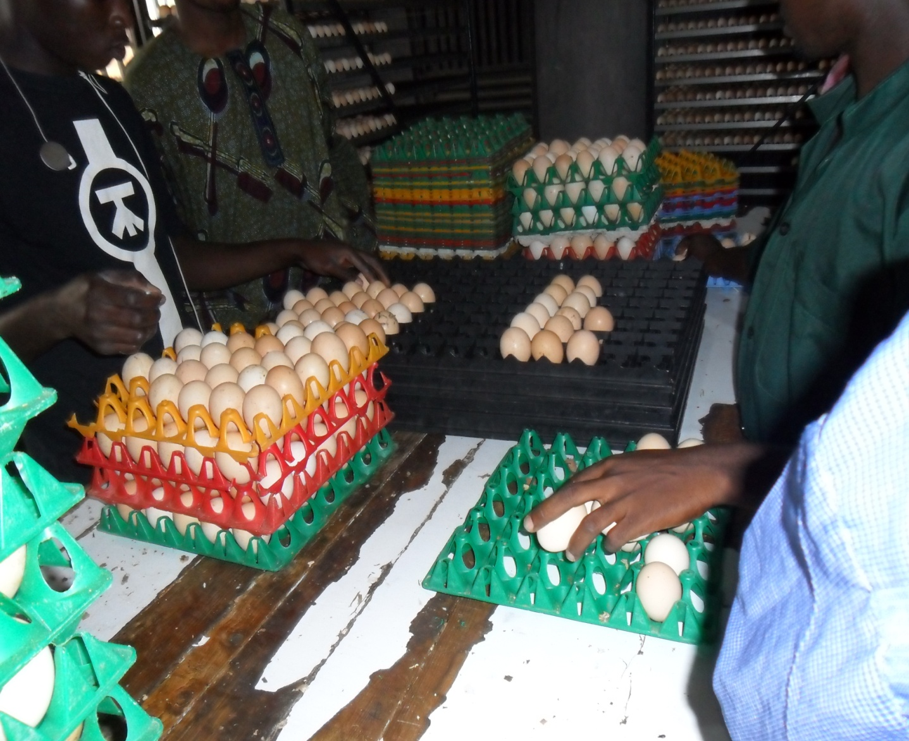
Figure 2.1 Setting of Eggs on Incubator Trays

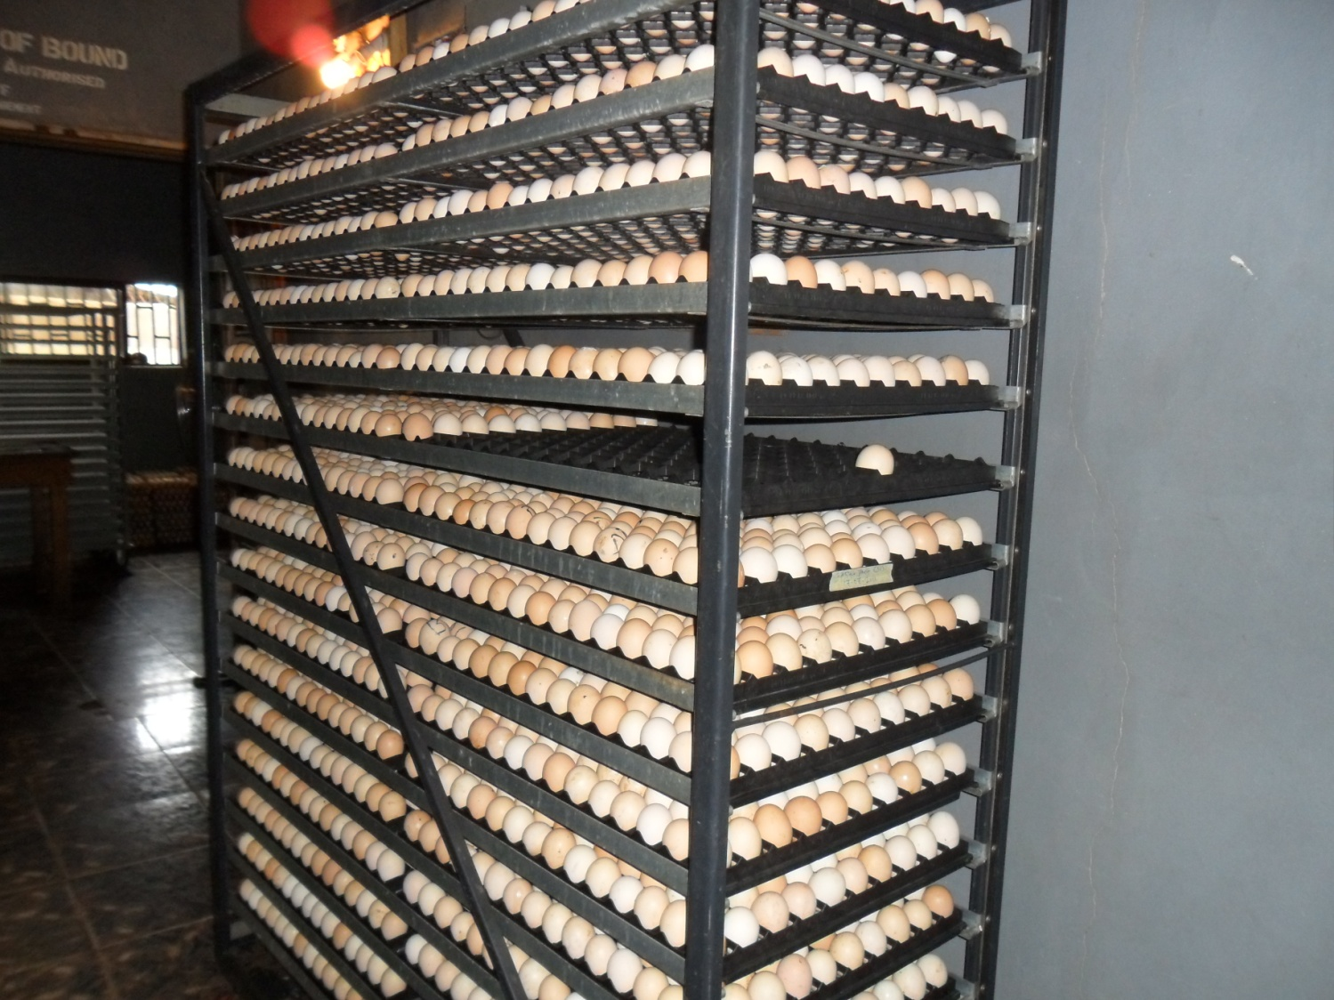
Figure 2.2 Eggs in an Incubator Trolley

2.1.1.4 Fumigation
Fumigation is the process through which pathogenic organisms on the eggs could be destroyed. The method of fumigation process that was used at AJOKE FARM was formalin solution and Potassium permanganate (KMnO₄).

Procedure for Fumigation at Ajoke Farm
- Hatchable eggs were clean with dry spongy (not iron spongy)
- Fumigation was done in the box after each collection
- 10g of potassium permanganate (KMnO₄) in 20ml of formalin solution for box of 4x8x4 feet cabinet for half an hour.
(This was not done in my presence but was given to me by the Hatchery manager Mr. Ibraheem yahaya).

2.1.1.6 Candling and Transfer
This is the process by which a clear cut distinction is made between fertile and unfertile eggs i.e. it helps to determine the fertility of the incubated hatchable eggs. Candling was done at 18th day of incubation at AJOKE FARM.

Processes of Candling
Eggs were subjected to direct beams of light. The fertile eggs will be opaque but the unfertile eggs will give colour like yellow e.t.c.

Egg transfer
The fertile eggs after candling were transferred into the hatcher at 18th day for the completion of the incubation for 72 hours (3 days).

2.1.1.7 Chicks Handling, Sorting and Boxing
Handling: After hatching, Chicks were handled with care to prevent injury and death of the chicks because improper handling will cause stress on the chicks.
Sorting: Chicks were removed from the midst of broken egg shells within the hatching trays, after which they were sorted to remove the undesirable ones and to grade the good ones. The undesirable ones were usually the runts, deformed chicks, very weak chicks, chicks with unhealed navel and dead chicks.
Boxing: After sorting, chicks were parked carefully into chick boxes. The chick boxes used at AJOKE FARM, were paper type which is partitioned into two compartments, each compartment usually accommodates 25 chicks, all together making 50 chicks in a box.

2.1.1.8 Chicks Vaccination
After boxing, vaccinations of chicks were done and this was carried out by the veterinary doctors. The chicks were usually been vaccinated against Mareks and Newcastle diseases at day old. Mareks diseases vaccines were usually administered subcutaneously with the use of automatic syringe. The Newcastle disease vaccine (NDV La Sota) was usually administered intra-ocularly or intra-nasally with droppers.

2.1.1.9 Cleaning and Disinfection after Hatching
The hatcher, hatching trays and egg trolleys were usually been washed properly with detergent and disinfectant after each hatch. The equipment were allowed to dry and they were been fumigated.
    - Routine Management Practices in Hatchery
- Sweeping of the floor of hatchery, making sure the environment is kept clean.
- Putting of disinfectant in the tyre dip and foot dip.
- Collection of eggs from breeders’ farm
- Storage and fumigation of eggs
- Setting and traying of eggs
- Checking and regulation of the readings on the incubator control panel, readings like; temperature, humidity and egg turning counter.
- Checking of the effectiveness of the incubator gadgets, which are, heating system, cooling system, incubator fan, humidity bowl, ventilator, red light and alarm.
- Check and remove blown up, cracked or fallen eggs on the floor of the incubator.
- Candling and transfer of eggs at 18th day of incubation
- Washing and disinfecting of incubator equipment like; egg trays, egg trolleys, hatching trays after each hatch.
- Fumigate the hatcher and hatching room after each hatch.
- Packing, boxing and Vaccination of chicks.
- Servicing of incubator.

2.2 LIVESTOCK DEPARTMENT
This is the department that enveloped poultry section, piggery section and ruminant section.

2.2.1 Poultry Section
This is a section where poultry birds were raised for meat and egg production, the main poultry birds reared at AJOKE FARM are chickens (Hacco black and Isa brown).
Poultry section is sub divided into four.
- Rearing/Growing unit
- Laying unit

2.2.1.3 Laying Unit
The points of lay chickens from growers section were transferred after 16 weeks of age to the house where battery cages were prepared ready to house the layers. The types of battery cage system are; automatic feeder and drinker 3 steps battery cage housing and manual feeder and drinker 3 steps battery cage housing. Birds here were fed with pre-lay mash from 16 weeks of age until they started laying eggs before their feed was changed to layer mash. The type of breeds reared were Hacco black and Isa brown and the total number of layers during my stay at the unit were about 6,000.

Management practices
- Cleaning of feeder, washing of drinker and Provision of fresh feed and clean water
- Removal of dead birds and isolation of the sick birds from the cages
- Cleaning of the passages and the surrounding
- Collection of eggs three time daily (9:30 am, 12:30 pm and 5:30 pm)
- Daily record keeping of feed intake, egg collected, mortality, medication and vaccination

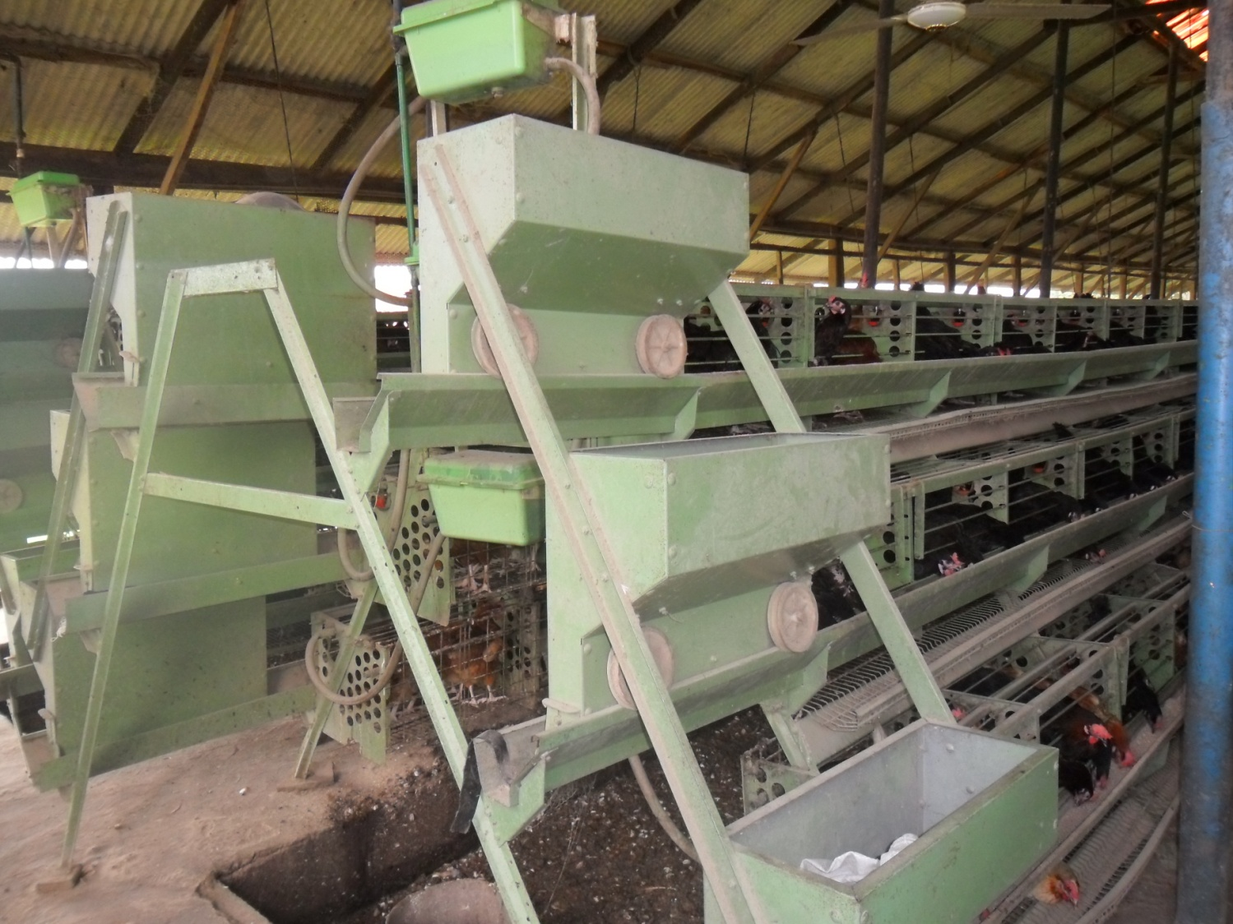
Figure 2.3 Laying Unit (3 Step battery cage with automatic feeder and drinker)

2.2.1.4 Health Management Practices
The health management practices at AJOKE FARM were medication and vaccination.
Medication is the administration of drugs to sick animals or Chickens.
Vaccination is to inoculate animals or birds with vaccine to produce immunity to a disease.

TABLE 2.1 Vaccines and drugs administered from day old to point of lay for commercial layers at AJOKE FARM
Age (days) Vaccines/drugs Route
1 Mareks vaccine + NDV La Sota Subcutaneous and ocular/nasal
2 Gumboro Intraocular
2-4 Vitamins, Glucose + Antibiotics Oral
5 Immucox Oral
14 IBDV (Gumboro) Oral
24 NDV La Sota Oral
6 weeks NDV Komarov Intramuscular
8 weeks Fowl pox Wing web jab
9 weeks Dewormer Oral
12-13 weeks IBV Oral
16 weeks NDV Komarov + EDS Subcutaneous
Keys:
NDV = Newcastle disease vaccine
IBDV = Infectious Bursal disease vaccine
EDS = Egg drop syndrome

2.2.3 Ruminant Section

At the section large and small ruminant were reared, only cattle and sheep were the ruminants present at AJOKE FARM during my stay in the section. The breeds of cattle were White Fulani and their crosses with total numbers of 50, while the breed of sheep was West African dwarf (WAD) with total number of 68. They were reared under semi-intensive system.

2.2.3.1 Management Practices in Ruminant Section
- Inspection of the animals to see the sick or injured one
- Taking of animals for grazing by the herdsmen
- Deworming :- this was done by administering ivermectin injection
- Repairing of the damaged paddocks
- Occasional cleaning of the paddocks by packing the dung of the animals.
- Occasional spraying of cattle against ecto-parasites e.g. ticks.

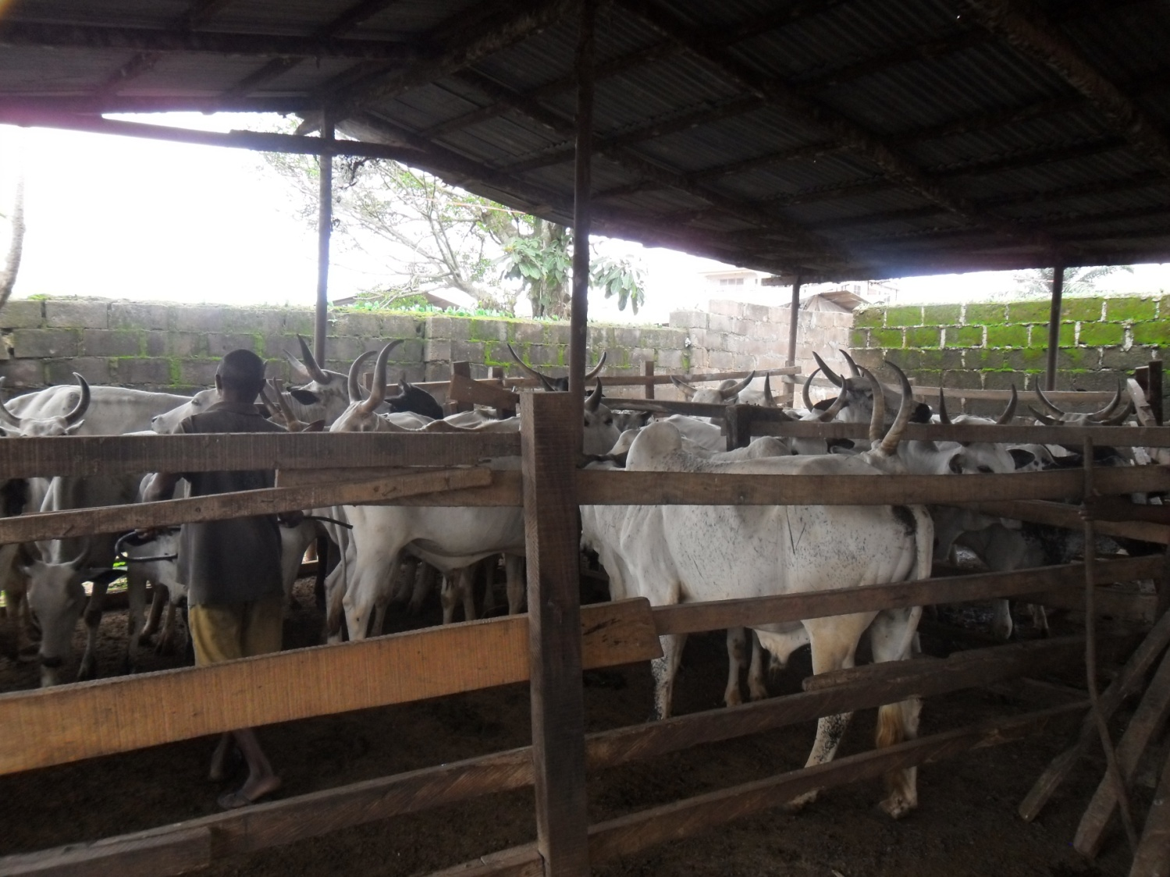
Figure 2.5 Administering of IVERMECTIN Injection to cattle for Deworming (Subcutaneous)

2.3 FEEDMILL DEPARTMENT
This section was responsible for feeds formulation and production for different animals. During my stay in feedmill, feed were been formulated for poultry chickens (chick mash, growers mash, broilers mash (starter and finisher), layer mash) and also for fish (pelletized fish feed and fish feed rebranding). The feed ingredients used were; maize, groundnut cake (G.N.C), wheat bran, wheat offal, soya meal, bone meal, fish meal, biscuit dust, oyster shell, palm kernel cake (P. K. C), toxynil, lysine, methionine, salt, vitamins premix, mineral premix e.t.c.
There are different units in feedmill section at AJOKE FARM
Storing unit: where all the feed ingredients were stored, here, we have several stores which are;
- Macro ingredient store
- Micro ingredient store
Milling, mixing and bagging unit: this was where all the ingredients were milled, mixed and bagged into 50 kg or 25 kg.

During my stay at the feedmill, Feed formulations were always based on the following:
- Nutrient level of each ingredient
- Nutrient requirement of the animals
- Total quality of feed ingredients
- Essential feed ingredients sources. e.g. energy sources, protein sources, vitamin sources or mineral sources.

2.3.1 Equipment in the feed mill department
Crusher/hammer mill: used for crushing different feed ingredients like maize, GNC, oyster shell, bone meal, e.t.c
Mixer (contain auger for mixing): this was used for mixing the feed ingredients together.
Weighing balance (scale): this was used to weigh the feed ingredients.
Digital scale: this was used to weigh the lighter feed ingredients like lysine, methionene, premix e..t.c.
Sewing and sealing machine: this was used to seal the bags of feed ingredients after mixing and weighing them into the required quantity 50 kg or 20 kg.
Needles and thread: used to sow the bags of feed manually. Other equipments are Scaling pans, knives e.t.c.

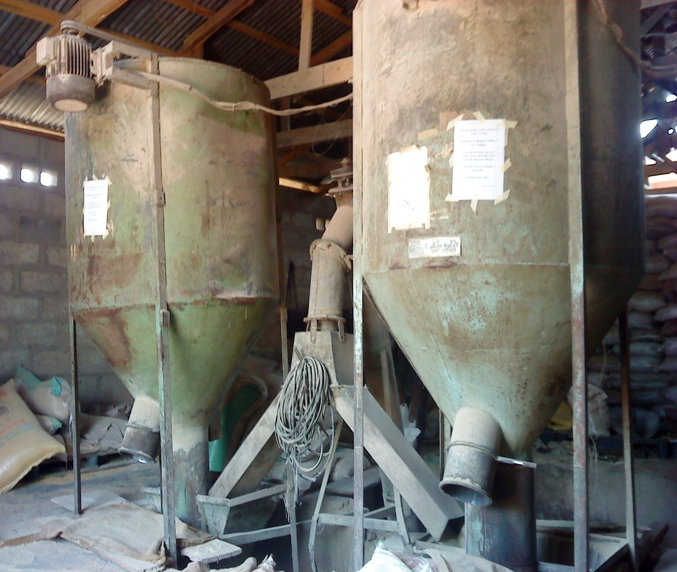

Figure 2.6: A Pair of Mixer with Feed Conveyor from the underground Crusher

2.3.2 Management practices at feedmill
- Sweeping of the floor
- Inspection of the machines and equipment
- Checking of feed ingredients to see those that are spoiled and those that are not available.
- Weighing and scaling of feed ingredients
- Crushing, milling and mixing of feed ingredients
- Offloading, weighing, Bagging and sowing of mixed feed in 50 kg or 25kg
- Changing of worn out parts in the crusher and mixer
- Repairing of machines and equipment

CHAPTER THREE
CONCLUSION AND RECOMMENDATIONS

3.1 CONCLUSION
The industrial training has really been a channel of exposition of the challenges ahead to me as an animal producer and has broadened my knowledge and widened my practical scope. The programme was such a challenging, interesting, educative and informative one to me. It is therefore a laudable scheme.
The period of my Industrial Training at the Ajoke Farm, Yakuba Area, Ilorin Kwara State, Nigeria was a success because it affords me the opportunity to acquire more practical and technical experiences on Agricultural practices like: hatchery management, livestock rearing, vaccination and drug administration, feedmill and fishery production. Above all, the experiences gathered has been tremendous
3.2 RECOMMENDATIONS
Recommendations to Ajoke Farm
- The welfare of the workers in terms transport and incentives to them should be improved to enhance maximum productivity.
- The road from the farm to the main road is bad, the management should repair the road for better transportation.
- There should be clear distinction and specialization of duties among staffs.
Recommendations to the Industrial Training Unit
- The Industrial Training unit of KWARAPOLY should intensify effort in visiting students at their respective training sites as this will give them encouragement and regard from their site’s supervisors and also help students solve their problems of getting along.
- The programme should be continued.
Recommendations to the Polytechnic/students
- Students should try and put in their best to acquire the knowledge needed while in school and during the training. It could be much more costly to get the knowledge after leaving school.
- Also they should embrace the scheme and see it as capacity building scheme.

