

A TECHNICAL REPORT
ON
STUDENT INDUSTRIAL WORK EXPERIENCE SCHEME (SIWES)
HELD AT
MAT ARC. PC LIMITED
200 TAIWO ROAD, BEHIND BOVAS FILLING SATTION,
ILORIN KWARA

WRITTEN BY

ISSA MUHAMMED
ND/23/BLD/PT/0007

SUBMITTED TO:

DEPARTMENT OF BUILDING TECHNOLOGY
INSTITUTE OF TECHNOLOGY (I.O.T) KWARA STATE POLYTECHNIC, ILORIN

INPARTIAL FUFILMENT OF THE REQUIREMENT FOR THE AWARD OF NATIONAL DIPLOMA (ND) CERTIFICATION IN BUILDING TECHNOLOGY

AUGUST TO NOVEMBER 2024

DEDICATION
This report is dedicated to Almighty God, the king of kings for his supreme and absolute control over the entire universe, for his protection, love and kindness. I also give my profound gratitude to Almighty God for sparing my life through this program.

ACKNOWLEDGMENT
I hereby express my profound gratitude to Almighty God for his absolute control over my life during this program. I also express my gratitude to my parents who have done all within their capacity to ensure me of a better and brighter future. Despite all challenge of life, they still strive to see me through this stage of my life. I pray Almighty God in his mercy will grant you good health and make sure they reap the fruit of their labour.
My profound appreciation to all those who have contributed to my success during this training program, my amiable friends won’t be left out. I hereby say a very big thank you to you all. May God reward you back abundantly.
Finally, my appreciation goes to my H.O.D, and also my siwes Supervisor Mr Bolaji Adetoro D.F Principal instructor department of computer science, and my level adviser and all department lecturers at the BUILDING TECHNOLOGY.

PREFACE
The main body of this report contains details on how my industrial training attached was spent at MAT ARC PC LIMITED.

TABLE OF CONTENT
Title page i
Dedication ii
Acknowledgement iii
Preface iv
Table of content v
CHAPTER ONE
1.0 Introduction 1
1.1 Aims and objectives of SIWES 1
1.3 The organization chart 4
CHAPTER TWO
2.0 Section / units of the organization 5
2.1 specific function of the organization 5
2.2 Construction 6
2.3 Types of construction in tear of BUILDING TECHNOLOGY 6
2.4 Major building components 6
2.5 Site processes and operation 8
2.6 Site investigation 8
2.7 Site preparation 8
2.8 Preliminary work 9
2.9 Setting out 9
3.9.1 Setting out equipment 10
3.9.2 Method of setting out 11
3.9.3 Excavation 11
3.9.4 Method of excavation 11
CHAPTER THREE
3.0 Student specific involvement at various sections 13
CHAPTER FOUR
4.0 Relevance of experience gain at the field of study 14
4.1 Concrete work 14
4.2 Drainage 15
4.3 Important of drainage 15
CHAPTER FIVE
5.0 Conclusion 17
5.1 Suggestion and recommendation to the organization and polytechnic concerning the SIWES program 17

CHAPTER ONE
- INTRODUCTION
Student industrial work experience scheme (SIWES) programmed, was establish in year 1973 by federal Government of Nigeria through the industrial Training Fund (ITF) under the NBTE (National Board for Technical Examination). It has it’s headquarter in jos, plateau state. The major reason behind the establishment of SIWES programmed and the importance of the student to display their talents and also learn the practical aspects of their fields of study. After their graduation, they will have something valuable to contribute to the society. They will also be able to face future challenges in their respective field of study.
In accomplishment of my compulsory four months training program, I did my SIWES at Ace bricks Construction
I was involved in several operation on site and experience in relation to my career of study (BUILDING TECHNOLOGY).
  - AIM AND OBJECTIVES OF SIWES
- To enhance the knowledge of students (theory) of what they have been
taught in school by backing it with enough practicals.
- To provide students the opportunity to apply their theoretical knowledge
in real work situation, bridging the gap between university work and actual site work.
- To provide an avenue for students to acquire industrial skill and
experience in their course study.
- To enable students to develop more affection for their chosen profession.
- To expose students to working method and technique in handling
equipment and machineries that may not be available to them in school.
1.2 ORGANIZATION CHART
MANAGING DIRECTOR

ASSISTANT M.D.
OPERATION OFFICER
SERVICE

CHIEF ENGINEER
CHAPTER TWO
2.0 SECTION / UNIT OF THE ORGANIZATION
ACEBRICKS CONSTRUCTION was divided into four section / unit they are as follows.
- Planning Approval Department
- Construction Management Department
- Building / Structural Department
- Administration Section
2.1 SPECIFIC FUNCTION OF THE ORGANIZATION
- PLANNING APPROVAL DEPARTMENT
This unit deals with planning approval of a proposal to use or develop land against the rules in planning scheme. The planning process is mainly concerned with the impacts of a proposed use or development upon neighboring land.
- CONSTRUCTION DEPARTMENT
This department provides construction management services on a project such as building, highway and other BUILDING TECHNOLOGY projects.
- BUILDING TECHNOLOGY DEPARTMENT
The department is made up of Civil & Structural engineering with wide range of experience in design detailing and supervision of structure.
- ADMINISTRATION SECTION
This section ensure the smooth running of the organization .The section make sure that the administration setup by the organization is in good order.

2.2 CONSTRUCTION
Construction is defined as the act of process of building something, but in BUILDING TECHNOLOGY construction is the process of designing of structure (ie construction of building) for dam, railway, dam water way and bridge.
  - TYPE OF CONSTRUCTION IN TEAR OF BUILDING TECHNOLOGY
- Building construction / Structural
- High way /road construction
- Construction of dam
Building construction: this aspect of construction is involved In building and erecting of structure examples are office, house, churches, mosques etc
High /road construction: this is the process of constructing bridges, road, highways or idealization of road.
Dam construction: this kind of construction is based on the construction of dam.
2.4 MAJOR BUILDING COMPONENTS
A building has two basics parts
- Substructure or foundations, and
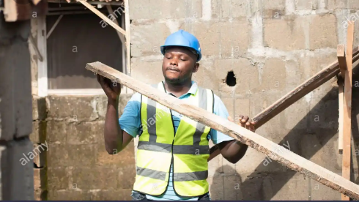
- Super structure

SUB- STRUCTURE OR FOUNDATION : is the lower potion of the building, usually located below the ground laurel, which transmits the pads of the superstructure to the supporting soils. A foundation is the therefore that of the structure which is in direct contact with the ground to which the loads are transmitted .
SUPER – STRUCTURE : Is the part of the structure which is above the ground level and which serves the purpose of its intended use. A part of the super-structure, located between the purpose of its intended use. A part of the super-structure, located between the ground level and the floor hovel is known as plinth. plinth is therefore defined as the portion of the structure between the surface of the floor, immediately above the ground. The level of the floor is usually known as the plinth level. The component of a building can be broadly summarized as follows
- Foundation
- Columns
- Floors
- Walls
- Doors
- Windows and ventilation
- Roots
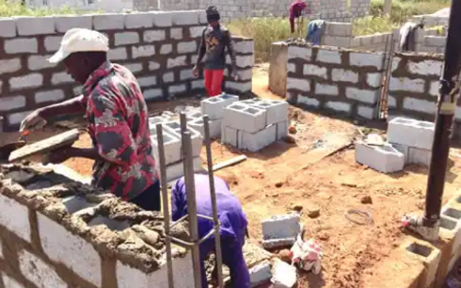
- Stairs

SITE INVESTIGATION
This is a process of ascending the suitability of a particular chosen site for building construction purpose.
The type and nature of sub soil, geological condition and behavior, the depth of the water table the load bearing capacity, the difficulties that may arise construction and the change or occurrence that may arise after construction.
SITE PREPARATION
Site preparation includes everything you need to do to get the ready to build on. that include clearing of tree, rock , underbrush, anything that may be in the way of your foundation .this must be removed from site clearance in an initial major work to be carried out. this extend of work require labour plant and equipment depend on factor line size of site nature constituent to be removed from site, ground condition of the site distance debris to be remove from site in some cases or instant site clearance could involves large or small scale demonation of existing structures.
2.8 PRELIMINARY WORK
This involve all the activities before the building can be setting out for construction his include site investigation and consideration of site suitability.
2.9 SETTING OUT
The method of setting out is the reverse of surveying process. the process includes the position and level of the building lines and road alignment shown on the construction plans to be established on the grounds by various techniques and instrument. it is necessary to have a good knowledge of geometry in order to ensure accurate work. the first task in setting out in building is to established base line from which the whole of the building can be set out. The position of this line must be mark on site so that it can be re-established at anytime. the building line is frequently deterring by the highway authority and from the back of the public foot path. If other building have been erected at the area the building line can be determine from this existing building.
    - EXCAVATION
Excavation is done to received the foundation that will be constructed for a building. This is done after the setting out and marking out.

    - METHOD OF EXCAVATION
- Manual method
- Mechanical method
The choice of method of excavation is depend on the size work in small construction, it is more economic to used the manual method, whole large works will be economic to be executed using the mechanical method of excavation but the one that was fully involve is manual method, which labourer were digging the ground to specific depth and the width which was specified by engineer on site.
4.6 FORMING
This is the major part of the building that deals with the settings or arrangement of blocks, and the method used is Stretcher Bond.
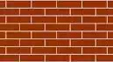
Stretcher bond
CONSTRUCTION
Construction is defined as the act of process of building something, but in BUILDING TECHNOLOGY construction is the process of making or creating or creation a structure (ie construction of building) for movement purpose.

  - TYPE OF CONSTRUCTION IN TEAR OF BUILDING TECHNOLOGY
- Building construction
- High way /road construction
- Construction of dam
Building construction: this aspect of construction is involved In building and erecting of structure examples are office, house, churches, mosques etc
High /road construction: this is the process of constructing bridges, road, highways or idealization of road.
Dam construction: this kind of construction is based on the construction of dam.

CHAPTER THREE
3.0 BLOCKS
Blocks are manufactured in a variety of materials clay and concrete being the most usual. They can be hollow and joggle jointed. Blocks work is treated in the same way for brick work. A block is a solid material that is commonly square in shape and usually has flat shape.
Block is a mixture of cement, sand and water which is usually form of different shape and size, depending on the mauling used.
Block has different size such as:
9x9x18 inches (225x225x450)mm.
6x9x18 inches (150x225x450)mm.
Ratio used for molding in my site was 1:2:4 which normally gives 45 pieces of 9x9x18 inches block and 60 pieces of 6x9x18 inches block.
Ratio 1:2:4
Cement …… (1)
Fine aggregate …… (2)
Coarse aggregate …… (3)
3.1 BLOCK SETTING
Block setting is the process of laying blocks or joining blocks together by using mortar in order to form to a regular shape wall of the building.

INSTRUMENT USED
✓ SHOVEL

✓ HAND TROWEL



✓ HEAD PAN
3.2 BRICK BONDING
To provide stability to a wall under construction it must be fixed together by means of mortar, which is mixture of cement, sand, lime and water. Mortar should fulfill the following requirements:
- Provide adequate strength but not greater that the required for the purpose of the wall
- It must provide good work ability and plasticity to enable the bricks to be bedded and adjusted to the required line and level
- Provide a good bond with the bricks, block or stones being used to construct the wall
- Provide water penetration through the joint when hardened
- The materials used should be readily available and economic
3.2.1 TYPE OF BONDS
- Stretcher bond
- Flemish bond
- Header bond
Stretcher bond: is the commonest bond used today and the least interesting in appearance.
Stretcher bond wall
Stretcher bond wall with piers
Stretcher bond piers

STRETCHER BOND
English bond: consist of alternating courses of headers and stretcher with the alternative headers centred over and under the vertical joint of the stretcher.
Flemish bond: consist of alternating headers and stretcher along each course with the header centre on the stretchers above and below.
3.3 WALLS
Walls are any continuous vertical member whose length and height are both much large than the thickness, walls are provided to enclose or divide the floor space in desired pattern. In addition walls provide privacy, security and give protection against sun, rain, cold and other adverse effects of weather. Walls are constructed by used building units like bricks, stone, construced by used building units like bricks, stone, concrete blocks (hollow or solid)
3.3.1 CLASSIFICATION OF WALL
Walls can be classified into following
LOAD BEARING WALLS: Are walls that support it own weight as well as the super-imposed loads transferred to it though floors/roofs. E.g external wall
NON-LOAD- BEARING WALLS: Are walls on the other hand that carries its own weight and is not designed to carry and superimposed load from the structure.
They are normally provided as partition walls.
3.3.2 FUNCTION OF WALLS
- It provides necessary resistance to rain penetration
- It is capable of resisting both positive and negative wind pressure
- It give required degree of thermal insulation
- ROOFING
- Roof is the uppermost covering of the building which is for protecting and installation against atmospheric precipitation, temperature action and other environmental agent.
- Component of roof
- • King post
- • Rafter
- • Puling
- • Tan beams
- • Ceiling joint
- • Wall plate
- INSTRUMENT USED FOR ROOFING
- • Hammer: It is used for nailing
- • Saw :It is used in cutting the plank
- • Line: It is used as leveling
- • Measuring tape :is used for measurement
- • Bar :is used to removed nails
ROOF SKELETAL SYSTEM (ROOF CARCASS)
Roof carcass is the wooden part of the building which is constructed so the roofing sheet can be laid on it to form the roof.
MATERIALS USED TO CONSTRUCT THE ROOF CARCASS
- Planks ( 2 by 2, 2 by 3, 2 by 4 and 2 by 6 )
- Nails.
- Hammer.E.T.C.
SECTIONS OF THE ROOF CARCASS
- Wall plate.
- Ridge board.
- King post.
- Rafter.

2.3 ROOF COVERING
Roof covering is any material attached to the roof carcass to protect the building against weather element (e.g. rainfall, heat and wind etc.) And also beautify the building.
4.4.1 SECTIONS OF THE ROOF COVERING
- Cladding
- Dash board
- Ridge
- Eve angle
- Gutter
- Roofing sheet
3.4.2 TYPES OF ROOFING SHEETS
- Zinc sheets.
- Aluminium sheets.
- Box profile
- Step tile.
- Gerald roofing sheets.
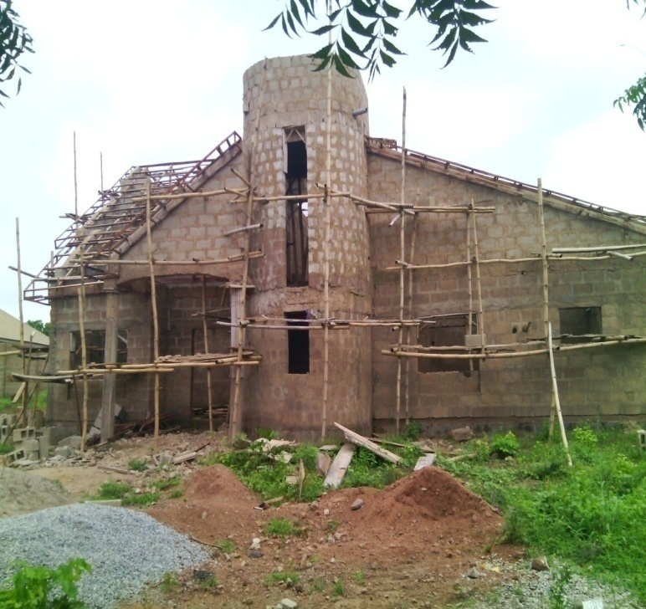
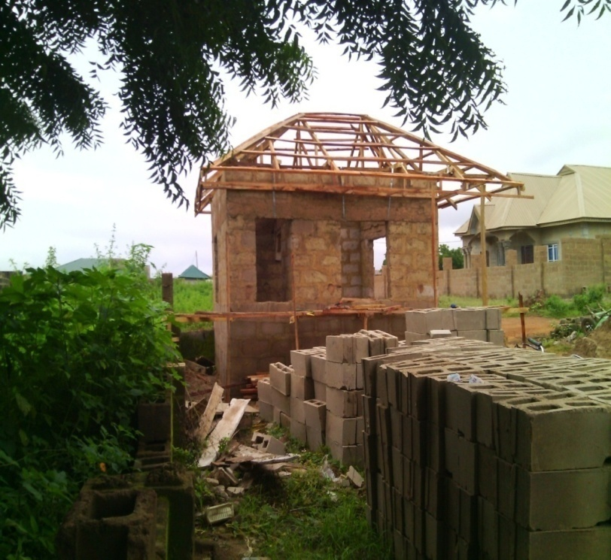

CHAPTER FOUR
4.0 RELEVANCE OF EXPERIENCE GAIN AT THE FIELD OF STUDY
In BUILDING TECHNOLOGY, casting means the mixture of granite / gravel, sharp sand and cement with a certain volume of water.
4.1 CONCRETE WORK
Concrete works can be defined as the mixture of fine aggregate, course aggregate, cement and water and when mixed at its fluid state it forms paste and consistency that can be mounded to any shapes and sizes and on drying it forms a very hard and soil materials inform of rocks. There are two major classification of concrete (a)pre-cast concrete (b)cast-in-situ.
Concrete works done on site are follows:-
- BEAM: these are horizontal members which support and distribute the
weight of upper floor and roofs (usually of timber, steel, or reinforced concrete).
- LINTELS:- These are small beams placed over door and window openings
and Support the load of the wall over these opening.
- COLUMNS:-They are bull with stool or reinforced concrete. They are
usually Isolated vertical members which carry the weight of beams, floors and roofs in framed buildings. The walls of framed building are non-load bearing.
4.2 DRAINAGE
Drainage system usually provided in the design of high way for the protection at the investment make in high way structure and for safety of the users in rural areas. Some portion of high way that provide for the surface drainage.
4.3 IMPORTANT OF DRAINAGE
Drainage and culvert are important part of highway and the reason why it cannot just be left out of the designing stage of highway are follow:
- Water retained or logged on highway surface could cause fatal accident for moving vehicle especially those on high speed.
- Where drainage facilities are not provided, the sides of the roadway are normally subjected to erosion.
- See page of water it pavement and sub-grade will cause a structure failure of the road.
- The absence of the destruction of pipe culvert course hindrance to traffic flows.
In view of the above reasons, various types of drainage and culverts facilities are used to protect the highway against surface and sub-grade water. This is designed to covey water under, across along or away from the highway in the most economical, efficient and practical manner without damaging the highway or adjacent property.
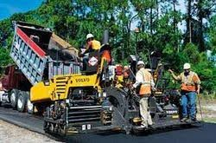
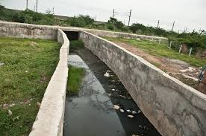


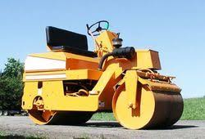

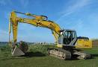




CHAPTER FIVE
5.0 CONCLUSION
I was highly impressed on the ways the company carried out their activities.
They work with me time to time and skill acquisition is of great import. I learnt a lot from the company.
5.1 SUGGESTION AND RECOMMEDATION TO THE ORGANIZATION AND POLYTECHNIC CONCERNING THE SIWES PROGRAM
SIWES coordinator and the polytechnic authority should try to stop the habit of rejecting student for SIWES program by the industry. The institution supervisor should make it a priority to visit their designated student in the various organizations to update the student’s log book.
Finally, they should resist the habit of staying in school and wait for their wards to finish the SIWES program only for them to sign their training log book and award them grade of the choices without checking the performance of the
student in the field.

