

A TECHNICAL REPORT ON
STUDENT INDUSTRIAL WORK EXPERIENCE SCHEME
(SIWES)

HELD AT:
MINISTRY OF AGRICULTURAL AND RURAL DEVELOPMENT, KWARA STATE.

WRITTEN BY

OMONIJE TOLASHE ABDULAZEEZ
ND/23/AGT/PT/0023

SUBMITTED TO
DEPARTMENT OF AGRICULTURAL TECHNOLOGY, INSTITUTE OF APPLIED SCIENCE, KWARA STATE POLYTECHNIC, ILORIN

AUGUST - NOVEMBER, 2024

DEDICATION
I dedicate this work to Almighty God, the Creator of the universe, to Him be the glory for giving me the grace and ability to work and achieve a set goal as a student, also to my lovely Parents (Mr & Mrs. Omonije), for her sincere support towards my success.

PREFACE
This Report contains the description of technical experience acquired during my Student Industrial Work Experience Scheme (SIWES) Program undertaken at Federal Ministry of Agriculture and Rural Development, Kwara State.
I worked with Agricultural specialists. I practiced Tillage, nursery, transplanting, pests control, harvesting, processing and packaging of agricultural crops (produce).

ACKNOWLEDGEMENT
All glory and adoration be to Almighty God for his mercy throughout my SIWES period. I also acknowledge my parents Mr. & Mrs. Patrick, for their parental guides and sincere support.
Thanks to Engr. Suleiman Makanjuola, Mr. Daramola John Olakunle and Engr Suleiman for their advice and moral support throughout the training period. I also appreciate my Lecturers for their contributions which have great impacts in my success. Finally, I acknowledge my Friends and family for your sincere contributions towards my success and achievement. Thank you all.

TABLE OF CONTENTS
Title page i
Certification ii
Dedication iii
Preface iv
Acknowledgement v
Table of contents vii
CHAPTER ONE
1.0 Introduction 1
1.1 Objectives of SIWES 1
CHAPTER TWO
Brief History of Federal Ministry of Agriculture and Rural Development Kwara State Nigeria 2
CHAPTER THREE
3.1 Irrigation
3.2 Planting
3.3 Fundamental of Store Grains Management
3.4 Tractor
3.5 Tillage Operation
CHAPTER FOUR
4.0 Experience gained during the SIWES Training and their relevance to my course of study. 17
4.1 Problems encounter during the programme. 17
CHAPTER FIVE
5.0 Conclusion and Recommendation 19
5.1 Conclusion 19
5.2 Recommendation 19

CHAPTER ONE
1.0 INTRODUCTION
The student Industrial Working Experience Scheme (SIWES) was established by Industrial Training Fund (ITF) in 1973 so as to solve the problem of lack of adequate practical skills experience when employed in industry by Nigerian graduates of tertiary institutions.
The student Industrial Working Experience Scheme (SIWES) exposes students to industries based experience and skill necessary for smooth transition from the class room to the world at large.
1.1 OBJECTIVES OF SIWES
The objectives of SIWES are as follow:
- It provides industrial skill and experience for students in higher institutions in their course of study.
- It provides students for industrial work situation which are likely to encounter when gained employment.
- It exposes students to work, method and techniques in handling equipment and machinery.
- It bridges the gap between practical and theoretical aspect by applying the knowledge of theory in real work.
- It also prepares student for employment in their courses of study.
CHAPTER TWO
BRIEF HISTORY OF MINISTRY OF AGRICULTURE AND RURAL DEVELOPMENT KWARA STATE NIGERIA
The Ministry of Agriculture and Rural Development [FMARD] is responsible for developing the agriculture sector of the Nigerian economy, with a view to growing the sector, driving income growth, accelerate food and nutrition security, generating employment and transforming Nigeria into a leading global food market, through the commodity value chain concept of the Agricultural Transformation Agenda (ATA).
The Ministry of Agriculture and Rural Development (FMARD) is a Ministry of the Nigerian government that regulates agricultural research, agriculture and natural resources, forestry and veterinary research all over Nigeria. Established in 1966, the Ministry has the responsibility of optimizing agriculture and integrating rural development for the transformation of the Nigerian economy, with a view to attaining food security and positioning Nigeria as a net food exporter for socio-economic development.

The Organogram of the Ministry (Flow Chat)
CHAIRMAN
SECREATARY
DIRECTOR
HOD
Account
Health
Works
Education
Supervisors
Foremen
Clerks

CHAPTER THREE
3.0 Irrigation
Irrigation (also referred to as watering) is the practice of applying controlled amounts of water to land to help grow crops, landscape plants, and lawns. Irrigation has been a key aspect of agriculture for over 5,000 years and has been developed by many cultures around the world.

Types of Irrigation Systems in Nigeria
The following are the types of irrigation systems used in Nigeria:
- Drip Irrigation System
- Rain Gun Irrigation System
- Spray Tube Irrigation System
- Center Pivot Irrigation System
- Flood Irrigation System
- Sprinkler Irrigation System

Drip Irrigation System
The drip irrigation system uses a set of pipes, drip tapes, hoses, emitters and other tools for the application of water in a slow and controlled manner to the root zones of plants. The drip irrigation system is the most efficient type of irrigation system when it comes to water management.
The drip irrigation system consists of drip tapes, drip tubings, emitters, connector, end plugs, venturi injector for Fertigation and Chemigation, source of water, pumps and valves. These components enable the drip irrigation system to work properly.
Some of the advantages of using a drip irrigation system include the following:
- Conservation of water
- Optimisation of water use by the plants
- Significant increase in yield as compared to other irrigation systems
- Reduction in the quantity of fertilizers to be used for plants
- Reduction in the need for labour and labour cost
- Ability to fertigated and send soluble fertilizers to roots of plants
- Reduction in weeds pressure
- Ease of setting up

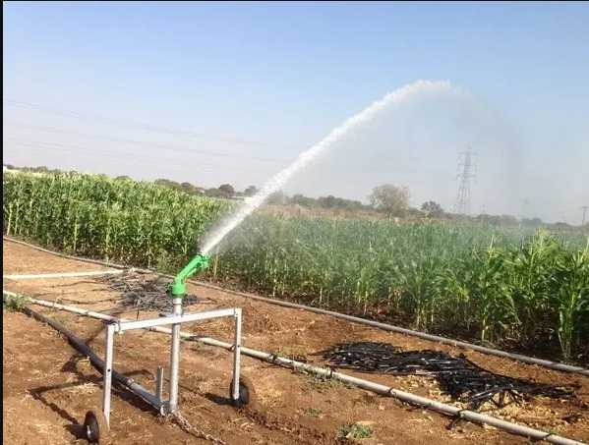
Spray Tube Irrigation System
The spray tube irrigation system consists of spray tubes or rain hoses, connectors, end plugs, main hoses, source of water and pumps.
The spray tubes are laid beside the rows of plants. The spray tubes work like sprinklers. They spray o sprinkle water to the plants.
The spray tubes use more water than the drip irrigation system, but they are efficient in the use of water than rain guns.
The spray tubes sprinkle water on both sides of the hose.
Some of the merits of using a spray tube irrigation system include:
- All year round farming
- Efficiency in nitrogen usage by plants
- Disruption of the activities of pests like insects and flies
- Ability to apply foliar fertilizers and pesticides to plants
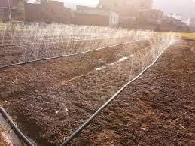

Center Pivot Irrigation System
The center pivot irrigation system consists of a center pivot or water wheel, source of water, hoses, pipes and pumps. The center pivot irrigates plants whilst it moves around a pivot.
The center pivot is usually used to irrigate plants in large acreages of land. It is not uncommon to see centre pivots used to irrigate several thousands of hectares of farmland.
The center pivot needs a big water reservoir for it to work well. The water reservoir may be a river or a dam.
The advantages of using a center pivot irrigation system include:
- Ability to easily irrigate plants in large farmlands
- Ability to grow crops all year round
- The center pivot can disrupt the breeding of pests like insects, aphids and flies etc.

Flood Irrigation System
Flood irrigation system is a method of irrigation that involves the application and distribution of water to the surface of the soil through gravity. Flood irrigation is common among small older farmers in Nigeria.
Flood irrigation system is a type of surface irrigation system. The uncontrolled distribution of water and the poor water and energy efficiency of flood irrigation are some of the problems of using this type of irrigation.
The advantages of flood irrigation system are:
- It enables farmers to cultivate their crops all through the year
- It provides much needed water to crops
Planting
This is the activity of putting plants into the ground or into a container of soil so that they will grow: Heavy rain delayed planting in parts of Indiana. Tree planting sounds so simple, yet its impact is profound.
Land preparation for planting include;
- Clearing of land.
- Stumping.
- Harrowing.
- Ridging.
Different types of crop that can be planted on the land include; maize, beans vegetables e.t.c. and it is be propagated by seed. It may be planted manually or mechanically.
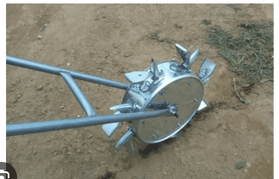
Seed Planter
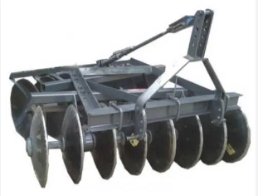
Harrowing Tools
Fundamental of Store Grains Management
The fundamental requirements of every grain storage methods or structures are to secure the grains from insect, rodents and prevent spoilage of the grains by the activities of the microorganisms. It is also essential to keep the grains cools and dry during storage.
- Store grain Ecosystem
- Relative humidity
- Mold or micro toxic
- What plant breath and release
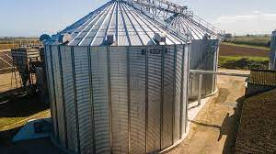
Silo
This can be used for preservative of crops, it takes air from the bottom to the top and preservative taken in the silo to avoid danger or to invite insects.
Daily maintenance of Tractor
- Check the oil level and top when necessary
- Check the water level in the radiator before starting
- Operate at appropriate speed for farm operations
- Check the fuel level before starting
- Do not overload the tractor
- Inspect the tractor everyday before starting.
Tractor
Is an engineering vehicle specifically designed to deliver a high tractive effort (or torque) at slow speeds, for the purposes of hauling a trailer or machinery such as that used in agriculture, mining or construction.
Periodic maintenance of Tractor
- The tractor should be service at regular interval
- Air filter should be cleared when necessary
- Oil filter should be changed after each service
- The engine oil should be change when necessary
- Fan belts should be replaced when necessary.
- Always, park the tractor in a shed
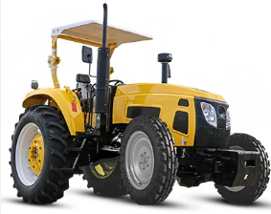
- The transmission oil should be change after each service.

Tractor
3.6 Tillage Operation
Tillage operation is the preparation of soil for planting of crops. The first implement to be use in tillage operation is plough and the process is called ploughing operation. This operation is the means of grass clearing, trees trump and also used in mixture of soil particles. Harrow is the second implement in tillage operation which is used for mixing of top layers with lower layer of the soil. Ridger is the last implement used in tillage operation which is used in ridges making.
Ridger and Its Function
The ridger is a secondary soil cultivation implement used for land preparation: it is also use after ploughing and harrowing have been completed. It is been attached to three point of linkages on a tractor. Parts of ridger are: beam, disc, opposed single disc, point of attachment to the tractor and hub.
Functions of Ridger
- Ridgers are mainly used for making ridges
- It also makes harvesting of crops easy.
- It collect together rich top soil, thus increasing nutrient availability of soil.
Maintenance of tillage implements (plough, Harrow and ridgers).
- Always ensure that nut, cap, screw are tight before and after operation.
- Grease the bearing regularly.
- Scrap the soil that attached to the disc before storage.
- Keep implement clean by removing all dirty before storage.
- Always keep implements in a cool and dry shed before and after yearly operation.

CHAPTER FOUR
4.0 Experience Gained During The SIWES Training and their Relevance to my Course of Study.
Student Industrial Working Scheme (SIWES) is a programme that exposes students to practical aspect of their discipline or their different courses of studies.
During my SIWES program at the Ministry of Agriculture and Rural Development, Ilorin Kwara State, I was able to identify different tools that are used to carryout simple maintenance tasks on Agricultural machinery. I also learnt periodic maintenance of a tractor and implement for tillage operation.
I learnt propagation methods of different crops (both food and cash crop), their nursing requirements, harvesting, processing, packing and marketing.
4.1 Problems Encounter during the Programme.
- Transportation problem.
- Far distance of farm locations.
Suggestion
All institutes should make proper arrangement with the ITF in sending students to certain Company/Industry which is allied with his/her course of study. ITF should try to pay the students at the appropriate time since the school and company are not paying with the belief that so far that ITF is paying them.
CHAPTER FIVE
5.0 CONCLUSION AND RECOMMENDATION
5.1 CONCLUSION
The Ministry of Agriculture and Rural Development, Ilorin Kwara State has some of the required machines, implements and tools for Agricultural purpose. The few available staff are devoted and ready to impact knowledge into undergraduates, graduates & trainees.
5.2 RECOMMONDATION
I hereby recommend this place (Ministry of Agriculture and Rural Development, Ilorin) in Kwara, State that they should provide room for impacting students with proper knowledge of technical operations.
They should provide experts, practitioner, well reequipped with good hospitality.

