CHAPTER ONE
INTRODUCTION
1.0 BRIEF HISTORY OF SIWES
The Student Industrial Work Experience Scheme (SIWES), also known as Industrial Training is a compulsory Skills Training Programme designed to expose and prepare students of Nigerian Universities, Polytechnics, Colleges of Education, Colleges of Technology and Colleges of Agriculture, for the industrial work situation they’re likely to meet after graduation.
The scheme also affords students the opportunity of familiarizing and exposing themselves to the needed experience in handling equipment and machinery that are usually not available in their institution. The scheme also affords students the opportunity of familiarizing and exposing themselves to the needed experience in handling equipment and machinery that are usually not available in their institution. The duration of SIWES is four months in Polytechnics at the end of NDI, four months in College of Education at the end of NCE II and six months in the Universities at the end of 300, 400 or 500 level depending on the course of study and departments preference.

The government’s decree No. 47 of 8th Oct; 1971 as amended in 1990, highlighted the capacity building of human resources in industry, commerce and government through training and retraining of workers in order to effectively provide the much needed high quality goods and services in a dynamic economy as ours (Olusegun A.T. Mafe, 2009). This decree led to the establishment of Industrial Training Fund (ITF) in 1973/1974.
The growing concern among our industrialists that graduates of our institutions of Higher learning, lack adequate practical background studies preparatory for employment in industries, led to the formation of students Industrial Work Experience Scheme (SIWES) by ITF in 1993/1994(Olusegun A.T. Mafe, 2009).

Before the establishment of the scheme, there was a growing concern among industrialists, that graduates of institutions of higher learning lacked adequate practical background studies preparatory for employment in industries. Thus, employers were of the opinion that the theoretical education in higher institutions wasn’t responsive to the needs of the employers of labour. SIWES introduction, initiation and design was done by the Industrial Training Fund (I.T.F) in 1993 to acquaint students with the skills of handling employer’s equipment and machinery. The Industrial Training Fund (I.T.F) solely funded the scheme during its formative years. However, due to financial constraints, the fund withdrew from the Scheme in 1978.
The Federal Government, having noticed the significance of the skills training handed the management of the scheme to both the National Universities Commission (N.U.C) and the National Board for Technical Education (N.B.T.E in 1979. The management and implementation of the scheme was however reverted to the I.T.F by the Federal Government in November, 1984 and the. administration was effectively taken over by the Industrial Training Fund in July 1985, with the funding solely borne by the Federal Government. ITF has as one of its key functions; to work as cooperative entity with industry and commerce where students in institutions of higher learning can undertake mid-career work experience attachment in industries which are compatible with student’s area of study.
1.1 AIMS AND OBJECTIVES OF SIWES
The objectives of SIWES among others includes:
- SIWES provide an avenue for students in higher institutions to acquire industrial skills and experience in their approved course of study.
- It Prepare students for possible industrial works situation which they may meet when they graduate.
- It makes the transition from school to the world of work easier and enhance students contact for future job opportunities.
- Provide students with an opportunity to apply their knowledge in real work situation thereby bridging the gap between theory(classroom) and practice(industry).
- Enlist and strengthen employers’ involvement in the entire educational process and prepare students for absorption into the field after graduation.
- Expose students to work methods and techniques in handling equipment and machinery which may not be available in their institutions.

1.2 BENEFITS OF SIWES TO STUDENTS
It affords the student an opportunity to learn how to function in multi-disciplinary teams.
- Students can now effectively communicate within the working environment.
- It provides the opportunity for students to understand professional and ethical responsibilities more.
- The scheme provides an opportunity for the industries to evaluate prospective employees and give healthy feedback to the institutions.
- It gives opportunity for the student to make better mastery of the theoretical knowledge acquired in classrooms using practical knowledge acquired in the industry.
- It enhances the student’ attitudes to work like commitment, dedication, punctuality, politeness, effective communication and such like.
1.3 BODIES INVOLVED IN THE MANAGEMENT OF SIWES
The bodies involved are: Federal Government, Industrial Training Fund (ITF), Other Supervising Agencies are: National University Commission (NUC), National Board for Technical Education (NBTE) & National Council for Colleges of Education (NCCE), Institutions of learning (say, UBITS Department in the case of University of Benin)
- The functions of these agencies above include among others to:
- Ensure that the scheme is adequately funded
- Establish SIWES and accredit SIWES unit in the approved institutions.
- Formulate policies and guideline for participating bodies and institutions as well as appointing SIWES coordinators and supporting staff.
- Supervise students at their places of attachment and sign their log-book and ITF Forms.
- Vet and process student’s log-books and forward same to ITF Area office
Ensure payment of Allowances for the students and supervisors.

Chapter two

2.0 HISTORY OF LOY HOTEL
Loy hotel in Ogun State, Nigeria is a modern hotel that offers excellent services is an upscale clientele around the world looking for unique luxury experiences and unparallel service.
Loy hotel is a first class hotel with excellent facilities, offering exceptional services. We promise to consistently anticipate guest’s expectations, by offering superior services, with a highly motivated and hospitable team. Our objective is to offer 5 star services with excellent facilities that give our customer’s a memorable experience.
The building is beautiful with adequate parking space. There is an outdoor swimming pool with a bar. The reception is small and a little cluttered. The staff were courteous and friendly and dedicated but could be more professional in their approach to guest needs and personal comportment. The room is large for the price compared to some other hotels i have stayed. There is a flat screen TV, Refrigerator, coffeemaker, a work station, nice chairs to relax while watching TV. There is a king size bed with low quality bed side lamps. The bathroom is large with hot water running. But the bathroom fittings are not up to the quality of the hotels the want to compete with. The roads to the hotel are very bad, though the hotel management said the are ready to fix the road after the rain has subsided. It het can fix all the issues above, Golden Sand has the potential of been one of the top hotels in Ogun state.
Golden Sands Hotel and Suites has 35 Luxurious Rooms ,which are 5 Golden Standards,23 Golden Deluxe, 3 Golden Executive,2 Golden Suites, and 2 Pent House .All rooms are spacious and stylishly designed to provide the comfort expected of an International Hotel. All rooms are fully equipped with the state-of-the-art ultra modern facilities, electronic keys and self programmable electronic safes, High speed internet facility (WIFI) and daily complimentary water, complimentary tea and coffee in all rooms.

OBJECTIVES OF THE ESTABLISHMENT
The Major Areas of Operations undertaking By the Establishment are;
1. To provides a lodging centre for individual and corporate.
2. For invent planning and social function organizing centre.
3. Provides laundry services.
4. Provide gymnastic house for exercises and watch of weight.
5. Its kitchen provides food and other edible substance for human
Consumption
Various Departments in the establishment and their Functions
The following are the departments in the hotel and their functions: -
1. Reception: The Reception is the heart of IBD International Hotels, where
guests are greeted with warm smiles and open arms. This department
ensures a smooth and swift check-in and check-out process, addressing any
inquiries with professionalism and a personal touch. The staff here is wellversed
in multiple languages and remains at the guests' disposal 24/7,
making sure their stay is comfortable and their needs are met promptly.
2. Housekeeping: The Housekeeping department is dedicated to maintaining
the highest standards of cleanliness and hygiene throughout the hotel. From
the pristine condition of guest rooms to the public areas, the housekeeping
team works diligently, ensuring every corner of the hotel reflects perfection.
Their attention to detail and discreet service play a significant role in
enhancing guest satisfaction and comfort.
3. Restaurant: - The Restaurant at IBD International Hotels is a culinary haven,
offering an array of dishes that cater to diverse palates. Whether it's a hearty
breakfast to start the day, a sumptuous lunch, or an elegant dinner, the
restaurant provides an exceptional dining experience. The chefs use the
freshest ingredients to create both local and international cuisines, while the
service staff ensures a memorable meal with their impeccable service.
4. Kitchen: The Kitchen is the backbone of the hotel's culinary offerings, where
creativity meets tradition. Led by experienced chefs, the kitchen team is
13
passionate about delivering exceptional food quality and taste. They
constantly innovate and update the menu to incorporate seasonal specialties
and cater to dietary preferences, ensuring every guest has a delightful
culinary experience.
5. Bar: The Bar at IBD International Hotels is a sophisticated retreat for guests
looking to unwind after a long day. It offers a wide selection of drinks,
ranging from classic cocktails to rare wines, all served in a cozy and inviting
ambiance. The bar staff is knowledgeable and attentive, ready to recommend
the perfect drink or concoct a guest's favorite cocktail with a delightful twist.
6. Laundry: The Laundry department ensures that all linens, uniforms, and
guest clothing are impeccably cleaned and pressed, contributing to the
overall sense of luxury and meticulous attention to detail that IBD
International Hotels is known for. Using state-of-the-art equipment and ecofriendly
cleaning agents, the laundry team ensures that every item is treated
with the utmost care.
At IBD International Hotels in Ilaro, every department works in harmony to create
an atmosphere of elegance, comfort, and hospitality. It's a place where every
guest is treated to an exceptional experience, making their stay not just
memorable but truly extraordinary.

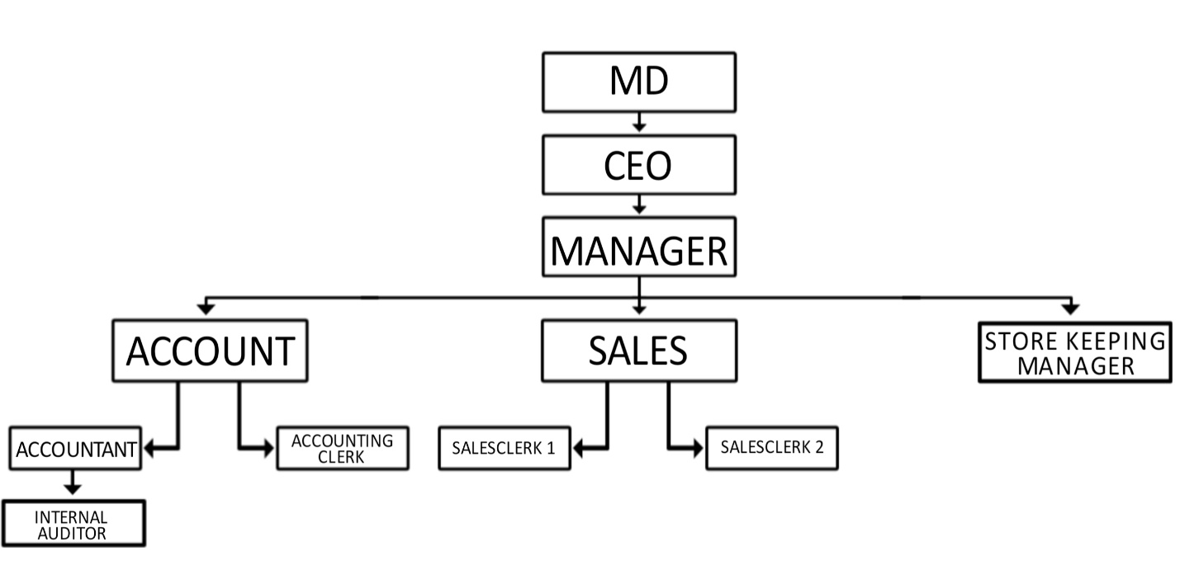
1.3 Organizational Structure of the firm/organization
CHAPTER THREE
2.0 WORK EXPERIENCE GAINED
The first day of my arrival into the company. It was an induction exercise. I was shared different sectors of department.
The first week of resumption It was basically am induction week. We were exposed to different section of the department and various personnel. We were also shown the working environment comprises of various offices, toilets etc. And also the basic rules and regulations of the company.
The second week, I carried out some office duties like typing of document using the Microsoft word and excel/ we carried out cleaning routines of arrangement of files and errands for the manager.
The third week, we were taught some office ethic like attendance to work on time, good communication skills and appearance.
2.1 Nature of Activities Carried Out During the Training Programme
The nature of activities was fundamentally on practical work. Series of guides and instructions was given to me on the first week of commencement and subsequent week emphasis was on some theoretical knowledge on quickBooks accounting software.
The practical activities were learning how to draw and prepare sales, debtors and debt recouped analysis, and as well as accounting and auditing of financial reports. Furthermore, I also learnt how to make good use of quickbooks accounting software.
2.2 Tools and Equipment Used
In performing certain accounting functions or in carrying out accounting operations, some set of equipments and tools are required to make the job easier. Some tools and equipments that were exposed to me include: computer, printer, banknotes counter or bill counter machine, quickbooks.
- Computer
A computer is an electronic device for storing and processing data, typically in binary forms according to instructions given to it in a variable program.

A computer helps an accountants to store and access financial records, make changes and alleviate the need to keep paper files. Some popular uses of the computers in offices include preparation of word documents such as letters, reports, processing if work documents such as work orders and financial reports, presentation of reports and proposals to and behalf of executive and higher level of office personnel.
- Printers
A printer is a hardware output device that is used to generate hard copy and print any document.

A document can be of any type such as a text file, image or the combination of both. The accountant uses the printer to print out important documents such as accounting documents, employee information, customers information etc.
- Bank note counter or bill counter

A currency counting machine is a machine that counts money either in stacks of banknotes or loose collections of coins. Currency counters are commonly used in vending machines to determine what amount of money has been deposited by customers, it also detects counterfeit bill (the machine stops when it reaches a counterfeit bill).

- Quickbooks

Quickbooks is an accounting software just as sage and others. It is a great business accounting software for small to mid-sized business owners. It helps save time on bookkeeping and paper work. It automatically handles some of the easy bookkeeping tasks, saving your time and making your day easier. It also provides tools to making your day easier. It also provides tools to manage your customers, vendors, clients inventory and finances.
2.3 Relation of the Training to the Course of Study
The correlation of the training to the Course of Study is that of the practical job and functions that was executed during the attachment period. Most of the theoretical work done in the school such as source documents, journal entries, double entry concept of bookkeeping etc, were all practically done during the training period.

CHAPTER FOUR
CONCLUSION AND RECOMMENDATIONS
4.1 CONCLUSION
Generally, I have been able to discuss SIWES itself. Its history, purpose, bodies involved in its management and its benefit to the students. Also, we now know what Business Administration is about and how to become a qualified Business Administrator in Nigeria. Above all, the wonderful experiences I gained during the period of my training have all been concisely outlined too including Managing, Organizing, Supervision, Preparation of BoQ, Office management, Programme of work, Contract Administration.
Until now, I have always esteemed managing as the peak of Business Administration practice, I had little awareness of the professional ethics required in Business Administration and I also did not see must importance on basic attitudes to work especially punctuality. All these and several other fallacies I had in mind about quantity have been carted away by the educative, practical and first-class professional training I received during my Internship at Loy hotel. Now, I am able to synergize what I have been learning in classroom with what is applicable in the industry.
Although much have been learnt during the period of my training, but majority of my experiences are related to management because I was attached to a Management firm. Also, the passive nature of the hospitality market in Ogun unlike Abuja and Lagos affects flow of jobs which causes dormancy at times.
I hope it only gets better with SIWES in department of Busness Admnstration. The limitations in the preceding paragraph can be taken into consideration and possible solutions made for better performance of the SIWES program.
4.2 RECOMENDATIONS
As it has been noted earlier, the one-sided nature of my experience as regards business Administration in a consultant is a challenge in the sense that few knowledge about administration was gained. Also, the poor market competition in Ogun State causes dormancy at times in companies because no or less work is at hand to do. In addition to these, inadequate supervision from the institution is a problem as this may cause some students to take the program less seriously.
It is therefore recommended that students be supervised on regular basis during the training say, monthly. This is to ensure that the students are assessed on the job and to keep track on how the students are improving on the job. I also recommend that the institution create structure whereby students can easily move from one organization to the other without difficulty in situation where the initial organization has less than three departments.

