

A TECHNICAL REPORT ON
STUDENT INDUSTRIAL WORK EXPERIENCE SCHEME (S.I.W.E.S)

UNDERTAKEN AT:

NURULAKIKH COMPUTER SPECIALIST
SHOP 5, LINE 8 OPP. HOT CAKE RESTAURANT, YANKARI KWARAPOLY, ILORIN KWARA STATE

BY:
HAMZAH WALIYULLAHI OLADIMEJI
ND/23/PAD/PT/0533

DEPARTMENT OF PUBLIC ADMINISTRATION, KWARA STATE POLYTECHNIC, ILORIN

SUBMITTED IN PARTIAL FUFILMENT OF THE AWARD OF NATIONAL DIPLOMA (ND) IN PUBLIC ADMINISTRATION FROM:
AUGUST TO DECEMBER, 2024

DEDICATION
This report is dedicated foremost to God Almighty for his favor, mercy and grace upon my life especially during my 4 months SIWES program at Nurulakikh Computer Specialist.
I would also like to dedicate it to my parents and siblings for their love and support and everyone else that contributed towards making my SIWES training a fun and successful one.

ACKNOWLEDGEMENT
My appreciation goes to the Industrial Training Fund (ITF) for their foresight in putting this program in place and also to the Kwara State Polytechnic, for providing a platform on which I was engaged on the training. I appreciate the siwes Coordinator, Many thanks to my supervisor for taking time to supervise me during my training. I also express my profound gratitude to all members and staff of Nurulakikh Computer Specialist who gave me training an exciting and blissful one. Also to my parents and siblings thank you all for your moral and financial support.
I am deeply indebted to God Almighty, the giver of all wisdom, knowledge and understanding without whom I would have achieved nothing at all.
Finally to my Industrial based supervisor Mr. A.B. Abdulrahmanfor his support and to my other friends and colleagues. Thank you all I am highly grateful.

TABLE OF CONTENTS
Front Page
Dedication
Acknowledgement
Table of Content
CHAPTER ONE
Introduction1.
1 Purpose of Working at the Organization
1.2 Definition of terms
CHAPTER TWO
Corn Stick (Ingredients)
Nutritional Composition and health benefits of corn stick
CHAPTER THREE
Employee Hygiene and Good Manufacturing Practices
CHAPTER FOUR
Conclusion, Challenges and Recommendations.

CHAPTER ONE
INTRODUCTION
1.1 Background of Study
Student Industrial Work Experience Scheme (SIWES) is one of the Industrial Training Fund (ITF) programs which were introduced in 1974 due to the inability of students in Nigeria universities and polytechnics to meet the practical aspects of their training. That is, the needs to enable students match their theoretical school knowledge with the practical aspect of their training in industry.
The program was designed for students of tertiary institutions with the aim of exposing students that have acquired theoretical knowledge in the classrooms to the practical exposure and experience. The scheme is a tripartite program, involving the student, the university and the industry (Employer of labor). It is funded by the Federal Government of Nigeria and jointly coordinated by the Industrial Training Fund (ITF) and the National Universities Commission (NUC).
1.2 Brief history of SIWES
In recognition of the shortcomings and weakness in the formation of graduates, particularly with respect to acquisition of relevant production skills (RPSs), the Industrial Training Fund (which was itself established in 1971 by decree 47) initiated the Students’ Industrial Work-experience Scheme (SIWES) in 1973. The scheme was designed to expose students to the industrial environment and enable them develop occupational competencies so that they can readily contribute their quota to national economic and technological development after graduation. Consequently, SIWES is a planned and structured program based on stated and specific career objectives which are geared toward developing the occupational competencies of participants. Participation in SIWES has become a necessary condition for the award of degrees and diplomas
The main thrust of ITF program and services is to stimulate human performance, improve productivity, and induce value-added production in industry and commerce. Through its SIWES and Vocational and Apprentice Training Program, the Fund also builds capacity for graduates and youth self-employment, in the context of Small Scale Industrialization, in the economy.
1.3 AIMS AND OBJECTIVES OF SIWES
The program was specially designed to carry out the following;
- Bridge the gap between theory and practical thereby giving students the opportunity to apply their knowledge accurately.
- Expose students to what their professions entail.
- Improve inter-personal relationship skills of the students.
- Develop skills on practical knowledge
CHAPTER TWO
2.1. DESCRIPTION OF THE ESTABLISHMENT OF ATTACHMENT

Brief History of Nurulakikh Computer Specialist
Nurulakikh Computer Specialist was established in the year 2012, which is first office situated at University of Ilorin Mini Campus, Ilorin. And the main branch is situated at Kwara State Polytechnic, Ilorin. The Company is made up of Chief Executive Officer, who is responsible for the day to day running of the organization. It was charged with the broad function of cyber café and data analysis by carrying out the online registration, graphics design etc.

2.3.2 Vision
To make Nigeria one of the acknowledged leaders of the scientifically and technologically developed nations of the world.

2.4 Major Activities of the Organization/Company
Nurulakikh Computer Specialist was majorly established for online registration, project research analysis and graphic desingn etc.

2.5 Organization Chart of Nurulakikh Computer Specialist.

OUR VISION
- To move with re-positioning agenda of the present administration
- To bring the dividend of democracy closer to the students of the grassroots level of the institution.
- Making sure that policies and plans of institution are properly implemented
- To empower the youths and the women
- To build capacity for small and medium scale enterprises
- To ensure market sanitation and street cleanliness
- To secure the life and properties of the citizens of the country
- Improving access to quality knowledge service delivery

CHAPTER THREE
  - PURPOSE OF WORKING AT THE ORGANIZATION
GETTING STARTED WITH COMPUTER
In our definition of computer, we started that computer is an electronic device that simply means that before computer can put into use: it must be connected to power source. But unlike any other electronics items like television or radio. Computer is not put into use immediately it is switched on; there must be a diagnostic procedure that the computer system must be undergone. Before computer is connected to electrical socket, the user must ensure that all connections are made.
- Power cord from VDU to the UPS or Socket
- Signal cord from VDU to CPU
- Connection of mouse to CPU
- Connection of keyboard to CPU
- Connection of printer to CPU
- VDU to UPS or socket
- Power Cord from CPU to UPS or Socket
- Connection of other devices that is available for use to CPU as well e.g. speaker.
After the above connection have been made, and then just press the power button located at the front panel of the CPU to switch on the computer. When the computer is on. It is given some seconds to perform a diagnostic check in order to make itself ready for use.
The process of switching on the computer and its diagnostics check before it can accept command, instruction and data is called BOOTING PROCESS.
The term boot computer language used instead of start.
Booting is the process of starting computer. It is of two types
CODE BOOTING AND WARM BOOTING.Code booting is the process of switching on the computer afresh from the power button after it has been previously shut down normally. Warm booting is the process of restarting computer as a result of hang up of computer by make use of the reset button locate below the power button on the front panel of CPU
Tip: press Alt + Ctrl + Delete key on your keyboard shortcut.
At the completion of the booting process, computer will display the Desktop there the user will locate the start the start Button on the Task Bar

3.2 1INTRODUCTION TO MICROSOFT WINDOW
Microsoft is a company that specializes on the development of computer software. One of its inevitable stem software is the Microsoft window operating system.
Microsoft window is operating systems that form a graphical user interface between computer system and user. Windows is an example of a Graphical User Interface (GUI) operating system. It adequately provides a friendly interface for all you need to manage your version of Ms Windows.
- Ms Window 3.x (earliest versions)
- Ms Window 95
- Ms Window 97
- Ms Window 98
- Ms Window 2000
- Ms Window NT (Networking)
- Ms window ME (Millennium)
- Ms Window XP ( Experience )
- Window Vista
- Window 7 etc.
3.3 The Desktop Environment
Once the user boots the computer system. Microsoft Windows Operating System automatically loaded onto the memory for use (if it has been pre – installed into the system immediately after the diagnostics checks, a friendly interface environment is displayed called Desktop.
On the desktop, the following items are noticeable:
- Icon: Is a graphical representation of a command, a window, a program, a file, a folder or an application. Most common examples are My Computer icon, my document icon, Recycle Bin icon etc.
- Task bar: is usually located at the desktop environment. It housed the start button. Time indicator and a few icons.
- Startbutton:Is a point through which other programs or application windows can be loaded.
- Time Indicator: this indicates or displays current time and by a simple method can display also the current dates.
- Mouse Pointer: this is an arrow shaped symbol that serves as an interface between the computer user and the operating system. Commands are issued by clicking. Clicking means pressing a button on the mouse.
- DesktopBackground: this is simply beautifies the desktop environment. Note that it can be changed, edited and modified or even customized.
- Hourglass: this is a kind of “Hourglass shape” symbol. When this is displayed it indicates that the computer is still responding to the last command invoked.
3.4 TYPES OF COMPUTER
The four basic types of computer are as under:
- Super Computer
- Mainframe Computer
- Mini Computer
- Micro Computer
- Super Computer: The most powercomputer in terms of performance and data processing are the super computers. These are specialized and task specific computers used by large organizations. These computer are used for research and exploration purpose like NASA use super computer for launching space shuttles, controlling them and for space exploration purpose.
The super computers are very expensive and very large in size. It can be accommodated in large air-conditioned rooms; some super computers can span an entire building. The Seymour Cray designed the first super computer “CDC 6600” in 1964, CDC 6600 is known as the first super computer. Also super computer are used for weather forecasting and to study the nature and extent of Hurricanes, Rainfalls, Windstorms etc.
- Mainframe Computer: Are not as powerful as super computers, but certainly, they are quite expensive nonetheless and many large firm and government organizations uses mainframe to run their business. Mainframe computer can also process and store large amount of data, Banks, Educational, Institution and Insurance companies use mainframe to store data about their customers, student.
- Mini Computers: Are used by small business and firms. Minicomputers are also called as “midrange computer” these are small machines and can be accommodated on a disk with not as processing and data storage capabilities as super computer and mainframe.
- Micro Computer: The micro computer are widely used and the fastest growing computers. These computers are cheapest among the other three types of computer. The micro computers are specially designed for general usage like entertainment, education and non purpose. Desktop computers, Laptop, tablet and Smartphone are all types of micro computers. Well known manufactures of micro-computer are hp, Dell, Apple, Samsung, Sony, Toshiba, and Fijitsu Siemens etc.
3.5 COMPUTER AS A SYSTEM
Computer as a system which consists of hardware components that have been carefully chosen, so that they work well together and Software components or programs that run in the computer. The main software component is itself an operating system that manages and provides services to other programs that can be run in the computer. The hardware and software work as team to make computer system completed, without hardware there nothing called software likewise without software the hardware remain immobile.
3.6 COMPONENTS OF COMPUTER SYSTEM
Component of computer system are those parts of computer work as a team to give computer component of two these are:
i. Hardware
ii. Software
Hardware: Computer hardware refers to the physical part of a computer and related devices. It can further be grouped into two. Internal hardware devices which include: mother boards, hard drives, and Ram.
External hardware devices: Which include; the V.D.U [Monitor] keyboard, mouse, printer and scanners the internal hardware devices are usually called peripheral.
Software: Computer software is refers to the part of the computer that is non physical.
3.7 UNITS OF HARDWARES
I. Input Units
ii. Processing Unities.
iii, ` Output Units
3.8 INPUT UNITS
These are the devices that are used to send data, commands and instructions into the computer.
It is a communication link and point of interaction between the computer and the user. Example: of input devices(unit) are keyboard, mouse, and scanner.
For the purpose of this book our subsequence discussion will be concentrate on the keyboard and mouse.
KEYBOARD: This is predominant computer input device. The computer keyboard is very similar to that of typewriter. It has all the alphabetical numeric and special character keys which are known as standard key that are found on a typewriter keyboard.
This type of keyboard is called standard keyboard or QWERTY keyboard because of his letter in the upper left corner of the alphabetic portion of the keyboard other type of keyboard is called enhanced keyboard, it is also kwon as DEVORAC keyboard. The standard keyboard contains 108keys while the enhanced contains 96keys.
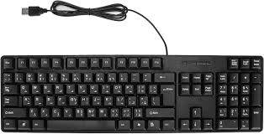
KEYBOARD
KEYBOARD: This is the arrangement or section of keys on the board [keyboard] the keyboard is of seven sections. These are:
1. First functional key
2. Second functional key
3. Cursor control keys
4. Special computer keys
5. Alphabetic keys
6. Numeric keys
7. Editing keys
First functional key: These are the set of the key arranged horizontally at the uppermost part of the keyboard and labeled F1 to F12. They are used to invoke commands to be applied to computer operation while installed. Some is used in conjunction with other keys e.g. Control F2 = Print Preview, alt F4= closing program.
SECOND FUNCTIONAL KEY: These are keys located immediately below the first function keys, contains figures from 0 to 9 and a special symbol is on the o4key is owner keys and the second one is borrow key. The owner keys are 0 to 9 while the borrow keys are the symbols on the owner keys. To activate symbols one needs to hold down the shift e.g shift 2 = @, Shift 5= %, sift 9 = (. etc.
CURSOR CONTROL KEY: These are arrow keys located immediately below the editing keys they are four pointing to different direction such as Up, Down, Right and Left. They are used to control the movement of cursor on the screen. Cursor is the tiny character that links on the screen indicating the position where the next character to start it something called navigational keys.
SPECIAL COMPUTER KEYS: These keys that perform special function such as: Escape key, Tab key, Control key, Space key Caps lock, Shift key, Backspace, Enter key, Alternative key, Window logo key and Correct key. Some is used alone while some is used together with other keys. E.g. Control A to Z etc
ALPHABETIC KEYS: These are the key contains the letter of alphabets used to types either lower case or upper case. The lower case or upper of the alphabets are made possible by activating on or off the caps lock key. It sometimes called typing keys.
NUMERIC KEYS: The pad is located at the extreme right side of the computer extreme right side of the computer keyboard digit 0 to 9 and other symbols. The numeric keys are essentially used for large volume of numeric data. The numeric keys are activities when numeric lock light indicated by pressing the numeric lock key and activated when the key is pressed again.
EDITING KEYS:These are the keys that used to editing document while or after typing such as home key, delete key, page up, page down end etc.
MOUSE
It is an input device that tells computer what to do in a specific format. the process of pressing is called CLICKING the use of mouse is very important and indispensable in two basic buttons, one at the left side and other one at the right side, the mouse is a hand hold pointed device that help you use your software more easily and efficiently.
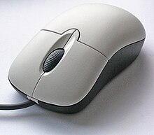
MOUSE
SKILLS IN USING MOUSE
The following are skills or techniques in using mouse.
1. RIGHT CLICKING: it is the pressing of the right buttons of the mouse.
2. LEFT CLICKING: It is the pressing of the left button of the mouse. Trains should master the use of left clicking because; this is the one that frequently used to give commands to computer.
3. OUT CLICKING: This is the clicking of the left button of the mouse outside the working area; it is used instead of escape key.
4. SINGLE CLICKING: This is the pressing and releasing of the mouse button once in a quick
5. DOUBLE CLICKING: This is the pressing of the left bottom of the mouse twice in quick successions
6. POINTING: This is the placing of the mouse pointer on an icon on the screen tip.
7. Screen tip; is a yellow box that is displayed when the mouse pointer is placed on an icon showing the relevant information abort the icon
8. Dragging; this is the pressing down the left button on an icon or text while the user moves the mouse pointer to another location before releasing the button for instance you can drag any of the icon to another location
OUTPUT UNIT
I hope you have not loss your track from our main topic which is hardware components of computer system. Output unit is another important unit of hardware under which different types of ways and means of producing data will be discussed. The data that have been processed by the computer can be produced in hardcopies. Other output devices are punched card. Microfilms and magnetic ink character Reader. Our discussion in this book will be centered on only two output devices.
- The visual display unit
- The printer
VISUAL DISPLAY UNIT (VDU)
The VDU is like a television set which is sometimes referred to as monitor. Its major function is to display the data that has been processed by the CPU. Such as typing.VDU also displays the means and other processing facilities of the application program that currently in use.
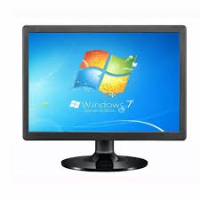
MANITOR
VDU can be monochrome and colour monitor
Monochrome which displays data and graphics in one colour, mostly black or white: colour monitor which displays data and graphics in multi- colors.
PRINTERS
Printers are used to print the output on paper is called hard copy output while the output displayed on the screen is called softcopy output. Printers are classified into two: Non-impact printers and impact printers.
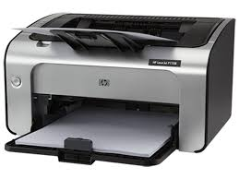
PRINTER
SOFTWARE
Software is the non-physical aspect of computer system. It is a set of programs that classified the operations of computer and coordinate its activities.
Software can be divided into two
- System software
- Application software
System software: These are set f programs that are mainly used by the computer itself to carry out its day to day operations.
Definition:
Data Processing can be regarded as the act of selecting, refining and combining text in order to make it readable meaningful and acceptable as information that can serve useful communication purpose in a prescribe former.
Data can be described as raw fact that has not been. Before data meaningful and readable it must undergo processing.

CHAPTER FOUR

4.1DATA PROCESSING TECHNIQUES
Thereare three basic techniques of data processing
- Manual data processing
- Electro- mechanical data processing
- Electronic data processing
Manual data processing: this is the act of selecting text with the use of pen book and human brain.
Electro- Mechanical Data processing: this is the act of selecting text with use electro- mechanical devices such calculator, organizer, Pascal machine etc.
Electronic Data Processing: this is the act combining text with use of electronic device such as computer.

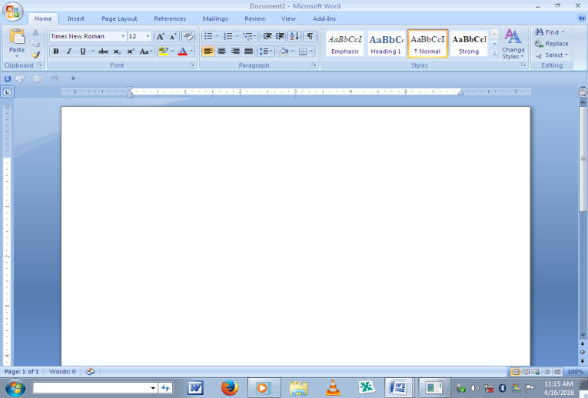

OPEN
Opencommandisinvoked to retrieve existing document file that has stored or saved in the computer or any auxiliary storage device like diskette.
- Click file menu
- Click open
Then a dialog box appears on the screen. Which will display ail the existing files stored in the computer? If the document to be is a diskette, must change where “my document” is printed on the dialog box to “3¹/₂ floppy” when the entire files name in the computer or in the floppy diskette is display and the click the file name you wish to retrieve and click open from the option buttons.
Close
Close is related document in the current window. If a document will be required in the feature, it is advisable to save such document before you close it. When you invoked close commend and the current document is not save the dialog box will show on the screen requesting from the user “DO you want to save change to Document ” if you want to save click “YES” and follow the necessary save procedure, if not, “NO” from the option buttons.
- Click file menu
- Click close
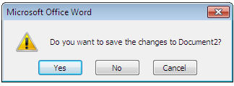

SAVE
Save command enables you to store your active or current document into the computer or into a diskette for the first time, it also update already save document.
PROCESS
- Click file menu
- Click save
- A dialog box appears on the screen demanding for the following information.
- Where to save the document (my Document or 31/2 floppy A)
- Click the file name space provided, then type the name you want for the document.
- Click on save from the option buttons after you have entered the necessary information.
SAVE AS
- It is used to save a new document
- It is used to rename a file
- It is used to save document into another storage device
Save as command displays dialog box just as started under save command. It is never used to update document because when it is invoked, it always display dialog box which indicate a request for new arrangement for saving the current document.
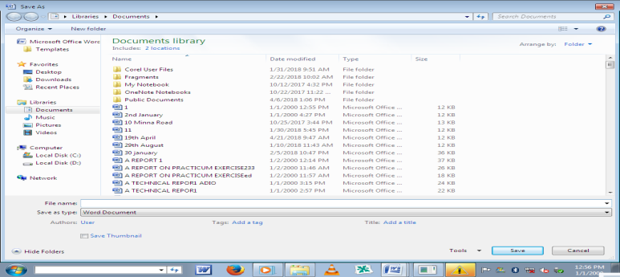

PAGE
Pagesetup command allows formatting the pages of your current document, and performing the following operations.
- Set the document margins (Right, Left, Top and Bottom )
- Select the paper size (Letter, legal, A4 etc)
- Select paper orientation (Portrait or Landscape)
The above process is done through the following steps:
- Click file
- Click page setup
- A dialog box appear on the screen which displays the following margins, paper size, and paper orientation, select the appropriate stabs and setting and click “OK” from the option buttons.

PAPER ORIENTATION
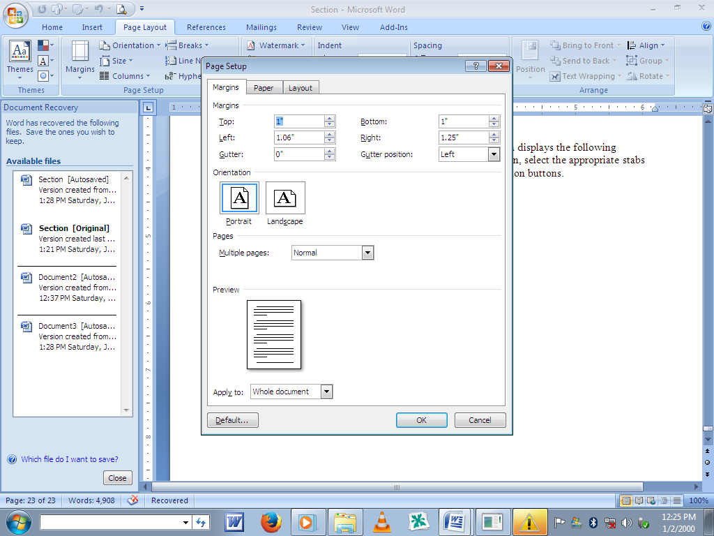

CHAPTER FIVE

5.1 My Personal Impression About the Organization
Nurulakikh Computer Specialist, a very friendly organization which addresses issues in a polite manner and equally encourages both the SIWES students and apprentices to be self-dependent and motivated. I can say that the organization as a bright/promising future if she will not change the way she operates.

5.2 Experience Gained
Working as a student Trainee at NurulakikhComputer Specialist has given me the opportunity of getting a firsthand appreciation of Computer Business Center, learning its fundamentals, learning to work with the various equipment used. I was able to apply some of the theoretical knowledge gained during my study at the Polytechnic to real work situations thereby bridging the gap between school work and actual practice.
My general experiences concerning Business Administration are as follow:
- I was able to understand what Business Administration generally was all about.
- I was made to understand how to use some Computer equipment and their general maintenances
- I learnt how to do online registration.
- I learnt how to use mouse, keyboard and photocopies machine.
- Finally, I learnt how difficult tasks are handled to ensure smooth progress of a project work in conjunction to the time frame for a given project.

5.3 Recommendation to the Organization and to the Polytechnic Concerning the SIWES Program
In view of the relevance of the SIWES program, it is important that it is sustained by the government through the industrial training fund (ITF) as it exposes the student to work tools, facilities and equipment that may not be available in their respective institutions in relation to their course of study.
- To this end, I recommend that the following under-listed points should be implemented.
- Students’ Industrial work Experience Scheme (SIWES) needs to be strengthened by all concerned stakeholders in order for its objective to be full realized.
- Regular monthly allowances for students on attachment should be paid promptly.
- Organizations should always accept students for SIWES and subsequently assign them to relevant jobs.
- It will be of great benefit if the institution can create a platform whereby student can obtain Pre-SIWES knowledge or excursion programs, before the student embark for general 4-Months Industrial Training Programme.

5.4 Interpersonal Relationship
My four (4) month SIWES programme at Nurulakikh Computer Specialist was much educational because their staff was always ready to entertain every question and to provide reasonable answers to them. In other words, the workers there were hard working, reasonable and also good at clearing doubt.

5.5 Conclusion
This report has been able to X-ray an account of the entire work-experience garnered by me during my SIWES program at Nurulakikh Computer Specialist which is a core scheme in ITF and which is saddled with the responsibility of strengthening the effective teaching and learning skill-based course such as Business Administration. I therefore concluded that SIWES is of great benefit to students in tertiary institutions. It therefore implies that the proper and effective administration of SIWES will go a long way in boosting and enhancing the competencies of the workforce of the country. I also that SIWES is confronted with series of challenges and this may have hindered the realization of the goals and objectives of the scheme and it therefore needs to be given attention by all concerned stakeholders.

