

A TECHNICAL REPORT ON STUDENT INDUSTRIAL WORK
EXPERIENCE SCHEME(SIWES)

HELD AT
SUCCESS AUTOMOTIVE
ALONG OJATUNTUN AGBO-OBA ILORIN

PRESENT BY:
ADAM AZEEZ OLAREWAJU
ND/23/MEC/PT/0169

SUBMITTED TO:
DEPARTMENT OF MECHANICAL ENGINEERING INSTITUTE OF TECHNOLOGY (I.O.T) KWARA STATE POLYTECHNIC, ILORIN

IN PARTIAL FULFILLMENT FOR THE REQUIREMENT FOR THE AWARD OF NATIONAL DIPLOMA (ND) IN MECHANICAL ENGINEERING

AUGUST - NOVEMBER 2024

DEDICATION
I dedicate this report to Almighty God, the creator of heaven and earth for his guidance and blessing upon me. Also to my lovely parent in person of MR and MRS Azeez and the entire member of the family at large for their support during the four months programme.

ACKOWLEDGEMENT
I wish to express my profound gratitude and sincere appreciation to my lovely and caring parent in person of MR and MRS Azeez. Also to the SIWES coordinator at Success Atomotive in person of Mr. Junior for providing enabling environment for me during the programme, my gratitude also goes to the entire staff of the company for their adequate support.

TABLE OF CONTENT
TITLE PAGE
DEDICATION
ACKNOWLEDGEMENT
ABSTRACT
CHAPTER ONE
- Introduction to SIWES
1.1 Aims and Objectives of SIWES
1.2 Organization Chart of the organization
1.3 Major activities of the Organization
1.4 Workshop safety
CHAPTER TWO
2.0 Basic Workshop Hand tools and Equipment with their Functions
2.1 Components of Automobile Engine
CHAPTER THREE
3.0 Welding process
3.1 Main type of Welding
3.2 Cutting Process
3.3 Bending Operation
3.4 Electrical Joints
3.5 Electrode Holder
3.6 Material used
3.7 Surface finishing and through cleaning
CHAPTER FOUR
4.0 Drilling Machine
4.1 Types of Drilling Machine
4.2 Types of drills
4.3 Drilling Operations
CHAPTER FIVE
5.0 Experience Gained
5.1 Interpersonal Relationship within the Organization
5.2 Suggestion for Improvement of the Programme
CHAPTER SIX
6.0 Recommendation
6.1 Conclusion

CHAPTER ONE
1.0 INTRODUCTION TO SIWES
The Student Industrial Work Experience Scheme (SIWES) is established in year 1973 by the industrial training fund (ITF).The Student Industrial Work Experience Scheme (SIWES) is established to facilitate the full realization and mandatory skills acquisition and proper training programmes designed to expose students to the industrial working environment in their respective disciplines during their course of study. The students are expected to develop occupational competence that would facilitate their fitting into the world of work after graduation.
The Students Industrial Work Experience Scheme (SIWES) programme involves the student, the Universities, polytechnics and various institutions, and the industries. This training is funded by the Federal Government of Nigeria and jointly coordinated by the Industrial Training Fund (ITF), the National Universities Commission (NUC) and National Board for Technical Education (NBTE).
1.1 AIMS AND OBJECTIVES OF SIWES
The SIWES programme is designed to achieve the following aims and objectives:
- To expose students to working methods and techniques in handling equipment and machineries that is not available in their various institutions.
- To prepare students in skills development by participating in field works, particularly in report writing in their field of works.
- Provision of avenue for students to acquire industrial skills and experience during their course of study.
- To expose students to working methods and techniques in handling equipment and machineries that is not available in their various institutions.
- To provide students with an opportunity to apply their theoretical knowledge in real work situation, thereby bridging the gap between theory and practice.
1.2 ORGANIZATION CHAT OF THE COMPANY
MANAGING DIRECTOR
TECHNICIANS
ENGINEERS
APRENTICE
SIWES STUDENT

1.3 MAJOR ACTIVITIES OF THE ORGANIZATION
Success Automotive mainly in repairing and maintenance of an automobile machine, drilling, cutting , welding, etc.
1.4 WORKSHOP SAFETY
Safety is generally the preventive measure that are taken against hazards, accident or harm in day to day activities in the workshop, industry and there environment. Safety is an essential ingredient for existence. Workshop safety is particularly focusing on ways of preventing dangers, harm particularly accident, injury a times death to personnel, or others and things around the operator while doing work. The following are the basic workshop safeties that must be comply with. These include:
- Never walk under a load carried by crane or mechanical hoist
- Clean any oily material on the floor to avoid slipping
- Keep hands away from moving/rotating
- When attempting practical work all stools should be put away.
- When learning how to use a machine, listen very carefully to all the instructions given by the teacher. Ask questions, especially if you do not fully understand.
- Do not use a machine if you have not been shown how to operate it safely by the instructor.
- Use the right tools and equipment for the right job
- Emergency way must be free of obstacles
- Make sure the gangways are free of any object
- Always co-operate with your colleagues

CHAPTER TWO
2.0 BASIC WORKSHOP HANDTOOLS AND EQUIPMENT WITH THEIR FUNCTIONS
There are various hand tools and equipment in the mechanical workshop for repairing and maintenance of an automobile machine, drilling, cutting , welding, the following are the major hand tools and equipments used, they include:

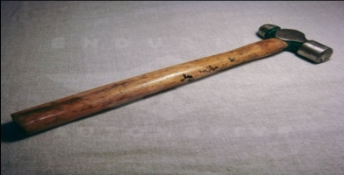
Hammers: Hammer is mainly use in driving, hitting and pulling some part of the motor vehicle out. They are of different type which includes: ball pane hammer straight pane hammer, cross pane hammer, double face sledge hammer.

Spanner: Spanners are use in tighten and loosing bolt and nut, they are of different type like the flat, ring, socket, open ended.
- Screw driver: is used in driving out screws from a particular surface
- Hacksaw: is use for cutting metal and some materials in the workshop

- Allen key: it is used in driving in or out Allen bolt i.e bolt of a hexagonal head
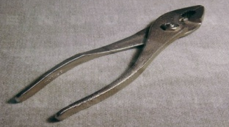
- Pliers: are use for griping, cutting small flat or round materials

- Center Punch: it a marking out tool which is use in locating centres of a material for drilling or other purpose.
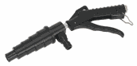
- Coolant system flush gun: it enables thorough flushing of debris and contaminants from cooling system during repair and maintenance
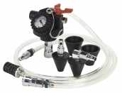
- Cooling system filler: it eliminates the introduction of bubbles and air-locks into the system and drastically reduces system filling time.

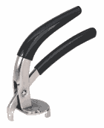
- Radiator cap wrench: it removes all standard radiator caps, it also allows the extra torque required to be applied to free tight caps and easily safely

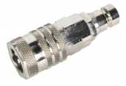
- Radiator coupler: used in draining and filling coolant system

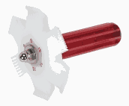
- Radiator fin straightener: used in straightening delicate fins found in the radiator, air conditioning condensers, oil coolers etc


- Water pump spanner: used in adjusting the timing belt of an engine by rotating the water pump on its eccentric mounting
Others includes: Hose clamp vice, pressure testers, welding helmet, drilling machine, filling tools, flaring tools, adjustable spanner etc

CHAPTER THREE
3.0 WELDING PROCESS
Welding is a fabrication or scruptinal process that join material usually metal or thermo plastics by causing fusion. Welding process be classified into fusion welding and solid phase - welding.
- fusion welding is the process of joining two piece of metal together by application of heat. The two metals are placed together, heated until they melt and solidify on cooling with or without the addition of filler metal. The heat may be develop in several ways like combustion of fuel gas with oxygen, electric arc., electric resistance heating e. t. c.
- Solid phase welding is a process of welding in which the clean faces of component are brought together to produce a metallic bond with or without the application of heat but the application of pressure is essential to induce plastic flow.
The base metal melt and a filler material is added to the joints to form a pool of molten material that cools to form a joints. That is usually stronger than the base material. Pressure may also be used in conjunction with heat or by it self to produce a weld.
3.1 Main type of welding
- Electrical Arc welding:- is normally carried out by transformer or motor generator set that take their supply from electrical distribution system in the workshop or alternatively, by engin driven generator.
Welding transformers, which may or may not incorporate rectifuers, are either oil cooled by fan. Care should be taken to ensure sufficient ventilation around the transformer to avoid exceeding the rate temperature rise and there by causing dangerous over of the equipment.
- Electric circuit:- in the majority of cases, the electric circuit is relatively simple, but it us important to understand the three essential connection for every welding circuit. These are
- The welding head:-As the welding lead is normally connected to the electrode holder, the cable has to be capable of caring the full welding current without over heating and much be sufficiently flexible and robust to without every day use.
- The welding return:-It is often the most neglected part of the whole welding system. It is not the earth lead. It is the cable by which all the welding current returns to the welding set. Once this fact is realized, the importance of its efficient become obvious. It must be at least of equal cross sectional area to that of the welding cable, but it need not be as flexible.
- The welding circuit:-this is essential to ensure that the welding circuit is adequately earthed. The cross section of the welding earth current. It should be ensure that the welding earth torches the work piece properly to avoid lost of welding current.
3.2. Cutting process(operation)
Theimportantstepintheconstructionprocessistocutthefulllengthgalvanizedroundpipeof2mmthicknesswhosefulllengthis18ftlong,weneed2fulllengthtocoverupforthethreelegof12fteach,weneed1½inchesgalvanized round pipe of 1.5mm thickness whose 1 length is 18ft; since we have 18ft length 2mm thickness round pipe was cut to 12ft and remain 6ft, the short length remain was weld with the second short length, after the three leg are cut we need to cut the 1½ inches round pipe to maximum size of 24ft and 16ft length, 2 length was cut form 24ft for the front view each, while 2 length for the side view of 16ft each, while 4 length for roofing and 2length for the handle 18ft each and also 1½ length for middle brazing.
3.3 Bending operation (process)
In this project we shall adopt bending process especially for the u-channel part of the construction, mostly the corner are bend to join the side view and front view to connect to each other and also to drill the bending part to connect the joining part together using bolt and nut. The coner and joint will be joined by using the chain link fence tube fittings and roof with a cross shaped channel.

3.4 Electrical joints
It must be emphasized that the welding circuit is frequently carrying current or several hundreds amperes in adoption to ensure adequate capacity, cable for the welding lead, weld return, and earth return it is important to ensure that poor connection and poor joint are avoided. All joint whether in the sufficient at the equipment, the electrode holder and at he work. If the cable is joined throughout its length coupling should be effected by plug and socket cable connection or efficient cable joint and not by bolt and nut, which after work become loose and corroded. This result is an inefficient circuit with danger to personnel and equipment.
3.5 Electrode holder
Electrod holder should be of sufficient capacity to hold largest electrode to be used and carry maximum welding current without over heating. The holders must be produced with an insulating handle, as relevance must not be placed on the welders gloves for insulating the operation hand from live part care is necessary in leaving an electric holder when welding is temporary suspended.
The safest procedure is to make the holder dead either or at the transformer regulator, alternatively by disconnecting the complete equipment.
3.6 Material used
- Galvanized round pipes
- Polyethylene
- Electrodes.
- Galvanized round pipes:- features excellent forming properties, paint ability, weld ability, and is suitable for fabrication by forming, pressing and bending.
zinc coating is one of the most effective and economical method of protecting bore steel from a corroding environment.
- Polyethylene:-sheets are made of closed-cell crossed linked polyolefin foam that control condensation, has high thermal efficiency, and sound absorption. They are available as a sand which product that is composed of room, alupet foil, and self adhesive backing. In addition to the dimensional stability, the rolls and sheet have a memory 'memory effects' that enable them to take back their original shape. The foil and the foam can have different colors ( apart from the standard grey foam and silver foil) depending on the customers needs. Not only are they environmentally friendly but they pose no harm to human to human health and have zero ozone depletion (ODP), global warming potential (GWP) of less than 5, and a low volatile organic compound (VOC) of less than 4ug/m2/hr in 24 hour.
- Electrode:- An electrode is an electrical conductor used to make contact with a non metallic part of a circuit (e.g a semi conductor, an electrolyte, a vacuum or air). The word was coined by Williams wheel at the request of the scientists Michael Faraday from two Greek words: electron, meaning an Ber (from which the word electricity is derived), and hodes, a way.
3.7 Surface finishing and through cleaning
This is essential in any fabrication work because it improve paint and allow paint to stick properly to the surface. The process involved grinding of the welded joint and surface to remove bores and excess slag and also sanding the surface to remove dirty and corroded surface.

CHAPTER FOUR
4.0 AUTOMOBILE
Automobile: is a self-propelled vehicle by an internal combustion engine and is usual for transportation of passengers and goods on ground
Example: bus, cars, jeep, truck, motorcycle
Parts of automobile
- Machine portion
- Carriage portion i.e. body
DIFFERENT PARTS OF I.C ENGINES
A. parts common to both petrol and diesel engine
(1) Cylinder
(2) Cylinder head
(3) Piston
(4) Piston rings
(5. Gudgeon pin
(6) Connecting rod
(7) Crankshaft
(8) Crank
(9) Engine bearing
(10) Flywheel
1. CYLINDER: It contains gas under pressure and guide the piston the movement of the piston or stroke bearing in most case, longer than the bore. It is known as the stroke bore ratio. The upper end consists of a combustion or clearance space in which the ignition and combustion of the change take place.
2. CYLINDER HEAD: It helps to seal the working ends of the cylinders and not to permit entry and exist of gases on cover head valve engines. The inside cavity head is called the combustion chamber. It Is usually made by cast-iron or aluminum
3. PISTON: A piston is filled to each cylinder as a face to receive gas pressure and transmit the thrust to the connecting rod
4. GUDGEON PIN: it is hard steel parallel spindles filled through the piston bosses and the small end bushes or eyes to allow the connecting rod to swivel.
5. CONNECTING ROD: It transmits the piston load to the cranks causing the latter to turn.
B. parts for petrol engine only
1. Spark plug (2) Carburetor (3) Fuel pump
Spark plug: It helps to conduct the high potential from the ignition system into the combustion chamber
Carburetor: it helps to atomize and meter the high fuel and mix it with the air as it enters the induction system of the engine
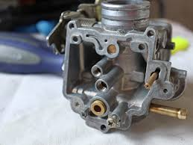
Fuel Pump: it is use in petrol engine to supply fuel to the carburetor/ injector
4.1 SYSTEM IN A VEHICLE
1. Fuel system: it helps to deliver the best performance with lowest emission it is a system that transfer fuel from the fuel tank and pass it through the fuel filter for straining before it arrives at the agents (carburetor)
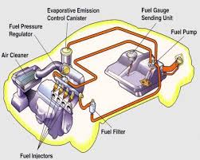
2. Brake system: it helps to slow and stop a vehicle when you push the brake pedal. The force generated hydraulic pressure in the master cylinder this pressure flows through the hydraulic line and hoses to the wheel cylinder and calipers. Forcing the shows against the brake down or pads against the rotor or disc
i. Brake Pedal: this is a rod (pedal) inside a vehicle, commonly use to control the speed/motion of a car.
ii. Brake Servo/Brake Air Box: this is a box that helps the effectiveness of the brake when the car is on motion, because when the servo is bad, air been pump to the brake system may not return which will make the brake sticky and have no effect on the brake disc, i.e. affect the halting of the brake pad.
iii. Master Brake: this is the brake fluid distributor in which the fluid is kept and passes this fluid through the brake holes to the caliper.
iv. Brake Disc: this function whenever the piston is shoot out which is gripped by the brake pads. The gripness of the brake pad help the movement of the brake disc to stop.
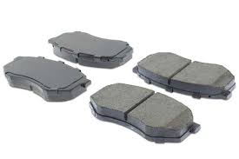
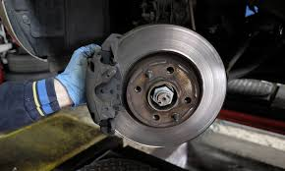
4.2 DRILLING MACHINE
Drilling is the process of creating hole on a component. Drilling machine is the machine tool used in accomplishing the task of originating hole, reaming, boring, counter boring and other drilling operations.
4.3 TYPES OF DRILLING MACHINE
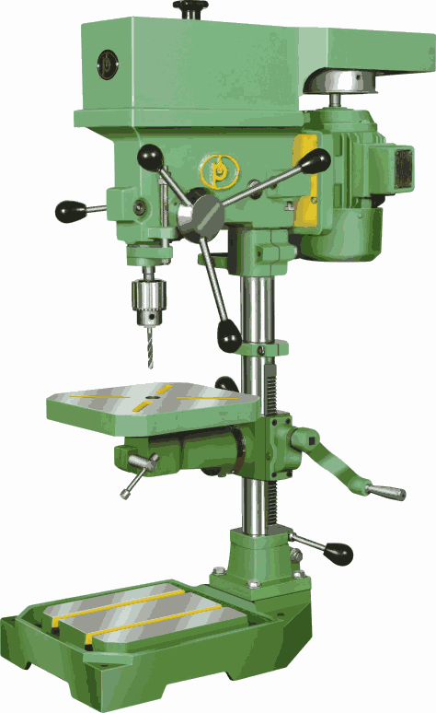
- Pillar drilling machine
- Sensitive drilling machine
- Radial arm drilling machine
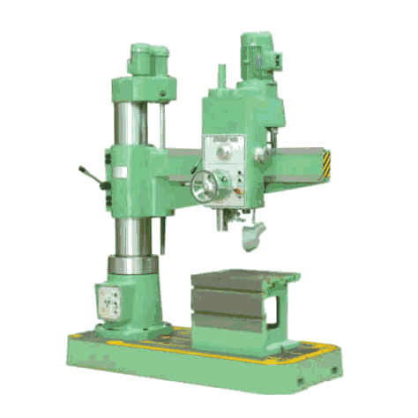

DRILLING MACHINES
4.4 TYPES OF DRILLS
Drills are multi point cutting tools used in performing drilling operation. The common types are: The Twist Drills (both parallel and taper shank) and The Centre Drills
4.3 DRILLING OPERATIONS
Drilling operations includes:
- Counter sinking
- Counter boring
- Boring
- Reaming

CHAPTER FIVE
5.0 EXPERIENCE GAINED
During the sixteen weeks (four months) programme, I gained a lot especially in the repairing and maintenance of an automobile machine, drilling, cutting , welding etc.
5.1 INTERPERSONAL RELATIONSHIP WITHIN THE ORGANIZATION
My four months SIWES program has equipped me the knowledge of mechanical repairing and maintenance of an automobile machine, drilling, cutting , welding
During the course of staying with the coordinator in person of Mr. Junior has no small amount of contribution to my field of study and success for the programme in general..
5.2 SUGGESTION FOR IMPROVEMENT OF THE PROGRAMME
The industrial training fund should have up and hold committee on inspecting the student in their various organizations that they are attached to as this will improve the level of seriousness of the student to the program
The federal government in collaboration with the industrial training fund (ITF) to increase the student allowance for the program as this will encourage them in active participation

