

KWARA STATE POLYTEHNIC, ILORIN

REPORT ON STUDENT INDUSTRIAL WORK EXPERIENCE SCHEME
(SIWESS)
UNDERTAKEN AT
NATIONAL ASSEMBLY ABUJA
THREE-ARMS ZONE, P, M, B 141, ABUJA
PERIOD OF ATTACHMENT:
August 2024 to November 2024
By
UMAR HABEEB OLAYINKA
ND/23/COM/PT/0269

SUBMITTED TO
DEPARTMENT OF COMPUTER SCIENCE

KWARA STATE POLYTEHNIC, ILORIN

CERIFICATION
This is to certify that this work was undertake by UMAR HABEEB OLAYINKA with matric number ND/23/COM/PT/0269 at KWARA STATE POLYTECHNIC, ILORIN, The report submitted to the department of computer science kwara state polytechnic ,Ilorin, Nigeria during 2024 Student industry work experience

DEDICATION
I dedicate this siwes report to God almighty for the opportunity and grace given to me during the period of this piece of work to my wonderful parent and my family.

Chapter 1
INTRODUCTION
The unit started in the following facility of engineering technology in 1979 as an industrial co-odinating unit catering for engineering student on industrial attachment. The foundation staff comprised of as industrial co-odinator was engaged.
In the earlier stage of science and technology education in Nigeria student were graduating from their respective institution without any technical knowledge or working experience. It was in this view that student undergoes science and technology related courses were mandated for students in different institution in view of widening there horizontal so as to enable them have technical knowledge or working experience before graduating from their various institution

OBJECTIVES
- Provide an avenue for student in higher institution or learning to acquire industrial skills and experience during their course of study
- Prepare student for industrial work situation that they are likely to meet after graduation
- Expose student to work method and techniques in handling equipment and machinery that may not be available in their institutions
- Make the transition from school to the world of work cahier and enhance student contact for later job placements
- Provide student with the opportunity to apply their education knowledge in real work situations thereby bridging the gap between theory and practice

CHAPTER TWO

DESCRIPTION OF THE ESTABLISHMENT
National Assemble is an ICT that was formed to meet the communication and network demand of industry. We drive network transformation for entries and service provides through communications technologies that increase productivity and open network source of revenue

A BRIEF HISTORY OF KNON TECHNOLGY
National assembly Nigeria three-arm zone, P.M.B 141, Abuja

NATIONAL ASSEMBLY ORGANIZATION OF THE NETWORK STRUCTURE
Connectively solution for multi-branch city network which require secure reliable high speed connectivity between branches and their head office whether your office network spans between two branches or across a whole city or across major cities within Nigeria we are able to offer you a reliable connectivity solution our network spreads within 15cities in Nigeria at the moment and we are gradually expanding our coverage metropolitan area network (MAN) virtual private network (VPN) and secure private circuits can be establish using our access solution.

CHAPTER THREE

THE KNOWLEDGE GAINED AND AUTUAL WORK DONE
This chapter tells in detail the actual work carried out. During the duration of my SIWES program in National assembly. I gained experienced on computer networking fiber to the home setting up of internet link, configuring of network device and troubleshooting on client’s network national assembly offer support service to all of it clients which involves going to troubleshoot client computer network or internet links when is down I was mostly involve in carrying out this engineer services as well as support services. Highlighted below is the knowledge I acquired about computer networking.

KNOWLEDGE GAINED

TROUBLESHOOTING A PROBLEM WITH A LOCAL AREA NETWORK
It is pertinent that the process of troubleshooting a network is discussed as it will be needed at one point or the other. Usually issues could arise whereby a computer refuses to send or receive data over a network and at such times necessary troubleshooting step must be carried out to eradicate this problem. The common step of troubleshooting are listed and explain below in appropriate order from the first thing to check to the last thinkable thing to do.

CHECKING THE INTERNET PROTOCOL (IP) ADDRESS: in some cases, the port might be active but there won’t be any data activity. This can be caused by a problem with the IP. The IP is a protocol used by network devices to assign a unique sequence of numbers used to identify a particular computer (or domain name in the case of the internet).

Checking The Server Or Switch Or Router: Since the connection of computers is aided by a central device, problem problem may arise from a source of connection such the server or switch. These problems may be due to power cut on the devices. Error in configuration of the devices or disconnected of the central cable connecting such central devices to the computer.
NETWORK ADDRESS TRANSLATION (NAT)
Furthermore I learn how to NAT a radio and the reason for netting them this is because it helps to translate private IP address inside our network device that is not routable over the internet into a public address and there are of two forms:
- Static
- Dynamic
STATIC: Method of nutting is used when we have just one private inside our network and we just NAT our router to help translate that particular private IP address into local public IP that would be assigned to the device that will be connected to it.
DYNAMIC: This is another method of natting whereby a pool of local global addresses are casted inside the router whereby when the private IP is trying to access a server outside of its network, the router helps to translate it into a local global address by allowing it pick from a pool of locally created global address

CHAPTER FOUR
NETWORKING EQUIPMENTS USED AT NATIONAL ASSEMBLY

ROUTERS
A router is a device that forwards data packets along network. A device that forward data packet between computer networks. Creating and overlay internetwork. A router is connected to at least two network, commonly two LANs or WASs and its IPS’s network. When a data packet comes in one of the lines, the router reads the address information in the packet to determine its ultimate destination then using information in its routing table or routing policy, it directs the packet to the next network network on its journey. Routing are located at gateways, the places where two or more connect.

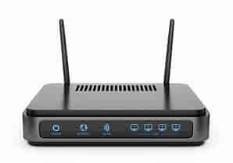
SWITHCH
Equipment such as switch are needed because the cable that runs to the radio would come back on the switch and then to the monitored.
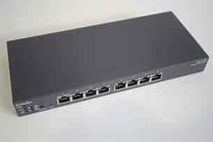

NETWORKING CABLES
Are used to connect one network device to other device or to connect two or more computers to share printer, scanner etc. Different types of networking cable like coaxial cable optical fiber cable. Twisted pair cables are used depending on the networking topology, protocol and size

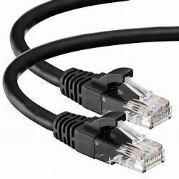

CRIMPER
This is an R, 145 crimper tool, which is use for crimping of twisted pair cables or LAN cable such as a cross over cables and straight through cables.

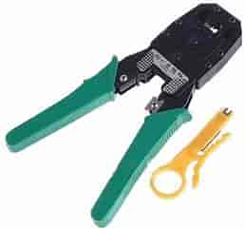

OPTICAL LINE TERMINAL (OLT)
This is devices that is located at the service provider central office and is the endpoint of a passive optical network (PON)

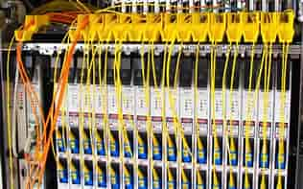

CHAPTER FIVE
SUMMARY
Chapter one of these report is about introduction to the work experience gained while industrial training at NATIONAL ASSEMBLY ABUJA. And also about the background and objectives of the scheme (SIWES) that was established by ITF in 1993/1994, in order to promote the acquisition of practical skill in industrial and commerce sector of the economy.
Chapter two gives details about the establishment and its objectives, the various department and their functions.
Chapter three and four is about some of the works/activities and experience gained at IT department in NATIONAL ASSEMBLY which is basically on networking
Chapter Five which is the last chapter of this report contain summary, recommendation and conclusion.
After my four months of Student Industrial Working Experience Scheme (SIWES) at NATIONAL ASSEMBLY, I was able to familiarize myself with networking, their basic tools and also setting up internet links and also more about Cisco company and there certifications which am intending to partake in soon.
RECOMMENDATION
The operation of SIWES lies on the proper supervision Thus it becomes necessary that something must be done at the operational level to enhance adequate functioning of the programme. Also ITF should be providing insurance cover to student on attachment, improve on paying students supervisors allowance for motivation and probably pay the students before the commencement of the programme the help with any financial challenge.
CONCLUSION
I really appreciate the effort of the government for embarking and keeping alive training. It was not only to be practically oriented but to also expose student to working experience. How to relate with people at work and instilling of discipline into students. And I want to advice the next SIWES student to really take this program with all seriousness and not just do it became of the grade involved through it a large grade unit but they should take it seriously because this would make them standout as practical scientist.

