
A TECHNICAL REPORT ON STUDENT INDUSTRIAL WORK EXPERIENCE SCHEME (SIWES)

HELD AT
GLOBALINK LIMITED
Alh. Zubair Street, Kosubosu, Baruten, Kwara State

BY
SALAMI AYOMIDE AZEEZ
ND/22/PAD/PT/0323

SUBMITTED TO
DEPARTMENT OF PUBLIC ADMINISTRATION
INSTITUTE OF FINANCE AND MANAGEMENT STUDIES (I.F.M.S), KWARA STATE POLYTECHNIC,
ILORIN.

IN PARTIAL FULFILMENT OF REQUIREMENT FOR
THE AWARD OF NATIONAL DIPLOMA
(ND) IN PUBLIC ADMINISTRATION

SEP., – DEC., 2024

TABLE OF CONTENTS
TITLE PAGE
CHAPTER ONE
1.0 Introduction
1.1 Historical development of SIWES
1.2 Aim and objectives of SIWES
1.3 The scope of the scheme
1.4 Contribution of the scheme
1.5 Problems affecting the scheme
CHAPTER TWO
2.1 Background of the organisation
2.2 Vision
3.3 Mission
3.4 Organogram of the organisation
3.5 policies/programmes
3.6 public service departments
CHAPTER THREE
EXPERIENCE GAINED
3.0 Definition of financial management
3.1 Significance of financial management for non-finance students and professionals
3.2 Important concepts and areas in financial management
3.3 The position of financial managers in organizational hierarchy and their respective work domain.
3.4 The external and internal business environments and their relevance to financial management.
3.5 Different types of financial and real assets markets.
3.6 Problems encountered
CHAPTER FOUR
4.1 Conclusion
4.2 Recommendation
CHAPTER ONE
- . INTRODUCTION
This report was written in respect to the Industrial Training (IT) program undergone. It examines the activities carried out during the program as regard to the duties and responsibilities undertaken by my department.
This program was incorporated and funded by the Industrial Training Fund (ITF) jointly coordinated by Student Industrial Work Experience Scheme (SIWES), for the acquisition of skills and added values to students of various institutions.
In the course of the program, I was meant to understand the verse responsibilities and duties of the Public service commission with the flow of command which is majorly bureaucratic (a procedure of performing a task in consideration of the laid down rules and regulation). It also induce in me the knowledge of chain of command is important and to have someone under-checking your performance and coaching you on a more positive aspect of carrying out all paper works.
  - ABOUT INDUSTRIAL TRAINING FUND (ITF)
In October 1971, the Federal Government established the Industrial Training Fund (I.T.F). In its policy statement No.1 published in 1973, a clause was inserted dealing with the issue of practical skills among the locally trained professionals in the tertiary institutions especially the universities of technology, polytechnics, colleges of education and technical colleges.
Hence, Section 15 of the policy statement states clearly that “Great emphasis will be placed on assisting certain products of the post-secondary school system to adapt or orientate easily to their possible post-graduation job environments”, subsequently leading to the launch of a scheme known as Student’s Industrial Work Experience Scheme (SIWES).
  - BRIEF HISTORY OF S.I.W.E.S
SIWES (Student industrial work experience scheme) was established by ITF in 1973 to solve the problem of lack of adequate skills by graduating student in the industrial world. The scheme exposes students to industry based skills necessary for an easy transition from the classroom to the industrial world.
Participation in SIWES has become a necessary pre-condition for the award of diploma and degree certificates in specific disciplines in most institutions of the higher leaning in the country, in accordance with the education policy of government.
Operators of SIWES include: the ITF, the coordinating agencies; NUC, NCCE, NBTE, employers of labour and the various institutions. The SIWES program is funded by the Federal Government of Nigeria.
  - OBJECTIVES OF SIWES
- SIWES provides the avenue for students in institutions of higher learning to acquire industrial skills and experiences in their course of study.
- Prepare the students for the industrial work situation they’re likely to meet after graduation.
- Expose students to work method and techniques in handling equipment and machinery that may not be available in their institutions.
- Make the transition from school to the world of work easier and enhance students contact for later job placement.
- SIWES provides students with an opportunity to apply their knowledge in real work situations thereby bridging the gap between theory and practice.
1.5 PROBLEMS AFFECTING THE SCHEME
SIWES has encountered a lot of problem in recent times, and this has affected its growth and development. Below are some of the problems;
- There is inadequate funding system which reduces the student capability at work since they are not well motivated
- Supervision sometimes is not carried out as scheduled due to inadequate motivations which make student unserious and relax to work.
- Employers hardly have time to impact knowledge to the student.

- IT trainees are usually treated like normal staff, been over-worked and are been paid nothing or less for their efforts
CHAPTER TWO
2.1 BACKGROUND OF THE ORGANISATION
2.2 VISION
To sustain a reformed Public service, proficient in professionalism, effective and transparent service delivery.
3.3 MISSION
To create quality and objective Public Service through adherence to rules and regulations.
3.4 ORGANOGRAM OF THE ORGANISATION
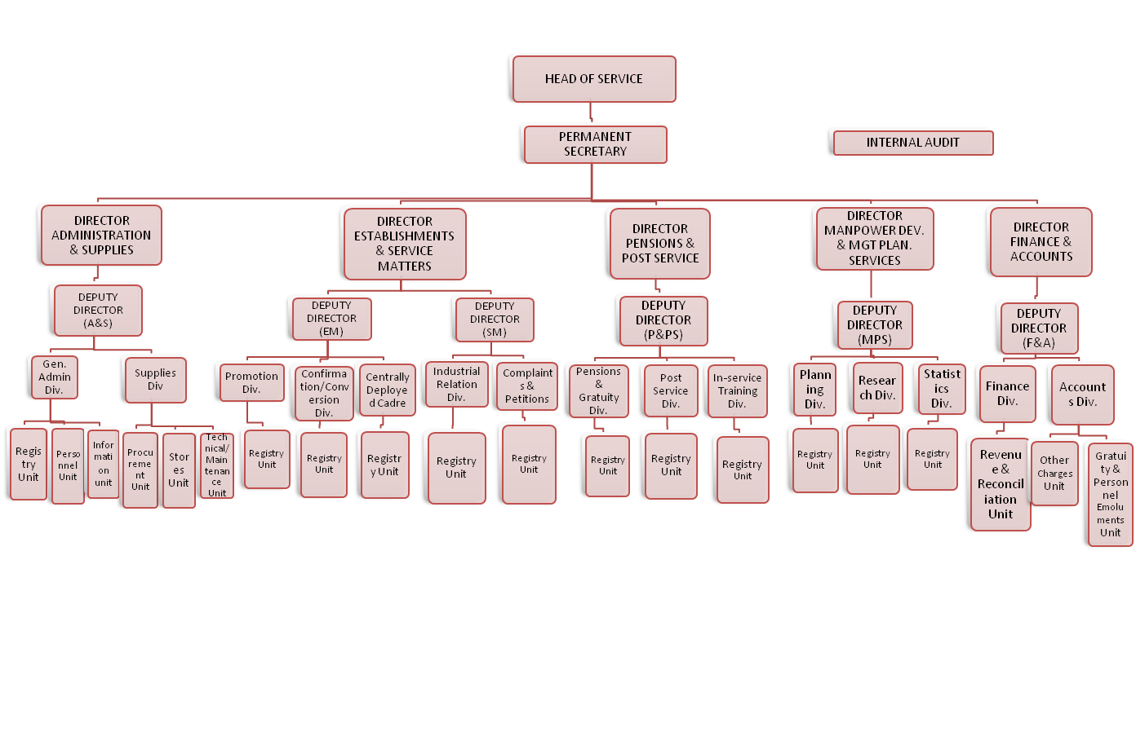

3.5 POLICIES/PROGRAMMES
- Monthly payment of pension and gratuities
- Biometric verification of pensioners
- Distribution of welfare packages to pensioners (every quarter of the year)
- Visitation
3.6 PUBLIC SERVICE DEPARTMENTS
The Commission has the following departments:-
- Administration Department: This Department is responsible for the General Administration of the Commission. It takes charge of staff Welfare and Maintenance of Vehicles.
- Finance Department: This department deals with all matters of Finance and Budget Estimates.
- Planning, Research and Statistics: This Department is charged with the responsibility of collating, collecting and keeping records of Public Servants. The data collected are used for the preparation of the Commission's Annual Reports, Achievements and Quarterly Reports. The Department is also responsible for providing information/data for Gazette publications of promotions, transfers, secondment, new appointments, withdrawals, resignations and retirements from service on request.

CHAPTER THREE
EXPERIENCE GAINED
3.0 What is FINANCIAL MANAGEMENT
FINANCIAL MANAGEMENT is the management of financial resources – how to best find and use investments and financing opportunities in an ever-changing and increasingly complex environment.
3.1 Why should CS majors study FM?
First of all, financial management is a core life skill; almost everyone needs to understand some concepts of finance to manage his/her business & personal finances.
It is generally and quite rightfully said, “Money makes the world go round”. Finance is like a life-blood for a company. Even the best of the companies and CEOs go out of the business because of poor financial management policies.
Management Information Systems (MIS) and Information Technology (IT) are just a part of the overall corporate strategy which runs on finances, the major resource. So the computer sciences professionals need to have an understanding of the financial concepts to understand and contribute to the overall corporate strategy.
Financial Engineering is an upcoming field that requires people with CS, math/science, and finance background. Financial engineering is the application of engineering methods to finance. One important area of study is the design, analysis, and construction of financial contracts to meet the needs of enterprises. This field is experiencing an increased demand for professionals, especially those who are trained in both the underlying mathematics/computer technologies and finance.

3.2 Definitions
Finance:
Finance is the science of managing financial resources in an optimal pattern i.e. the best use of available financial sources. Finance consists of three interrelated areas:
1) Money & Capital markets, which deals with securities markets & financial institutions.
2) Investments, which focuses on the decisions of both individual and institutional investors as they choose assets for their investment portfolios.
3) Financial Management, or business finance which involves the actual management of firms.
3.3 Major Areas & Concepts of Financial Management
Following are some of the important areas and concepts of financial management, which would be discussed in detail in the lectures to come.
Analysis of Financial Statements:
Analysis of financial statement is one of the most common techniques of financial analysis, in the financial performance and financial health of a company is analyzed based on its past performance.
The following financial statements are used in the analysis process.
• Profit & Loss Statement or Income Statement
Income statement reflects the operating efficiency or profitability of a company as a result of its operations along with the net profit available to the shareholders for a given year (usually one accounting period). This statement provides the analyst with some insight into the financial performance of the company.
• Balance Sheet
Balance Sheet is a snap-shot of an organization’s financial health at a particular time. It shows what assets are owned by the business and the sources of acquiring these assets.
Balance Sheet – An FM Perspective (Fig.1)
Fig. 1
• Statement of Shareholders’ equity
Statement of shareholders’ equity provides the share of the owners in the business.
• Statement of Cash Flows
Statement of cash flows explicitly reflects the cash movement (inflows and outflows) during the operations in an accounting period.
Taken together, these statements give an accounting picture of the firm’s operations and financial position. Financial statements report what has actually happened to the assets, earnings, and dividends over the years. The analysis of the information contained in these statements help management of the organization to evaluate the performance and activities of the concern; it also helps the investors and creditors to have an idea of the profitability potential and creditworthiness of the business.
Investment Decisions & Capital Budgeting:
Investment decisions are the most critical as they usually involve huge sums of money and these decisions are likely to bring prosperity or doom to a business. A company’s future income depends on how much investment is made, in what type of assets, and how these assets add to the overall value of the company.
Capital budgeting is a term strictly related to investment in fixed assets; here, the term capital refers to the fixed assets that are used in production, while budget is a plan which details projected cash inflows and outflows over some future period. The following concepts and techniques are employed while analyzing investment decisions.
- Interest rate formulas
- Time Value of Money
- Discounted Cash Flows
- Net Present Value
- Internal Rate of Return
Risk & Return:
Investors, individual or institutional, invest their money with the expectations of earning a return on their investment. While investors wish and attempt to earn maximum return, they are constrained by risk. How the risks and returns are related and how do investors make a choice of their portfolios is important for investment decision making. Following concepts and theories would be discussed while discussing the risk-return choices of the investor:
- Uncertainty
- Risk
- Portfolio Theory
- Capital Asset Pricing Model
Corporate Financing & Capital Structure:
When a firm plans to expand, it needs capital or funds. Acquisition of funds is considered to be a primary responsibility of a finance department in an organization. There are numerous ways to acquire funds, i.e., finances can be raised in the form of debt or equity. The proportion of debt and equity constitutes the capital structure of the firm. Financial experts attempt to find a combination of debt and equity that could increase the overall value of the company, i.e., they try to find the optimal capital structure. The following concepts would be used to understand how an optimal capital structure could be attained.
- Cost of Capital
- Leverage
- Dividend Policy
- Debt Instruments
Valuation:
Asset or company valuation is important not only for financial managers, but also for creditors and investors. It is important to know the value of the company or its assets to make important financing and investment choices. Different valuation techniques and factors that influence the value of a company or its financial instruments would be discussed in this section.
- Share
- Bond
- Option
- Corporate
Working Capital & Inventory Management: Working capital and inventory management pertains to the effective management of current assets. As we will see, an optimal and effective utilization of working capital and inventory increases the operating efficiency of the firm.

International Finance & Foreign Exchange: With the increasing importance of international trade and global markets, the role of international finance has increased manifold. In a global environment, the finance managers have more choices pertaining to investing and financing than ever before. However, it is important to understand the implications of working in a global environment, since fluctuations in the currency rates can convert a good financing or investment decision into a bad one. This section of the course would discuss the international financial environment and the financial implications of working in a global environment.

3.4 Internal and External Business Environment

Fig.2
Internal Business Environment:
Internal environment of business normally consists of the following. I. Finance
ii. Marketing
iii. Human Resources
iv. Operations (Production, Manufacturing)
v. Technology
vi. Other Functions (Logistics, Communications)
External Business Environment:
The following business environment factors outside an organization have a profound effect on the functions and operations of an organization.
I. Customers
ii. Suppliers
iii. Competitors
iv. Government/Legal Agencies & Regulations
v. Macro Economy/Markets: vi. Technological Revolution
An analysis which is used in a business is called SWOT Analysis. SWOT is an acronym where
S stands for Strengths
W stands for Weaknesses
O stands for Opportunities
T stands for Threats
Strengths and weaknesses are within an organization, i.e., they pertain to the internal environment of the organization.
Opportunities and threats, on the other hand, pertain to the external environment, i.e., outside the organization.
3.5 Financial Markets
Capital Markets:
These are the markets for the long term debt & corporate stocks.
Stock Exchange:
A stock exchange is a place where the listed shares, Term finance certificates (TFC) and national investment trust units (NIT) are exchanged and traded between buyers and sellers.
Long term bonds:
Long term government & corporate bonds are also traded in capital markets.

Money Markets
Money market generally is a market where there is buying and selling of short term liquid debt instruments. (Short term means one year or less). Liquid means something which is easily en-cashable; an instrument that can be easily exchanged for cash. Following financial instruments are traded in money markets.
Short term Bonds
Government of Pakistan: Federal Investment Bonds (FIB), Treasury-Bills (TBills) Private Sector: Corporate Bonds, Debentures
Call Money, Inter-bank short-term and overnight lending & borrowing
Loans, Leases, Insurance policies, Certificate of Deposits (CD’s)
Badlah (money lending against shares), Road-side money lenders
Real Assets or Physical Asset Markets
Following are the active markets of real and physical assets in Pakistan
- Cotton Exchange, Gold Market, Kapra Market
- Property (land, house, apartment, warehouse)
- Computer hardware, Used Cars, Wheat, Sugar, Vegetables, etc
  - PROBLEMS ENCOUNTERED
As this department play some essential to the organization, some of the problem adhere to it are as follows:
- The department was over staffed which cause some of the officers to be idle
- The department now sees the commission as a place concerned with their own personal business neglecting the affairs of the government
- Late coming of some staffs of the department
- Lack of stationery to carried out the organization duties
- Sleeping on duty
- Absence from duty without leave
- Filing system which an essential part in the department was carelessly handed
- Misplacement of officers file
3.6 PROPOSED SOLUTION TO ENCOUNTERED PROBLEMS
- All officers should be treated equally and duly discipline should be given in accordance of the Public Services Rules
- The organization should employed competent and ready minded staff
- Provision of stationeries when required
- Office cabinet should be made available and damaged ones should be replaced

CHAPTER FOUR
4.1 CONCLUSION
In conclusion, from my experience, it is revealed the importance of the S.I.W.E.S program for tertiary student, not only for the reason of keeping their selves busy, but for the enclosure it brings to them. The S.I.W.E.S programs gives the student the first hand experience of what is been taught in lecture halls, thus improving, enhancing and also giving the student a broader knowledge and also creating an opportunity to maximize them through the practice of the supposed course.
4.2 RECOMMENDATIONS
Based on the findings of this study the following recommendations are made:
- Tertiary schools should have an evaluation test after the S.I.W.E.S program to check on the job satisfaction level of their students so as to know the factors/necessities lacking in the industries for S.I.W.E.S students.
- Tertiary schools should organize a seminar for students after their S.I.W.E.S program for them to discuss their experience.
- Schools should from time to time recommend outstanding students for IT employment.

